

Student Name: Netsanet yadergal
Student Number: 24131569
Module Code: BMHP5015
Module Title: Changemakers: Building your personal brand for sustainable Employment
Date of Submission:
Submit to: Caroline Salami

Table content

1,Introduction .............................................................................................3
2, Analysing the Personal Employability Skills Required........................3
2.1 Job description and person specification..........................................3-4
2.2, Essential skills for employment............................................................4
2.3, Frameworks of concepts for these abilities........................................5
3, Assessing My Own Strengths ................................................................,5
3.1,Self-evaluation using SWOT analysis.....................................................5
3.2 Reflecting on Experience: Gibbs’ Reflective Cycle...............................6
3.3 Feedback from Others.............................................................................6
3.4 Motivation for growth...............................................................................7
4, Developing a Professional and Personal Brand....................................7-8
5, Plan of Action and Long-Term Goals.......................................................8
6, conclusion ..................................................................................................9
7, Reference....................................................................................................10

- Introduction
For this report, I have chosen the role of Senior Care Assistant at HC-One, a private provider of dementia, nursing, residential and specialist care homes across the UK, based within the independent (private) sector of health and social care (HC-One, 2026). I found this vacancy on Indeed, and screenshots of the advert are included as evidence below.
I chose HC-One specifically because it is one of the UK's largest care providers, with a structured Learning and Development offer, including its Aspiring Home Managers programme, which gives a realistic route from Senior Care Assistant into future leadership roles (HC-One, 2026). This matters to me because it builds directly on my existing experience as a Care Assistant and my current role as a Trainee Early Years Support Worker, and it is the next deliberate step towards the leadership and communication skills I want to develop. My longer-term ambition to open a domiciliary care business is addressed separately later in this report; the focus of this analysis is becoming a confident and competent Senior Care Assistant at HC-One.
This report analyses the employability skills the Senior Care Assistant role requires, evaluates my own skillset against those requirements using reflective and self-assessment tools, explains how I will build my personal brand and communicate my skills to employers, and sets out a realistic, evidenced action plan for closing my current gaps.

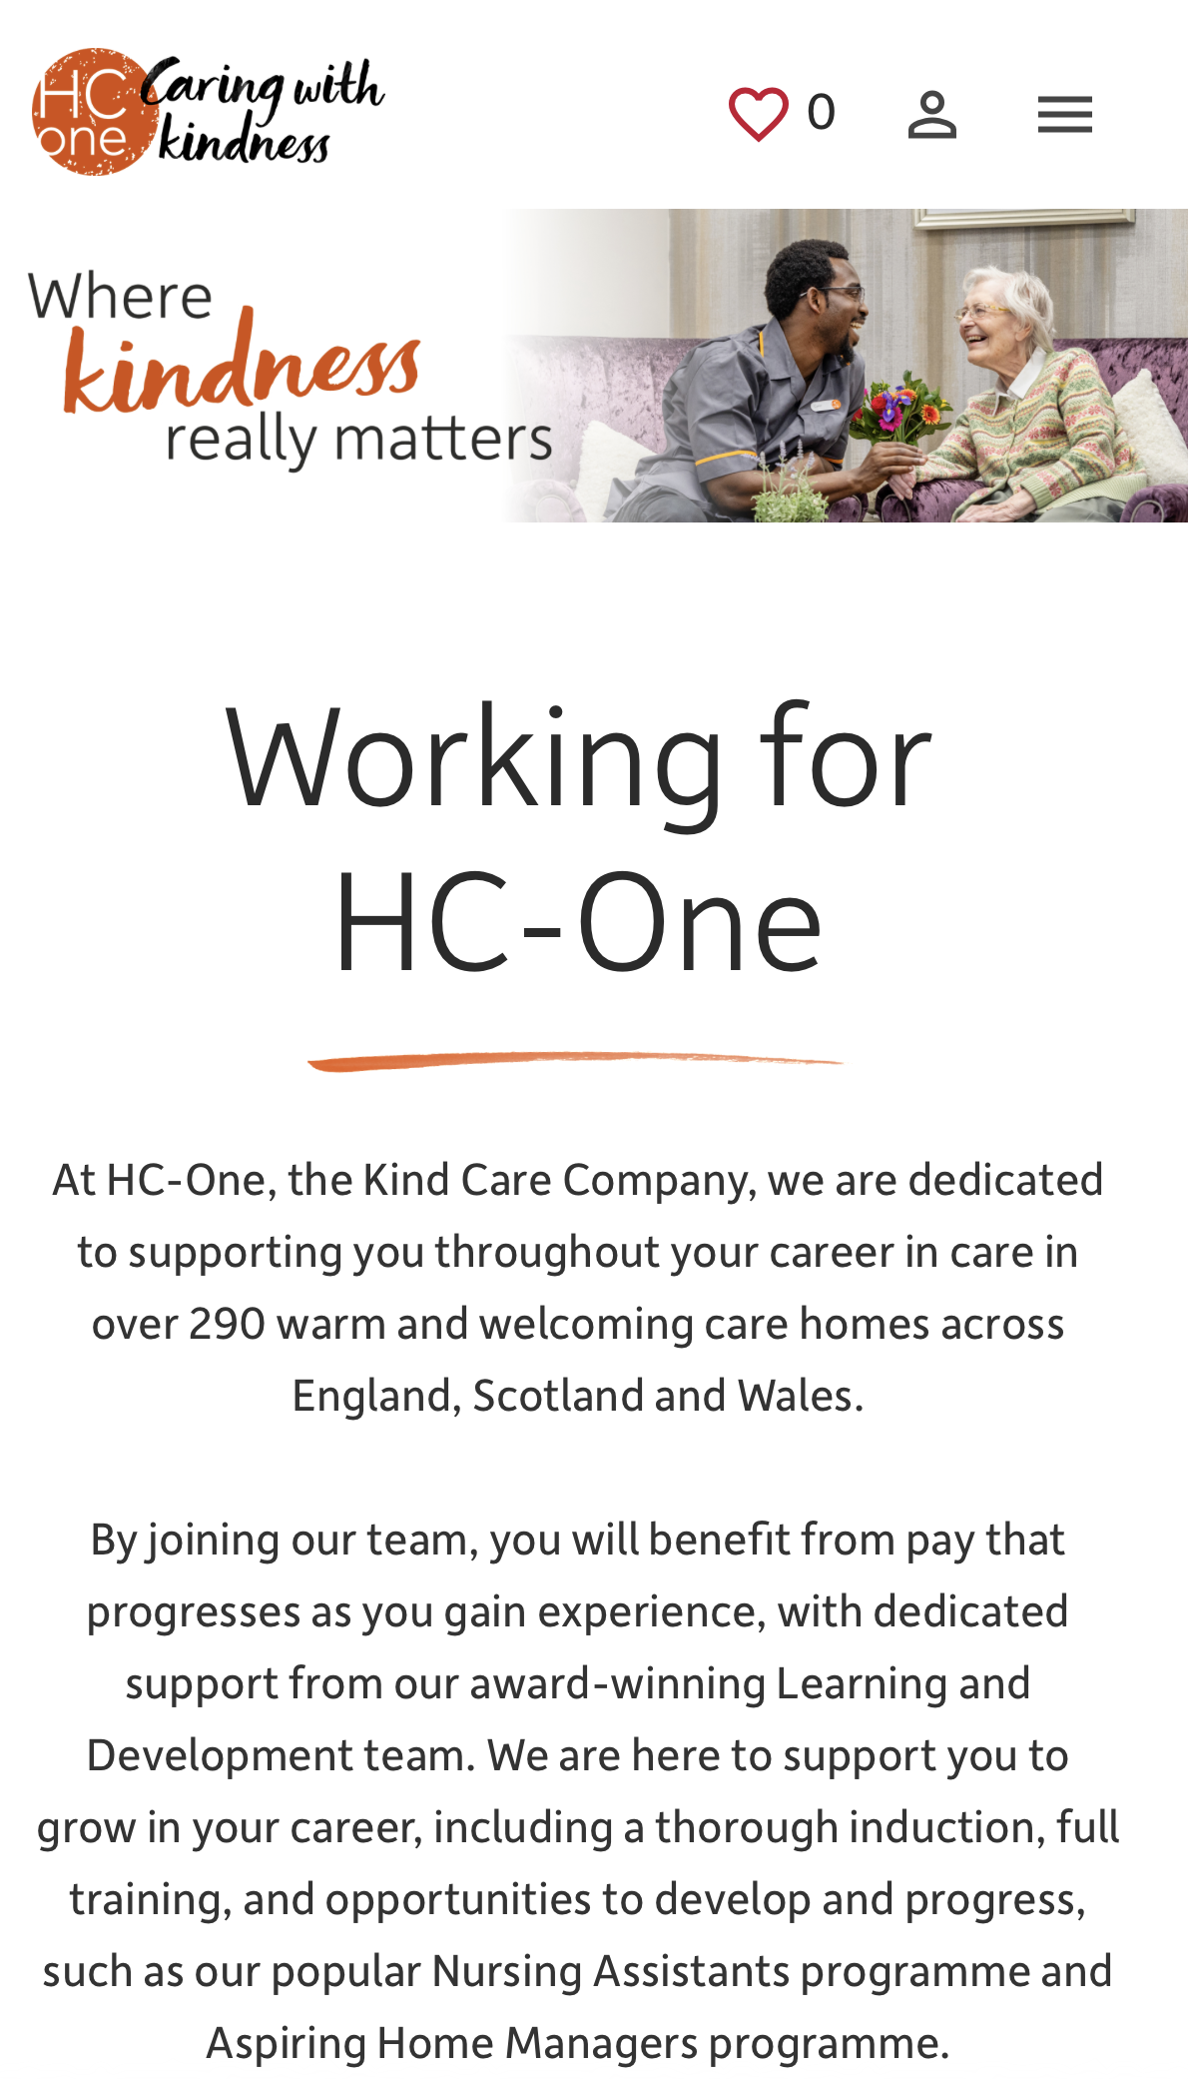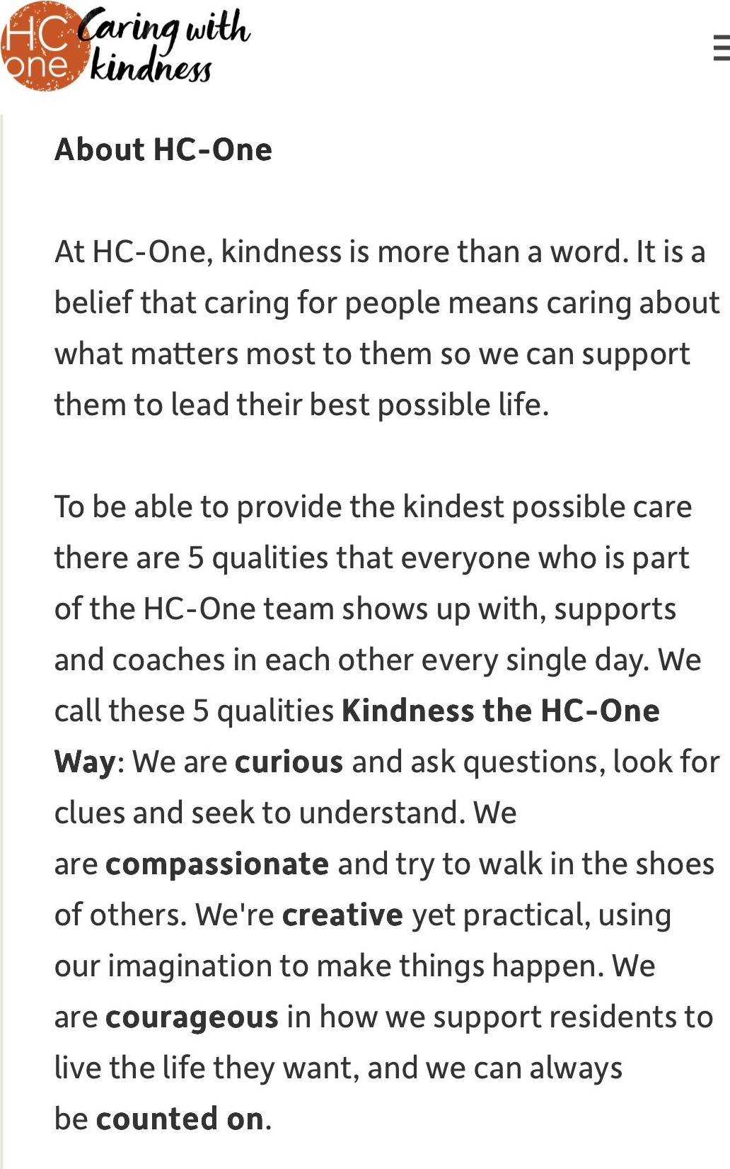
Figure 1: HC-One Senior Care Assistant vacancy advert (HC-One, 2026)

2, Analysing the Personal Employability Skills Required
2.1 Job description and person specification
According to the HC-One job posting, a Senior Care Assistant should ideally have a Level 2, Diploma/S-NVQ in Adult Social Care, be open to working toward Level 4 and have experience with person-centred care planning and dementia care (HC-One, 2026). However, the advertisement makes it clear that the most important traits are an optimistic outlook, a natural capacity for forming connections with others, as well as effective time management and record-keeping (HC-One, 2026). The position also entails supervisory duties, such as supporting the care manager and registered nurse, managing a group of care assistants, and upholding the highest standards of resident care (HC-One, 2026).
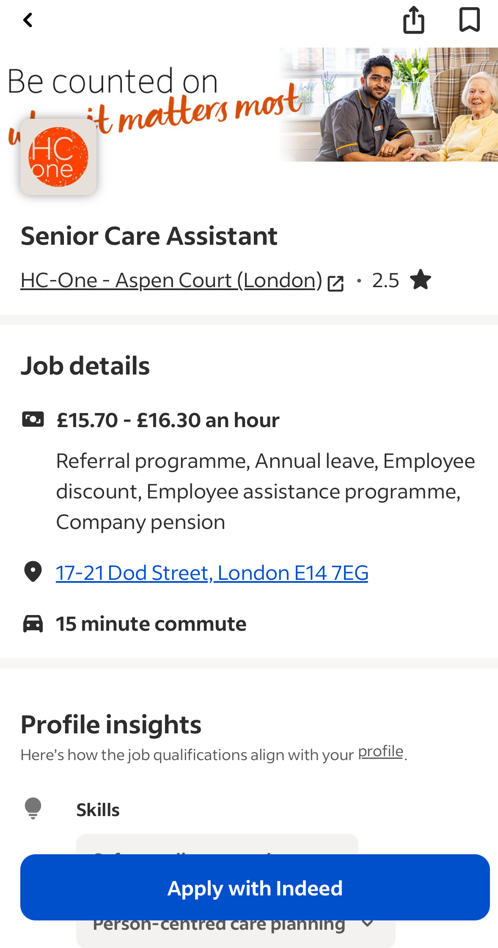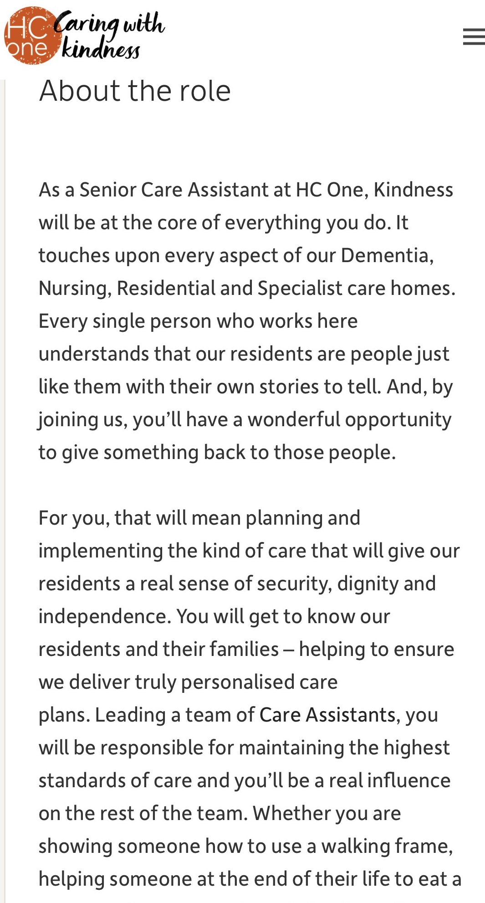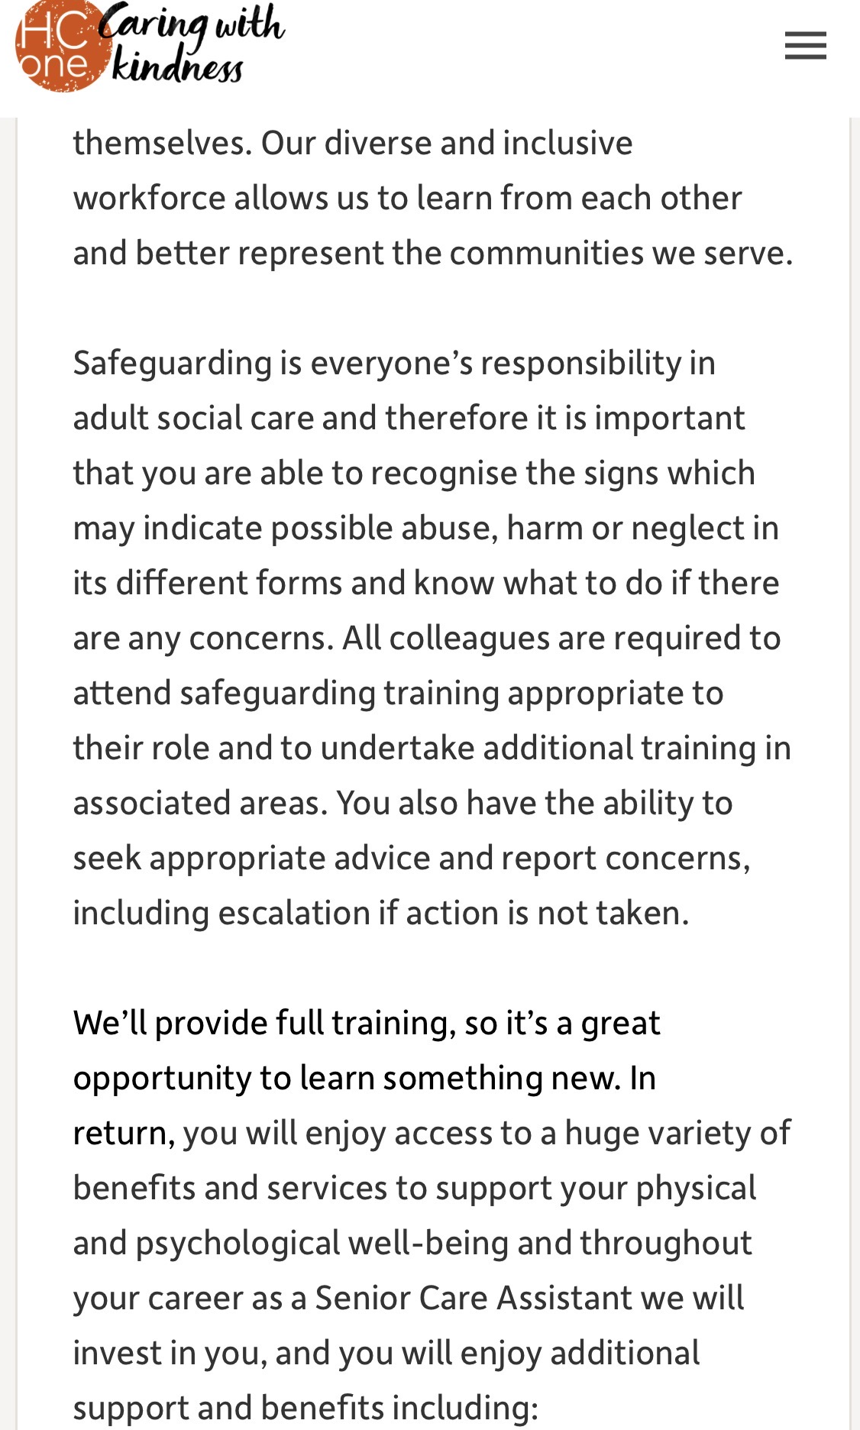
Figure 2: HC-One Senior Care Assistant person specification (HC-One, 2026)

2.2, Essential skills for employment
Leadership and delegation (essential): As a senior, I’d guide the team and work closely with the nurse and manager. Without it, jobs go undone or care becomes patchy.
Resilience (essential): The role includes end-of-life care. Without resilience, I risk burning out and giving less support when it matters most.
Teamwork (essential): Senior Care Assistants work closely with nurses, managers and colleagues. Without teamwork, care becomes disjointed and things get missed.
Digital literacy and record-keeping (essential): Good records matter, and most homes use electronic systems now. Without this, mistakes creep in, like medication errors or missed safeguarding concerns.
Safeguarding (essential): Senior staff must spot and report concerns, in line with the Care Certificate Without it, residents could be left at risk (Skills for Care, 2022).
Dementia care knowledge (desirable): Useful, since most residents live with dementia. Without it, I might upset someone without meaning to.
Observation (essential): Spotting small changes early is a big part of the job. Without it, health problems can go unnoticed.
Time management (essential): Shifts are busy, so I need to manage my time and help others do the same. Without it, tasks get rushed or missed.
Managing family concerns (desirable): Families need calm, clear answers. Without this, trust can break down and complaints rise.

2.3, Frameworks of concepts for these abilities
To keep this focused, I’ve used two frameworks that explain the skills above most directly. The Care Certificate (Department of Health and Social Care, 2025). Sets out 15 standards for anyone working in care. Standard 6 (Communication), Standard 9 (Dementia awareness) and Standard 10 (Safeguarding) match closely with the skills this role needs (Skills for Care, 2025).
I’ve also used HC-One’s own values, “Kindness the HC-One Way” — being curious, compassionate, creative, courageous and someone people can count on (HC-One, 2026). This fits HC-One specifically better than a generic framework, so I’ve used it instead.
STAR example:
Situation: I was supporting a resident living with dementia who became distressed during personal care.
Task: My task was to help her feel safe and calm, in a way that respected what she wanted, not just what the task required.
Action: I used a person-centred approach. Instead of insisting on the task, I calmly paid attention to what she wanted in that moment. If she wanted to dance, I danced with her. If she wanted to walk, I walked with her. This kept her engaged and let her lead.
Result: She became calmer and more cooperative, and personal care could continue once she felt comfortable, without her being rushed or upset.
3, Assessing My Own Strengths
3.1, Self-evaluation using SWOT analysis
My care experience to date has been in 2023 at Stage Care, alongside my current early year's role. Below, I set out my strengths, weaknesses, opportunities and threats in relation to the Senior Care Assistant requirements identified in Section 1.
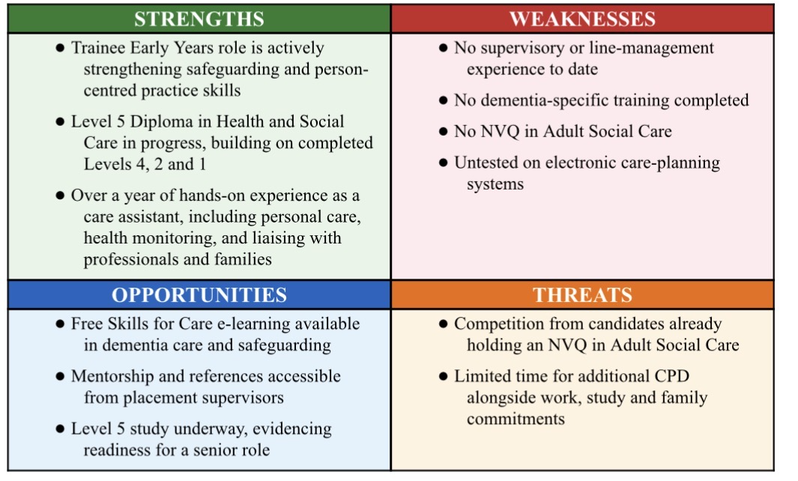

Table ;1 SWOT analysis

3.2 Reflecting on Experience: Gibbs’ Reflective Cycle
Using Gibbs’ (1988) Reflective Cycle, I want to reflect on part of my role at Stage Care ([clarify: your job title, and briefly what Stage Care is, e.g. a residential care home]): noticing and reporting a change in a resident’s behaviour.
Description: A resident with dementia became quieter and withdrawn and started refusing personal care. Her daughter liked to do a lot for her herself, which made it harder to know what the resident wanted from us.
Feelings: At first, I wasn’t sure if I was overreacting by reporting it.
Evaluation: I did the right thing by writing it down clearly and telling the office straight away, rather than trying to sort it myself. The hard part was trusting my own judgement and working out how to involve the family without pushing them out.
Analysis: This links to the Care Certificate’s Communication and Duty of Care standards (Skills for Care, 2025) — noticing and reporting changes early is part of the job, not overreacting.
My manager spoke to the daughter, explained the resident’s needs, and agreed how staff and family could work together during personal care. Things got easier after that, and the resident got more consistent support.
Conclusion: Reporting things early and clearly is already a strength of mine. In a Senior role I’d also need to help family members feel included, not shut out.
Action plan: I want to get more confident having these conversations myself, not just passing them up the chain.

3.3 Feedback from Others
Residents I cared for told me I was kind and easy to talk to, and that I understood them well. My colleagues said I was cooperative and easy to work with as a team.
After hearing this, I made a point of checking in with residents one-to-one, not just during care tasks, so they felt heard, not rushed.
This ability to build trust and stay calm carries over to speaking with residents’ families in a care home, though I know adult social care comes with different responsibilities, especially around end-of-life care and knowing when to escalate
3.4 Motivation for growth
Maslow's (1943) Hierarchy of Needs offers a useful lens for understanding my own motivation. Having already met more basic needs through stable employment, my drive to pursue a Senior role and, eventually, my own domiciliary care business sits at the esteem and self-actualisation levels of Maslow's hierarchy (Maslow, 1943): I am motivated by the sense of purpose and achievement that comes from doing meaningful work well, and by the desire to grow into the fullest version of my professional self, rather than by pay or job security alone.
4, Developing a Professional and Personal Brand
My personal values, compassion, dignity, reliability and a genuine desire to help people grow or age well, align closely with the sector I work in, and they are echoed in HC-One's own "Kindness the HC-One Way" values (HC-One, 2025). Being able to demonstrate these values consistently, not just describe them, is at the heart of my personal brand.
I promote myself professionally through a clear, well-formatted CV that highlights both my adult care experience at Stage Care and my current early years role, and I am building a LinkedIn profile with a headline along the lines of "Trainee Early Years Support Worker | Studying BA Health and Social Care | Aspiring Domiciliary Care Business Owner", supported by an up-to-date experience section and recommendations from placement supervisors. I am also interested in writing short, accessible pieces on health and wellbeing topics, which would give me a public professional presence beyond my CV and demonstrate reflective practice to future employers.
My unique selling point is the breadth of my experience across the life course: I have worked directly with young children in an early year setting and with older adults in residential care, alongside international experience as a teaching assistant and community fundraiser in Ethiopia. This combination gives me a level of cross-generational and cross-cultural understanding that is genuinely valuable in a diverse city like London, where care staff regularly support residents and families from many different backgrounds.
In terms of professional networks, I plan to engage with the Skills for Care community and relevant LinkedIn groups for health and social care professionals, which is where Holland's (1997) theory of career choice is useful: it classifies people into six personality-environment types, and my own interests fit clearly within the "Social" type, people motivated by helping, teaching and caring for others, which explains why both early years and adult care settings suit me. The CareerEDGE model (NIH, 2024) adds a further layer, arguing that employability depends on career development learning, work and life experience, degree subject knowledge, generic skills, emotional intelligence and self-efficacy, all of which are reflected in the different sections of this report. Finally, building genuine relationships within these networks, rather than simply collecting contacts, reflects social capital theory and Granovetter's (1973) idea that even loose, "weak tie" professional connections can open doors to opportunities that close family or friendship circles cannot (NIH, 2024)

.
Figure 3 Linken profile

5, Plan of Action and Long-Term Goals
To move from my current role towards a Senior Care Assistant position at HC-One, and eventually towards my longer-term ambition of owning a domiciliary care business, I have set a realistic, staged action plan addressing the gaps identified in Section 2.
Over the next three months, I will complete Skills for Care’s free Dementia Training Standards Framework and Adult Safeguarding e-learning, keeping a reflective CPD log as evidence. Between three and nine months, I will build my leadership experience by shadowing shift handovers and requesting supervisor feedback, while also arranging basic training on an electronic care-planning system. By nine to eighteen months, I will have updated my CV and LinkedIn profile, secured references and STAR examples, and be ready to apply for the Senior Care Assistant role. Beyond eighteen months, I will confirm with HC-One’s Learning and Development team whether the Level 2/3 Diploma in Adult Social Care is required alongside my Level 5 study, and enrol if so.
Bandura’s (1977) theory of self-efficacy underpins this staged approach: confidence to take on harder tasks grows from succeeding at smaller, achievable ones first (Garrido, 2025). I will review progress every three to six months and adjust actions as needed.
Owning a domiciliary care business remains my genuine long-term ambition, but I see it as a later stage, built only once I have gained real management experience through the Senior Care Assistant role. Beyond that, I plan to complete a Level 5 Diploma in Leadership for Health and Social Care, learn about staffing, finance, safeguarding and CQC registration requirements for domiciliary providers, and seek mentorship from an experienced Registered Manager before drafting a business plan.
6, Conclusion
Overall, my current profile is a reasonably strong fit for the Senior Care Assistant role at HC-One: I already bring over a year of hands-on adult care experience, ongoing Level 5 study, and transferable safeguarding and communication skills from my current early years role. The main gaps are formal dementia-specific training and direct leadership experience, both of which my action plan addresses through staged, achievable steps rather than one large leap.
Working through this report has clarified how closely my past and current experience, across early years and adult care, already supports my long-term goal of leading and eventually owning a domiciliary care service. Building my personal brand alongside these practical steps, being clear about my values, visible in professional spaces like LinkedIn, and honest about what I still need to learn, has also given me a noticeable boost in confidence about presenting myself as capable of a senior role, rather than waiting until I feel "ready" in every respect. This process has strengthened my motivation to keep developing, one achievable step at a time, towards a career supporting people at every stage of life.

7, Reference
Department of Health and Social Care (2025). Care certificate standards. In: Department of Health and Social Care. [online] Available at: https://www.skillsforcare.org.uk/resources/documents/Developing-your-workforce/Care-Certificate/Care-Certificate-Standards/Care-Certificate-standards-March-2025.pdf [Accessed 7 Aug. 2026].
Garrido, G.L. (2025). Bandura’s self-efficacy theory of motivation in psychology. [online] Simply Psychology. Available at: https://www.simplypsychology.org/self-efficacy.html [Accessed 7 Aug. 2026].
HC-One (2026). Senior care assistant in poplar | HC-One. [online] HC-One. Available at: https://apply.hc-one.co.uk/vacancies/73104/senior-care-assistant.html [Accessed 7 Aug. 2026].
Indeed (2026). Senior care assistant - London E14 7EG - indeed.Com. [online] indeed. Available at: https://uk.indeed.com/viewjob?jk=e700d393aaa9d12d&from=appshareios [Accessed 7 Aug. 2026].
Maslow, A. (1943). A theory of human motivation. [online] Psychological Review, Psychological Review, pp.370–396. Available at: https://psychclassics.yorku.ca/Maslow/motivation.htm [Accessed 7 Aug. 2026].
Mcleod, S. (2025). Kolb’s learning styles and experiential learning cycle. [online] Simply Psychology. Available at: https://www.simplypsychology.org/learning-kolb.html [Accessed 7 Aug. 2026].
NHS England (2015). Introducing the 6 C’s. [online] NHS England. Available at: https://www.england.nhs.uk/6cs/wp-content/uploads/sites/25/2015/03/introducing-the-6cs.pdf [Accessed 7 Aug. 2026].
NIH (2024). Logics of career choice - concept and results of an approval-sensitive career guidance workshop. Frontiers in psychology, 14. doi:10.3389/fpsyg.2023.1235221.
NIH (2025). Emotional intelligence in action: Theoretical models for educators to enhance learning and connection in the classroom: A conceptual review. Frontiers in Psychology, 16. doi:10.3389/fpsyg.2025.1660296.
Skills for Care (2022). Safeguarding. [online] www.skillsforcare.org.uk. Available at: https://www.skillsforcare.org.uk/Support-for-leaders-and-managers/Managing-a-service/Safeguarding.aspx [Accessed 7 Aug. 2026].
The Access Group (2026). Care certificate standards. [online] www.theaccessgroup.com. Available at: https://www.theaccessgroup.com/en-gb/health-social-care/resources/care-certificate-standards/ [Accessed 7 Aug. 2026].
University of Cumbria (2020). Gibbs’ reflective cycle. In: University of Cumbria. [online] University of Cumbria, pp.1–4. Available at: https://my.cumbria.ac.uk/media/MyCumbria/Documents/ReflectiveCycleGibbs.pdf [Accessed 7 Aug. 2026].

