

Student name: Bozica Katic
Student ID: 2008115

Module name: Principles of Health and Social Care Practice
Module code: BMHP5002
Lecturer: Mentesnot Mengesha

Table of content

- Introduction …………………………………………………….. 1
- Discussion ……………………………………………………… 2
- Recommendation ……………………………………………… 5
- Conclusion ……………………………………………………… 6
- References ……………………………………………………… 7
- Appendix ………………………………………………………… 9

- Introduction

" Person-centred care" is a slogan for care that reflects a new approach to caring for the elderly in different settings. These environments include long-term care, rehabilitation, disability learning, and dementia care. It has become synonymous with good elderly care practices. (Nolan, Brown & Davies, 2004). The principle is that the service is performed in cooperation with service users and not just for them. Person-centred care is a caring approach that includes care planning, delivery and monitoring of care following the wishes and needs of service users. Their wishes and their families are placed at the centre of the care decision. It is also used in the treatment of chronic diseases such as diabetes, cancer, alcoholism when an individual's illness is reflected in the quality of life of the whole family. Service users become equal partners with professionals in making decisions about their care to achieve the highest quality care. The type of care based on person-centred care involves primarily the way patients and professionals think and not just activities (Health innovation network, n. y,). The importance of this approach to care is in the development of high-quality service. One important clinical priority area, which has and good scientific research background where person-centred care is applied, is dementia. Therefore, I will critically review the application of the principle of person-centred care in patients with dementia and how such an approach affects the quality and fulfilment of the lives of people with dementia. Nowadays, all organizations that care for the elderly must provide care based on the principle of person-centred care. It is a standard prescribed by the Care Quality Commission.

- Discussion

The basic concept of person-centred care is based on four main principles. Care is personalized according to the uniqueness of each person. The basic concept of person-centred care is based on four main principles. The first states that care should be personalized. Emphasis is placed on what the person is capable of doing on their own, not on their disability. This means that support should be tailored to the specific needs and circumstances of the individual. It is necessary to take into account the background of the person (age, gender, beliefs, interests, likes, dislikes, goals, skills, abilities, culture, life experience). Care should be coordinated and integrated and include the cooperation of all organizations that can provide support (GP, social worker, hospital, care home, church). Care should be enabled to all who need it. The availability of access to care should be equal for all. When a person is in care should be treated with respect and dignity. Compassion, looking at things from the other persons perspective and empathy, putting yourself in the shoes of the other person, are essential in person-centred care. This approach should enable and keep the person in control of their own life. Services often seem uncoordinated, and some are unnecessarily duplicated, according to some research (Bareham, Miller & McCay, 2018). The heart of every care is dignity in action (Mabbot, 2012). This is the factor that most affects the quality of work and outcomes of care for the elderly, and especially for the elderly with dementia. However, burdened with numerous costs and constant reduction of available funds, the system, as the most responsible link in the chain, sometimes loses insight into the purpose of its existence, setting limits that may jeopardize the dignity of its users, such as difficult access to care. Changes in health, the need for support in personal care, long-term institutional care, and loss of loved ones, but also social factors such as age discrimination and unequal access to health and social care, lack of education of professionals to work with the elderly or the public on dignity and rights, contribute to the marginalization and devaluation of the elderly, which undermines their dignity. Protection of dignity should be one of the foundations of creating measures and activities towards the elderly because inseparable from human rights, active ageing, and quality of life of the elderly affects one of the basic international efforts - successful and quality ageing of the population. National health and social care policies are increasingly emphasizing the right to dignity of the elderly and the necessity of its existence (Department of Health, 2001). The dignity of the elderly is manifested through respect and recognition, participation and inclusion in society, and dignity in the necessary care. Dignity in care also promotes and supports a person's self-esteem. Although the personalities of service users are different, professionals need to treat them with dignity. Dignity in care is reflected in the self-esteem of the person receiving care. All dignity factors should be included in care: communication that should be honest and respectful; empower, encourage, and support in making independent decisions; help with healthy eating and help during meals; help people with medication; helping people with personal hygiene; practical help; protect the privacy of the person; support in engaging in social activities. Every health and care professional should have a developed awareness that their job is to protect human dignity (especially the elderly, the sick and the vulnerable people). According to the Care Act, 2014 caregivers must include person-centred care when safeguarding a demented person. Safeguarding principles (empowerment, protection, prevention, proportionality, partnership, and accountability) should be followed, and place the dementia person’s needs and wellbeing in front of safeguarding processes. This would partly prevent the ethical problem of neglect and abuse of the elderly by health and social care professionals. The person-centred care approach is very effective in caring for people with dementia and if applied professionally can reduce dementia. One of the characteristics of dementia is a change in mood and protective-aggressive behaviour of a demented person (refusal to bathe, desire to leave), so establishing good communication with the service user is a challenge for the caregiver. Communication must be open and direct, and the relationship with the demented person is friendly (Bosh, 2011). This reduces the occurrence of negative consequences of care. Communication with a demented person may seem like a limitation because they live in their reality (someone is constantly rushing towards the bus because is late for school, someone is waiting for a phone call, someone needs to take care of a baby, etc.). Caregivers need to eliminate their concerns and still confirm their reality. The caregiver should "enter in their reality" and follow the signs of non-verbal communication (facial expression, tone of voice, body language, touch). Knowledge of the language of non-verbal communication is more important for working with people who have dementia. It is also important to encourage service users to engage their abilities as much as possible (helping people help themselves) because if a person with dementia doesn't use them then loses them quickly and irreversibly (e.g., to wash hair while bathing). Keep these abilities of the person as long as possible. Allowing a person to do as much as possible for themselves helps maintain their abilities and contributes to a sense of independence and well-being. The essence of person-centred care is to give the person a tool to do for himself as much as possible alone, not to do everything for him instead of him. to. This strategy can improve both the patient experience and the quality of care. For people with dementia who are housed in a residential home, the person-centred care approach allows them to wake up naturally and get out of bed whenever they want. The normal sleep pattern for each individual is respected because it affects their better behaviour during the day. Although it also affects the organization of the daily routine of employees (housekeeping, time of breakfast…) this allows service users to be perceived as individuals with their own needs. Spirituality and religion are important aspects of a holistic approach to person-centred care. This is an ethical issue that needs to be addressed as older people in particular have an increased need for spirituality as they are at the end of their lives. (Polzer & Engebretson, 2012). Although insufficiently emphasized, the role of the chaplain in a holistic approach to person-centred care is important to respect the diversity and dignity of the person regardless of the needs of spiritual or religious care. (Brady, et al., 2021). People with dementia have reduced mental capacity so they cannot make all the decisions for themselves. They need to be helped to participate in making decisions for themselves as much as possible (Office of the Public Guardian, 2013). Family members can decide for them. Here can raise an ethical problem. How can a family know what is the best decision for the person? In my opinion, in that situation would be good cooperation between family and professionals who provide care. Include suggestions both and then decide for them. Communication between professionals and family is very important too. Family can help by providing some information about service users which can later help professionals manage difficult behaviour. Communication between all stakeholders is very important. Very often happen a lack of coordination between stakeholders and can reflect on the quality of care. According to the theory, this approach is the responsibility of the service users and not the caregiver, so needs to provide a safe environment (comfort, honesty, and personal progress).
Person-centred care also has its limitations that are visible in the financial costs required for care. It is not known for which group of service users this approach is most appropriate. There are people, who for some reason, do not want to be part of this kind of care. This approach mainly focuses on service users and their rights, while professional ones are neglected. This can cause employee dissatisfaction, their reduced motivation to achieve good results. Professionals are at risk of being overburdened with obligations and involvement with their patients. They are often mentally and emotionally exhausted and suffer from fatigue. The problem of excessive empathy is another limitation in person-centred care. Empathy is a desirable and key characteristic of a caregiver, but if it is overused in a relationship on one side only, there may be a risk of injustice in the relationship, which inadvertently violates ethical rules

- Recommendation

My basic recommendation for improving person-centred care in the care of people with dementia is primarily to establish better communication on all levels, and especially with service users. When open and honest communication is achieved, the benefits for both parties are manifold. The person must feel safe, protected, and cared for. Also, involve motivational communication in practice (Amery, 2012). We need to work on improving the experience of service users they have according to their care. Help service users become more aware of their priorities and concerns, involve them in decision making as much as possible. We need to devise other ways to influence service users to live healthier lives, not just with healthy eating and exercise. After service ask them for their feedback and according to their feedback improve its service next time. As their socialization is important for people with dementia (Kitwood & Bredin, 2008), it is necessary to provide more activities that connect these people. Playing and joint, soothing, creative activities such as drawing can establish better communication and new interaction, improve the quality of care and the way people with dementia live (The Health Foundation, 2021). To reduce the cost of care and ensure its quality, it is necessary to work on more effective awareness of people about the disease and find new management methods in primary care and the community. It is necessary to work on prevention in the initial phase of the disease. Easier access to information and improved post-diagnosis support is needed. It is necessary to improve the communication of coordinated care during the transfer of care (NICE, 2021), for example between the hospital and the resident home, so that all changes in the service user’s folder are recorded. More investment is needed in educating professional staff to understand the needs of older people (and especially the need of people with dementia) to manage conflict situations, to manage their stress. As caring for people with dementia is a demanding job, it is necessary to enable professionals to empower themselves, improve their sense of satisfaction and self-confidence in caring. This would reduce the fluctuation of staff who are already in deficit. Need to find ways to reduce the frequency of service use and to devise a way for service users to manage some easier situations themselves, such as the introduction of a 24-hour phone line for advice on living with dementia. This could reduce overall care costs and increase the availability of the service to those who need it most. More needs to be done to intensify the parameters of a holistic approach to person-centred care, not just medical and social care. More content that meets their cultural, emotional, and spiritual needs should be included. One of them could be "readings about death" (storytelling complementary therapy) or how to prepare yourself during your life for the process of dying. Awareness of this topic could help remove the underlying human fear, the fear of death and, what is most important, facilitate the process of dying. It could be implemented in principle ¨dying with dignity¨ and improve the quality of care for dying people in nursing homes. There are no empiric results for quality of care in nursing homes (Wolfgang, 2015) although about 21-23% of people in England and Wales pass away in the nursing home (Nuffield Trust, 2020). We need to develop ways how to measure outcomes of person-centred care for a better understanding of its benefits.

- Conclusion

Person-centred care is one of the seven fundamental principles of the NHS in England. This attitude is reflected in all four UK countries. Person-centred care is a type of care approach that puts service users at the centre of care. Service is planned, organized, and implemented according to their wishes and needs, in cooperation with professionals. The main goal is to help the service users to help themselves, or to include his available abilities and possibilities in care. The use of person-centred care in dementia service users is of great importance. As I pointed out in the discussion, this method helps people with dementia to preserve their ability to help themselves for as long as possible, because as the disease progresses, this ability is lost, and they become increasingly dependent on other people's help. The success of the implementation of this approach depends on how professionals perceive and implement it in practice. Although there is scientific evidence that this approach to care can improve the quality of care, some research has mixed results (Dwamena et al. 2012). The reason for this is that person-centred care has an individual approach to the care user, so people with different needs are approached in different ways. As this is a relatively recent practice, more scientific research is needed in the future. Also, different approaches are needed (e.g., a holistic approach) to this type of care to better understand, as well as its benefits.

- References:

Bareham, K., Miller, A. & McCay, K., (2018), P 217 Collaborative neighbourhood team working enabling improved use of resources and person-centred care, BMJ supportive & palliative care, 8(2), p. p. A87
Bosh, J.V., (2011), More than words: A new culture of care and communicating with persons who have dementia, [Video], Available at: video.alexanderstreet.com/wach/more-than-words-a-new-culture-of-care-and-communicating.with.persons-who-have-dementia
Brady, V. et al. (2021) ‘Supporting diversity in person-centred care: The role of healthcare chaplains’, Nursing Ethics, 28(6), pp. 935-950.
Care and The Health Foundation, (2021), Creative activities to improve staff wellbeing, quality of care and the way people living with dementia and their carers support their own health, Available at: https://www.health.org.uk/improvement-project/creative-activities-to-improve-staff-wellbeing-quality-of-care-and-the-way, (Accessed: 27 December 2021)
Department of Health, (2001), National Service Framework for Older People, Available at: https://assets.publishing.service.gov.uk/government/uploads/system/uploads/attachment_data/file/198033/National_Service_Framework_for_Older_People.pdf, (Accessed:26 December 2021)

Dwamena, F., (2012), Interventions for providers to promote a patient‐centred approach in clinical consultations, Available at: https://www.cochranelibrary.com/cdsr/doi/10.1002/14651858.CD003267.pub2/full, (Accessed: 28 December 2021)

Kitwood, T. & Bredin, K. (2008), Towards a Theory of Dementia Care: Personhood and Well-being, Published online by Cambridge University Cambridge core, Available at: https://www.cambridge.org/(Accessed: 01.11. 2021.)

Mabbot, I., (2012), ‘The Heart of Care: Dignity in Action – A Guide to Person-centred Compassionate Elder Care Amanda Waring the Heart of Care: Dignity in Action – A Guide to Person-centred Compassionate Elder Care Souvenir Press 180pp £15 9780285640870 9780285640870’, Nursing standard, 27(12), pp. 24–24.

National Institute for Health and Care Excellence, Dementia Management, Available at: https://pathways.nice.org.uk/pathways/dementia#path=view%3A/pathways/dementia/dementia-management.xml&content=view-index, (Accessed: 27 December 2021)

Nolan, M., Brown, J., & Davies, S., (2004), Beyond Person-Centred Care: A New Vision for Gerontological Nur, Journal of Clinical Nursing ,13(3a), p.p.45-53

Nuffield Trust, (2020), Deaths in care homes: what do the numbers tell us? , Available at: https://www.nuffieldtrust.org.uk/news-item/deaths-in-care-homes-what-do-the-numbers-tell-us, (Accessed: 28 December 2021)

Office of the Public Guardian, (2013), Mental Capacity Act Code of Practice, Available at: https://www.gov.uk/government/publications/mental-capacity-act-code-of-practice, (Accessed: 27 December 2021)

Polzer Casarez, R.L. and Engebretson, J.C. (2012) ‘Ethical issues of incorporating spiritual care into clinical practice’, Journal of clinical nursing. 21(15-16), pp. 2099–2107
Wolfgang, G., (2015), Place of death nursing home, MMW Fortschritte der Medizin, 157 (5), pp. 17–24.

Wolters. F., J. & Ikram, M., A., (2019), Epidemiology of Vascular Dementia, AHA Journals, 39(8), p.p. 1542–1549

Co with Persons Who Have Demen

- Appendix:

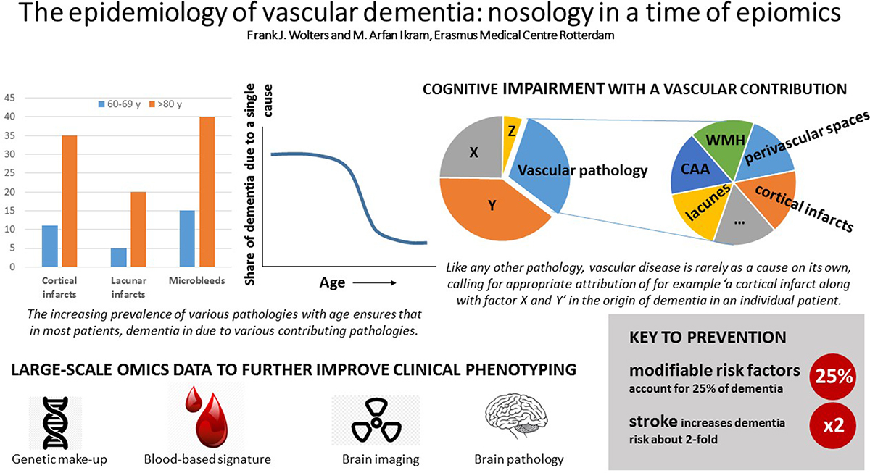
(Wolters & Ikram, 2019)

