The University of Wales Trinity and Saint David
3/6/2022
Effective Team Working and Communication

Certificate of Higher Education Skills for the Workplace
BMSW4002

Student: Lector:
Neli Miteva Khaza Ahmed
2113297

Effective Teamworking for team success

Table of Contents

Page #

- Introduction 2
- Main body 2-10
2.1 How can Abdul develop an effective team and what theoretical model
Can be used? 2-7
2.2 What are the types of roles that are needed to create an effective team? 7-9
2.3 What type of impact can effective teamwork have on team success? 9
2.4 What are the barriers to effective teamwork identified in this scenario? 9-10
- Conclusion 10
- Reference list 11-12
1. Introduction

Team is a group of people who are gather together have a shared purpose trying to achieve the same goal. To be effective in one team requires a selection of members with certain skills such as good leadership, time management, etc. Working in a team is a collection of actions that involve creating a pleasant working environment and helping one another in terms of common goals. In this report are covert models of effective teams such as Tuckman`s model and Wheelan`s model, types of roles based on Belbin`s model to create an effective team, the impact, and the barriers that effective team working have on team success.

2. Main body

2.1 How can Abdul develop an effective team and what theoretical model can be used?

Building an effective team entails a variety of actions that are intended to enhance team performance. The goal is to embrace the best of the team and their ability to work together and able to solve problems. According to Katzenbach and Smith (1993), a team can be simply defined as a group of individuals with a common goal who are committed to a shared mission and who hold one another accountable for outcomes. People who join organizations and find out how to work together with each other have a better opportunity of addressing common challenges and achieving individual demands (Qin, Johnson, & Johnson, 1995).
For one team to be effective are required several things: the team must be carefully selected based on the members’ skills required for the task, trust, time management, the right leadership, the members of the team to share the same goals. Many authors have come up with different models for team development such as:

With time many models have been created and all of them have as a goal to help develop and improve the effectiveness of the team in a global economy. It takes a lot of information as well as a wide range of abilities for every single person to properly do such difficult jobs on their own. Like an outcome, an increasing number of businesses rely on teams as the major means of achieving objectives and responsibilities (Wheelan, 1994). Therefore, the success of an organization depends heavily on the effectiveness of workgroups or teams. However, not every group or team is successful and manages to achieve any productivity and efficiency as in Abdul`s team. In this paper, we will discuss and compare Tuckman’s model and Wheelan`s model also why in this case more appropriate and helpful model for Abdul “Integrated Model of Group Development (IMDG)” created by Susan Wheelan.

Tuckman (1965) suggested a team development model a few years ago after doing a thorough analysis of the literature. For its 'form, storm, norm, perform' sequence, his four-stage model became widely recognized. Later, Tuckman and Jensen (1977) found that the research generally supported the original model, which was supplemented by a fifth stage 'adjourn’.

Forming stage – this is the first stage where the group or a team has been formed and all the members are starting to know each other. Normally at this stage, the members of the team are feeling nervous, unsecured not just because they are not familiar with the goals, but also what the leadership is going to be. The duration of this stage depends on many different factors.
Storming stage – in the second stage if the group already has a leader, the members are testing his knowledge and his managing abilities. If the leader is missing, the members are trying to embrace themselves and take a significant position. Although Tuckman thinks the transition of this stage is necessary for developing the team, according to Burn (2004) the group or a team can evolve without necessarily going through this stage.
Norming stage – Tuckman describes this stage as a clear sky after the storm. The members are passed the previous two phases and now are focusing on the common goals. One of the most essential outcomes of this phase is team cohesiveness, which grows in close relationship to its standardizing framework. This improves the team for better performance.
Performing stage – in this stage the members of the team are united and start to focus on the key problems. In this stage is essential for the leader to provide feedback based on team performance.
Adjourning – this is the final stage where the team has reached the final goal but is time to end the existence of the group. After this stage, some members may feel emotionally detached and experience difficulty leaving the group. Of course, not every case is the same.
Nowadays, the stages are seen to be romanticized (Buchanan and Huczynski, 1997). As a broad sequence, the phases may have significant authenticity. New researchers of unique teams, however, show difficulties that cannot be described by a simple step structure. It is possible the team never achieves quality standards and might return to a previous level. Nonetheless, this model is considered useful and straightforward in team development.
Even though Tuckman’s model has been considered by many organizations as the right and the best model to develop an effective team in Abdul`s case it is not the right one. The team has been already created and Abdul has been chosen as a leader, not by the other members, also the group has not met yet due to Covid 19 regulations which point that the second stage “storming” does not apply in this case.
Many researchers have created their frameworks based on Tuckman`s model. One of them is Susan Wheelan with probably the most extensive team development model known as the Integrated Model of Group Development (IMDG)
Fig. 3 –” Integrated Model of Group Development” by Susan Wheelan
According to her, the group can simply achieve success if their members are working together. She also claims that between the time group exists and members’ behavior there is a substantial relationship, and she describes it truly in her model with four key stages: Dependency and inclusion, Countertendency and fight, Trust and structure, Work and productivity.
Dependency and inclusion – This is the first stage where the situation is new and the goals are unclear, and where all the members are depending on the appointed leader. In this stage may occur some work but it is very insignificant.
Countertendency and fight – in this second stage everything is similar to the “storming” stage. The member is raising their disagreement and trying to challenge their leader. In this stage, the members are making decisions about the process and the roles everyone will take. According to Wheelan conflicts are required for developing trust in the group members so they can feel free to disagree with each other.
Trust and structure – once the group has gone true stage two trust start to build, the members became more committed, and the level of cooperation increase. In this stage the group is more confident, they communicate more, start negotiations about roles, their goals, etc., they also do not need to demand leadership as much.
Work and productivity – this is the stage where the team is focused on the work and achievement of the best results. This phase is often equated to the “performing” stage.

To develop his team by using Wheelan`s model Abdul could use the following steps:
Going true the first stage he should devote effort and time to each member so he can understand their interest, strong and weak sides, how they contribute the best. He should explain to them what he is expecting, offer support, and show understanding.
In the second stage, Abdul should expect the members to fight and disagree, but he should stay calm and understand this is nothing personal, and try to empathize and share the same values.
For the third stage, Abdul should back off and leave the team to decide if he wants the team to reach his potential. He should not disturb them and give them some space but at the same time supervise them from a distance and acknowledge teams’ accomplishments and give them feedback. Splitting the team into small groups may be helpful as based on her “Group Size, Group Development, and Group Productivity” research where she studies the impact of large and small groups based on development and group success where the results show that the size is connected to the results of the team performance. According to the results of this research, the larger is the group the lower is their performance. In larger groups, members are less united, more competitive, and the chance of the group to succeed is minimum. According to her study, a group of 3-6 members has a higher chance to achieve better results.

2.2 What are the types of roles that are needed to create an effective team?

Over time team roles very often improve casually and go unnoticed. Throughout the time our team roles include how we perform, participate, and interact. As an example, some members may have new and different ideas every time, others to create new relationships, while others can be better at turning the ideas into action, some others may stud up with raising the problems. Belbin (1981) defines the team role as “a tendency to behave, contribute and interrelate with others in a particular way." His work is particularly significant as an early example of the team role idea and, possibly, the foundation for later team role concepts. According to Belbin, through knowledge of every member’s team role, he can predict their performance as a team. At first, he declared that he identifies eight roles when he published his book in 1981 but in 1993 publishing another book, he changed the names of some roles and included a new one as the ninth role. Belbin, categorize the nine-team roles into three categories: action-oriented, people-oriented, and cerebral roles.
Action-oriented role – In this category are included:
- Shaper – these are usually individuals who are very sociable like to challenge others, like the dynamics, and to work under pressure. But they can also offend others and hurt their feelings.
- Implementer or company worker – these people are very reliable, disciplined, concentrated, and efficient but they often can be slow in responding to new possibilities.
- Completer finisher – these people are painstaking, anxious, they are looking for mistakes and deliver on time. As their weakness is the reluctance to delegate.
People-oriented roles – In this category are included:
- Co-ordinator known as chairman - they are mature, confident, delegate well and promote decision-making. But they can be seen as manipulative and offload personal work.
- Teamworker – These people are cooperative, mild, they listen, but they can be unhelpful in a difficult situation.
- Resource investigator – these people are extroverts, communicative, they like developing contacts and to explore opportunities. As a weakness, they lose interest fast once the enthusiasm has passed.
Cerebral roles – in this final category are:
- Plant – these people can be creative, unorthodox, and can solve difficult problems, but they are also too preoccupated to communicate.
- Monitor evaluator – they are sober, strategic, see all options, and judge precisely but they are not good at inspiring other people.
- Specialist – these people are self-starting, single-minded, and dedicated, they provide more knowledge and skills than others. But they also dwell on technicalities, they contribute only on a narrow front.

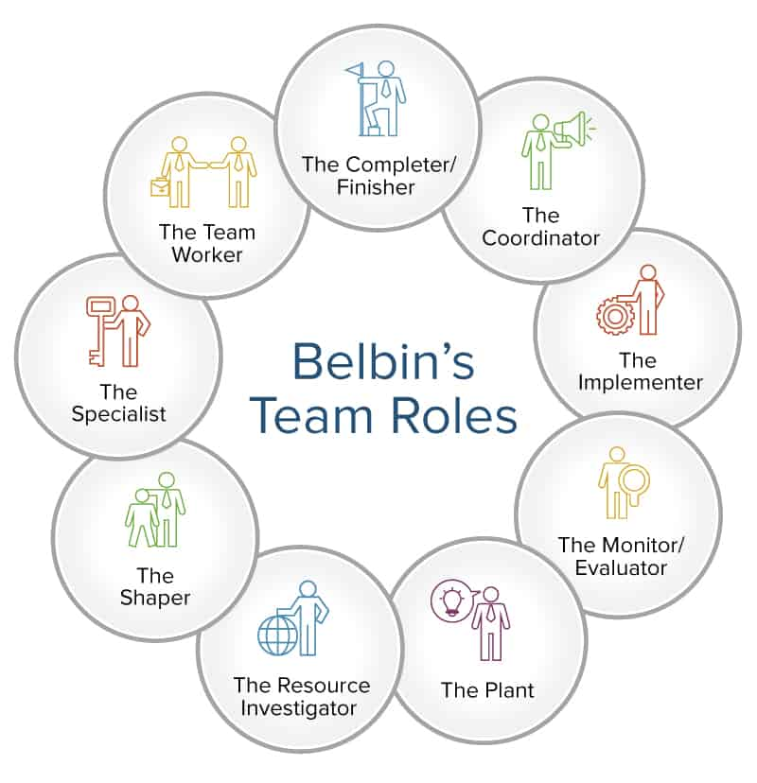

Stages of team activity 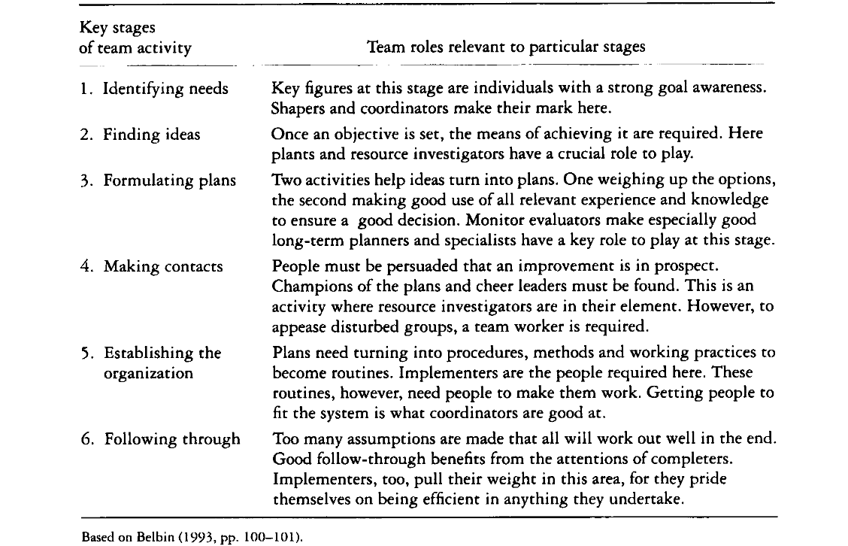
Many factors impact an organization's performance in accomplishing the goals of the organization, including vision, infrastructure, technology, new workers, and style of leadership. Among these is the 'human' element, which relates to individual employee behavior and its impact on personal, group, and business performance. The above technique helps a team able to profit from self-awareness and affect behavior in response to external pressures.

2.3 What type of impact can effective teamworking have on team success?

For one person to succeed and accomplish difficult tasks on his one is required many and various skills as well as too much knowledge. That is why companies and organizations count on teams for accomplishing the best results and achieving goals. Without any doubt team working has a huge impact on how the employees are performing and the future of the company. Bacon and Blyton (2006) imply that self-management team and interpersonal team skills have an essential impact on team performance. In their study, Tarricone&Luca (2002) refers to an effective team as: “Successful teamwork relies upon synergism existing between all team members creating an environment where they are all willing to contribute and participate in order to promote and nurture a positive, effective team environment”. Another impact is Leadership – the right and strong leadership are from a fundamental need for a team to succeed. He also has to be aware of how each member differs from him and what type of leadership and style has to apply for each situation. Communication and feedback – for one team to be successful open communication and real feedback are very important. Relationships – while one team exists there always be created strong relationships which can be a massive impact on the team’s success. As Daniel Coyle aimed to find in his book “The Culture Code” what made a team effective, he discovered three characteristics that were related: 1. Using nonverbal and vocal clues to make others feel safe, 2. Trust can be built by expressing vulnerability, 3. A clear strategy for expressing a group's purpose can engage its members.

2.4 What are the barriers to effective teamworking identified in this scenario?

Poor communication and physical disconnection – With the progress of technology over the decades a lot of teams are working online. As is stated above communication is one of the impacts of effective team working. In this case, due to Covid 19 restrictions, the team has not met yet and this leads to a lack of communication, the team cannot establish any relationships.
Lack of trust – working as a team the member should have trust in each other to achieve their goals. The lack of trust may lead to misunderstanding and disagreements which can obstruct teamwork. Based on a lack of communication Abdul`s team is unable to create any connections and based on this they cannot build any trust.
Size of the team – Abdul`s team is eighteen members which according to Wheelan`s research to achieve higher results the best size of a group is from 3 – 6 members. This is a big barrier in terms of achieving any goals.

3. Conclusion

Based on all the information in this report from above having an effective team is essential for every organization to achieve high performance. Even though due to Covid 19 restriction and the fact that the team has never met, Abdul must find a way for his team to have regular meetings so they can start establishing some relationships and trust. For him to succeed in developing an effective team Wheelan`s model can apply and help in further problems and difficulties along the way. He also can improve the team by establishing the roles of all his team members by using Belbin`s model and trying to avoid all the barriers are mentioned above.

- Reference list

- Bacon, N. & Blyton, P. (2006) ‘The Antecedents of Training Activity in British Small and Medium-Sized Enterprises’, Work, Employment and Society, Vol.18, No.4, pp.749-773
- Belbin, R. M. (1981). Management Teams. Why They Succeed or Fait. London: Butterworth-Heinem
- Belbin, R. M. (1993). Team Roles at Work. Oxford: Butterworth-Heinemann.
- Buzaglo, G. and Wheelan, S.A. (1999) ‘Facilitating Work Team Effectiveness: Case Studies from Central America’, Small group research, 30(1), pp. 108–129. doi:10.1177/104649649903000106.
- Fisher, S.G., Hunter, T.A. and Macrosson, W.D.K. (1998) ‘The structure of Belbin’s team roles’, Journal of occupational and organizational psychology. Received 16 May 1997; revised version received 17 October 1997, 71(3), pp. 283–288. doi:10.1111/j.2044-8325.1998.tb00677.x.
- Griffith, B.A., and Dunham, E.B. (2017) Working in teams : moving from high potential to high performance. Los Angeles: SAGE.
- Katzenback, & Smith, D. K. (1993). ‘The wisdom of teams’. Small Business Report (Monterey, Calif.), 18(7), 68–.
- Regenold, T.A. (2019) ‘Review of The Culture Code: The Secrets of Highly Successful Groups, by Daniel Coyle’, Performance Improvement. Silver Spring: Wiley Subscription Services, Inc, pp. 44–46. doi:10.1002/pfi.21839.
- Rickards, T. and Moger, S. (2000) ‘Creative Leadership Processes in Project Team Development: An Alternative to Tuckman’s Stage Model’, British journal of management, 11(4), pp. 273–283. doi:10.1111/1467-8551.00173.
- Senior, B. (1997) ‘Team roles and team performance: Is there “really” a link?’, Journal of occupational and organizational psychology. Received 2 November 1994; final version received 16 April 1996, 70(3), pp. 241–258. doi:10.1111/j.2044-8325.1997.tb00646.x.
- Tarricone, P. Luca, J. (2002). Successful teamwork: A Case Study. Edith Cowan University, Perth, Australia.
- Tuckman, B. W. (1965). ‘Developmental sequences in small groups’. Psychological Bulletin, 63, 384-399
- Tuckman, B. W., & Jensen, M. A. (1977). ‘Stages of small-group development revisited’. Group & Organization Studies, 2, 419-427.

- Wheelan, S.A. (2009) ‘Group Size, Group Development, and Group Productivity’, Small group research, 40(2), pp. 247–262. doi:10.1177/1046496408328703.
- Zoltan, Raluca. (2016). ‘Workgroup development models - the evolution from simple group to effective team’. Ecoforum. 5.

