Assignment title: Individual Business Model Canvas with entrepreneurial reflection
Proposal for Greeny Inn - An Eco-friendly Hotel ( own creation)

Name of the Student: Anca Roxana Iclanzean

Student ID number:2207144

The module code: BMIH5001

Lecturer’s name: Charlotte Joyner

Part 1: Proposal for Greeny Inn - An Eco-friendly Hotel (my own creation) using the Business Model Canvas (BMC)
The environment has become a burning concern throughout the world. As the hospitality industry is significantly responsible for leaving its footprints on the environment, a shift towards building eco-friendly and sustainable hotels is a crucial demand of time (Gardetti and Torres, 2017). The ‘Greeny Inn’ is a business start-up proposal that will reduce the environmental footprint of the industry as well as raise awareness among tourists to save the ecological balance of this beloved planet. This essay aims to illustrate the entire business model using BMC.
Greeny Inn's business model is characterized by several crucial elements that need detailed discussion to get a comprehensive idea. The unique value proposition that makes Greeny Inn different from its competitors, the main activities that form the base of its operations, the important partners, the targeted customer segments, the revenue streams, and the cost structure among others are the very important drivers of the business model of Greeny Inn. The following discussion, by going deeper into each of these elements in detail, will draw an overall picture of how Greeny Inn will be a potential venture.
The ‘Greeny Inn’ will be located near Oxwich Bay, Gower Peninsula in South Wales. The core value proposition of Greeny Inn that makes it different from its competitors is rooted in its outstanding integration of sustainability without compromising the quality of customer services. Greeny Inn aims to provide unparalleled residence quality and customer service quality that will ensure the utmost comfort of the tourists. There will be many eco-friendly features integrated into the rooms and other facilities that will definitely reduce the negative impact on the environment. For example, the house will be powered by renewable energy which will reduce the impact of producing electricity in a traditional way. It will also be possible to gather and use water again with the help of an effective water management system. According to Pietsch et al. (2017), following the zero-waste approach will also have a big effect. There will be a lot of choices and packages that can be changed to fit the needs of all kinds of tourists. The idea of sustainable travel will be pushed and praised by high-end comfort and eco-friendly design. For instance, organic products will be provided to cut down on the use of chemicals and plastic that could be harmful. Eco-friendly tours and events will also be available for visitors to help them learn more about the environment. The purpose of these trips is to make people more aware of how important it is to protect natural places so that future generations can enjoy them. Their goal is to educate visitors about environmental problems and give them chances to help make the world a better place.
The Greeny Inn can establish partnerships and collaborations with the local suppliers of organic food and eco-friendly products such as Gower Seafood Hut, Rasoi Waterfront etc., travel agencies such as Booking.com, local transportation agencies, eco-saving organisations, and non-governmental organisations, as well as statutory water and energy regulators. Establishing partnerships with these relevant bodies will help Greeny Inn provide a comprehensive experience for travellers. With blended efforts from all the parties involved in the industry, a good ecosystem for a sustainable tourism and accommodation industry will be attainable (Chen et al., 2021).
Among the key activities of the Greeny Inn will be sustainably and comprehensively constructed buildings and parking lots, as well as other facilities that impact the ecology, such as eco-friendly toilets and others (Gardetti and Torres, 2017). Another critical activity of the ‘Greeny Inn’ is its well-trained staff, who will set an example of sustainable habits and behaviours such as using the right recycle bin for the right type of trash to educate the travellers to behave the same way and so on (MacInnes et al., 2022). Green volunteering opportunities for the visitors will also be a significant part. Proper maintenance of sustainable equipment and arrangements, eco-conscious waste management, and energy reservation systems will also be good indicators in measuring sustainable performance (Dewi et al., 2022).
The Greeny Inn may attain several key resources that will make it stand out as an eco-friendly and sustainable hotel (Harrabin, 2021). Firstly, the Greeny Inn will be constructing sustainable and comprehensive buildings and facilities in a way that will minimize the environmental impact. Additionally, Greeny Inn will need to properly train its workers in eco-friendly methods that will set a good example for guests to follow (Filimonau et al., 2023). Eco-friendly furniture and decor should also be used at the hotel. This will leave even less of an impact on the earth (Broadway, 2020). The Greeny Inn also needs to set up a good waste management system. This will make sure that trash is handled in an environmentally friendly way (Filimonau, 2020). Lastly, the hotel will have a method for managing energy use that will help them use less energy.
Visitors to The Greeny Inn will mostly be business and vacation travellers who strongly believe in the importance of being environmentally friendly. Potential customers also include eco-tourism fans looking for eco-friendly places to stay and travellers wanting to do eco-friendly things and learn about the local culture (Verma, Chandra, and Kumar, 2019).
The hotel will be promoting its eco-friendly policies and practices through social media, email, and targeted marketing. To further encourage sustainable practices, they team up with local companies and organisations to offer environmentally conscious tours and activities. Their goals in doing so are to draw in more environmentally conscious consumers and raise public awareness of the significance of sustainable tourism and environmentally friendly activities (Bilynets et al., 2023).
The Greeny Inn will maintain a good customer relationship by providing tailored services and amenities to ensure a relaxing accommodation. The Greeny Inn will be focused on providing environmentally sustainable excellent service. Campaigns, activities, and excursions in eco-friendly surroundings will help them learn about environmental protection in addition to a delightful stay (Wang et al., 2024). The Greeny Inn manages its operations with environmental and goal-oriented care. The Greeny Inn strives to keep guests coming back by providing a distinctive, value-based experience. The hotel wants residents who care about the community and environment to help it thrive.
The Greeny Inn will generate revenues that are similar to the other hotels. But the difference is it is not going to harm the ecology for generating money. Different hotel rooms fit the necessities, desires, tastes, and budgets of a diverse range of people. The Greeny Inn will have a flexible array of services. It will also profit by serving healthy, locally farmed food and drinks at its restaurants. The hotel cafeteria provides breakfast, lunch, and supper which will be a good source of revenue (Hayes et al., 2021). Finally, the Greeny Inn will generate money from eco-tours where the customers may visit without harming nature.
It will cost the Greeny Inn a lot of money to buy land and build a hotel. Building sustainable facilities may cost more than the regular ones in some cases. The hotel will also spend on taking initiatives to save the environment by saving water and energy. With these projects, the hotel hopes to cut down on its carbon impact and operating costs. Greeny Inn will have to pay their well-trained employees and offer benefits such as training and opportunities to grow (Chung and D’Annunzio-Green, 2018). There will also be some extra expenditure to provide superior customer services. The hotel will also spend money on tools and technology that are good for the earth to keep costs low while still giving guests a great time they will remember (Solway, 2020).
The Greeny Inn keeps a close eye on its environmental objectives and business achievements by regularly monitoring its service and facility utilization rates. The hotel also conducts guest satisfaction surveys to ensure that they are providing eco-friendly services (Kokkhangplu et al., 2023). Moreover, they keep a record of their carbon footprint, resource conservation, and waste reduction efforts to minimize their impact on the environment (Kristanti and Jokom, 2017).
The justification behind the idea of starting an eco-friendly hotel that will operate its accommodation and hospitality business doing as little harm to the ecology as possible is being popular day by day around the globe (Braw, 2013). Moreover, tourists are always interested in tasting local foods and cuisines and visiting scenic local destinations. Moreover, people around the globe are becoming much more concerned about the sustainability and ecological balance (Rehman et al., 2023). Hence, Greeny Inn will be doing great business if the model is implemented effectively.
In conclusion, the Greeny Inn is a hotel that cares about the environment and will last. Its BMC model displays important partners, jobs, resources, client groups, channels, contacts with customers, sources of income, and cost structures. The Greeny Inn wants to teach tourists about Earth's delicate natural balance and lessen the damage that hotels do to the environment. The hotel's major customers will be ecotourism, tourists who care about the environment, and environmentalists. The customers will have a nice time at the Greeny Inn because it has helpful staff, personalized services, and projects and activities that are good for the environment. Room rentals, sales of food and drink sales, and eco-tours will generate the most revenue for the hotel. Putting customer satisfaction and protecting the earth as the priority, the hotel The Greeny Inn will set standards of how the tourism and hospitality industry might take more responsibility for doing business without hurting the environment.

Part 2: A Reflective Essay on My Entrepreneurial Motivation and Attributes
The questionnaire provided in the class to test my management and entrepreneurial traits helped me a lot to understand myself precisely in this regard. Using the Gibbs reflective model, I am evaluating and analysing my entrepreneurial attributes in the following six stages.
Description: The total result of the questionnaire was 48, which implies that I might have the capabilities as well as the potential to be an entrepreneur, but I am much more cautious sometimes when taking risks. I have noticed that I tend to overthink things and analyse every possible outcome before deciding. This has sometimes held me back from taking the leap into entrepreneurship and also I score low on locus of control so I need to work deep on that skill to improve it.
Feelings: The idea of being an entrepreneur is both exciting as well as confusing for me. Doing something new and innovative always excites me. On the other hand, I get worried about the financial and personal risks that are related to starting a business and the probable harm it may have on my life.
Evaluation: These attributes can be capitalized as strengths to be an entrepreneur and overcome (Barringer and Ireland, 2018). On one hand, it helps me to evaluate the situation and make better decisions regarding this. Oppositely, it often holds me back from taking more risks and making bold decisions that might lead to success. However, a balance needs to be drawn between these to be successful as an entrepreneur (Williams, 2021).
Analysis: Fear of failure is the key reason behind these attributes I feel insecure about the negative consequences of making a mistake and the impact it could have on my life. However, I understand that failure is a crucial part of the entrepreneurial journey. Moreover, failure is a good way to learn and grow. I better change my mind and take failure as a learning opportunity rather than worrying about a negative outcome.
Conclusion: These attributes are necessary to be successful as an entrepreneur (Burns, 2022). Though, I need to find a balance between my cautious nature and my willingness to take risks. By changing my mind and learning to take failure as a learning opportunity, I will be able to overcome my fears and achieve success as an entrepreneur.
Action Plan: Fear of failure is one of the key characteristics that held many potent entrepreneurs back from chasing their goals can be overcome through practice and consistent efforts (Mariotti and Glackin, 2012). So, overcoming the fears of failure and taking risks will enable me to be my true version and follow my passion. To overcome my fear of failure and find a balance between my cautious nature and willingness to take more risks, I will try to embrace each failure as a learning opportunity. Secondly, I will try to take calculated risks and keep a clear alternative plan. Also, I will seek advice from mentors and successful entrepreneurs. Finally, I will try to develop my decision-making skills. Practice can be started with small decisions. By following this action plan, I believe I can overcome my fears and become a successful entrepreneur.

References:

Barringer, B. R. and Ireland, R.D. (2018) Entrepreneurship: Successfully Launching New Ventures. 4 th Ed. Prentice Hall: New Jersey.
Bilynets, I., Knezevic Cvelbar, L. and Dolnicar, S. (2023) Can publicly visible pro-environmental initiatives improve the organic environmental image of destinations?. Journal of Sustainable Tourism, 31(1), pp.32-46.
Braw, E. (2013) Sustainable tourism: the rise of the eco-boutique hotels. The Guardian. [online] 22 Jul. Available at: https://www.theguardian.com/sustainable-business/blog/sustainable-tourism-eco-boutique-hotels.
Broadway, K. (2020) 10 Ways Hospitality Can Reduce Their Impact on The Environment. [online] www.linkedin.com. Available at: https://www.linkedin.com/pulse/10-ways-hospitality-can-reduce-impact-environment-broadway-c-f-s-p/ [Accessed 30 Jan. 2024].
Burns, P. (2022) Entrepreneurship and Small Busines. 5th Ed. Palgrave Macmillan: Basingstoke.
Chen, M.-H., Wei, H., Wei, M., Huang, H. and Su, C.-H. (Joan) (2021) Modeling a green supply chain in the hotel industry: An evolutionary game theory approach. International Journal of Hospitality Management, 92, p.102716.
Conceptboard(2024) Individual Business Model Canvas:[Visual Workspace]: Available at: https://app.conceptboard.com/board/t8bn-dyca-zga9-8e25-7muk (Accessed 5 Feb 2024)
Chung, K.L. and D’Annunzio-Green, N. (2018) Talent management practices in small-and medium-sized enterprises in the hospitality sector: An entrepreneurial owner-manager perspective. Worldwide Hospitality and Tourism Themes, 10(1), pp.101-116
Dewi, K.I.E., Bagiastuti, N.K., Sutama, I.K. and Sarja, N.L.A.K.Y. (2022) Implementation of eco-friendly behavior by front office employees to support green hotel at The Ritz-Carlton Bali. International Journal of Green Tourism Research and Applications, 4(2), pp.68-85.
Filimonau, V. (2020) The Prospects of Waste Management in the Hospitality Sector Post COVID-19. Resources, Conservation and Recycling, 168, p.105272.
Filimonau, V., Bai, L., Romanenko, A., Tarakanova, V. and Ermolaev, V.A. (2023) How employees perceive and (dis)engage with ‘green’ practices in luxury hotels. International Journal of Hospitality Management, [online] 114, p.103567.
Gardetti, M.A. and Torres, A.L. (2017) Sustainability in Hospitality: How innovative hotels are transforming the industry. Routledge.
GET2 (2024) Get2 Test for Enterprising Potential [Reflective Tool.] Available at: http://www.get2test.net/get2test.html (Accessed 17 Jan 2024)
Harrabin, R. (2021) Building strategy to look at embodied carbon, says government. BBC News. [online] 12 Oct. Available at: https://www.bbc.co.uk/news/science-environment-58878192 .
Hayes, D.K., Hayes, J.D. and Hayes, P.A. (2021) Revenue management for the hospitality industry. John Wiley & Sons.
Kokkhangplu, A., Onlamai, W., Chokpreedapanich, T. and Phikul, K. (2023) What Predicts Behavioral Intention in Eco-Friendly Hotels? The Roles of Tourist’s Perceived Value and Satisfaction: A Case Study of Thailand. Sustainability, 15(4), p.3219.
Kristanti, M. and Jokom, R. (2017) The influence of eco-friendly attitudes on tourists’ intention toward green hotels. In Balancing Development and Sustainability in Tourism Destinations: Proceedings of the Tourism Outlook Conference 2015 (pp. 21-29). Springer Singapore.
MacInnes, S., Grün, B. and Dolnicar, S. (2022) Habit drives sustainable tourist behaviour. Annals of Tourism Research, 92, p.103329.
Mariotti, S. and Glackin, C. (2012) Entrepreneurship: Starting and Operating a Small Business. 3rd Ed). London: Prentice-Hall.
Pietzsch, N., Ribeiro, J.L.D. and de Medeiros, J.F. (2017) Benefits, challenges and critical factors of success for Zero Waste: A systematic literature review. Waste management, 67, pp.324-353.
Rehman, S.U., Elrehail, H., Alshwayat, D., Ibrahim, B. and Alami, R. (2023) Linking hotel environmental management initiatives and sustainable hotel performance through employees’ eco-friendly behaviour and environmental strategies: a moderated-mediated model. European Business Review, 35(2), pp.184-201.
Solway, A. (2020) Sustainable tourism. Mankato, Minn.: Arcturus Pub.
Verma, V.K., Chandra, B. and Kumar, S. (2019) Values and ascribed responsibility to predict consumers’ attitude and concern towards green hotel visit intention. Journal of Business Research, 96, pp.206–216.
Wang, J., Vo-Thanh, T., Gursoy, D., Dang-Van, T. and Nguyen, N. (2024) Effects of hotels’ green practices on consumer citizenship behavior. International Journal of Hospitality Management, [online] 118, p.103679.
Williams, S. (2021) FT Guide to Business Start Up 2021-2023. Pearson UK.

Appendix1 :Business Model Canvas for Eco Friendly Hotel

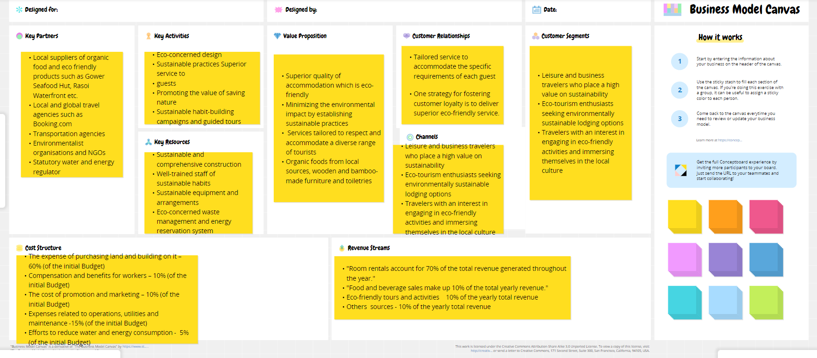

(Conceptboard, 2024)

Appendix 2: Get2 Test for Enterprising Potential Own Results
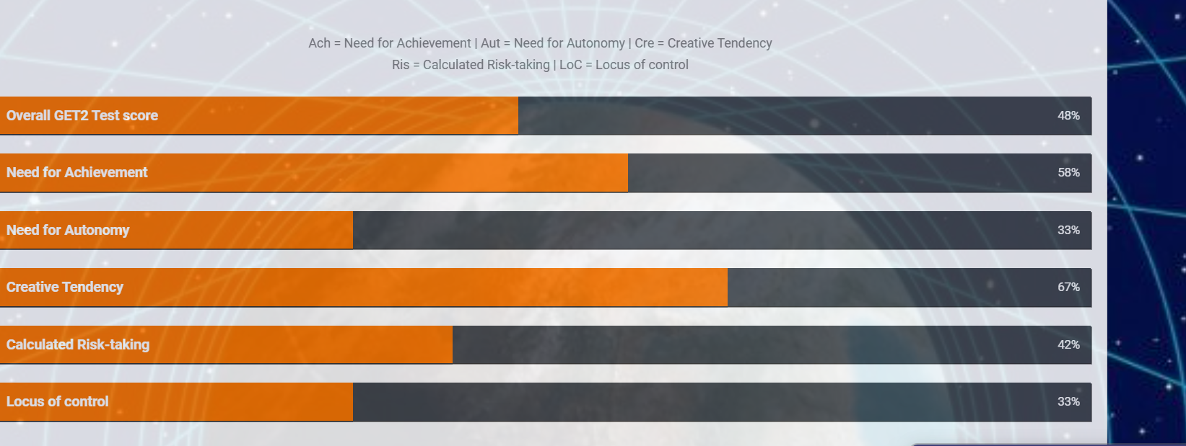

(Get2, 2024)

