Chef Position – Green King
Personal Data
Name: Estera Filip
Email: filipestera9@gmail.com
Right to work: Eligibility to work full-time in the United Kingdom
Personal Statement
I am a hardworking chef with experience in restaurants, Hotel kitchens, and working in a fast-paced environment. I am familiar with food preparation hygiene standards and teamwork during busy times. I am always focused on serving high-quality dishes and maintaining customer satisfaction. I would like to use my culinary skills and positive attitude to support the team at Green King.
Employment History
Chef – Pizza Hut (Oct. 2015- Feb 2018 Bucharest, Romania)
I help with the preparation of pizza, side dishes, appetisers and desserts according to company standards.
I maintained stock levels and followed food safety procedures, working closely with team members to provide excellent service during peak periods.
Call Centre Operator – Customer Support (Feb 2018- Feb 2019, Bucharest, Romania)
Two online shops for genuine leather and eco-leather shoes.
- Assisted customers with order product information, delivery updates and the system.
- Handled complaints professionally and updated customer records in the system.
Hard Rock Cafe (Feb 2019- Jun 2019 Bucharest, Romania)
Prepared ingredients and assisted with burgers, salads, and sides, and supported the chef team.
Cucina JW Marriott (Jun 2019- Dec 2019 Bucharest, Romania)
Prepared Authentic Italian dishes, including pasta, risotto, antipasti, and grilled items.
Followed high hotel standards for food quality, presentation, and hygiene.
Managed fresh ingredients and supported mise and place for lunch and dinner service.
Work efficiently with cheers during busy service hours in a fast-paced hotel environment.
Eldorado Casino Cashier /Gaming Attendant (Dec 2019- Feb 2020)
Handled customer payments and exchanged money for tokens.
Offered drinks (coffee, tea, soft drinks, occasionally alcoholic beverages)
Removed money from machines, counted it, and entered data in the system.
Paid customer winnings and recorded high-value wins according to procedure.

Showroom& Presentation Assistant – Motor Clean Ltd (Bentley & Range Rover Dealership), (Feb 2020- Nov 2022, UK)
Maintained the cleanliness and presentation of luxury vehicle showrooms.
Prepared rooms for meetings, new car launches, presentations, and promotional events.

University of Southampton Highfield Campus (Nov 2022- present, UK)
Cleaned engineering spaces, study rooms, offices, and high-traffic surfaces.
Guided students to classrooms/ buildings when needed
Report lost items or incidents to the appropriate department
Contributed to a safe, organised, and professional study environment
Education History
High School Diploma – Natural Sciences
Baccalaureate Diploma
Currently studying at the University of Wales Trinity Saint David (Year 1)
ACCA Financial Accounting (ongoing)
Key Skills
Punctual and reliable
Strong attention to detail
Excellent hygiene and cleaning standards
Good communication and customer service
Fast leader adaptable , and organised
Able to work under pressure
Certificates
High School Diploma
Baccalaureate Diploma
Professional Chef Certificate
References
Available upon request
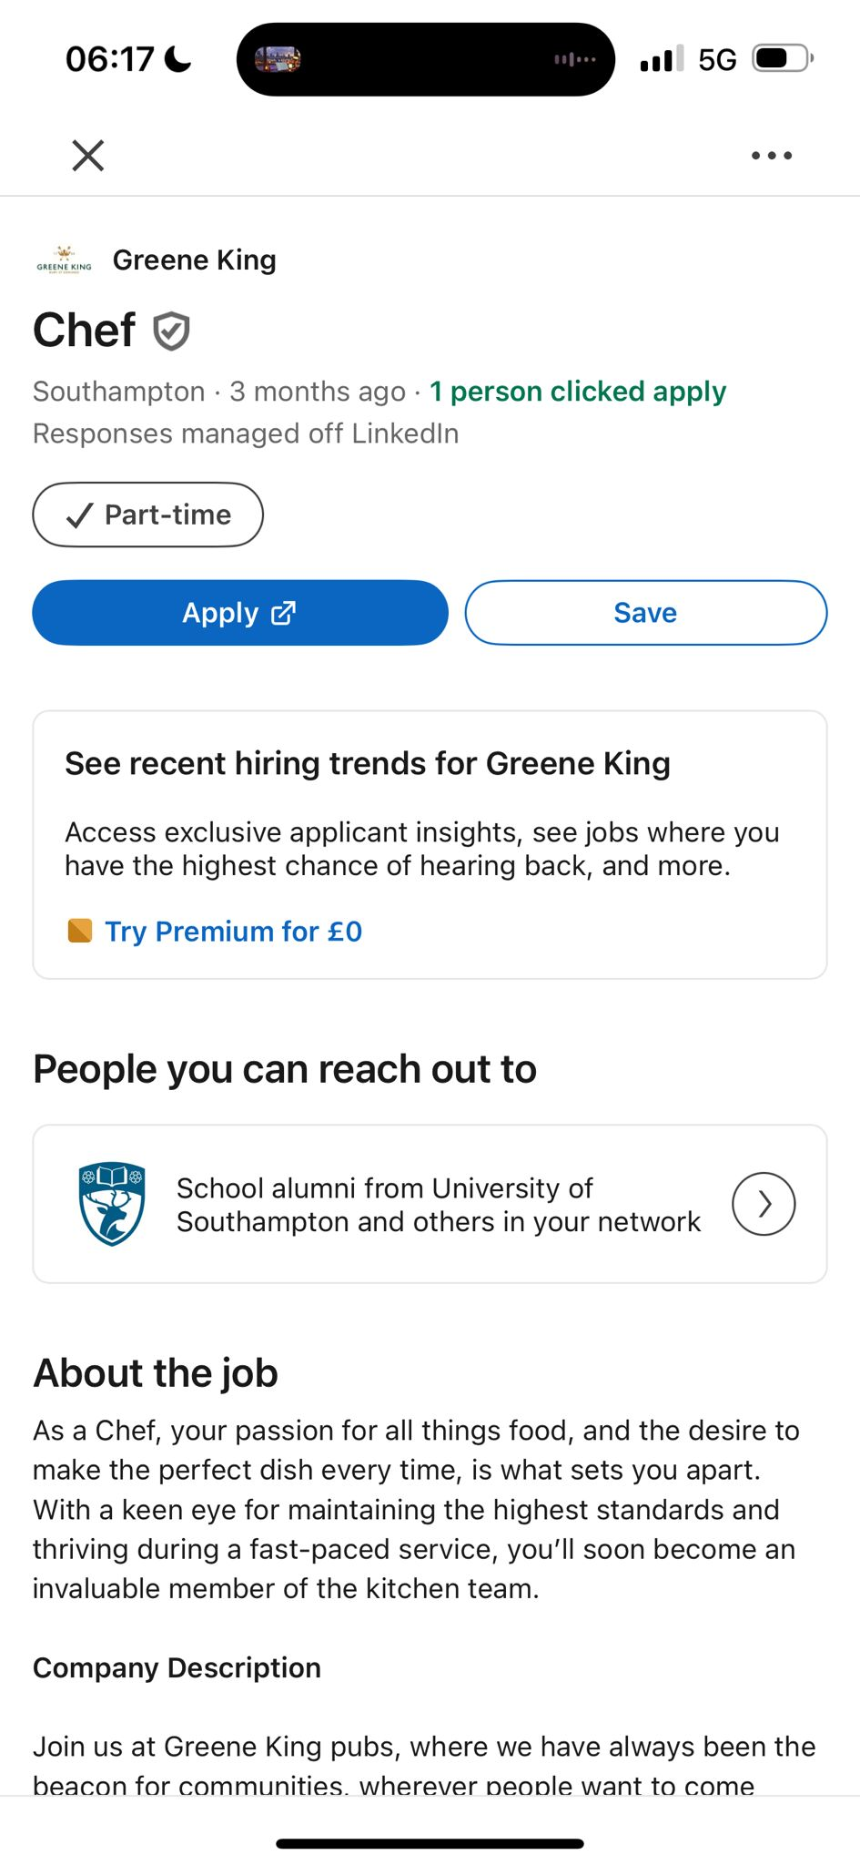
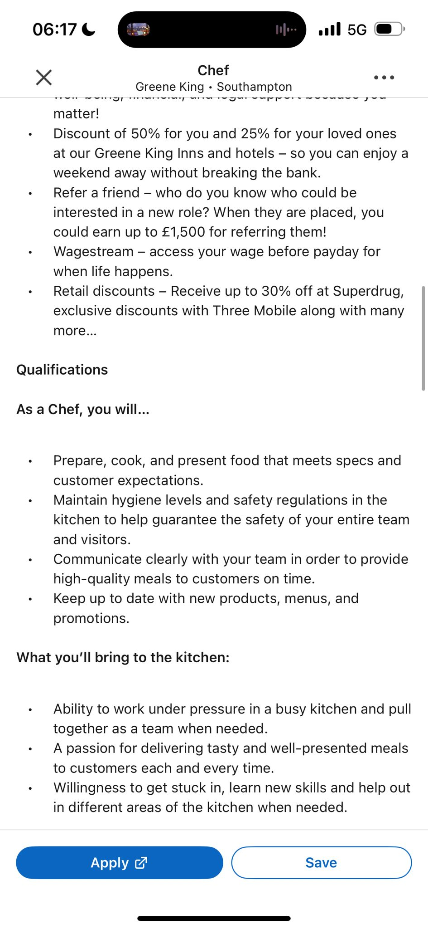
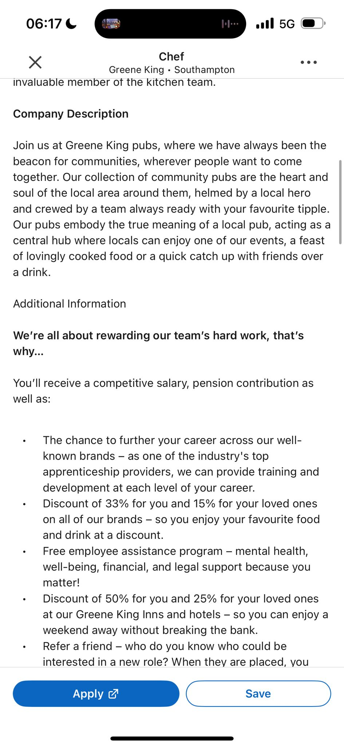
Cover Letter Chef Position (Green King)
Estera Filip
filipestera9@gmail.com
Dear Ms or Mr,

I am writing to apply for the Chef position at Greene King. I am interested in this role because I enjoy working in busy kitchens and I am passionate about preparing good-quality food for customers.
I have more than two years of experience working as a chef in restaurants and hotel kitchens. At Pizza Hut in Bucharest, I prepared pizzas, side dishes and desserts while following company standards and food safety rules. I also worked at Hard Rock Cafe and JW Marriott, where I learned to prepare different types of dishes, organise the kitchen and support the team during busy periods.
I always respect hygiene standards, work well under pressure and communicate clearly with colleagues. I am reliable, Punctual and motivated to learn new techniques. I enjoy being part of a team and helping to maintain a positive working environment.
I believe my work experience, attitude and passion for cooking make me a good match for Greene King. I would be happy to contribute to your kitchen and support your goal of providing great customer service.
Thank you for considering my application. I would welcome the opportunity to attend an interview and discuss how I can contribute to your team.
Estera Filip

