

ACCA4022
Operating Systems

Computer Architecture and Operating Systems
April 26

Computing Science:
Data and Information Systems
@student.uwtsd.ac.uk
Siân Kiely 2218899


Table of Contents
Computer Architecture and operating systems 3
Introduction 3
Task One: Key functions of general Operating Systems 4
What is an Operating System (OS)? 4
What does an Operating System Do? 4
User interface provision (GUI & CLI) 4
Process & Memory Management – Kernal 5
System & Performance Management 6
Screenshots 7
File & Directory Management 10
Device Management (Manages I/O devices) 11
Error detection and System recovery 11
System Security & Network management 11
Task Two: Use of Windows OS CLI commands. 12
Task Three: Use of Linux OS CLI commands 19
Task Four: Use of Windows OS Scripts 24
Task Five: Use of Linux OS scripts. 28
Conclusion 31
References 32
Appendices 36
Tutorial Activity: on OS Types from Tutorial 1 36
Evidence of engagement with 1 online certified course 37
Cisco Course: Linux Unhatched 37

Computer Architecture and operating systems

Introduction
Whilst Charles Babbage [1] is credited with designing the first manual computer, integrating punch cards into his digital analytical engine design as early as 1830. The design was ahead of its time with mechanical technologies available incapable of the high precision required as explained by Tanenbaum and [2],8] Bos. Anticipating a software requirement Ada Lovelace was hired as the world’s first programmer. Interestingly there is debatably an even earlier computer from 1774, if defined by its programmability. Bruderer writes [3]
“The writer (L’évrivain) of Pierre Jaquet-Droz… boy dips the goose quill into the ink well and writes nearly any arbitrary texts up to 37 letters”. It comprised of a programable wheel which could form different words and sentences.

Fascinatingly similar concerns and uncanny valley hesitancy were felt at the first computer creation, and we find ourselves in a similarly apprehensive state in the 21st century as AI technologies advance. Our rapid advancement in knowledge and technology makes it an interesting time to be alive with new possibilities emerging. It also serves as an opportunity to reflect as suspicious certainty resurfaces as we are once again faced with challenging questions about ourselves and our future. As AI technologies develop, we can observe parallels with similar uncertainties in 1774 following the Swiss watchmaker’s creation. Gaby Wood writes of the unageing automata; [4]
“the writer still communicates to its audience an eerie philosophical joke: “I think,” it writes, “therefore I am.””

This interpretation of instructions, with the user presenting a problem, the “input” and the computer processing this request or set of instructions to execute an “output” serves as a launching point for this assignment. How do we interact with computers, and get them to fulfil specific functions in a user friendly and efficient manner? The above-mentioned early computers existed before operating systems and the need for such a program became more apparent, seeing transistor and batch systems develop to the point of inefficiency.

This report seeks to explore computer operating systems, their key functions, examples of command line and batch scripting which ultimately demonstrates how we use computers and offers an insight into their potential. Knowledge is the only limit and we’re witnessing a rapid gain of understanding in the last century alone. Naturally unfamiliar technologies bring uncertainty especially as the problem presents in the user interface exchange, but also presents untold potential.

Task One: Key functions of general Operating Systems

What is an Operating System (OS)?
An OS acts like an interface between the computer hardware and user. Designed to manage hardware and software on a computer, an OS allows a user or “Admin” to manage the computer system. Even though ‘modern’ computers have been around since the 1940s, Dr Gorgon explains [1] Prior to operating systems computers such the first of its kind; ENIAC (1942-1945). ENIAC used over 18,000 vacuum tubes, an all-electric computer with no mechanical parts, still replied upon punch cards offering instructions.
Tanenbaum writes [2] how modern computers consist of complex systems when considering all involved. Including one or more processors, hard disks / flash drivers, printers, mice and keyboards, input / output devices, display, network interfaces and memory. Too much for every programmer to remember in detail and utilize optimally.
“For this reason, computers are equipped with a layer of software called the operating system, whose job is to provide user programs with a better, simpler, cleaner, model of the computer and to handle managing all the resources just mentioned.”

What does an Operating System Do?
To simplify an operating system, it manages the interaction between user, computer hardware and software, the OS coordinates many applications at the same time. Various users can have various levels of access and permissions.
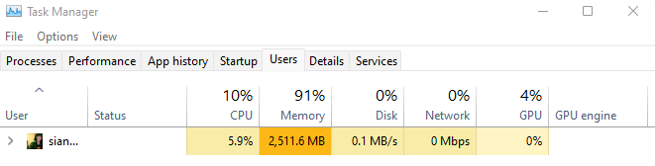
Figure 1 Task Manager: Users (also discernable is the lack of memory…)

User interface provision (GUI & CLI)
The user can interact with the Operating System through a graphical user interface (GUI) using components such as menus and icons. Prior to GUI, released in 1981 by Xerox (Xerox Star) and shortly after 1984 by Apple (Macintosh), Command line interfaces (CLI) were unappealing to novice users and inefficient requiring command memorization and accuracy. This serves as a key function of operating systems; they should be user friendly but secure.
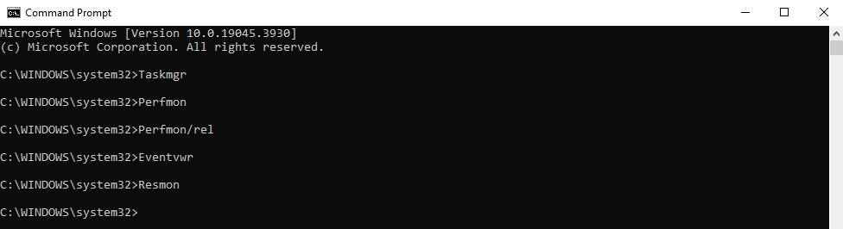
Figure 2 Command Prompt Taskmgr
Users are still able to access CLI and with the right understanding it can be powerful. The above screenshot shows how it can be used to launch task manager, performance manager, reliability monitor, Event viewer and resource monitor. All of which provide useful insight into the computer’s performance and capability.

Process & Memory Management – Kernal
One of the OS jobs is Resource Allocation. All the apps would need access to the computer central processing unit (CPU), memory and storage. Kernel is the core of the OS. To allow the user to operate the computer efficiently, the OS must ensure each app and program gets the system resource required to run effectively. Much of this happens in the background. As explained by Robert Love [5],67]
“The process scheduler is an important part of any kernel because running processes is (for most of us at least) is the point of using the computer in the first place. Juggling the demands of process scheduling is nontrivial, however: a large number of runnable processes, scalability concerns, trade-offs between latency and throughput, and the demands of various workloads make a one-size fits all algorithm hard to achieve.”

 | Web Browser | E-mail reader |  | Music Player
User mode
User mode | User interface program |  |  |  | Software
Kernel mode | Operating System
 | CPU |  |  |  | Hardware

Table 1 Where the operating system fits in

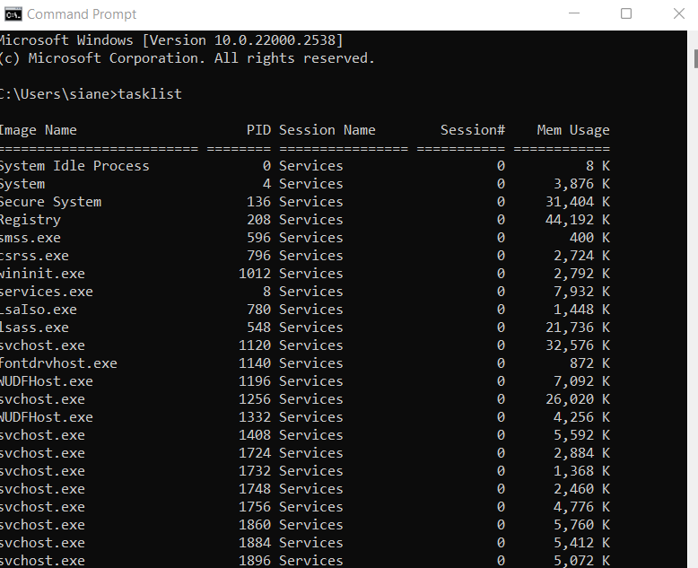
Figure 3 Command Line: tasklist

System & Performance Management
There are several tools in which users can manage and monitor their system performance. Tanenbaum and Bos write [2], 2]
“The operating system, the most fundamental piece of software, runs in kernel mode (also called supervisor mode) for at least some of its functionality. In this mode, it has complete access to all the hardware and can execute any instruction the machine is capable of executing. The rest of the software runs in user mode, in which only a subset of the machine is available.”
User mode programs determining security boundaries, instructions that affect machine control, I/O (Input/Output) are forbidden.

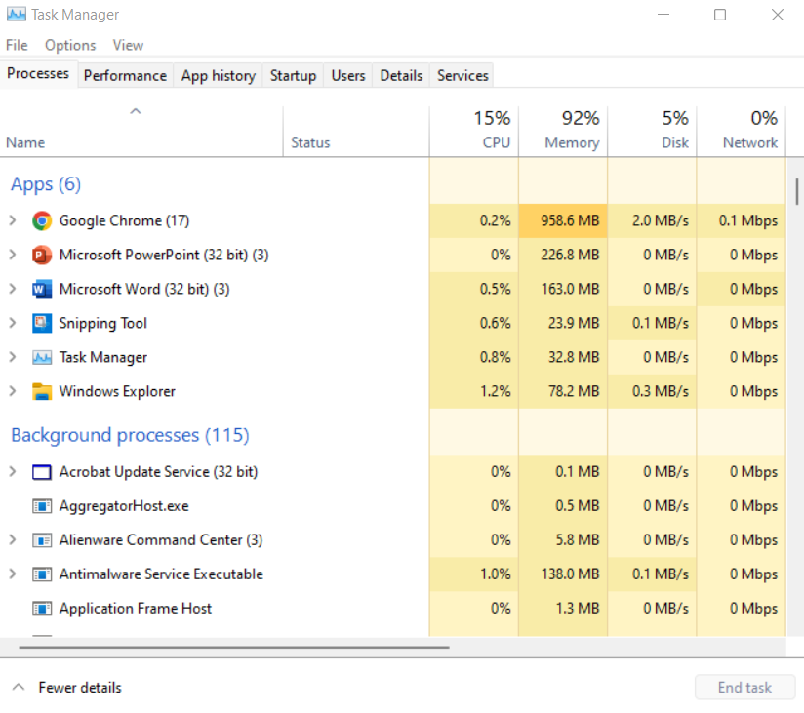
Screenshots
Figure 4 Task Manager: Processes - Apps, Background processes.
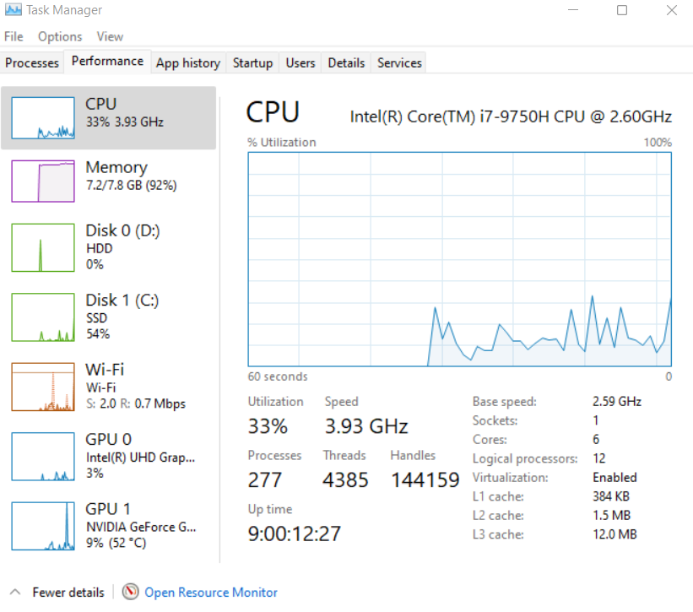

Figure 5 Task Manager: CPU
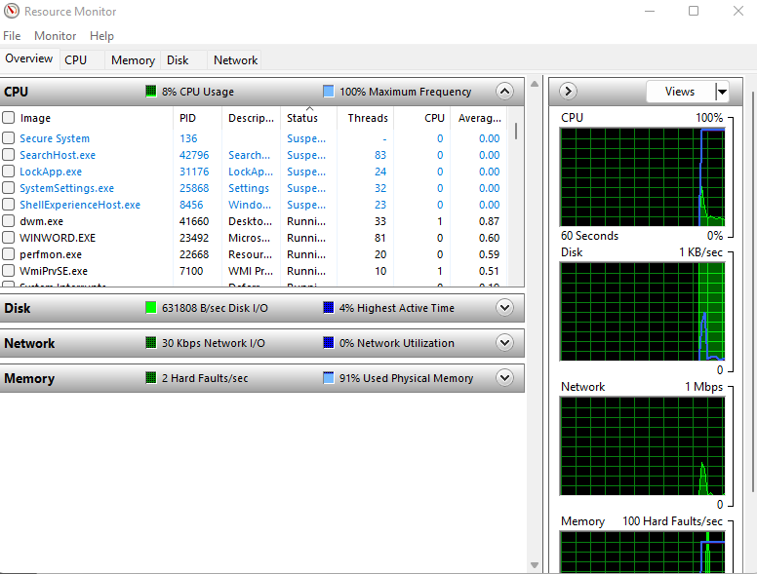
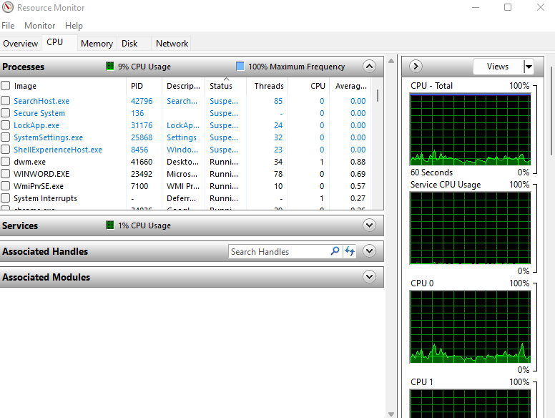
Figure 6 Resource Monitor: Overview CPU
Figure 6 `Resource Monitor: CPU Processes
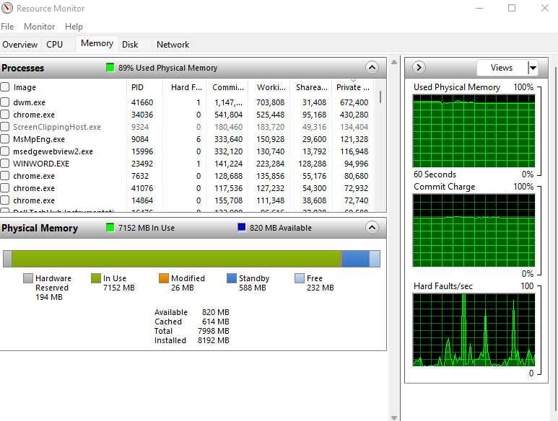
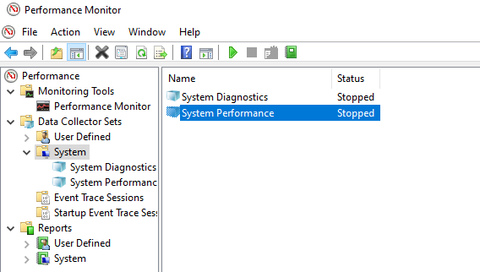
Figure 7 Resource Monitor: Memory - Processes, Physical Memory
Figure 7 Performance Monitor: System Performance

File & Directory Management
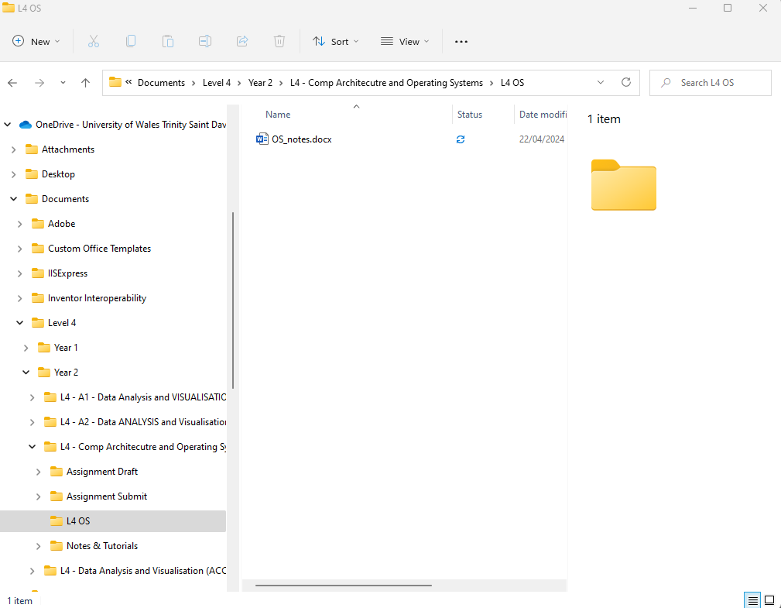
If users have the required permissions, as access can be determined, they can find their required files and folders. To navigate the system, they can use file manager or CLI to locate and access to find their way around a tree like hierarchical structure containing directories, folders, and files. They can be organized, e.g. University may contain a folder per subject with separate files for notes and assignments.
Figure 8 File Explorer: File structure - University Cloud, Documents, Level 4, Year 2, L4 – Comp Architecture and Operating Systems L4 OS: OS_notes_docx.
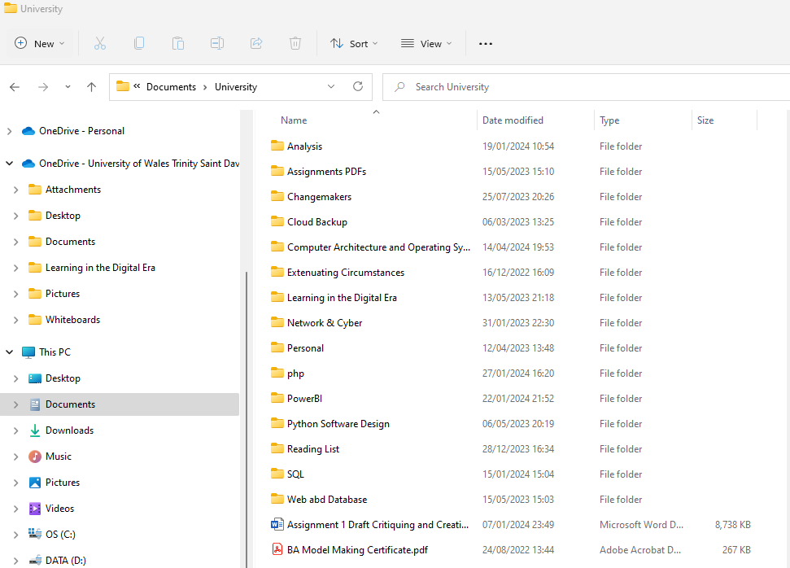
Figure 9 File Explorer: File structure - Documents, University

Device Management (Manages I/O devices)
Resource allocation is an important aspect of managing Input/Output (I/O) devices. Resources include memory, device access and CPU time. The operating system needs to communicate with peripheral devices to ensure device control and data transfer. For hardware to be efficiently utilized, conflicts should be prevented as part of device synchronization. If a process cannot proceed due to waiting for resources, ‘deadlock’ occurs, this should be prevented and algorithms should detect, prevent, and resolve such occurrences.

Error Detection and System Recovery
Linux has something known as ‘panic’ for critical errors. Used as a last resort when the kernel cannot recover from an encountered situation. Love [5] , p. 371]
“A more critical error is signaled via panic(). A call to panic() prints an error message and then halts the kernel. Obviously, you want to use it only in the worst of situations:
If (terrible_thing)
Panic(*terrible_thing is %ld!\n”, terrible_thing);
Errors can be identified, and sometimes include software bugs. Restarting processes, rolling back to stable state or system reboot form part of system recovery.

System Security & Network Management
Further security measures include monitoring access. Maintaining system integrity requires protection against unauthorized access, either malicious or unqualified. Encryption can add an additional layer of protection especially with sensitive information which gets transmitted over networks. It is paramount to protect data integrity and system stability.

Task Two: Use of Windows OS CLI commands.
Some window commands are considered especially useful as detailed in NetworkChucks [6] video. One example being battery report, which saves a batter-report.html file which can be viewed. Batch commands as explained by Microsoft [7]:
- mkdir test
  - command – create new folder called ‘test’.
- dir
  - command – view contents of current directory listed.
- powercfg /battery report
  - saves batter-report.html files with computer details, battery details and usage.
- rmdir test
  - command – delete folder called ‘test’.
- notepad
  - command – opens notepad.
- help dir
  - command – either help about specific command (dir) or command list displayed.
- color
  - command – change back/foreground color of cmd window using 2-digit hex code.
- ipconf
  - command – displays computer IP address (router web interface)
- ping
  - command – test connectivity of network – ping specific host with 32 bytes.
- netstat
  - command – display network info, TCP address, listening ports, active connection.
- tasklist
  - Command – display list current running tasks & process IDs.

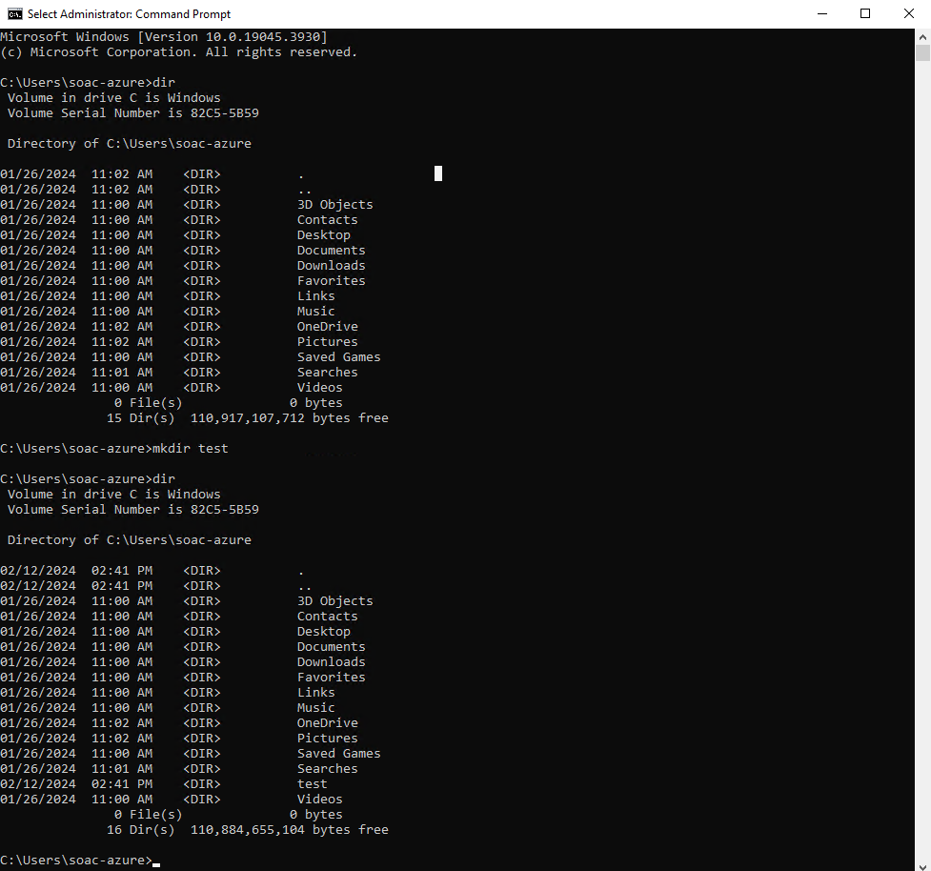

Figure 10 mkdir test - create test folder.
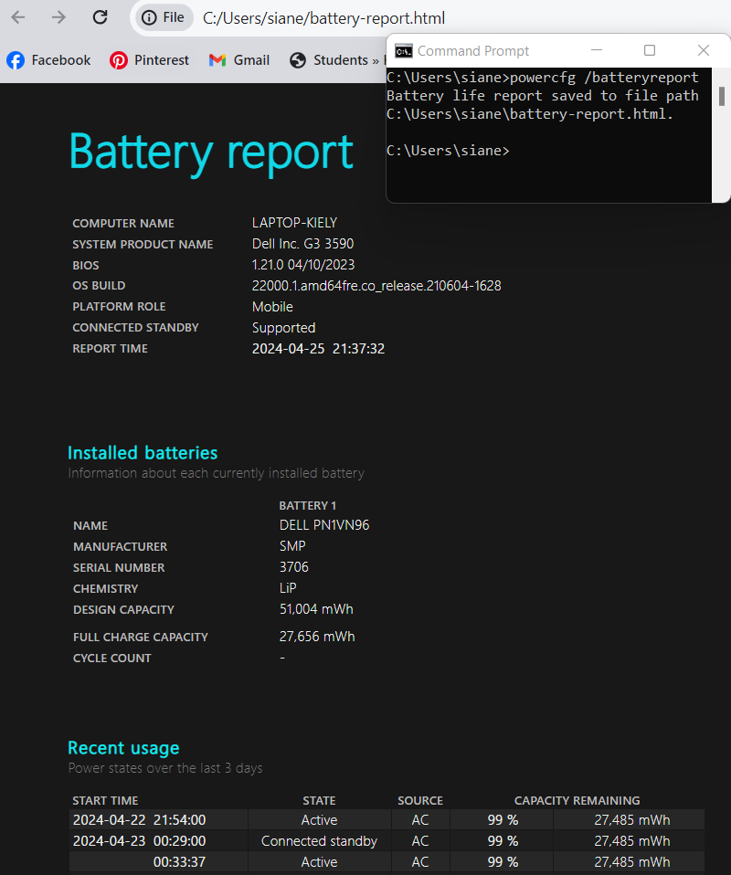
Figure 11 powercfg /battery report - battery-report.html
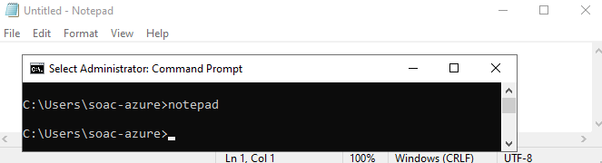
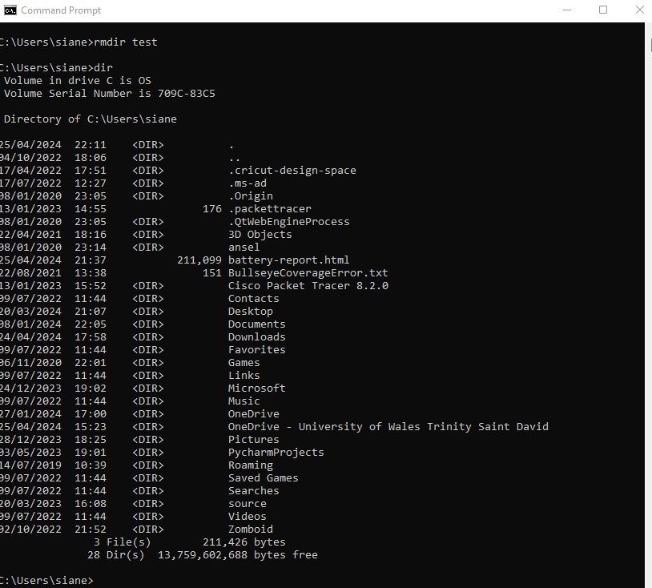
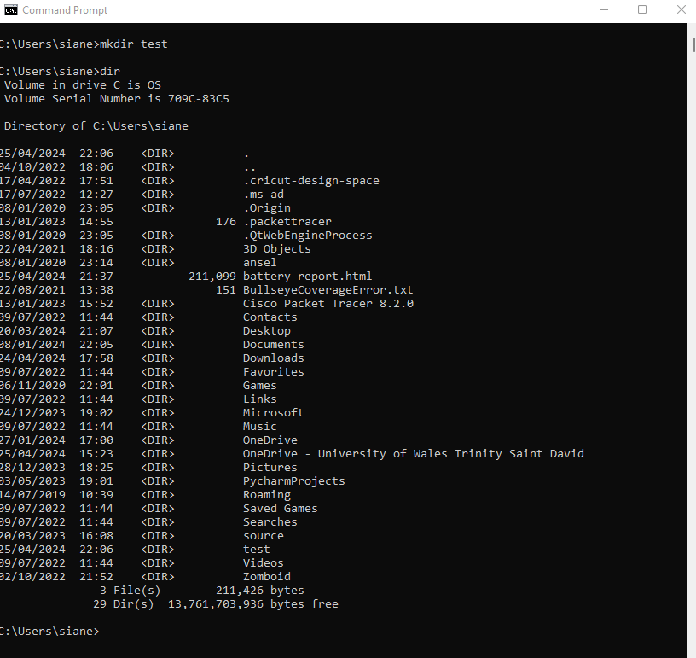
Figure 12 command notepad - opens Notepad
Figure 13 command rmdir test - delete test folder - folder no longer visible (cropped rows)
Figure 14 command mkdir test, dir - test visible (cropped middle rows to highlight test)

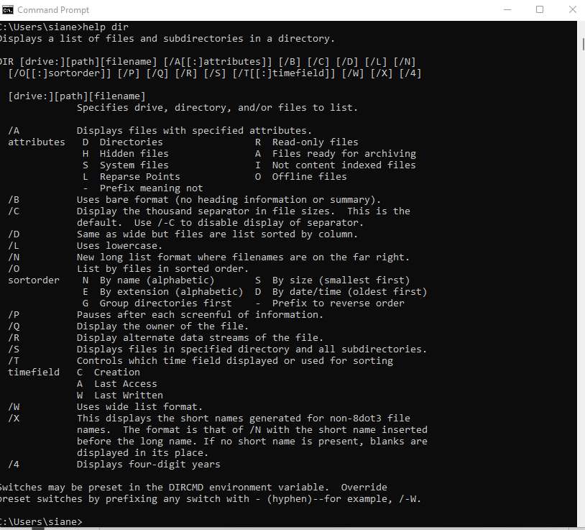
Figure 15 command help e.g. dir - shows specific about specific command
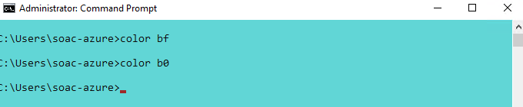
Figure 16 command - colour bf / bo (b = light aqua, 0 = black, f = white)

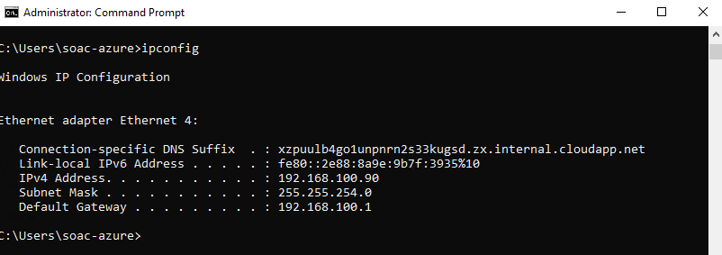
Figure 17 command - ipconfig - IP configuration IPv4 Add 192.168.100.90 (VM)
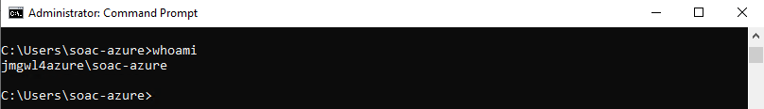
Figure 18 command - whoami - displays username.
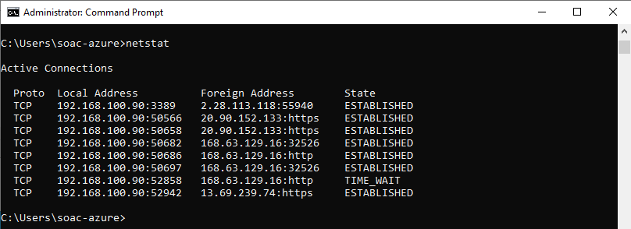
Figure 19 command - netstat - displays network info, TCP, active connections
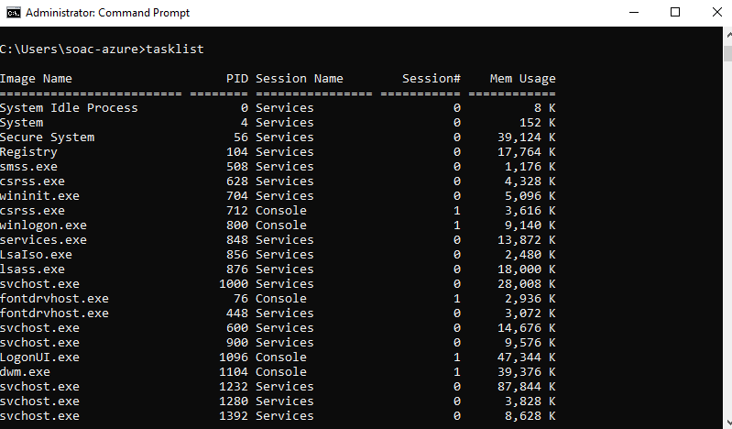
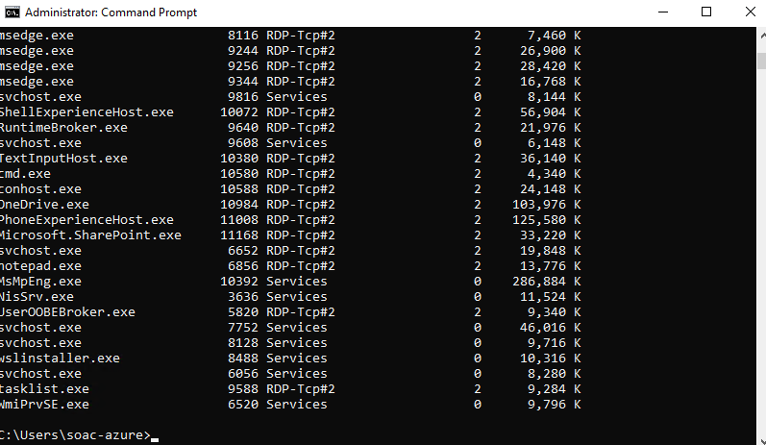
Figure 20 command - list running tasks & process ID

Task Three: Use of Linux OS CLI commands. 344
Linux was derived from UNIX systems, using a program referred to as the shell to interpret and manage commands. Christopher Negus writes [8], p. 61]
“Although the shell is less intuitive than common graphical user interfaces (GUIs), most Linux experts consider the shell to be much more powerful than GUIs. Shells have been around a long time."

Shells have advanced features which aren’t accessible via the desktop but are available when shell commands are run. This is further supported by Daniel Barrett [9], p. 21]. Bash shell is a consistently used command-line interface (CLI). Command language which provides a set of useful tools for users to manage tasks.

Negus explains [8], p. 67] some popular commands and their uses in regards:
“The pwd command shows your current working directory. Entering host name shows your computer’s hostname. The Is command lists the files and directories in your current directory.”
Below are listed the bash commands with brief descriptions, as broken down by William Shotts [10] used in bellard.org [11], also visible in following figures.
hostname –help
- pwd
  - command - print working directory.
  - super user directory or /root
- cd/
  - change directory command - go to actual /root directory.
- ls
  - list command – allows user to view subdirectories.
- cd home
  - command – enter new directory.
- mkdir testdir
- command – create a new directory.
- cd testdir
  - command – enter specific (new) directory.
- touch testfile.txt
  - command – create a new file.
- cat testfile.txt
  - read command – output text from file.
- ls -1
  - command – view all directory files and associated permissions.
- rm -r testdir
  - command – remove directory.
- history
  - Command – output previous commands.
- clear
  - Command – clear CLI.
- echo
  - Command – wrote standard output e.g. “Well done me!”
  - ‘Echo “” >testfile.txt input text into file.
- chmod
  - Command - change file and directory access permissions.
  - chmod 755 file.txt
  - octal method – permission group represented by 3 numbers (0-7).
  - User, Group, Other. 4 (r) read, 2 (w) write, 1 (x) execute. Sum for each.
  - Example: 4+2+1 = 7. 777 would grant all groups read, write & execute.
  - 755 “you” can do anything. Others cannot modify, can ready & execute.
  - Example: 4+2 =6. 644 “you” can read & write. Others cannot write & execute, can read.

chmod command
Barret describes [9],62] the command used to set file and directory access permissions, chmod - short for “change mode”. This is a way of managing user access and limiting which files are available to which users.

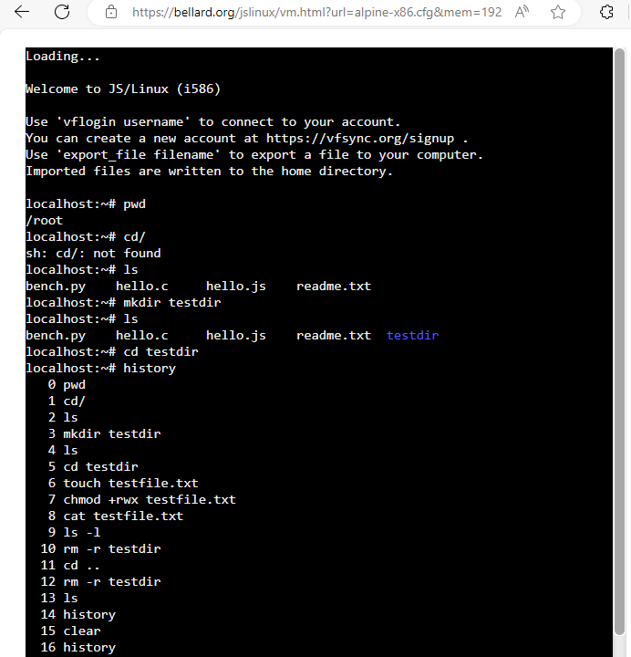
Figure 21 Linux OS CLI commands: Bash
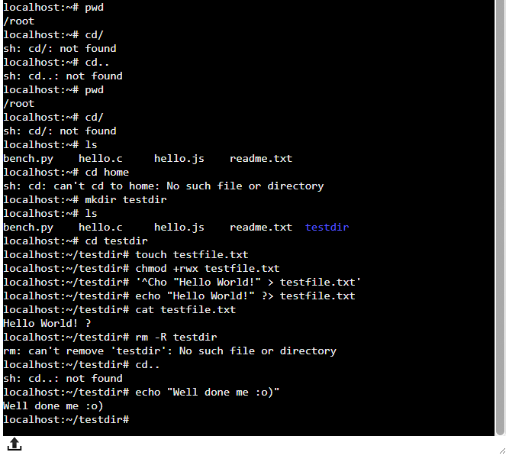
Figure 22 Bash testdir, mkdir

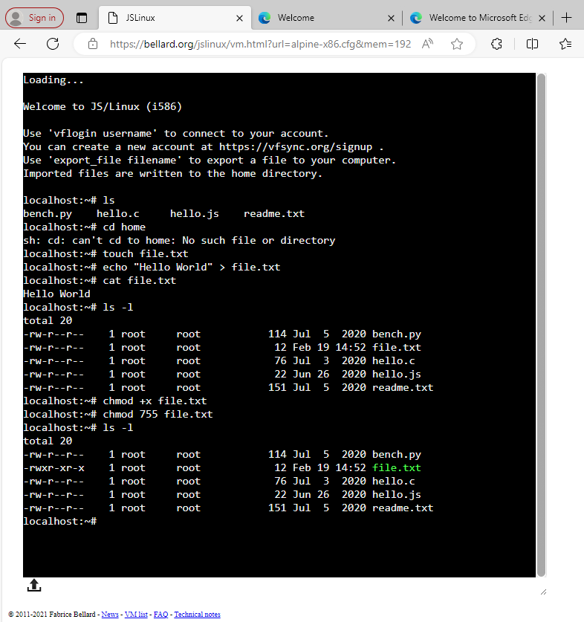
Figure 23 bash command chmod 755 file.txt
Task Four: Use of Windows OS Scripts.
The next page details the commands used as part of Bat. File – windows script, followed by screenshots of the commands being demonstrated. [12] Windows Central provides explanation.
- Basic Bat File – Chris Hoffman explains a simple batch file. [13]
  - Created in notepad++ the file needs to be saved with a .bat extension. To run the script, double click the file.
- Echo off
  - Bat code will be printed out in the prompt if echo isn’t turned off.
- Title
  - Text that appears top of prompt window
- Pause
  - To make viewing output in prompt possible. Otherwise, file automatically closes.
- ::
  - :: comments out text
- Variables
  - Created using the ‘set’ command. % required to display value of variable. Echo %name%
  - /A used to store numeric value. Set /A age=21
  - Echo command – print output variable value. Echo %age%
- Goto command (is using Batch)
  - Skip code lines. Line 3 Go to CodeJump Line 4 echo text line 5: CodeJump – ‘text’ is skipped.
- if else statement
  - computer language uses 1s and 0s. Electronic signals activate a transistor - a tiny switch.
  - Binary reflects on and off state of the transistor, 1 and 0.
  - Programming Logic uses 0 for False or 1 for True
  - If else statements used for decision making between true & farse in a certain condition
  - Used in batch scripts.
- Array – Tutorial Reference [14]
  - Set command used to assign values to array elements.
  - Starting at 0, row of elements. Some other languages may have fixed size.
  - Element can have a structure, structure has attributes. Can set user [0] first and last name.
- for Loop
  - Allow iteration until condition is met.
  - For loop variable declaration uses (%%var) two percentage symbols prefixing the variable.
  - In list of values in variable included
- Function
  - Performs specific task. Label (name) -: function_name. Body (performs purpose) – Script_code. Exit (separation from main code)- Exit /B 0
  - Call to return value. CALL: function_name value1, value2. Return values set using % and ~ %~1 to receive values.
- User Input
  - /p switch – used after set command. Asks and accept user input as input variable value.
  - Script continues if user provided value. Input can be combined with if, else, go to.
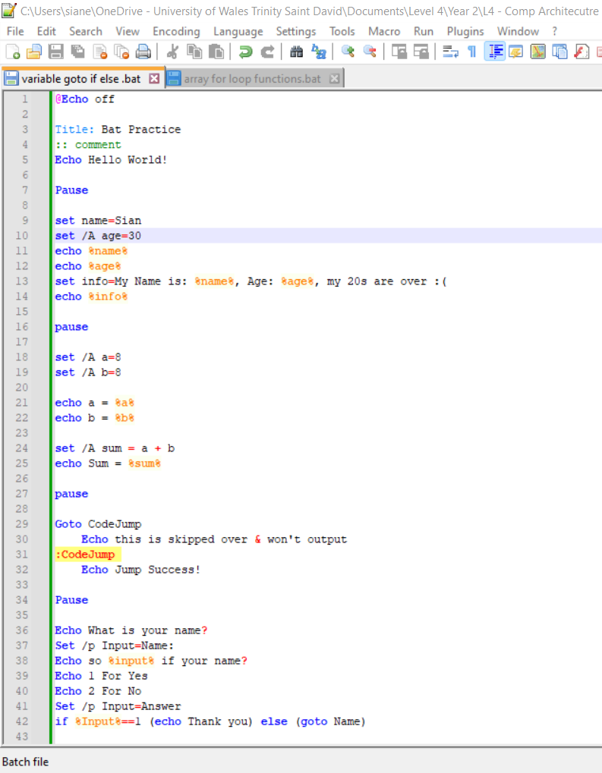
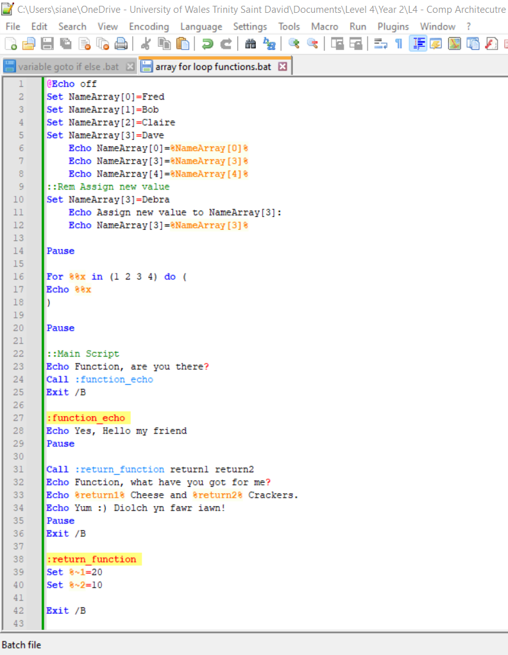
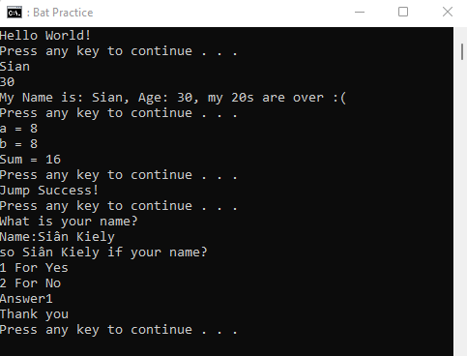
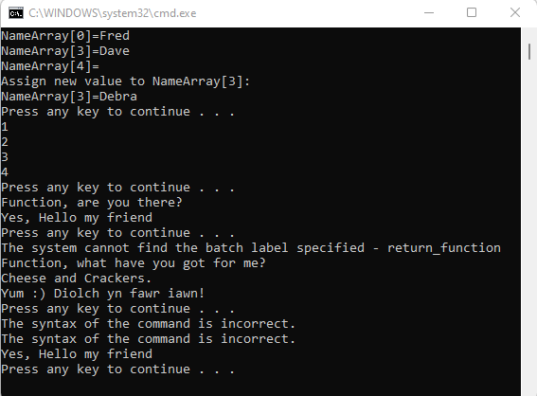
Figure 24 Bat. array, for loop, function - CMD
Figure 25 Bat. Variable, Goto, if, else, user input - CMD

Task Five: Use of Linux OS scripts.
Ellen Siever [15] breaks down some of the key bash shell commands. By creating a script, it can be used more than once. The shell acts as a ‘buffer’ between user and operating system. ‘Bourne shell’ became standard from shell script writing. /bn/sh on Linux systems.

Zaira Hira [16] explains how scripting can be used as a way to save time. You can even schedule daily tasks as there’s no need to write certain commands repeatedly, they can be saved instead.
“Shell scripting is an important part of process automation in Linux. Scripting helps you write a sequence of commands in a file and then execute them.”
Some scripts can even be executed on startup.

- Variables [15], p. 606]
  - Allows us to store and assign values.
  - Echo can be used to recall values.

- User Input
  - For example, users asked to enter username and password.
  - -p allows user to input read command on same prompt line.
- if else statement
  - Can be used to check values meet specified condition, depending on input.
  - Else adds additional potential output.
- Array [15], p 611]
  - First element number 0. No upper limit.
  - Initialized with special form of assignment.
  - Each value assigned becomes an array element and can be assigned individually.
- for Loop / until loop
  - Will continue to run until specific criteria is met, can set various conditions.
- Function
  - Self-contained block of code.
  - Echo command calls the function. Parenthesis won’t need to be used in bash.
- Case Statement
  - can be used with user input to determine output.
  - can accept more than one answer if specified, separated by pipe Yes|yes|Y|y.
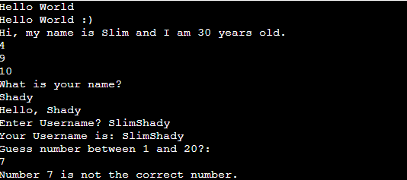
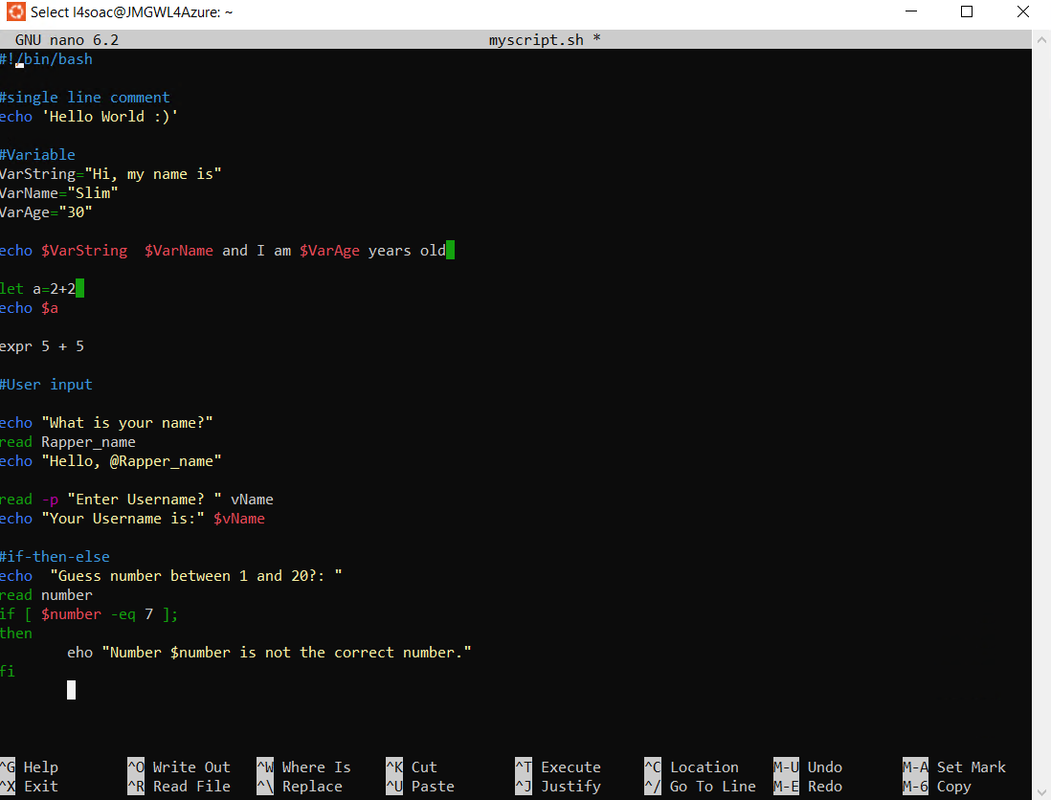
Figure 26 Bash nano variable, if-then-else
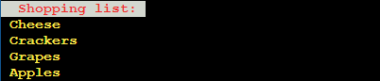
Figure 28 Bash output, variable, if then else
Figure 27 Bash for loop output: shopping list

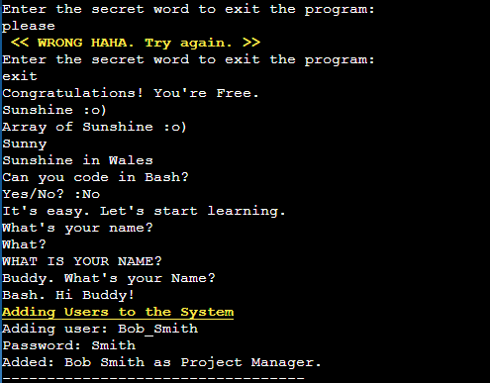
Figure 29 Bash Case Statement output -p
Figure 30 Bash Array output - Array of sunshine in Wales
Figure 31 Bash until loop output: secret word to exit program,
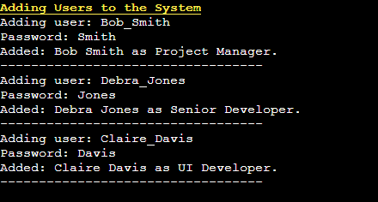
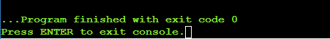
Figure 32 Bash function output new user
Figure 33 Bash Function output. Script

Conclusion
Tanenbaum and Bos elude [2],3] the importance and complexity of an operating systems.
“It should be clear now why operating systems live a long time – they are very hard to write, and having written one, the owner is loath to throw it out and start again. Instead, such systems evolve over long periods of time.”
Operating systems allow programmers to create programs which will operate on different devices with a level of confidence regarding compatibility. They also make computers easier to use for the wider public. They allow further potential as they’re able to focus on learning the tools relevant to the task they wish to perform rather than a deep understanding of the system start to finish. They are powerful and impact how well a computer performs and manages its resources. Most users will interact with an operating system through a GUI – however CLI is capable of further commands from creating folders, directories, changing user access and permissions required and a range of other abilities from monitoring to making changes. The modern world as we know it would not exist without Operating systems.

References

[1] | D. Gorgon, "Computers Before Operating Systems," 1 September 2022. [Online]. Available: https://www.youtube.com/watch?v=nCndSm9y46s&ab_channel=Dr.Gorgon. [Accessed 20 March 2024].
[2] | S. T. Andrew and H. Bos, Modern operating systems, 5th ed., Uppser Saddle River: Pearson, 2023.
[3] | H. Bruderer, Milestones in Analog and Digital Computing, Cham: Springer Nature, 2021, p. 614.
[4] | G. Wood, Edison's Eve: A Magical History of the Quest for Mechanical Life, 1st ed., New York: Alfred A. Knopf, 2002, p. xiv.
[5] | R. Love, Linux Kernel Development A thourough guide to the design and implentation of the Linux kernel, 3rd ed., Upper saddle River, NJ: Addison-Wesley, 2010.
[6] | NetworkChuck, "40 Wndows Commands you NEED to know (in 10 Minutes)," 30 September 2022. [Online]. Available: https://www.youtube.com/watch?v=Jfvg3CS1X3A&ab_channel=NetworkChuck. [Accessed 7 April 2024].
[7] | Microsoft, "Windows Commands Comand-line shells," 26 April 2023. [Online]. Available: https://learn.microsoft.com/en-us/windows-server/administration/windows-commands/windows-commands. [Accessed 15 April 2024].
[8] | C. Negus, Linux Bible, 10th ed., Indianapolis: John Wiley & Sons, 2020, p. 61.
[9] | J. B. Daniel, Linux Pocket Guide, Sebastopool: O'Reilly, 2004, p. 62.
[10] | W. Shotts, "Manual Pages Bash Builins," 6 April 2024. [Online]. Available: https://linuxcommand.org/lc3_man_page_index.php. [Accessed April 2024].
[11] | F. Bellard, "Welcome to JS/Linux (i586)," 2021. [Online]. Available: https://bellard.org/jslinux/vm.html?url=alpine-x86.cfg&mem=192. [Accessed 6 April 2024].
[12] | M. Huculak, "How to create and run a batch file on Windows 10," 5 August 2022. [Online]. Available: https://www.windowscentral.com/how-create-and-run-batch-file-windows-10. [Accessed 10 April 2024].
[13] | C. HoffmN, "How to Write a Batch Script on Windos," 6 September 2023. [Online]. Available: https://www.howtogeek.com/263177/how-to-write-a-batch-script-on-windows/. [Accessed 10 April 2024].
[14] | Tutorial Reference, "Batch Script Arrays," 2022. [Online]. Available: https://tutorialreference.com/batch-scripting/batch-script-arrays. [Accessed 10 April 2024].
[15] | S. Ellen, Linux : in a nutshell, Beijing: O'Riley, 2009.
[16] | Z. Hira, "Shell Scripting for Beginners – How to Write Bash Scripts in Linux," 31 March 2022. [Online]. Available: https://www.freecodecamp.org/news/shell-scripting-crash-course-how-to-write-bash-scripts-in-linux/. [Accessed 15 Apri 2024].
[17] | LearnFree, "Computer Basics: Understanding Operating Systems," 1 September 2020. [Online]. Available: https://www.youtube.com/watch?v=fkGCLIQx1MI&t=2s&ab_channel=LearnFree. [Accessed 11 March 2024].

Figure 1 Task Manager: Users (also discernable is the lack of memory…) 4
Figure 2 Command Prompt Taskmgr 5
Figure 3 Command Line: tasklist 6
Figure 4 Task Manager: Processes - Apps, Background processes. 7
Figure 5 Task Manager: CPU 7
Figure 6 Resource Monitor: Overview CPU 8
Figure 7 Performance Monitor: System Performance 9
Figure 8 File Explorer: File structure - University Cloud, Documents, Level 4, Year 2, L4 – Comp Architecture and Operating Systems L4 OS: OS_notes_docx. 10
Figure 9 File Explorer: File structure - Documents, University 10
Figure 10 mkdir test - create test folder. 13
Figure 11 powercfg /battery report - battery-report.html 14
Figure 12 command notepad - opens Notepad 15
Figure 13 command rmdir test - delete test folder - folder no longer visible (cropped rows) 15
Figure 14 command mkdir test, dir - test visible (cropped middle rows to highlight test) 15
Figure 15 command help e.g. dir - shows specific about specific command 16
Figure 16 command - colour bf / bo (b = light aqua, 0 = black, f = white) 16
Figure 17 command - ipconfig - IP configuration IPv4 Add 192.168.100.90 (VM) 17
Figure 18 command - whoami - displays username. 17
Figure 19 command - netstat - displays network info, TCP, active connections 17
Figure 20 command - list running tasks & process ID 18
Figure 21 Linux OS CLI commands: Bash 21
Figure 22 Bash testdir, mkdir 22
Figure 23 bash command chmod 755 file.txt 23
Figure 24 Bat. array, for loop, function - CMD 27
Figure 25 Bat. Variable, Goto, if, else, user input - CMD 27
Figure 26 Bash nano variable, if-then-else 29
Figure 28 Bash output, variable, if then else 29
Figure 27 Bash for loop output: shopping list 29
Figure 29 Bash Case Statement output -p 30
Figure 30 Bash Array output - Array of sunshine in Wales 30
Figure 31 Bash until loop output: secret word to exit program, 30
Figure 32 Bash function output new user 30
Figure 33 Bash Function output. Script 30
Figure 34: Welcome to Linux Unhatched! 38
Figure 35: Linux Virtual Machine 38
Figure 36 Linux Unhatched - Command Syntax 39
Figure 37 Linux Unhatched - aptitude -vvv moo 39
Figure 38 Linux Unhatched Working Directory 40
Figure 39 Linux Unhatched Listing Files 40
Figure 40 Linux Unhatched Administrative Access 41
Figure 41 Linux Unhatched Final Slides 41

Appendices

Tutorial Activity: on OS Types from Tutorial 1
As Explained by Learn Free [17]
“It (the computer) speaks in 1s and 0s, you can’t communicate directly with your computer, but that’s where your operating system come in… two of the most common ones are Microsoft Windows and MacOS”
Considering Linux is based on UNIX and macOS and therefore iOS are derived from Berkeley UNIX, UNIX is the most popular operating system and the focus of ‘Modern Operating Systems’. Tanenbaum and Bos explain [2],1]
“It is important to realize that smart phones and tablets (like the Apple iPad) are just computers in a smaller package with a touch screen. They all have operating systems. In fact, Apple’s iOS is fairly similar to macOS, which runs on Apple’s desktop and MacBook Systems.”
The main difference is the smaller size and touch screen functionality, otherwise not much changes about the operating system’s purpose and functionality. Mobile phones and tablets also run operating systems such as Android, these smart devices use a layer on top of what is Linux as the true operating system.
Windows has had variations. [2],3]
“Windows 95/98/Me” being different to “Windows NT/2000/XP/Vista/Windows 7/8/9/10”. With “Windows 2000/XP/Vista/Windows 7” being like their predecessor windows 98, Windows 8 was criticized as the Graphical User Interface (GUI) had a different look and feel, seeing some of these changes revered in Windows 10 and 11 in addition to other improvements.

Devices such as printers, files, email services user network to access shared resources. Especially used in organizations, more and more in the modern world as we’re in constant communication. Large data centers tend to use Linux-based Oss, even windows back up onto Linux servers and can coexist.

Additional devices include routers and switches which run on internetworking. Naturally Oss facilitates necessary functionality through software, allowing management, operation and configuration of network devices. Largely used to direct and control data traffic, connection management and hopefully smooth communication network operation.

1st Gen. OSs: Approx. 1940s to 1950s: Punch cards and Single Job Processing
2nd Gen. OSs: Approx. 1950s to 1960s: Transistors and Batch Processing
3rd Gen. OSs: Approx. 1960s – 1970s: Multiprogramming
4th Gen. OSs: Approx. 1970s – 1980s: Microprocessors & Personal Computers
5th Gen. OSs: Approx. 1980s - 2000s: Networked Computing and GUIs
6th Gen. OSs: Approx. 2000s - Present: Mobile and Cloud Computing
7th Gen. OSs: Present – Future Now: IoT & Edge Computing, AI & Quantum Computing.

Evidence of engagement with 1 online certified course

Cisco Course: Linux Unhatched
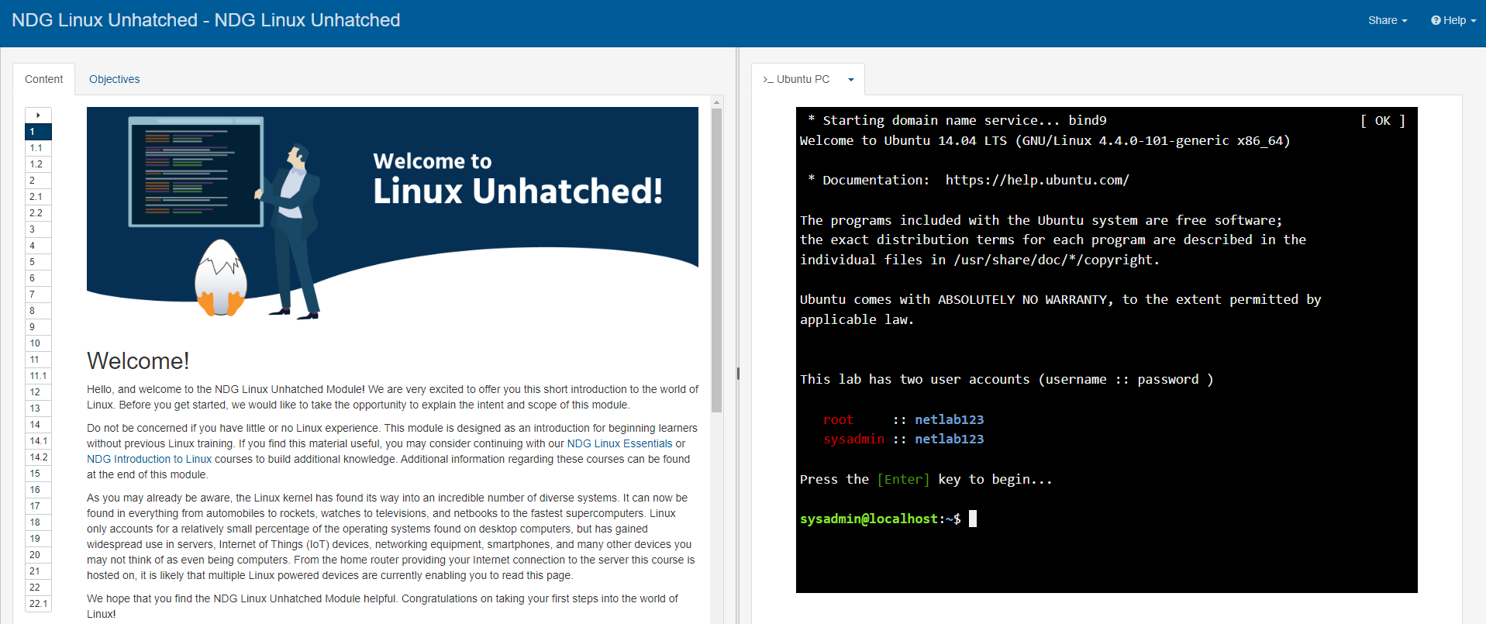
Figure 34: Welcome to Linux Unhatched!
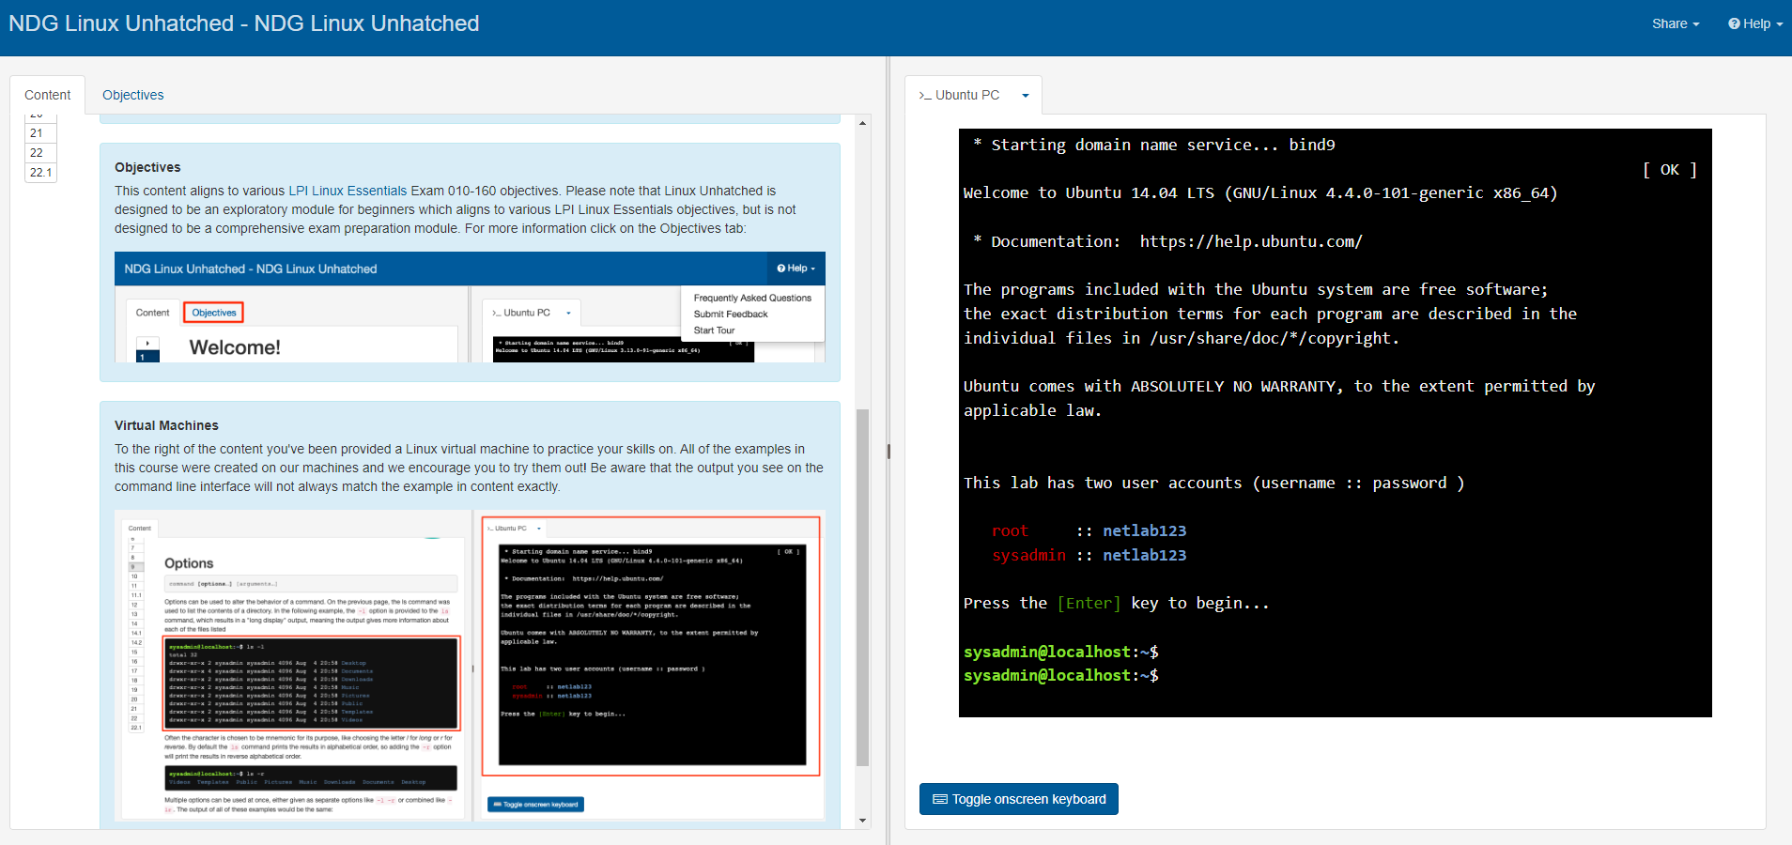
Figure 35: Linux Virtual Machine
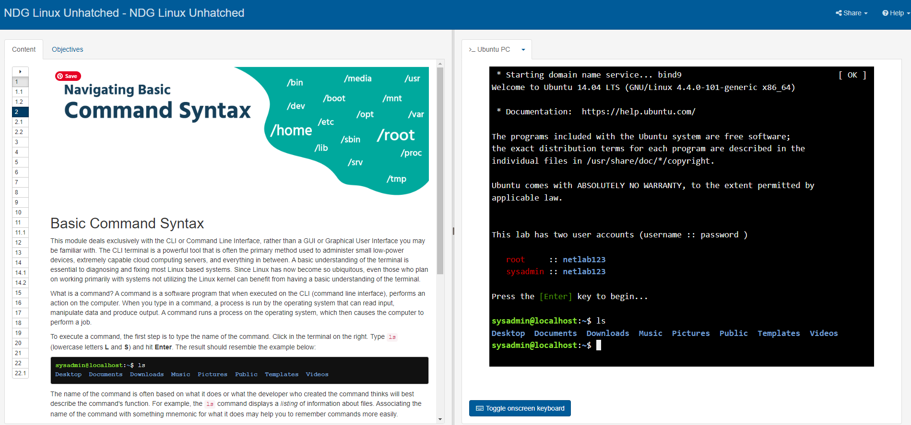
Figure 36 Linux Unhatched - Command Syntax
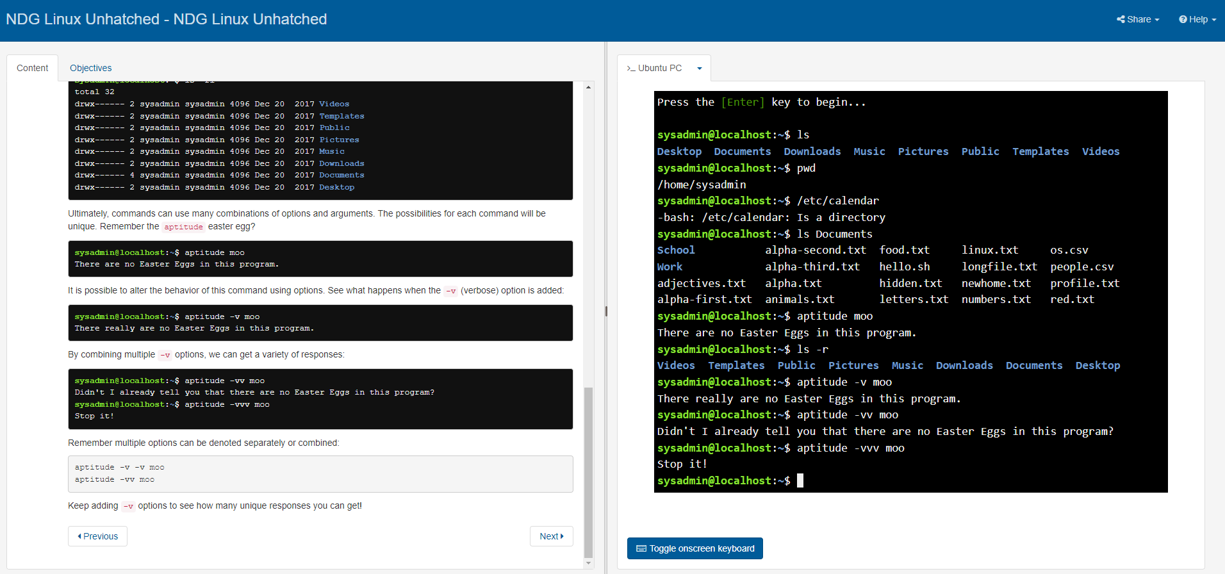
Figure 37 Linux Unhatched - aptitude -vvv moo
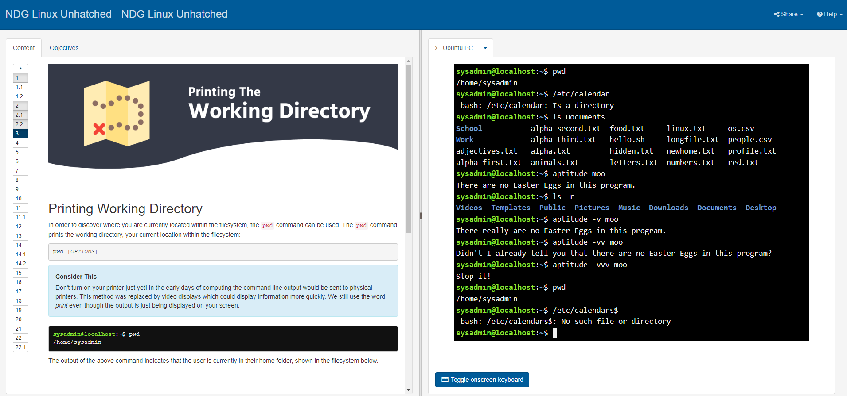
Figure 38 Linux Unhatched Working Directory
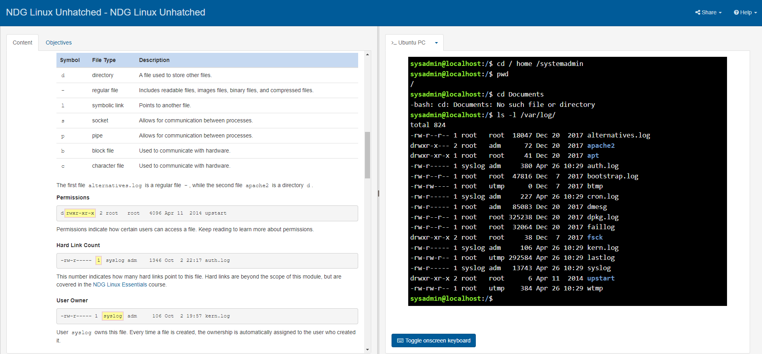
Figure 39 Linux Unhatched Listing Files
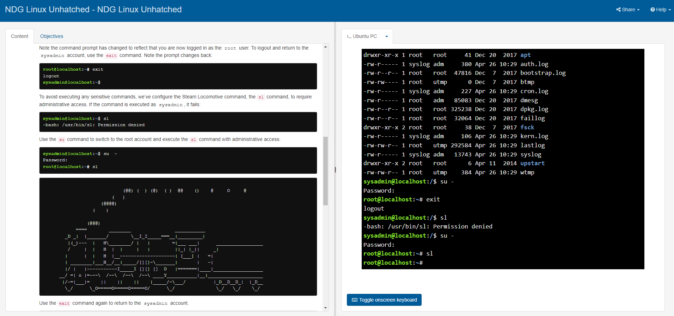
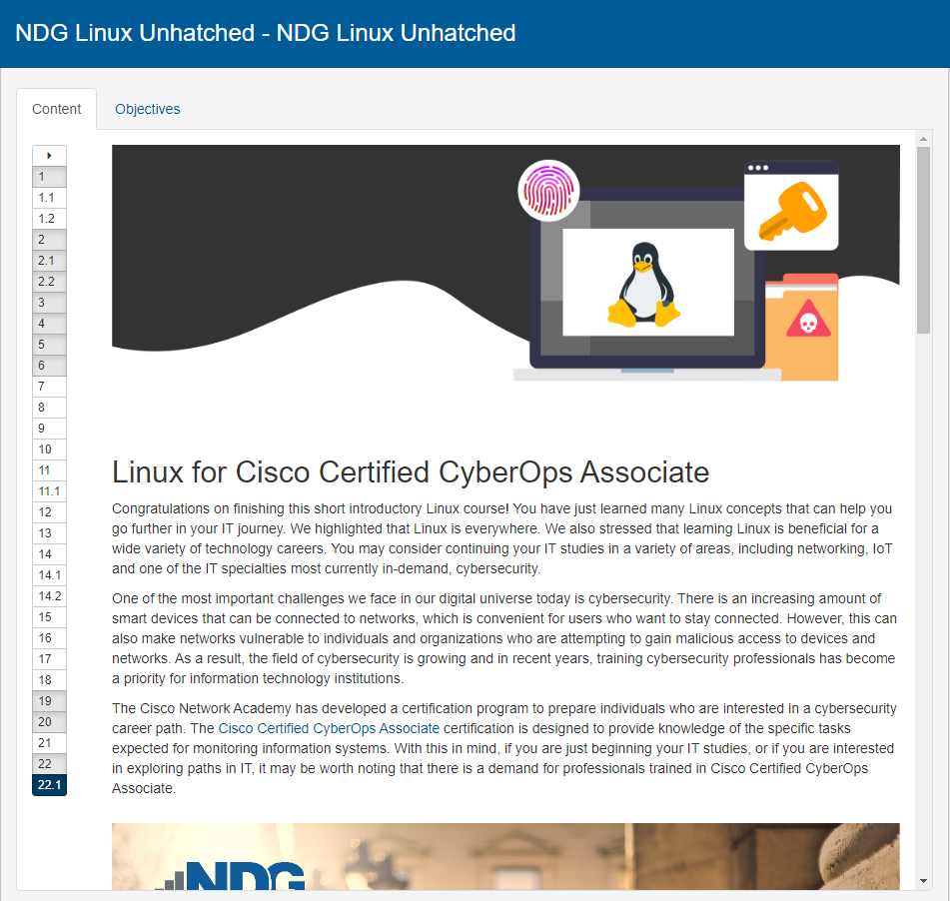
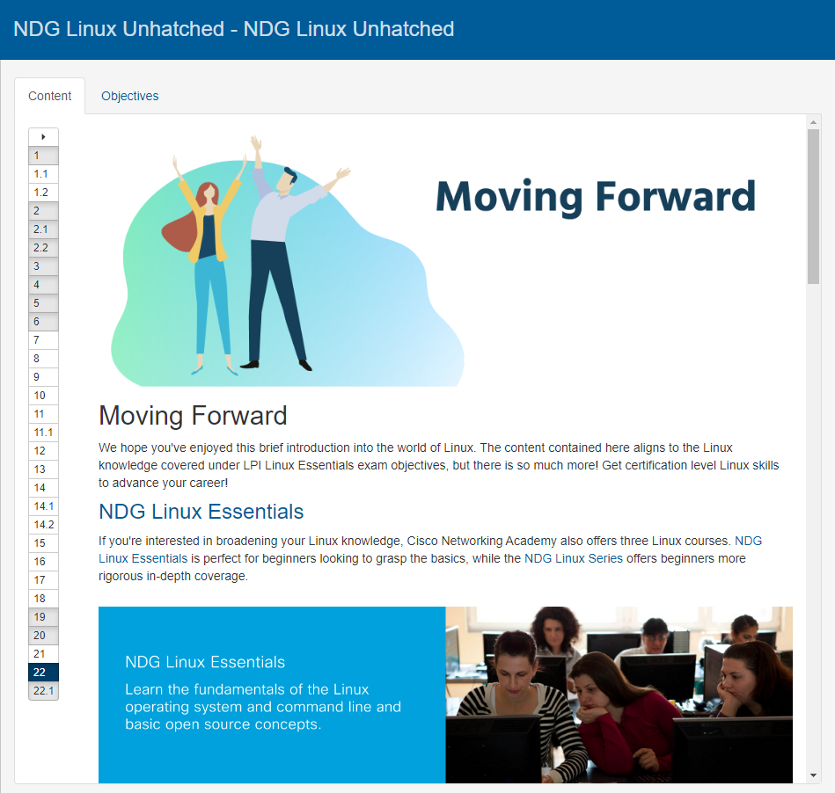
Figure 40 Linux Unhatched Administrative Access
Figure 41 Linux Unhatched Final Slides

