Accessing Core Data SQLite File

- Download & Install DB Browser for SQlite from http://sqlitebrowser.org/

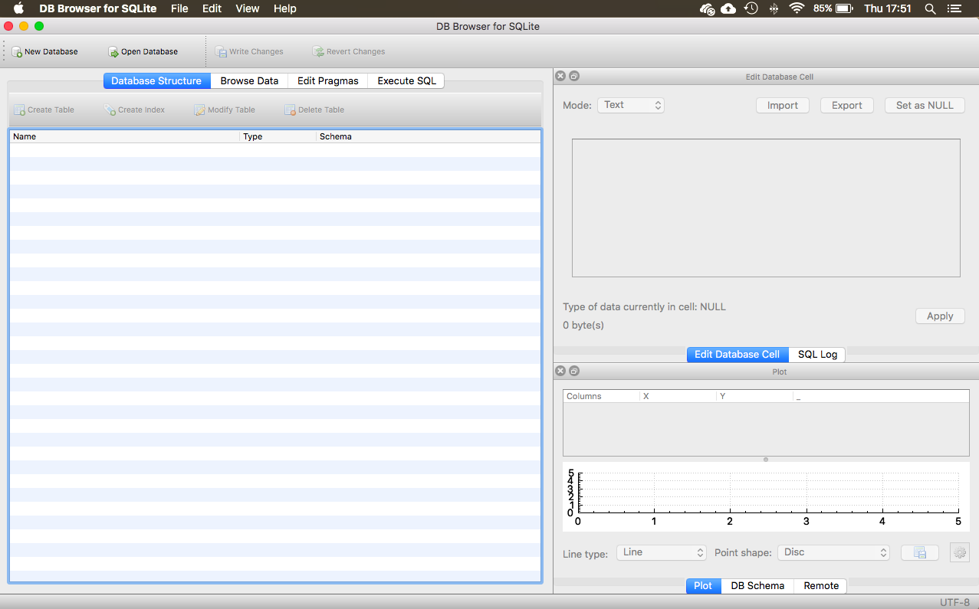

- Open terminal by searching in the spotlight search

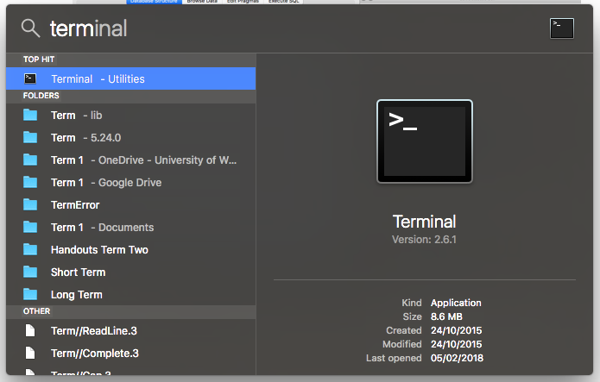

- Type in the following command line to show all hidden files. Please note that you may need to relaunch the finder for this to take effect. (Hold down option key and right click the finder icon and select ‘relaunch’.

defaults write com.apple.finder AppleShowAllFiles YES

- Then search for your Core Date SQLite file by typing in the following command in terminal. For this example. My project was named ‘Tides’ so the search is for ‘Tides.sqlite’

find ~ -name 'Tides.sqlite'

You should have a result which yields a ridiculously long file path, like this…

Peters-MacBook:~ Pet$ find ~ -name 'Tides.sqlite'
/Users/Pet/Library/Developer/CoreSimulator/Devices/9FFA788D-89D4-4696-A343-75055C2A0090/data/Containers/Data/Application/6927719A-F200-4F5D-958A-909BF9E95423/Library/Application Support/Tides.sqlite

- Navigate to this file path to your SQLite file in the finder. (Note – to get into the Library folder – right-Click and select "Open")

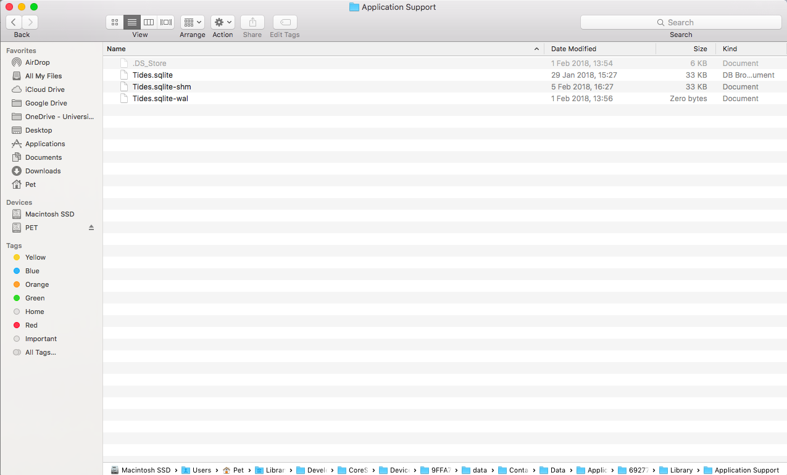
*The file path can be seen along the bottom of the finder window. (Please note that I have the file path setting turned on for this example in the finder preferences! It doesn’t show like this as default)

- If you cannot see your ‘Home’ folder (where the library file is located) in the finder window, then you need to add it in the preferences.

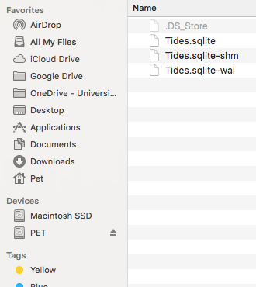

My Home folder. Where ‘Library’ folder is located. (After you show all files in step 3!)

If you don’t have this home folder in your finder, in the task bar for the application go to finder > preferences and click on the sidebar tab, then select the home folder. See image below. You should now be able to see your ‘home’ folder in the finder sidebar. From here you can navigate to your Core Data SQLite file!

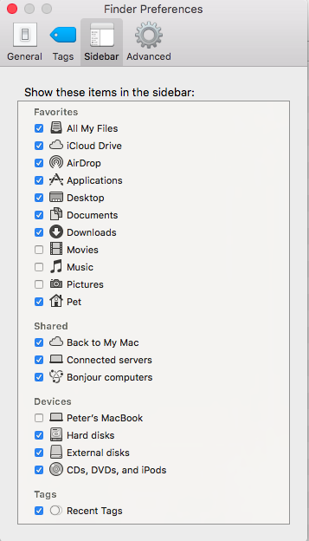
My Home folder. Where ‘Library’ folder is located. (After you show all files in step 3!)

Select your home folder.

- To open your Core Data file, right click the file and select ‘open with’ and find DB Browser for SQLite.

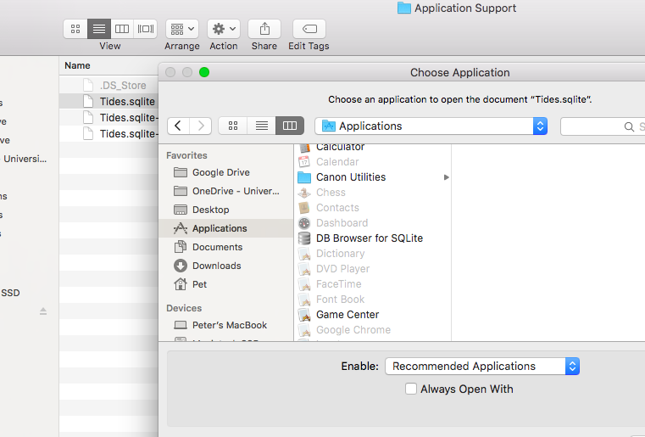

To save time in the future, select the box which says, ‘Always open with’, this means that any SQLite file will automatically be opened with DB Browser.

If you don’t see this box, right click on the file and select ‘get info’ and scroll down to the ‘open-with’ section, expand the box and select DB Browser as the default program.
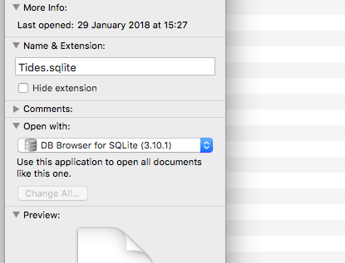

- When you open your Core Data SQLite file, you should see all your data (if you have entered any). From here you can add, amend or delete data just as you would in a database.

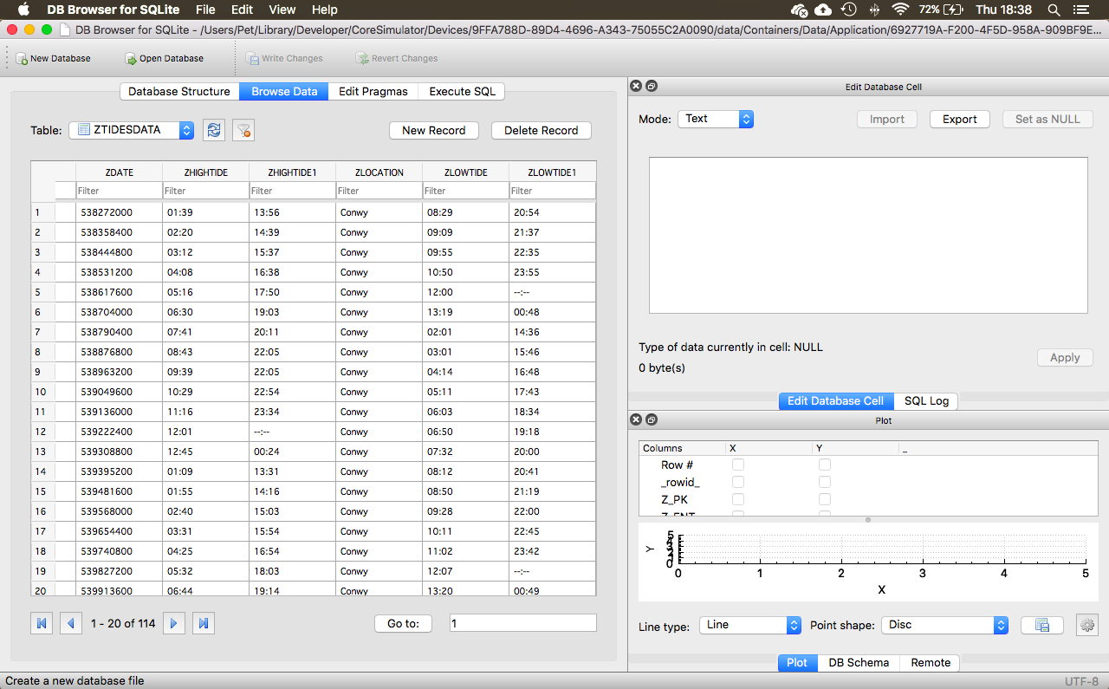

- After making changes to your file, make sure you save it by selecting file > write changes.



