STUDENT NAME: RIFNA BEGUM

STUDENT ID: 1713342

LECTURER NAME: DUSHIKA SOUNDARARAJAN

MODULE NAME & CODE: MENTAL DISORDERS & PSYCHOPATHOLOGY BMHP6006

COMPONENT 1

Table of Contents
Did the UK support and include individuals with mental disorders during the 20th century? 3
Introduction 3
Mental Disorders 3
Historical Context of the Mental Health Provision in the UK 4
Changes Took Place in the UK Legislation 5
Inclusion and Exclusion 6
Recommendations 7
Conclusion 7
References 8

Did the UK support and include individuals with mental disorders during the 20th century?

Introduction
Mental health issues were prevalent in the United Kingdom. And the individuals suffering with these issues required more support. In the UK one in four individuals were diagnosed with mental health disorder every year and one in ten adolescent or children required support in terms of treatment for their conditions due to mental health issues (Lea, 2014). Lea (2014), also identified that the government should require to set out its commitment in means to establish standards for physical and mental health care, which do not exist in the UK. This supportive paper will aim to define the mental health disorders in the UK, historical context of mental health provision and changes in the mental health legislation, inclusion and exclusion in the mental health legislations and also give recommendations for future improvement.

Mental Disorders
The international classification of disease -10 (ICD-10) endorsed by the World Health Organisation (WHO, 2021) in the early 1990’s, adopted by many countries throughout the world gives a clinical description of metal disorder to be a set of recognisable symptoms and behaviours associated with cases of distress and interference of personal functions. Mental disorders have a substantial impact on society and UK the economy. Telles-Correia, et al., (2018), stated that mental health disorders are or refer to as the clinically substantial psychological or behavioural pattern or syndrome which take place in an individual and is usually related with distress or disability in one or more vital areas of functioning. Different types of mental disorders are prevalent in the UK which affect the positive thinking, mood, feeling and behaviour of people and affect their ability to deal with others in society and function properly. Mental disorders such as anxiety, depression, mood disorder, bipolar disorder, dementia, phobias and panic disorders have affected millions of the UK population. Anxiety and depression being the most common mental health disorder of the UK’s population that must experience by themselves during their lifespan. These two mental health disorder affect 7.8% people in the UK (Mental Health Foundation, 2019). According to Jia, et al., (2020), increase mental disorder prevalence was evident in the younger people across the UK which impact their ability to function properly and also leads to physical health issues among them. These mental health disorders not only affect adults but also increase burden by affecting large number of children and adolescents.
Historical context of the Mental Health provision in the UK
According to Turner, et al., (2015), historical context of the provision of the mental health services in the UK needs a conscious withdrawal from the historiographical development of ideas of the 19th and 20th century, that have focused on the legal developments in this area that influencing the social, cultural, institutional and clinical context of the delivery of services for the treatment of people with mental disorders. Prior to the 20th century there were a small number of public institutions that provided mental health services, the Lunacy Act 1890 was passed in the end of nineteenth century which set out a legal system for the provision of mental health services to mentally ill patients in Asylums. This led to various ethical issues regarding means to provide services (York, 2009). Before the passage of the Mental Deficiency Act 1913, the treatment of patient with mental illness in relation to their physical and mental health was not satisfactory. It was the first legislation by the British Parliament which supported by all the parties with the aim to create institutional changes in the delivery of services for mentally ill people. Mental Deficiency Act 1913, particularly related to the provision of services for individual with learning disabilities and also performed a role on the provision of mental health care for those individuals who were feeble minded and insane (The British Psychological Society, 2020). Ministry of the Mental Health Act 1919 was established with the intention to secure the health of the people in the UK regarding the treatment of physical and mental disorders (Gov.UK, 2021). Social psychotherapy centre was established in 1946 in the mean to better counter the mental needs of patients and provide effective care to them. It recognised that the psychotherapy profession but not gain popularity because of the gaps with the public, medicine and credibility issues.

In 1949, Mental Health Foundation was established with aim to support people with mental illness through understanding, securing and sustaining their mental health. The Mental Health Act 1959, which was implemented on the recommendations of Percy Commission 1957 was to improve the status of mental health delivery to patient with mental illness. This Act improved the mental health provision by eliminating the difference between the psychiatric care and other hospitals, ensured that patient with mental illness also benefited from social services and general health facilities, along with the promotion of equality between physical and mental health. According to Hilton (2007), the Mental Health Act 1959 created change in the provision of mental care to patient but the consent to treatment was not discussed in the Act lead to negative perception that mentally ill people were cared against their will. During the 1950s to 1960s number of drugs were introduced to properly treat psychiatric disorders to ensure effective provision of mental health care services (Haddad, et al., 2016). In 1971, the UK Government issued white paper on hospital services for mentally ill, adopted by general hospital leads to the abolition of system of separate psychiatric hospital for mental health provision (Killaspy, 2006). This paper had defined the concept of effective care and gave guidance to authorities which led to improvement in the care of mentally handicapped people. According to Mills and Phull (2017), it is a vital piece of legislation of the 20th century that positively contribute to the promotion of mental health care as this legislation clearly focused on the treatment, assessment and rights of individuals living with mental illness. These are some historical developments in the background of improving provision of mental health across the UK.

Changes in the UK legislation
Changes that have taken place in the various mental health legislation in the UK caused improvement in the healthcare delivery and reduce the negative influences of mental health outcomes on patient, healthcare system and society. Major reforms in the UK mental health legislation will empower individuals to have effective control over their care, which based on an important manifesto commitment. Reforms in different mental health legilsaitons provide support to patient and their choices were being respected and better support should be provided to them in a least restrictive manner. In the Mental Health Act 1959 the only limitation which had changed in the Mental Health Act 1983 was related to the consent of patient for their treatment (Hilton, 2007). Instead of this change there was no other known changes that occurred in this Act. The move to community based mental health services in the UK had unexpectedly caused rise in the number of patient being detained in hospitals every year and in specific inexorable increase in involuntary admissions was indicated to some improvement through changes in legislation. According to Keown, et al., (2018), some changes in Part II (civil) sections of the Mental Health Act 1983 were made due to increase in rate of detention in the 1980s which had doubled since the 1960s. Main changes to the 1983 Act also related to five new guiding principles; new sections on human rights, health inequalities and care planning; more guidance regarding the ways to give support to young people and children with mental disabilities; and substantially updated sections on accurate use of restrictive interventions, police powers and safety places (Department of Health and Social Care, 2015). Changes also made in the Mental Health Act 2007 for Wales and England in order to meet the need to demonstrate that it was effective, workable and ethical when implemented on subject for delivery of care. Changes made in the section that allow professionals who were not registered medical practitioner to give the clinical report needed to renew orders for detention (Zigmond, 2008). The Mental Capacity Act 2005 also amended in the 2019 in order to reform the procedure under it for permitting arrangements that allow the treatment of individual who does not have ability to consent to arrangement that give increase to a distress of their liberty (Gov.UK, 2021). Daw (2014), stated that the Mental Health Act 2007 was amended during the parliamentary procedure and focus on some problem that raised due to this act. These are some changes that performed during the mid of 20th century till date in order to improve mental health provision across the UK.
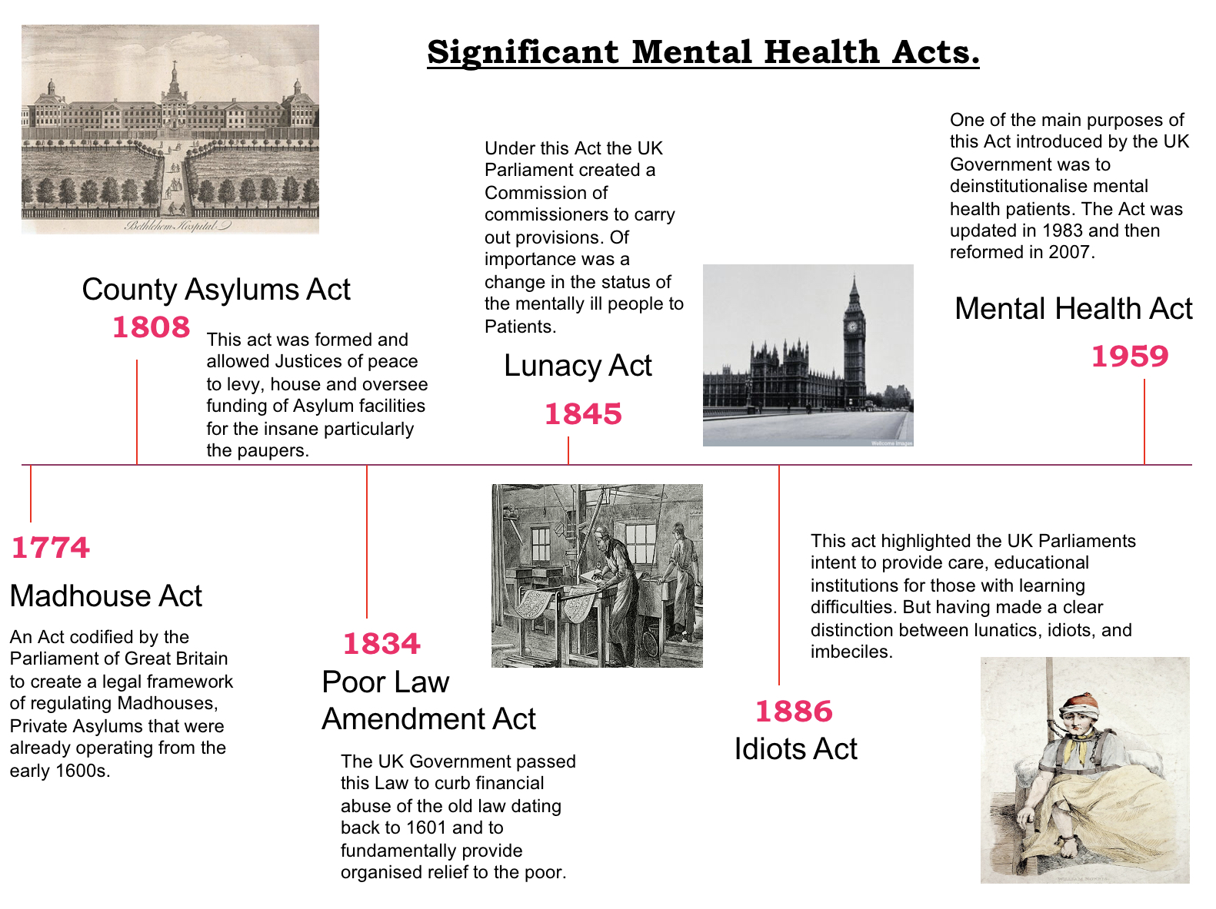
(Source: Roberts, A. 2021)
Inclusion and Exclusion
This section define some examples of the exclusion and inclusion from the mental health legislation in the UK. The first example of exclusion related to the 1983 Act, which excluded people from being dealt with under the Act because of immoral conduct, promiscuity, sexual deviancy and dependence on substance abuse. The amended 2007 replace the exclusion only because of dependence on drugs or alcohol (Lawton-Smith, 2008). According to Maciel, et al., (2019), exclusion should occur due to the pressure of legislation and the justification of individuals towards their actions by appealing to non-discriminatory criteria. The amended Act also exclude those individual who have learning disability, whether the disability is related with seriously irresponsible conduct or abnormally aggressiveness. Another example of exclusion from the 1983 Act is related to the power of social workers who were not professionals to detain individual in hospitals and get essential medical agreement but the Mental Health Act 2007 has renamed the role as approved mental health professionals and opened this function to broader group of professionals (Lawton-Smith, 2008). According to Lawton-Smith (2008), the Mental Health Act 2007 has amend the Mental Capacity Act 2005 and the Mental Health Act 2003 and introduce the new guiding principles related to statutory requirements. It include various matter such as respect for patient’s diversity, reduced constraints on liberty, public safety and treatment effectiveness. Another example of inclusion is related to the inclusion of inform consent in the Mental Health Act 1983 which was missed out in the Mental Health Act 1959 (Hilton, 2007). This inclusion was to ensure patient treatment according to their will along with their respect and satisfaction. Third example of inclusion is related to the accurate treatment with mental health services that had to be available for individuals placed under supervised community treatment. The purpose of this inclusion is to prevent deterioration which was not addressed in the 1983 Act. These are some presented examples of inclusion and exclusion from the legislations related to mental health in the UK.

Recommendations
In this section some recommendations are provided for future improvements in this context. It is recommended to regularly amend the legislations after assessing the needs of population with such disorders, this should lead to significant improvements and reduce the challenges. According to Albert (2015), the formal and persistent amendment rules is a vital procedure for the perfection of apparent imperfection in the written legislation according to the requirements. It is also recommend to introduce advance choices in the legislative documents which help individuals to set out their wishes related to treatment and future care that would have more significance than they do in current legislation. Also it’s recommended to design a shared care plan with the patients to reduce the issue of enforced implementation of care that adversely effect on the mental and physical health of the population. In the end it is recommended to completely review the legislation for further improvement this is the first step for development and advancing in legislation (Mind.Org, 2021). To think over the prevailing approach, emphasis on improving the infrastructure paying attention to the care framework and providing necessary adequate funding. These recommendations are useful and necessary for the future in mental health care and its legislations which ultimately reduce challenges and issues in providing detail complex care.

Conclusion
Mental disorders have affective influences on the activities of daily living for those people suffering. Anxiety and depression are common mental disorder among people in the UK. The Mental Deficiency Act 1913, Mental Health Act 1959, white paper 1971 issued by UK Government on hospital services for mentally ill and the Mental health foundation are some historical improvement in the 20th century for the provision of mental health across the UK. Changes for improvement in mental health legislation had been occurred in the Mental Health Act 1983, Mental Health Act 2007 and Mental Capacity Act 2005.

References

Albert, R., (2015). The expressive function of constitutional amendment rules. Journal of Constitutional Investigations, 2(1), pp. 7-64.

Daw, R., (2014). The Mental Health Act 2007 – The Defeat of an Ideal. International Journal of Mental Health and Capacity Law, 1(16), pp. 131-132.

Department of Health and Social Care, (2015). Changes to Mental Health Act (1983) Code of Practice, London : Department of Health and Social Care.

Gov.UK, (2021). Mental Capacity (Amendment) Act 2019. [Online]
Available at: https://www.legislation.gov.uk/ukpga/2019/18/notes/division/2/index.htm#top
[Accessed 25 February 2021].

Gov.UK, (2021). Ministry of Health Act 1919. [Online]
Available at: https://www.legislation.gov.uk/ukpga/Geo5/9-10/21/enacted
[Accessed 26 February 2021].

Haddad, P., Kirk, R. & Green, R., (2016). Chlorpromazine, the first antipsychotic medication: history, controversy and legacy, Cambridge : British Association of Psychopharmacology..
Hilton, C., 2007. Changes between the 1959 and 1983 Mental Health Acts (England & Wales), with particular reference to consent to treatment for electroconvulsive therapy.. History of psychiatry, 18(2), pp. 217-229.

Jia, R. et al., (2020). Mental health in the UK during the COVID-19 pandemic: Cross-sectional analyses from a community cohort study.. BMJ Open, 10(9), pp. 40-42.

Keown, P., Murphy, H., McKenna, D. & McKinnon, I., (2018). Changes in the use of the Mental Health Act 1983 in England 1984/85 to 2015/16.. The British Journal of Psychiatry, 213(4), pp. 595-599.

Killaspy, H., (2006). From the asylum to community care: learning from experience.. British Medical Bulletin,, 79(1), pp. 245-258.

Lawton-Smith, S., (2008). Mental Health Act 2007, London: The King’s Fund.
Lea, W., 2014. Achieving Better Access to Mental Health Services by 2020, London: Department of Health .

Maciel, S. C. et al., (2019). Social Exclusion of People Who Suffer from Mental Disorders: A Proposal for an Explanatory Model. Paidéia, 29(1), pp. 1-12.

Mental Health Foundation, (2019). Mental health statistics: The most common mental health problems. [Online]
Available at: https://www.mentalhealth.org.uk/statistics/mental-health-statistics-most-common-mental-health-problems#:~:text=Mixed%20anxiety%20%26%20depression%20is%20the,people%20meeting%20criteria%20for%20diagnosis.&text=4%2D10%25%20of%20people%20in,experience%20depr
[Accessed 25 February 2021].

Roberts, A. ( 2021). Mental Health History Timelines. [Online] Available at:
http://studymore.org.uk/mhhtim.htm
[ Accessed: 25th February 2021].

Mills, J. & Phull, J., (2017). The Mental Health Act 1983. Sage Journal , 1(1), pp. 1-12.
Mind.Org, (2021). Mental Health Act Review. [Online]
Available at: https://www.mind.org.uk/about-us/our-policy-work/mental-health-act-review/
[Accessed 25 February 2021].

Telles-Correia, D., Saraiva, S. & Gonçalves, J., (2018). Mental disorder—the need for an accurate definition. Frontiers in psychiatry, 9(64), pp. 1-10.

The British Psychological Society, (2020). Looking Back: Mental deficiency – changing the outlook. [Online]
Available at: https://thepsychologist.bps.org.uk/volume-21/edition-11/looking-back-mental-deficiency-changing-outlook
[Accessed 25 Febraury 2021].

Turner, J. et al., (2015). The history of mental health services in modern England: Practitioner memories and the direction of future research.. Medical History, 59(4), pp. 599-624.

World Health Organisation (2021). International Statistical Classification of Diseases and Related Health Problems (ICD). [Online] Available at:
https://www.who.int/standards/classifications/classification-of-diseases
[Accessed: 25th February 2021].

York, S. H., (2009). Suicide, Lunancy and the Asylum in the Nineteenth Century England , Birmingham: The University of Birmingham.

Zigmond, T., (2008). Changing mental health legislation in the UK.. Advances in Psychiatric Treatment, 14(2), pp. 81-83.

