Harvard Referencing - Practice Activity 1
This activity is designed to help you practice your referencing skills.
On the pages that follow there are 20 reputable sources from either books, journals, or websites.

You must first decide if the source you are looking at is a book, journal article, or a web site in order to look for the correct information.
Using your new knowledge of referencing, along with your ‘Grab Sheet’ and your ‘Referencing Diagrams’ (both available on the Harvard Referencing tile), please provide the 2 citation for each source, and the full correctly formatted reference for each source in the spaces provided.
The images of the webpages all contain hyperlinks – this means you can click on the link and look around the webpage to search for the information you need (You may need to right click and select ‘open link’ – also accept any blocked pop-ups).
When referencing journal articles, keep in mind that they sometimes do not include a page number – or in some instances a volume – or in some cases an issue!
When referencing webpages – Keep in mind - your accessed on dates will not be the same as mine!
When you are finished, ensure you check your answers against the ones provided.
The first question has been done for you as an example…

Good luck!

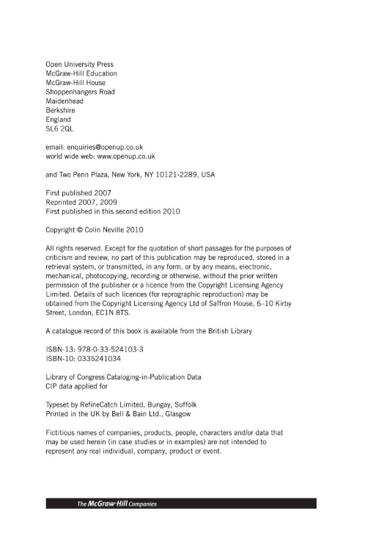

Citation : (Neville, 2010) or Neville (2010)
Reference : Neville, C. (2010) The Complete Guide to Referencing and Avoiding Plagiarism. 2nd edn. Maidenhead: Open University Press.
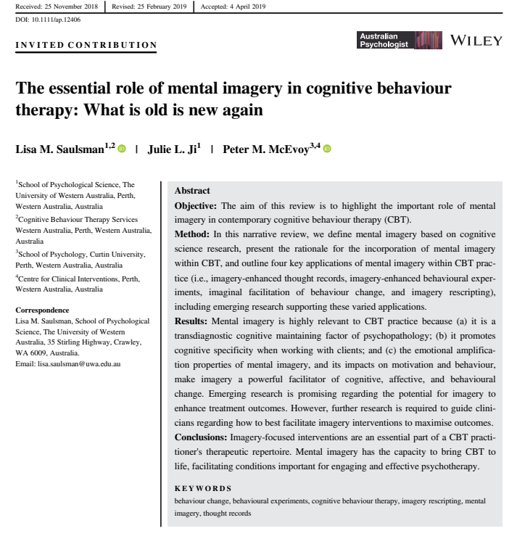
Citation : (Saulsman, Ji and McEvoy, 2019) or Saulsman, Ji and McEvoy (2019)
Reference : Saulsman, L. M., Ji, J. L. and McEvoy, P. M. (2019) ‘The essential role of mental imagery in cognitive behaviour therapy: What is old is new again’, Australian Psychologist.

Citation : (Westgate et al, 2017) or Westgate et al (2017)
Reference : Westgate, E. C., Wormington, S. V., Oleson, K. C. and Lindgren, K. P. (2017) ‘Productive procrastination: academic procrastination style predicts academic and alcohol outcomes’, Journal of Applied Social Psychology, 47, pp. 124 – 135.

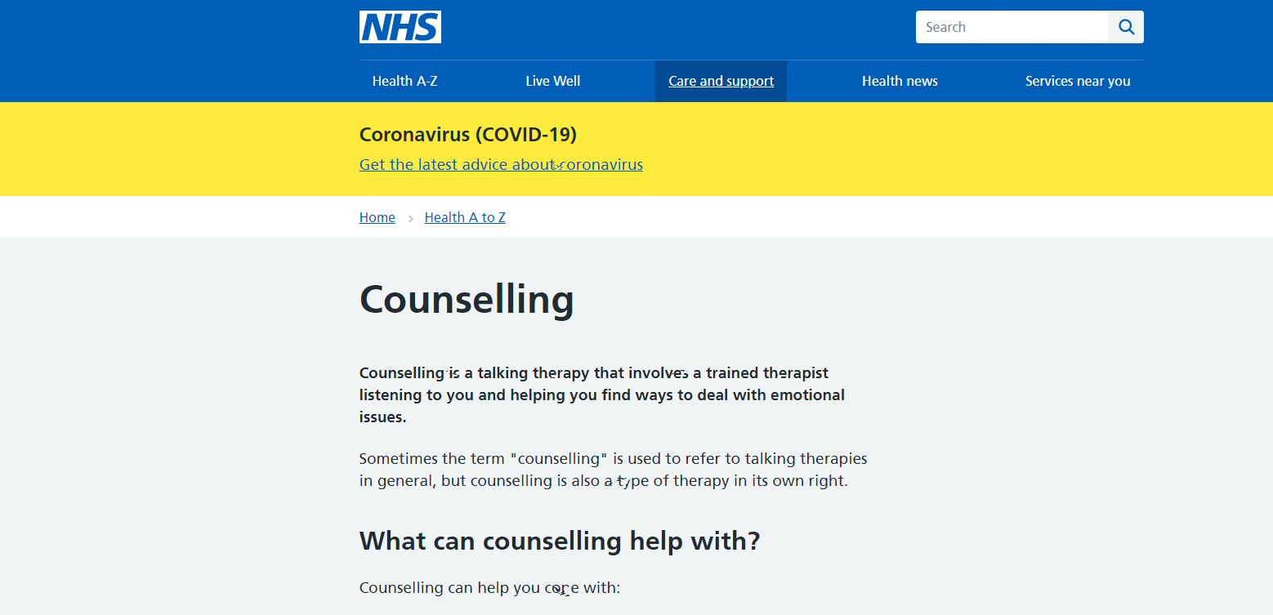

Citation : (National Health Service, 2020) or National Health Service (2020)
Reference : National Health Service (2020) Counselling. Available at: https://www.nhs.uk/mental-health/talking-therapies-medicine-treatments/talking-therapies-and-counselling/counselling/ (Accessed on 16th October 2022).
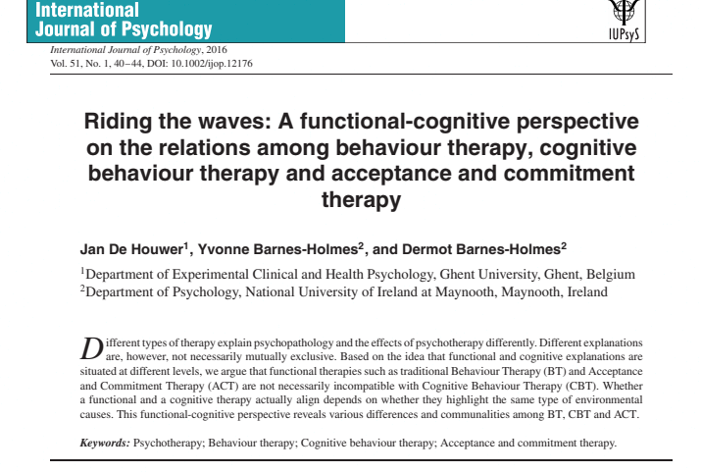

Citation : (De Houwer, Barnes-Holmes and Barnes-Holmes, 2016) or De Houwer, Barnes-Holmes and Barnes-Holmes (2016)
Reference : De Houwer, J., Barnes-Holmes, Y. and Barnes-Holmes, D. (2016) ‘Riding the waves: A functional-cognitive perspective on the relations among behaviour therapy, cognitive behaviour therapy and acceptance and commitment therapy’, International Journal of Psychology, 51(1), pp. 40 – 44.
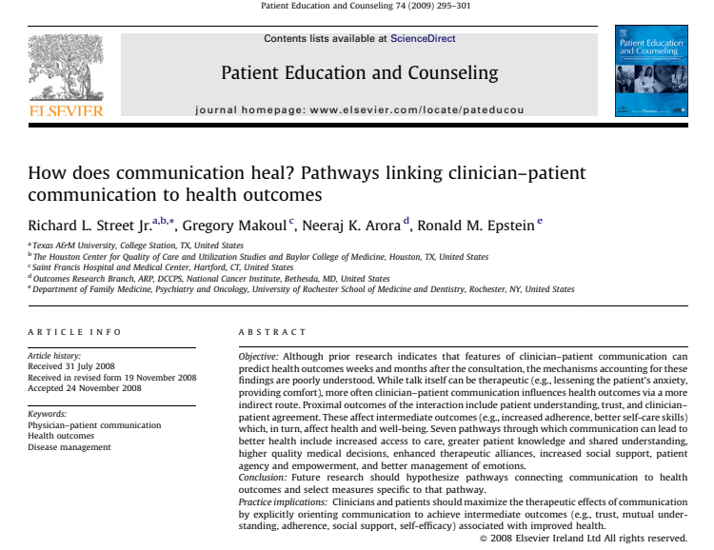

Citation : (Street Jr et al, 2009) or Street Jr et al (2009)
Reference : Street Jr, R. L., Makoul, G., Arora, N. K. and Epstein, R. M. (2009) ‘How does communication heal? Pathways linking clinician-patient communication to health outcomes’, Patient Education and Counselling, 74, pp. 295-301.

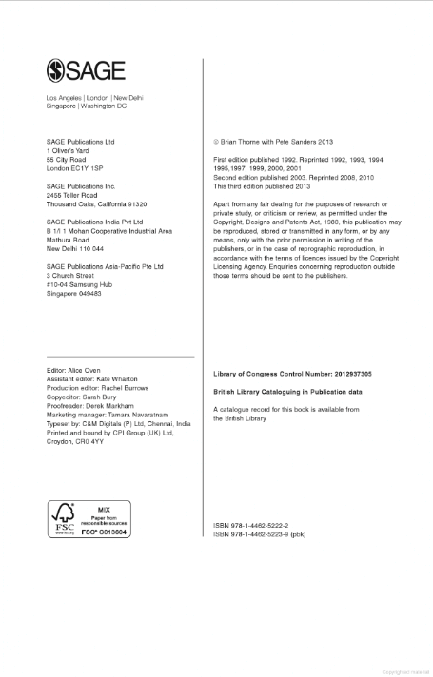

Citation : (Thorne and Sanders, 2013) or Thorne and Sanders (2013)
Reference : Thorne, B. and Sanders, P. (2013) Carl Rogers. 3rd edn. London: Sage.
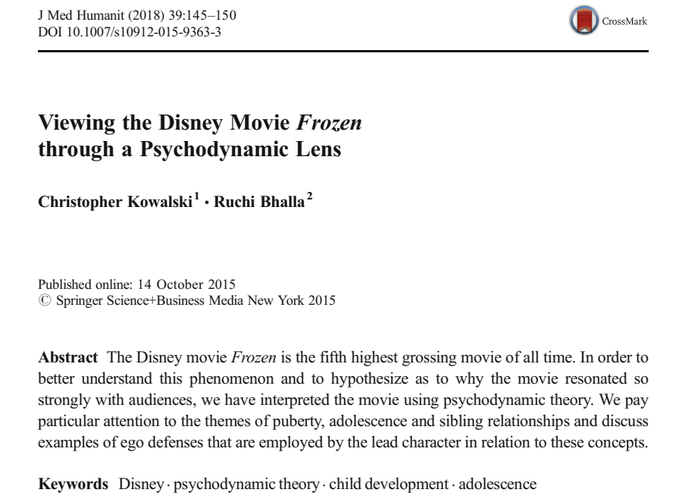

Citation : (Kowalski and Bhalla, 2018) or Kowalski and Bhalla (2018)
Reference : Kowalski, C. and Bhalla, R. (2018) ‘ Viewing the Disney movie Frozen through a psychodynamic lens’, Journal of Medical Humanity, 39, pp. 145-150.

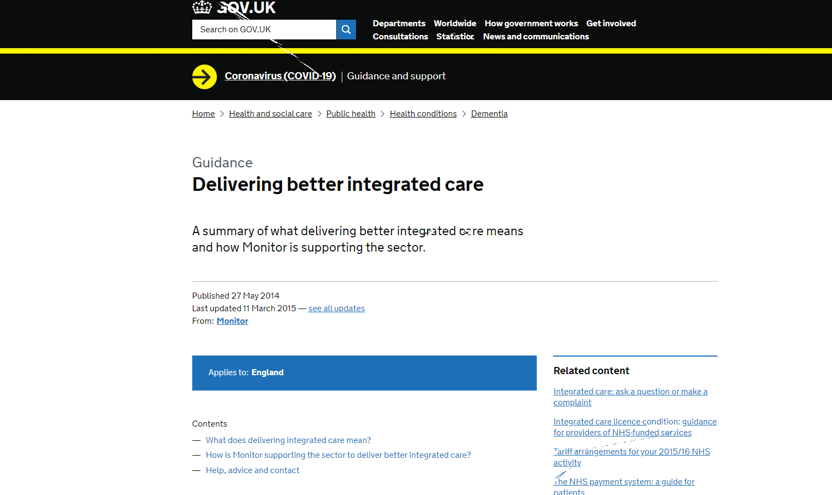

Citation : (UK Government, 2015) or UK Government (2015)
Reference : UK Government (2015) Delivering Better Integrated Care. Available at: https://www.gov.uk/guidance/enabling-integrated-care-in-the-nhs (Accessed on 11th October 2022).
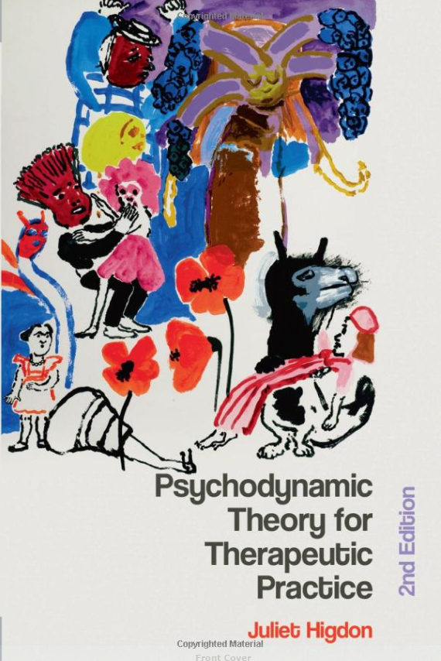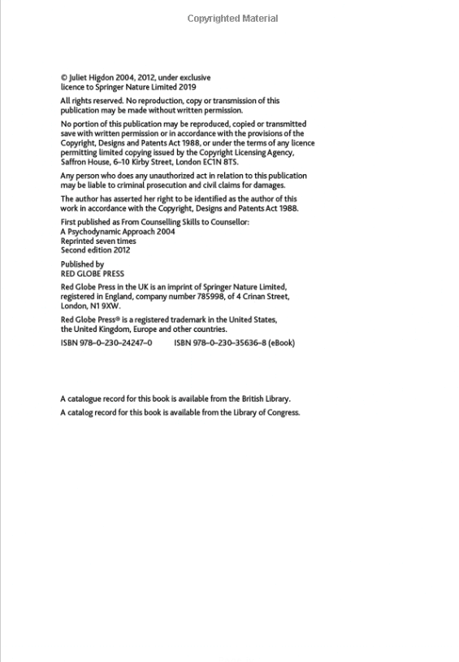

Citation : (Higdon, 2019) or Higdon (2019)
Reference : Higdon, J. (2019) Psychodynamic Theory for Therapeutic Practice. 2nd edn. London: Red Globe Press.
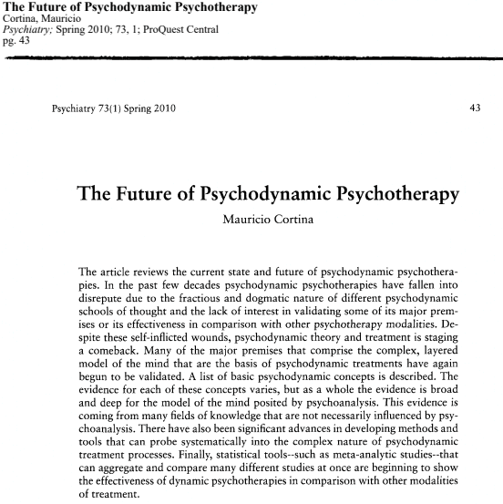
Citation : (Cortina, 2010) or Cortina (2010)
Reference : Cortina, M. (2010) ‘The future of psychodynamic psychotherapy’, Psychiatry, 73(1), pp. 43.

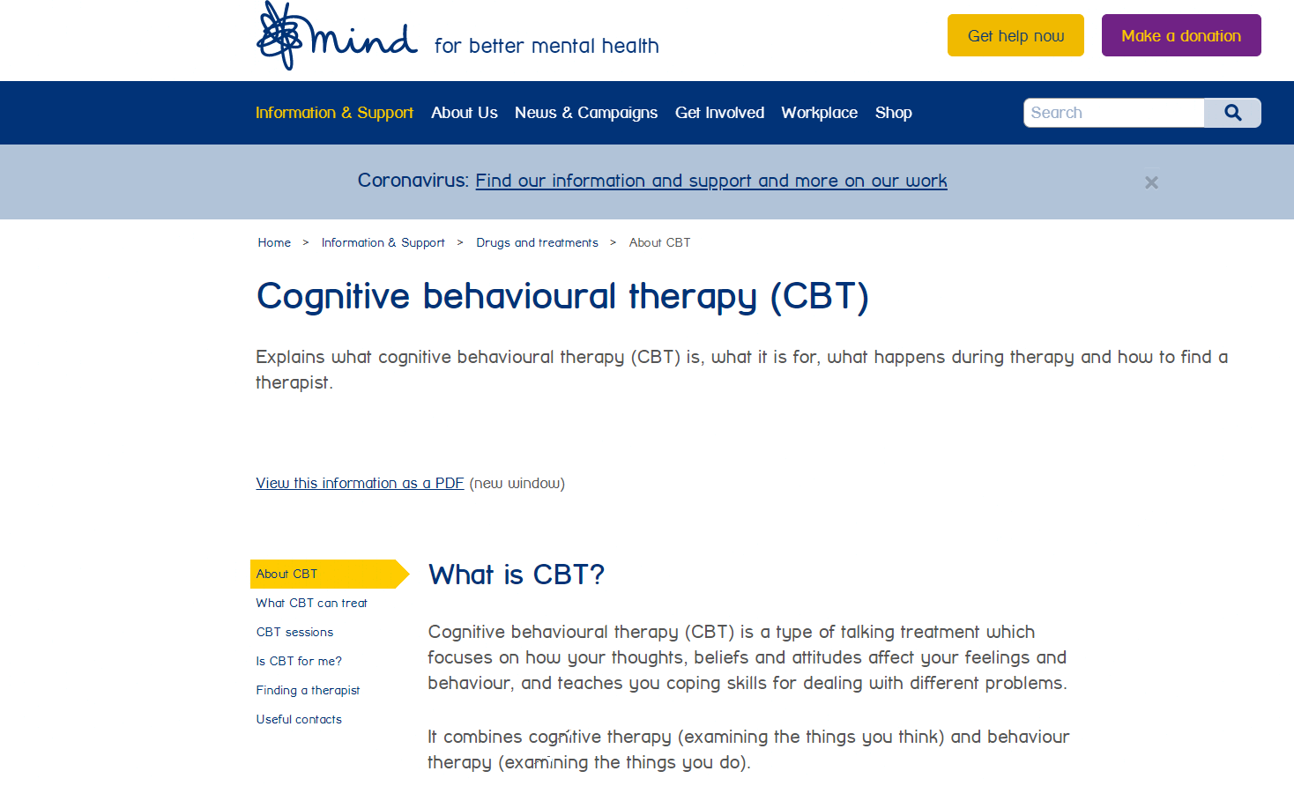
Citation : (Mind, 2021) or Mind (2021)
Reference : Mind (2021) Cognitive Behaviour Therapy (CBT). Available at: https://www.mind.org.uk/information-support/drugs-and-treatments/talking-therapy-and-counselling/cognitive-behavioural-therapy-cbt/#WhatAreCBTSessionsLike (Accessed on 12th October 2022).
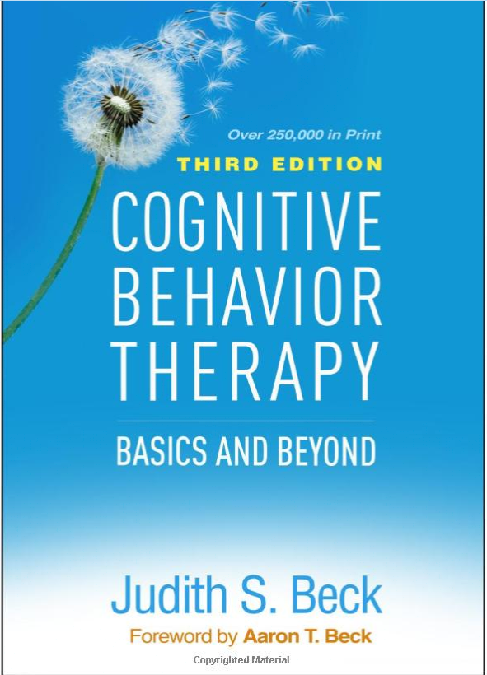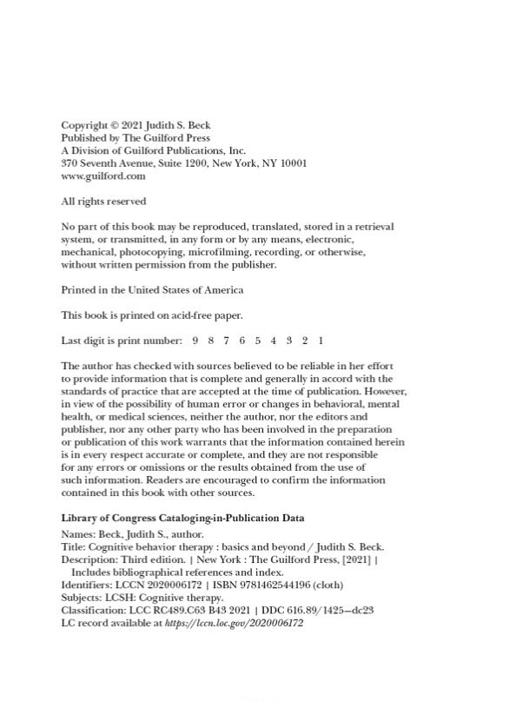
Citation : (Beck, 2021) or Beck (2021)
Reference : Beck, J. S. (2021) Cognitive Behaviour Therapy: Basics and Beyond. 3rd edn. New York: The Guilford Press.
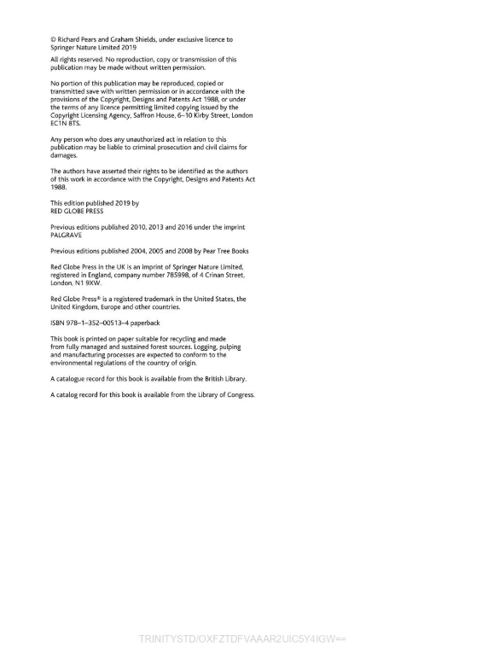
Citation : (Pears and Shields, 2019) or Pears and Shields (2019)
Reference : Pears, R. and Shields, G. (2019) Cite Them Right: The essential referencing guide. 11th edn. London: Red Globe Press.

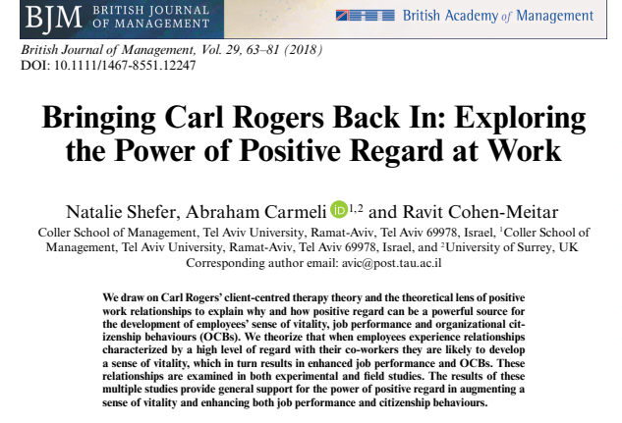

Citation : (Shefer, Carmeli and Cohen-Meitar, 2018) or Shefer, Carmeli and Cohen-Meitar (2018)
Reference : Shefer, N., Carmeli, A. and Cohen-Meitar, R. (2018) ‘Bringing Carl Rogers back in: Exploring the Power of positive regard at work’, British Journal of Management, 29, pp. 63-81.
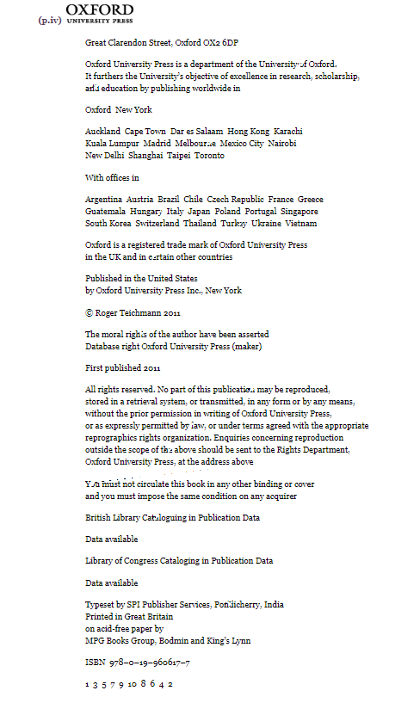
Citation : (Teichman, 2011) or Teichman (2011)
Reference : Teichman, R. (2011) Nature, Reason & the Good Life: Ethics for Human Beings. Oxford: Oxford University Press.

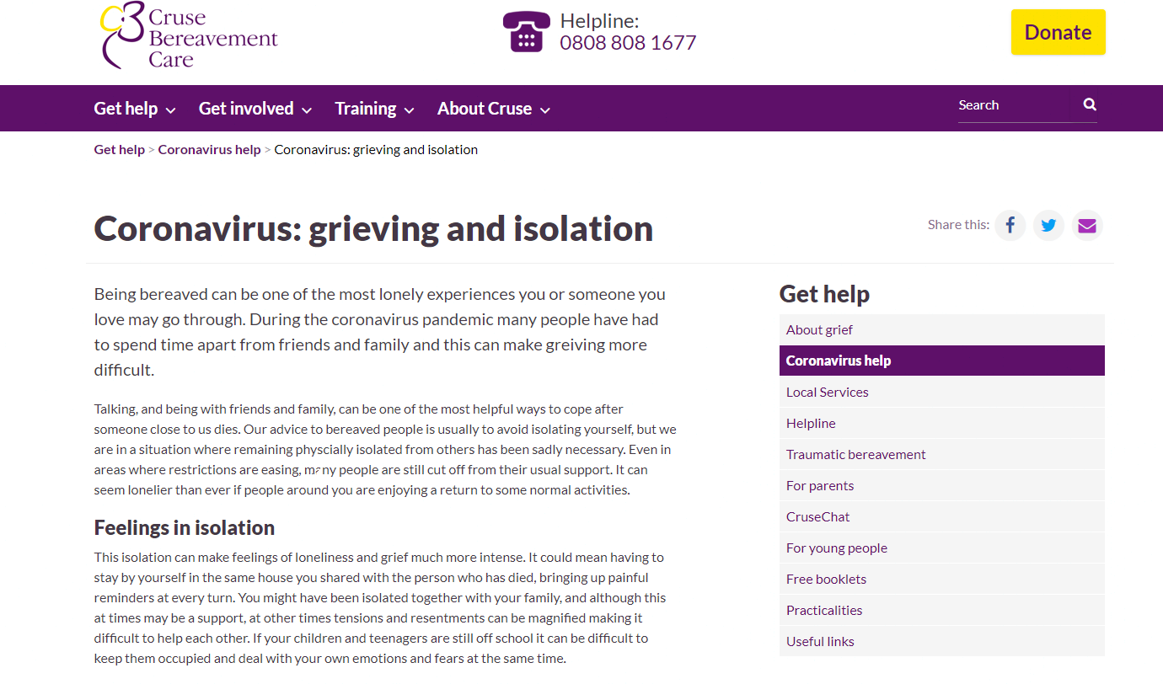

Citation : (Cruse, 2022) or Cruse (2022)
Reference : Cruse (2022) Coronavirus: Grieving and isolation. Available at: https://www.cruse.org.uk/understanding-grief/grief-experiences/traumatic-loss/coronavirus-bereavement-and-grief/ (Accessed on 8th October 2022).
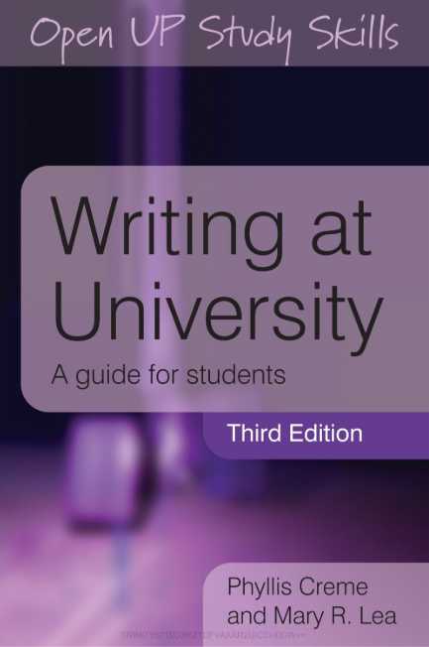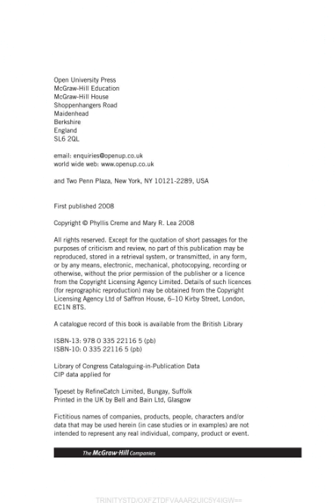

Citation : (Crème and Lea, 2008) or Crème and Lea (2008)
Reference : Crème, P. and Lea, M. R. (2008) Writing at University: A guide for students. 3rd edn. Berkshire: Open University Press.

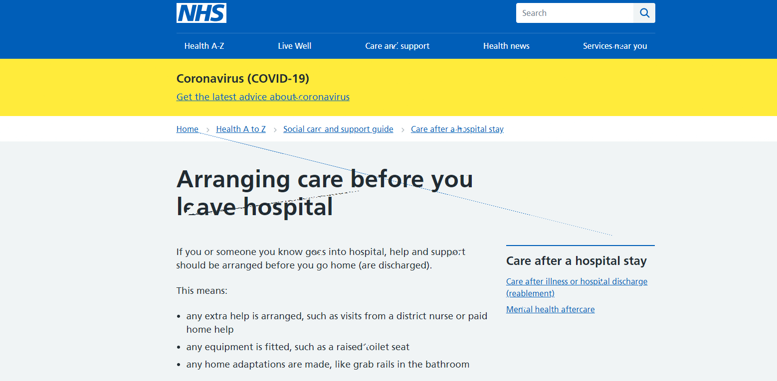

Citation : (National Health Service, 2021) or National Health Service (2021)
Reference : National Health Service (2021) Arranging Care Before you Leave Hospital. Available at: https://www.nhs.uk/conditions/social-care-and-support-guide/care-after-a-hospital-stay/arranging-care-before-you-leave-hospital/ (Accessed on 15th October 2022).
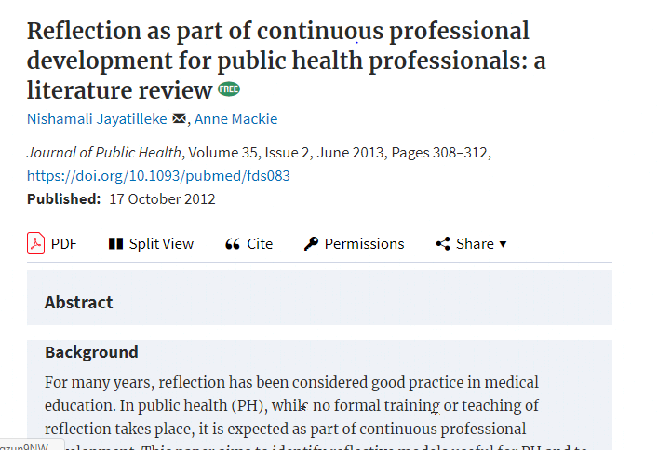

Citation : (Jayatilleke and Mackie, 2013) or Jayatilleke and Mackie (2013)
Reference : Jayatilleke, N. and Mackie, A. (2013) ‘Reflection as part of continuous professional development for public health professionals: a literature review’, Journal of Public Health, 35(2), pp. 308-312.

