BMSW5106
Knowledge and Information Management Skills for the Workplace

Student Name: Marina K. Ivanova
Student ID: 2128092
Module code: BMSW5106
Module Name: Knowledge and Information Management Skills for the Workplace
Module Lecturer: Essa Bah
Table of Contents
Introduction 1
An Overview of the Chosen Organization: Amazon and Emirates 2
Overview of Amazon 2
Overview of Emirates 3
Main Organizational Activities Summary 3
TWOS Analysis of Amazon’s and Emirates’s Knowledge Management 4
TOWS Analysis: Amazon's Knowledge Management System 4
TOWS Analysis: Emirates' Knowledge Management System 6
Amazon vs. Emirates' Knowledge Management 8
Critical Evaluation of Knowledge Management System 10
Assessing Amazon's Knowledge Management System 10
Assessing Emirates Knowledge Management System 11
Compare Analysis of Knowledge Management Systems 13
Recommendations 15
Recommendation for Amazon 15
Recommendations for Emirates 16
Conclusion 17
References 18

List of Tables
Table 1: TOWS Analysis of Amazon's Knowledge Management System. 4
Table 2: TOWS Analysis of Emirates' Knowledge Management System. 6
Table 3: Similarities and Contrasts Between Amazon and Emirates. 8

List of Figures
Figure 1: Amazon's E-Commerce Market Share. 2
Figure 2: Africa-Asia Pacific Market Share by Airline. 3
Figure 3: Knowledge Management Value Chain at Amazon. 10
Figure 4: Knowledge Management Value Chain at Emirates. 12
Figure 5: Recommendations for Amazon. 15
Figure 6: Recommendations for Emirates. 16

Introduction
In today's rapidly evolving business world, information is the most valuable strategic asset that can be possessed. Companies are realizing that to maintain their competitive edge, they must effectively manage and utilize their information (Abell, 2008). To identify areas in which Amazon and Emirates could enhance their knowledge management techniques, this report investigates such strategies. Two companies are highlighted in this report: the e-commerce giant Amazon and the international airline major Emirates. Amazon and Emirates were selected for this report because they represent different industries, offering insights into how knowledge management adapts to diverse business strategies. As well-regarded specialists in their respective industries, they provide helpful recommendations for adopting knowledge management. Their different approaches underscore the varied nature of effective knowledge management solutions. There is a need for robust knowledge management systems in each of these enterprises, even though their operations are very different from one another. The strengths of Amazon in the areas of product development, customer service, data analytics, and shipping are vital to the company's success. Emirates can effectively manage its diverse personnel and facilitate the smooth operation of its global network. This report presents a comprehensive comparison of the knowledge management systems utilized by Amazon and Emirates. Identifying internal and external knowledge management elements will be accomplished through the utilization of TOWS analysis by the organization (Maier, 2010). After that, there will be a comprehensive examination of the knowledge management value chain, information technology systems, and deployment strategies of each organization. The comparison of these elements will allow the research to determine the strengths, weaknesses, and opportunities for improvement of respective knowledge management systems. The findings of the research indicate that the report will provide comprehensive recommendations to each company to enhance and safeguard its knowledge management procedures.

An Overview of the Chosen Organization: Amazon and Emirates

Overview of Amazon
The varied business strategy of Amazon encompasses a variety of services, including online retail, cloud services, streaming services like Prime Video, and artificial intelligence technology like Alexa (Amazon.com, 2024). For the most part, it is an online marketplace that brings together buyers and sellers of a variety of items. Amazon can provide cloud computing and manufacture smart speakers thanks to its expertise in technology. By the year 2023, Amazon will have become the most successful online retailer and marketplace, with a market capitalization of more than one trillion dollars.
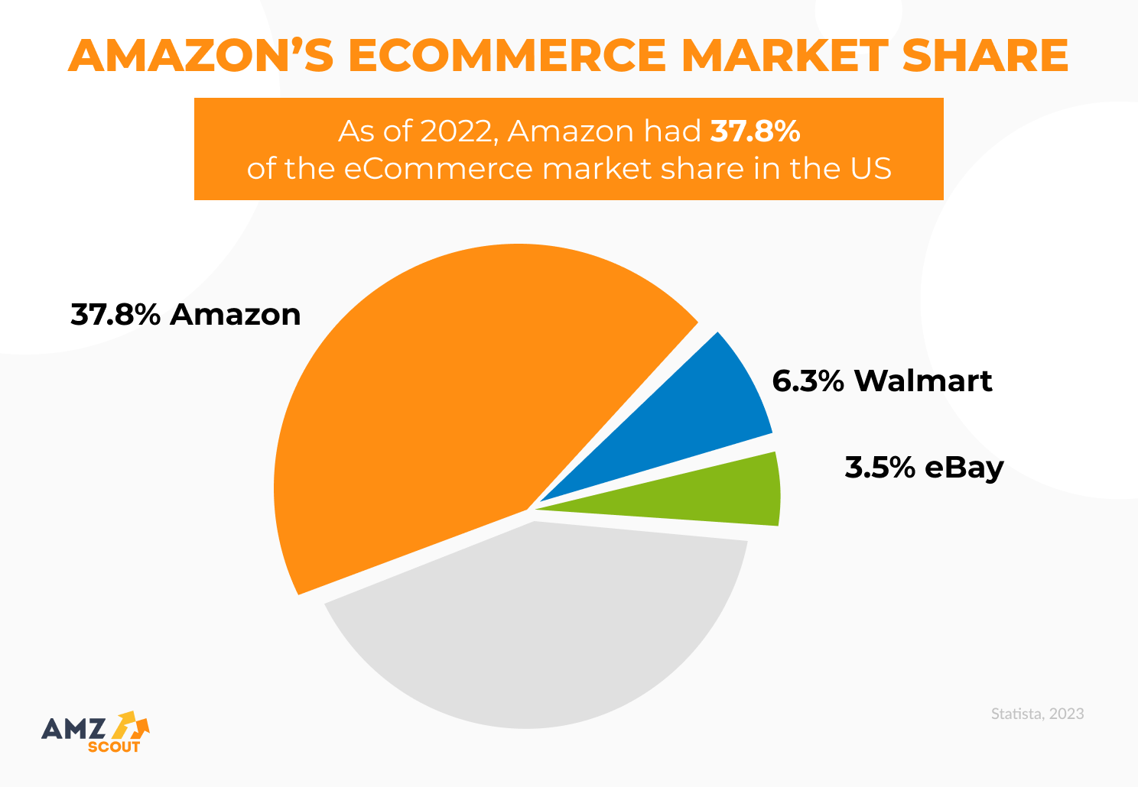
Figure 1: Amazon's E-Commerce Market Share.
Source: (Taylor, 2023)
Over twenty nations, this business provides a wide range of goods and services to its customers. Amazon was initially established by Jeff Bezos in 1994 as an online bookstore. The company quickly grew into a prominent player in the e-commerce industry. Membership in Amazon Prime began in 1997, Amazon Web Services (AWS) was introduced in 2006, and Whole Foods Market was purchased in 2017, further strengthening Amazon's position as the dominant player in the retail and technology industries.

Overview of Emirates
Dubai Emirates Airlines is the most prominent airline in the Middle East. Transportation of passengers and goods is the primary focus of the massive international aircraft network that spans six continents. Emirates operates through Dubai International Airport using a hub-and-spoke model to connect passengers (Emirates.com, 2024). In 2023, Emirates will be the fourth largest airline in terms of passengers, while it is the sixth largest airline in terms of cargo.

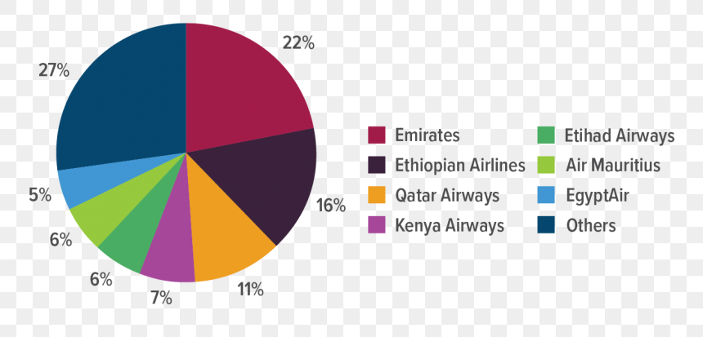
Figure 2: Africa-Asia Pacific Market Share by Airline.
Source: (Frank, 2024).
This company is a significant player in the aviation industry on a global scale, with over 150 destinations spread across 80 countries. Since its founding in 1985, Emirates has grown to become one of the most successful airlines in the world. In 2008, it made its first purchase of an Airbus A380, and in 2016, it began operating a direct flight from Dubai to Seattle. In 2013, it completed a contemporary terminal at Dubai International Airport.

Main Organizational Activities Summary
Even though they operate in different industries, Amazon and Emirates both facilitate the transportation of goods (whether they are real or digital) over huge networks. However, their approaches are fundamentally different from one another (Abell, 2011). When it comes to online transactions, Amazon largely acts as a facilitator between customers and sellers. On the other hand, Emirates places a greater emphasis on physical transportation by flying passengers and commodities all over the world. Despite their differences, both companies rely on knowledge management to enhance their operations, successfully handle complicated situations, and maintain a competitive advantage.

TWOS Analysis of Amazon’s and Emirates’s Knowledge Management

TOWS Analysis: Amazon's Knowledge Management System
To enhance its knowledge management methods, an organization must first have an understanding of both its internal and external components (Plotkin, 2020). An examination of the strengths, flaws, possibilities, and risks associated with Amazon's Knowledge Management system is presented in this analysis.
Table 1: TOWS Analysis of Amazon's Knowledge Management System.
TOWS Analysis of Amazon's Knowledge Management System
Threats | Opportunities
- Amazon's knowledge management systems are vulnerable to data breaches and cyberattacks, which might expose sensitive data and disrupt operations (Kragulj, 2022).  - Changes to data privacy and intellectual property rules can complicate knowledge management and need ongoing compliance.  - To stay competitive, Amazon must innovate as other companies improve their knowledge management strategies.  - As younger generations enter the workforce, knowledge management and communication must adapt to their preferences and learning methods.  - Knowledge management projects may be affected by budget cuts and resource constraints during financial downturns. | - Amazon may explore AI and machine learning to automate knowledge gathering, analysis, and dissemination, improving efficiency and effectiveness.  - Building and promoting robust information-sharing platforms like internal communities or collaboration tools can help Amazon to improve cross-functional knowledge exchange and teamwork (Hamilton & Webster, 2018).  - Employees can learn crucial knowledge management skills through specific training.  - Leaders' rewards, recognition, and support can drive people to share and contribute expertise across the organization.  - Amazon can learn more and make better decisions by actively seeking other ideas and experiences.
Weaknesses | Strengths
- Amazon has a high personnel turnover rate, which might cause knowledge loss and retention issues.  - Although encouraging innovation, Amazon departments and teams can occasionally silo knowledge sharing, hindering cross-functional cooperation and knowledge flow (Kniazeva & Baskin, 2023).  - Technology is useful, but overusing AI and automation in knowledge management may reduce judgment and creativity. Due to Amazon's size, managing knowledge across business divisions and locations is difficult. If data lacks diversity or representation, decision-making might be biased. | - Amazon encourages employees to exchange ideas and experiment to foster innovation. This promotes organizational knowledge production and exchange (Yang, 2022).  - Amazon guides various decisions with superior data analytics. This data-driven strategy improves knowledge management.  - Amazon continuously invests in AI, machine learning, and cloud computing to capture, store, and analyze data.  - Amazon's global location lets it access a wealth of knowledge and market insights.  - Amazon's employees receive substantial training and development to succeed in their jobs.

Amazon can improve its knowledge management by analyzing these internal and external aspects. Amazon may improve its knowledge management system and stay competitive by exploiting its strengths, grabbing opportunities, avoiding weaknesses, and addressing risks.

TOWS Analysis: Emirates' Knowledge Management System
Creating and upgrading a knowledge management system requires understanding the internal and external environment (Awad & Ghaziri, 2013). This report examines Emirates' knowledge management system's strengths, shortcomings, possibilities, and threats. Due to the scenario's constraints, this research relies on publicly available information and industry patterns rather than statistical data.
Table 2: TOWS Analysis of Emirates' Knowledge Management System.
TOWS Analysis of Emirates' Knowledge Management System
Threats | Opportunities
- Emirates must retain experienced staff and recruit new talent in the competitive global aviation market (Hislop et al., 2018). Staying competitive requires keeping up with fast-paced technological advances and implementing them into knowledge management procedures.  - knowledge management processes and compliance may need to change to comply with data privacy and security standards.  - Budget cuts and resource constraints during financial downturns may impair knowledge management project investments.  - A lack of experienced aviation workers may make it hard to maintain a knowledgeable crew. | - Collaboration platforms and knowledge management systems can enable organizations to share and collaborate knowledge.  - Encourage knowledge sharing through awards, recognition, and leadership can support Emirates to improve employee involvement with knowledge management efforts (Kniazeva & Baskin, 2023).  - Implementing ways to capture and document experienced employees' expertise before they leave can preserve valuable insights.  - Knowledge sharing and collaboration amongst diverse groups can boost creativity and problem-solving.  - Emirates can stay competitive by adapting knowledge management practices to industry trends and laws.
Weaknesses | Strengths
- Isolated organizations and lack of collaboration can make knowledge sharing between departments and teams difficult.  - Insufficient employee engagement in Knowledge Management projects may lead to underutilization of knowledge resources.  - Dependence on expatriate workers can make knowledge retention challenging, especially when they leave (Johannessen, 2016).  - Emirates may not be maximizing its veteran employees' knowledge.  - Economic downturns and geopolitical upheavals can impact aviation knowledge management. | - Emirates attracts a talented and diverse workforce because of its quality and innovative brand (Salim, 2021).  - Through extensive training and development, the airline prepares its personnel with vital abilities.  - Emirates' extensive network and diverse workforce provide knowledge and expertise.  - The organization invests in innovative technology and procedures to improve efficiency and client experience.  - Emirates shares information via internal channels and knowledge repositories.

Emirates can analyze these elements to get insights into its knowledge management system and develop plans to address internal weaknesses, seize opportunities, and eliminate external risks. The airline may build a solid knowledge management system to succeed in the ever-changing aviation industry by employing this system.

Amazon vs. Emirates' Knowledge Management
As the TOWS framework demonstrates, the knowledge management environments of Amazon and Emirates share some commonalities while also exhibiting some noteworthy distinctions (Hall, 2016).
Table 3: Similarities and Contrasts Between Amazon and Emirates.
Similarities and Contrasts Between Amazon and Emirates
Similarities | Contrasts
- Both organizations have knowledge silo issues. Knowledge-sharing issues across departments and teams can inhibit collaboration and information flow inside the firm.  - They also train and develop their staff since they recognize they need the skills and expertise to succeed (Kragulj, 2022).  - They also work in dynamic, competitive environments that require constant knowledge management strategy innovation to stay ahead.  - Both firms emphasize the need to foster a culture of information sharing and collaboration among employees to maximize their knowledge assets.  - Finally, Amazon and Emirates realize the power of technology to improve their knowledge management activities, with Amazon pursuing a more complex approach due to its commercial operations. | - Each companies have different knowledge sources. Amazon relies on data and technology for knowledge, whereas Emirates uses its global workforce's diversity. Different approaches are needed to obtain and use information.  - Amazon's digital operations are more flexible and adaptive than Emirates' complex physical processes, which require processing information over a huge network and diverse people (Unger, 2022).  - Both face economic downturns and shifting legislation, but Amazon is more exposed to cyberattacks due to its data-driven decision-making and online activity.  - Amazon has a high turnover rate, which causes knowledge loss and retention concerns, whereas Emirates has comparable issues due to its expatriate personnel.  - Finally, Amazon's culture of experimentation and risk-taking may accelerate innovation cycles compared to Emirates.

Each company's subtle knowledge management strategies reflect its operational surroundings and corporate cultures. Recognizing these similarities and differences allows Amazon and Emirates to learn from each other's knowledge management approaches and areas for improvement. This will improve their knowledge management systems, giving them a competitive edge and industry success.

Critical Evaluation of Knowledge Management System

Assessing Amazon's Knowledge Management System
Knowledge Management Value Chain:
Through various techniques to gather, share, innovate, and apply information throughout its operations, Amazon excels in its knowledge management Value Chain. First and foremost, the organization prioritizes knowledge acquisition through extensive employee onboarding and training to ensure new personnel integrate successfully (Ermine, 2013).

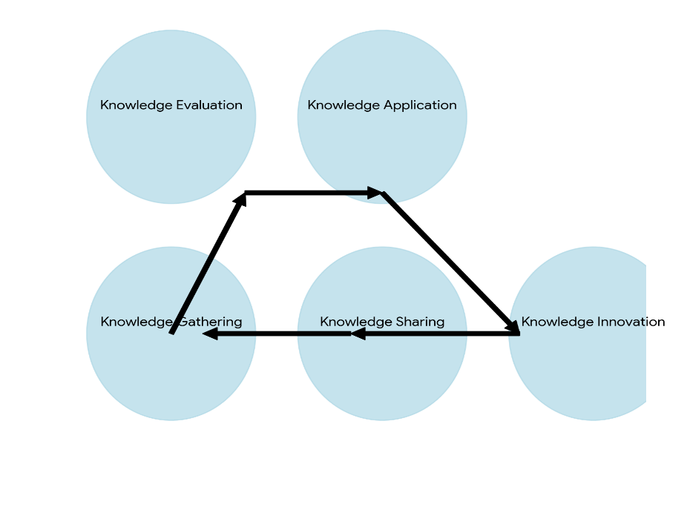
Figure 3: Knowledge Management Value Chain at Amazon.
Source: (Ermine, 2013).
Internal platforms like the "Wiki," where staff discuss best practices and document procedures, encourage knowledge sharing at Amazon. Amazon's knowledge management strategy relies on data from customer evaluations and operational indicators to make strategic decisions and improve. Hackathons and innovation challenges encourage cross-functional teamwork and problem-solving at the firm. Internal communities and forums foster idea-sharing and collaboration, advancing the company. Amazon uses AWS and other technologies to store data securely. Centralized sources like "Wiki" make documented knowledge easy to access. Mentorship initiatives, communities of practice, and communication platforms like Chime facilitate knowledge sharing (Miller & Jones, 2014). Amazon relies on standardized processes, data-driven decision-making, and performance management to apply knowledge. These approaches encourage employees to use their knowledge effectively, improving it. Amazon surveys employees and tracks knowledge utilization to evaluate their knowledge management system. This shows its impact on customer happiness and operational efficiency. Amazon's knowledge management Value Chain covers knowledge gathering, sharing, innovation, application, and evaluation. Amazon's culture of continuous learning and improvement helps it become a top global company.
Support systems:
Amazon supports its knowledge management using numerous systems. Learning Management Systems, like the "Amazon Learning Path," offers online courses, training resources, and certification programs to improve employee knowledge and skills (Hannig, 2015). Chime and internal social media platforms offer rapid communication, knowledge exchange, and collaboration between departments and locations. Data analytics technologies like Amazon Redshift and Amazon Quick Sight let employees analyze data, find insights, and make decisions, leveraging data-driven expertise.
Deployment Strategies:
Amazon deploys its knowledge management system centrally and decentralized. All employees can access knowledge repositories and learning platforms, creating organization-wide homogeneity. Additionally, departments and teams can tailor knowledge management techniques to their needs (Chmelewski, 2016). To satisfy the company's growing needs and changing knowledge needs in multiple departments and regions, this strategy fosters scalability and flexibility with Amazon's cloud-based infrastructure. For instance, the "Amazon Knowledge Graph" shows the company's commitment to knowledge management innovation. This network of information links data points across the organization, enabling staff to find essential information and insights faster and make better knowledge-based decisions.

Assessing Emirates Knowledge Management System
The Value Chain:
A comprehensive Knowledge Management Value Chain captures, creates, stores, shares, applies, and measures knowledge at Emirates Airlines. Emirates collects information through formal training, coaching, and after-action reviews. These courses teach workers essential skills and allow veterans to teach newcomers. Emirates promotes innovation through forums, suggestion schemes, and cross-functional project teams to collaborate and share ideas (Davenport & Prusak, 2013). The "Emirates Knowledge Base," a document management system, provides easy access to critical publications, instructions, and best practices. Emirates uses internal communication tools like the "Emirates Connect" app, online groups, and departmental knowledge management champions to promote knowledge exchange.
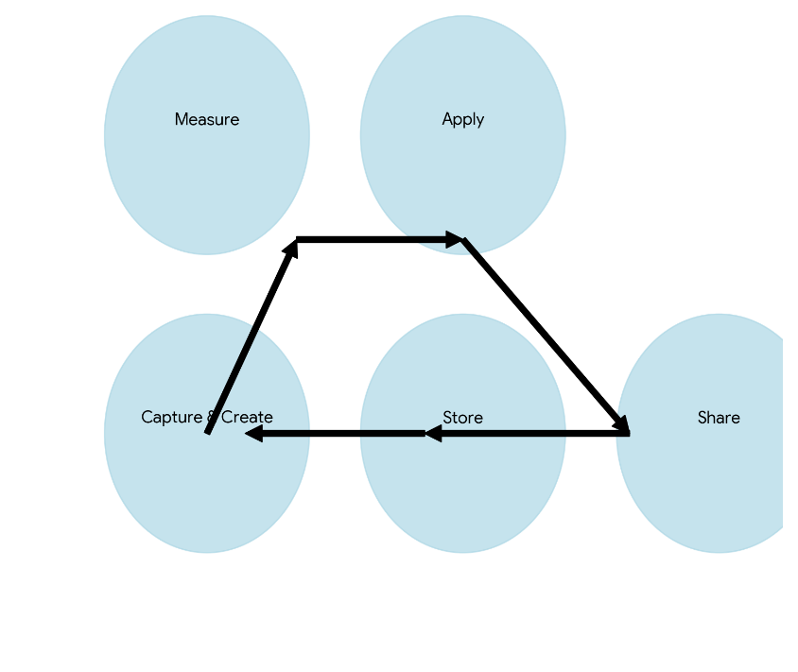
Figure 4: Knowledge Management Value Chain at Emirates.
Source: (Davenport & Prusak, 2013).
These approaches foster department and site staff communication and coordination. Emirates emphasizes knowledge application through standardization, performance management, and training. Standard operating procedures and best practices help staff complete daily duties, fostering departmental uniformity. Performance reviews, feedback, refresher training, and knowledge updates help employees keep their abilities throughout their careers. Emirates measures knowledge management system efficacy with staff surveys, knowledge utilization metrics, and performance improvement analysis (Scheeder, 2015). Employee satisfaction surveys measure knowledge access and sharing opportunities while monitoring knowledge repositories and assessing the effects of knowledge-sharing efforts on operational efficiency, safety records, and customer satisfaction revealing the importance of knowledge management in the organization. Emirates Airlines' KM Value Chain promotes innovation, cooperation, and continuous improvement by managing knowledge across the company.
Support systems:
There are multiple support systems that Emirates utilizes to boost operations and personnel growth. Many different departmental training options are available through the Emirates Skywards Training LMS (Weed-Schertzer, 2020). "Emirates Connect" is an app that facilitates communication and knowledge sharing among employees. To improve data management, flight operations management software, and crew scheduling tools are utilized. This allows for more informed decision-making and the optimization of processes.
Deployment Strategies:
By adopting flexible deployment, Emirates can optimize its knowledge management. By centralizing the knowledge repository and learning management system, all employees would have access to them. Customized simulators and flight planning software are two options that departments have at their disposal for pilot training (Caner et al., 2016). To ensure that newly hired employees are kept up to date on the latest industry trends and operational requirements, Emirates conducts thorough onboarding and continuous training. For example, Emirates' recent VR cabin crew training shows its commitment to knowledge management innovation. Immersive virtual reality simulations improve information retention and real-world readiness.

Compare Analysis of Knowledge Management Systems
Emirates and Amazon use different Knowledge Management systems, yet they share challenges and strengths. The firms employ data and technology to support their Knowledge Management goals and teach and develop through excellent learning management systems (Daft, 2022). However, companies struggle with isolated team knowledge sharing. Amazon's Knowledge Management system harnesses its global digital operations to create knowledge and make data-driven choices. Emirates uses current information and standardizes procedures across its geographically dispersed operations. Amazon's culture and cloud-based architecture foster innovation. Emirates uses operations management system data and VR cabin staff training to make decisions. Due to high turnover and reliance on expatriate workers, both firms struggle with fragmented information exchange, knowledge management efficacy, and knowledge preservation (Gottschalk, 2017). Emirates might improve operations by encouraging knowledge production and using technology to share knowledge. Amazon should overcome knowledge silos and improve retention despite significant turnover. Both organizations need robust KM measures to assess effectiveness. By acknowledging these similarities, differences, and potential for improvement, both firms may learn from each other and improve their knowledge management systems, giving them a competitive edge.

Recommendations

Recommendation for Amazon
Amazon may implement several proposals to boost knowledge exchange. Rewarding and recognizing employees who share expertise helps foster a culture of knowledge sharing. Gamification tactics on platforms like "Wiki" can inspire users to contribute and share knowledge by awarding points and badges for timely responses and contributions (Maier, 2010). Knowledge measurement must include monitoring access to knowledge resources and how knowledge is used to solve problems or improve processes.

Figure 5: Recommendations for Amazon.
Source: (Maier, 2010).
Create metrics to quantify knowledge use and conduct impact studies to assess knowledge management's impact on KPIs. To combat knowledge silos, promote cross-functional collaboration through collaborative initiatives, hackathons, and communities of practice. Knowledge management platforms and knowledge mapping can help departments collaborate and share knowledge, bridging silos. Consider Microsoft Teams or Slack with team-specific channels for cooperation.
Recommendations for Emirates
Emirates can boost knowledge generation with several techniques. First, knowledge cafés or innovation workshops can enable diverse personnel to discuss unique solutions. Promote attendance at industry conferences and knowledge-sharing activities so employees may share their thoughts and improve internal knowledge (Gottschalk, 2016). Technology is essential for knowledge sharing. Advanced knowledge management platforms like Confluence or SharePoint ease knowledge capture, organization, and search, making it easier for employees to access and share relevant information.
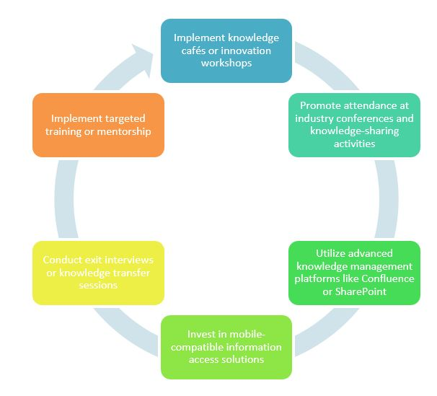
Figure 6: Recommendations for Emirates.
Source: (Gottschalk, 2016).
Putting resources into dynamic data access arrangements like as portable applications or archives permits workers to helpfully access and trade data even while not in their work areas. To further develop information maintenance, it is critical to lead flight meetings or information move meetings with leaving workers to gather their aptitude before they go (Gottschalk, 2017). Moreover, it is pivotal to carry out information maintenance drives, for example, designated preparation or mentorship programs for new representatives to work with the exchange of information from experienced specialists. By carrying out these ideas, both Amazon and Emirates might upgrade their insight into the executives’ frameworks and assets. Fostering a staff that has broad information and flexibility will essentially work on general execution over the long haul.

Conclusion
Amazon and Emirates' Knowledge Management systems have parallels and variances, according to a TOWS study and critical reviews. Both companies emphasize training and development, use technology to manage knowledge, and struggle with isolated knowledge sharing. Amazon prioritizes data-driven knowledge generation and innovation, whereas Emirates standardizes knowledge use. Any business must provide proper knowledge management to preserve talent and knowledge development (Hislop et al., 2018). Organizations can easily capture, distribute, and use knowledge with an advanced knowledge management system, creating a skilled and flexible workforce ready to face future problems. Amazon encourages knowledge exchange through incentives, gamified platforms, and usage measurements and effect studies. Promote cross-functional collaboration and use knowledge mapping tools to eliminate information silos. Emirates should implement knowledge creation initiatives like workshops and industry knowledge sharing, use advanced knowledge management platforms and mobile access, and improve knowledge retention through knowledge capture and mentorship programs. Amazon and Emirates can develop powerful and durable Knowledge Management systems by stressing key growth areas, earning a competitive edge, and ensuring industry success.

References
Abell (2008) Knowledge and information management. Taylor & Francis.
Abell, A. (2011) Knowledge and information management: The DNA OF SUCCESS. London: Facet Publishing.
Amazon.com (2024) Amazon.com: Online Shopping for electronics, apparel, computers, ..., Amazon.com. Available at: https://www.amazon.com (Accessed: 04 March 2024).
Awad, E.M. and Ghaziri, H. (2013) Knowledge management. New Delhi (India): PHI Learning Private Limited.
Caner, T., Cohen, S.K. and Pil, F. (2016) ‘Firm heterogeneity in complex problem solving: A knowledge‐based look at invention’, Strategic Management Journal, 38(9), pp. 1791–1811. doi:10.1002/smj.2615.
Chmelewski, A.P. (2016) The creation of knowledge: Transforming tacit knowledge into explicit knowledge.
Daft, R.L. (2022) Management. Boston, MA: Cengage.
Davenport, T.H. and Prusak, L. (2013) Working Knowledge: How Organizations Manage What They Know. Boston, MA: Harvard Business School Press.
Emirates.com (2024) Book a flight: Emirates Bangladesh, Emirates. Available at: https://www.emirates.com/bd/english/book/?gad_source=1&gclid=CjwKCAiA_5WvBhBAEiwAZtCU78mkwJ5DZtGELBH2-ULj7xP-j_s403hWabAqDKTM3LQlqqS5vBmTnhoC9ZYQAvD_BwE&gclsrc=aw.ds (Accessed: 04 March 2024).
Ermine, J.-L. (2013) ‘A knowledge value chain for knowledge management’, Journal of Knowledge &amp; Communication Management, 3(2), p. 85. doi:10.5958/j.2277-7946.3.2.008.
Frank, J. (2024) Transparent fly emirates PNG - market share of Emirates Airlines, PNG Download - vhv, vhv.rs. Available at: https://www.vhv.rs/viewpic/ibJobhh_transparent-fly-emirates-png-market-share-of-emirates/ (Accessed: 04 March 2024).
Gottschalk, P. (2016) ‘Knowledge management’, Knowledge Management Systems [Preprint]. doi:10.4018/9781599040608.ch002.
Gottschalk, P. (2017) Knowledge Management Systems, pp. 27–48. doi:10.4018/978-1-59904-060-8.ch003.
Hall, M. (2016) ‘Knowledge management and the limits of Knowledge Codification’, Journal of Knowledge Management, 10(3), pp. 117–126. doi:10.1108/13673270610670894.
Hamilton, L. and Webster, P. (2018) ‘The Global Business Environment’, The International Business Environment [Preprint]. doi:10.1093/hebz/9780198804291.003.0005.
Hannig, U. (2015) ‘Knowledge management + business intelligence = decision intelligence’, Knowledge Management und Business Intelligence, pp. 3–25. doi:10.1007/978-3-642-55950-1_1.
Hashem, T. (2023) ‘The role of marketing knowledge sharing in building organizational immunity’, European Conference on Knowledge Management, 24(1), pp. 533–540. doi:10.34190/eckm.24.1.1259.
Hislop, D., Bosua, R. and Helms, R. (2018) ‘The contemporary importance of knowledge and knowledge management’, Knowledge Management in Organizations [Preprint]. doi:10.1093/hebz/9780198724018.003.0001.
Johannessen, J.-A. (2016) Knowledge management. Jon-Arild Johannessen.
Kniazeva, M. and Baskin, E. (2023) SWOT analysis [Preprint]. doi:10.4135/9781071902943.
Kragulj, F. (2022) ‘Theoretical framework of the need knowledge-driven organization’, Knowledge Management and Sustainable Value Creation, pp. 37–284. doi:10.1007/978-3-031-12729-8_3.
Maier, R. (2010) Knowledge Management Systems: Information and Communication Technologies for Knowledge Management. Berlin: Springer.
Maier, R. (2010) Knowledge Management Systems: Information and Communication Technologies for Knowledge Management. Berlin: Springer.
Miller, C. and Jones, L. (2014) ‘Value chain business models’, Agricultural Value Chain Finance, pp. 27–54. doi:10.3362/9781780440514.003.
Plotkin, M.J. (2020) ‘History: The struggle for the Amazon’, The Amazon [Preprint]. doi:10.1093/wentk/9780190668297.003.0006.
Salim, A. (2021) ‘SWOT analysis of Emirates’, Elementary Education Online, 20(3). doi:10.17051/ilkonline.2021.03.373.
Scheeder, D. (2015) ‘13. knowledge management: Toward understanding in a Multicultural World’, Knowledge Management in Libraries and Organizations, pp. 170–178. doi:10.1515/9783110413106-016.
Taylor, B. (2023) Amazon statistics: Up-to-date numbers relevant for 2023-2024, AMZScout Blog. Available at: https://amzscout.net/blog/amazon-statistics/ (Accessed: 04 March 2024).
Unger, R.M. (2022) The knowledge economy. Brooklyn, NY: Verso Books.
Weed-Schertzer, B. (2020) ‘Tools for knowledge and organizational learning’, (Il)Logical Knowledge Management, pp. 83–117. doi:10.1108/978-1-83867-803-620201003.
Yang, Z. (2022) ‘Amazon vs. Alibaba: Comparisons of two E-commerce Giants based on SWOT analysis’, Highlights in Business, Economics and Management, 2, pp. 497–503. doi:10.54097/hbem.v2i.2409.

