
Change and stability
Dyson Limited 5/May/2023


Executive Summary ………………………………………………….Page 4
Introduction…………………………………………………………….Page 5
Main body
- Organisational change is defined as…………………………...…….Page 7
- Changes Dyson underwent………………………………………….…page 7
- Background information on Singapore economy………………….Page 7-8
- Kurt Lewin's Force Field Analysis …………………………………..Page 8-11
- LEWIN’S THREE-STEP MODEL APPLIED FOR THE CHANGE…...Page 12
- Typology change………………………………………………………….Page 13
- What is a PESTLE analysis?......................................................Page 14-15
- Stakeholder Analysis………………………………………………Page 16-17
- 8 Elements of an Effective Change Management Process ….Page 19-20

Conclusion………………………………………………………………Page 20

Recommendation……………………………………………………..Page 21-22

Bibliography…………………………………………………………..Page 23-26

Executive Summary:
The purpose of this report is to analyse and evaluate the change of Dyson happened in 2019. This report will look at various models in change management.
This report will start with a brief introduction, then a main body will be illustrated. The main body will have the latest definition of change management as well as the background information about dyson, background information about Singapore, reason Dyson decided to relocate to Singapore. Next, the process of the change is listed in a table, then analysis will be given in detail including the types of the change, the driving and restraining forces, Pestel, stakeholder analysis and lastly 8 Elements of an Effective Change Management Process. After the main body part, there is the conclusion and finally, future recommendations for Dyson moving to Singapore. This report makes use of several models of change management: Typology of change provided by Hodges and Gill, and Nadler, Lewin’s Force Field Analysis, Stakeholder map and Kotter’s eight-step model. Additionally, useful data and theories from textbooks, newspapers and websites will also be adopted to enrich the whole report.

Introduction:
Dyson Limited Founded in 1991 by Sir James Dyson in Malmsbury, England. The company specialized in designing and manufacturing a range of household appliances including vacuum cleaners, air purifiers, and hair care products (Dyson.2020). However, Dyson undoubtedly become a popular choice among consumers worldwide. Therefor Despite its success on British territory, the corporation nonetheless chose to move to South Asia Singapore, which led to several back-and-forth discussions about why it did so. Dyson was privately owned, but I mention it in this report because it was involved in so many lawsuits that ended in victory.

In January 2019, Dyson Limited made the decision to relocate its corporate headquarters from the United Kingdom to Singapore Asia. Dyson's aspirations to increase the business in the Asia side, which currently adds a huge amount of the company's revenue since a lot of consumers order products from their and majority of it suppliers are from that region, decision to relocate the headquarters of the company to Asia.
The change will be critically assessed in this report to determine whether it has helped or hurt organizations. It will assess by looking at important internal and external factors such as culture, leadership, authority, economic and political pressures, and competitive forces.
With an emphasis on organizational growth, the sociopsychology of change resistance, and maintaining organizational effectiveness, the report will assess and make references to theoretical models, ideas, and concepts.
To clarify to the reader and back the analysis and findings, this report will redraw a wide range of data sources, including published literature, and secondary research.
To achieve this goal, this report will initially provide a brief introduction to the Dyson move, and then make a thorough analysis of the main factors that result in the change. After that, an evaluation of the benefits and drawbacks will be made based on the company revenue breakdown. A brief conclusion is to be formed.

Organisational change is defined as
“A process in which a large company or organization changes its working methods or
aims, for example in order to develop and deal with new situations or markets” (Dictionary.cambridge.org, 2019). In this report, it will be used to clarify the change, what caused it and to provide theoretical direction for the change.
Changes Dyson underwent:
British Brexit supporter Sir James Dyson has chosen to move to Singapore. This step caused a stir in the move's justification (The Independent, 2021). Sir James was very excited about his Brexit deal for the UK but decided to change his mind and move Dyson to Singapore, leading many to view it as hypocrisy. James Dyson responded to these allegations by saying, " The Dyson move is for Dyson. The decision of Dyson Limited to move to Singapore could have been influenced by several factors. This review will find out if the move is actually a good move.
Background information on Singapore economy:
Over the past decades Singapore was competing with the most influenceable and prosperous countries in the world. The reason for it success comes to attributes to many reasons such as the strategic location, work ethics of it population, Government support and willing to attract business to succeed instead of just making them pay for taxes and Vat’s (Hussain, 2015).
Over the past years, Singapore has developed its economy with key sectors such as manufacturing, finance and services. Relocating to Singapore would be a great deal for any company to move to as the country created an supportive environmental and fair playing field.

Kurt Lewin's Force Field Analysis:
Kurt Lewin's Force Field Analysis is a strategic tool used to understand the forces (both driving and resisting) behind a given change initiative. A force field analysis the pros and cons of leaving the UK and identifies the key factors that influence the success of that decision.
Below is an example of driving and resisting which applies in the context of Dyson Limited.
Resistance for change
Driver for change

Moving to Singapore
Growth strategy

Position

Exchange Rate

More consumers
Less tax
Cheaper labor
Brand reputation
Technical innovation
Brexit

Total =35

Technology Limitations

Loyal customers
Loyal employs

Laws and regulation

Intense competition
High production cost

Total =28

Driver force:
- Innovation: Dyson earned high quality loyal customer by maintaining and investing heavily in research and development and is known for its cutting-edge technology, which significantly leads its competitors in terms of product innovation and performance (Arnott, 2010).
- Brand reputation: Over the many years Dyson built its reputation Dyson has successfully defended the name of a brand known for quality, reliability and invested heavily on their innovation in research and development to create unique and distinctive designs, helping to generate repeat business and attract new customers (Art, 2022).
- Growth strategy: The expansion into Asia shows that Dyson is looking to expand and expand its market, rather than just being limited to the UK (Jolly, 2011). The only way Dyson can do that is through product differentiation and innovation.
- Position: Singapore is very strategically located. Singapore is the gateway to many markets (Vaswani, 2019). The advantage of being based in Singapore provides easy access that allows the company to generate huge revenue and generate huge sales. It has an excellent infrastructure and a strong legal system, making it an ideal location for multinational companies (bbc, 2010).
- Tax: Singapore offers attractive tax incentives and government support to encourage business growth and innovation. This may have been a key factor in Dyson's decision to move to the country.
- Brexit: In June 2016, the UK decided to hold a referendum on whether to leave or leave the EU. Sir James advocated leaving. The UK voted 52% to 48% to leave the EU (BBC, 2016). The public was tricked into thinking a vacation was the best option, but it turns out it wasn't. Brexit politicians such as Sir James created a winning public image and sold them the dream of leaving, but Brexit would bring uncertainty and could lead to a devaluation of the euro, leading to a devaluation of the EU. May lead to devaluation. Companies based in will lose profits. Third, after the UK leaves her EU, there may be far fewer in-person connections and travel for visa applications than before, or immigration laws may become tougher and more complex.
- Labour cost: Singapore is known for high skilled labour force regardless to their cheap labour
- Entrance to new market
- Closer distance to the suppliers and partners in Asia
- Smoother supply chain: Singapore is located in a very strategic location the hub for trade and commerce in southeast Asia. Singapore is has good infrastructure good logistic and government support.
Resisting forces:
- High production costs:
Business expenses in the Uk is very high which will cause the business to maintain profit or breakeven sometimes. Moving to Asia where employee cost and rent cost are cheap will benefit the company to make an extra saving which will go towards there profit (Raybould.2012). Dyson's products are expensive to manufacture, which can make it difficult to maintain profitability.
- Intense competition:
Dyson main competitors are Sony, Samsung and others. They all compete in a crowded market, making it challenging and hard to gain market share (kenndy.2019).
- Technology limitations:
limiting the talents in the company will stop the company to become creative and design creative products despite Dyson’s reputation for creative innovation (moodle.uwtsd.ac.uk, 2018), Dyson's success ultimately depends on its ability to continue to develop creative solutions. Dyson invested money to adopt and create an advanced robotics to brighter the company’s future and stay way advanced on from there competitors (Dyson,2021).
- Potential downfall for UK economy
- Supply chain gets effected since Brexit lead to many European lorry drivers to not have their visa get renewed.
LEWIN’S THREE-STEP MODEL APPLIED FOR THE CHANGE
Kurt lewin came with a planned change model in 1951. It consists of three stages which are Unfreezing, changing and refreezing (Burnes.2004). applying changes with the company is very beneficial as it continues to outgrow it competitors and gives them the edge of been a head of the game and makes difficult for the coopetition to catch with them.
move for a successful business and its very widely recognised. When this applied to Dyson this is the three steps:
Lewis three stages are.
- Unfreezing: the first stage identifying the need of change to employees in the current situation, customers and government and make them realise why the change is urgent of moving to Singapore examples Dyson might need the change are technological advancements, or an increase in competition.
- Changing: The second stage helps with the transition period for Dyson to elevate and make the right moves to their wanted place and helps to make them ready to handle the change. To help them to make it a smooth transition maybe training is necessary and open line of communication between different departments within the company.
- Refreezing: The final stage is when Dyson settles down the changes and makes it stabilized and it became the new norm and gets it the system flowing by the new change. At Dyson the company needs to monitor the performance and keep an eye on it to make sure the way they wanted it to be and continue providing training and education and leave the line open at all times.
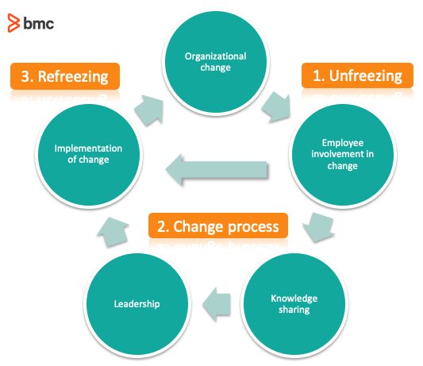
Figure 1(Raza,2019)

Typology change:

Dyson Limited is known for its creativity and excellence in consumer electronics. First, the move to Dyson Limited was not as sudden as originally "planned". Relocating to Singapore will not only attract more consumers but also retain their former consumers by creating better products because Dyson moved to Singapore where its workforce is better than its competitors (kotter.2012). Second, it should be a transformational because it changed the entire organization. The move changed the company's operations, operations and strategy. Third, the change was a strategic change because Dyson realized that doing it would open up so many markets because Singapore is the gateway to Asia. The move to Singapore includes a strategic change, as it affects the global position of the company, creating a significant position in the Asian market. And finally, it is an organizational change because it affected the entire organization, not just individuals.

What is a PESTLE analysis?
PESTEL is a tool used to analysis the company. The letters stand for Political, Economic, Social, Technological, Environmental and Legal. In this report, we will analysis Dyson using PESTEL (Perera,2017).
- Political
Political factor plays an important role for the growth of the company. Moving the company and relocating in Asia will expand on the operation, but It will also bring out challenges till the company adopts and learn the new political legislation as each country various. Beside looking at the challenges moving to Singapore during the transitional change “Brexit” would be the best time to operate away from the British soil, as Britain not stabled yet. Political stability in Singapore is good for Dyson’ business (Perera,2017).
- Economic
Dysons move is win for the company if you look at it from an economically factor. Cheap labour, Low taxes, faster shipping since is located in a gateway of Asia and liner rules and regulation will help the company to maximise their profits.
- Social
Covid 19 adopted and trained people to become more cleaner which will encourage people to buy more of Dysons product, so been able to produce and ship the items as quick as it needed to be shipped will be a factor to consider the success of the business.
- Tech
Most of dyson products are not easy to replicate which is an advantage and which makes Dyson most leading product manufactory and will always be since the company invests heavily on learning and developments (Dyson,2020).
- Environmental
Environmental politics is always changing, but Singapore might not be as strict as Britain. Dyson always been step ahead since dyson invest heavily to save the environment. Dyson been known to be environmentally friendly since they use less packaging on their products and have recently announced that they considering to manufactory their first electrical car. In 2018 Dyson won a case against the European court for environmental over the way the labelled the efficiency of the vacuum cleaners’ (bbc,2018).
- Legal
Dyson has a trademark on each product it produces. The patent law will protect dyson from its competitors. This is a competitive advantage for Dyson (Tyagi,2022). Dyson experienced a court case against hoover and won the case and hoover been ordered to pay a huge sum over four million pounds over the trademark (Dyer, 2002).
Stakeholder Analysis:
What is stakeholder analysis?
In 1984 R. Edward freeman came out with the Stakeholder analysis theory, A stakeholder analysis helps to identify and understand the stakeholders in your project (knowledgehut, 2023).
A stakeholder refers to ‘a person, group or organisation that has interest or concern in an organisation” (BusinessDictionary, n.d.).
Doing this before your project begins will help you successfully. Conducting the model by analysing Dyson’s internal and external stakeholders’ point of view will help to the company. firstly, identifying who’s going to be affected by relocating to Singapore.
Secondly prioritizing by assessing the level of interest and level of participating in the project and lastly understanding or just the customers wouldn’t help you to it connects different types of views For Dysons change. One single analysis wouldn’t give you the correct answer (Anon,2018). The list below illustrates the stakeholders for Dyson limited:
- Owner
- Suppliers
- Customers
- Government
- Trade unions
- Employees
- Senior management
- Board of directors
- Communities
The internal stakeholders of Dyson are those who own the direct interest with the Dyson such as James Dyson himself, employees and others. As for the external stakeholders, as not as direct as the internal but decision to relocate will have an impact to them such as Suppliers of the firm, competitors and others.
Stakeholder map below will be used to identify the important stakeholders so that the plan route gets planned.
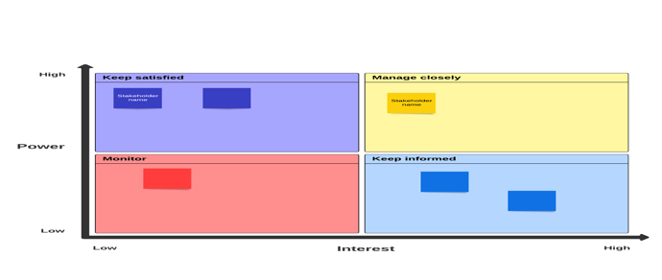
Figure 2(Lucidspark, n.d)

8 Elements of an Effective Change Management Process

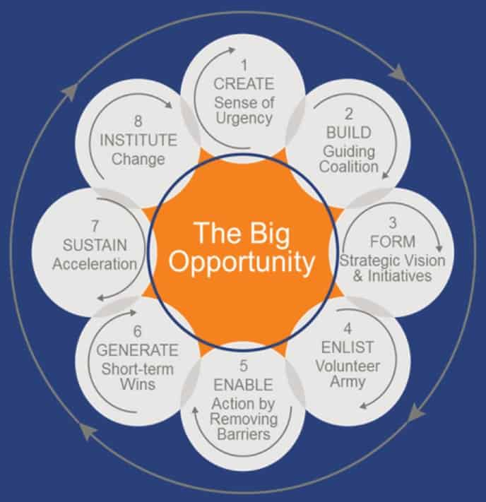
Figure 3(Ramos, 2019)

The overall assessment of the change done by Dyson should be that it managed this change very well.
Kotter talked about the eight-step model for the change management in 1995 (Cameron & Green, 2012), which will be used here as the evaluation steps:
- Creating sense of urgency: Dyson well planned the move carefully as it shows on the force field analysis when the force drive is greater than resistance drive.
- Building guiding coalition
- Create a strategic and vision: Dyson Limited made everyone aware of their strategic move and their vision through media and their company website
- Communicate the vision: Dyson update and share their vision every step on way on their company website by having a news section.
- Removing action by removing barriers: Everyone that needed to know the change been notified as the change is organisational change without the green light the change wouldn’t be possible.
- Generate short term wins: Dyson should generate shot wins by doing promotions and price reducing to make itself in the market.
- Sustain acceleration: Dyson invested heavily on education and training employees to sustain acceleration of dyson.
- Institution change: Dyson made use of different strategies to make sure that important stakeholders are on board on the change and held happy to carry forward with the plan

Conclusion:
In conclusion, this report applies different type of models to analysis Dyson limited to the change it went through due which was relocating to Singapore and moving the whole operation to Asia. Firstly, the change is classified as a planned, transformational change, strategic and organizational change, or it can be described as a transformational change. Secondly, driving forces and restraining forces of the change are listed and driving force was higher by scores as 35 vs. 28, so the change happened eventually, I have covered every factor and I have explained it carefully and detailed. Thirdly, all stakeholders within this change are classified and been divided according to their power and interest of the company. Fourthly, the effectiveness of the change is assessed from in 8 different steps using Dr Kotter theory.
Recommendation:
Indeed in spite of the fact that Britain has misplaced a really key player within the British soil playground field, a fruitful commerce such as Dyson will be progressing to be missed. Dyson constrained was a tremendous citizen which went and made a difference toward numerous perspectives of our government presence such as infostructures, wellbeing, instruction and numerous more. By and large, Dyson Restricted must have a well-defined procedure and arrange with clear objectives based on the company's long-term vision and mission in arrange to create the move effective. This will offer assistance the company overcome potential challenges and maximize the benefits of moving to Singapore. Be that as it may, I suggest that Dyson ought to carefully weight the benefits and challenges for it to move forward. ◦ Dyson ought to contribute the way it did within the UK nation in their neighbourhood showcasing to draw in more customers since the company has moved to Asia. ◦ Dyson ought to think of distinctive ways to set up itself and make it self-know by perhaps doing commerce with Asian trade. ◦ Since Dysons item might not the hit advertise as its modern to the nation it ought to give ways of pulling in buyer to buy their items by perhaps increment the guarantee length or think of a long-term win’s instep of short term since it needs to win and remain and not migrate once more which might the company a terrible notoriety. a smooth move for its representatives, clients, and providers in both the ancient and unused areas. This could be done through viable communication, giving fundamental assets and back, and following to local regulations and legitimate necessities.

Bibliography

- The Independent. (2010). Dyson profits double thanks to R&D investment. [online] Available at: https://www.independent.co.uk/news/business/news/dyson-profits-double-thanks-to-r-d-investment-1983841.html.
- ‌Statista. (n.d.). Dyson brand profile UK 2022. [online] Available at: https://www.statista.com/forecasts/1335503/dyson-smart-home-brand-profile-in-the-uk.
- ‌Singapore ‘best for businesses’. (2010). BBC News. [online] 4 Nov. Available at: https://www.bbc.co.uk/news/business-11671839.
- SE Asian governments gamble on making cheap labour less cheap. (2012). Reuters. [online] 7 Dec. Available at: https://www.reuters.com/article/asia-wages-cheap-labour-idINDEE8B607E20121207 [Accessed 27 Apr. 2023].
- Perera, R. (2017). The PESTLE Analysis. 2.0 ed. [online] Nerdyaut, pp.6–15. Available at: https://books.google.co.uk/books?id=ZWpLDwAAQBAJ&printsec=frontcover&source=gbs_ge_summary_r&cad=0#v=onepage&q&f=false [Accessed 7 Apr. 2023].
- ‌Kennedy, J. (2019). Dyson and Sony departures from UK reveal post-Brexit battlefront for FDI. [online] Silicon Republic. Available at: https://www.siliconrepublic.com/business/dyson-sony-brexit-fdi [Accessed 21 Apr. 2023].
- Jolly, A. (2011). The Growing Business Handbook.
- John P. Kotter. (2012-10-23). Leading Change. [Online]. Harvard Business Review Press. Available at: https://ebookcentral.proquest.com/lib/trinity/reader.action?docID=5182145&ppg=50 [Accessed 1 April 2023].
- ‌Dyson’s move to Singapore could help the UK. (2019). BBC News. [online] 23 Jan. Available at: https://www.bbc.co.uk/news/business-46968726.
- Dyson (2020). Technology Investment. [online] Dyson.co.uk. Available at: https://www.dyson.co.uk/newsroom/overview/features/november-2020/technology-investment.
- Corpbiz. (2022). Trademark Journal: All You Need to Know. [online] Available at: https://corpbiz.io/learning/trademark-journal-all-you-need-to-know/ [Accessed 2 April 2023].
- ‌ Raza, M. (2019). Lewin’s 3 Stage Model of Change Explained. [online] BMC Blogs. Available at: https://www.bmc.com/blogs/lewin-three-stage-model-change/.
- ‌ BBC (2016). EU Referendum Results. [online] BBC News. Available at: https://www.bbc.co.uk/news/politics/eu_referendum/results
- Anon, (n.d.). About | Stakeholder Theory. [online] Available at: http://stakeholdertheory.org/about/#:~:text=In%201984%2C%20R..
- Burnes, B. (2004). Kurt Lewin and the Planned Approach to change: a re-appraisal. Journal of Management Studies, 41(6), pp.977–1002.
- moodle.uwtsd.ac.uk. (n.d.). UWTSD Moodle 2022/23: Log in to the site. [online] Available at: https://moodle.uwtsd.ac.uk/pluginfile.php/594126/mod_resource/content/1/EMPLOYEE%20ATTITUDE%20TO%20CHANGE%20AND%20OD.pdf [Accessed 21 April 2023].
- www.knowledgehut.com. (n.d.). Stakeholder Analysis: Overview, Tools and Techniques. [online] Available at: https://www.knowledgehut.com/blog/project-management/stakeholder-analysis.
- BusinessDictionary, n.d. What is a stakeholder?. [Online]
Available at: http://www.businessdictionary.com/definition/stakeholder.html [Accessed 2 04 2023.
- Lucidspark. (n.d.). Stakeholder map template. [online] Available at: https://lucidspark.com/templates/stakeholder-map-template.
- The Independent. (2021). Sir James Dyson moves address back to UK from Singapore. [online] Available at: https://www.independent.co.uk/news/business/james-dyson-address-move-singapore-uk-b1835704.html.
- Dyson (2020). Dyson UK | Official Site. [online] Dyson.co.uk. Available at: https://www.dyson.co.uk/en.
- Ramos, D. (2019). 8 Elements of an Effective Change Management Process. [online] Smartsheet. Available at: https://www.smartsheet.com/8-elements-effective-change-management-process.
- Cameron, E. & Green, M., 2012. Making Sense of Change Management: A Complete Guide to the Models, Tools and Techniques of Organisational Change. 3 ed. Philadelphia : Kogan Page.
- Dyer, C. (2002). Hoover taken to cleaners in £4m Dyson case. [online] the Guardian. Available at: https://www.theguardian.com/uk/2002/oct/04/claredyer.
- Dyson wins ruling over vacuum cleaner tests. (2018). BBC News. [online] 8 Nov. Available at: https://www.bbc.co.uk/news/business-46135645.
- Dyson.co.uk. (2021). Dyson charges ahead with recruitment & new technology initiatives. [online] Available at: https://www.dyson.co.uk/newsroom/overview/news/april-2021/dyson-investment-details-2021.
- Hussain, Z. (2015). How Lee Kuan Yew engineered Singapore’s economic miracle. BBC News. [online] 24 Mar. Available at: https://www.bbc.co.uk/news/business-32028693.

