Victoria Richards-Green (Aneurin Bevan UHB - Pharmacy)
211053@student.uwtsd.ac.uk
The implementation of the smokefree environment policy within Aneurin Bevan University Health Board
Digital Strategy Development

Contents
Introduction 3
Figure 1 – AWMSG roles and responsibilities flow chart for patient access to NRT while in hospital 5
Current ABUHB process for documentation of smoking status 5
Figure 2 – Social History section of the ABUHB Emergency Assessment Proforma 6
Figure 3 – Breathing section of the ABUHB Hospital Admission Document (Adults) 6
Current ABUHB process for referral for smoking cessation support 7
Aim of the Project 7
Methodology 8
Service Improvement Analysis 8
Technology Requirements 8
Functional Requirements 8
Non-Functional Requirements (NFRs) 9
Technical standards 9
Gap analysis methodology 9
Options Appraisal Methodology 10
Figure 4 – The five-phase approach as detailed in the Local Partnerships & HM Treasury (2012) options Appraisal workbook. 10
Results 11
Technology Requirements 11
Functional Requirements 11
Figure 5 – BPMN of the in-patient smoking cessation journey 12
Table 1 – FAB matrix for a hospital based smoking cessation system 13
Table 2 – Suggested Functional requirements 13
Non-Functional Requirements (NFRs) 14
Table 3 – Suggested Non-Functional requirements 14
Data collection and analysis 15
Knowledge management 15
Technical standards 15
Gap analysis 16
Current situation 16
SMART goals 16
What is missing? 17
Plan for closing the gap 17
Options Appraisal 18
Phase 1 – What options are available? 18
Phase 2 – What information is needed for the assessment? 18
Table 4 – Mapping of available systems to defined requirements 19
Phase 3 – Short list of options 20
Phase 5 – Next steps 20
Discussion 21
Conclusions 21
References 22

Introduction

On the 1st of March 2021 the legislation (The Smoke-free Premises and Vehicles (Wales) Regulations 2020), came into effect and all Hospital grounds across Wales were designated as smoke-free areas. To support this legislation, health boards updated their own internal policies to detail how they would support patients, staff, and visitors to abide by the new legislation. Aneurin Bevan University Health Board (ABUHB) updated its Smoke Free Environment policy (ABUHB, 2021a) to bring it in line with both the NICE guidelines for smoking cessation (subsequently updated in November 2021) (NICE, 2021) and the recently published All Wales Medicines Strategy Group (AWMSG) guidance document - Initial Clinical Management of Adult Smokers in Secondary Care (AMWSG, 2021a).

The key aims of the ABUHB smoke free environment policy (2021a) were:
- Outline the health boards legal requirements linked to the legislation
- Detail the responsibilities of the Chief Executive Officer, Management and Staff
- Provide guidance for staff supporting patients admitted to the hospital who smoke
- Detail the enforcement procedure for patients and staff
- Provide details of staff training
- Answer frequently asked questions, regarding supporting smoking cessation

To meet the Welsh government legislation within the assigned government timeframes, ABUHB set up a Smoke Free Implementation Group (SFIG). The group includes members from a wide range of areas, including both healthcare professionals and other stakeholders such as Facilities and staff Trade Union representatives. The group meet monthly, with an action log documenting progress.
The following goals have been identified by the SFIG, as critical for implementing the legislation:
- Accurate internal documentation of staff non-compliance with the legislations, including an approved disciplinary pathway
- Offer a smoking cessation support package to staff, during the initial 6-month implementation phase of the legislation
- Make nicotine replacement therapy (NRT) available for purchase by staff (who do not wish to stop smoking but require NRT during working hours) and visitors to hospital sites
- Re-establish the ABUHB hospital-based smoking cessation service for in-patients
- Implement the AWMSG guidance - Initial Clinical Management of Adult Smokers in Secondary Care (AMWSG, 2021a)

As per NICE guidelines (NICE, 2021), smoking status should be documented in the patient’s medical record.
Smoking status is defined by the NHS Data Model and Dictionary as:
- Current smoker
- Ex-smoker
- Non-smoker – history unknown
- Never smoked
- Not stated (person asked but declined to provide a response)

The AWMSG guidance states that documenting smoking status is the responsibility of the nurse and should be completed during the ward admission process. Figure 1 is taken from the AWMSG document “Patient access to nicotine replacement treatment (NRT) while in hospital – Brief guide” (AWMSG, 2021b), written as a supplement to ‘Initial Clinical management of Adult Smokers in Secondary Care’.
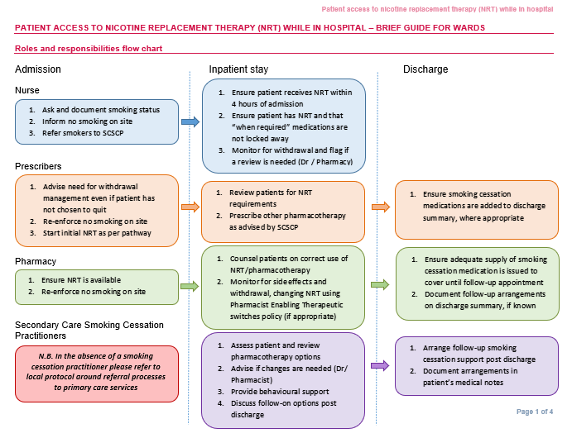

Figure 1 – AWMSG roles and responsibilities flow chart for patient access to NRT while in hospital

Another key part of the process described in figure 1 is the referral of patients who smoke to an in-house smoking cessation service. This is also the responsibility of nursing staff and should be undertaken as part of the ward admission process. To establish the staffing levels required for a new ABUHB hospital-based smoking cessation service, accurate representation of the number of smokers attending hospitals within ABUHB must first be obtained. The Ottawa model (Reid et al, 2010) can then be used to calculate the required staffing levels.

Current ABUHB process for documentation of smoking status

The smoking status of an in-patient should be logged in two paper documents, completed on admission to hospital. These are:
- The ‘Social History’ section of the ABUHB Emergency Assessment Proforma, completed by the doctor that undertakes the initial assessment of the patient on admission to hospital (Figure 2).
- The ‘Breathing’ section of the ABUHB Hospital Admission Document (Adults), known as the Patient Care Record (PCR), completed by the nurse responsible for the patient once they are admitted to a ward within the hospital (Figure 3).

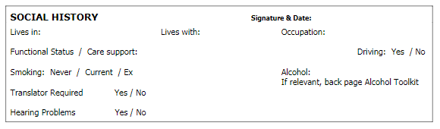

Figure 2 – Social History section of the ABUHB Emergency Assessment Proforma

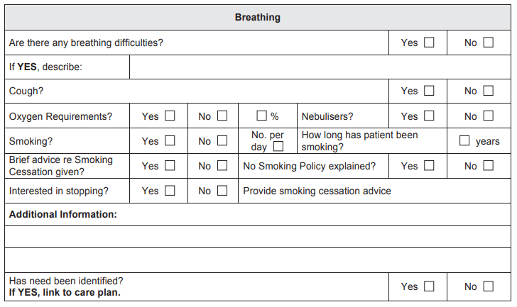

Figure 3 – Breathing section of the ABUHB Hospital Admission Document (Adults)

The information recorded regarding smoking status within these documents differs, with a greater level of detail required in the nursing documentation. As with all paper assessments, sections are often left incomplete (Jamieson et al, 2017, p,127), limiting the usefulness of the data. The availability of data within paper documents is also limited, as it requires manual extraction and duplication of effort to enter the data into a secondary digital source (should one be available).

Current ABUHB process for referral for smoking cessation support

ABUHB in-patient referrals for smoking cessation support are made in one of two ways:
- Completion of an on-line Help Me Quit (HMQ) professional referral form. The HMQ hub then email the details of hospital-based referrals, back to the ABUHB smoking cessation teams generic email account (Evans, 2022).
- By directly emailing the ABUHB smoking cessation teams generic email account (Gray, 2022).
Neither of the current referral mechanisms are integrated with other admission processes. Both require the referrer to have the time and opportunity to access either the HMQ website or their HB email account.

Aim of the Project

This work will look specifically at the ABUHB Smoke Free Environment Policy aim “To provide guidance for staff supporting patients admitted to the hospital who smoke”. The SFIG felt that this aim would be best supported by focusing on two main work strands:
- Implementation of the AWMSG guidance
- Re-establishment of the ABUHB hospital-based smoking cessation service
This report will describe an overview assessment of whether a digital strategy could be used to achieve this aim and its associated work strands.

Methodology

Service Improvement Analysis

The specific service improvements linked to the chosen aim were identified as:
- Patient Identification
- Training on the updated policy
- Access to NRT in a timely manner
- Access to services – via referrals
From a technical perspective, ‘patient identification’ and ‘access to services – via referrals’, have clear potential to be supported through digital solutions. The next step in the process was to identify the associated technology requirements.

Technology Requirements

Whether assessing existing software or developing/commissioning new software it is important to first set out the functional and non-functional requirements (NFRs). Functional requirements define the specific behaviours or functions that the system must undertake. i.e., what the system is supposed to do. NFRs are used to assess how well a system operates i.e., how the system is supposed to be (Wikipedia, 2022).

Functional Requirements

These can be broken down into features and capabilities. A feature is a service that the system fulfils, based on a stakeholder need. Capabilities are high-level solution behaviours and are usually then split into features that can be delivered in Program Increments (PI’s) (Scaled Agile, 2022a).
Before the capabilities and features could be defined, a Business Process Modelling Notation (BPMN) was undertaken to show the journey of a patient (who smokes) throughout a hospital admission. Following this a Feature and Benefits (FAB) matrix was used to define the ideal system features (Scaled Agile, 2022a).

Non-Functional Requirements (NFRs)

NFRs, also referred to as system qualities, ensure the effectiveness and usability of a system (Scaled Agile, 2022b). They should be written quantitatively, so that they can be measured against objectives and tested (Sommerville, 2016, p.110). Functions covered by NFRs include:
- Security
- Reliability
- Performance
- Maintainability
- Scalability
- Usability

Technical standards

A review of data required to achieve the goals was undertaken. Along with terminology used within the system and the interoperability needs, between any new system and current systems.

Gap analysis methodology
There are various methodologies that can be used for gap analysis. Each is broadly designed to focus the reviewer on the current state of play, the desired outcomes and what needs to happen to achieve them. For this review, the Forbes gap analysis (Leonard & Bottorff, 2022) was used. The following four steps of the Forbes methodology were undertaken:
- Identify the current situation
- Set SMART goals for where we want to be
- Analyse the gaps between where we are and where we want to be
- Establish a plan to close the gap

Options Appraisal Methodology

The Local Partnerships & HM Treasury (2012) Options Appraisal workbook has a 5-phase approach as detailed below in Figure 4. For this review only some of the elements from the 5-phases were considered, due to the limited scale of the review.
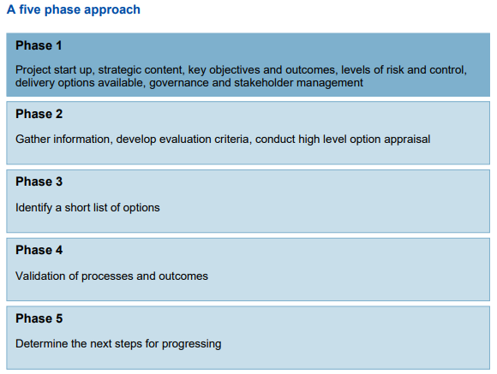

Figure 4 – The five-phase approach as detailed in the Local Partnerships & HM Treasury (2012) options Appraisal workbook.

Results

Technology Requirements

Functional Requirements
The BPMN describing the patient journey of a smoker when admitted to hospital is shown in Figure 5.
- The section highlighted in blue is currently processed via the HMQ on-line referral form, with data then stored centrally within the national HMQ database.
- The sections in orange are processed within the ABUHB Clinical Workstation (CWS), an in-house system, where electronic discharges are generated. Outputs from CWS (including discharge prescriptions) are communicated electronically to the patient’s General Practitioner (GP).
- The section in green is processed by the cessation team, with all documentation entered and stored within the Quit Manager® system. Quit Manager® is a smoking cessation database used by smoking cessation services across the UK (Brose et al, 2013). Quit Manager® is not integrated to any other healthcare systems.

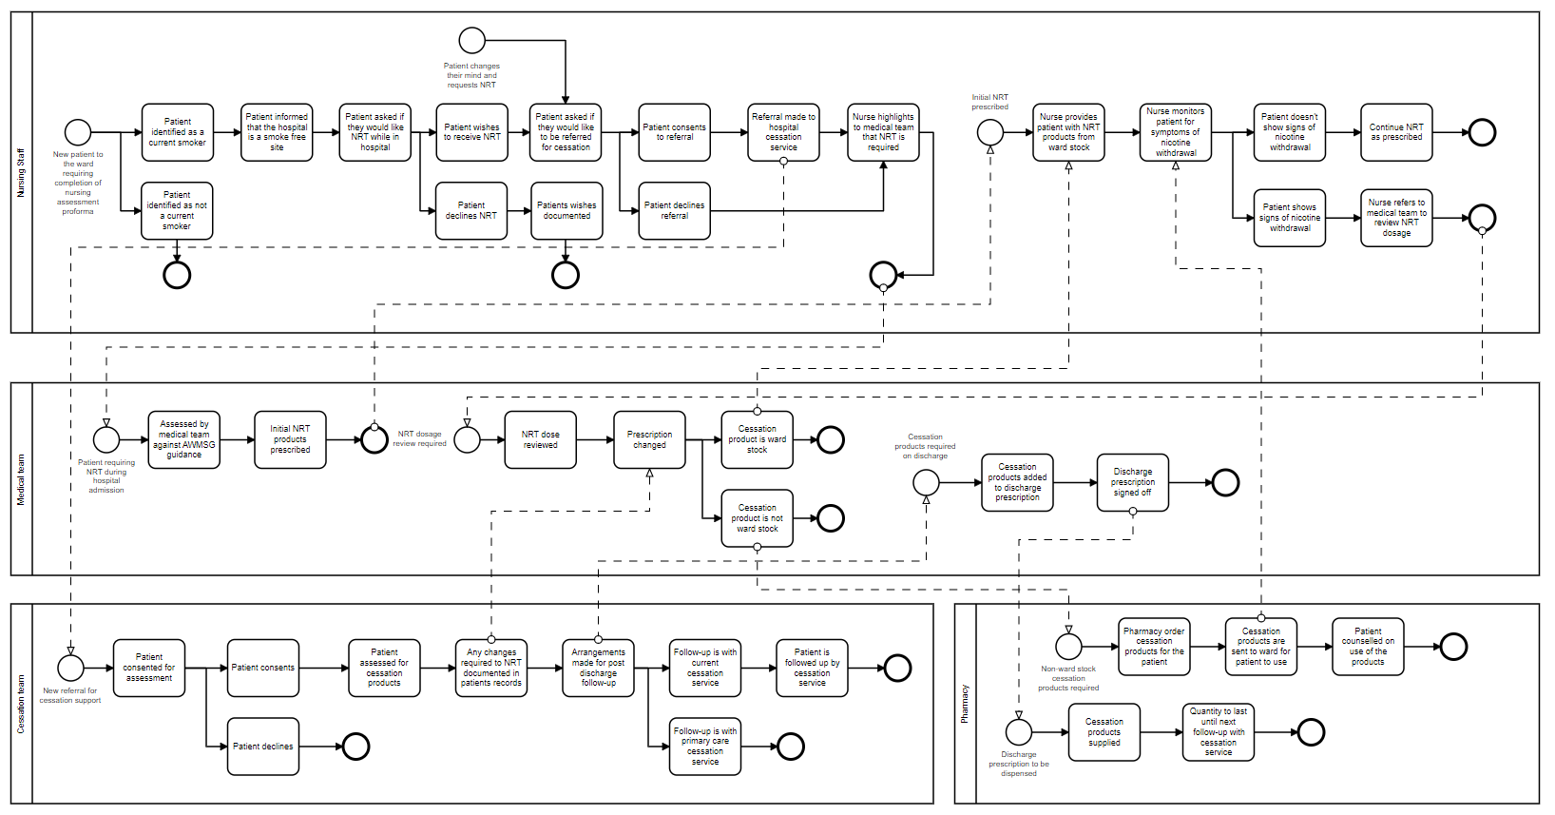

Figure 5 – BPMN of the in-patient smoking cessation journey

Table 1 below shows the completed FAB matrix, detailing features, and their associated benefit hypothesis. Derived from analysis of the BPMN.

Table 1 – FAB matrix for a hospital based smoking cessation system

Feature | Benefit Hypothesis
Automatic closed loop referral system | Will allow patients who smoke to receive timely cessation support during a hospital admission, with follow-up support on discharge with the appropriate cessation service
Shared access to information | By linking the patients smoking status to other digital records, patients can be identified and offered treatment and support in line with guidelines
Auditability | By linking smoking rates among hospital in-patients with in-patient referral rates (and subsequent quit rates) the success of the cessation service can be measured

Based on the BPMN and FAB matrix results the suggested functional requirements for the proposed system are detailed below in Table 2.

Table 2 – Suggested Functional requirements

 | Functional Requirements
1 | A user shall be required to log the smoking status of the patient as part of their admission information
2 | The system shall generate data to show the number of overall patients classified as a “current smoker” as well as the number that have requested support for their nicotine addiction during their in-patient stay
3 | The system shall generate an automated referral to the in-house smoking cessation service
4 | To system shall be able to display auditable data linked to smoking status and referral rates

Non-Functional Requirements (NFRs)

Table 3 below show the suggested NFRs by criteria and includes rational for each requirement.

Table 3 – Suggested Non-Functional requirements

Criteria | Rational | Non-Functional Requirement
Security | The system will contain patient data, so requires secure access and a digital audit trail | - Login to the system shall be using NADEX* credentials  - All entries and amendments within the system will be logged against the users’ NADEX credentials
Reliability | Loss of data can have a significant impact on patient care; therefore, there should always be a way to access the information for business continuity | - The system must be able to print a copy of the patient record during internet service interruptions
Performance | The system needs to provide data back-up in real time as well as for business continuity | - The system should work in real time
Maintainability | There will be a requirement for PI’s, which should be managed without affecting the system | - Updates should be managed to reduce / avoid system down time
Scalability | There are likely to be large numbers of simultaneous users logged into the system at any point in time | - The system shall be able to support large numbers of users simultaneously without loss of performance
Usability | The system needs to be intuitive and easy to use at the point of care | - The system should run on mobile devices  - The system should allow users to come back and update information, without losing data

*NADEX referrers to the National Active Directory & Exchange, which allows users access to systems from any NHS designated computer, via a unique authenticated identity (DHCW, 2021a).

Data collection and analysis
Current data availability is limited, due to a combination of paper-based processes and a lack of interoperability between electronic systems. With some data stored only on paper documents and electronic data stored within systems that do not allow for data transfer (e.g., Quit Manager®). The HMQ call centre can provide data on current ABUHB referral rates, provided the referrer has indicated an ABUHB hospital location, within the HMQ on-line referral form. Which is likely to yield incomplete results.

Knowledge management
Electronic Medical Records (EMRs) have been shown to be superior to paper documents with regards to completion rates (Moy et al, 2021, p.1005.), but they can take longer to complete (Akhu-Zaheya, Al-Maaitah & Bany Hani, 2018). When an EMR is well resourced and customisable, improvements can be seen in patient care (Bennett and Steen, 2010 p.338.). A Cochrane review of the use of EMRs to support smoking cessation, concluded that facilitating easy electronic documentation of smoking status and referral improved referral rates (Boyle, Solberg & Fiore, 2014).
When collecting smoking status within an EMR the quality of the data is important. Free text boxes result in data that is difficult to analyse. However, data discrepancies can occur over time when using set descriptors e.g., a patient being changing from a “current smoker” to “never smoked”, instead of an “ex-smoker” (Polubriaginof et al, 2018, p,1392.). If the system were to pull relevant data from previous admissions, then data discrepancies may be minimised, but not removed. An alternative would be to annotate smokers using a Boolean value. This is defined as a TRUE or FALSE expression (IBM, 2022), eliminating data discrepancies. Either the patient is a “smoker”, or they are not.

Technical standards
Data collected should be standardised to ensure interoperability between systems. To generate an automated referral a unique patient identifier is required. Within the current systems there are two patient identifiers: Hospital number (also known as a Case Reference Number (CRN)) and the NHS number (NNN). The CRN is specific to CWS, whereas the NNN is used across all healthcare systems (including CWS). Therefore, the NNN should be the standard for ‘patient identification’.
Documentation of smoking status should also be standardised. The smoking status serves two functions within the required system: quantifying smoking rates for in-patients and as a trigger for an automated referral. Terminology is important here, as correct classification of a patients smoking status could be used to ratify outcomes against policy implementation. The use of SNOMED-CT in this instance provided data consistency. SNOMED-CT is regarded as a common global language within coding systems and health terminology (NIH, 2016).

Gap analysis
The results of the four steps of the Forbes gap analysis are described below.
Current situation
A report (Flatman, 2022), which looked at baseline completion of paper nursing documentation across ABUHB, concluded that:
- Some sections of the PCR are frequently missed, with no data entered
- The PCR is not routinely updated during the patient’s admission
- Storage location of the document can contribute to poor updating, for example where it is kept separately to the nursing notes
A recommendation of the report was to move to an electronic document.

Digital technology is already in use on wards across ABUHB, with vital signs such as blood pressure and weight being entered via iPad mini devices, available at the patient’s bedside using CareFlow Vitals® software. This data is then made available within the patient’s CWS record.

Smoking status is assessed on two paper documents during admission but is not recorded electronically. Ascertaining the actual number of smokers who are in-patients within ABUHB acute hospitals at any one time is therefore impossible under the current system. Transfer of this data to an electronic system would require an additional process step that is not achievable with current workloads and pressures on staff. Workload pressure may also impact referral rates, as both mechanisms for referral require an additional process, which is separate from other documentation.
SMART goals
The following SMART goals were identified:
- To document smoking status within an electronic system for 95% of in-patients by September 2022
- To make closed loop automated electronic referrals to an in-house smoking cessation service available within ABUHB by September 2022

What is missing?
There is no interoperability between processes or data. Each task is undertaken in isolation and there is a lack of traceability and auditability of the data in its current format.

Training among all staff around awareness of the legislation, the guidance available to support compliance and the expectation for their individual roles is also lacking. An issue that can arise with training is the added time burden.

Availability of cessation staff to assess patients. Current staffing levels within ABUHB consist of:
- 2 whole time equivalent (WTE) band 5 hospital smoking cessation advisors, working 37.5 hours over a 5-day working week.
- Covering all 4 acute hospital sites within ABUHB and one community hospital. They may also be required to cover the ABUHB community and maternity smoking cessation services.
- Attendance at each acute hospital site is currently, a single advisor for one-half day clinic session per week (Evans, 2022)
For a service to meet the requirements of a hospital base service, as set out in a recent draft policy circulated by WAG, then a 7 day a week service is required, with sufficient staff for the health boards smoking population.

Plan for closing the gap
What is needed is a system that can be utilised by all staff collecting patient data, to populate a single electronic patient record. This will allow all users to be able to identify which patients smoke and to therefore undertake the required assessments, referrals, and actions. A closed loop referral system, which is part of this electronic record, is also required. It should generate an automated referral (to an in-house service) (Patel et al, 2018, p. 716.), based on smoking status, without the need for completion of a separate referral document. The patient information already in the system should populate the automated referral.

While it may not be possible to develop a full electronic patient record within the assigned timeframes, it may be an option to incorporate some of the key features and requirements within one of the systems currently being utilised.

Options Appraisal

The following sections have been determined based on the Local Partnerships & HM Treasury (2012) Options Appraisal workbook 5-phase approach.

Phase 1 – What options are available?
It was decided that only systems currently in use, or due for roll-out within ABUHB, would be included in the review. There is no scope either within budgets or time frames to commission a bespoke system. The systems included in the review were:
- CWS – an in-house system
- CareFlow Vitals® - an outsourced off the shelf (OTS) product
- Quit Manager® - an outsourced off the shelf (OTS) product
- Welsh Clinical Portal (WCP) – a shared services product developed by DHCW (DHCW, 2021b)
- WNCR – a shared services product developed by DHCW (Centre for Digital Public Services, 2021) in-use across Wales (Ford, 2021)

Phase 2 – What information is needed for the assessment?
A combination of the technical requirements and information from the gap analyses was used to assess each of the systems. Table 4 below shows the requirements mapped to each of the system options.

Table 4 – Mapping of available systems to defined requirements

Requirement | System
Requirement | CWS | CareFlow Vitals® | Quit Manager® | WCP | WNCR
Mandated recording of smoking status | Possible development |  | 
Can pull data on smoking status | Possible development
Generates automatic referrals | Possible development |  |  |  | Possible development
Customisable dashboard display |  |  |  | Possible development
Log in with NADEX
Digital audit trail utilising NADEX
Saves automatically
Is printable
Works in real time
Not slowed by multiple users
Minimal disruption with PI’s
Support multiple users
Can be run on a mobile device
Allows users to update without loss of data

Phase 3 – Short list of options
Based on information gathered during the review and the outcomes for the Phase 2 assessment the following two system options remain:
- CWS
- WNCR
The other systems were excluded from the short list for the following reasons: To make CareFlow Vitals® a viable option, would require the addition of a smoking status field and the ability to generate automated referrals. As a commercial (OTS) product, the likelihood of local development requests being accepted and actioned in the required timeframes is minimal. Quit manager® and WCP were excluded, as neither is routinely accessed by nursing staff as part of their core duties. This adds addition work, where capacity is not available.

Phase 5 – Next steps
To investigate if the missing requirements from either of the remaining systems can be developed and the timeframes mapped to the SMART goals.
As CWS is an ABUHB in-house system, the development of new features for any missing requirements is a possibility. CWS already has the functionality to push out an email when prompted. Therefore, generating an automatic referral could be achieved. The addition of smoking status to admission demographic could also be requested. However, timeframes may be the rate limiting factor for selecting CWS as the final system. The reviewer is aware that there is around a 3-year backlog of development requests, so the use of CWS may be excluded based on time frames.
WNCR is a new system due for roll-out within ABUHB this spring/summer and as such is still undergoing a degree of development and PI’s. Currently if a patient says yes to requiring NRT support while in hospital, the nurse can then ask if they wish to be referred for support and open a link to complete the Help Me Quit Professional referral form. This could be changed at a health board level to send an automated email, to a named email account. Limited duplication of effort and data.

Discussion

WNCR is due to roll-out across all sites within ABUHB in spring/summer 2022. There is already an implementation plan in place for WNCR, managed by the ABUHB informatics team. Prior to roll-out the reviewer will link in with the ABUHB nursing informatics leads for WNCR, to request the amendment to the current referral process. Discussions have already taken place around the requirements for a dashboard to review data from WNCR around smoking status and referrals. The dashboard can then be used as part of the evaluation data.
The ABUHB cessation team already collect data on referral rates, which can be monitored to show the impact of WNCR implantation.

Conclusions

- Without the use of technology, to document smoking status and generate an automated referral to an in-house smoking cessation service, ABUHB will not meet the service improvement linked to the implementation of the AWMSG guidance.
- Any intervention must be part of a system already in use by staff as part of their core duties.
- The use of the WNCR to facilitator both data collection and to generate referrals is the best fit.

References

ABUHB (2021a) Smoke-Free Environment Policy. Available at: https://nhswales365.sharepoint.com/sites/ABB_Pulse_Policies/Corporate Policies/Forms/All Staff Documents.aspx?id=%2Fsites%2FABB_Pulse_Policies%2FCorporate Policies%2FSmoke-Free Environment Policy%2Epdf&parent=%2Fsites%2FABB_Pulse_Policies%2FCorporate Policies (Accessed: 6 April 2022) .
ABUHB (2021b) Smoke Free Legislation – FAQs for Staff. Available at: https://nhswales365.sharepoint.com/sites/ABB_Pulse_Policies/Corporate Policies/Forms/All Staff Documents.aspx?id=%2Fsites%2FABB_Pulse_Policies%2FCorporate Policies%2FFrequently Asked Questions SmokeFree Environmnet ABUHB Sites 0192a%2Epdf&parent=%2Fsites%2FABB_Pulse_Policies%2FCorporate Policies (Accessed: 6 April 2022) .
Akhu‐Zaheya, L., Al‐Maaitah, R. and Bany Hani, S. (2018). ‘Quality of nursing documentation: Paper‐based health records versus electronic‐based health records’. Journal of clinical nursing, 27(3-4), pp.e578-e589. https://doi.org/10.111/jocn.14097 (Accessed:5 May 2022).
AWMSG (2021a) Initial Clinical Management of Adult Smokers in Secondary Care. Available at: https://awttc.nhs.wales/files/guidelines-and-pils/initial-clinical-management-of-adult-smokers-in-secondary-care-pdf1/ (Accessed: 18 April 2022).
AWMSG (2021b) Patient access to nicotine replacement treatment (NRT) while in hospital – Brief guide. Available at: https://awttc.nhs.wales/files/guidelines-and-pils/patient-access-to-nrt-while-in-hospital-brief-guide-for-wards-docx/ (Accessed: 18 April 2022).
Bennett, K.J. and Steen, C. (2010). ‘Electronic medical record customization and the impact upon chart completion rates’. Fam Med, 42(5), pp.338-42. Available at: https://citeseerx.ist.psu.edu/viewdoc/download?doi=10.1.1.607.4640&rep=rep1&type=pdf (Accessed: 5 May 2022).
Boyle, R., Solberg, L. and Fiore, M., (2014). ‘Use of electronic health records to support smoking cessation’. Cochrane Database of Systematic Reviews, (12).
Brose, L.S., West, R., Michie, S. and McEwen, A. (2013). Smoking in Britain. Available at: http://www.smokinginbritain.co.uk/downloads/final/Brose et al. Success rate reports v3.pdf (Accessed: 5 May 2022).
Centre for Digital Public Services (2021) Nursing records go digital – a case study. Available at: https://digitalpublicservices.gov.wales/nursing-records-go-digital-a-case-study/ - :~:text=In%20April%202021%2C%20the%20Welsh,form%20at%20a%20patient%27s%20bedside. (Accessed: 3 May 2022).
Digital Health and Care Wales (2021a) Providing the Infrastructure. Available at: https://dhcw.nhs.wales/providing-the-infrastructure/ - :~:text=National%20Active%20Directory%20%26%20Exchange%20(NADEX,access%20to%20national%20electronic%20systems. (Accessed 2 February 2022).
Digital Health and Care Wales (2021b) Welsh Clinical Portal. Available at: https://dhcw.nhs.wales/systems-and-services/secondary-care/welsh-clinical-portal/ (Accessed 13 May 2022).
Evans, S. (2022) Conversation with Victoria Richards-Green, 18 May.
Flatman, L. (2022) Nursing Documentation Quality Audit Baselining Report. Internal Aneurin Bevan University Health Board report. Unpublished.
Ford, M. (2021). Digital nursing documentation system to be rolled out across Wales. Available at: https://www.nursingtimes.net/news/technology/digital-nursing-documentation-system-to-be-rolled-out-across-wales-14-06-2021/ (Accessed: 3 May 2022).
Gray, C. (2022) Email to Victoria Richards-Green, 25 January.
IBM Integrated Analytics System (2022) Boolean Values. Available at: https://www.ibm.com/docs/en/ias?topic=list-boolean-values (Accessed: 19 May 2022).
Jamieson, T., Ailon, J., Chien, V,.Ophyr Mourad, O,.(2017) ‘An electronic documentation system improves the quality of admission notes: a randomized trial’, Journal of the American Medical Informatics Association, Volume 24, Issue 1, Pages 123–129, https://doi.org/10.1093/jamia/ocw064
Leonard, K., Bottorff, C. (2022) Conducting A Gap Analysis: A Four-Step Template. Available at: https://www.forbes.com/advisor/business/gap-analysis-template/ (Accessed: 3 May 2022).
Local Partnerships & HM Treasury. (2012) Options Appraisal Workbook. Available at: https://www.local.gov.uk/sites/default/files/documents/pas-options-appraisal-wor-7f5.pdf. (Accessed: 3 May 2022).
Moy, A.J., Schwartz, J.M., Chen, R., Sadri, S., Lucas, E., Cato, K.D. and Rossetti, S.C. (2021). ‘Measurement of clinical documentation burden among physicians and nurses using electronic health records: a scoping review’. Journal of the American Medical Informatics Association, 28(5), pp.998-1008. Available at: https://academic.oup.com/jamia/article/28/5/998/6090156?login=true (Accessed: 5 May 2022).
NICE (2021) NICE guideline [NG209] Tobacco: preventing uptake, promoting quitting and treating dependence. Available at: https://www.nice.org.uk/guidance/ng209 (Accessed: 18 April 2022).
National Library of Medicine (NIH), (2016) Overview of SNOMED CT. Available at: https://www.nlm.nih.gov/healthit/snomedct/snomed_overview.html (Accessed: 19 May 2022).
NHS Data Model and Dictionary (2022). Available at: https://www.datadictionary.nhs.uk/attributes/smoking_status.html - :~:text=The%20SMOKING%20STATUS%20of%20the,the%20TOBACCO%20USAGE%20is%20recorded. (Accessed: 18 April 2022).
Patel, M.P., Schettini, P., O’Leary, C.P., Bosworth, H.B., Anderson, J.B. and Shah, K.P. (2018). ‘Closing the referral loop: an analysis of primary care referrals to specialists in a large health system’. Journal of general internal medicine, 33(5), pp.715-721. Available at: https://link.springer.com/article/10.1007/s11606-018-4392-z (Accessed: 5 May 2022).
Polubriaginof, F., Salmasian, H., Albert, D. A., & Vawdrey, D. K. (2018). ‘Challenges with Collecting Smoking Status in Electronic Health Records’. AMIA ... Annual Symposium proceedings. AMIA Symposium, 2017, 1392–1400.
Reid, R.D., Mullen, K.A., Slovinec D’Angelo, M.E., Aitken, D.A., Papadakis, S., Haley, P.M., McLaughlin, C.A. and Pipe, A.L., (2010). ‘Smoking cessation for hospitalized smokers: an evaluation of the “Ottawa Model”’. Nicotine & Tobacco Research, 12(1), pp.11-18.
Scaled Agile, Inc. (2022a) Feature and Capabilities – Scaled Agile Framework. Available at: https://www.scaledagileframework.com/features-and-capabilities/. (Accessed: 3 May 2022).
Scaled Agile, Inc. (2022b) Nonfunctional Requirements – Scaled Agile Framework. Available at: https://www.scaledagileframework.com/nonfunctional-requirements/. (Accessed: 3 May 2022).
Sommerville, I. (2016) Software Engineering. Pearson.
The Smoke-free Premises and Vehicles (Wales) Regulations 2020 (SI 2020/1221 (W.273)). Available at: https://www.legislation.gov.uk/wsi/2020/1211/contents/made (Accessed: 6 April 2022).
Wikipedia (2022) Non-functional requirement. Available at: https://en.wikipedia.org/wiki/Non-functional_requirement. (Accessed: 7 May 2022).

