Cai Howes (2205975)

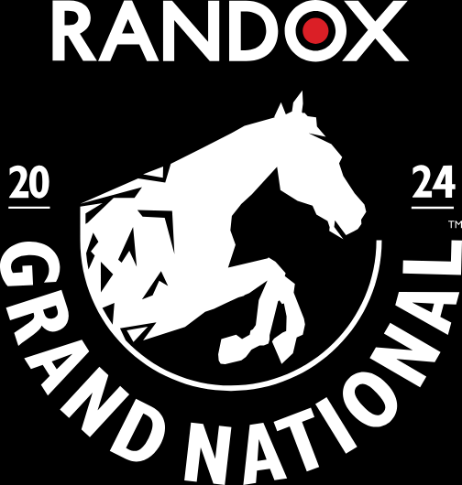
Research Project – The Grand National
BMTP5022

Contents

Introduction 2
Methodology 2
Netnograpghy 2
Triangulation 2
SWOT Analysis 2
PESTEL Analysis 3
Findings &Analysis 3
Conclusions and Limitations 3
References 3

Introduction
The purpose of this field study is to assess the business performance of the Grand National and the economic benefits it has on the surrounding hospitality sector.
The Grand National is a national horse race that started in the early 1800s, with the first-ever win coming from a horse called Lottery in 1839. Currently, the Grand National takes place in Aintree, Liverpool, and is owned by Jockey Club Racecourses which is one of 14 operated by the Jockey Club subsidiary (The Jokey Club 2023). It is one of the biggest events of the year in the UK, and over the course of three days, approximately 150,000 people attend the event annually, with an additional 600 million people watching it around the world (BBC 2023). According to the BBC (2023), the Grand National brings a massive boost to the Liverpool economy, claiming that in 2022, it brought in over £60 million.
The horse race is run over three days: The Opening day, The Ladies’ Day, and the Grand National day. They offer a range of package deals such as restaurant packages and private boxes (The Jokey Club 2023).

Methodology
To assess the current business performance of the Grand National and its economic benefits to the surrounding hospitality sector, the following research methods will be employed: Qualitative and quantitative, Netnograpghy, triangulation, SWOT and PESTEL analysis will be employed.
Qualitative and Quantitative
Research is the process of collecting, analysing, and interpreting data to understand a phenomenon (Leedy and Ormrod). The Qualitative research method is a method of gathering in depth and descriptive information on a topic. It is mainly used when a company needs to further understand people's attitudes, beliefs experiences, interactions and behaviours. It can take place in many different ways such as interviews, focus groups, case studies and observations to name just a few (Pathak, Jena and Karla,2013). Moving on to Quantitative data this method has to do with analysing and quantifying information to obtain numerical data. It focuses on data that says the “what, when, how, where and how many questions(Apuke, 2017). There are however some negatives about both studies. Qualitative studies normally are more time consuming and is research-intensive so the number of people you will be able to speak to is limited. Also as a result it's harder to say that the views represent the views of a wider population because the number of people you have asked are small and only gather a small percentage of opinions. The negatives of quantitative research are that you get less insight into the thoughts on why people chose what they did and as a result get a less detailed picture. Jason Mander (2022).

Netnograpghy

The Netnographic method is an extension of ethnography, the main difference between them is that the netnographic method uses online methods such as the internet, mobile phones and other online devices (Rhazzali, 2015). Netnography uses marketing research to reveal habits, social behaviours and needs of customers. It helps to analyse problems businesses have and develop solutions to problems with the power of social media (Kozinets, 2018). According to Kozients (2018), there are four types of netnorgraphy: autoethnography, symbolic netnography, digital netnography and humanistic. Netnography can also help to monitor the newest trends whilst seeing what improvements need to be made in the business. Some positives of it are that is it cost-effective and it saves the need for travel and equipment. It also gives you an understanding of communities and you have a large pool of data which captures the dynamics of online communication such as tone and sense of humour. In the negatives, it demands high expertise so it's heavily reliant on a person's knowledge of what platform they have used. The reliability of the study is an issue with people who might be biased or the participants might not be from the demographic you are trying to reach. Moradeke Owa (2023)

SWOT Analysis

Swot analysis is a tool designed to help companies reach their full potential, optimize performance, manage the competition, and minimize risk. The main purpose of having a Swot analysis is to help make better decisions and evaluate the efficacy of a product or service (Gomer and Hille, 2015). A Swot analysis can be broken down into four main areas: strengths, weaknesses, threats and opportunities. Ioannou (2012) defines strengths as “the resources and capabilities that can be used to develop a competitive advantage”. The main idea of highlighting weaknesses is to try to turn them into strengths in the future. The purpose of opportunities is to recognize opportunities for growth, greater profit and a larger market share and then to think of what can be done differently. Threats look at external factors that can impact services, so that mitigation and planning can be considered (Gomer and Hille, 2015). Swot analysis offers both positives and negatives. The simplicity of the swot analysis is one of the positives it requires no technical skills or training so it can be performed by anyone who knows the business. Also, the cost the company can hire a staff member to do the analysis rather than spend money on an external consultant. The swot analysis has no tool to rank one factor versus the other so it is difficult to judge whether one factor's true impact on the objective. The swot creates a one-dimensional model which doesn’t have anything if one factor is both a strength and weakness which says about the ambiguity of the method. Billie Nordmeyer (2019)

Triangulation

The purpose of triangulation is to maximise the credibility and validity of the research findings. Triangulation is a good way to see human behaviour and understand why people make certain choices. It is a method that can enrich research and offer different datasets, explaining different aspects of a phenomenon of interest. Triangulation can explain why the results of the study happened in the way that they did. The core aim of triangulation is that when methods lead to the same results this gives more credibility to research findings (Noble and Heale, 2019). Some of the positives include revealing unique findings, challenging or integrating theories and providing a clearer understanding of the problem at hand (Thurmond, 2001, p. 254). One of the disadvantages of the triangulation method is that it can be time-consuming the more data you collect requires more planning and organization which aren’t always available. (Thurmond, 2001). another negative is that there could be disharmony in the group because it is based on investigator biases. ” (Thurmond, 2001, p. 256).

Findings &Analysis

Using the key methods I have laid out we will now talk about my analysis.
Netnography
The Grand National uses netnography in many ways one of the main ways it uses netnography is by seeing what people have said on TripAdvisor. According to D Sumarsono Trip Advisor is one of the most treated customer review sites on the internet and is different from Trivago and Traveloka which don’t provide customer reviews. It is a way for customers to find out about an event or travel destination by customers who have been there before. On the site TripAdvisor the Grand National has a four out of five stars which on the trip advisor scale relates to the event being “very good”. They have got mostly positive reviews on the site with 38 people rating it excellent one of the positive reviews came from Markforth who said “What a great day first class service and brilliant staff we couldn’t ask for more”. TripAdvisor(2022)
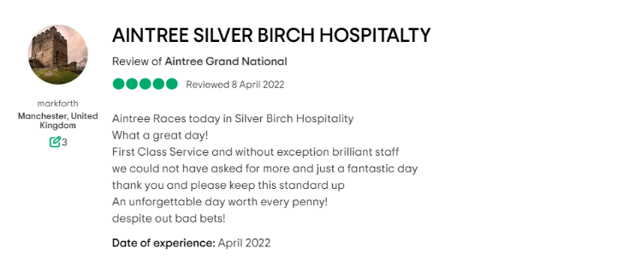

Only two people rated it one-star meaning terrible one of them being AndyD who said “Total rip off outrageous bar prices, the staff are as miserable as sin and I would never go again” TripAdvisor (2019)
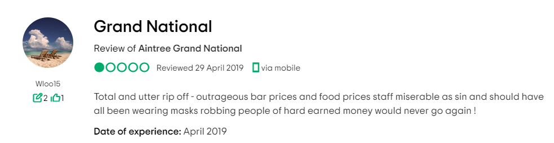

Qualitative and Quantitative research analysis

Using qualitative research we will look at an interview done by an animal rights group. GB News Ben Laidman said in his interview that he plans to protest the grand national happening. He says “The sport is wrong and we should be doing better than using animals for food and fun” he goes on to say that “everyone who wants to take part in the protest to come down at 9:30 on the 15th to learn more”. Ben Newman (2023). In another interview we get another perspective Charlie Proctor says that saying horse racing is cruel is absurd. “The cruelty of animals towards animals has and never will be condoned by anyone in racing” he goes on to say that people who say “The Grand National is a horse killer or death trap is ridiculous this is extremely insulting to what the staff do who work with the animals”. Charlie Proctor (2017)

using qualitative research we can see that people's beliefs and attitudes are changing in horse racing. The grand national saw the greatest change in its YouGov/SMG insight sports index buzz score changing 3.8. BUZZ is one of 16 metrics recorded and asks people whether they have heard anything good or bad about the event in the last two weeks. The high change points to how the Grand National has been promoting effectively and how it has been able to deal with the criticism it faces regarding the safety of the horses. Amelia Brophy (2018)
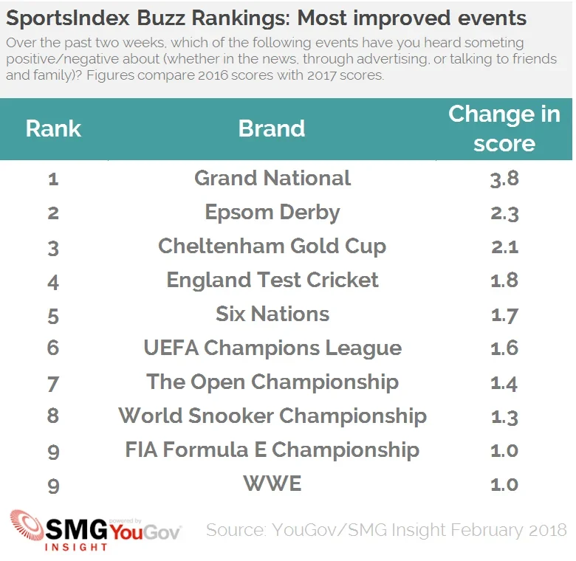

Using Quantitative research which is the research method where data is collected and stats are measured. (Saunders et al (2019, p. 175). We can see that the £60 million was split into 2 ways with £44 million coming from direct economic impact with 17 million being in direct. The Grand National was mainly attended by family and friends with only a small percentage 7.2% coming alone or with colleagues. The vast majority of people who come to the Grand National are regular customers with nearly 65% of them saying they go out of habit. 74% of people who are engaging with the event online are from the UK however there has been a rise in the number of overseas viewership with countries like India, USA, and Australia. LJMU (2023).

The SWOTT analysis
Starting with the strengths of the Grand National is steeped in history it being nearly two hundred years old people young and old have been going there for generations. According to the jockey club the Grand National is completely unscripted this makes the racing so exciting that anyone can win. The Jockey Club (2023). On to the weaknesses it has one of them being more and more people are seeing it as a cruel sport a YouGov poll was put out 2806 voted and 54% of people said that they either find it very cruel or fairly cruel to the horses. As for the threats the covid pandemic made the 2020 event cancelled for the first time since the second world war. It came back in 2021 but was behind closed doors so no spectators could attend. According to Dickson White, this has had negative impact not only on the event but on the whole economic impact it has on the Northwest region. Having the grand national benefits everyone including hotels and restaurants and even salons and barbers. Dickon White,(2022).
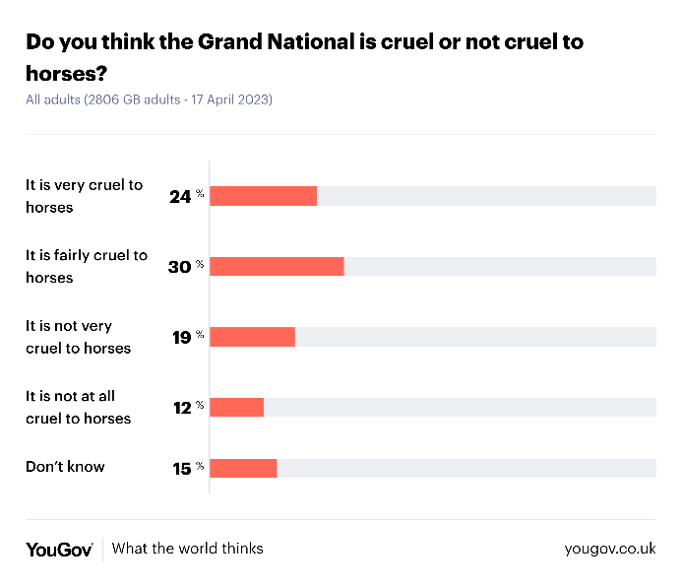

Conclusions and Limitations

To evaluate my study, I would say my strengths are that I have used more than one method in my findings and I have gone into depth on what are the pros and negatives of the methods. However, being that this case study can only be 2000 words I have found It difficult to say everything I wanted to with only a small study. I found that the most productive of the methods was the swot analysis as it had many different factors using both positives and negatives.

Strengths
- Detailed what the methods are I am using.
- Explained the pros and cons of the methods for a detailed analysis.
- Found great information from a range of different sources to see the full picture of what the people think about the grand national.
Weaknesses
- Limited word count so I haven’t been able to gather as much information as I would have liked
- Not being able to go to Aintree and interview them directly
- Too much theory and needs more about the economic side of the Grand National.

References

Barlow, E. (2022). Crowds prepare to return to Grand National Festival after two-year break. [online] The Independent. Available at: https://www.independent.co.uk/news/uk/aintree-grand-national-covid-north-west-b2052052.html [Accessed 6 Dec. 2023].
Blog, F. (2023). Netnography in Research: What it is, Important, Pros & Cons. [online] www.formpl.us. Available at: https://www.formpl.us/blog/netnography-in-research-what-it-is-important-pros-cons [Accessed 1 Dec. 2023].
Brophy, A. (2018). Grand National remains a sporting highlight for public despite safety worries | YouGov. [online] yougov.co.uk. Available at: https://yougov.co.uk/politics/articles/20578-grand-national-remains-sporting-highlight-public-d [Accessed 5 Dec. 2023].
Eddleston, S. (2018). Rugby makes strongest ever showing in SportsIndex Buzz rankings | YouGov. [online] yougov.co.uk. Available at: https://yougov.co.uk/society/articles/20296-rugby-makes-strongest-ever-showing-sportsindex-buz?redirect_from=%2Fnews%2F2018%2F02%2F26%2Frugby-makes-strongest-ever-showing-sportsindex-buz%2F .
Gomer, J. and Hille, J. (2015). FormSwift: SWOT Guide. [online] Available at: http://mci.ei.columbia.edu/files/2012/12/An-Essential-Guide-to-SWOT-Analysis.pdf .
Grand National 2019: Everything you need to know - CBBC Newsround. (2023). www.bbc.co.uk. [online] Available at: https://www.bbc.co.uk/newsround/17703344 [Accessed 6 Dec. 2023].
Grand National worth £60m to local economy, study finds. (2023). BBC News. [online] 13 Apr. Available at: https://www.bbc.co.uk/news/uk-england-merseyside-65252199 .
Mander, J. (2022). Qualitative & Quantitative Research Methods. [online] GWI. Available at: https://blog.gwi.com/trends/qualitative-vs-quantitative/ [Accessed 4 Dec. 2023].
Munro, C. (2023). Four Horses Die at the Grand National Festival 2023. [online] PETA UK. Available at: https://www.peta.org.uk/blog/grand-national-festival-2023/ [Accessed 8 Dec. 2023].
Noble, H. and Heale, R. (2019). Triangulation in Research. Evidence Based Nursing, [online] 22(3), pp.67–68. doi: https://doi.org/10.1136/ebnurs-2019-103145 .
Nordmeyer, B. (2019). Advantages & disadvantages of SWOT analysis. [online] Chron. Available at: https://smallbusiness.chron.com/advantages-amp-disadvantages-swot-analysis-41398.html [Accessed 5 Dec. 2023].
Proctor, C. (2016). No, the Grand National Is Not Cruel. [online] HuffPost UK. Available at: https://www.huffingtonpost.co.uk/charlieproctor/grand-national_b_9656590.html [Accessed 1 Dec. 2023].
Tripadvisor. (n.d.). AINTREE GRAND NATIONAL: All You Need to Know BEFORE You Go (with Photos). [online] Available at: https://www.tripadvisor.co.uk/Attraction_Review-g186337-d8820141-Reviews-Aintree_Grand_National-Liverpool_Merseyside_England.html [Accessed 8 Dec. 2023].
Tripadvisor. (n.d.). Grand National - Aintree Grand National, Liverpool Traveller Reviews. [online] Available at: https://www.tripadvisor.co.uk/ShowUserReviews-g186337-d8820141-r670216305-Aintree_Grand_National-Liverpool_Merseyside_England.html [Accessed 8 Dec. 2023].
Turk, A. (2023). Grand National set for chaos as animal rights group plan to stop race. [online] Express.co.uk. Available at: https://www.express.co.uk/sport/horseracing/1757019/Grand-National-animal-rights-planning-stop-race-Aintree [Accessed 8 Dec. 2023].
www.ljmu.ac.uk. (2023). Randox Grand National Festival worth more than £60 million for Liverpool City Region. [online] Available at: https://www.ljmu.ac.uk/about-us/news/articles/2023/4/12/grand-national [Accessed 8 Dec. 2023].
www.thejockeyclub.co.uk. (2023a). Event History. [online] Available at: https://www.thejockeyclub.co.uk/the-grand-national/about-the-event/grand-national-event-history/?clickid=a9bed4b5-920d-11ee-bd3f-0a0bd9fb2d25 [Accessed 8 Dec. 2023].
www.thejockeyclub.co.uk. (2023b). History. [online] Available at: https://www.thejockeyclub.co.uk/aintree/about/history/#:~:text=They%20provided%20the%20solid%20foundation [Accessed 5 Dec. 2023].
www.thejockeyclub.co.uk. (2023c). The Randox Grand National. [online] Available at: https://www.thejockeyclub.co.uk/the-grand-national/ [Accessed 3 Dec. 2023].
www.tripadvisor.co.uk. (2022). markforth | @markforth | Profile on Tripadvisor. [online] Available at: https://www.tripadvisor.co.uk/Profile/markforth [Accessed 8 Dec. 2023].
yougov.co.uk. (2023). Do you think the Grand National is cruel or not cruel to horses? | Daily Question. [online] Available at: https://yougov.co.uk/topics/sport/survey-results/daily/2023/04/17/0896d/1 [Accessed 28 Nov. 2023].

SWOT ANALYSIS
Ioannou, Charlie. SWOT Analysis: An Easy to Understand Guide. (2012)

Strengths and weakness / threats
SWOT Analysis II: Looking Inside for Strengths and Weaknesses. Harvard Business School Press.(2005)

Thousand Oaks, CA: SAGE Publications. Leedy, P. & Ormrod, J. (2001).
Apuke, D. O. (2017). ‘Quantitative Research Methods : A Synopsis Approach’ Journal of Business and Management Review 6(11), p. 40-47. DOI: 10.12816/0040336.
Pathak, V., Jena, B., & Kalra, S. (2013). Qualitative research. Perspectives in Clinical Research, 4(3), pp.192-194. DOI: 10.4103/2229-3485.115389.

