
Planning and Delivering an International Meeting/Event
International Meetings Management BMIH6007

Lecturer: Kathryn Flynn
Cecilia Maria Cojocaru(1816288)
WORD COUNT: 2702

ACKNOWLEDGEMENT OF AI TOOLS USE
I acknowledge the use of Grammarly (https://grammarly.com/) on 07.11.2024 to check my work using the prompt: check the text for readability, grammar and syntax,
I confirm that I have not presented any AI generated text as my own work. I confirm I have copies of my drafts, notes and other resources I used before and after the use of AI tools which I may be asked to provide in evidence.

Executive Summary
The International Christmas Market Charity Event will take place at the Mansfield City Centre from November 29 to December 1, 2024. This event is designed to bring together diverse local and international communities, celebrating Christmas traditions from around the world while raising funds for underprivileged children. With a mix of festive activities, charity auctions, and culturally themed stalls, the event aims to revive the Christmas spirit and support a good cause.
Why a Christmas Market event? Probably you will already put in your mind this question! And I know they are common in December period, but I have found some massive unique prepositions in comparation with competition. For example, our event involves all international cultures, and it’s located in a small town besides the other similar events which involve just the local country which takes place in and they usually take place just in the big city. Another fact which I take in consideration it’s our event promote culture exchange, local businesses and also put a lot of accents on sustainability (promote by our eco-friendly decoration stall) beside of other events how just give you the impression of: “HAVE TO BE DONE, IT IS A TRADITION! Of course nothing will be possible to put in practice if we don t think about an bouget, sponsors and founds, so we based on our Local council –full sponsorship :offering the free city centre market street with all free access on council parking near the location, light, electricity and water for all business and country participation; charity foundation witch contribute with all ingredients for Santa cookies, and small presents for the event competitions; and we try to attract as many we can Other local business:-Hotel Premier Inn (offering 30%discount on the days of events for all international participants;-local restaurants offering discount for food for all international participants on events; and other small business witch donated sweets for our charity cause. Apart of all the unique phrase created by this event our stockholder’s slogan it’s: “Bring community together for a good charity cause!” and we relied on stockholders which involve local Council; Local and internationals charity organizations; Baking and cooking's schools; Arts and design schools; Local hotels and accommodation; Local business and individual businesspeople. About our marketing strategy of course we need and have one based on social media (using all social media platforms), Secure Sponsors, focus on the Charity, Newsletters and Leaflets, Invitation local television and radio to speak about event, and an Post-Event Marketing (feedback after event, and take in consideration all suggestion for next year event).
In conclusion, my report its aim to present in detail a plan for an massive International Charity Event, from start to post event evaluation by integrating community engagement and corporate partnerships aspires to bridge this gap and bring the holiday spirit to children in need.

Contents
ACKNOWLEDGEMENT OF AI TOOLS USE 1
Executive Summary 1
1.0 Introduction 3
2.0 The Event Cycle 4
3.0 Event Concept 5
4.0 Aim and Objectives of the Event 6
5.0 Event Management 9
6.0 Event Budget 11
7.0 Industry Trends / Issues / Impacts 12
8.0 Situational and Cultural Considerations 13
9.0 Conclusion 15
10.0 Reference list 15

1.0 Introduction
The International Christmas Market Charity Event, which will be hosted in Mansfield's City Centre Market from November 29 to December 1, is a large-scale, festive event designed to spread holiday cheer while boosting funds for underprivileged youngsters. This event is inspired by the traditional Christmas markets in Europe, this event brings a multicultural twist, with stalls showcasing artisan goods, holiday foods and traditions from several countries. By raising funds, the event aims to ensure that every child, regardless of their family's financial situation, can experience the joy of receiving a Christmas gift. Mansfield is an ancient Nottinghamshire market town (Ourmansfieldandarea, 2024). The reason for choosing this location as the place for a charity event was its accessibility and strong community support. Mansfield's City Centre Market is a popular venue, drawing thousands of visitors each month. Henceforth, the city centre makes an ideal spot to attract attendees and maximise donations. The significance of this event is strengthened by recent statistics on child poverty in the UK. One of the reports has shown that 4.3 million children in the UK live in poverty, representing about 3 in 10 of all children (Org, 2024). During the holiday season, the need for support becomes even more pressing, as many families cannot afford necessities, let alone holiday gifts. By integrating community engagement and corporate partnerships, this event aspires to bridge this gap and bring the holiday spirit to children in need.

2.0 The Event Cycle
The Event Management Body of Knowledge (EMBOK) model provides a structured approach to managing events effectively. It covers five main stages: Initiation, planning, implementation, event and closure (Silvers and O’Toole, 2020). Applying the EMBOK model framework to the International Christmas Market Charity Event provides details about how it is meticulously planned and executed.
Initiation: During this stage, goals are set, and target audiences are defined such as local families, internal visitors and corporate sponsors. Henceforth, research was conducted to understand the demographics of Mansfield trends and historical holiday event attendance. Through this, it is projected that an estimated of 5,000 attendees would attend the event over a three-day period.
Planning: In this stage vendor participation, arranging the logistics such as power, safety and sanitation as well as layout was set up. Marketing activities have also been planned through social media and PR campaigns to increase visibility by targeting both local audiences and corporate donors. Estimated costs that have been determined are £5,000 for marketing and £3,000 for venue-related expenses.
Implementation: In this stage of the event, vendors and volunteers are organised with specific roles in crowd management and donations. The donation stations would be set up across the market and the logistics would be ensured for seamless setup of decorations, stalls and equipment.
Event: The event would open with a tree-lighting ceremony, and it would also include performances, cultural foods and live donation updates to boost contributions. Volunteers would support the guests and donations are encouraged through real-time tracking and engagement.
Closure: The event would conclude with cleanup, post-event feedback collection and reporting on the funds that would be raised. Tallying of the donations, acknowledging the sponsors and future event planning would be done. Lastly, sponsors and volunteers would be given thank-you notes and the outcomes of the event would be shared with the community to highlight the impact.

3.0 Event Concept
The International Christmas Market Charity Event will offer a fully immersive holiday experience over three days, combining entertainment, food and shopping with charity initiatives. Below presented is the breakdown of the itinerary and guest experiences:
Day 1: November 29
10:00 AM: The opening ceremony with local school chores singing the carols and the council leader of Mansfield kicking off the event with a speech consisting of a charity mission.
12:00 PM to 8:00 PM: Various stalls featuring international holiday foods, crafts, and decor from regions like India, France and Singapore.
3:00 PM: Baking cookies for Santa where the children would have the opportunity to learn how to bake cookies and biscuits with help of students from local baking schools.
6:00 PM: Christmas tree lighting ceremony accompanies by a live performance to enhance the festive atmosphere.
Day 2: November 30
10:00 AM: Reopening of the market
12:00 PM to 4:00 PM: Children's craft workshops where the children would learn to make different ecofriendly decoration which the attendees could purchase as donations.
5:00 PM: Guest speakers giving a speech regarding charity and its goals.
Day 3: December 1
10:00 AM to 2:00 PM: Charity auction for the goods donated by sponsors and vendors.
3:00 PM: Event closing ceremony where the total funds generated through the event would be announced and major donors would be acknowledged.
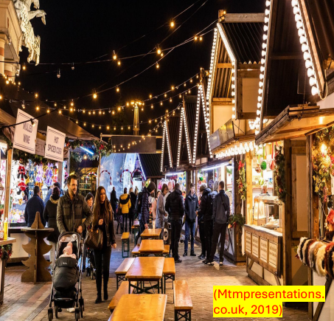

4.0 Aim and Objectives of the Event
Aim of the International Christmas Market Charity Event
To provide Christmas presents for underprivileged children by raising funds through a community-centred international holiday market

SMART Objectives
Specific | Measurable | Achievable | Relevance | Time-bound
By the end of the event raise £50,000 | This could be measured by tallying the overall funds generated through donations and sales. | This is achievable by auctioning the goods provided by vendors and sponsors. | This is relevant because if the event is successful in raising £50,000, 1000 children would be supported for the purchase of Christmas guests with an estimated cost of £50 per child. | 3 days
To secure 50 business partnerships through the charity event | This is measured by looking at the total number of business partnerships that the event organisers have been able to work with. | This could be achieved by conveying what the event is all about and the things that the event organisations aim to do in future. | This is relevant because, with more partnerships with foundations and companies, the event would be able to raise donations that would support the charity. | 3 days
To attract 5,000 attendees to the event | This could be measured by noting down the visitors/ attendees that come to the event. | This is achieved through effective marketing such as leaflets and newsletters and local television and radio to speak about the event. | This is relevant because the more attendees to the event, there is greater the chance to attract more funds for the charity. | 14 days
Table 1: SMART objectives for the event
(Source: Created)

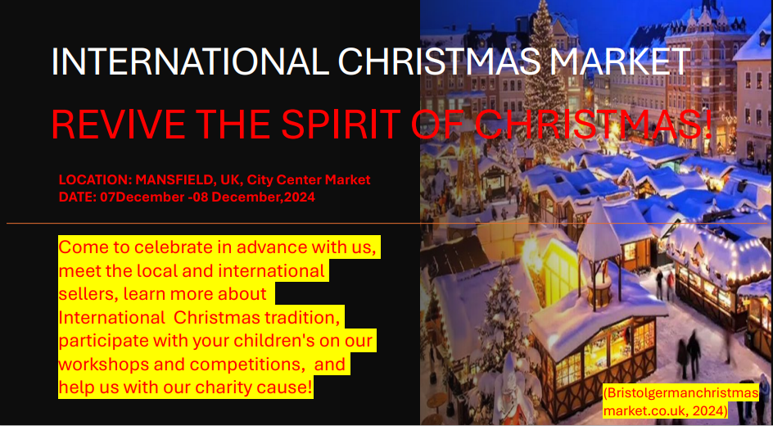
(Source:Presentation assignment 1)

5.0 Event Management
In the aspect of managing an event, there are various skills required to efficiently and feasibly conduct the event. However, certain skills play a crucial role in the course of managing an event. In the event of International Christmas Market Charity Event skills such as planning, marketing, organising, networking and communication would become important. As per Harwood-Jones (2024), event management is a daunting aspect, and there is a common misconception regarding eh management of events, which is that event managers, planners and organisers only emphasise extravagant events and glitzy celebrations. However, it is important to note that events can be at different times, based on the intent to which the event is being organised. In the context of the International Christmas Market Charity Event, planning, marketing, organising, networking and communication are pivotal, as they will help the event to be conducted and completed desire fully. Being specific, planning skill is important in the event because contacting local and international sellers, and marketing the event to the local and international regions required planning. As per Berridge (2020), planning effectively helps event managers to prioritise the tasks which will contribute to the event's completion and pivots the event to be organised and completed desired manner. As the event aims to raise money for a charity cause, marketing skills are also important.
Allen et al. (2022) stated that developing a comprehensive marketing strategy is crucial for managers of event marketing. Knowing the target demographic, developing interesting event topics, and employing astute promotional strategies are all necessary to boost attendance and engagement. In the International Christmas Market Charity Event, marketing skills would become essential to bring the community together. The marketing will be conducted on social media platforms which will help to interact and reach stakeholders like local and international charity organisations, schools, local hotels and hospitality firms, along with the business sectors. In addition, to marketing skills, networking skills are another important skill. Marketing resources such as social media Platforms, Social Media Examiner, online communication tools (Google Meet, Zoom and others), marketing managers, and relater professionals will be required. In essence, seasoned event planners actively build relationships with vendors, suppliers, clients, and colleagues. These crucial relationships can help event coordinators gain a deeper understanding of the industry and create beneficial alliances and collaborative opportunities (‌The Event School London, 2024). In the International Christmas Market Charity Event, networking skills will become crucial as it will enable the event planners and organisers to build a strong professional network, coordinators can reach a wider audience and gain access to additional resources. Resources such as records of the local and international charity organisations NGOs, local hotels and accommodations, and businesses will be required for the event

6.0 Event Budget

The course of the funding will be from donations made in the past, and financial support will be taken from the local government. A sum of £360 million was allocated by the UK government to the central government departments to fund charities in England (Gov, 2020). So to conduct this charity event, it will also take financial support from the government.

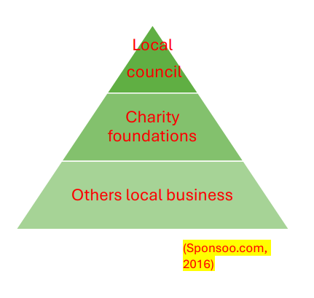(Source: Presentation Assigment 1)

7.0 Industry Trends / Issues / Impacts
The meetings and events industry has been heavily influenced by recent trends, including sustainability, social responsibility and hybrid event models. In recent years hybrid and virtual events are increasingly becoming popular and it is expected to continue in 2024. According to Meriläinen (2023), hybrid events combine virtual experiences and in-personal experiences. This format of the event would offer the benefits of both formals including reaching a larger audience and providing flexibility. Although, this is one of the most trending aspects of the event industry, the event that has been proposed does not aim to follow this model. The reason is that the attendees that the event aims to target are local populous that are primarily living around Mansfield. One of the key trends that this charity event is impacted by is sustainability and eco-friendly practices. In the UK, environmental consciousness has been part of the culture of festivals (Economist, 2023). Henceforth, the attendees of this event are increasingly conscious of the environmental impact of events. Henceforth, for this event, it has been encouraged that vendors use sustainable packaging and materials. Recycling stations on-site will also be placed in different locations across the market. Transparency is also one of the industry trends within the event industry, especially charity-related events. One of the researches has shown that donors need to feel confident that their hard-earned money is being put to good use (Pridephilanthropy, 2024). Therefore, to build trust, this event will use digital tools to provide live updates on progress and donations towards fundraising goals. Community-based event models are also on the trend which this event also leverages as it fosters a sense of collective purpose. Therefore, with the adoption of this model, the event aims to attract attendees to the charity event and raise funds.

8.0 Situational and Cultural Considerations
As per the estimate of Brown (2024), it was noted that 30% of the children in the UK, or equal to 4.3 million children were living in low-income households [Refer to below figure]. As the housing costs and cost of living have risen the recent years, along with the sudden financial burden on make houses during the pandemic and amid the post-pandemic situations have created hardships for many livelihoods.
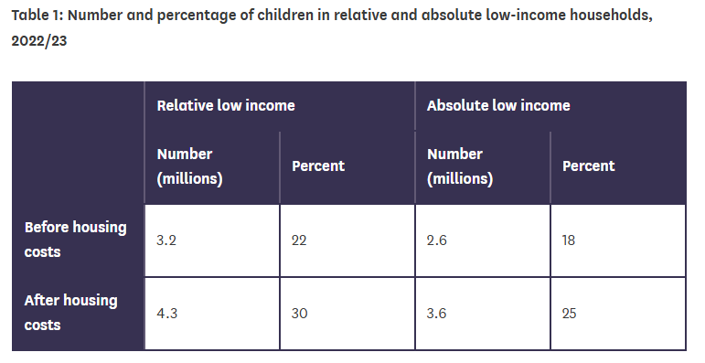
Figure 1: percentage of children living in relative and absolute low-income households
(Source: Brown, 2024)
The situational consideration linked to this event is to raise funds and do well for a charity cause. In the charity event, raised money will be spent to buy gifts and presents and give them to children living in low-income households in the UK along with the nations where this event is involved. In order to analyse the situational PESTLE matrices are being considered.
Political: The political scenario has always focused on helping social causes. UK government has allocated a £360 million package to help social services, charity organisations and NGOs for social causes (Gov, 2020).
Economical: The GDP per capita of the UK was $48,867 in 2023 which in comparison to the 2022 data has seen a 7.25% increase. In 2022, the GDP per capita of the UK was $45,564 (Macrotrends, 2024).
Social: There are a number of charity organisations contributing their efforts in making a social impact through charities and other social activities.
Technology: The UK is considered to be technologically advanced nations, wherein people are considered to be the early adopters of new technologies.
Legal: Social works are government y government as well as private entities. It must be ensured that the social works are done by abiding the legal norms.
Environment: The UK has net zero 2050 targets, aimed at making the nation a carbon-neutral nation.
The cultural consideration of this event is that it will help to make the childhood of several children memorable and contribute to bringing joy into the lives of children through presents, gifts, chocolates and others. Not only does the event entail charity organisations, but renowned corporations, businesses and the community as a whole to help make Christmas enjoyable for the children.

9.0 Conclusion
The International Christmas Market Charity Event has been proposed to be hosted in Mansfield’s City Centre Market from November 29 to December 1. Through the use of the EMBOK model framework, it has been found through social media and PR campaigns to increase visibility by targeting both local audiences and corporate donors. Through the analysis that would be performed, it is expected that £5,000 for marketing and £3,000 for venue-related expenses. The event will begin at 10:00 AM on 29 November 2024 and it is expected to close by 3:30 PM 1st December. The objectives of the event are to raise £50,000, secure 50 business partnerships and attract 5,000 attendees. This charity event, rooted in both community and international collaboration, not only aligns with these industry trends but also sets an example of how events can create a positive, meaningful impact for all involved. By leveraging these trends, the event aims to maximise attendance, enhance community involvement and attract support from major corporations and donors.

10.0 Reference list
Allen, J., Harris, R., and Jago, L. (2022). Festival and special event management. John Wiley and Sons. [ Accessed on 05 Nov 2024]
Berridge, G. (2020). Designing event experiences. In The Routledge handbook of events (pp. 378-395). Routledge. [ Accessed on 05 Nov 2024]
Brown, T. (2024). Child poverty: Statistics, causes and the UK’s policy response. [online] House of Lords Library. Available at: https://lordslibrary.parliament.uk/child-poverty-statistics-causes-and-the-uks-policy-response/ [Accessed on 06 Nov 2024]
Griffin, A. (2022). 10 Easy Steps to Planning a Unique, Successful Charity Event. [online] Eventbrite Blog. Available at: https://www.eventbrite.co.uk/blog/how-to-plan-a-successful-charity-event-ds00/ [Accessed on 6 Nov 2024]
Economist, (2023) Festivals sector moves to make events greener Available at: https://impact.economist.com/sustainability/social-sustainability/festivals-sector-moves-to-make-events-greener [Accessed on: 07 November 2024]
Gov, (2020). Financial support for voluntary, community and social enterprise (VCSE) organisations to respond to coronavirus (COVID-19). [online] GOV.UK. Available at: https://www.gov.uk/guidance/financial-support-for-voluntary-community-and-social-enterprise-vcse-organisations-to-respond-to-coronavirus-covid-19.[Accessed on 05 Nov 2024]
Harwood-Jones, Chad (2024). Uncover The Top Required Skills for Successful Event Management. [online] Les Roches. Available at: https://lesroches.edu/blog/skills-for-successful-event-management/. [Accessed on 06 Nov 2024]
Macrotrends (2024). U.K. GDP Per Capita 1960-2024. [online] Macrotrends.net. Available at: https://www.macrotrends.net/global-metrics/countries/GBR/united-kingdom/gdp-per-capita[Accessed on 05 Nov 2024].
Meriläinen, J., (2023). New normal of B2B trade fair events: on-site, online, hybrid or something else?. Org, (2024) Child poverty Available at: https://www.jrf.org.uk/child-poverty [Accessed on: 06 November 2024]
Ourmansfieldandarea, (2024) The History of Mansfield - An overview Available at: https://www.ourmansfieldandarea.org.uk/content/place/mansfield/mansfield-miscellaneous/the-history-of-mansfield-an-overview [Accessed on: 06 November 2024]
Pridephilanthropy, (2024) Building Trust: The Role of Transparency in Fundraising Available at: https://pridephilanthropy.com/blog/the-role-of-transparency-in-fundraising [Accessed on: 05 November 2024]
Silvers, J.R. and O'Toole, W., (2020). Risk management for events. Routledge.The Event School London (2024). The Importance of Networking in the Event Industry. [online] Event School London. Available at: https://www.eventschool.london/post/the-importance-of-networking-in-the-event-industry.[Accessed on 06 Nov 2024]
Bowdin, G., Allen, J., O’Toole, W., Harris, R. and McDonnell, I. (2023) Events Management. Oxford: Elsevier. [Accessed:7 Nov 2024]
Mtmpresentations.co.uk. (2019). Christmas Market Stalls Hire 2019 | MTM Presentations. [online] Available at https://www.mtmpresentations.co.uk/act/christmas-market-stalls/ [Accessed 6 Nov 2024]
Bristolgermanchristmasmarket.co.uk. (2024). The Best Christmas Markets in Europe. [online] Available at: https://www.bristolgermanchristmasmarket.co.uk/christmas_markets_in_europe.html/ [Accessed 6 Nov 2024]
Mtmpresentations.co.uk. (2019). Christmas Market Stalls Hire 2019 | MTM Presentations. [online] Available at https://www.mtmpresentations.co.uk/act/christmas-market-stalls/ [Accessed 7 Nov2024]
Charity Digital. (n.d.). How to throw a fundraising event. [online] Available at: https://charitydigital.org.uk/topics/how-to-throw-a-fundraising-event-11161/ [Accessed on 7 Nov 2024]
Eventbrite Australia Blog. (2020). Your Complete Guide to the Event Evaluation Process (with Template). [online] Available at: https://www.eventbrite.com.au/blog/event-evaluation-process-ds0c/ [Accessed on 6 Nov 2024]
Bowdin, G., Allen, J., O’Toole, W., Harris, R. and McDonnel, I. (2023) Events Management. Oxford: Elsevier [Accessed on 07 Nov 2024]
Walsh, S. (2019). What To Consider When Selling At A Christmas Market. [online] Protectivity - Insurance. Available at: https://www.protectivity.com/knowledge-centre/what-to-consider-when-selling-at-a-christmas-market/ [Accessed on 6 Nov 2024]
www.bbpress.co.uk. (n.d.). 5 Winning Tips and Tricks for Marketing a Charity Event. [online] Available at: https://www.bbpress.co.uk/news/marketing-a-charity-event [Accessed on 7 Nov 2024]

