NAME: ADEBOMI OLUYINKA SALU
STUDENT NUMBER: 1809923
MODULE CODE: LCMB7000
MODULE NAME: HUMAN RESOURCE MANAGEMENT
LECTURER: DR GLADIUS KULOTHUNGAN
ASSIGNMENT TITLE: 2
SUBMISSION DEADLINE: Tuesday 18th JANUARY 2022

TABLE OF CONTENT

INTRODUCTION 3
BACKGROUND HISTORY OF THE INTERNATIONAL TECHNOLOGY COMPANY (GOOGLE). 4
GOOGLE CAREERS AND EXTENDED WORKFORCE 4-5
MEANING AND DEFINITION OF HRM AND IHRM 5
STRATEGIC HUMAN RESOURCE MANAGEMENT 6
RECRUITMENT AND AVAILABILITY OF SKILLED LOCAL LABOUR 7-8
EMPLOYEE RETENTION STRATEGY 8-10
CHANGE MANAGEMENT 10-11
APPLICATION OF CHANGE MODELS 11-13
CONCLUSION AND RECOMMENDATIONS 13
REFERENCES 14-15

INTRODUCTION
In the field of Human Resource Management (HRM) and International Human resource Management (IHRM), both operate within the same parameters albeit IHRM which activities are carried out globally. HRM and IHRM strategies in organisations are faced with different issues as their functions are performed and these issues need to be effectively managed. To be able to achieve efficient and effective management of current issues, HRM and IHRM in organisations should understand how to implement fair, efficient and effective policies and procedures which would result in delivering the strategic goals and purpose of the organisation.
This report therefore is about the different challenges facing HRM and IHRM particularly in an International Technology company. The chosen company for this purpose is Google, a global technology company. Although there are several areas in human resource management that may need solutions to the challenges faced, this report will be concentrating on three areas with a discussion and analysis of the appropriate human resource strategies aided by theories, models, and framework.
The first part of this report will be covering a short overview of Google including the history, mission, locations, their extended workforce, and careers. In the second section, HRM and IHRM is defined with explanation. The next part will look at Strategic Human Resource Management, the definition with explanation and the importance to HRM. The next part is the introduction of the chosen three areas of HRM strategies, with in-depth discussions and analysis using principles, concepts and models or framework, to facilitate employee engagement, sense of being valued, appreciated, and belonging in the organisation. The three chosen areas are Recruitment and availability of labour, Retention Strategy and Change Management. Lastly, there will be recommendations and conclusion to the report.

BACKGROUND HISTORY OF THE INTERNATIONAL TECHNOLOGY COMPANY (GOOGLE)
Google’s story started with two students meeting at Stanford University graduate school in 1995, striking a partnership despite some disagreements at first, and then building a search engine known as ‘Backrub’ using links for determining the significance of people’s pages on the world wide web (www). 1998 saw the birth of Google Inc with the financial investment from Andy Bechtolsheim the Sun co-founder with a check for $100,000 which enabled the organisation to have their first office equipped with bulky desktop computers, ping-pong tables and a bright blue carpet (Google, 2022). This colourful appearance of their offices has which capture the organisation’s unconventional and non-traditional way continues till date. Both men’s passion for building innovative technology, being one step ahead of others have ignited the company employing the best staff in their fields of expertise, producing products for people around the world through Google Search, Gmail, Android, and YouTube. This leads to Google’s mission which is “to organise the world’s information and make it universally accessible and useful” (Google, 2022). It has been reported that Google occupies 154 locations around the world with the global headquarters at Mountain view California USA known as Googleplex; has been a division of the publicly traded ‘Alphabet Inc’ through a significant restructuring (Farfan, 2021). Google is known as one of the four largest technology organisations in the world.

GOOGLE CAREERS AND EXTENDED WORKFORCE
Careers at Google is based on four disciplines which are: Coding, Building, Creating and Designing for everyone. The human resource department as it is traditionally known takes a new name dimension at Google. HR is known as the ‘People Operations Team’ (Pops) who work in conjunction with the administration team, facilitating staffing and development within the organisation’s distinct and inclusive culture and live by the mantra “find them, grow them, keep them” (Google Careers, 2022). Google has a dedicated webpage to finding desired career for those looking to become part of the organisation. Roles range from Analysts to Administrative Support, to Programme Manager or Executive and working in Strategy and Operations, becoming a Recruiter, working in Sales, Service and Support, and working as an HR Business Partner as shown on the Careers page.
Google’s extended workforce comprises of temporary staff, independent contractors and vendors who are specialists and have expertise in specialised services not available with Google employees. In 2019, Google stipulated to their extended workforce in the US some requirements which would provide a new benchmark of benefits to their workers to make Google projects a fulfilling, positive and rewarding experience (Google, 2022).

MEANING AND DEFINITION OF HRM AND IHRM
The meaning and definition of human resource management (HRM) have evolved over the decades. Experts in the field have distinguished the traditional ‘Personnel Management’ from what has come to be known as HRM in organisations currently. HRM is often used to describe a collection of various activities organisations incorporate into their relationship and management of employees to meet the business objectives (Torrington, et al., 2020). On the other hand, Armstrong & Taylor (2014, p.5), defines human resource management as “A strategic, integrated, and coherent approach to the employment, development, and well-being of the people working in organisations”. Human resource is the crucial element which brings competitive advantage to organisations and these elements are found in recognising and nurturing people’s talents, including making people feel valued and have a sense of belonging in the organisation.
International human resource management (IHRM) involves management of people including expatriates across international boundaries by multinational companies known as ‘MNCs’ (Armstrong, 2020, p.151). On further explanation, it involves human resource management policies and practices in global enterprises, ensuring they attract, employ, develop, and engages the right quality of people to achieve their strategic goals (Armstrong & Taylor, 2014, p.465). In simple terms, IHRM is all that HRM means in an international or global setting. Google Inc is a multinational technology company; therefore, the human resources management strategy is found on IHRM strategies.
An article written in one of HR online newsletter by Sullivan (2013), highlights a strategic move towards focusing on great people management by organisations like Google which leads to producing continuous innovation. Google introduced ‘People analytics’ to enable the organisation to attain market success and workforce productivity which it still enjoys. Other global companies like Apple and Amazon are using the people analytics strategy as well. There is the realisation that innovations emanate from people because of effective recruitment and retainment of innovative people (Sullivan, 2013).

STRATEGIC HUMAN RESOURCE MANAGEMENT
Equally important is ‘Strategic Human Resource Management’ SHRM in Organisations. Organisational leaders and managers must always work in collaboration with the human resource department to implement their designed strategic plan. As emphasised by Armstrong & Mitchell (2019, p.9-10), the most successful organisations in the current competitive business world connects their universal strategic plans to their objective of recruiting and retaining employees; and then find out if the organisation lacks any resources or identify challenges that might be faced by their people resourcing department. Both Authors reinforced this by pointing out the importance of HR to strategic planning in organisational activities. Emphasised by pointing out that all HR experts, leaders, and managers must learn their organisational language and engage in conversations about the overall strategy because there should be a link between people issues and the organisational strategy (Armstrong & Mitchell, 2019). Subsequently, strategic human resource management has bend some in specific terms. For instance, Mabey et al. (1998), sees SHRM in terms of capability in delivering organisational strategies. However, one of the definitions which seems to sum up all the factors is:
“An approach to managing people that deals with how the organisation’s goals will be achieved through its human resources by means of integrated human resources strategies, policies and practices. It is based on the fundamental proposition that the human resources of an organisation play a strategic role in its success” (Armstrong, 2008).
Despite good meaning and great effort by leaders, managers and the HR executives working together for the greater success of an organisation, different challenges come up as the human resources functions changes especially in the current economic, political, social, and technological and environmental changes seen recently. Prominent among the challenges faced by HR departments in organisations are recruitment, retention, learning and development, leadership development, motivation, change management, salary and compensation, and HR effectiveness measurement. With the application of models, frameworks and theories, attempt will now be made in suggesting human resource strategies that could help in dealing with chosen three of the challenges mentioned, regarding Google Inc. The chosen three areas will be recruiting and availability of skilled local labour, retention strategy and change management.

RECRUITMENT AND AVAILABILITY OF SKILLED LOCAL LABOUR
Recruiting in general involves many stages of hiring people to fill vacancies in organisations. For recruiting to be successful, the technique used must attract a wide range of qualified applicants both internally and externally. This is supported with an effective job description because it has been proven to be the foundation of effective recruiting, interviewing, hiring and employee retention (Muller, 2009). Torrington et al. (2020), believes that regarding recruitment, job analysis has commonly identified the crucial tasks and responsibilities involved in a specific role and the essential knowledge, skills and capabilities needed to handle the tasks and responsibilities. These Authors also pointed out that research from recent years have resulted in identifying traditional job analysis and competency-based analysis being used collaboratively by pulling on the traditional job analysis to describe and measure tasks, whilst the competency-based analysis deliberately effects employee behaviour.
In recent years, recruiting has taken up a new word of ‘Talent Acquisition’ and this process is simply the hiring process which develops loyal and hardworking employees that is crucial to organisational success (Armstrong & Mitchell, 2019). As human resources experts, both Armstrong and Mitchell believe that talent acquisition is most effective when tied to the organisation’s HR strategic goals, developing workforce planning also leads to organisations being more proactive and not reactive. To sum up, recruitment process in organisations generally involves the following as stated by (Armstrong, 2020):
- Specifying requirements in form of role profiles and person specification.
- Attracting candidates by identifying potential sources of candidates, the kind of candidate and examining strengths and weaknesses of candidates for value proposition and brand equity. This can be done through online, social media, recruitment agencies, job centres to name a few.
- Examine applications by sorting, processing, and preparing for testing, assessment, and interview.
Furthermore, it is believed that recruitment is affected by some external and internal forces which include supply and demand, rate of unemployment in local area, competition for workers with similar organisations, legal and social environmental factors (Lussier & Hendon, 2019). It is important to note that organisations use both internal and external recruiting methods depending on their strategy. Both methods could be beneficial and have disadvantages.
Regarding Google organisation, their recruitment process is known to be robust and not traditional. Report shows that Google is known to use what is regarded by some people as ‘shocking’ strategy of arriving at a hiring decision through a team agreement rather than HR executive making the final decision (Umoh, 2018). In Umoh’s report, she cited Google’s global staffing lead and senior recruiter Lisa Stern Haynes who said, “Research tells us that teams that have diverging opinions can make better less biased decisions which includes recruitment decisions”. This statement is supported during a TED Talk by Stefanie Stanislawski an HR expert and advocate for Women at the workplace, Millennials, and the Future of work. Her views are centred around the application of Artificial Intelligence (AI) to recruitment process which could tackle the challenges faced by organisations regarding recruitment process. Studies showed that AI would help organisations to expand their internal business and external pull of talents, adapt the recruitment process to individual personality thereby making it applicant friendly, ensuring more diverse, empathetic, and dynamic place of work (Stanislawski, 2017). Shown in the outcome of studies that using algorithms could increase the reliability of selecting the right applicants for a job by 50% and as a result, organisations like Google could make their recruitment process more effective in addition to their current strategy.
In brief, using AI algorithm could make the recruiting process less cumbersome, faster, and more effective in organisations. It does come with its setback due to some companies not having resources and funds put in place to execute this strategy. It impacts organisational strategy of recruitment and retention of employees.

EMPLOYEE RETENTION STRATEGY
Retention strategy is one of the main functions of the human resources department in an organisation. In the present day, recruitment and retention of employees have become a top agenda for HR executives in most organisations in the UK and globally, superseding performance management (Taylor, 2002). Research has shown that there is a close link between engagement and retention of employees. Torrington et al. (2020), believes that relatively high level of engagement is connected to relatively high level of retention because disengaged employees have a high possibility or resigning than engaged employees who are much likely to stay in the organisation. It has also been proven that a good retention strategy reduces employee turnover in an organisation therefore, there should be a good retention plan. Retention strategy plan involves areas like Job design, Performance, Learning and development, Career development (Armstrong, 2011), and as shown in Fig 1 below from hiring the right people as the first step in the strategy model through to the eight step of cultivating team spirit. Maxwell, (2021) defined employee retention as “the extent to which an employer retains its employees and may be measured as the proportion of employees with a specified length of service (typically one year or more) expressed as a percentage of overall workforce numbers”.
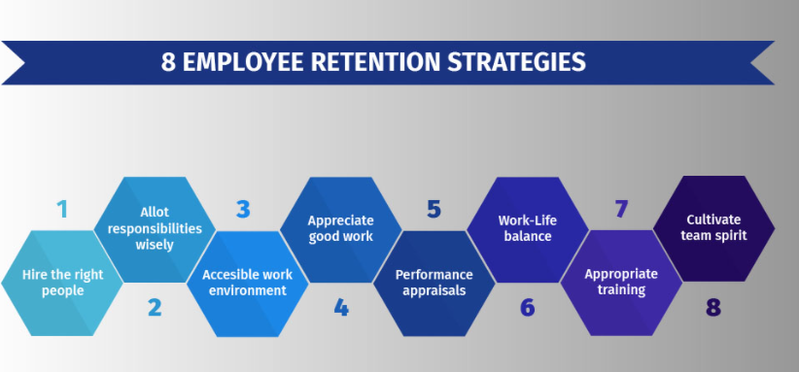
Fig. 1 Model of Employee Retention Strategy (Source: QuestionPro)
To illustrate how an employee could become disengage leading to resignation and the organisation losing a skilled staff, is the following case study:
Sarah worked for Google as one of the few women engineers who loved her job. After a couple of years of being in the same position without promotion or increase in salary and remuneration, she started to become disengage with her job. Despite the original salary and perks of working in Google which some other technology company employees do not enjoy, Sarah got bored with the being in the same job for several years. Her response time to completing tasks began to fall behind others. Despite all these signs of disengagement, her manager failed to notice. One of the reasons for the slow growth or none could be found in Google becoming the victim of their success because the organisation hires highly skilled people therefore, competition is high.
Sarah started to look for a new job and once she secured a job with one of Google’s competitors, she informed her manager however, it was too late for any action to be taken to retain her. The People resourcing Department commenced finding a replacement and it took 3 to 5 months to find one and in addition to one month of training, 6 months in total. In the interim, Sarah’s former colleague had to absorb her job meaning more responsibilities and workload. Inevitably, some of these former colleagues started to feel overworked and disengaged in their jobs too which could lead to more resignation.
To tackle this challenge of Google losing Sarah and making the rest of the team feel valued, appreciated, and develop a sense of belonging, the following actions and suggestions is advised.
- Putting in place algorithm which would have predicted Sarah’s current and future actions so that solutions could be found because the algorithm system would have informed HR of time factor needed to find a replacement, suggest applicants locally or globally based on their skills and success (Stanislawski, 2017).
- Google should endeavour to find out how its competitors are retaining their employees, build on current employees’ skills and abilities, recognition and rewarding put in place and value the employees.
- Introduce appropriate training and development programmes because it equips employees the confidence and proficiency in achieving expected performance standards, boosts current skills and abilities, acquire new skills, and increase employability in the organisation (Armstrong, 2011).
- Work environment should encourage, support, and facilitate work-life balance of employees by options of working from home (WFH), hybrid working, flexible time, part-time, and use seasonal workers to cover maternity leaves and any other aspects of employees’ personal life (Armstrong, 2011).
- Improving the performance of immediate managers by investing in their training and development for effective management (Torrington, et al., 2020).

CHANGE MANAGEMENT
It is common knowledge in the field of organisational change that change can be difficult and challenging to execute for different reasons. It requires different measure of human collaboration and teamwork which involves preparation and support of employees, setting up the necessary steps for change, supervising the before- and after-change activities for a successful execution of change (ASQ, 2022). As a result, various social scientists, clinical psychologists, and management consultants have carried out thorough research on the dynamics of change and suggested frameworks and models in a bid to have better understanding of change in organisations and how it can be implemented successfully (PeopleWiz, 2013). The realisation is that organisations need to change despite some achieving the desired outcome therefore, HR executives, leaders and managers need to work together to understand the issues preventing change and use the appropriate tools and techniques to tackle and support the change management initiatives (CIPD, 2021).
A recent change happened in Google recently which led to Eileen Naughton head of People Operation Team (HR) for Google and leader of the sales and operations in the UK and Ireland over 13 years had to step down from her role (Ghaffary, 2020). It was reported that under her leadership, Google’s fundamentally and well-known open culture of freedom of speech by employees, regarding debates on controversial topics which includes the organisation itself was abruptly changed. Employees were no longer allowed to ask their managers or leaders hard-hitting questions, stricter rules on internal messaging boards and controversially dismiss those deemed employee activists. Also, a few employees left the organisation because of the departure from the known culture. It was alleged that Naughton played a significant role in implementing the change and signifies a changing shift in leadership. Also reported was that despite stepping down from her role, some employee ‘activists’ believe that the issues still lie with the leadership and implementation of change in Google. Case study culled from (Ghaffary, 2020).
As a result, it is evident that Google needs to move in a different direction by working closely with senior management to implement change. To introduce and manage change effectively, there are proposed models and frameworks which could be used. It has also been proven that a combination of two or more models proves to be more effective because each model or framework has its limitations. For this purpose, Kotter’s Eight Steps to Change and Lewin’s Change management Model is suggested because the former has clear stages and focuses on employees as the centre for success (PeopleWiz, 2013); whilst the latter focusses on understanding the organisational and structural change (smarp, 2020).

APPLICATION OF CHANGE MODELS
The eight stages or steps of Kotter’s model of change is illustrated in Fig. 2 and the three stages of Lewin’s change model in Fig. 3 as shown below:
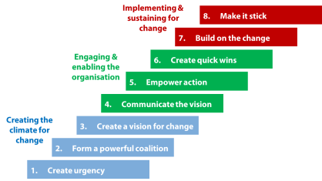
Fig. 2. Kotter’s Eight-Step model of Change (Source: Frontline management)

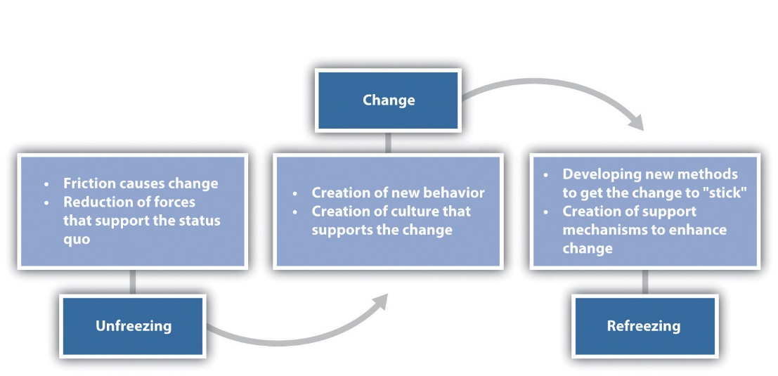
Fig. 3. Lewin’s Change model (Source: Leadership centre)
As shown in Fig.2, Kotter’s Eight Step model functions within 3 major roadmaps of creating the climate for change which could be used in conjunction with Lewin’s ‘Unfreezing’ process. The next 3 which features under engaging and enabling the organisation could work together with Lewin’s ‘Change’ process, leading to the final 2 steps of Kotter’s model which could work with Lewin’s final process of the model ‘Refreezing’.
Establishing a sense of urgency before change happens is important for Google HR executives and leaders to gain needed cooperation of the team and employees. This is the ‘Unfreezing’ process where preparations for the change in culture of free speech could be introduced to soften the sudden change causing friction. Although Kotter (2012), suggested creating a crisis to push the sense of urgency which could work in a crisis like the Covid-19 pandemic situation, it would not have worked in this scenario. Involving the medium level managers could help in gently introducing talks about the possible change in culture which leads to forming a powerful coalition. These identified managers could be trained so that they would influence their team on the proposed change. In collaboration with the identified leaders, emerges the development of new strategies and vision for change. These first 3 steps should work together with the functions of Lewin’s ‘unfreezing’ stage to smoothen the top-down style of Kotter’s model and introduce the empathic functions of Lewin’s model.
The next stage is to communicate the vision of shaping the culture, policy changes and new strategy through the formed coalition, which leads to empowering the action planned and subsequently creating short wins along the way. Perhaps some of the employee labelled as ‘activists’ and dismissed by Google could have become the coalition if a different approach was used in dialogue with them. Similarly, Lewin’s ‘change’ process is already happening by employee displaying new behaviour which signifies a new culture which supports the change. The last 2 stages in Kotter’s eight step model are building on the change and making it stick where new support mechanism is created to enhance and ‘Refreeze’ the change of culture.

CONCLUSION AND RECOMMENDATIONS
In conclusion, it is evident from the findings of this report that human resources are the critical element which brings competitive advantage to any organisation. It is about nurturing, valuing, and appreciating the workforce so that they develop a sense of belonging with the organisation. Recruiting the right people using effective recruiting strategies, putting in place retention strategies to keep employees engaged and applying change models to any change situation generates job satisfaction, willingness to perform at a high level and enthusiasm for staying and performing long-term, are fundamental to the success of any human resource management in organisations.
In brief, in addition to the recommendations already discussed in the body of this report, crucial to recruitment is to utilise data in finding the best places to recruit new employees locally or globally, with tools like LinkedIn Talent Insight because it enables HR executives focus their recruiting efforts on specific areas of large supply of skills and talents (Petrone, 2020). Organisations should endeavour to focus on employee retention and have a working strategy and initiatives as am important part of their policy (Maxwell, 2021). Finally, regarding change management, it is suggested that organisations should be agile in the current marketplace, constantly ready, willing, and able embrace change as part of the changing world (Betterworks, 2021).

REFERENCES

Armstrong, M., 2011. Armstrong's Handbook of Strategic Human Resource Management. 5th ed. London: Kogan Page.
Armstrong, M., 2020. Armstrong's handbook of human resource management practice, London: Kogan Page.
Armstrong, M. & Taylor, S., 2014. Armstrong's Handbook of Human Resource Management Practice. 13th ed. London: Kogan Page.
Armstrong, S. & Mitchell, B., 2019. The Essential HR Handbook. 1st ed. Newburyport: Career Press.
ASQ, 2022. About Change Management. [Online]
Available at: https://asq.org/quality-resources/change-management
[Accessed 10th January 2022].
Betterworks, 2021. 8 of the Biggest Challenges for HR in 2021. [Online]
Available at: https://www.betterworks.com/magazine/8-of-the-biggest-challenges-for-hr/
[Accessed 12th January 2022].
CIPD, 2021. Change management. [Online]
Available at: https://www.cipd.co.uk/knowledge/strategy/change/management-factsheet#gref
[Accessed 10th January 2022].
Farfan, B., 2021. Google's Global Headquarters and Offices Around the World. [Online]
Available at: https://www.thebalancesmb.com/google-headquarters-offices-2892790
[Accessed 7th January 2022].
Ghaffary, S., 2020. Google’s head of HR is stepping down, but that won’t fix the company’s internal problems. [Online]
Available at: https://www.vox.com/recode/2020/2/11/21133360/google-head-hr-human-resources-quit
[Accessed 10th January 2022].
Google, 2022. About Google’s. [Online]
Available at: https://about.google/extended-workforce/
[Accessed 7th January 2022].
Google, 2022. Our History: From the garage to the Googleplex. [Online]
Available at: https://about.google/our-story/
[Accessed 7th January 2022].
GoogleCareers, 2022. People. [Online]
Available at: https://careers.google.com/teams/people/
[Accessed 7th January 2022].
Kotter, J. P., 2012. Leading change. 1st ed. Boston: Harvard Business Review Press.
Lussier, R. N. & Hendon, j. R., 2019. Fundamentals of Human Resource management: Functions, Applications, Skill Development. 2nd ed. London: Sage publications Inc.
Mabey, C., Salaman, G. & Storey, J., 1998. Human Resource management: A Strategic Introducton. 2nd ed. Oxford: Blackwell.
Maxwell, G., 2021. CIPD: What are employee turnover and retention?. [Online]
Available at: https://www.cipd.co.uk/knowledge/strategy/resourcing/turnover-retention-factsheet#gref
[Accessed 12th January 2022].
Muller, M., 2009. The Manager's Guide to HR: Hiring, Firing, PerformanceEvaluations, Documentation,Benefits, and Everything Else You Need to KnowThe Manager’sGuide to, New York: Amacom.
PeopleWiz, 2013. Change Management Models- a comparison. [Online]
Available at: https://www.slideshare.net/peoplewizconsulting/change-management-models-a-comparison
[Accessed 10th January 2022].
Petrone, P., 2020. 7 of the Biggest Problems Recruiters Face And How to Overcome Them. [Online]
Available at: linkedin.com/business/talent/blog/talent-acquisition/biggest-problems-recruiters-face-and-how-to-overco
[Accessed 12th January 2022].
smarp, 2020. 5 Change Management Models to Take a Look At [blog]. [Online]
Available at: https://blog.smarp.com/5-change-management-models-to-take-a-look-at
[Accessed 10th January 2022].
Stanislawski, S., 2017. Talent 5.0 - Taking Recruitment Practices to a New Level. [Online]
Available at: https://www.ted.com/talks/stefanie_stanislawski_talent_5_0_taking_recruitment_practices_to_a_new_level
[Accessed 11th January 2022].
Sullivan, J., 2013. How Google reinvented HR and drives success through people analytics, London: Inside HR.
Taylor, S., 2002. The Employee Retention Handbook, Trowbridge: Cromwell Press.
Torrington, D., Hall, L., Taylor, S. & Atkinson, C., 2020. Human Resource Management, Harlow: Pearson.
Umoh, R., 2018. Top Google recruiter: Google uses this ‘shocking’ strategy to hire the best employees. [Online]
Available at: https://www.cnbc.com/2018/01/10/google-uses-this-shocking-strategy-to-hire-the-best-employees.html
[Accessed 11th January 2022].

