Dafydd Edwards (2417062)
ACCD5000 Synthesize a solution to a potential real-life scenario
Computer Forensics

Table of Contents
Abstract 2
Introduction 3
Task 1 – Research 4
FTK Imager 4
Paladin 5
Autopsy 5
Cellebrite UFED 5
Caine Linux 6
E3 Universal 6
Comparison 6
Task 2 – Case Study 9
Methodology 9
Professional Forensic Report 11
Professional Invoice 20
Conclusion 22
References 23
Appendix 25

Abstract
This report explores the world of digital forensics. It explores the different methodologies used, what forensic tools are used for this and the application of these tools. The report begins with a research element where 6 different forensic tools are discussed. This includes FTK, Paladin, Autopsy, Cellebrite UFED, Caine Linux and E3 Universal. These tools are analysed and compared by their key features, cost, compatibility and disadvantages.
The second half of this report is the application of forensic investigation techniques to a real life case study. From this, a structured methodology report is constructed following ACPO guidelines to guide the investigation. A professional forensic report is then formed. Within this report, it will first give an executive summary of the case where a brief explanation is given on what happened. Then follows the investigation steps that Troy Simpson was to follow. Findings of the investigation are then displayed alongside evidence. Additionally, a professional style invoice is included to demonstrate real life forensic investigations.

Introduction
Computer Forensics is fast becoming a vital component of modern investigations and cyber security. As life is becoming increasingly reliant on technology, the need for the collection and analysis of evidence has grown rapidly. It brings Computer Science and Legal Forensics together in a way that can be used within the court of law. [1] Law enforcement agencies rely upon digital forensics for a wide range of investigative and legal purposes. [2] It is responsible for preserving, analysing and presenting data findings from electronic devices.
Task 1 of this report is a research element. It focuses on the critical evaluation of modern digital forensic tools across different categories including imaging applications, all-in-one forensic suites and mobile phone forensic applications. The comparison considers the costs, key functionality, types of evidence handled and identifies which tools are best suited for the different phases of the Computer Hacking Forensics Investigator (CHFI) process.
For Task 2 of the assignment, a real-life scenario is given involving suspected company sabotage and property theft at Cyfusion Mobile Manufacturing Company (CMMC). The investigation is centred around Rich Daley after it was suspected that he had deleted critical files following a deal made with CMMC’s competitor 360tech. A methodology report will be developed in line with CHFI and ACPO principles. Within this report, it will show how evidence will be acquired, proof of anti-forensic activity, strategies for file carving and extraction from cloud synchronization devices.
Following this methodology, a professional forensic report will be developed. An executive summary, investigation steps and findings will be documented. This will be done using one of the researched applications and made in a way that is suitable for legal proceedings. A professional invoice is to be included to display standard forensic practices. This report will display both the understanding behind the tools and the practical application of computer forensic techniques.

Task 1 – Research
There are a number of different computer forensics analysis tools built for preserving, analysing and interpreting digital evidence from devise such as computers, phones and servers. These tools vary in functionality and each tool plays a distinct role within computer forensics. The following section below highlights several different forensic tools outlining their features and capabilities alongside a comparison of the different tools.

FTK Imager
FTK Imager, developed by Exterro, is a computer forensics application that investigators use. It creates a like-for-like copy of the system so investigators are able to work on the data without altering the current data and potentially sabotaging court proceedings by editing the original copy. [3]
There are 3 different packages available. The standard free version is available to users to create forensic images and preview data without any licensing fees. The pro version of FTK imager is $499/ year. It comes with an extended number of features compared to its free counterpart. This includes iOS logical collection, encryption detection and decryption. The final package is the enterprise licensing. This is $3995/ year. The subscription is priced at $2227/ year and the support is $1119/ year. [4]
There are many key features of the FTK Imager application. Firstly, FTK uses a disk imaging process to create an exact copy of the system to be able to edit this without disrupting any evidence and allowing it to be used within court. Hashing is used within FTK to ensure that images are the same throughout the investigation process. It creates a unique hash of the original data and compares it with the forensic image to verify that the evidence has not been modified at all. This is also done with files to ensure these are not changed or accessed at all during the pending investigation. Investigators will often mount the image as a read-only copy using FTK so it is able to function like a normal drive on the system. FTK takes snapshots of the volatile memory system (RAM) to ensure no evidence is lost if the computer is powered off.
Forensic reports are created using this software which often aid in displaying any evidence. Timestamps, hash values, file paths accessed and investigator notes are often included within these reports alongside much more key information. [5]
FTK Imager supports a wide range of different file systems across different operating systems allowing investigators to analyse diverse data types. It can interpret data from Windows File Systems such as NTFS and Linux file systems such as EXT2/3/4. The application also supports the MacOs filing system, HFS. [6]

Paladin
Paladin is an open source forensic tool developed by Sumuri that is used by Law Enforcement Agencies across the world. [7] It allows investigators to examine systems without altering any data helping to preserve data integrity.
Paladin is free to non-profit organisations and individuals as they often ask for donations for using the software. However, there is a Paladin Pro version available on the Sumuri Website for $99/ year. [7] In order for Sumuri to support the software, a minimum donation of $25 is required.
The Paladin forensic tool is an All-in-one forensic toolkit which includes many different key features. There is a write-blocking system built-in to the application that prevents modification whilst investigating. Paladin contains many major tools such as Autopsy and Sleuth kit, both of which are vital when it comes to digital forensics. The Pro Version of Paladin is preloaded onto a USB stick which allows for investigations to start immediately and keeps evidence admissible. [8]
Although Paladin is able to help with investigations on the MacOs, it is somewhat limited to older unencrypted devices and basic analysis. It does however support both Windows and Linux OS’ such as NTFS and EXT2/3/4. [7]

Autopsy
Autopsy is an open-source forensic investigation tool built by Sleuth Kit Labs that is used to analyse evidence from computers, drives and mobile devices. It provides a graphical, user friendly interface to the popular powerful tool, Sleuth Kit. [9] The software is free to download and use which is a massive benefit but it does have some optional paid services such as training, support and advanced features. [10]
There are many key features of Autopsy. Despite the tool being more user friendly and accessible, it is still a very powerful tool that investigators are able to use to build evidence towards a digital forensics investigation. It allows them to recover deleted files which can be vital for investigations that involve sabotage. It is possible to build timelines within the application for the investigator to gauge exactly what happened on the device. Another key feature is the ability to examine web browser history, emails and other computer artifacts such as the logs on the device. [9] The tool supports most file systems including NTFS, FAT32, EXT2/3/4 and HFS but the latter is limited. [11]

Cellebrite UFED
Cellebrite UFED (Universal Forensic Extraction Device) is a digital forensics tool that primarily is used to converge evidence such as call logs, contacts and text messages. It is widely used by law enforcement agencies to gather data within investigations or cybersecurity cases. This tool is able to track a number of different things ranging from data from chat apps, GPS, browser history and app data. [12]
There a large number of key features of this application. Firstly, Cellebrite is able to extract data from locked device, depending on the model and security. It can provide full file system access for further analysis of the apps and system information. Similar to most digital forensic tools, it creates a copy of the system so data can be analysed without altering anything so that it is admissible in court. [13] Cellebrite UFED 4PC Ultimate, starts at approximately $9,000/ year with the option for a number of paid extras such as cloud extraction. [14]

Caine Linux
Caine Linux is a Linux specialised digital forensics tool. It mainly supports EXT2/3/4 (the main Linux system), as well as NTFS and HFS. [15] The software can be used in 3 different ways. It can be installed on a USB stick, DVD and installed directly onto a device’s drives. A DVD copy of Caine Linux costs around $3.39.
There are a number of key features that Caine Linux has. Firstly, it helps recover deleted files which can be vital in forensic investigations. It also allows for analysis of hard drives and USB drives which can detect whether data could have been copied onto a USB device. There is also the ability to examine system artefacts such as prefetch files and system logs. The software could also work alongside the popular tool Autopsy. [15]

E3 Universal
E3 Universal is an all in one forensic tool that is used by investigators to collect, analyse and report on computer evidence from multiple sources. It supports file systems such as NTFS, EXT2/3/4, Android, iOS and HFS. [16] E3 Universal is one of the more costly tools costing around $6295/ year and is subscription-based. [17] It is the most universal digital forensic tool which has many key features.
Firstly, similarly to most other forensic tools, preservation of data is at the forefront. It allows the data to be analysed without modifying the original files, maintaining data integrity throughout the investigation. Secondly, one of its many key features is its ability to analyse data from multiple devices at any time. This is supported by the ability of remote acquisition allowing for streamline investigations. The software supports a number of different capabilities including keyword searching. The application also allows for fully customisable reporting tools which allows for better displayed findings. [18]

Comparison
Below is a table that compares each of the forensic tools side by side.
 | FTK Imager | Paladin | Autopsy | Cellebrite UFED | Caine Linux | E3 Universal
Cost | -Standard - Free  -Pro - $499/ year  -Enterprise - $3995/ year | -Free to run, donation required for support. | -Free to download with optional paid extras | -Higher pricing, Starts at around $9000/ year | -Available for free on Live USB  -DVD copies start around $3.39 | Available on all devices for $6295/ year. Also available exclusive to mobiles or computers.
Key Features | -Creates Forensic Images  -Preview Files and Folders  -Hashing  -Mount Forensic Images | -Contains Sleuth Kit and Autopsy  -Write-Blocking System | -File Recovery  -Timeline Creation  -Web analysis  -Email analysis  -Hash Filtering | -Call Logs  -Text Messages  -Data extraction from locked devices  -GPS tracking | -Write-blocking system  -Evidence integrity tools (hashing)  -Recover deleted files  -Includes Autopsy | -Cloud Analysis  -Email Analysis  -Hashing  -Call logs  -Files and Folders
Supported File Systems | -NTFS  -FAT  -EXT2/3/4  -HFS  -UDF | -NTFS  -EXT2/3/4 | -NTFS  -FAT  -EXT2/3/4 | -iOS  -Android | -EXT2/3/4 | -iOS  -Android  -NTFS  -HFS  -EXT2/3/4
Types of Evidence | -Disk and File Systems  -RAM  -Emails  -Browser History, Cache, Cookies etc.  -Documents  -System Architecture | -Disk and File Systems  -RAM  -Network History  -Encryption Keys | -File Systems  -RAM  -Internet History  -System artefacts | -Application Analysis  -Call Logs  -Text Messages | -File Systems  -USB Devices  -System Artefacts | -Mobile logs  -Cloud Storage  -Email Analysis  -File Systems
Reporting Capabilities | -Reports are created within the system that cover the key details. | -Structured Forensic Reports | -Reports and timelines available within Autopsy | -Produces basic reports based off the data extracted | -Generates reports that can be used for legal cases | -Generates reports for investigations and legal use  -Automated timeline creation
Advantages | -User friendly GUI  -Quick searching for keywords  -Strong Email analysis  -Strong Memory Analysis | -Portable and easy to deploy  -Trusted Source  -Free/Cheap to run | -Mostly free with specific services costing.  -User friendly GUI  -Creates timelines and reports | -Can track calls logs, sim cards and storage media for both Android and iOS  -Recover hidden and encrypted data  -Data integrity | -User friendly GUI  -No install required, runs from USB  -Cheap | -Most Universal digital forensics tool  -Cross-device analysis  -Remote data acquisition
Disadvantages | -Can be slow with extensive use  -Weaker MacOS and Mobile Support  -Higher Hardware Requirements  -Higher Costing for Commercial Licensing | -Hardware Compatibility  -Doesn’t have all key features required for forensic investigations | -Slower with large datasets  -Specific tools are paid services | -Detailed reporting not available  -Higher costing  -Not guaranteed to unlock all devices (dependant on security)  -Requires specialist training | -Not up to date  -Limited Automation  -Hardware compatibility | -More costly than most tools  -Requires powerful hardware  -Require specialist training

Task 2 – Case Study
This report outlines the forensic investigation conducted into suspected data theft and sabotage involving Rich Daley, a former employee of Cyfusion Mobile Manufacturing Company (CMMC). Rich Daley was involved in the development of the Samsung Galaxy Z Flip 6. Evidence suggests that he intended to sell the designs to a global tech competitor called 360tech prior to his resignation. Following his departure, critical design files were found to be missing from his company device.
The primary evidence consists of a single Windows 11 device workstation assigned to Rich Daley. The device was fully encrypted using Bitlocker, essentially creating two walls of defence. There are no backups for the system due to the confidential nature of the work, making this device the only source of evidence.

Methodology
Computer Hacking Forensic Investigator (CHFI) is a professional certification offered by EC-Council that develops the skills required to investigate digital forensics and analyse electronic evidence. It focuses on teaching individuals how to collect, preserve, analyse and present evidence acquired from devices in a way that makes it admissible in the court of law. The certification covers a number of topics ranging from investigating computer crimes, using computer forensic tools and handling evidence in the correct way. There is also a focus on analysing hardware, software and producing the reports required in legal proceedings. [19]
Association of Chief Police Officers (ACPO) is an organisation that is in control of the general standards that should be followed within all digital forensic investigations. There are 4 main principles of ACPO. These are:
- Preservation – ensure data integrity is maintained;
- Competence – only trained professionals should examine digital evidence;
- Audit Trail – all actions should be recorded; and
- Responsibility – the investigator should follow all rules and remain accountable for the investigation. [20]
This follows closely in line with the chain of custody. This ensures that everything is documented in chronological order to ensure data integrity is maintained throughout the investigation. A chain of custody is vital for legal proceedings as it tracks exactly who would have touched the evidence and proves nothing could have been tampered with. [21]
In Digital Forensics, maintaining data integrity is critical. This means that the data must be preserved and remain unchanged from the moment it is seized until it is available to be presented as evidence. The investigator should avoid actions such as turning off the device unless it is completely necessary or all evidence of volatile memory is documented. In order to minimise the risk of accidental modification, only trained investigators should handle the device.
An audit trail must be maintained throughout the entire investigation, documenting every action taken on the device. This ensures transparency and allows the process to be reviewed and verified. The investigator must take accountabilities for all decisions and clear documentation is essential for the justification of all decisions. When seizing the device, the investigator must ensure it is secure and documented properly. This requires them to note details such as time, location, condition and any visible activity. If the device is powered on, investigators may attempt to capture RAM as it could contain valuable information such as running processes, encryption keys or any unsaved information that would be lost if the device is shut down.
The tool that the investigator decided to use was FTK Imager and Autopsy. This is due to its ease of being able to create an exact copy of the original device. This is done so analysis can be performed on the copy rather than original device, preserving the original data entirely. It also prevents modifications further enhancing the evidence. By doing this, it allows the investigator to verify data through hash values, ensuring the copy is identical and has not been altered which is essential within legal proceedings. FTK was also chosen as their investigation tool as it has a user-friendly graphical user interface which further supports the ease-of-use claim. Furthermore, reports are created of all key details within the system which is vital within forensic investigations. It logs timestamps, key logs, file paths and hash values.
During analysis, an investigator should look for indicators of potential evidence tampering or malicious activity. This includes things such as installed wiping tools, suspicious registry entries and relevant event logs. These artefacts can provide insight into user activity, attempts to delete data or actions taken on the system prior to the seizure. The investigator should examine the file system data such as timestamps for creation, modification and access to identify unusual patterns or signs of anti-forensic activity like timestamp manipulation. Prefetch files, recent files lists and shortcuts allow the investigator to piece together user activity by showing which programs were run and which files were opened, helping to form a clear understanding of what happened on the system.
The investigator should also review the browser history, downloads and cached data to understand online activity. Being able to determine what sites have been visited to the case as it was mentioned that Rich Daley saved it to his personal cloud storage and this could be proved using the browser history. Cookies may also provide valuable evidence about Rich’s login sessions helping to link activity to specific actions performed. The cache can sometimes be useful as it can store copies of web pages or downloaded content which might include traces of the files that were uploaded or accessed. USB connection history could also be vital within legal proceedings as it could identify if any external devices were connected to transfer data to another device or to remove the data entirely. The investigator could also review user accounts, their permissions and installed programmes on the device. In this case, Rich Daley works for a large company so there is a high likelihood that their network runs off Active Directory or something similar so they would be able to check access control using this.
It would also be possible to check their running processes to spot anything unusual such as unauthorised access or suspicious software. This includes potentially finding any wiping tools that could have been accessed. Despite Rich’s device not having backups, there may be a possibility that there any data could be restored through the devices auto backup system. The investigator can then build a timeline of what happened on the system and potentially find any anti-forensic activity.
The investigator should carry out file recovery techniques such as carving to try and retrieve deleted data from the system. This involves searching the storage media for file fragments by recognising their unique locations instead of depending on the file system that may have been changed or erased. The unallocated space within the file system should also be checked as this is where remnants of wiped data may still be. Traces can sometimes still be available if the file deletion process was not completely finished or if parts were missed, even if any wiping tools were utilised.
There should be a focus on the attempt of recovery on the Autodesk Maya project files as these are vital to the case. Recovering small fragments of the files could be critical to the investigation as it could provide evidence of the original designs and demonstrate to law enforcement agencies what was potentially deleted in the sabotage attempt.

Professional Forensic Report

Executive Summary
The investigation was conducted to examine suspected data theft and sabotage involving former employee of Cyfusion Mobile Manufacturing Company (CMMC), Rich Daley. Following his resignation, a number of critical mobile phone design files were discovered to be missing from his computer, raising concerns about potential property theft and unauthorised data transfer.
A forensic investigation of Rich’s device revealed evidence that deliberate illegal actions took place prior to his departure. This includes the use of a file-wiping tool that aided in the deletion of Autodesk Maya files and there were traces of activity that suggested that there was an unauthorised transfer of data to a personal Google Drive account.
Further examination of system artefacts and browser activity suggests that the important design files of the Samsung Galaxy Z flip 6 were accessed and prepared for the transfer prior to deletion. These findings strongly suggests that there was an intentional sabotage including both the destruction and unauthorised transfer of data.
To conclude, the evidence strongly supports the claim that Rich Daley deliberately attempted to sabotage company data, especially those relating to the design of a GUI of the new Samsung Galaxy Z flip 6. The results of this investigation could be used within the court of law to prove Rich Daley as the guilty party. These results could also highlight the need for improved security measures, especially when asking sensitive information.

Investigation Steps

Step 1 – Preservation of the Data
The first step that Troy Simpson will be taking is to preserve the data. This prevents the loss of volatile data (RAM) and any unsaved data. Restarting the laptop could lose vital information that will be key to investigation and legal proceedings.

Step 2 – Forensic Imaging
A forensic image of the device should be created using a tool such as FTK Imager. This ensures a bit-by-bit copy is made so that investigations can be conducted on the copy whilst preserving the integrity of the original data. Hash values should also be calculated for later comparison to verify integrity.

Step 3 – Handling Encryption
The next step for the investigator is to attempt to gain access to the Bitlocker-encrypted drive by retrieving the encryption keys. These would be found in the devices volatile memory (RAM). This step is vital as it ensures full access to all the data on the device ready for analysis.

Step 4 – System Overview
Troy would then begin to analyse the system. This involves checking what applications are installed, how the device is setup and what users have used this device. This would allow him to find out if any file wiping tools have been installed and used in order to sabotage the company and data. It will also detect if there are any other unauthorised applications or access was given.

Step 5 – File Recovery
The investigator will then carry out file carving and analyse file fragments within unallocated space to determine whether the data is able to be retrieved. Even if wiping tools were used, traces of the data may be able to be pieced back together.

Step 6 – System Analysis
Troy will then analyse the system artefacts such as the registry entries, event logs and recent activities to understand exactly what took place on the device. This could help identify and provide evidence anti-forensic tools were used, such as a file wiping tool, prior to Rich’s resignation.

Step 7 – Browser Analysis
The investigator would then analyse browser history, cookies and cache to be able to identify online activity including access to things such as Google Drive. This can detect whether the files were uploaded whilst still on this device or if they were taken off the device first and then transferred through an external source.

Step 8 – Data Theft Investigation
There would then be an investigation as to whether there were uploads made to Google Drive or if there was the use of USB devices. This could also be tracked using device manager or the recent files accessed. This step would confirm if data was just stolen or if it was also shared.

Step 9 – Timeline Construction
All of the evidence recovered would then be constructed into a timeline to show the sequence of events and get a better understanding of what happened. This would allow Troy to display what happened before, during and after the potential sabotage.

Step 10 – Reporting and Documentation
The final step of the investigation is that Troy will develop a detailed forensic report outlining everything that was done and all evidence found. Using this evidence, he will draw the report to a conclusion, giving CMMC his suggestions as to what they should do next. The report will all be clearly documented with an up to date audit trail so that it able to be used in legal proceedings.

Findings
An FTK Case was created by Troy Simpson with a small description below just giving him the insight into what happened and what he needed to investigate.
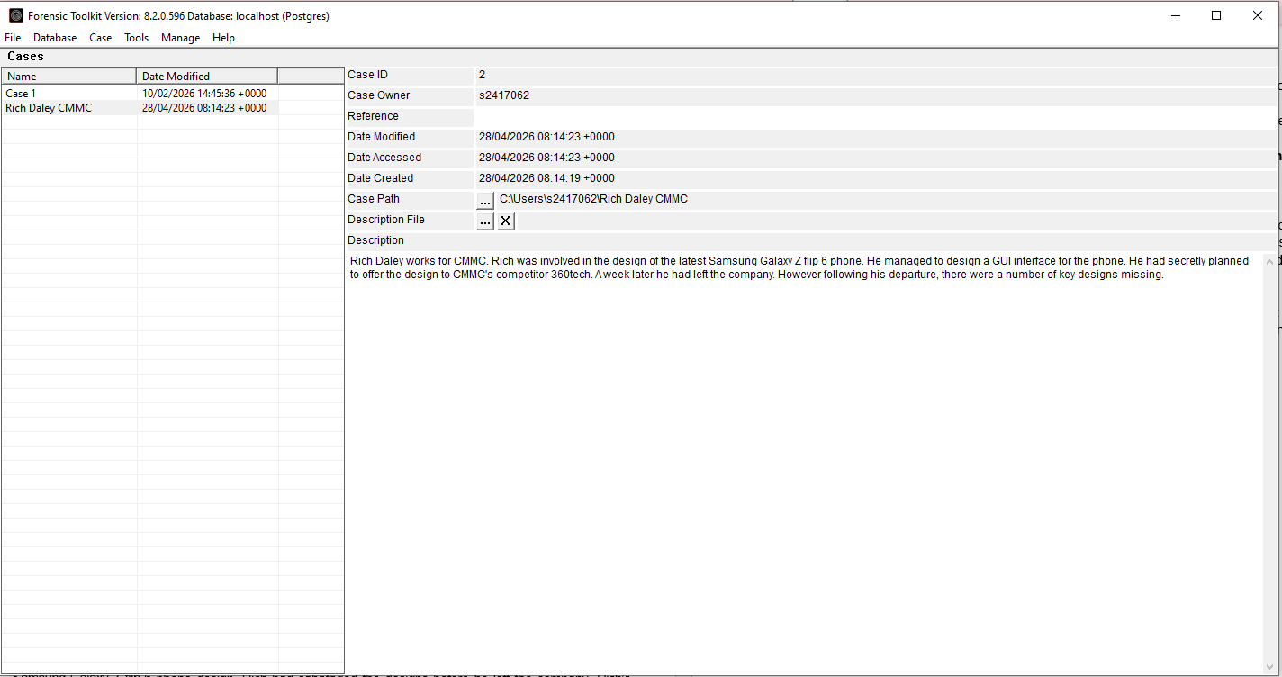

Figure 1 – An FTK case was created by Troy Simpson

Below is evidence found by Troy Simpson that a file wiping tool (Eraser) was found within the applications. This suggests that the claim that data was deleted can be proved true.
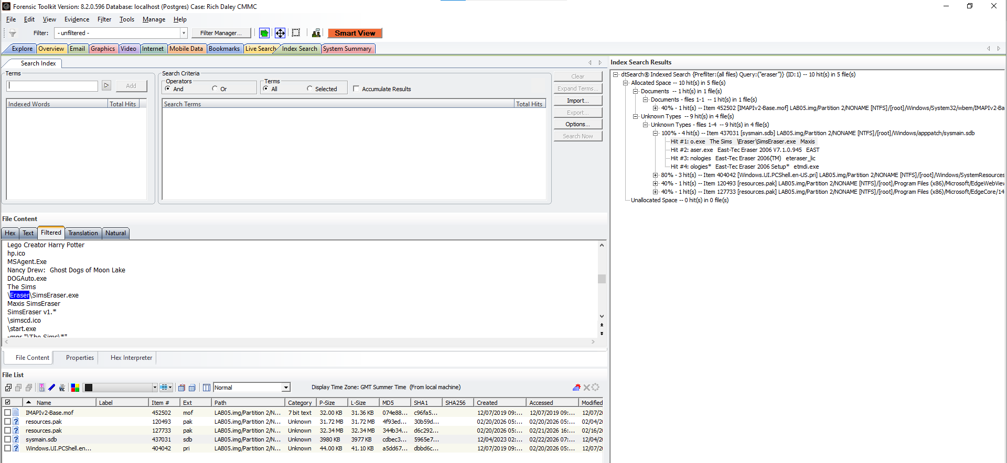
Figure 2 – Proof of a file wiping tool installed within the system (Eraser)

Upon searching the Internet History on the device, there was further evidence of sabotage when Google Drive appeared on the Browser History. The browsing records suggests that files may have been uploaded to the personal Google Drive, further supporting the claim of unauthorised data transfer.
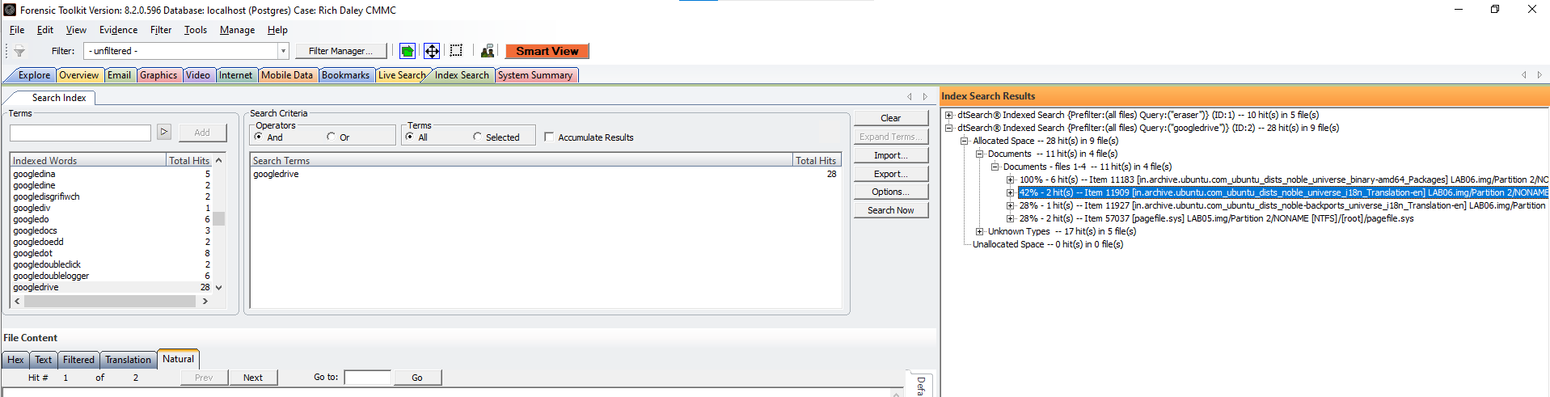
Figure 3 – a search providing evidence of multiple accounts of Google Drive being accessed

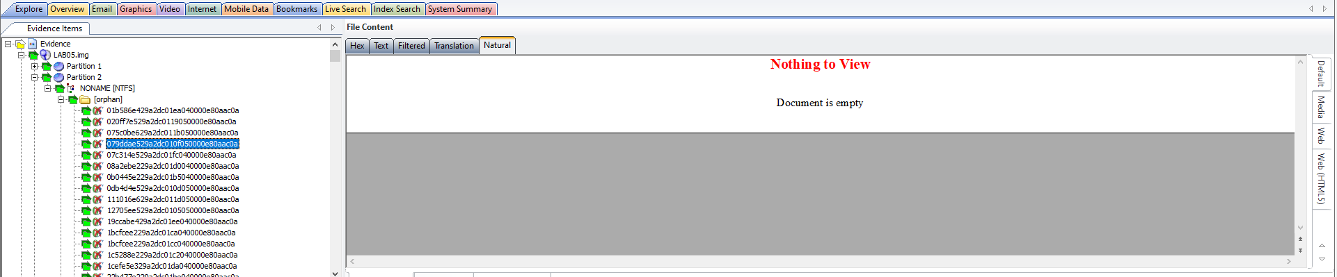
The images shown below shows a number of potential file fragments found within the unallocated space section on the device. This suggests that there may have been files that were deleted and traces remained.
Figure 4 – File Fragments within unallocated space
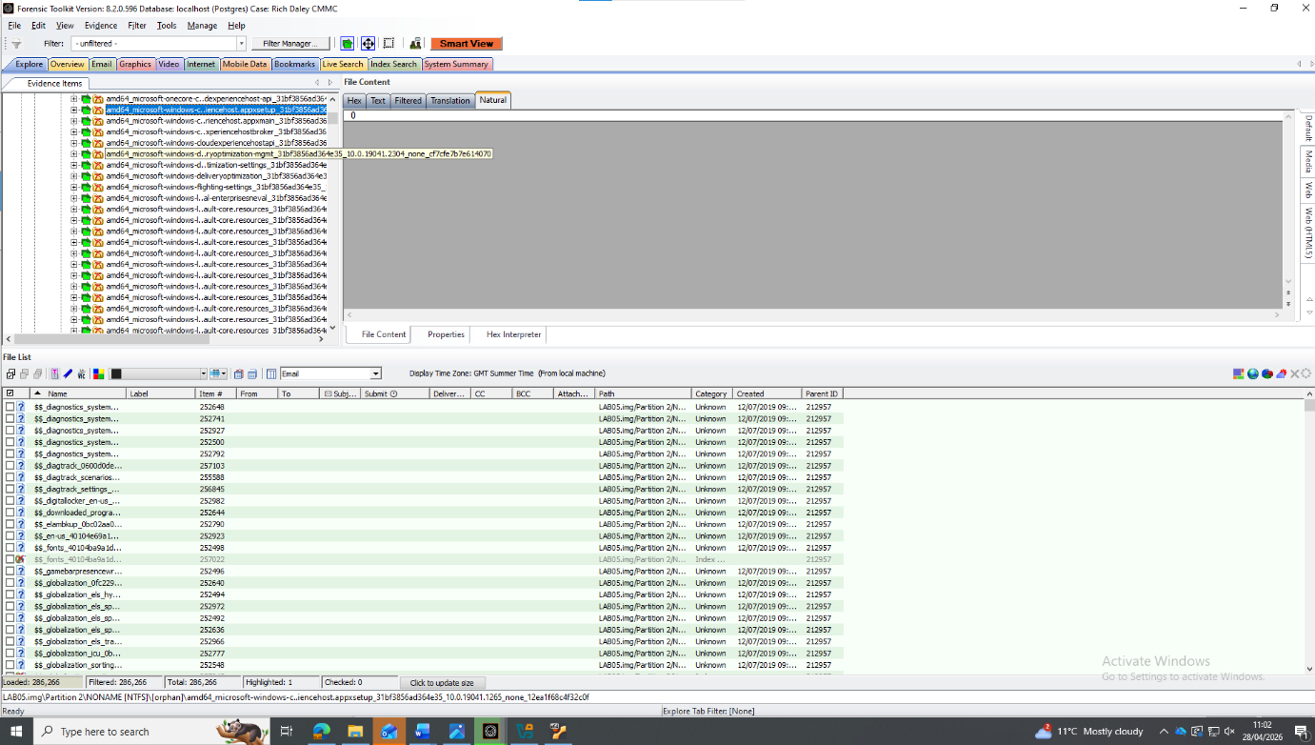
Figure 5 – More File Fragments within unallocated space

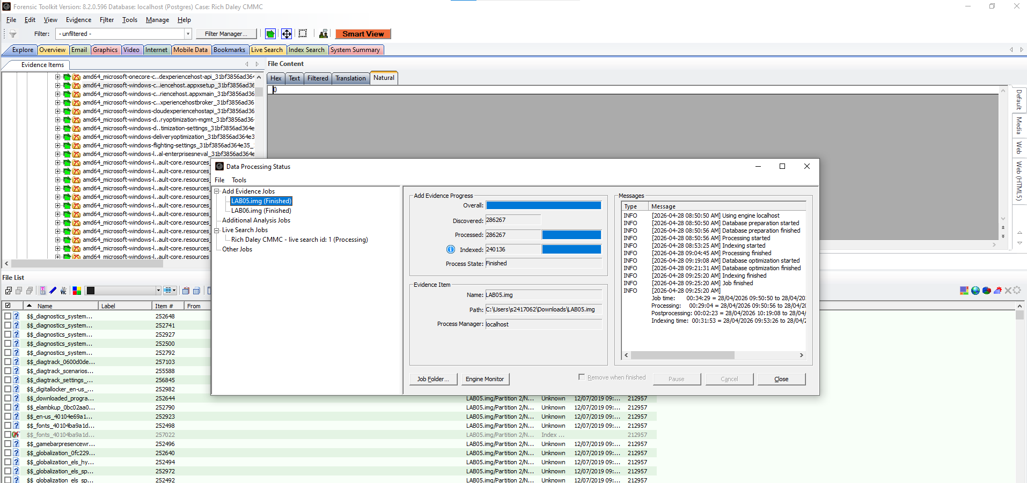
Figure 6 – Lab Images fully processed within FTK
The image shown above demonstrates the ability to add multiple images to the FTK system. This shows that multiple systems could be analysed side by side on the system, further giving FTK an advantage over other digital forensics tools.
The image below demonstrates potential emails found within Rich Daley’s system. Although this one does not specifically mention the files about the Samsung Galaxy Z flip 6 phone, it does prove that there may have been unauthorised transfer of data from his device.
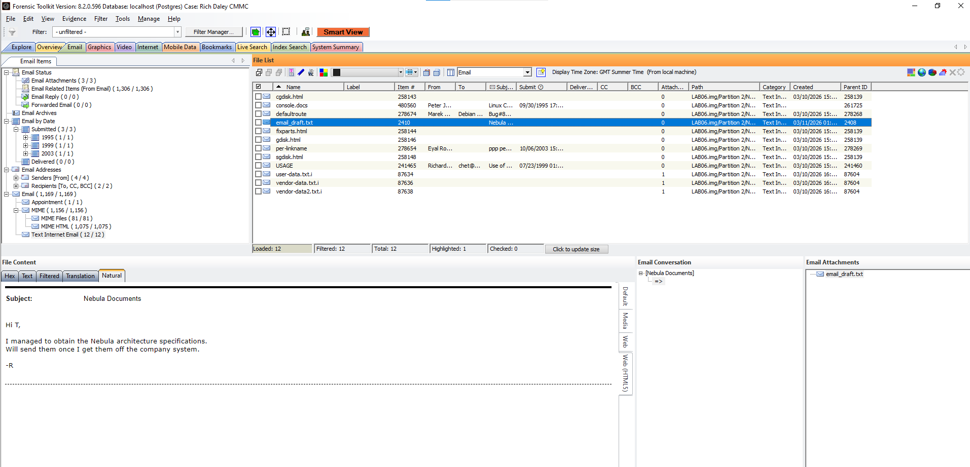
Figure 7 – Example email found within FTK

An image shown below clearly shows that a USB stick was used as one of the more recent files. This could suggest that files were transferred from the device onto a personal device before being transferred to 360tech.
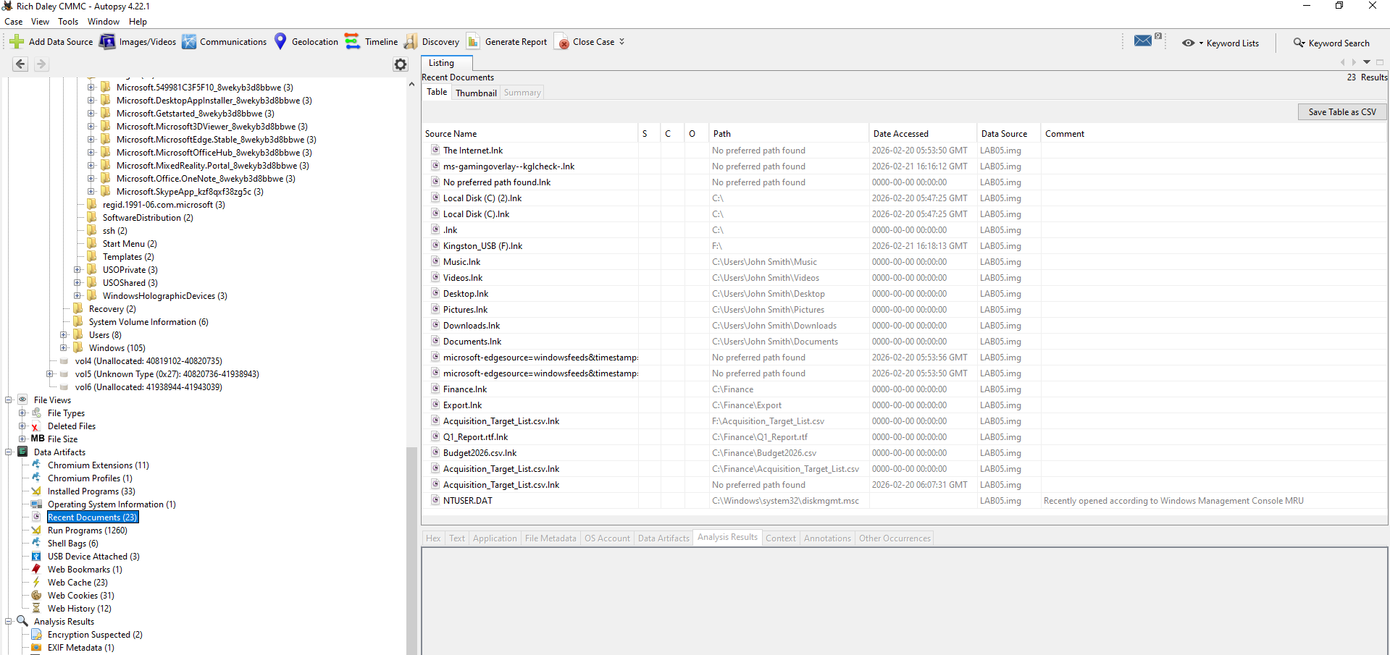
Figure 8 – Evidence of USB Drive being accessed on Autopsy

The image below proves that the device did have encryption keys on the system which does make digital investigations slightly more difficult.
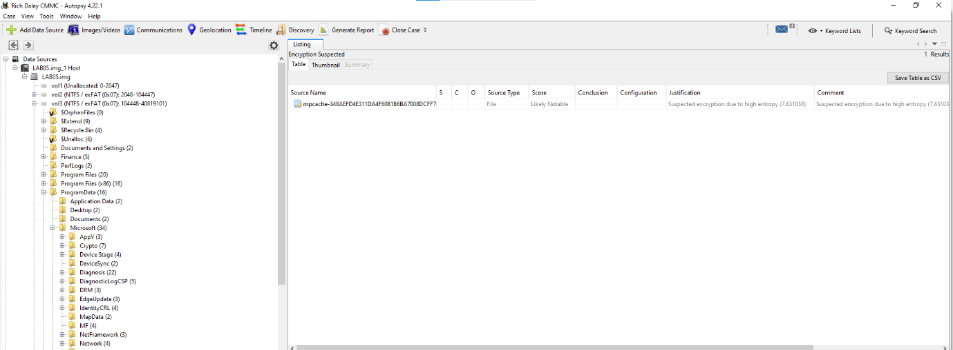
Figure 9 – Evidence of Encryption on Autopsy

Below is an example image of a timeline created within Autopsy. This can be beneficial within forensic investigations as it can show companies what happened and when this event took place.
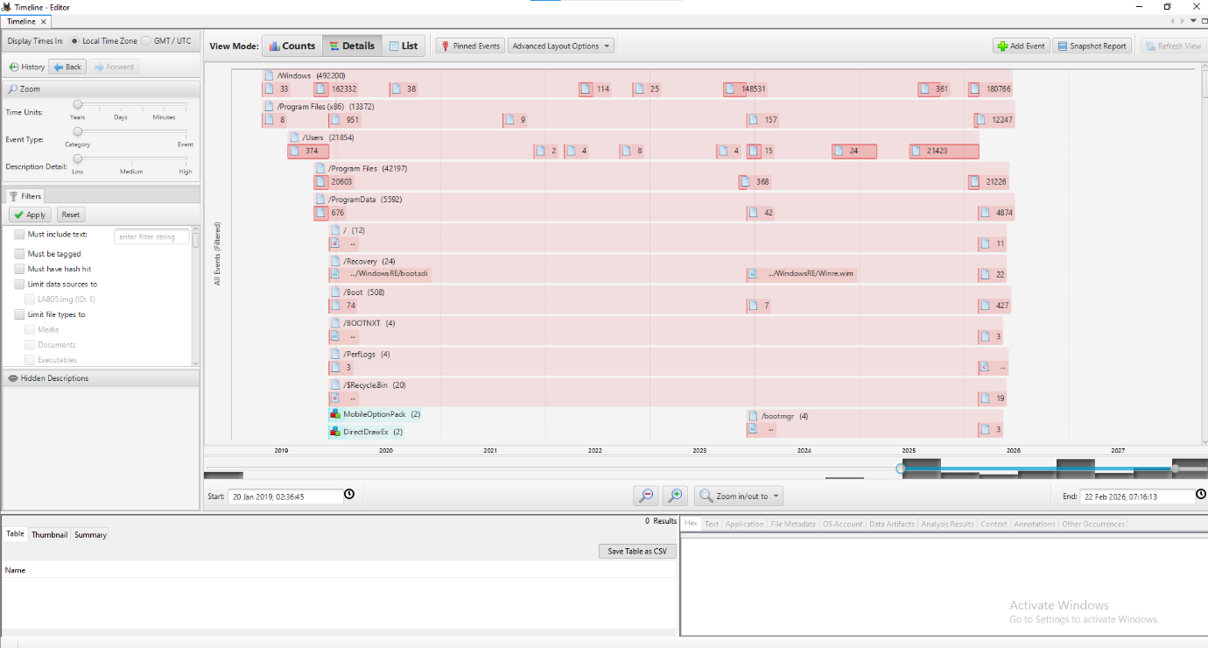
Figure 10 – Timeline Creation
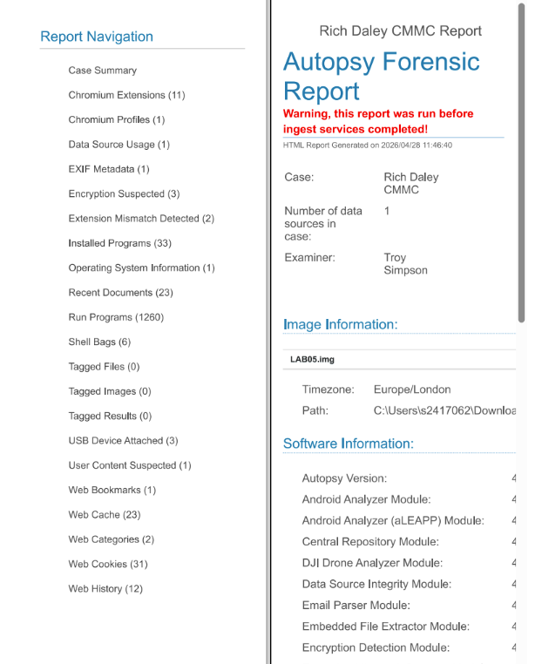
Figure 11 – An Example Report created using Autopsy
The image above demonstrates an example report that is able to be generated within Autopsy. This is an automated tool that is found within Autopsy. It puts all data into one report and has functioning buttons that can show each of the different sections.

Recommendations
It is recommended that CMMC takes appropriate action based on the findings of this investigation. The company should first consider pursuing legal action using the forensic evidence obtained from investigation conducted by Troy Simpson. There are many different UK Legal Offences that Rich has broken including unauthorised access, data theft and the deliberate destruction of company property.
Measures should be introduced to prevent similar incidents in the future. This includes implementing regular secure backups for critical systems, implementing stricter access control groups with multi-factor authentication. It would also be advised that there are thorough checks put in place when someone leaves the company, especially for staff members that are in sensitive roles to ensure that no confidential information is shared or removed prior to departure.

Professional Invoice

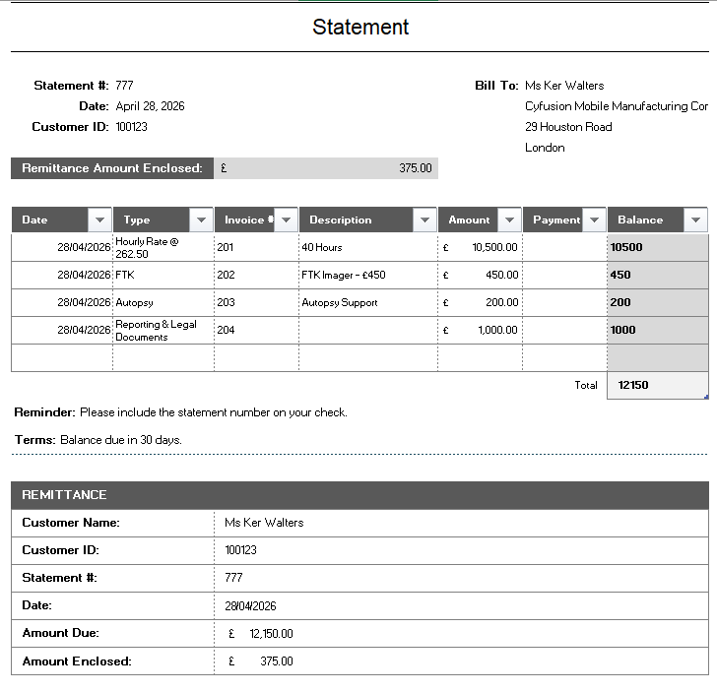
Figure 12 – Professional Invoice created for work completed by Troy Simpson

Conclusion
This report demonstrates that whilst the digital forensics tools such as FTK, Cellebrite, Autopsy etc. are all highly useful within the forensics environment, there is not necessarily a ‘one tool fits all’. All tools continue to evolve as the digital footprint grows and grows. However, there is no single tool that effectively allows for investigation of a whole case. Instead, effective forensic investigations involve the use of multiple tools dependant on what stage of the investigation it is at.
The case study given regarding the potential sabotage at Cyfusion Mobile Manufacturing Company (CMMC) had one clear result. There was ample evidence to prove that Rich Daley had deliberately engaged in data deletion and the unauthorised transfer of data. Whilst completing the investigation, Troy Simpson had found evidence of file wiping tools such as Eraser, the use of a USB device to transfer data to alongside file fragments within unallocated space proving that files had been deleted. In the browser history, there was proof that Google Drive had been accessed by Rich Daley, further proving that claim. This information provides a strong evidential basis for legal action to take place on Rich. To conclude, this report demonstrates the importance of adhering to ACPO standards, CHFI standards and maintaining a chain of custody. It also highlights the vital role digital forensics plays within the technology industry.

References
[1] A. Ngo. "What is Computer Forensics? | IBM." Accessed: Apr 21 2026. [Online]. Available: https://www.ibm.com/think/topics/computer-forensics
[2] Dana Wilson-Kovacs and Jen Wilcox, "Managing Policing Demand for Digital Forensics through Risk Assessment and Prioritization in England and Wales," 2023 Accessed: Apr 21 2026
[3] Pawan Panwar. "Learn what FTK Imager is, how it works, and why it’s essential in digital forensics. Explore its features and importance in data preservation." Accessed: Apr 21 2026 [Online]. Available: https://www.linkedin.com/pulse/what-ftk-imager-tool-digital-forensics-explained-pawan-panwar-ynu3c
[4] "exterro." Accessed: Apr 21 2026 [Online]. Available: https://www.exterro.com/digital-forensics-software/ftk-forensic-toolkit
[5] "What Is FTK Imager, And How Does It Complement FTK?" Accessed: Apr 22 2026. [Online]. Available: https://www.cyberly.org/en/what-is-ftk-imager-and-how-does-it-complement-ftk/
[6] "FTK Imager - Free Download for Windows PC." Accessed: Apr 23 2026. [Online]. Available: https://ftkimager.com/
[7] "Digital Forensics Software : SUMURI Digital Forensics" SUMURI. Accessed: Apr 23, 20262026, [Blog]. Available at: https://sumuri.com/software/paladin/
[8] "PALADIN" CDFS - Digital Forensic Products, Training & Services. Accessed: Apr 24, 20262026, [Blog]. Available at: https://cdfs.com.au/product/paladin/
[9] C. F. Academy. "Autopsy Forensics Tool: Complete Step-by-Step Beginner Guide (2025)." Accessed: Apr 24 2026. [Online]. Available: https://www.cyberforensicacademy.com/blog/autopsy-forensics-tool-complete-step-by-step-beginner-guide
[10] "Autopsy," Accessed: Apr 24, 2026. Available at: https://www.sleuthkit.org/autopsy/
[11] "What File Systems Does Autopsy Support?" Accessed: Apr 24 2026. [Online]. Available: https://www.cyberly.org/en/what-file-systems-does-autopsy-support/
[12] A. Vijayan. "What is Cellebrite UFED?" Forensics Insider. (-01-012025). Accessed: Apr 25, 2026, [Blog]. Available at: https://www.forensicsinsider.com/digital-forensics/cellebrite-ufed/
[13] Xpert Forensics “Cellebrite UFED 4PC Tutorial | Introduction, Key Features & Complete Guide for Digital Forensics” (Aug 2025) Accessed: Apr 25,2026, [Video]. Available at: https://www.youtube.com/watch?v=a93njxZKAR4&t=166s
[14] "How Much Does a Cellebrite Physical Analyzer Cost?" Accessed: Apr 25 2026. [Online]. Available: https://hub.sivo.it.com/digital-forensics-software-cost/how-much-does-a-cellebrite-physical-analyzer-cost/
[15] "CAINE Forensic Environment." Accessed: Apr 25 2026. [Online]. Available: https://www.geeksforgeeks.org/python/caine-forensic-environment/
[16] "Comprehensive Digital Forensic Capabilities." Accessed: Apr 25, 2026. Available at: https://cdfs.com.au/wp-content/uploads/2022/03/Paraben-Universal-Digital-Forensic-Capabilties-3.0.pdf.
[17] "E3 Forensic Platform Pricing Options | PDF | Subscription Business Model | I Cloud." Accessed: Apr 25 2026. [Online]. Available: https://www.scribd.com/document/875062154/Paraben-Software-Price-List
[18] "E3:Universal: Details, Pricing, Features, & Integration in 2026." Accessed: Apr 25 2026. [Online]. Available: https://www.softwaresuggest.com/e3-universal
[19] D. Greenspan. "CHFI Certification Overview & Training." Accessed: Apr 27 2026. [Online]. Available: https://www.itcareerfinder.com/it-certifications/ec-council-certification-training/computer-hacking-forensic-investigator-chfi.html
[20] "ACPO guidelines & principles explained" Forensic Control. Accessed: Apr 27, 2026, [Blog]. Available at: https://forensiccontrol.com/guides/acpo-guidelines-principles-explained/
[21] "What Is the Chain of Custody and Why Is It Important?" LegalClarity. (-07-152025). Accessed: Apr 27 2026 [Online] Available at: https://legalclarity.org/what-is-the-chain-of-custody-and-why-is-it-important/

Appendix


