
Opportunities for female leaders in 21st century organisation

Implementation Plan

SARWAT ZAREEN ASFI
1905650
January 13, 2023
University of Wales Trinity Saint David

Summary

This implementation report aims to evaluate the role of education and the political sector to facilitate the career prospects for women in the football profession nationally and internationally. A brief explanation will be presented to consider if the organisation’s aims, objectives, and values limit the progression of a woman in a leadership role. The discussion will be conducted related to self-awareness, well-being, gender discrimination, and the struggle to survive in a male-oriented organisation. The gender pay gap and diversification in the workplace and the culture of the organisation will determine and the recommendations will be made by using contemporary management and leadership theories to eliminate any negative assumptions and supporting the points of Women’s progression and improvement in the football sector for future development and growth. FIFA and UEFA's future action plan and strategy for the development and growth of women's football between 2019 and 2024 are described in this report. A variety of academic and reliable sources were used for the research, including the library at the University of Wales Trinity Saint David (UWTSD), online articles and journals, and online books.

Table of Contents
Title Page 0
Summary 1
Table of Figures 2
1. Implementation Plan 2
1.1 Introduction 2
2. Rationale 3
2.1 Aims and Objectives 3
2.2 Action Plan 3
2.3 Women Leadership Development Programme (WLDP) 3
2.4 Time Plan 4
2.5 Risk Management and Strategies 5
2.5.1 Strategy Plan For Women’s Leadership and Football 7
3. Barriers and Limitations of Women’s Leadership role 7
4. Recommendations for Women’s Leadership Roles 9
5. Conclusion 10
6. References 11
7. Bibliography 13

Table of Figures
Figure 1: Women Leadership Programme 4
Figure 2: UEFA ''Time for Action Plan’’ thus far 5
Figure 3: UEFA Plan to Achieve by 2024 5
Figure 4: Strategic Plan for Women’s football and Leadership 7
Figure 5: Barriers and Limitations in Women's Football and Leadership role 8

1. Implementation Plan

1.1 Introduction
This implementation plan will be focused on Women’s Leadership opportunities and leadership roles in professional football organisations. The discussion will be around the organisation's cultural and political aspects, which limit the progression of women’s leadership roles. The existence of gender pay gap, racism, and Gender discrimination in the workplace will be identified the benefit of diversity, and the future vision of setting goals to achieve leadership approaches to develop numerous opportunities for women in the football profession.

2. Rationale
Women's professional football is growing expeditiously, and producing some remarkable female players, coaches, managers and leaders. In many regions, however, employment opportunities and working conditions are lacking, and it is women’s right to reach their full potential (Williams, 2007). Empowering women in the industry must be accompanied by developing and implementing global standards that protect the rights and welfare of women (Kabeer, 2003).
Offord (2022) observed that the conditions in which women players train, perform and compete must support their physical and mental well-being, promote their skills and protect their integrity. Mogaji (2022) indicates that it is time to prioritise investment in women players and ensure that this growth path does not overshadow working conditions as well as equalising women’s status in professional football. It must be learned through the challenges and opportunities that have developed across the football industry and used this knowledge to help lay the foundations for a sustainable global market based on healthy and safe working conditions.

2.1 Aims and Objectives
This implementation plan aims to set a strategic proposal to measure the success of reducing gender inequality and discrimination by empowering women in professional football.
- The first objective is to develop leadership and education programmes to support the growth and development of women in the football profession.
- The second objective is to improve the popularity of women’s football by increasing their strength through advertising, gaining new competitors and increasing playing opportunities.
- The third objective is to address female inequality by ensuring female representation in leadership positions. Address gender differences in regularity bodies and increase women’s global football opportunities.
- Create a sustainable foundation for future success for women in a male-oriented career and bring diversity to the workplace culture by eliminating gender discrimination.

2.2 Action Plan

2.3 Women Leadership Development Programme (WLDP)
O’Connor (2010) highlighted that no doubt that the sports industry is one of the most global industries and the main objective is to increase women’s presence in the sports sector where they have decision-making power. Gender discrimination is the key barrier faced by women in the sports industry. They are breaking this barrier by coming forward to show their capabilities and adapt to the sport’s culture while working in a male-oriented environment (Gelen and Cömert, 2021).
There are eight programmes offered by FIFA and the purpose is to provide all member associations (MAs) with additional resources and support to develop their skills and knowledge in women’s football (FIFA, 2020a).
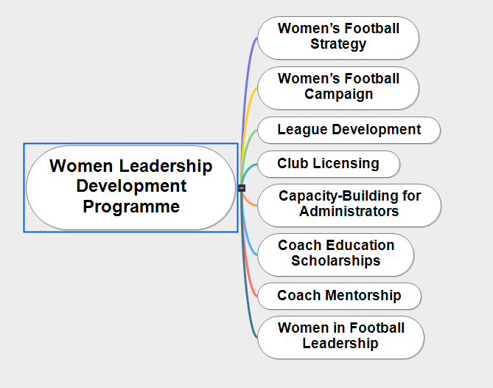
Figure 1: Women Leadership Programme
During the 2020-2023 timeframe, member organisations will be able to seek funding in eight critical areas of women's football development. The football organisation will provide financial aid, professional support, extra equipment and technical support to encourage women to progress and promote their presence in the football profession. (FIFA, 2020b).
To encourage and continuous development in upcoming sessions in 2023 FIFA has increased the participants limit from 24 to 32. Furthermore, FIFA announced the investment will be increased to 1 billion USD for women’s football. FIFA underpins this strategy with specific goals, such as getting sixty million female participants by 2026 (FIFA, 2022).
Hindley (2016) stated that the football development programme is a joint effort of FIFA and UEFA and aims to promote women’s leadership roles around the globe. The participants, who are nominated by their respective member associations and represent all six confederations, have high management roles in football such as General Secretaries, Executive Board Members, or Directors.

2.4 Time Plan
UEFA designed the women's football strategy for female players in Europe to raise the numbers to double by 2024. As a result, UEFA will make considerable financial investments in the sport, demonstrating how UEFA is willing to aim high and create projects that inspire optimism, and the success of football in the Europe region. By 2024 this initiative will bring more productivity, women empowerment and growth to women’s football. UEFA also mentioned that it is their responsibility to empower women in the governing body (UEFA, 2019).
UEFA named this football strategy 2019 - 2024 as ‘’#Time for Action’’ and to achieve this UEFA committed to a five-year plan and set their goals, objectives, vision, mission and priorities. This action plan significantly boosts the presence of women in all areas of football.
UEFA (2019) stated that to be able to achieve higher and adopt more with the expansion of resources, leadership and agreement of governance bodies women’s football can bring a substantial change in the economic growth of the football market.
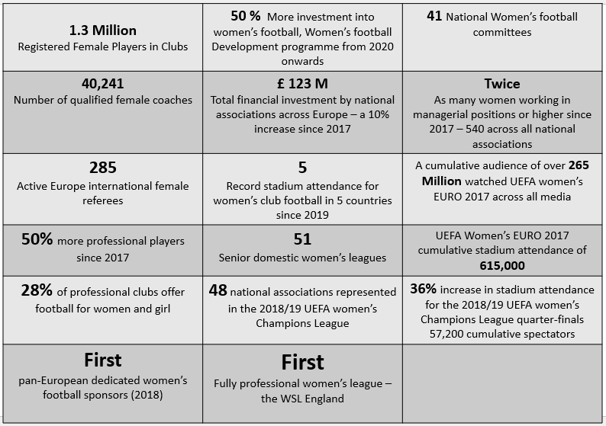
Figure 2: UEFA ''Time for Action Plan’’ thus far

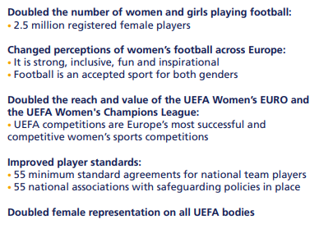
Figure 3: UEFA Plan to Achieve by 2024

2.5 Risk Management and Strategies
Risk management entails being aware of what could happen in the organisation and taking actions to reduce it happening. Risk is not always damaging itself, but it can lead to a substantial negative influence on the organisation if ignored. This risk assessment aims to determine the essential component of modern football administration at all levels.
Women’s Football Risk Management
Hazard / Requirement | Risk | People at Risk | Control Measure | Risk Rating  (High/ Medium/ Low) | Comments / Action
Staff Qualification | Promote Leadership Programme for Women |  | Leadership Programme – Make it more accessible and introduce it worldwide | Medium | To empower/ encourage women to enhance their abilities
Safeguarding and Policies | Legal Liability | Player | Ensure staff fully aware of  safeguarding policies | High
Mental Health and Well-Being | Can affect due to discrimination and diversity issues | Managers, Leaders and co-workers | Involve work colleagues in completing risk assessments so can be identified potential problems and identify a solution | High | Involve work colleagues in completing risk assessments so can be identified potential problems and identify a solution
Coaching and Mentoring | Affect the working environment and become toxic | Work colleagues/managers/ leaders/ coaches | Introducing courses of coaching and counselling session | Medium | Regular staff meetings and feedback can help the work setting
Female-Friendly Facilities / Variable Working hour | Lack of Privacy, Lack of facilities, Lack of childcare, shift work pattern | Female Players, Managers, coaches, Club members | Providing safe and appropriate facilities, childcare provisions, and Improve facilities in the football clubs | High | Making these changes will encourage women to work more hours, and in a safe environment

2.5.1 Strategy Plan For Women’s Leadership and Football
According to FIFA (2020c), in recent years women's football has grown rapidly, which offers many opportunities for women in different fields of football. The introduction of FIFA Strategy for WLDP outlines how FIFA will collaborate with all stakeholders to take tangible initiatives to promote girls and women, make football a sport for everyone, and eliminate gender discrimination.
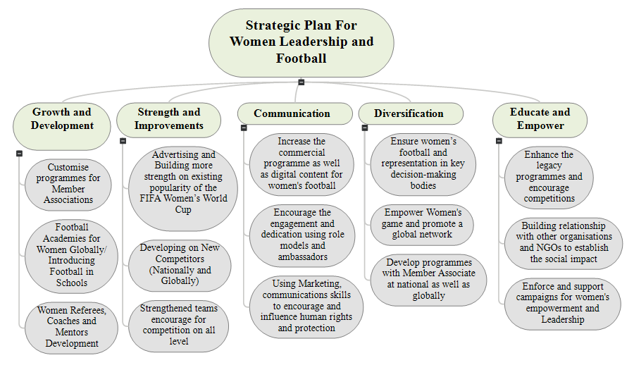
Figure 4: Strategic Plan for Women’s football and Leadership
This strategic plan presents the aim to achieve the development and growth to increase female participation in football worldwide by 2026, with 60 million players expected. It is expected to raise the number of female coaches, and female referees and expand football in schools, academies, and local sports venues to make the game accessible for girls. The goal is to enhance the technology implementation and engagement using brand strategy by 2026, launching a commercial programme for women’s football. Expansion of development efforts will be possible through the creation of a new economic flow, and sustainable system to encourage women’s leadership role in the organisation.

3. Barriers and Limitations of Women’s Leadership role
Culver et at., (2019) emphasise there are insufficient support structures in place to encourage females to take on leadership and decision-making responsibilities. At the Beijing Olympic Games, there were more female athletes than ever before, yet just twenty-two of Canada's head coaches were women which made up 9% of all head coaches. At the 2016 Olympic Games in Rio, this percentage fell even further to 6% (Canadian Association, 2019). To increase gender equality and leadership diversity the WLDP uses a practice community method to encourage and support women in this male-oriented profession (Bryan, 2021).
Holmes (2018) stated in a sports media article that a survey report revealed that 40% of women face gender discrimination working in the sports sector. 30% of women have said they have to deal with inappropriate behaviour from men, and also enhance the problem of the pay gap, unrecognised in the workplace, and lack of opportunities to advance in Leaders’ roles.
NADS, (2016) explained despite centuries of male domination, women's football is gaining popularity in the United Kingdom. National women's football teams have had the same level of achievement as their male football teams in recent years. It is critical to identify the limitations and barriers to encouraging the development of women's football nationally and internationally.

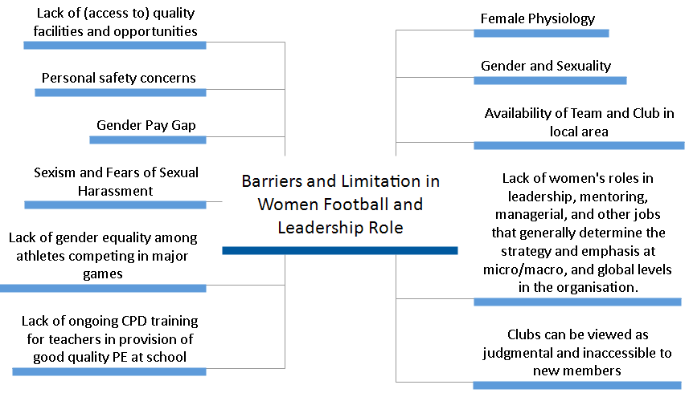
Figure 5: Barriers and Limitations in Women's Football and Leadership role

4. Recommendations for Women’s Leadership Roles
Jones (2022) reflects gender discrimination in recruiting and promotion practices must be eliminated, women should be provided training and education resources so they can pursue their careers in decision-making roles and leadership jobs. However, Wallington (2016) specifies that there should be a balance between the genders in the number of elite athletes competing in major competitions. Maintaining the workplace culture to develop skills and capacity building for all employees. To benefit the community, leadership, coaching and mentoring programmes should be on offer widely for women working in or volunteering in the sport or the sports and leisure industry. These programmes can give women the chance to exchange experiences, ideas, skills and knowledge. Make diversity on top of the list, ensuring that volunteers and employees are educated on matters relating to diversity. Open new communication channels change the impression of any club to a more dynamic, contemporary, and open organisation.
Babiak, K. and Wolfe, R. (2009) emphasise that employers’ support is regarded as considerably high if they support ethically in the workplace. Charity sports leagues, competitions, charitable sporting activities, and training that are conducted at the workplace employers could match the donations to show their support.

5. Conclusion

Women are more prominent and visible in football as professionals, sports representatives, news reporters, club officials, and managers not only as a player. Increasing the visibility of women is not enough to solve many problems related to their participation in sports. A gender revolution is required to achieve equality and justice on and off the field. Starting from the players to managers, fans, and sponsors, everyone needs to take a clear and consistent stance for women and help create a positive environment in football as well as in all sports. Equality and inclusion should be anchored in clubs and associations.
FIFA continues to place a high focus on women's football since it offers the greatest potential for expansion. Despite the fact that women’s football has expanded quickly at all levels, there is still a tonne of unrealised potential due to its growing popularity and interest in it. FIFA and UEFA are investing in specialised funds, personnel, and creative, specialised development programmes to enhance women's football. In recent years, development programmes and coaching and mentoring programmes have been added for the growth and development of women in leadership roles. The Women's Football Strategy of FIFA's eight development programmes will promote the strength, women empowerment and growth of FIFA Member Associations.

6. References
Babiak, K. and Wolfe, R. (2009) ‘Determinants of Corporate Social Responsibility in Professional Sport: Internal and External Factors’, Journal of sport management, 23(6), pp. 717–742. Available at: https://doi.org/10.1123/jsm.23.6.717 [Accessed January 10, 2023].
Bryan, A., Pope, S. and Rankin-Wright, A.J. (2021) ‘On the Periphery: Examining Women’s Exclusion From Core Leadership Roles in the “Extremely Gendered” Organization of Men’s Club Football in England’, Gender & Society, 35(6), pp. 940–970. Available at: https://doi.org/10.1177/08912432211046318 [Accessed January 08, 2023].
Canadian Association for the Advancement of Women and Sport and Physical Activity(2018). Women in Sport Leadership: Board Snapshot 2017–2018. Available at: www.canadianwomen.org/our-work/gender-equality-network-canada [Accessed January 10, 2023].
Culver, Diane M., Erin Kraft, Cari Din, and Isabelle Cayer (2019) ‘The Alberta Women in Sport Leadership Project: A Social Learning Intervention for Gender Equity and Leadership Development’, Women in sport & physical activity journal, 27(2), pp. 110–117. Available at: https://doi.org/10.1123/wspaj.2018-0059 [Accessed January 10, 2023].
FIFA (2020) FIFA launches a programme to help member associations further develop women's football, FIFA. Available at: https://www.fifa.com/media-releases/fifa-launches-programme-to-help-member-associations-further-develop-women-s-foot [Accessed: January 10, 2023].
FIFA (2022) Strategy details, FIFA. Available at: https://www.fifa.com/womens-football/strategy/strategy-details [Accessed: January 10, 2023].
FIFA Digital Hub (2020) FIFA. Available at: https://digitalhub.fifa.com/m/3337fe5231c26c72/original/mzliwvh0tj7maojqnyim-pdf.pdf [Accessed: January 10, 2023].
FIFA (2020) Third edition of women in football leadership programme launches, FIFA. Available at: https://www.fifa.com/womens-football/news/third-edition-of-women-in-football-leadership-programme-launches [Accessed: January 10, 2023].
FIFPro (2020). Available at: https://fifpro.org/media/1n4mp3ht/fifpro-womens-report_eng-lowres.pdf [Accessed: January 9, 2023].
GELEN KANDAZ NURA and CÖMERT, ESRA (2021) Career barriers of women managers in women football. 15 (4). Available at: https://pjmhsonline.com/2021/april/1433.pdf [Accessed: January 10, 2023].
Hindley, M. (2016) Women implementing leadership skills: Inside UEFA, UEFA.com. Available at: https://www.uefa.com/insideuefa/football-development/news/022d-0f8e2d29fc9e-a4b4fafc988b-1000--women-implementing-leadership-skills [Accessed: January 10, 2023].
Holmes, E. (2018) Gender discrimination affects 40% of women in the sports industry, SportsPro. Available at: https://www.sportspromedia.com/news/gender-discrimination-women-in-sports-industry-report [Accessed: January 10, 2023].
Jones, S. (2022) Women in leadership: The barriers faced with increasing women's participation in Leadership & decision-making, Sarah Jones Leadership Coaching. Available at: https://www.sarah-j.com/women-in-leadership-the-barriers-faced-with-increasing-womens-participation [Accessed: January 10, 2023].
Kabeer, N. (2003) Gender mainstreaming in poverty eradication and the Millennium Development Goals: A Handbook for Policy Makers and other stakeholders. London: Commonwealth Secretariat.
Mogaji, Badejo, F. A., Charles, S., & Millisits, J (2022) ‘To build my career or build my brand? Exploring the prospects, challenges and opportunities for sportswomen as human brand,’ European sport management quarterly. 22(3), pp. 379–397. Available at: https://doi.org/10.1080/16184742.2020.1791209 [January 08, 2023].
NADS (2016) Barriers to female participation in football, NADS. Available at: http://www.nads.org.uk/football-history/barriers-to-female-participation-in-football [Accessed: January 10, 2023].
O'Connor, K. (2010) Gender and women's leadership in sport: The Reference Book. Los Angeles: SAGE.
Offord, J. (2022) The euros prove it: Women's football is not like men's – and that's good. Guardian News and Media. Available at: https://www.theguardian.com/commentisfree/2022/jul/27/womens-football-is-not-just-a-spin-off-of-the-mens-game-its-great-in-its-own-right [Accessed: January 9, 2023].
Scheadler, T. and Wagstaff, A. (2018) Exposure to women's sports: Changing attitudes toward female athletes, The Sport Journal. Available at: https://thesportjournal.org/article/exposure-to-womens-sports-changing-attitudes-toward-female-athletes [Accessed: January 10, 2023].
SWinGleader, C.P. (2021) The Women in Football Leadership Programme by UEFA, SWinG. Available at: https://gamechangeher.org/2021/09/29/women-in-football-leadership-programme-wflp [Accessed: January 11, 2023].
UEFA (2018) Women in football leadership programme: Inside UEFA, UEFA.com. Available at: https://www.uefa.com/insideuefa/football-development/news/0211-0e156d5942ec-fda5f664cac7-1000--women-in-football-leadership-programme [Accessed: January 10, 2023].
UEFA.com (2019) Time for Action: first ever UEFA women’s football strategy launched |Available at: https://www.uefa.com/insideuefa/about-uefa/news/0251-0f8e6ba98884-3dd4ba899f93-1000--time-for-action-first-ever-uefa-women-s-football-strateg/ [Accessed: 12 January 2023].
UEFA (2021) Women in football leadership programme (WFLP), UEFA Academy. Available at: https://uefaacademy.com/courses/wflp [Accessed: January 11, 2023].
Wallington, C. (2016) Blog, Women's Sport and Fitness Foundation: Available at: https://www.wsff.org.uk/ [Accessed: January 11, 2023].
Williams, J. (2007) A beautiful game: International perspectives on women's football. Oxford: Berg Publ.

7. Bibliography
Association, T.F. (no date) History of women's football, www.thefa.com. Available at: https://www.thefa.com/womens-girls-football/history [Accessed: November 26, 2022].
Bell, M. P., Mclaughlin, M. E. and Sequeira, J. M. (2002) Discrimination, harassment, and the glass ceiling: Women executives as change agents ’, Journal of Business Ethics, vol. 37, no. 1, pp. 65–76. DOI: 10.1023/A:1014730102063 [Accessed 5 December 2022].
Bryan, A., Pope, S. and Rankin-Wright, A. J. (2021) ‘On the Periphery: Examining Women’s Exclusion from Core Leadership Roles in the “Extremely Gendered” Organization of Men’s Club Football in England’, Gender & Society, SAGE Publications Inc, (35) 6, pp. 940–970. DOI: 10.1177/08912432211046318 [Accessed 25 October 2022].
Burton, L.J. (2015) ‘Underrepresentation of women in sport leadership: A review of research’, Sport management review, 18(2), pp. 155–165. Available at: https://doi.org/10.1016/j.smr.2014.02.004 [Accessed December 3, 2022]
Carter, N., Mangan, J.A. and Majumdar, B. (2006) “The football manager,” A History, (1st Edition), p. 216. Available at: https://doi.org/10.4324/9780203969991 [Accessed December 3, 2022]
Doble, A. (2015) The secret history of women's football, BBC News. BBC. Available at: https://www.bbc.co.uk/news/newsbeat-33064421 [Accessed: December 2, 2022].
FIFA Digital Hub (2021) FIFA publishes the first-ever comprehensive analysis of the Elite Women's Football Landscape, FIFA. Available at: https://www.fifa.com/en/media-releases/fifa-publishes-first-ever-comprehensive-analysis-of-the-elite-women-s-football-l [Accessed: December 3, 2022].
Football Landscape (no date) FIFA publishes first-ever comprehensive analysis of the Elite Women's. Available at: https://www.fifa.com/media-releases/fifa-publishes-first-ever-comprehensive-analysis-of-the-elite-women-s-football-l [Accessed: December 3, 2022].
Footbalists, (2020) Top 10: Female managers of men's football teams, footbalists. Available at: https://footbalists.wordpress.com/2020/08/18/top-10-female-managers-of-mens-football-teams [Accessed: November 26, 2022].
Forsdick, S. (2019) Women working in football: 11 female directors at Premier League clubs, NS Business. Available at: https://www.ns-businesshub.com/business/women-in-football-premier-league/ [Accessed: December 3, 2022].
Gill, A. (2022) Football's gender problem: From the pitch to the boardroom, women are still being blocked from the top jobs, The Conversation. Available at: http://theconversation.com/footballs-gender-problem-from-the-pitch-to-the-boardroom-women-are-still-being-blocked-from-the-top-jobs-106905 [Accessed: November 30, 2022].
Gorman, S. (2019) Ellen Wille, the mother of women's football, France 24. France 24. Available at: https://www.france24.com/en/20190626-ellen-wille-mother-women-football-norway-fifa-world-cup-france [Accessed: December 3, 2022].
Hill, C. (2022) FIFA World Cup 2022: Stephanie FRAPPART, women referees - top facts, Olympics.com. International Olympic Committee. Available at: https://olympics.com/en/news/world-cup-2022-female-referees-top-facts-qatar [Accessed: December 4, 2022].
Neeley, T. (2015) ‘Global Teams That Work’, Harvard Business Review. Available at https://hbr.org/2015/10/global-teams-that-work [Accessed 5 December 2022].
Olsen, Wendy, Vanessa Gash, Sook Kim, and Min Zhang. 2018. The gender pay gap in the UK: Evidence from the ukhls. Research Report Number DFE-RR804. London: Department for Education, Government Equalities Office. https://www.gov.uk/government/publications/the-gender-pay-gap-inthe-uk-evidence-from-the-ukhls.
Rial, B. (2022) Barcelona sets new women's football attendance landmark, The Stadium Business. Available at: https://www.thestadiumbusiness.com/2022/04/25/barcelona-sets-new-womens-football-attendance-landmark/ [Accessed: December 3, 2022].
Scott, L. (2022) World Cup 2022: Female refs 'a positive message' for women in Qatar - Stephanie Frappart - BBC Sport, BBC News. BBC. Available at: https://www.bbc.co.uk/sport/football/63571254?at_campaign=KARANGA&at_medium=RSS [Accessed: December 4, 2022].
Shaw, S., 2006. Analyzing gendered social processes in sport organizations. Journal of Sport Management, 20(4), pp.510-534.
Shirbon, E. (2021) '#metoo movement' in British schools as teens recount sexual abuse, Reuters. Thomson Reuters. Available at: https://www.reuters.com/article/uk-britain-schools-sexual-abuse-idUSKBN2BM20L [Accessed: December 2, 2022].
Sports, B.B.C. (2015) Sexist chanting must be tackled says FA after 'horrible' footage, BBC Sport. BBC. Available at: https://www.bbc.com/sport/football/31750397 [Accessed: November 30, 2022].
Taylor, M. (2013) The Association game a history of British football. London: Routledge.
The Football Association, (no date) History of women's football, www.thefa.com. Available at: https://www.thefa.com/womens-girls-football/history [Accessed: December 2, 2022].
The Guardian (2004) Soccer chief's plan to boost women's Game? hotpants, The Guardian. Guardian News and Media. Available at: https://www.theguardian.com/uk/2004/jan/16/football.gender [Accessed: December 4, 2022].
The Guardian (2016) The 20 greatest female football players of all time. Guardian News and Media. Available at: https://www.theguardian.com/football/2016/aug/03/the-20-greatest-female-football-players-soccer [Accessed: December 2, 2022].
Tyler, M. (2019) ‘Tyler, M., Carson, L., Reynolds, B. (2019). Are Fire Services Extremely Gendered, Organizations? Examining the Country Fire Authority (CFA) in Australia,’ Gender, Work; Organization. Available at: https://www.academia.edu/39318576/Tyler_M_Carson_L_and_Reynolds_B_2019_Are_Fire_Services_Extremely_Gendered_Organizations_Examining_the_Country_Fire_Authority_CFA_in_Australia. https://doi.org/10.1111/gwao.12393 [Accessed 2 December 2022].

