DIGITAL SKILLS PORTFOLIO – DS3
Portfolio Selection and Audio/Video Reflection

Module Code: LCLM4002
Student Name: Viorica Raducan
Student ID: 2543250

1.Portfolio Overview.
I chose four pieces of proof from my work because they represent various stages of my digital skill development. The proof includes utilising Microsoft Word to work with photos and descriptions, Microsoft Excel to arrange numerical data, generating a chart to graphically convey outcomes, and analysing my own work using a Decision & Iteration Log.
These works are significant because they reflect not only the end outcomes, but also how I practiced, checked, and refined my work.

2. Selected Digital Work
Piece of work | Skill shown | Tool used | Audio/video reflection point
1. Task 1 – Images and descriptions | Inserting images, adding written descriptions and organising visual information. | Microsoft Word | I learned how to combine images and text clearly and became more confident using Word.
2. River Fitness – Excel table | Entering, checking and organising numerical customer feedback data. | Microsoft Excel | I learned how to organise data accurately in a spreadsheet and check it against the original information.
3. River Fitness – Column chart | Turning data into a clear visual summary and formatting a chart. | Microsoft Excel | I learned how a chart can make business information easier to compare and understand.
4. Decision & Iteration Log | Reviewing choices, checking accuracy and identifying improvements. | Microsoft Word / Excel evidence | I learned to evaluate my own work and explain what I would improve next time.

3. Evidence 1 – Task 1: Images and Descriptions
For Task 1, I used Microsoft Word to incorporate several photographs into a paper and provide a brief explanation of each image. This data demonstrates that I can deal with both visual and textual material and organise it into a structured document.
Inserting photos, arranging visual material, and providing clear written descriptions are all examples of skills demonstrated.
The tool utilised was Microsoft Word.
Why is this item important? It depicts an early stage of my digital work and exhibits how I may blend graphics and text in a single document.
What I would describe in my reflection: At first, I needed more time to properly arrange the photos and text. After practicing, I gained confidence and can now enter photos and explanations more autonomously.
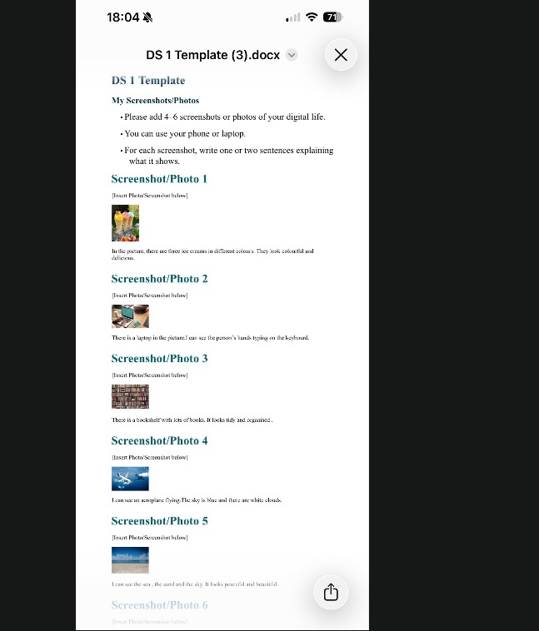
Evidence from task 1

4. Evidence 2 – River Fitness: Excel Table
I utilised Microsoft Excel to enter customer feedback results for the River Fitness assignment. The data were divided into three groups: not satisfied (11 responses), neutral (18 responses), and satisfied (46 responses). Before using the figures, I compared them to the scenario and organised the information into two columns.
The capacity to accurately enter, arrange, and validate numerical data was proven.
Microsoft Excel was the tool used.
The relevance of the article It exhibits my ability to organise corporate data in an intelligible format using a spreadsheet.
What I would say in reflection: Although Excel originally required more attention, I ultimately learned how to correctly input data, use headings, and organise information so that it is easy to understand.

5.Evidence 3: River Fitness Column Chart
After adding the River Fitness data, I picked the table and generated a clustered column chart. I added the headline "River Fitness Customer Feedback Survey" as well as data labels to make it obvious how many replies were received. The graphic allows you to easily compare the three feedback categories.
Skill demonstrated: Creating and structuring a chart to explain facts graphically.
The tool utilised was Microsoft Excel.
Why is this item important? It demonstrates that I can convert numerical data into a visual summary that is relevant in a commercial setting.
What I would explain in my reflection: I discovered that a chart may express findings more quickly than statistics alone. I can now build simple charts and make basic formatting modifications with confidence.
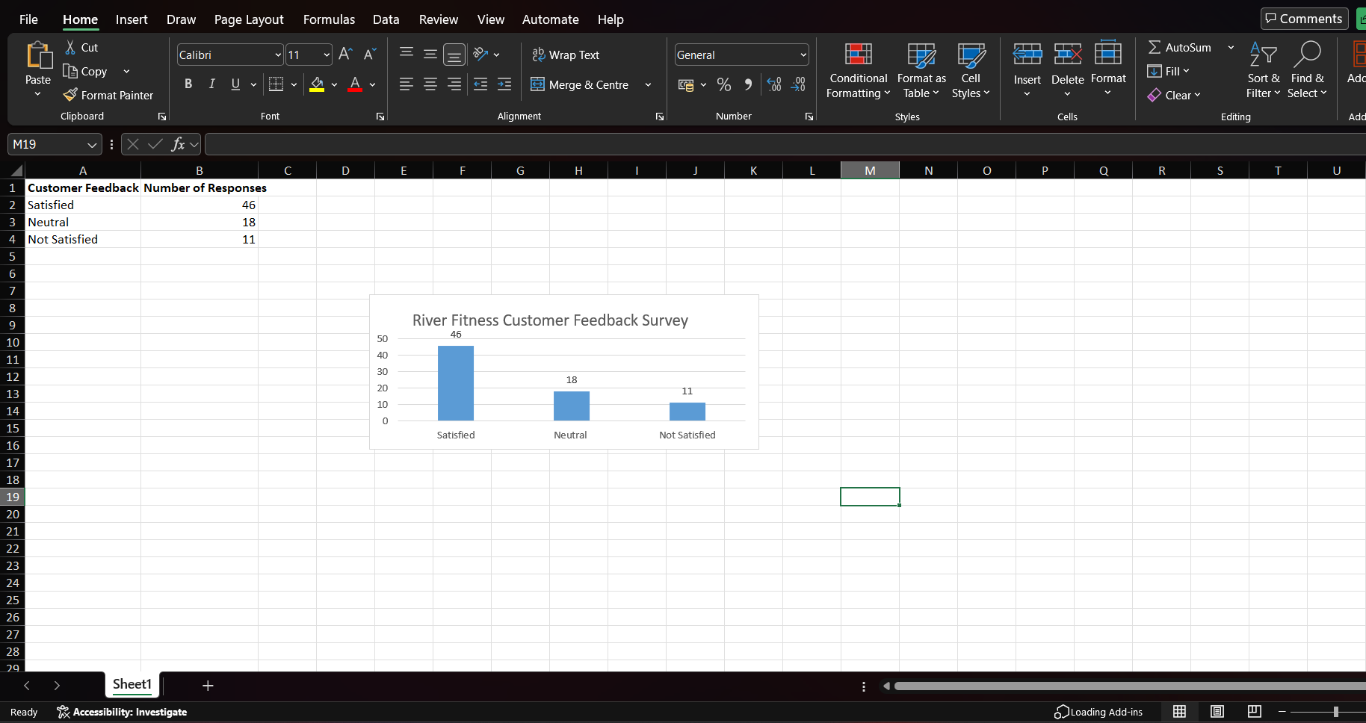
Evidence 2 from task 2

6. Evidence 4 – Decision & Iteration Log
My Decision & Iteration Log outlines why I picked Excel, what data I utilised, the modifications I made, and how I improved my work. I confirmed the statistics' correctness, employed a tidy style, assessed the formatting, and considered other enhancements.
Skill demonstrated: Reviewing, assessing, and enhancing digital work.
Tool used: Microsoft Word, reflecting on work done in Microsoft Excel.
Why this item is important: It demonstrates that I can consider the quality of my work rather than simply finishing the assignment.
In my reflection, I would say that I learnt to thoroughly verify my work and consider the user. If I had to do the assignment again, I would include the River Fitness logo, brand colours, and a brief recommendation based on the survey findings.

7. Short Reflection Notes
What does my portfolio show?
It demonstrates that I have practical abilities in Word and Excel and can present material in a variety of ways.
What am I proud of?
I am very happy of the River Fitness Excel work since I structured the data and produced a clear chart based on client feedback.
What was challenging at the beginning?
Working effectively with Excel and selecting how to show information clearly requires additional focus and experience.
What can I now accomplish on my own?
I can insert and describe photos in Word, enter and organise basic data in Excel, construct a simple chart, and review my work independently.
How would these talents benefit me?
They will assist me in my academics by making assignments and presenting material, as well as at work by using papers, spreadsheets, and business data.

