UWTSD
Electronic Ignition & Fuel Injection Systems
Engine Control Systems
William Wallace (1902566)
1902566


Figure 1 uwtsd logo
Contents
List of figures 2
Introduction 3
Research/literature review 3
Vauxhall 2.0 litter motronic injection/ignition system 3
LE3 Jetronic 3
systems Improvements 3
Methodology 4
health and safety 4
Motronic engine test 5
throttle potentiometer 5
air flow sensor 5
Coolant temperature sensor 5
Air temperature sensor 5
NTC2 sensor 5
Injection on time 6
rotary idle valve 6
charcoal canister 6
lambda sensor 6
primary coil 6
secondary coil 6
HT leads 6
Injectors resistance 6
Jetronic LE3 engine test 7
Throttle switch 7
Coolant temperature sensor 7
Auxiliary Air Valve 7
Injector Valves 7
NTC 2 7
Injection on time 7
primary coil 7
secondary coil 7
king lead 7
HT leads 7
Analysis 8
Motronic system 8
Throttle Potentiometer 8
Air Flow Sensor 8
Coolant Temperature Sensor 8
Air Temperature Sensor 8
Lambda sensor 9
Charcoal canister 9
rotary idle valve 9
Fuel injection on time 9
NTC2 10
Injection on time 10
Primary coil and secondary coil 10
HT leads 10
Injectors resistance 10
Jetronic LE3 system 11
Throttle switch 11
Coolant Temperature Sensor 11
Auxiliary Air Valve 11
Injector valves 11
NTC2 sensor 12
Injection on time 12
Primary and secondary coils 12
HT leads 12
secondary ignition waveform 12
Injection on time 13
Conclusion 14
Reference 14
Appendices 15

List of figures
Figure 1 uwtsd logo 0
Figure 2 secondary ignition waveform 12
Figure 3 injection on time 13
Figure 4 motronic system 15
Figure 5 motronic system 15
Figure 6 motronic system 16
Figure 7 Jetronic system 16
Figure 8 Jetronic system 17
Figure 9 Jetronic system 17

Introduction
This assignment will be analysing data from motronic and Jetronic LE3 and breaking down how both systems work and how they could be improved with different electrical and mechanical differences and how these changes could affect the engine. Then it will look into the stages to testing both systems electronic systems in a test lab and the health and safety required to do so. Then this report will Analyse the data collected from these test and brake down what each individual component and systems are doing during the tests and why it is doing so then it will also brake down two scope patterns the injection on time and the ignition on time.

Research/literature review

Vauxhall 2.0 litter motronic injection/ignition system
This system had two generations the 4.1 and the 1.5 the 1.5 being newer, was introduced to improve the throttle by changing it from a throttle switch to a throttle position sensor which was used to enable the throttle positions and movement to be identified. This system uses a variable dwell angle this allows the system to operate correctly and acutely irrespective of engine speed, supply voltage or current flow through the primary circuit.

LE3 Jetronic
The Jetronic system uses two separate ECUs to control ignition and fuel separately and the motronic system uses a 5 volts supply and the LE3 system uses the battery supply which means that test requirements will be different.

systems Improvements
both system uses Mechanically timed ignition which means that the battery supplies a 12-volt supply to the catering coil which has two coils a primary and secondary coil. The primary coil is taking in the voltage which produces a magnetic field, then supply is switched of which causes the magnetic field to collapse which produces a high voltage which is transferred to the secondary coil which has more coils. It then sends this high voltage to the distributer which distributes the voltage to each of the cylinders. Inside a distributer is a rotor that rotates within contact points this is where the electricity can jump from the rotor to the contact points, each of these contact points is allocated to a cylinder which is timed to the compression stroke of the cylinder.
This could be improved with a wasted spark system. The wasted spark system is an improvement to the reliability of the spark as it doesn’t require a distributer to send the high voltage to each cylinders. This is a disadvantage as the contact points inside a distributer can wear away and are effected by wet weather and dirt which can interfere with the spark delivery, also a wasted spark system has the timing fixed as it is electronically controlled by using a single coil for 2 cylinders on a conventional 4 cylinder this system can’t be used with engine that have an odd number of cylinders.
A more advanced improvement would be to use a Direct Ignition Cartridge system which is used and invented by Saab this system is attached directly to the cylinder head and uses a coil per cylinder the coil is directly attached to each spark plug this means that flash over is much less likely to happen because this tends to happen to damp and dirty high tension components and insulators. The components used on this system are a transformer which is used to step up the voltage from the 12-volt supply from the battery to 400-volts, then a capacitor which holds the 400 volts which means that the coil only need to step up the voltage from 400-volts to the final spark-firing voltage this means that it only takes 1 microsecond to build up a spark compared to the Mechanically timed ignition which can take 20 microseconds which supplies the system with a more accurately timed spark this system also can produce a higher voltage at 40 000-volts
Direct injection could be a change to the port injection systems as direct injection has a cooling effect to the cylinder this is from the fuel which means it is less likely for knock to occur, this means you can advance the ignition timing which makes more power. But port injection does have the same effect but cooling the air just before it enters the cylinder making the air denser which means you can add more fuel which makes more power but this means the cylinder is still hotter so the ignition can’t be advanced as much so direct injection would be better to produce more power.

Methodology
Equipment
- digital multimeter
- digital oscilloscope (Bosch MEA 850)
- test lab
- engine test specification

health and safety
To ensure safe practice when testing PPE will be required and various safety devices will be used to aid in the safety of the group.
- exhaust fume extractor
- carbon dioxide and monoxide sensors
- steel toe cap shoes
- eye protection
- protective overalls
to perform this test safely the group must wear protective overalls that are non-flammable as tests could result in sparks when testing, turning the ignition on and cranking the engine it must be told to the hole group to keep everyone safe. And using the exhaust extractor and checking the carbon dioxide and monoxide levels in the room to insure safe working practice

Motronic engine test
Tests were done on every pin of the ECU with the ignition off and with the ignition on.

throttle potentiometer
pull back multi plug cover and check terminals 1 and 3 , turn the ignition on and take reading with throttle closed and slowly open throttle and the voltage should change progressive with throttle closed throttle should be 0,12-4,95 volts and fully open throttle should be 3,90-4,95 volts specifications are shown in Autodata fuel injection book.

air flow sensor
disconnect air flow sensor multi-plug and disconnect air intake pipe from sensor then check the sensor flap through full range of motion and if necessary clean any deposits off. The resistance of terminals 2 & 4 and 3 & 4 need to be checked use the ohmmeter in the correct manner to find the specified resistance.
Checking for voltage connect voltmeter to terminals 3&4 and switch ignition on and check voltage compare with specified voltage.

Coolant temperature sensor
Disconnect sensor and check specified resistance within temperature listed

Air temperature sensor
Pull back rubber cover and connect voltmeter to terminal 4 & 5 start engine within normal operating temperature and check the voltage comped to specified switch ignition off and check the resistance of 4 & 5 to that specified.

NTC2 sensor
NTC2 required the resistance and the voltage to be tested. The resistance was found by taking the sensor off and using the multimeter to test the resistance at the sensor and the voltage was measured at the ECU pin 45. This was done within 10˚C increment of engine temperature.

Injection on time
The injection on time was measured using the digital oscilloscope (Bosch MEA 850) which was measuring the injection on time when the engine was idling at a steady rate the oscilloscope was paused and the measurement was taken. This was done within 10˚C increment of engine temperature.

rotary idle valve
the rotary idle valve was found by looking at the voltage coming from pin 4 in the ECU as the reading would have been 0.41 volts and this is 41% open. This was done within 10˚C increment of engine temperature.

charcoal canister
the charcoal canister was found in pin 5 of the ECU this test was done by checking the pins at 10˚C intervals this could have been improved by someone holding the multimeter in during the hole test to see what temperature it turned on but it was found to turn on between 52˚C and 61˚C

lambda sensor
the lambda sensor was found in pin 28 of the ECU and this test was done in intervals of 10˚C and shown to turn on between 40˚C and 46˚C

primary coil
connect multimeter to the primary coil and use the multimeter to collect the resistance of the primary coil.

secondary coil
connect multimeter to the secondary coil and use the multimeter to collect the resistance of the secondary coil.

HT leads
Take each HT leads off in turn and measure the resistance of each lead with the multimeter.

Injectors resistance
Was measured by disconnecting the injectors multi-plug and using a multimeter to measure the resistance of each injector.

Jetronic LE3 engine test
The Ignition ECU, fuel ECU and the amplifier all was tested with the ignition on and off

Throttle switch
Disconnect switch and connect ohmsmeter to pin 2 & 18 and compare with the specified reading from spec book and check the same with pins 3 & 18.

Coolant temperature sensor
Disconnect sensor and check resistance at 20C and 80C and compare to specified reading in the book. But during the test the fans and thermostat open which meant that it never got up to temperature and 64˚C was the highest temperature achieved.

Auxiliary Air Valve
Disconnect and check resistance with ohmsmeter and compare with specified readings

Injector Valves
disconnect each injectors in turn and use the ohmmeter in the correct manner and measure the resistance this should be between 15-17 ohms.

NTC 2
The NTC2 sensor’s resistance and voltage was measured within 10˚C increment of engine temperature by going to pin 8 in the ecu to find the voltage and using the multimeter to find the resistance.

Injection on time
The injection on time was measured in 10˚C increment of engine temperature by using the oscilloscope to measure the injection on time.

primary coil
uses the multimeter in the correct manner to collect the resistance from the primary coil. The primaries resistance is so low that the resistance of the cables from the multimeter have to be considered.

secondary coil
uses the multimeter in the correct manner to collect the resistance from the secondary coil.

king lead
take lead off and measure resistance in the correct manner.

HT leads
to measure the resistance of these the cables must be taken off and the multimeter must be used in the correct manner to find the resistance of each lead and the king lead.

Analysis

Motronic system

Throttle Potentiometer
The throttle potentiometer was all actuate to spec with the voltage with the throttle closed being within the 0.12-1.22-voltage at 0.55-volts and with the throttle being open it was within the 3.90-4.95 voltage specification with the reading being 4.2-volts and the supply was to specification at 4.9-volts.

Air Flow Sensor
The air flow sensor required between 8-2500-ohms for terminals 2 & 3 and reading was 34.6-ohms but the resistance for terminals 3 & 4 where higher than specification 300-550-ohms with the reading being 561-ohms and the overall voltage was high with the recording at 5-volts and the requirement being 4.9-volts both these reading could be different because the age of the system is affecting the resistance of the system and this would affect the voltage Also, another factor could be that these tests were performed in a test lab and not a test cell that can reduce any anomalies that might accrue in a test lab, also the group hadn’t tested together before and this could have some human error effecting the results.

Coolant Temperature Sensor
The coolant temperature was to specification 1300-3600 ohms with the reading being 2665-ohms

Air Temperature Sensor
The air temperature voltage and resistance was to specification with the required voltage being 2.3-2.9-volts and the measured voltage was 3.62-volts and the resistance requirement was 1450-3300-ohms and the measurement was 2700-ohms
The motronic system uses additional sensors to help improve the emotions of the vehicle these systems where tested

Table 1 motronic system sensors

Lambda sensor
Lambda is an air fuel sensor In the exhaust which is able to communicate the air to fuel ratio after combustion which helps the ECU to fuel the car correctly to optimize the emotions emitted by the engine shown in table 1 it is switched on at 40˚C

Charcoal canister
Charcoal canister is used to take the fuel vapor and burns it separately on table 1 it shown when is it operated between 50˚C and 60˚C

rotary idle valve
rotary idle valve helps console the rpm in addition to the foot throttle this is used to compensate for various loads that might be placed on the engine, in table 1 it shown that the fan is adding electrical load to the engine so the idle valve opens more. The rotary idle valve was expected to be at 45% at 20˚C and could be a contributing factor to why the engine was not idling correctly.

Fuel injection on time
The injection on time is longer to help warm the engine and ones it up to temp it reduces the time on if the ECU didn’t know the temperature this could cause knock/pre ignite the fuel if it help 2.7 injection on time

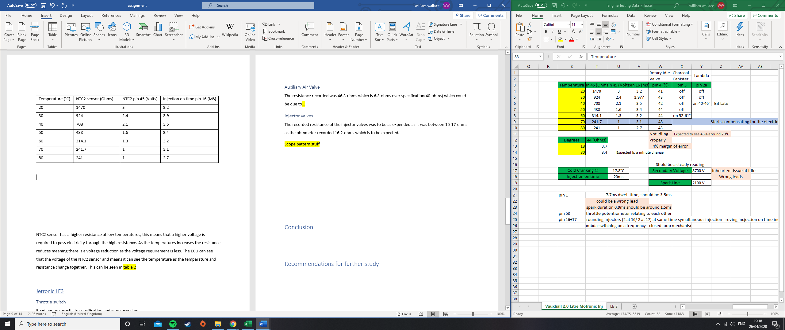
NTC2
Table 2 motronic system sensors
NTC2 sensor has a higher resistance at low temperatures, this means that a higher voltage is required to pass electricity through the high resistance. As the temperatures increases the resistance reduces meaning there is a voltage reduction as the voltage requirement is less. The ECU can see that the voltage of the NTC2 sensor and means it can see the temperature as the temperature and resistance change together. This can be seen in table 2, figure 1 and 2. this book was found that supports what is trying to be said. Hunter M.H (2011) Canadian Electronics Engineering, (volume 33) the University of California

Injection on time
In table 2 and figure 6 you can see the duration time of the injectors and notice that the temperature has an impact on the injection on time because when the engine is cold it uses more fuel to help during the warmup phase. this book was found that supports what is trying to be said. Dingell J.D(1989) automotive fuel efficiency U.S printing office.

Primary coil and secondary coil
The secondary coil has a higher resistance because there is more coils on the secondary coil than the primary coil. The resistance from the multimeter cables have to be subtracted from the resistance of the primaries resistance which was 0.2 ohms that had to be considered.

HT leads
the cables from the distributer are different with different resistance which changes the voltage this is another reason why the engine isn’t idling correctly.

Injectors resistance
The resistance from the injectors was all very close to each other which doesn’t show anything to indicate anything is wrong.

Jetronic LE3 system

Throttle switch
Readings are exactly to specification and were expected

Coolant Temperature Sensor
The resistance recorded for the coolant temperature sensor at 20˚C was as expected and was within the 2100-2900-ohms at 2770-ohms but the measurement at 80 was not actuate as the temperature was 64.2˚C which meant that the resistance was high at 570-ohms when at 80˚C should be within 270-390-ohms which looks to be close as the temperature wasn’t correct this can be conformed to be correct as it would have to be tested at the correct temperature.

Auxiliary Air Valve
The resistance recorded was 46.3-ohms which is 6.3-ohms over specification(40-ohms) which could be due to the age of the system and that as its only a small difference is the reading was more significantly off then it would be more concern but as the system isn’t affected by this then there I a low likely hood of anything being wrong. Also, another factor could be that the tests were performed in a test lab and not a test cell that can reduce any anomalies that might accrue in a test lab, also the group hadn’t tested together before and this could have some human error effecting the results.

Injector valves
The recorded resistance of the injector valves was to be as expended as it was between 15-17-ohms as the ohmmeter recorded 16.2-ohms which is to be expected.

Table 3 Jetronic system sensors

NTC2 sensor
NTC2 sensors shows the same outcome in the resistance vs voltage as the motronic system where the resistance starts off high due to the lower temperature and as the temperatures increases the resistance drops which means there is less voltage needed this is shown well in table 3, figure 4 and 5.

Injection on time
The injection on time for the Jetronic system uses triple injection to aid in the warm up phrase which means the injection on time shown on table 3 is X3 but once it hits 50˚C is increases this is due to the triple injection being turned off and the injection on time is taking into account the less fuel that the triple injection was supplying the engine then continues to reduce fuel as it heats up then at 64˚C the fan and thermostat turn on which requires more from the engine which put more load on the engine which means more fuel is added. This is shown in table 3 and figure 9.

Primary and secondary coils
The same effect happens to this system as the motronic system where there is more coils on the secondary coil than the primary coil which mean there is a higher resistance.

HT leads
The HT leads have the same problem as the other engine test as the engine has mis matching leads with different resistance on each this will cause the spark plugs to reserve different amounts of voltage which could defect the engines operation.

secondary ignition waveform
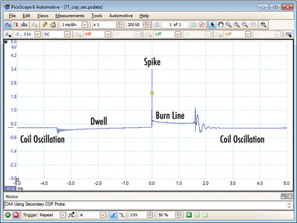
Figure 2 secondary ignition waveform

The dwell is the section of time it takes for the primary coil to saturate the secondary coil but at the start there is a sine wave that is this is the coil oscillation this is the power turning on the dwell should show a steady increase but his can change due to the engine demands.
The spike at the centre of figure 2 is the coil discharge and is the spark jumping from the electrodes on the spark plug. The resistance can change as the fuel to air ratio changes.
The burn line is the time that the spark is firing this line should be a smooth line decreasing but is jagged “this is theorized as changes in the gases and turbulence in the cylinder.” After the burn line has finished some oscillations which is the energy left over in the coil this is called back EMF, this shouldn’t have more than 4 oscillations
Wave forms are used to compare different ignition system and each cylinder to each other to correct wave forms from other sources to confirm that the system is operating correctly.
This article supports what has been said references are in the reference section https://www.autosuccessonline.com/scoping-and-interpreting-secondary-ignition-wave-forms/

Injection on time
The start of the scope pattern is the battery voltage this then changes by pulling the circuit to a ground this is the lowest point of the scope pattern this the injection on time this is a the amount of time the injection is on for then the large spike is the voltage as it regains the injector then this quickly returns back to battery voltage.
This article supports what has been said references are in the reference section https://www.underhoodservice.com/fuel-injector-circuit-waveforms/

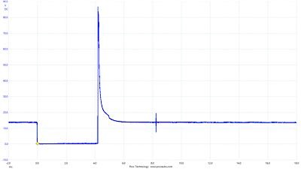
Figure 3 injection on time

Conclusion
In conclusion this report is to show an understanding of a vehicles electrical system and has found the operation of how a spark is generated and delivered to the spark plug and has found ways to improve from a Mechanically timed ignition system with various different systems and technologies. It has also found how to test a Jetronic and motronic electrical system in a test lab to collect data and find any issues that have been affecting the engines operation. Then it has used the data collected from the engine test sessions to find and explain what the engine electronic systems are thinking and how it deals with various different circumstances through warm up phase. It also explains various stages to a Secondary Ignition Wave Form and how this can be used to compare the system to other systems

Reference
Bosch website http://br.bosch-automotive.com/en/internet/parts/parts_and_accessories_2/motor_and_sytems/benzin/injection_system/le_jetronic_1/le_jetronic.html#
Bosch website http://br.bosch-automotive.com/en/internet/parts/parts_and_accessories_2/motor_and_sytems/benzin/injection_system/motronic/motronic_1.html
Hillier & Coombes, V.A.W.H. & P.C. (2004) Hiller’s fundamentals of motor vehicle technology, (5^{th Ed}), Cheltenham: Delta Place.
Autodata limited (1995) fuel injection(4th), Berkshire priors Way
by Autolite (2018) “Understanding Ignition Systems: The advantages and disadvantages of three common ignition systems”https://www.aftermarketnews.com/understanding-ignition-systems-the-advantages-and-disadvantages-of-three-common-ignition-systems/[September 28, 2018]
Muir, A.M https://www.howacarworks.com/ignition-system/checking-the-dwell-angle [how a car works]
Jackson, J.J(2020) https://drivecave.com/direct-injection-vs-port-injection/
Markel A.M (2018) “Scoping and Interpreting Secondary Ignition Waveforms”https://www.autosuccessonline.com/scoping-and-interpreting-secondary-ignition-wave-forms/[June 7, 2018]
Markel A.M (2017) “Fuel Injector Circuit Waveforms” https://www.underhoodservice.com/fuel-injector-circuit-waveforms/ April 27, 2017
Hunter M.H (2011) Canadian Electronics Engineering, (volume 33) the University of California
Dingell J.D(1989) automotive fuel efficiency U.S printing office.

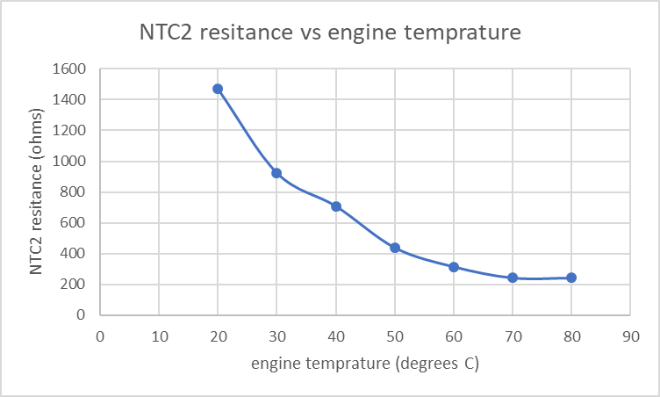
Appendices
Figure 4 motronic system

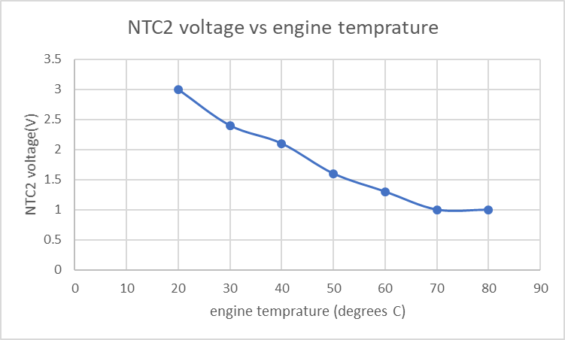
Figure 5 motronic system

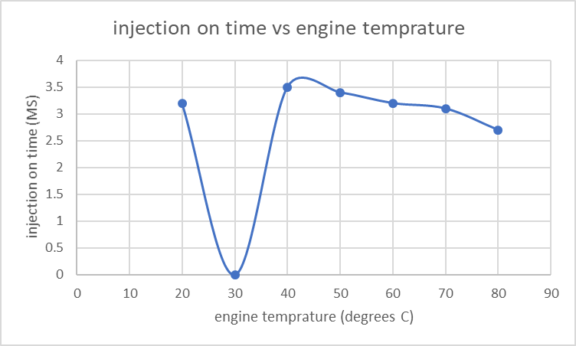
Figure 6 motronic system

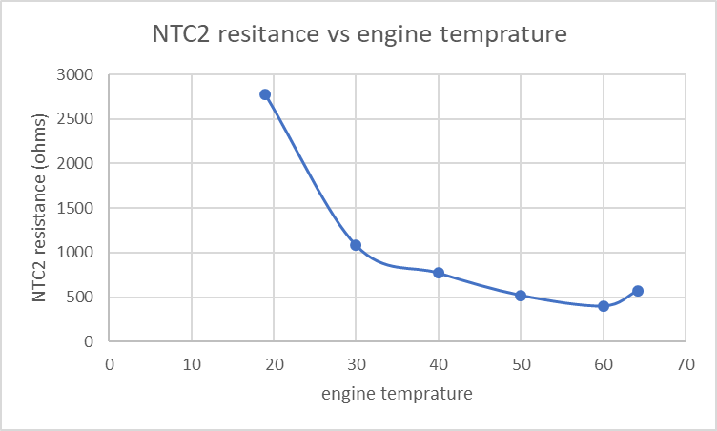
Figure 7 Jetronic system

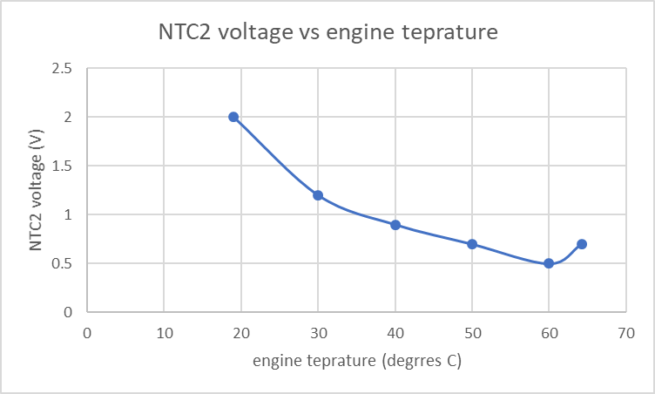
Figure 8 Jetronic system

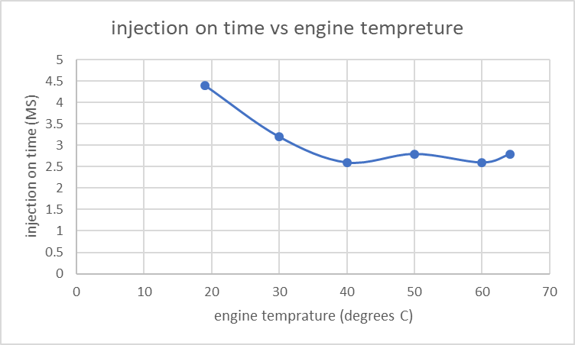
Figure 9 Jetronic system

