Module Name: Understanding and Engaging in the Customer Experience
Module No: BMSK5003
Module Lecturer: Tanja Nathan
Student Name: Sheikh Halim
Student ID: 1605419

Executive Summary
Customer value can be defined as the level of satisfaction a customer gets or expects from a product or service for which he/she is agreed to pay cost/ price (Weinstein, 2012). This assignment is about the understanding and engaging in the customers’ experience by Nestle, a multinational food and beverage products manufacturer & distributor which have more than 450 factories in 84 countries and 323,000 employees work in the company to provide millions of customers worldwide (Nestle.com. 2018). There are different factors which influence Nestle’s ability to maximize customers’ value and Nestle successfully utilized those factors. Nestle is a company which fulfills both customers’ desired and perceived value by running market research, collecting feedback and innovating & making changes in products to reflect the experience of the customers. Moreover, the company diversifies its products and ethically operates to add value to the people of overall society. Nestle uses different quality management theories and approaches such as Total Quality Management, Kaizen or continuous improvement, Lean production, Standardization so that the quality of the products get better with time and the process achieves zero waste or zero defect milestone. Thus Nestle has been able to maximize the customers’ value, fulfilling customers’ requirements and create a sustainable and leading position in the consumer market worldwide.

Table of Contents
Executive Summary 2
Introduction 4
Task 1 5
Factors that influence Nestle’s ability to maximize customer value. 5
What is a Customer’s Value? 5
Factors which influence the Value of the Customers 5
Task 2 13
A critical understanding of your organizations quality processes and its effectiveness in meeting customer requirements. 13
Total Quality Management 13
Standardization 16
Lean Production 17
Kaizen or Continuous Improvement 19
Conclusion 20
Bibliography & References 21

Introduction
Nestle is a Swedish transnational company which provides more than 2000 brands of foods and beverages to the people worldwide. Started its journey in 1866, it is the largest food and beverage company in the world since 2014 in terms of income, employment, and other metrics. The company has a clear goal- serving people to help them to lead a better and healthier life. The company not only looks for developing the lives of people by providing their foods and services directly but also with engaging them in their work process and developing their life standards (Nestle.com. 2018). In this assignment, the approaches of how Nestle becomes engaged in making customers’ experience better have been analyzed. In the first task, how different factors influence Nestle’s ability to maximize the value to the customers & how the Nestle took actions in response to the influencing factors were analyzed. In the latter task, Nestle’s different quality processes were analyzed & the effectiveness of each approach to fulfilling customers’ requirements was analyzed.

Task 1

Factors that influence Nestle’s ability to maximize customer value.
For every organization which offers product or service to the customers, customers’ value is the core area to focus because the firms are established to produce, promote and distribute the products which have the substantial demand to a segment or different segments of people.

What is a Customer’s Value?
Before discussing how several factors influence Nestle’s ability to maximize customers value, it is important to know which is meant by customers’ value. Customers’ value can be interpreted in several ways as the customers may have different values for a product over different dimensions. Customers’ value can be defined as the low cost/ price of the product which is purchased or getting high-quality attributes/ benefits from a product which is desired by the customers or getting something in exchange for paying something (Gale, 2014). In a nutshell, customers’ value means which benefits a customer gets for purchasing a particular product or pay for a specific service from a company.
As discussed earlier, customers’ value can be different in different dimensions. The customers’ may have a desired value or perceived value before and after purchasing a product. Before purchasing a product, the customers can develop expectations that they will receive a set of facilities/ features from a product. After purchasing a product, their perceived value becomes the advantages they believe they got from the products (Weinstein, 2012). Desired or perceived- both values can be different. It is crucial for the entrepreneurs and suppliers of the products that they deliver the values to the customers’ on time in different dimensions and failure to perform it may threaten the success of their operations.

Factors which influence the Value of the Customers
Nestle is currently offering more than 2000 brands and it is working regularly to sustain the values to the customers. The company has become successful in ensuring the fulfillment of customers’ value for a period of years & it has evaluated the factors which are crucial for maximization of customers’ value and implemented necessary strategies to gain advantage from the factors.

Evaluation of the Customers Desires and Needs
Every business creates a product or service which fulfills the needs of its target segment of customers and thus it achieves success. Therefore, knowing about the customers’ need and creating a product fulfilling their particular needs are the success factor for companies. Nestle provides a wide range of food and beverage products to its customers. Ideas of inventing all of these products weren’t generated from the people of the Nestle naturally, rather by evaluating the needs of the people in the society for a continuous period. To know what the customers desire from the products and services of a company, it is necessary to run a research in a systematic method on the market where the company will operate (Weinstein, 2012). Over years, Nestle regularly ran market research- both in existing markets and in the new markets. During expanding the market to a new region, Nestle operates a market research on how the products of the company will be welcomed by the people in the particular region. People in different places have different cultures, tastes, and preferences. All of which influence their desired value for a product. As an example, Nestle’s popular Hot Pocket Bacon sandwich is n’t available in Islamic countries as Bacon is prohibited in Islamic culture. Also, Nestle’s Alcohol drinks aren’t available in these particular areas as these products won’t add value to the customers rather may make a negative impact on the brand reputation of the company.
Nestle not only evaluates the change in the needs of the customers in different places but also observes the change in trends of the customers over different periods. Recently, Nestle observed that people are becoming more health conscious. They are not only looking for foods and drinks with good tastes but also they check the nutritional values the foods add to their and their children’s bodies.

Figure 1: Nestle Nutrition Institute, established to foster “Science for Better Nutrition” (Nestle.com. 2018)
Nestle targets the trend of the customers and manufactures products which have natural or organic ingredients and are locally manufactured. The company focuses on the desired value of the customers by running market research and innovating products based on their desires and needs.
Diversification
To ensure the maximization of customers’ perceived or desired value, it is very important to arrange diversification of products to the customers. In a particular region, there exists different segments of customers who have a completely different set of needs regarding a product or service. Nestle became a global company because it evaluated the desires of different segments of customers and innovated thousands of products to add value to the different segments of customers (Nguyen, 2014). It offers healthcare products for health-conscious people as well as alcoholic products for alcohol lovers. For children, Nestle offers different products such as Cerelac, Noodles etc. and for grown-up people, Nestle offers Coffee, Juice etc. For pet lovers, Nestle offers Cat Chow, Dog Chow etc.
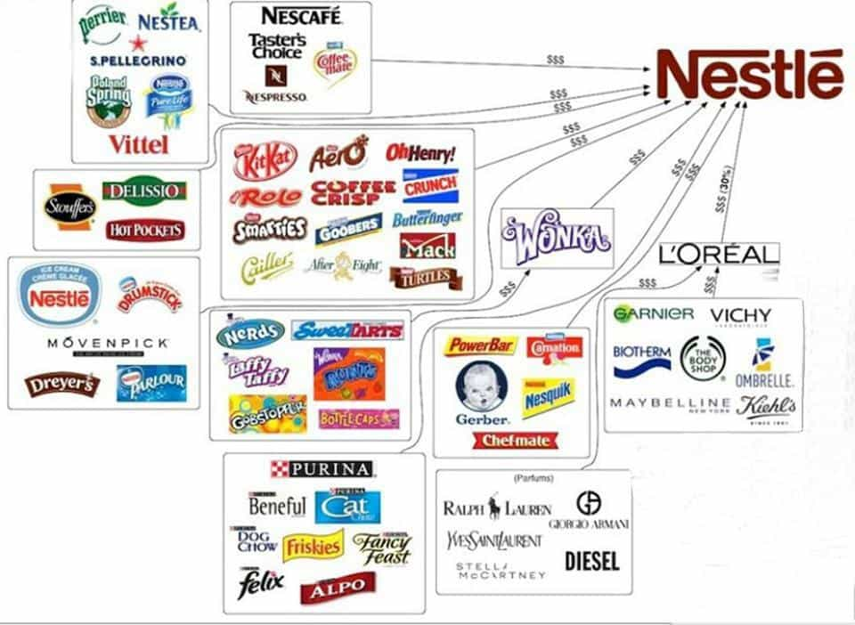
Figure 2: Nestle’s Areas of Diversification in Products (Nestle.com. 2018)
Nestle not only promises quality in its products but also adds the value of the customers who have limited purchasing ability. Such as, Nestle’s Maggie Noodles is one of the most popular food products all over the world because not only the food is tasty and healthy but also it is very cheap which makes it available to every person.

Focus on Innovation:
Customers don’t have the same desires over a product for a continuous period. With time, different firms make improvements in the features of a product which also changes the demand of the people for a particular product over the different period (Winslow, 2016). In the case of food products, previously people would expect either good taste or nutritional value from a product. But people currently expect both a product. Nestle has been a pioneer of bringing continuous changes in the attributes of the food and beverage products. The company has been established on health, nutrition and wellness strategy. The founder of the firm had a belief that adding value to the life of people by making their lives healthier will make them satisfied and help to build a sustainable business environment for Nestle. The focus on innovation helped to observe the change in the demands of the people.
The core of the value creation for Nestle is the innovation in the product, service and business model. Currently, the company has the biggest research & development network in the food industry which operates all over the world. The network works with different public organizations and start-ups which helps to generate ideas about new products based on the change in the needs of the customers. Nestle focuses on innovating the products in order to maximize the quality. Also, the company wants to innovate new process in order to manufacture the products by saving the production costs. Thus, the focus on innovation helped the company to maximize customers’ value in several ways- by offering quality products, by offering products at cheaper costs and by maximizing the benefits of customers by reducing what they have to pay.
Perceived Value of the Customers
Every supplier and entrepreneur should be capable of delivering the value to the customers in different dimensions in the form of their products and services. Customers’ perceived value refers to the benefits which customers expect after purchasing a product from a firm. It is necessary for a firm to maximize the perceived value because differences in the values perceived by the customers from the products offered by different firms decide to which firm they will be loyal in the future (Malik, 2012).
To know about the perceived value of a product from the customers, it is important to collect the feedback from the customers after using the products. There are many ways to collect feedback from the customers. Previously, the firms used to collect feedback directly from the customers to know about their experience. But with the advancement in technology, there are several communication methods using which firms interact with the customers. Nestle is the leading food and beverage company and it has a huge responsibility to its customers to help them to lead a happy and healthy life. The company utilizes the information technology to connect with the people, know about their needs and their experiences regarding Nestle Products. Oracle service cloud platform provided a platform to the company to consistently communicate with the customers, monitor their needs and feedbacks and achieve their satisfaction. As an example, BabyNes is a start-up division of Nestle which was established to ensure nutritional food products for the babies. The division operated its activities by innovating new nutrition formulas, using them to manufacture new products, observing the nutritional growth in the children, collecting feedback from the parents and evaluating their satisfaction level. Using the Oracle service cloud platform, the division communicated with the parents through social media, text messaging services, phone calls and other ways and ensured that their opinions and feedback regarding their children’s development are reflected in the further research and innovation in the nutritional products (Oracle.com. 2018).

Figure 3: A High-tech Machine used by BabyNes after the implementation of Oracle Service Cloud System (Oracle.com. 2018)
Using the platform, BabyNes became able to develop an effective Customer Relationship Management system. The platform resulted in the increase in the efficiency by requiring less marketing costs, less communication cost due to the availability of four-shared service call centers which are able to communicate with parents in multi-languages and develop customers’ experience.
Customer Centricity
Customer centricity is a strategy of business in which the companies focus on creating a positive attitude in the minds of the customers by providing its service. Nestle has always been a company which valued the needs of the customers and devised strategies to fulfill the needs of the customers. The core mission of Nestle is to facilitate people to lead a healthier and happier life and the company is working hard to make this possible. The company not only produces the products in a way that it includes exclusive features which fulfill the customers’ needs in better ways, the company designs its marketing, distribution and other strategies to ensure maximum benefits to the customers. Recently, social media has been a place where the people share their experiences over products, give reviews, see advertisements and are influenced to purchase products (Weinstein, 2012). Based on this trend of consumers, Nestle already developed a strong presence in social media.
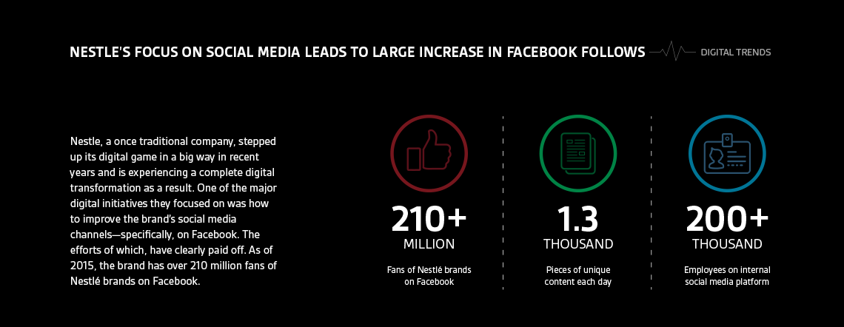
Figure 4: Nestle’s Presence in the Leading Social Media, Facebook (Nestle.com. 2018)
As an example, the company has more than 210 million fans on its Facebook page who regularly gets updates about the new products arrival of Nestle and can share their experiences to the management of Nestle which contributes to the development of a customer-centric strategy for Nestle. Nestle evaluates the customers perspective not only in its core products but also in its packaging, promotion and other services (Nestle.com. 2018). For an example, the packaging of the products is performed in a sustainable way and at cheaper costs. Also, the advertisements are made by complying with the advertising policies of the country so that they may not have a bad moral impact on the customers- especially the children and young people.
Ethical Considerations of Nestle
As a global food and beverage firm, Nestle not only focuses on the maximization of the customers’ value but also believes in maximizing shared value- fulfilling the interests of all its stakeholders. By providing quality products and services, Nestle wants to maximize the profits for the shareholders. Also, it ensures that suppliers get the necessary materials to produce the raw materials and get proper compensation in exchange for the raw ingredients. Nestle takes care of its employees by encouraging them to participate in decision making, participating directly in CSR activities and getting proper compensation, equal rights, and other privileges. The ethical considerations of the management of Nestle towards its every stakeholder result in the commitment of every party towards the company and ensure the maximum participation which results in the addition of the value of the products and services offered by Nestle.
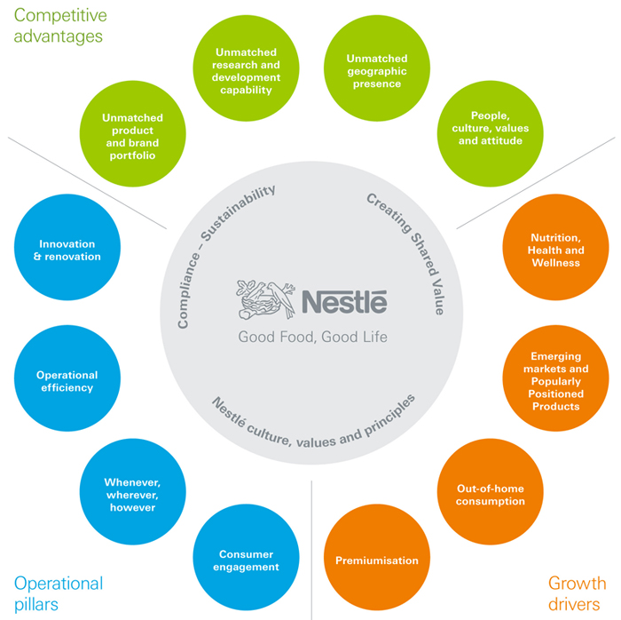
Figure 5: Nestle’s Operational Pillars and Creation of Shared Value (Nestle.com. 2018)
As mentioned earlier, Nestle not only contributes towards the customers’ value by offering products which fulfill their demands, the company operates in a way that it protects the environment, makes infrastructural development in society, performs welfare programs and others. Nestle’s product manufacturing, packaging, and labeling are performed in a way that they don’t make any harm to the environment and make it sustainable for the future environment. Nestle performs waste recovery and recycling to minimize the pollution to the environment. Also, Nestle performs CSR activities to ensure the better lives for its suppliers, employees and the people of the society in which it operates. The company has a Sustainable Development Goals program which is planned to fulfilled by meeting 41 commitments (Nestle.com. 2018). Thus, the company is adding value to the greater portion of the society.

Task 2

A critical understanding of your organizations quality processes and its effectiveness in meeting customer requirements.
Nestle is a global organization which has millions of customers in different parts of the world. Since its inception, the company always focused on the quality of its products. The founder of the company wanted to ensure that the quality foods and beverage products of Nestle will contribute to the health & nutrition as well as will serve people with better taste experiences. As Nestle operates in different regions, the company has to comply with the relevant laws and regulations of different countries. Different countries pass different legislation which ensures that consumers’ rights will be protected with quality products at a fair price. Nestle has a quality management system which follows different approaches which will help to comply with the legislation in different regions by producing quality food and beverage products.
The quality processes of Nestle reflects different quality management approaches. Again, quality issues are overlooked in different functions and different stages of productions (Russell, Russell and Taylor, 2013). Following the organizations, quality processes are analyzed and their effectiveness will be evaluated:

Total Quality Management
Total quality management is the approach in which an organization has a quality process all over the organization. In this approach, every employee is involved in the quality management process & all of them work for adding quality in every function of an organization. The culture of an organization is very crucial to implement TQM approach (Munro-Faure and Munro-Faure, 2001). TQM involves high-quality design, quality improvement, quality assurance and other functions.
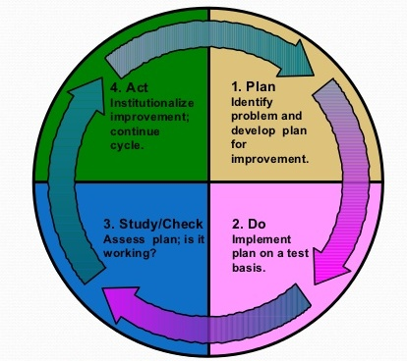
Figure 6: P-D-C-A Cycle in Total Quality Management (Munro-Faure and Munro-Faure, 2001)
In Nestle, the P-D-C-A cycle is used to implement a total quality management approach. At first, the employees identify a problem regarding quality and look for the potential solutions available. This is the initial phase. After analyzing the alternatives, a final alternative is chosen. In the third stage, the alternative is checked if it really contributed to the process by bringing the expected improvement in quality. Finally, after checking, the proper action is taken by the employees.
Preparation Phase: Nestle has hundreds of factories in different regions and all of them are adhering to the quality, health and safety policies. In Nestle factories, the workers are trained properly to ensure the hygiene of the food products. The factories of Nestle don’t allow foreign bodies to engage in the process and control the usage of pests and other hazardous materials (Nestle.com. 2018). The factories have a clear air filtration process and supply of safe water to ensure that the food products are produced in a safe way. There are different products manufactured in a factory and the manufacturing process of every product is segregated from each other. The raw materials and the final products are also stored in different ways.

Processing Phase: The processing phase of Nestle products are performed carefully. During the processing, the temperature of the foods is kept at an optimum level to achieve the highest nutritional value (Nestle.com. 2018). Also, during the processing, the chemical contamination and microorganism are prevented.
Testing Phase: Products must be tested very carefully to identify any defective product which failed to achieve the product standards determined by Nestle’s management. The philosophy of Nestle is, “We test not to check that the products are safe rather we verify that the products are safe” (Nestle.com. 2018). Every year, more than hundreds of millions of tests are performed to verify the quality, health and safety standards of Nestle products.
Packaging & Transportation Phase: The packaging and transportation of the products involve several functions and the managers of Nestle have to ensure that quality in all these functions. During the packaging, the process mustn’t involve the use of any dangerous material (Russell, Russell and Taylor, 2013). The packets of Nestle are environmentally friendly. Moreover, the costs of packaging are cheap which also reduces the cost burden on the product’s actual price. The packets of products include the unique batch code, the ingredients which were used to manufacture the products, guidelines on how to use the products and other necessary information. In the transportation phase, the products are stored in a way that their quality doesn’t become affected. As an example, frozen products are transported in a refrigerator at a specific temperature (Nestle.com. 2018).
These are the ways how Nestle implements TQM process to ensure the quality.
Effectiveness in Meeting Customer Requirements
Total quality management approach ensures that quality will be achieved in every single function of the organization. The TQM approach adds value to a product in every function which leads to the production and distribution of quality products to the final consumers. TQM is a costly process, but it involves every employee in the quality design, monitoring and assurance process. The P-D-C-A cycle also ensures that the approach is being monitored and evaluated. Therefore, TQM in Nestle carefully monitors if the approach has been really helpful for adding quality in the product. In different phases, the TQM approach finds the loopholes which can lead to a potential breach of the health & safety requirements for the company and fixes the loopholes by taking proper actions (Winslow, 2016). According to the quality standards upon which Nestle agrees to operate, ensuring quality is the commitment of every party. Proper implementation of the TQM approach helps the company to fulfill this condition by involving people from every section in the quality procedure.
TQM not only helps to add to the core features of a product and make the product better quality. It also takes care of people’s concern towards environmental soundness and minimization of environmental pollution. The controlled use of pesticides not only makes the product safer but also helps to reduce the pollution level in the environment in which the raw materials are produced. The minimization of hazardous chemical substances also leads to the goal of the company to ensure environmental sustainability for future generation.

Standardization
Standardization refers to the determination of fixed size, quality and other measurements of the products of an organization. Standardization is performed to ensure discipline and consistency in the product manufacturing and to achieve the expected quality of a product. Standardization is performed in two ways: commercial or industrial (Pullum, 2018). Industrial standardization refers to the specification of the raw materials and the manufacturing process and other materials which are determined by an industry in a specific region. On the other hand, commercial standardization refers to the specification of size, quality and other measures which are performed for the protection of the interests of the final consumers.
As a global food and beverage producer and provider, Nestle has different industrial and commercial standardization policies. To fulfill the industrial standardization in production and engineering phases, there are different bodies such as the authority of suppliers, research design, marketing, and inspection. To protect the rights of the consumers in different parts of the world, Nestle has its own policies which are designed by the international and regional laws. There are ISO standards which should be followed to ensure product quality. Nestle follows ISO 14001 & 22000 standards. Also, Nestle implements Good Manufacturing Practices (GMP) & Hazard Analysis and Critical Control Points which are recognized globally for ensuring the quality and safety of food and beverage products. Nestle also follows regional laws such as the Consumer Rights Act 2015 to provide quality products to the final consumers and maximize their benefits (GOV.UK. 2018).

Effectiveness in Meeting Customer Requirements
Products are manufactured to fulfill the demands of the final consumers. The standardization policies are also designed and the standard metrics are also determined in both industrial and commercial level to achieve a common purpose- for fulfilling customer requirements. Industrial standardizations specify the use of raw materials and the size of productions based on the population of a region and their aggregate demands. Standardization helps to ensure that there will be an adequate supply of food and beverage products for the people. Also, people of a region usually wants locally manufactured products and use of domestic materials in the final products. Industry standardization also helps to specify that (Stump and Beal, 2010).
The commercial standardization is directly related to the protection of customers’ interests. For an example, in the United Kingdom, Nestle has to follow the Consumer Rights Act 2015 in which it has to fulfill several requirements in design, manufacturing, distribution and other activities (GOV.UK. 2018). Nestle cannot provide inaccurate information about the specification of products in its advertisements. Also, the company should use a fair pricing policy which will be consistent with the pricing policies of the competitors which will not only meet the requirements of customers but also establish a fair ground for competition for every company.

Lean Production
A lean production is an approach for minimizing waste in the processes of an organization while improving quality at the same time. The process is applicable from the production to packaging transportation and final distribution (Miina, 2012). Waste minimization is a very important approach as every company should cut unnecessary costs to increase the profit of the company.
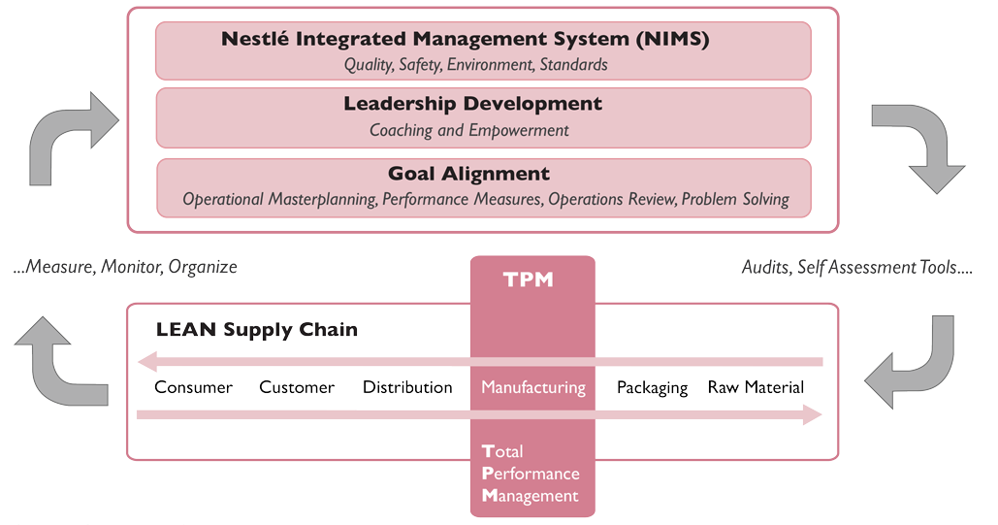
Figure 7: ONE Nestle Operating Model (Europeanfinancialreview.com. 2018)
In Nestle, there are different waste reduction approaches followed by the management. Nestle uses a waste hunting approach regularly in seven areas of lean production: Transport, Inventory, Motion, Waiting, Over-processing, Overproduction & Defects. Through the waste hunting exercise, Nestle minimizes excess materials used in the process or delay in the different processes which result in the improvement in quality. Also, the company uses Just-In-Time inventory system in order to minimize the inventory cost. Nestle also focuses on the transportation cost and ensures the balance between storage and transportation cost (Nestle.com. 2018). While establishing a JIT inventory system, Nestle also has to ensure that there are available supplies of raw materials which will respond anytime when the factories require inventories.
Effectiveness in Meeting Customer Requirements
Lean production approaches meet the requirements of the customers in different ways. Firstly, it contributes to eliminating the wastes in the products and the processes. The elimination of waste in the product makes the product better quality; which in turn satisfies the customers. The elimination of waste in the process or minimizing time makes the process more efficient. Thus customers can order the products and get the ordered products in the quick time period. Reducing the storage of inventories and using fresh inventories in the production process adds value to the final product. A lean production is a customer-centric approach in which the requirements of customers are reflected in the final products. In lean production approach, the employees of Nestle eventually becomes more committed to the organization and becomes more productive to meet the demands of the consumers.

Kaizen or Continuous Improvement
Kaizen refers to the quality management approach in which the company regularly makes improvements in working processes. Due to increasing business competition, every well-recognized organization practices continuous improvement within the work environment (Tomas, 2016).
Nestle uses different continuous improvement techniques not only to develop the quality of the product but also make the process more efficient. As an example, Nestle Waters uses VSM (Value Stream Mapping) technique before starting a new plant. In this technique, the management forecasts about different ways in which resources and materials can be used to produce and deliver the water bottles. By considering the costs of different ways, management decides a final process which is more efficient than the previous plants. Thus Nestle ensures continuous improvement in quality.
Effectiveness in Meeting Customer Requirements
Since its establishment, Nestle has been always focusing on the continuous improvement of the products and processes. Nestle has objectives of making a healthier future for the people. It believes that there are always scopes for making continuous improvement & this belief enabled the organization to innovate in the new products and processes over time. Focus on continuous improvement added value to the lives of the people in many ways (Winslow, 2016). Nestle has been able to utilize the advancement of technology for meeting the demands of people in better ways (Nestle.com. 2018). Continuous improvement also takes the trends of frequently changing demands, tastes, and preferences of people into consideration and looks for ways to fulfill the demands. Thus, the culture of continuous improvement ensures that the products will be continuously upgraded to fulfill the demand of the customers in every time period.

Conclusion
Delivering value to the customers is one of the core prerequisites for the success of any organization. The reason why Nestle has grown continuously and still operating as a successful organization even after more than hundred years of its establishment is its regular focus on the customers’ need and towards the welfare of the customers. The company has a philosophy of overall development in the livelihoods of all the people who are engaged as the stakeholders and its attitude towards its customers, employees, suppliers, stockholders and other parties have made people loyal to the company and helped to build a strong brand position. Evaluating customers’ need and their feedback while offering goods and products made it a customer-centric company and thus it won the loyalty of the customers. Nestle’s continuous approaches to add value to the customers’ life, health, taste and other aspects have been possible due to its quality design, monitoring and appraisal process throughout the company.

Bibliography & References
Europeanfinancialreview.com. (2018). Nestlé Continuous Excellence: Lessons for Driving Performance Improvement | The European Financial Review | Empowering communications globally. [online] Available at: http://www.europeanfinancialreview.com/?p=1130 [Accessed 23 Jul. 2018].
Gale, B. (2014). Managing customer value. [Place of publication not identified]: Free Press.
GOV.UK. (2018). Consumer rights. [online] Available at: https://www.gov.uk/consumer-protection-rights [Accessed 23 Jul. 2018].
Malik, S. (2012). Customer Satisfaction, Perceived Service Quality and Mediating Role of Perceived Value. International Journal of Marketing Studies, 4(1).
Miina, A. (2012). Lean Problem: Why Companies Fail with Lean Implementation?. Management, 2(5), pp.232-250.
Munro-Faure, L. and Munro-Faure, M. (2001). Implementing total quality management. 1st ed. London: Pitman.
Nestle.com. (2018). [online] Available at: https://www.nestle.com/ [Accessed 23 Jul. 2018].
Nguyen, D. (2014). Product Diversification and Demand Uncertainty. Southern Economic Journal, 51(2), p.330.
Oracle.com. (2018). Nestlé BabyNes Boosts Customer Satisfaction with Oracle Service Cloud. [online] Available at: https://www.oracle.com/customers/babynes-1-serv-cl.html [Accessed 23 Jul. 2018].
Pullum, T. (2018). Standardization. The Hague: International Statistical Institute.
Russell, R., Russell, R. and Taylor, B. (2013). Operations management. 1st ed. Upper Saddle River: Prentice Hall.
Stump, R. and Beal, D. (2010). Total Quality Management. 1st ed. Dearborn: Society of Manufacturing Engineers.
Tomas, S. (2016). Continuous improvement. Frederick, MD: Aspen Publishers.
Weinstein, A. (2012). Superior customer value. Boca Raton, Fla.: CRC Press.
Winslow, W. (2016). Strategic business transformation. 1st ed. London: McGraw-Hill.

