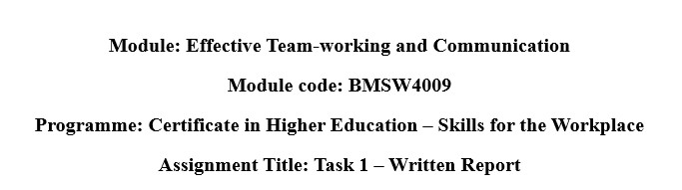
Student Name: RAMONA ELENA MIRON
Student ID:2421212

Table of Contents
- Introduction ............................................................................................................................. 3
- Findings................................................................................................................................... 3
  - Learning About Relationships and Communication ....................................................... 3
  - Belbin’s Team Roles ....................................................................................................... 3
  - Tuckman’s Team Development Model ........................................................................... 4
  - Thomas-Kilmann Conflict Style ..................................................................................... 4
- Conclusion .............................................................................................................................. 4
  - Specific Actions I Will Take: .......................................................................................... 5
- Reference List (Not included in word count) ......................................................................... 6
- Appendices .............................................................................................................................. 7
  - Belbin SPI Questions with Responses ............................................................................ 7
12.1 Thomas-Kilmann Conflict Management Style – Questions with Responses ................. 8

1 Introduction
This report reflects my experience working on a university group project, where we had to collaborate on a presentation. I will explore how teamwork theories helped me understand and improve my group performance. Teamwork is an important part of both academic and professional life. It involves people working together towards a shared goal by combining their skills and supporting one another. According to Duck and McMahan (2021), a successful team is made up of individuals who each play different roles that balance the group. Quintanilla and Wahl (2020), explain that good teamwork relies on trust, communication, understanding team diversity, clear goals, and managing conflict effectively. From the results of my Belbin Self-Perception Inventory, I identified myself as a Team worker. This means I usually try to keep harmony in the group, support others, and help solve issues in a calm and caring way. I focus on making sure everyone is included and feels comfortable. In addition, my results from the Thomas-Kilmann Conflict Mode Instrument showed that I mainly use the Compromising style. This means I try to find fair and practical solutions when disagreements happen, allowing the group to move forward peacefully.

2 Findings

2.1 Learning About Relationships and Communication
During this module, I learned that effective team communication goes beyond speaking clearly. It includes non-verbal cues like body language and facial expressions, as well as active listening, which involves giving full attention, nodding, and offering feedback. These skills, combined with empathy, help build trust and make others feel respected (Tuckman and Harper, 2012). In our group project, I applied this by encouraging a quieter member to share their ideas through kind questions and support. As a result, they became more involved, and our teamwork improved. I also practiced giving and receiving feedback politely, which helped strengthen collaboration without causing conflict.

2.2 Belbin’s Team Roles
According to Belbin (2010), an effective team consists of members who perform different roles that complement one another. The model includes nine roles, such as Shaper, Coordinator, and Teamwork. My Belbin Self-Perception Inventory identified me as a Team worker, meaning I aim to create harmony, support others, and maintain strong group relationships. During our group project, I helped mediate a disagreement over slide design by staying neutral and encouraging open discussion. I also supported quieter members to participate more. A challenge I faced was being too flexible, sometimes taking on extra work. Understanding my Belbin role helped me value my strengths and recognize the need to set healthy boundaries.

2.3 Tuckman’s Team Development Model
Tuckman’s model (Tuckman and Harper, 2012) explains how teams grow in five stages: Forming, Storming, Norming, Performing, and Adjourning. In the Forming stage, we were polite but unsure of our direction. In the Storming stage, we disagreed about task roles and responsibilities. Thanks to better communication and patience, we reached the Norming stage where we began to understand and respect each other’s working styles. By the Performing stage, we were more productive and confident in our work. Understanding this model helped in remain calm during the early confusion and see disagreements as a normal part of teamwork (Johnson et al., 2021). It also reminded me to support the team emotionally during difficult moments.

2.4 Thomas-Kilmann Conflict Style
The Thomas-Kilmann model identifies five conflict styles which includes competing, collaborating, compromising, avoiding, and accommodating (Cioarță, 2020). My results showed I use the Compromising style, which means I try to find middle ground in conflicts. In our group, one member wanted more design work, while another wanted to focus on content. I helped them agree by suggesting they both take responsibility for their preferred areas while still contributing to the whole project. Such a concession lowered the tension and made all feel heard. The knowledge of this model allowed me to remain unbiased and remain oriented towards nondiscriminatory solutions rather than shifting sides or evasion of the problems. It has also boosted my resolve on how to handle disagreements with calmness and ease.

3 Conclusion
The module has been of great assistance in learning a lot about me and my ability to work in a team. By using the Belbin Self-Perception Inventory, I found out that the natural Belbin team role that fits me is Team worker, and this gave me an understanding that I am oriented toward demonstrating harmony, supporting people, and making people work together. As a result, my primary conflict-handling style, depending on the Thomas-Kilmann model, turned to be a Compromiser. This does not imply that I seek some impartial solutions, which satisfy people, and it assists in achieving a reduction in stress and maintaining the group member on point. Now, I have learned there should be good communication both verbal and non-verbal in a team environment, and active listening is a great factor that contributes to trust building and enhancing teamwork.
Learning about different theories, like Tuckman’s team development model and Belbin’s team roles, has shown me how teams go through different stages and how every person brings something valuable to the group (Mullins and Christy, 2016). This has made me more open to different working styles and more confident in helping others contribute. It has also helped me to realize that it’s okay to set boundaries and speak up when needed (Stadler, 2019). In the future, I will apply these skills in different settings like university projects, workplace teams, and even social groups. I now have a better understanding of how to adjust my role, support others, and handle conflicts in a calm and fair way.

3.1 Specific Actions I Will Take:
- I will adapt my team role based on the group’s needs using Belbin’s awareness.
- I will manage conflict more assertively and calmly using Thomas-Kilmann insights.
- I will use Tuckman’s stages to guide team expectations and improve group harmony from the beginning.
This learning has made me more confident and prepared to be an effective team member in the future.

4 Reference List
Belbin, R. M., (2010) Team roles at work, (2nd edition). London: Routledge
Cioarță, I. (2020). Dealing with Conflicts in Social Work–A Discussion on Thomas-Kilmann Model Applicability in Social Work. Revista de Asistenţă Socială, 19(2), 33-44.
Duck, S. and McMahan, D.T. (2021). Communication in everyday life: a survey of communication
(4th Edition), Los Angeles: SAGE
Johnson, S. S., Grossman, R., Miller, J. P., Christfort, K., Traylor, A. M., Schweissing, E., ... & Hickman, A. (2021). Knowing well, being well: Well-being born of understanding: The science of teamwork. American Journal of Health Promotion, 35(5), 730-749.
Mullins, L.J. and Christy, G., (2016). Management & organisational behaviour Eleventh.(11th Edition). Harlow:Pearson.
Quintanilla, K.M. and Wahl, S.T., (2020). Business and professional communication: KEYS for workplace excellence (4th edition). Los Angeles: SAGE ©2020
Stadler, S., (2019). Conflict, Culture and Communication, Milton: Routledge.
Tuckman, B.W. and Harper, B.E. (2012) Conducting educational research. 6th edn. United States:
Rowman & Littlefield Publishers.

5 Appendices

5.1 Belbin SPI Questions with Responses
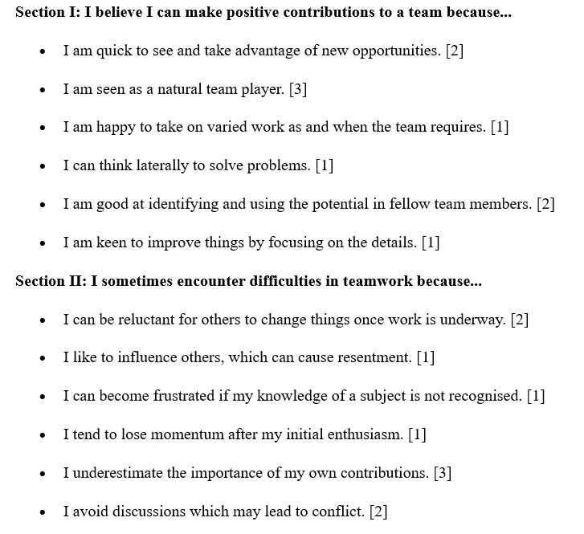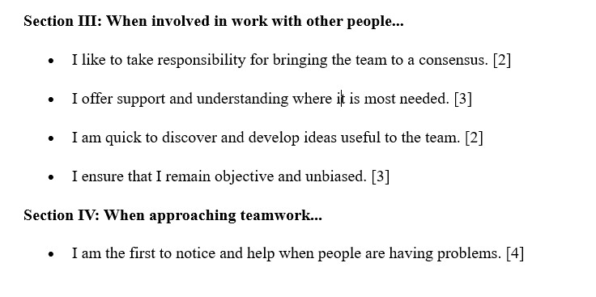

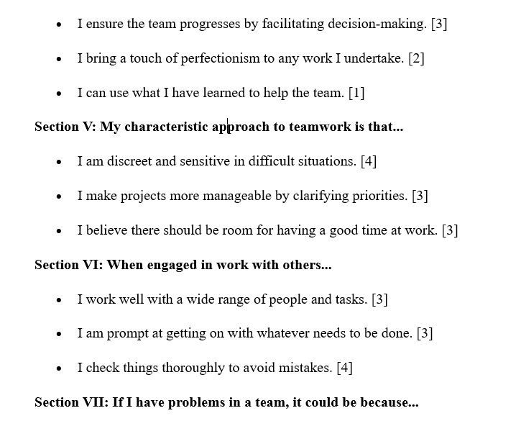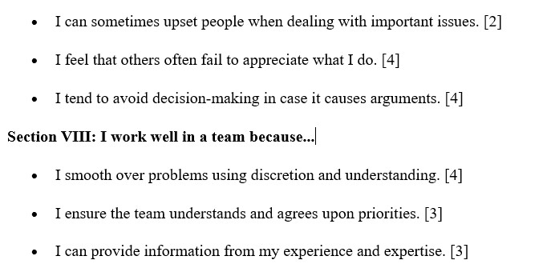

5.2 Thomas-Kilmann Conflict Management Style – Questions with Responses
No. | Question Pair | Response
1 | 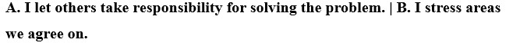 | B

2 |  | A
3 |  | B
4 |  | A
5 |  | B
6 |  | A
7 |  | B
8 |  | B
9 |  | A
10 |  | B
11 |  | A
12 |  | B
13 |  | A
14 |  | A
15 |  | A
16 | A. I avoid hurting others’ feelings. | B. I convince others of my position. | A
17 |  | B
18 | A. I let others maintain their views. | B. I give and take on issues. | B
19 |  | A
20 |  | B
21 | A. I consider others' feelings. | B. I prefer direct discussions. | A
22 | A. I find a middle position. | B. I assert my wishes. | A
23 | A. I want to satisfy all my wishes. | B. I let others solve problems. | A
24 | A. I meet others' wishes if it matters to them. | B. I suggest compromise. | B
25 | A. I show logic in my position. | B. I consider others' wishes in negotiation. | B
26 | A. I propose a middle ground. | B. I want to satisfy all my wishes. | A
27 | A. I avoid controversial positions. | B. I let others maintain their views if it makes  them happy. | A
28 |  | A
29 |  | A
30 | A. I avoid hurting others’ feelings. | B. I work out problems with the other  person. | B

