

Academic and Employability Skills
Refelective Report

Student Name: Ivone Amorim
Student Number: 1818223
Module Code: BMSW4001
Lecture Name: Christopher Mafuva

Table of Contents
Introduction 3
Reflection Definition 3
Kolb´s Experiential Learning Cycle 3
ACE Experience Course Reflection 4
Gibb´s Refletive Cycle (1988) 6
ACE – Term 2 Expirience 6
Conclusion 7
Appendices 8
Appendix 1- Cover Letter 8
Appendix 2- Mini Presentation 9
Appendix 3- Peer feedback 9
References 10

Introduction
The aim of this report is to my own reflection about the lessons taken from Academic and Employability Skills on term1 and term 2, explaining the contents and exercices in classe. I will refelect about what happen, what i learnt, the conclusions taken, what will i improved, and how to do better or use in my workplace. For this refection and analyse i will use two modules of refelecton Gibbs module and Kolbs module of reflection. Leaving this academic expirience , i am learning new skills to adapt and add to the ones i already have, i am leaving the moment and analyse if it was a good or bad expirienece, taking shared feedback from collegues and lectures, that are also helping me with learning contexts.

Reflection Definition
Reflection is a ability, capacity of looking back, to accesse memories, reviewing situations, expiriences, thoughts and describe it. Reflection is a process of critical thinking, analyse situations, learning outcomes and briefly summarising the events, analysing and try to give a conclusion, exploring solutions for a better compreention, for future outcomes.
(Arumugam et al. 2017)

Kolb´s Experiential Learning Cycle
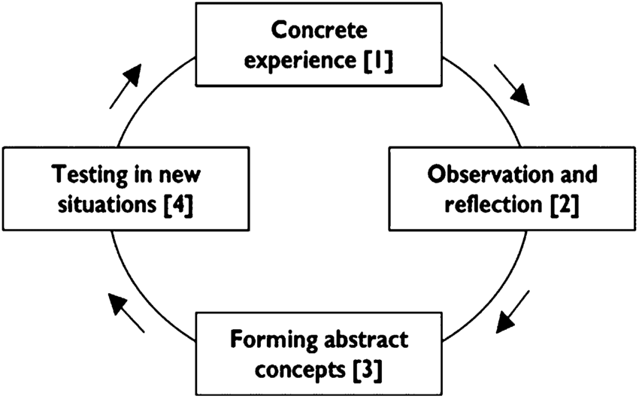

Source: (Hamilton,2010)
Kolb´s Experiential Learning Cycle suggests that people, individuals learn by leaving a concret expirience (1), something needs to happen to develop the learning process and reflection thinking cycle. When a situation occours, individuals will do their own observation of the facts, based in basic factors like smell, taste, vision, tact and listening abilities, they will observe, fell it , intrepet and give a concret explanation (2), The reflection of the observation will create a concept (3) We will learn from this reflection, take conclusions and make a plan to do it better.The cycle continuous and now its time to put in practice what we learnt, to see if the conclusions, concepts we formalate works in a pratice way.(4) (Kolb,and Kolb,2005)

ACE Experience Course Reflection
My name is Ivone and i am from Portugal, i moved to England to progresse at my job area. I am a healthcare assistant for 15 years now, 10 years on my country and 5 here, on those 10 years i never progressed , i worked in a care home, and theres nothing from there, i was in a confortable stage of habits. Until something change my personal life. The strees and pressure were so much that i had to make a huge change so i started applying for jobs outside of Portugal and i got some offers from England, has i had expirience and i was matching the requirements. From one day to another one i jumped out from Portugal. Already here, i start looking for better opportunities has i saw that this contry has an enourmous offerning of job changes, trainings and progressions. I Had my ups and dows, but after 3 years i am working for one of the most excellent companies in care provide, i growed with them being especialised in complex care, but i want more, i want to work in teams ,with NHS or even get a Nurse Degree.
The opportunitie to enter in Health and Social care course at University became part of my life this year, and i am enjoying it, mostly beacuse i am interacting with a class of colegues, lectures and staff. My recent job does not give me that interaction, because its a private agency who provides care at users homes. The communication with the agency is also very unpersonal, by phone, e-mails, or once in a wile at the office, to completly annual trainings.
Term 1 was easier but also interesting, we shared a lot of expiriences, discuss materials, topics, and exercices in class. Has a student i felt confident, because i love to learn, and i have a diversity of skills, that somethimes just need a little review, but contraditing that i also fell very unconfident, i like to be on the back stage, behind the discussing, behind the presentations. I learnt that expirience is not enough to progrees, job requirements are more demanding and not being stock in the same job for years is beneficial. Basic skills , expirience, academic skills, transferable, and social skills are necessary for increasing my employability skills , to improve and achive more goals.
Creating a Personal Development Plan- PDP was one of the class exercice that helped me to find out were i am, in what stage and what do i want for my life, my plan, goals and where do i see myself in the future, i also refelected about opportunities that came and the ones i lost it. Acording to this expirience i felt confused and i found it hard to decribe my personal skills, goals and steps to take on the future in written words. I realise, i do not have enough vocabulary and i need to improve. I also need to be more objective, pragmatic and establish a plan, a date, the steps to follow, goals, and put that in a paper-PDP made me see things more clear and defined .Some exercices in class were very helffull to explore myself as the SWOT analysis, i had to dentify my Strengths, weekness, opportunities and threats. I understood that my strengths are: paying attention to others, listening, eye contact, caring, learn every day, and that i am a hard worker. My Weekness is to be affraid of speaking, somethimes affraid of people, unconfidence even when i know what i am talking but the lack of vocabulary is not enough to express myself so i get lost and i just stop speaking. Academic attendence is a life opportunity, i am now able to fight for new changes in employement environment, i will be increasing my education status and also using training presentations to reforce my confidence, to speak in front of people and leave the confortable felling on the back.
To complete this course i need to be focus and manage well my time, i am using the Eisenhower's Mattrix method that was taught in classes, knowing what to do first, prioritize tasks is fundamental to not wast time and efford in unnecessary things, i need to make a list from the urgent things to do , to the ones not so important, be honest with myself and make small lists more likely to be done.(Clark,and Sousa, 2018)
I learnt about writing skills, language and grammar, reviewing vocabulary, how to writte sentences and paragraphs. This are essencial skills for the job world, can be applyied in diverses ways, when sending a formal or informal e-mail, when writing a reporting, when creating a desirable CV, or to writte a well structure assignement.
Has i said above i fell confortable at school environement and the contexts learnt i am already applying on my daily basis, but i am improving , i am writting better, adding new words to express myself and also learning new methods. I never did assignements or research from legal articles, it was out of my knowledgemnt that copy and past from a source was not legal, and now i understand that explaining things on my own words it is called paraphasing, without taking the meaning of the context but also citating. After paraphrasing and citation i need to make an Harvard Reference in the end of the document, this was completly new for me, it is more elaborated , but with commun sense and following the referencing handbook guide provide at the University it became easier. For each source the reference can be different , it dependes the quality and form of the source, it can be a book ,a jounal, a website, conferences and others. On the end of my report i will also summarise give a brief and clear explanation about my work, describing in a short sentence what i was speaking about. After reading from other sources and understanding the information, i will take relevante notes and give a logical order to the events.

Gibb´s Refletive Cycle (1988)
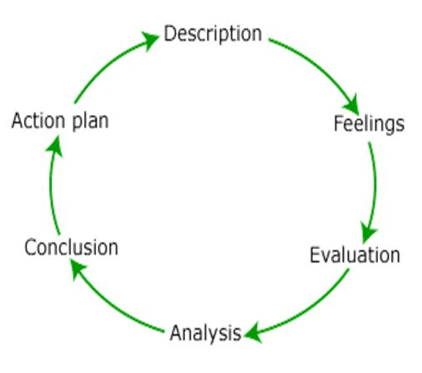

Source: (SlidePlayer,2019)
In the realization of this reflect report i am also using Gibb´s refelective cycle, where i am describing my own course expirience, through knowledgement learned, shared discussions, interactions and class exercices. When leaving those expiriences i was able to feel emotions, sensations, that i evaluated deciding if it was a good or a bad expirience, i made my analyse having thoughts about what happen, making a sence of the situation, and concluding in what could i have done better, or could i have done different. After concluding the expirience i need to make a plan , for what to do next or if i will go throught the same expirience what will i do .(Kitchen,1999)

ACE – Term 2 Expirience
Term 2 was based in review employability skills contexts, it was positive to review job requirements, skills and strategies. I learned new strategies to write a proper CV, and i spend some time at home creating a new one, with new vocabulary to increase my changes at the employability world. I am trying to win the employers, showing my qualities, atributes, qualifications and relevant skills based on positive comments. I was able to understand ,analise and reflect what i was doing wrong. Because of my different background i was not taught to do this way and i would start from my first employment and not from the recent one. I was also not used to send a cover letter, i did not understood the meaning of it until now, a proper cover letter can get me the job i want, selling my attributes and expirience , mencione that i am flexible to learn every day and i love to work in teams. The Cover Letter was one of the exercices in classes, is a short statement about someone background, skills, abilities, expirience and performance to attract and convince employers(appendix 1), i enjoyed talking about myself and my job, because i know me and i know what i am talking about, i have support evidences to make me fell confortable. I had a good feedback from the exercice and i felt recognised and happy with what i achived ((Karungi,2019).Finally we reach the modules of reflecting writting, analytical and critical thinking used in school environements to help students in the process to create assignements. Refelecting about my process is tremendous , i am doing well, i feel good with my progress, exploring the steps, the situations, what i have accomplish, making my point based on evidences makes part of my analyse, and now i need to think about my decisions, about what i am doing , if this is the right path for me, i need to take a step back and critical think about my plans.(Cottrell,2017)
I also did a mini presentation exercice, i had to refelect and explain Time-Management (appendix 2). I did prepared myself and i did a small document well structured with the most important points, but in the day of the presentation we had an unexpected turn, your lecture could not be present so we had another lecture covering the session. Although he was polited and kind, conforting us with words and also explaining if someone one was in a stressfull stage and does not want to present thats alright, but not even with this words i stoped paniking, i dont like presenting, and has expected i was paniking, my words sounded faithed, nervous, shaking, but i did it. My feedback was normal, i was expecting a lower one, so maybe i was not that bad, maybe i was nervous , paniking, but the context about time management was covered, thats the analise i can take from it, and i am happy.

Conclusion
Enter in the University was important on my life, the materials, interaction, and knowledgement adquired it is making a huge impact, i am learning everyday and improving my skills, my qualifications, employment expirience, decisions to make and new perpectives. The lessons provided and the exercices in classe where well implemented and taught me a variety of things, i am now able to apply and create better reports, e-mails, to refelect, analyse , question all the process and do it better. This knowledgement will also help me on my future goals, because i love working in Healthcare environement and things not always are good, anything can go wrong any minute and i need to be able to understand them before they happen, predicting them with my commun sense and knowledment, being able to judge my decisions, reflecting them, analyse future outcomes and taking conclutions after any episode.

Appendices

Appendix 1- Cover Letter
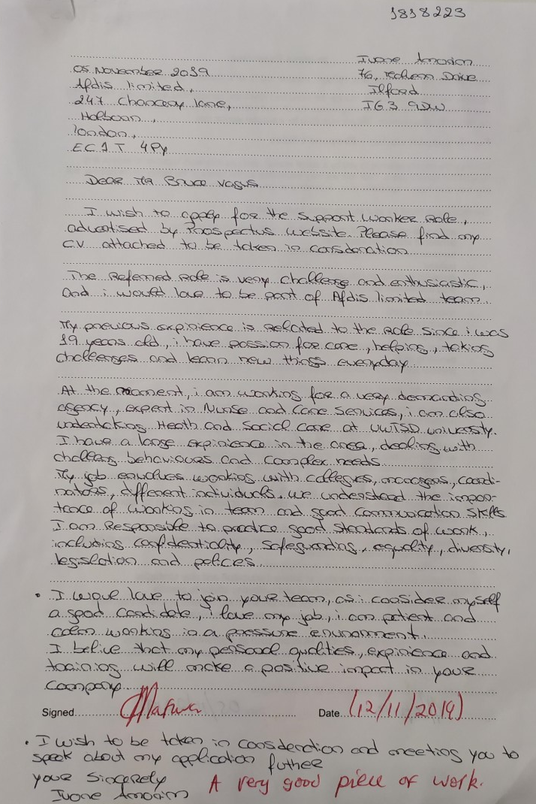

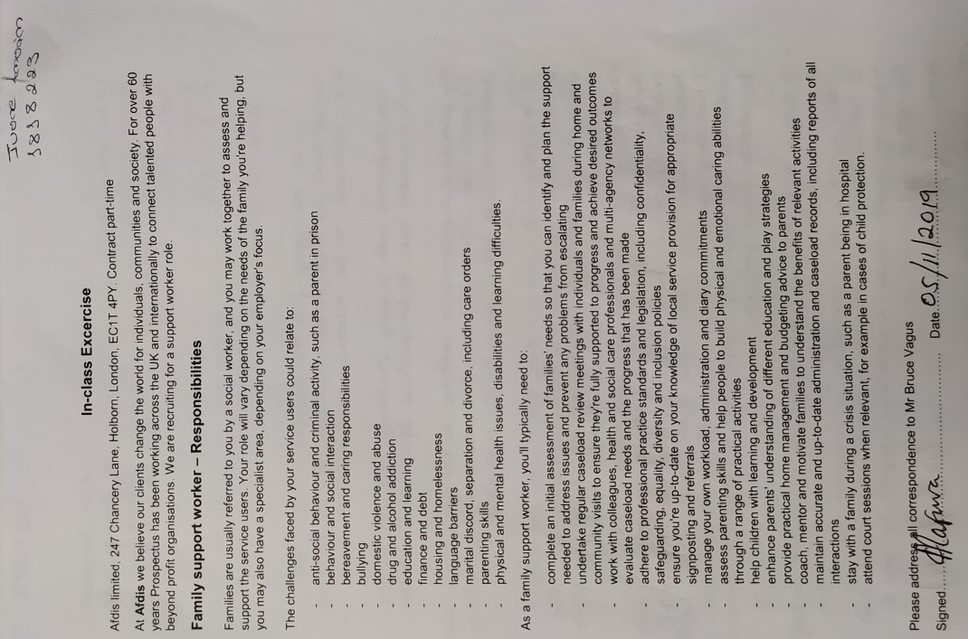

Appendix 2- Mini Presentation

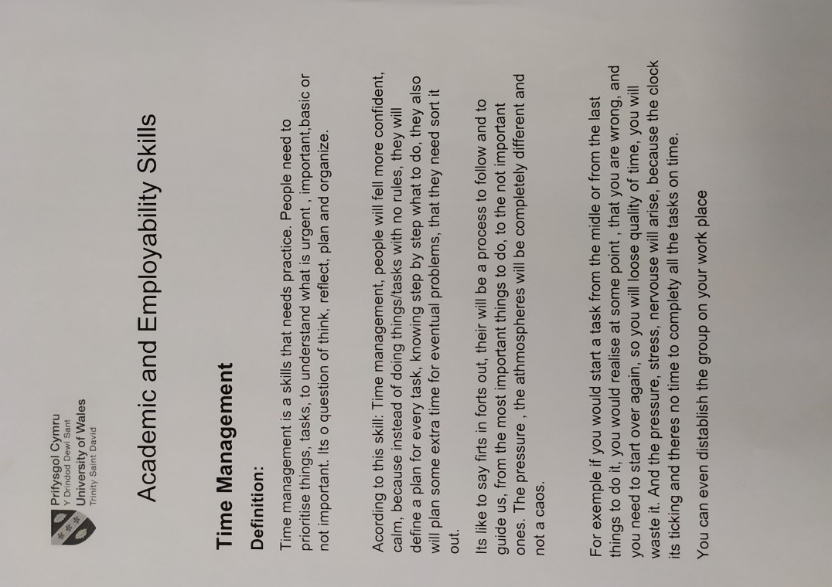

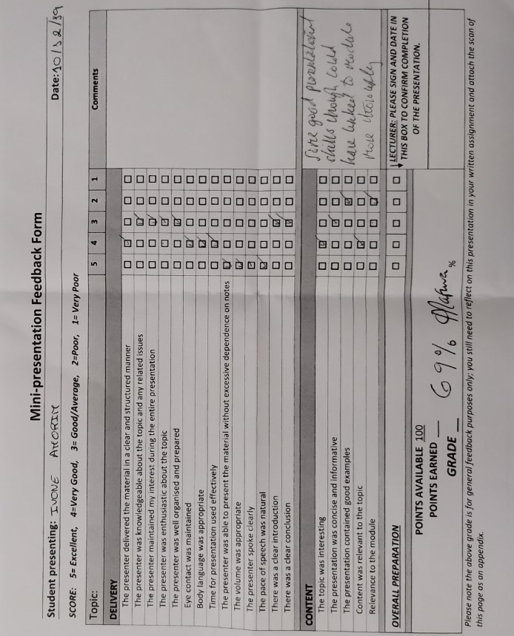
Appendix 3- Peer feedback

References

Arumugam,B. et al (2017) “Reflective writing–how a medical student can reflect?” Journal of Education Technology in Health Sciences, 4(2), 47-53. [Online] Available at: http://jeths.net/index.php/jeths/article/viewFile/159/125 (accessed 07th December 2019)

Hamilton,R.(2010) “Kolb's Experiential Learning Cycle.4”ResearchGate [Online] Available at:https://www.researchgate.net/figure/Kolbs-Experiential-Learning-Cycle-4_fig1_46010029 (accessed 07th December 2019)

Kolb,A.Y and Kolb,D.A.(2005) “The Kolb learning style inventory-version 3.1 2005 technical specifications” Boston, MA: Hay Resource Direct,200(72).[Online] Available at: https://www.researchgate.net/profile/David_Kolb/publication/241157771(accessed 07th December 2019)

Lim,S. (2017) “How To Deal With Urgent VS Important Work Using The Eisenhower Box Matrix” Stunning Motivation[Online] Available at:https://stunningmotivation.com/urgent-vs-important-eisenhower-box-matrix/ (accessed 07th December 2019)

SlidePlayer.(2019)"Reflective Learning Fashion Design BA (Hons) Top-up"[Online] Available at: https://www.google.com/url?(accessed 10th December 2019)

Kitchen,S.(1999). “An appraisal of models of reflection and clinical supervision”, British Journal of Theatre Nursing UK, 9(7), pp.313-317. Available at: https://doi.org/10.1177/175045899900900704 (accessed 18th December 2019)

Cottrell,S.(2017) “Critical thinking skills: Effective analysis, argument and reflection” Macmillan International Higher Education [Online] Available at: https://books.google.co.uk/books?(accessed 08th December 2019)

Clark, A. and Sousa, B. (2018) “ How to be a happy academic: A guide to being effective in research, writing and teaching” Sage,pp.183-184[Online] Available at: https://books.google.co.uk/books (accessed 10th December 2019)

Karungi,Z.(2019) “What you should never include in CV of cover letter”. Daily Monitor Available at: http://hdl.handle.net/20.500.12306/1759 (accessed 18th December 2019)

