Wireless Networks and Simulation

ACCB5004

Student Name: Lauren Davies
Student Number: 1805950

Abstract
The summary of the beginning of the report provides an explanation of what modulations equal with their description it goes on to details the benefits of the QPSK modulation system. The advantages/disadvantages QPSK are discussed, furthermore the report contains the applications that this modulation supports in day-to-day life. The second half of this report contains Wireless Sensor Network (Research & Design of network) along with an evaluation.

Introduction

This report was created to inform its readers of the benefits which QPSK can provide and show its performance within other applications that are available worldwide. The aim for this report is to be able to apply QPSK to the scenario given. The scenario is to create a wireless monitoring system that will be used to inspect a number ongoing problems that are occurring on different Caribbean Islands, which are having their farms attacked by thieves, meaning that crops and stock are being stolen before they are marketed. This requires a system that will be able to detect any possible threat to the farmers land and their possessions and be able to send a report to the police to act against it. A second part of the scenario is to apply a similar monitoring system on public transport and within cities to lower crime rates from weapons used against them whilst being robbed.

List of Acronyms

QPSK – Quadrature Phase-Shift Keying
OQPSK – Offset Quadrature Phase-Shift Keying
PSK - Phase Shift Keying
BSPK – Binary Phase Shift Keying
EM – Electromagnetic Waves
WLAN – Wireless Local Area Network
CDMA – Code-Division Multiple Access
LTE – Long-Term Evolution
CW – Cellular Wireless
TDMA – Time-Division Multiple Access

Contents
Abstract 1
Introduction 1
List of Figures 1
List of Acronyms 1
Task One: Research & Evaluation of Modulation Schemes 3
What is the function of modulation in a communication system? 3
How are computer network simulations like communication systems? 3
What are the Advantages & Disadvantages of QPSK? 4
Advantages 4
Disadvantages 4
Implementations of QPSK 4
QPSK Modulation Applications 5
Global System for Mobile communication (GSM) 5
Code-Division Multiple Access (CDMA) 5
Pros and Cons of using simulations over test-bed methods 5
Pros of Simulations 5
Cons of Simulation 5
Task Two: Wireless Sensor Network (Design & Evaluation) 6
Wireless Networks & Communication Systems 6
LoRa 6
WLAN 6
ZigBee 6
Wi-Fi 6
Satellites 6
Celluar 6
Internet of Things & Smart Cities 7
Security Imaging Technology for the Detection of Concealed Weapons 7
Network Designs 8
Farm Network Design 8
Public Transport Design 9
Conclusion 9
References 10

Task One:
Research & Evaluation of Modulation Schemes

What is the function of modulation in a communication system?
In a communication system the modulation functions by transforming data that is passed to it into radio waves, the modulation is then able to add additional information onto either a Electronic or sometimes through Optical carrier signals [1]. Following this the carrier signal appears as a waveform and will retain height/amplitude and frequency. Modulations are typically applied for EM signals, which are often used for networks and radio waves. When it comes to modulations there are plenty of them which are used in various ways to carry data, this report will contain further details of QPSK modulation.
QPSK is a different form of PSK, meaning that QPSK can alter two pieces (bits) of data at the same time. QPSK is able to select from four different ‘carrier phase shifts’ that are 0/90/180/270 degrees. This modulation can authorise signals to carry double the amount of information in comparison to PSK by using similar bandwidth available. QPSK is often relied on for transmitting satellite signals along with cellular systems and other digital communication. [2] QPSK is depended on for a diverse amount of applications that are based in current digital communication systems. The modulation is capable of high performances whilst on bandwidth efficiency and bit error rate. [3]

How are computer network simulations like communication systems?
Computer networks are like communication systems as they provide a variety of different components that can benefit testing of scenarios and can display devices that are connected within the simulation sending/receiving data packets. Network simulations can provide a range of results of what is occurring whilst the simulation is being carried out, such as the signal levels that are being produced, how much noise and the packet loss rate of all devices. On top of these elements, network simulations provide the producer of the simulation with how much bandwidth consumption is being used between the devices [4].

What are the Advantages & Disadvantages of QPSK?

Advantages
There are many advantages of QPSK, the first advantage of this modulation being that it has the ability to supply a great amount of noise immunity, by being able to give noise immunity this means that QPSK is able to boost the amount of signals needed before they deteriorate [5]. When it comes to error rates (which is the overall amount of failed data that has been unable to transmit) QPSK provides a steady low error rate. The bandwidth which is needed for QPSK is half of what BDSK requires and is more with bandwidth efficient and can make a more effective use with it in comparison to the BPSK modulation [6]. In comparison to BDSK, QPSK modulations have the ability carry 2 bits by an individual analog carrier, meaning the bandwidth will have double the more efficiency.

Disadvantages
Despite its many advantages, QPSK also has its disadvantages. QPSK uses a singular symbol to represent the bits that pass through the modulation, meaning that the receiver in QPSK is quite complicated in comparison to BPSK as this modulation has multiple states to gather binary data. As a result of the reason stated above QPSK is more reliant on an increased amount of power in place to transmit two bits on one signal whilst other modulations require less power [5].

Implementations of QPSK

QPSK is used in an extended amount of modern digital communication systems, due to its ability to be able to supply a good performance when depending on bandwidth efficiency/ error rate (bits). The communication systems which use QPSK modulation include mobile, satellite and wireless. When phase modulations were first created it positioned an immunity to noise where some amplitude was able to be demodulated. In modern technology the use of QPSK has provided great benefits as the transmission of data can be encrypted and can be corrected if there are any errors presented, QPSK has the ability to use certain aspects of modulation (frequency / Amplitude) to its advantage.

QPSK Modulation Applications
When inspecting the applications that QPSK modulation is used for a diverse amount of CW standards. The standards that include the use implementation of QPSK are the following detailed below:

Global System for Mobile communication (GSM)
GSM represents mobile networks (digitally) and is used by parts around the world, it is utilized for being able to transmit mobile voice and provide data services and makes use of the technique TDMA to transmit signals [7].

Code-Division Multiple Access (CDMA)
CMDA can be referred to the protocols which are used in 2G & 3G for mobile (wireless) communications. This is considered a form of multiplexing and allows countless amounts of signals to be present in a single transmission which in turn enhances the bandwidth that is available [8].

Pros and Cons of using simulations over test-bed methods
When testing scenarios before performing them in real-life, there are many pros by creating an environment that is similar, rather than applying it straight away.

Pros of Simulations
The pros of simulations include being able to analyse certain behaviours that may occur, without having to waste resources building the system. By doing this method it still provides accurate results in comparison to testbed methods and can often pinpoint anything that may be ‘unexpected behaviour’ in the system [9].

Cons of Simulation
Even though simulations having multiple advantages, building a precise simulation can often prove to be expensive to do, along with performing the scenario. The results that are provided via simulation are often hard to analyse after the scenario has been carried out [9].

Task Two: Wireless Sensor Network (Design & Evaluation)
In this section of the report it provides a detailed research about different areas that are a part of wireless networks. Furthermore, the designs for a wireless sensor system will detail how farmers and public transport can be monitored and protected against any possible malicious threats.

Wireless Networks & Communication Systems
When discussing Wireless networks and communication systems there are an assorted number of networks in place, such as WAN and LANs that are used for business and home networks. A larger scale wireless network is WWLAN which is made up of diverse (mobile phone) signals that are all supported by certain MP service providers [10], due to this there are a vast number of wireless devices which use 3/4G networks. On top of mobile communications another benefit of having wireless communication is that it makes use for devices that use satellite and Wi-Fi [11].

LoRa
This wireless tech. is referred to as a LPWAN, meaning that it provides a long range alongside of lower power. A benefit of this network is that is can secure transmissions containing data for a variation of IoT appliances. LoRa has the ability to establish extended communication between sensors and any gateways which are connected onto the network, allowing a fast structure of public/private IoT networks [12].

WLAN
Wireless Local Area Networks possess the ability to build connections between devices and networks wirelessly, where the devices can reach to each other via Wi-Fi. The benefits of having WLANs is that cables are not required and are not prevented from having a limited amount of users due to having no physical ports [13].

ZigBee
This network tech. is a wireless networking standard (IEE 802.15.4) that possess the ability to communicate two ways amongst sensors and other control systems. Unlike LoRa, this is mainly used for short distances (like Bluetooth) to carry more simple pieces of data, as it supports low data & power rates [14].

Wi-Fi
This is a wireless networking structure which also represents WLANs. It works by creates radio waves (and is on the EM scale) to produce a fast performance network and provides devices connected access to the internet. Wi-Fi has a wide span of applications are supported, such as game consoles and mobiles [15].

Satellites
Satellites have various uses within networking systems. This type of technology allows communication from one place of the world to another and can produce signals to both radio and TV to provide people with shows and songs [16].

Celluar
These are MP networks, which are spread over countries and consist of core networks that connect stations with towers that have antennas. They are structured to allow the access to the internet from mobile devices whilst on the move, even if not connected to a Wi-Fi network [17].

Internet of Things & Smart Cities
SC are in constant use of IoT devices such as sensors, lights and parking meters in order to be able to gather data and to analyse it, in turn this data is utilised to make improvements to the cities infrastructure for public services [18]. The utilisation of this technology means that all forms of data can be monitored, as detailed in the article ‘Business Insider’ different cities based in America, have begun using cameras in order to monitor traffic of both cars and people in order to reroute areas at peak times to avoid any possible accidents from occurring.

Security Imaging Technology for the Detection of Concealed Weapons
When is comes to detecting any concealed weapons that are carried by members of the public, the use of Passive millimeter wave is key to analysing any potential threats. The systems are proficient in scanning through peoples clothing in spot concealed weapons without individuals noticing or cause irradiation [19].
An additional option that has been identified is by using Ultrasound, this is because once the ultrasound has scattered of the target, some of it will bounce back to the emitter, allowing the detection of possible weapons [20].

Network Designs

As stated in the introduction, the network required had to be able to monitor farms, due to theft of crops and livestock just as they are ready for sale. Attempts had already been implemented to prevent the raids on farms from happening but have been unsuccessful so far. An element within the network designs, is a monitoring network on public transport that will alert the police if any possible robbery or harm is taking place against civilians.

Farm Network Design

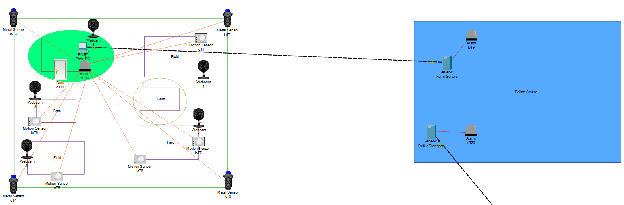
(Network created using Cisco Packet Tracer)
For the Farm Network, due to the possibilities of the raiders having concealed weapons, there would be a barrier in place, which would span 6ft tall, if they are to climb this wall and drop down inside the walls, metal sensors would detect whether they were carrying any potential lethal weapons on their persons this would then be forwarded to the motion sensors to activate. After this element of security has been tripped the motion sensors will be in full operation across the farm and await for any further changes to the environment, if there is a change it will connect to the cameras that it is associated with and begin recording the evidence, something to note is that due to the raiders wanting to raid the farm, they will ensure that there are no cameras and will damage them if they are spotted to avoid detection. If this is the case and a camera in operation were to be destroyed, an alarm will trigger a drone to fly to that area to gain further analysis of the situation. If any of the alarms are triggered at any point whilst the security elements are in operation, the alarm will automatically send a signal to the nearest police station to gain further assistance against the attackers.

Public Transport Design

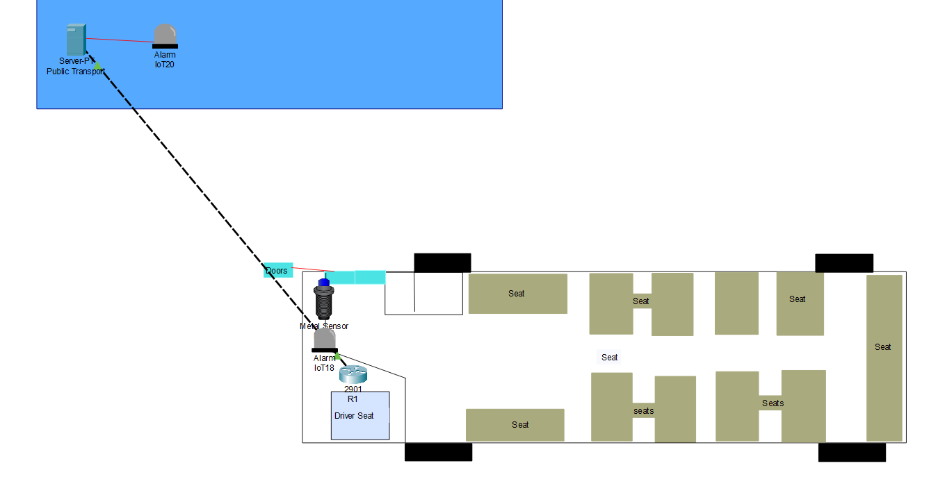

For the network design of the bus, it was important to ensure the safety of the public against any potential attackers. As shown in the bus structure above, in the cubicle where the driver is there will be a small device which is monitoring the metal sensors reactions in case of any sealed weapons being brought onto the bus, if this is the case the sensor will silently trigger an alarm and create a report to the police of a urgent assistance. A possible addition would be that an additional set of doors were in place to separate the entrance way from the seating areas, in case of an emergency, which traps the criminal in the doorway until police arrive.

Conclusion

As first discussed in the introduction the overall aim was to see if the researched modulation would be able to benefit the scenario provided, to be able to protect farmers and city life against any malicious threats. As confirmed throughout the research collected, it is clear QPSK can provide many benefits ranging from all areas of wireless communications, along with being implemented in a wide range of applications that are used in modern technology, this will ensure that all technology that will be used in the given scenario will be up to date on all newly existing protocols provided by IEEE. It will allow any of the wireless devices which have been represented, in the Network designs stated, to communicate effectively and prevent these attacks from being carried out.

References

[1] | T. Slattery and J. Burke, “Modulation,” SearchNetworking, 02 2018. [Online]. Available: https://searchnetworking.techtarget.com/definition/modulation. [Accessed 13 04 2020].
[2] | maxim integrated, “GLOSSARY TERM FOR QPSK,” [Online]. [Accessed 15 04 2020].
[3] | P. J. Gautam, N. Gautam, J. Patel and P. Balaji, “QSPK Modulator,” IEEE International Conference on Advanced Communications, Control and Computing Technologies, pp. 653-656, 2014.
[4] | F. D. Garcia, J. C. Granda, F. J. Suarez and P. Nuno, “Computer Networks Performance Modeling and Simulation,” Modeling and Simulation of Computer Networks and Systems - Methodologies and Applications, vol. 7, 2015.
[5] | ECSTUFF, “Advantages and disadvantages of QPSK,” 2019. [Online]. Available: https://www.ecstuff4u.com/2019/02/advantages-and-disadvantages-of-qpsk.html. [Accessed 16 04 2020].
[6] | RF Wireless World, “Advantages of QPSK | Disadvantages of QPSK,” [Online]. Available: https://www.rfwireless-world.com/Terminology/Advantages-and-Disadvantages-of-QPSK.html. [Accessed 16 04 2020].
[7] | tutorialspoint, “GSM - Overview,” [Online]. Available: https://www.tutorialspoint.com/gsm/gsm_overview.htm. [Accessed 16 04 2020].
[8] | M. Rouse, “CDMA (Code-Division Multiple Access),” SearchNetworkin, [Online]. Available: https://searchnetworking.techtarget.com/definition/CDMA-Code-Division-Multiple-Access. [Accessed 16 04 2020].
[9] | X. M., “Advantages and disadvantages of simulation,” 18 10 2002. [Online]. Available: https://www.eg.bucknell.edu/~xmeng/Course/CS6337/Note/master/node3.html. [Accessed 20 04 2020].
[10] | A. Agarwal, “Types of Wireless Networks,” labnol, 13 05 2015. [Online]. Available: https://www.labnol.org/tech/types-of-wireless-networks/13667/. [Accessed 18 04 2020].
[11] | ElProCus, “Different Types of Wireless Communication with Applications,” ElProCus, [Online]. Available: https://www.elprocus.com/types-of-wireless-communication-applications/. [Accessed 19 04 2020].
[12] | everythingRF, What is LoRa?, Editorial team, 2018.
[13] | P. Christensson, “WLAN Definition,” Techterms, 07 04 2017. [Online]. [Accessed 19 04 2020].
[14] | Electrical Technology, “What is ZigBee Technology and How it works?,” Electrical Technology, [Online]. Available: https://www.electricaltechnology.org/2017/09/zigbee-technology-wireless-networking-system.html. [Accessed 20 04 2020].
[15] | V. Beal, “Wi-Fi Definition is Not Wireless Fidelity,” 14 07 2010. [Online]. Available: https://www.webopedia.com/DidYouKnow/Computer_Science/wifi_explained.asp. [Accessed 20 04 2020].
[16] | Wonderopolis, “What can satellies do?,” Wonderopolis, [Online]. Available: https://www.wonderopolis.org/wonder/what-can-satellites-do. [Accessed 20 04 2020].
[17] | P. Liu, T. F. LaPorta and K. Kotapati, Network and System Security, Science Direct, 2014.
[18] | A. Meola, “How smart city technology & the Internet of Things will change our apartments, grids and communities,” Business Insider, 16 01 2020. [Online]. Available: https://www.businessinsider.com/iot-smart-city-technology?r=US&IR=T. [Accessed 21 04 2020].
[19] | G. N. Sinclair, R. Appleby, P. R. Coward and S. Price, “Passive millimeter-wave imaging in security scanning,” Passive Millimeter-Wave Imaging Technology IV, vol. 4032, 2000.
[20] | B. J. CLARKE, “CONCEALED WEAPONS DETECTION (CWD) TECHNOLOGIES,” Air Force Research Laboratory, notstated.

