Student name: Roberta-Carmen Burdighioiu
Student number: 1909880
Module code: BMSW4003_LON
Lecturer name: Modak Koushik

Digital Skills and Research Methods

Table of content
- Introduction (pag. 3)
- Existing review literature (pag. 3)
- Research Methodology (pag. 3)
  - Rationale (pag. 4)
  - Objective (pag. 4)
  - Qualitative research method (pag. 4)
  - Quantitative research method (pag. 4-5)
  - Population (pag. 5)
  - Sample size (pag. 5)
  - Data collection progress (pag. 5)
- Ethics in data collection (pag. 6)
- Findings, analysis and discussions (pag. 6-11)
- Summary of findings (pag. 11)
- Conclusion (pag. 11-12)
- References (pag. 13)
- Appendix A (pag. 14-15)
- Appendix B (pag. 16-17)

Introduction
This report is created to analyse student’s satisfaction about Virtual Learning Environment. A questionnaire has been sent to student of UWTSD which consists of 3 closed-ended questions, 3 multiple-choices questions and 2 open-ended questions. I will collect 20 samples from 20 students where I will gather information about Virtual Learning Environment opinions. I will be using Bar Charts and Pie Charts to show the results of the primary research made.
“A Virtual Learning Environment (VLE) is a system for delivering learning materials to students via the web. These systems include assessment, student tracking, collaboration and communication tools. They can be accessed both on and off-campus, meaning that they can support students' learning outside the lecture hall 24 hours a day, seven days a week.” (Oxford University Press, 2016)

Existing review literature
“There are numerous studies focusing on the acceptance and use of information technologies (Fishbein & Ajzen, 1975; Davis, Bagozzi, & Warshaw, 1989; Taylor & Todd, 1995; Venkatesh, Morris, Davis, & Davis, 2003; Sun & Zhang, 2006; Al-Gahtani, Hubona, & Wang, 2007; Lee, Choi, Kim, & Hong, 2007; Im, Hong, & Kang, 2011). These studies indicate that there are various important factors that affect the acceptance and use of information technologies by individuals belonging to different countries and cultures. These studies that began in the 1980s first made use of the Technology Acceptance Model (TAM), which is based on different social and behavioral theories, and which was gradually revised and further developed until it was finalized as the Unified Theory of Acceptance and Use of Technology (UTAUT).” (Kurt, 2020)
The importance of Virtual Learning Environment is that students can develop their knowledge in academic studies and have vast information available to access. Institutes of higher education should focus about student’s satisfaction about VLE. (Akamavi et all, 2019)
Research Methodology
Rationale
“The rationale of your research is the reason for conducting the study. The rationale should answer the need for conducting the said research. It is a very important part of your publication as it justifies the significance and novelty of the study. That is why it is also referred to as the justification of the study. Ideally, your research should be structured as observation, rationale, hypothesis, objectives, methods, results and conclusions.” (Editage Insights, 2020)
The background of the researches I have made done such as conducting a questionnaire, is to find the satisfaction and impact of VLE on UWTSD’s students. To see what is missing in VLE I created two open questions in my questionnaire about what should be improved and what are the things students like the most about Moodle.
Objectives:
The objective is to find the impact of VLE on UWTSD’s students.
Qualitative research method
“Qualitative research is multimethod in focus, involving an interpretive, naturalistic approach to its subject matter. This means that qualitative researchers study things in their natural settings, attempting to make sense of, or interpret, phenomena in terms of the meanings people bring to them. Qualitative researchers use a variety of methods to develop deep understandings of how people perceive their social realities and in consequence, how they act within the social world. For example, diary accounts, open-ended questionnaires, documents, participant observation, and ethnography.” (McLeod, 2020)

Quantitative research method
“Quantitative research is a method of research that relies on measuring variables using a numerical system, analysing these measurements using any of a variety of statistical models, and reporting relationships and associations and associations among the studied variables. For example these variables may be test scores for measurements of reaction time. The goal of gathering this quantitative data is to understand, describe, and predict the nature of a phenomenon, particularly through the development of models and theories. Quantitative research techniques include experiments and surveys.” (Williamson, Johnson, 2018)
This report will include both qualitative and quantitative research methods I will be conducting a report. Qualitative research includes; obtaining information on people that study in UWTSD. As a result, to understand the opinions of the people regarding VLE.
Quantitative research includes the graphs and pie chart to better understand the people’s statistical information regarding to the qualitative research that I have tried to achieve from my questionnaire.
Population
“A research population is generally a large collection of individuals or objects that is the main focus of a scientific query. It is for the benefit of the population that researches are done. A research population is also known as a well-defined collection of individuals or objects known to have similar characteristics.” (Explorable, 2020)
The research I made was collected from 20 student of UWTSD.
Sample Size
“Sample size determination is the act of choosing the number of observations or replicates to include in a statistical sample. The sample size is an important feature of any empirical study in which the goal is to make inferences about a population from a sample. In practice, the sample size used in a study is usually determined based on the cost, time, or convenience of collecting the data, and the need for it to offer sufficient statistical power.” (Bartlett et all, 2001)
The survey created will be sent to 30 student’s emails. I will chose only 20 students who will be my sample that I will create my research on VLE impact on students.
Data Collection Progress
“The data collection process is a challenging task and involves many issues that must be addressed before the data is collected and used. The collected data may not be in the usable form right away and may require additional efforts to make it usable. It is obtrusive and involves user privacy issues, among other problems.” (Garg et all, 2020)
I designed 8 questions based on student’s satisfaction on Virtual Learning Environment. I will collect data from 5 and choice question which are: Very satisfied, Satisfied, Unsatisfied, Very unsatisfied, Prefer not to say. This will allow students to respond faster and institutes to see clearly the level of satisfaction. However, the information I will collect will help me build charts to measure the student’s opinions.

Ethics in data collection
“Ethics are the moral principles that a person must follow, irrespective of the place or time. Behaving ethically involves doing the right thing at the right time. Research ethics focus on the moral principles that researchers must follow in their respective fields of research. Following ethical principles is indeed crucial for maintaining research integrity.” (Resnik, 2020)
Before I conducted my questionnaire I have asked for permission from the authorised department and from the lecturer. It is important as I will be using data based on students of UWTSD. It has been made clear that the information I will be using is only for study purposes for BMSW4003_LON module. I maintained all the data collection progress, my overall survey process and questionnaire was not biased.
Findings, Analysis and Discussions:
The questionnaire of The Impact VLE on UWTSD’s students.

Yes | No
19 | 1

The purpose of the first question of my questionnaire was to try to see approximately how many student are aware of Moodle, the VL platform used at UWTSD. As the results show, 90% of 20 people are aware of it. It is an insignificant percentage as Moodle should be promoted in every class by the lecturers, and also by university.

Every day | Every week | Once a month | Never | Whenever is needed | Prefer not to say
6 | 8 | 1 | 0 | 5 | 0

The aim of the second question of the survey is to see the frequency student actually access Moodle. If is every day or once a month, I design this question based of 6 choices of answer. As the bar chart shows the actual number of users, the pie chart show the percentage. The majority, 40% of 20 students use Moodle every week, also there is a small amount of 5% that use Moodle once a month.
Question 3. What do you appreciate the most about Virtual Learning Platform? (Please write in a few words)
The majority of the students who completed this questionnaire appreciate that on VLE platform they find easier to gather all the theory they need for assignments and it takes a more little time to search online than to go to library for books. They can access online library on Moodle.

Yes | No
1 | 2

This is an important question. The objective of this question is to find out if students are satisfied enough about Virtual Learning Environment so they can recommend to their friends. The importance of referral is that it can boost the efficiency of student’s grades by researching for information for assignments on the University’s platform for students or other online learning platforms. For this part 90% of positive answer is beneficial to university because this question implements in student’s mind they should recommend it.

Very Satisfied | Satisfied | Unsatisfied | Very unsatisfied | Prefer not to say
8 | 11 | 0 | 0 | 1

The data obtained from this question it shows the level of satisfaction about VLE. As 55% of students are satisfied and 40% are very satisfied about Moodle, the result is clear that those who use online platform for research have a good opinion about it.

Question 6. In a few words describe what would you like to improve in Moodle.
Using this question I discovered that most of the students who answered this question said there is no improvement needed. However, some of them would like to be improved the speed, and the theory which is needed for assignments to be more specified and complex.

Yes | No
19 | 1

The 7th question of my conducted survey is highlighting the students who are not confident in using Moodle. Although the majority of 90% of students find it easy, the important fact is that there are 10% of students who don’t find easy to access it. The university should take in consideration the small amount and implement additional classes of IT skills, or at least lecturers should accord help about it.

Summary of findings:
After I analysed the information collected, I can say that the majority of students of UWTSD feel satisfied about the opportunities VLE gives. Most of them find it easier than the traditional way of learning and is time saving. However, is necessary for the head office of the UWTSD to accord additional attention on students who are not confident using online platforms.

Conclusion
With all this together I explained the results and the survey I conducted gave opportunity to students for opinion. The questionnaire was developed in the academic year ‘Skills for the Workplace’ and sent to 20 students of UWTSD. This study designed to evaluate the frequency and satisfaction of the students. The researched I have done respect the ethics data collection.
UWTSD should embolden and support students to research for information on Moodle in order to develop their learning experience

References
- Oxford University Press, (2016). Learn about Virtual Learning Environment/Course Management System content, viewed on 6 May 2020 <https://global.oup.com/uk/orc/learnvle/ >
- Kurt O.E. 2020, International Journal of Educational Technology in Higher Education, BioMed Central, viewed on 10 May 2020, < https://educationaltechnologyjournal.springeropen.com/articles/10.1186/s41239-017-0064-z >
- K.R. Akamavi, A.M. Butterfield, G. Roushan, E. Mohamed (2006-2019). Relationship virtual learning environment and student learning experience: What are the mediating variables? , Bournemouth University, viewed on 6 of May 2020 < http://eprints.bournemouth.ac.uk/22158/ >
- Editage Insights (2002-2020). Planning to write, Cactus Communication, viewed on 6 May 2020 < https://www.editage.com/insights/how-to-write-the-rationale-for-research >
- S. McLeod (2007-2020). Research Methods / Qualitative vs. Quantitative, Simply Psychology, viewed on 6 May 2020 < https://www.simplypsychology.org/qualitative-quantitative.html >
- K. Williamson, G. Johnson, (2018). Research Methods, Chandos Publishing 2nd Edition. Elsevier Ltd. Ch. 2, pag. 157.
- Explorable (2008-2020). Research Population, Explorable, viewed on 6 May 2020 < https://explorable.com/research-population >
- J.E. Bartlett, J.W. Kotrlik, C. Higgins, (2001). Organisational research: Determining appropriate sample size for survey research. SIGOSRA Publications, Information Technology, Learning, and Performance Journal. Ch.1, pag. 43-50.
- A. Garg, K. Kwiat, (2020). Data Collection Progress, Science Direct, viewed on 7 May 2020< https://www.sciencedirect.com/topics/computer-science/data-collection-process >
- D.B. Resnik (2020). Research Ethics & Misconduct: What Researches Ned to Know, Enago Academy, viewed on 7 May 2020 < https://www.enago.com/academy/principles-of-ethical-research/ >

Appendix A
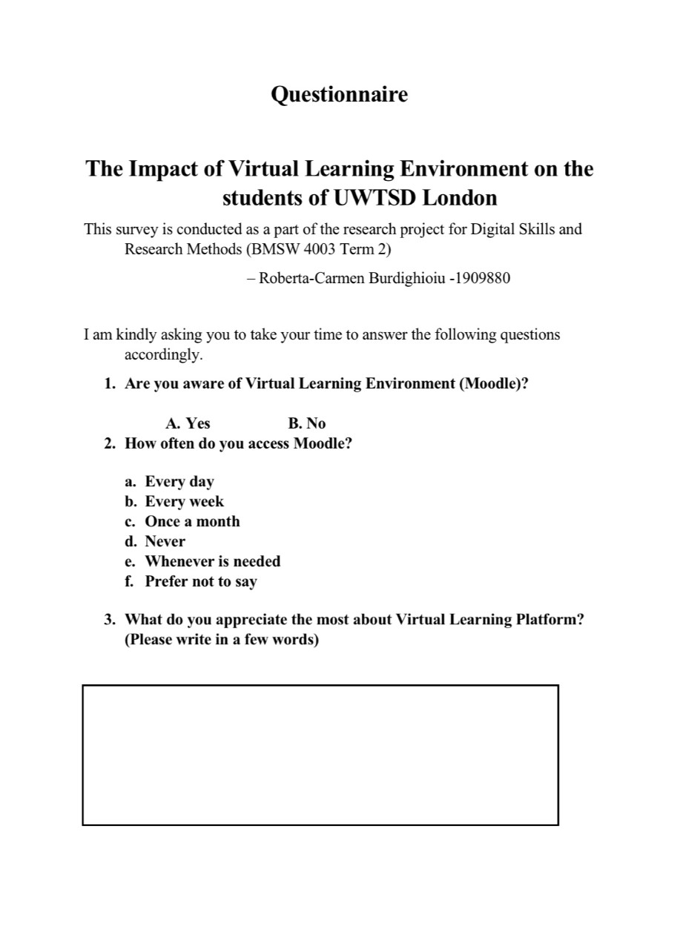
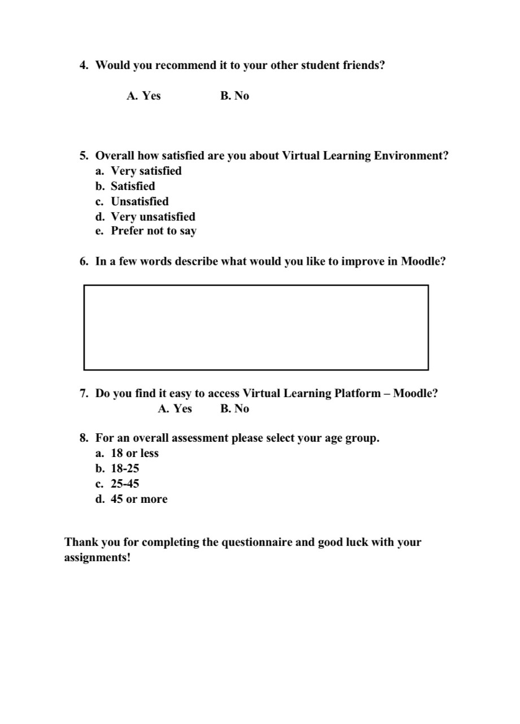

Appendix B


