Student Name: Corneliu-Bogdan Dan
Student ID: 2310378
Module: Project Management
Module code: LCBB6006
Assignment title: Assignment 1: Essay-Project Plan
Lecturer’s name: Md Ashikul Khan


Table of Contents
1. Introduction 3
2. Aim and Objectives of the Project: Scope of the Project 4
Table 1. SMART project objectives 4
3. Project deliverables 5
3.1 Store-readiness deliverables 5
3.2 Acceptance criteria and intended benefits. 5
Table 2. Main project deliverables 6
4. Project Activities and Work Breakdown Structure 6
Table 3. Work Breakdown Structure (WBS) 7
Table 4. RACI responsibility matrix 8
5. Project timeline and milestones 8
Table 5. Milestone and deliverable schedule 9
6. Stakeholder management 10
Table 6. Stakeholder power–interest and engagement plan 10
7. Resource planning 11
Table 7. Resource plan 11
8. Project monitoring and control 12
Table 8. Illustrative risk register 13
Table 9. Probability–impact risk matrix 14
9. Conclusion 15
Reference list 16

1. Introduction
Tesco PLC operates supermarkets, online channels, and convenience stores across the UK. Its 2025/26 results report sixty-five new UK Express stores, supporting the strategic relevance of the format (Tesco PLC, 2026a). This report evaluates a hypothetical Tesco Express opening in Birmingham; neither the site nor the investment has received Tesco approval. A refurbishment of an existing leased retail unit is assumed rather than a new-build scheme. This distinction matters because site condition, lease terms and customer demand must be verified before the proposed business case can be authorized (Tesco PLC, 2026c).
Project-management theory provides a rationale for treating this opening as a temporary change initiative rather than routine retail operations. Turner and Müller (2003) conceptualise projects as temporary organisations that coordinate resources and manage uncertainty. For Tesco, this requires the integration of property decisions, contractors, digital systems and staffing under a defined sponsor and handover process. However, delivery efficiency should not be equated with investment success. Shenhar et al. (2001) identify several dimensions of project success, including efficiency, customer impact, business performance and future capability. Completion within the agreed time and budget would demonstrate delivery performance, whereas customer satisfaction and financial returns can only be assessed after trading begins. The distinction matters because accelerating the opening could improve the schedule while creating defects or weakening longer-term customer outcomes. Consequently, project success must be defined through both operational acceptance criteria and a subsequent benefits review.
Although Tesco's convenience expansion supports strategic relevance, national performance cannot establish demand for an unspecified Birmingham unit. UK retail volumes rose 0.9% in the three months to August 2026 (ONS, 2026); nevertheless, local footfall, competition, rent, customer catchment and forecast contribution require site-specific testing. Birmingham's planning and retail context adds location-related uncertainty (Birmingham City Council, 2026). At the week-4 feasibility gate, the sponsor should assess discounted cash-flow forecasts and sensitivity to sales, rent and refurbishment costs before approving non-reversible commitments (Maylor and Turner, 2022).
The 32-week delivery baseline and £1.2 million cap are illustrative assignment assumptions, not Tesco estimates. A predictive lifecycle is appropriate for building works, statutory requirements and commissioning dependencies, while limited iterative reviews can improve layout and transaction-system testing. Joslin and Müller (2015) find that the relationship between project-management methodology and success depends partly on governance context, supporting a tailored rather than rigid approach. Fully agile delivery would offer flexibility but less certainty for physical procurement; exclusively sequential planning could neglect operational feedback (ISO, 2020; PMI, 2021).

2. Aim and Objectives of the Project: Scope of the Project
The aim is to deliver a compliant, operational Tesco Express in Birmingham by the end of week thirty-two, within the £1.2 million investment ceiling, subject to feasibility approval at the week-4 gate.
Success requires an approved site and business case by week four; fit-out by week 18; integrated payment, refrigeration, security, and network testing by week 23; approximately 25 full-time-equivalent colleagues recruited by week 24 and trained by week 26; opening stock verified by week 29; and final operational sign-off by week 31. The store must be registered as a food business at least 28 days before trading; registration is a statutory notification, not discretionary approval (Food Standards Agency, 2026). Any other necessary planning, building-control, licensing, and safety requirements will be confirmed during site due diligence.
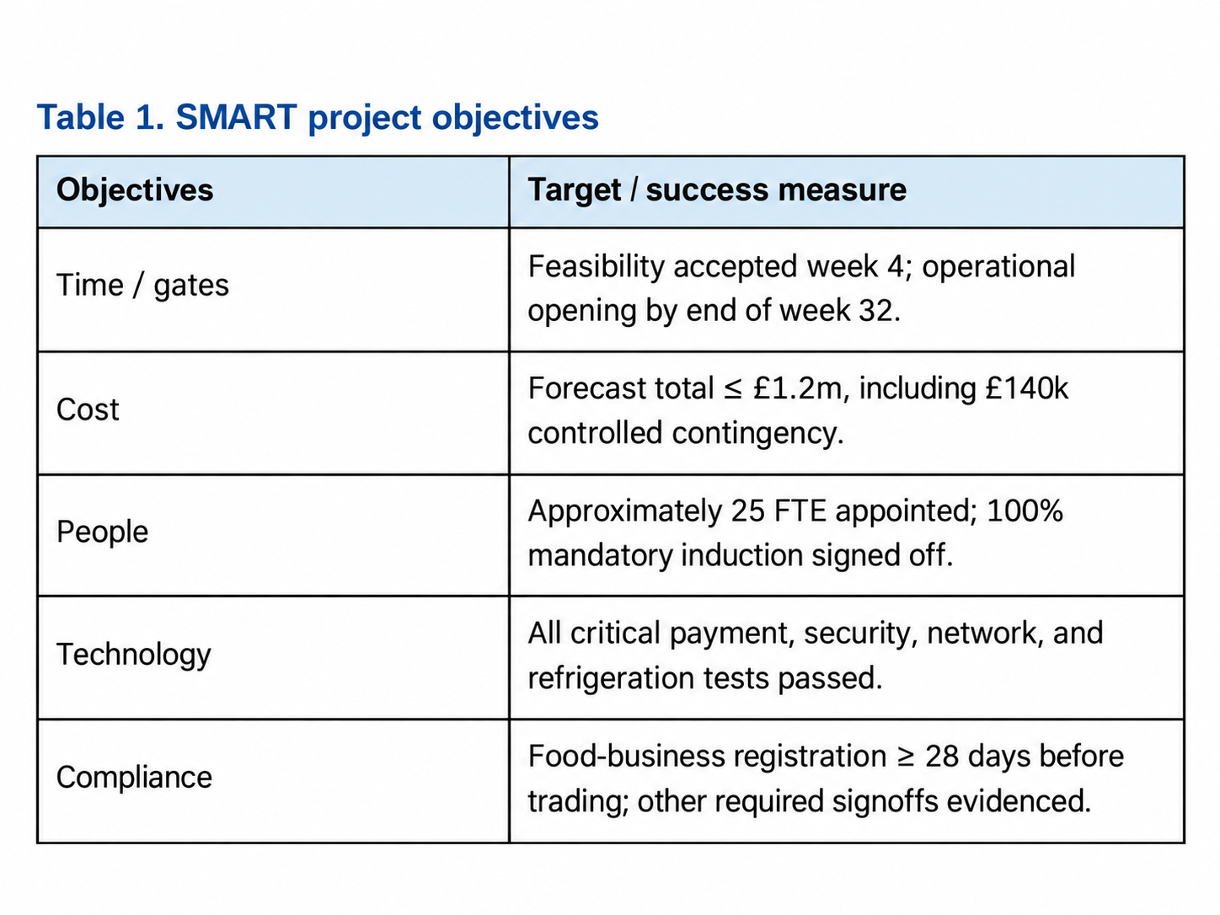
Table 1 establishes measurable acceptance criteria rather than simply listing activities.
Included work covers site surveys, lease and regulatory checks, design, procurement, refurbishment, fixtures, refrigeration, technology, staffing, stock, and launch. Exclusions are land purchase, major new-build works, distribution-centre expansion, and Tesco-wide platform changes. Operational trading and the four-week benefits review are transferred to store management after opening. These boundaries protect the cost baseline; however, exclusions do not eliminate interface risks, particularly where existing utilities or corporate systems are unsuitable (APM, 2025; Kerzner, 2022). Stakeholder mapping should include the property owner, council, contractors, store colleagues, residents, and suppliers. Their interests differ: a contractor may prioritise access and productivity, while residents may be concerned about deliveries, noise, and waste. Targeted engagement and documented responses are preferable to assuming a single communication approach meets all interests (Freeman, 2010).

3. Project deliverables

3.1 Store-readiness deliverables
The principal deliverable is a safe, legally compliant, staffed, and stocked convenience store capable of trading. Supporting outputs comprise an approved layout, refurbished premises, commissioned refrigeration, tested transactions and security systems, training records, reconciled opening stock and a signed handover pack. Table 2 specifies the evidence required for acceptance, preventing installation activity from being mistaken for operational readiness.

3.2 Acceptance criteria and intended benefits.
On-time, on-budget completion alone would not demonstrate investment success. Atkinson (1999) challenges reliance on the traditional cost–time–quality triangle; customer service, operating stability and commercial viability are also relevant. For example, installed tills are an output, whereas reliable transaction processing is a verifiable operational outcome. Future sales cannot credibly be claimed before trading, so a sponsor-approved benefits plan must specify measures, ownership, and a post-opening review (Too and Weaver, 2014; APM, 2025).
Sustainability will influence equipment decisions rather than function as an optional add-on. Tesco's 2035 net-zero ambition for its own operations reinforces the case for efficient refrigeration, lighting, and food-waste controls (Tesco PLC, 2026b; Tesco PLC, 2026d). The trade-off is higher initial expenditure against potentially lower whole-life costs; selection should be justified using life-cycle cost and commissioning evidence rather than environmental claims alone.
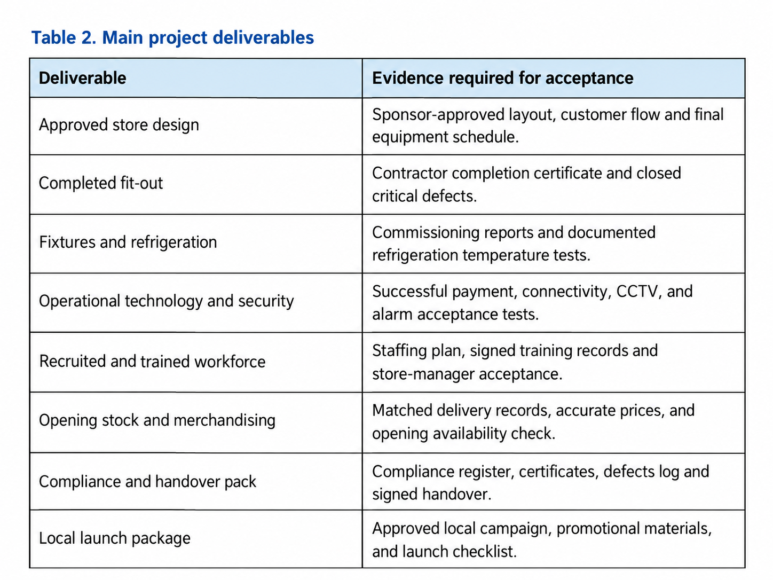

4. Project Activities and Work Breakdown Structure
A deliverable-oriented work breakdown structure (WBS) in Table 3 divides scope into eight controllable packages. This provides a basis for schedule, resource, and cost ownership, although decomposition alone does not reveal cross-package dependencies; the WBS must therefore be connected to the milestone plan and RACI assignments (PMI, 1994; PMI, 2008).
Initiation establishes the business case, sponsor, tolerances and risk and issue registers. Site/compliance work verifies surveys, lease conditions, utilities, and regulatory obligations. Design/fit-out then covers layout approval, contractor selection, refurbishment, refrigeration, and inspection. Procurement will favour clear specifications and staged acceptance, although fixed-price quotations cannot eliminate the risk of unforeseen building defects (Maylor and Turner, 2022).
Parallel packages cover network and payment systems; recruitment, induction, and rotas; opening orders and merchandising; and local marketing. The final package incorporates defect resolution, commissioning, readiness approval, handover, and closure. Overlap reduces elapsed time but increases coordination exposure: stock cannot be accepted into an insecure store, and refrigeration cannot be commissioned before adequate power is available (Larson and Gray, 2021).
Table 4 assigns one accountable role to each work package, separating sponsorship from daily delivery (Biesenthal and Wilden, 2014). Multiple responsible functions are permissible only when their tasks are clearly differentiated; otherwise, coordination delays can undermine the RACI's intended clarity. The store manager should be consulted on layout and readiness decisions so that technical completion does not displace operational usability (Turner, 2014).
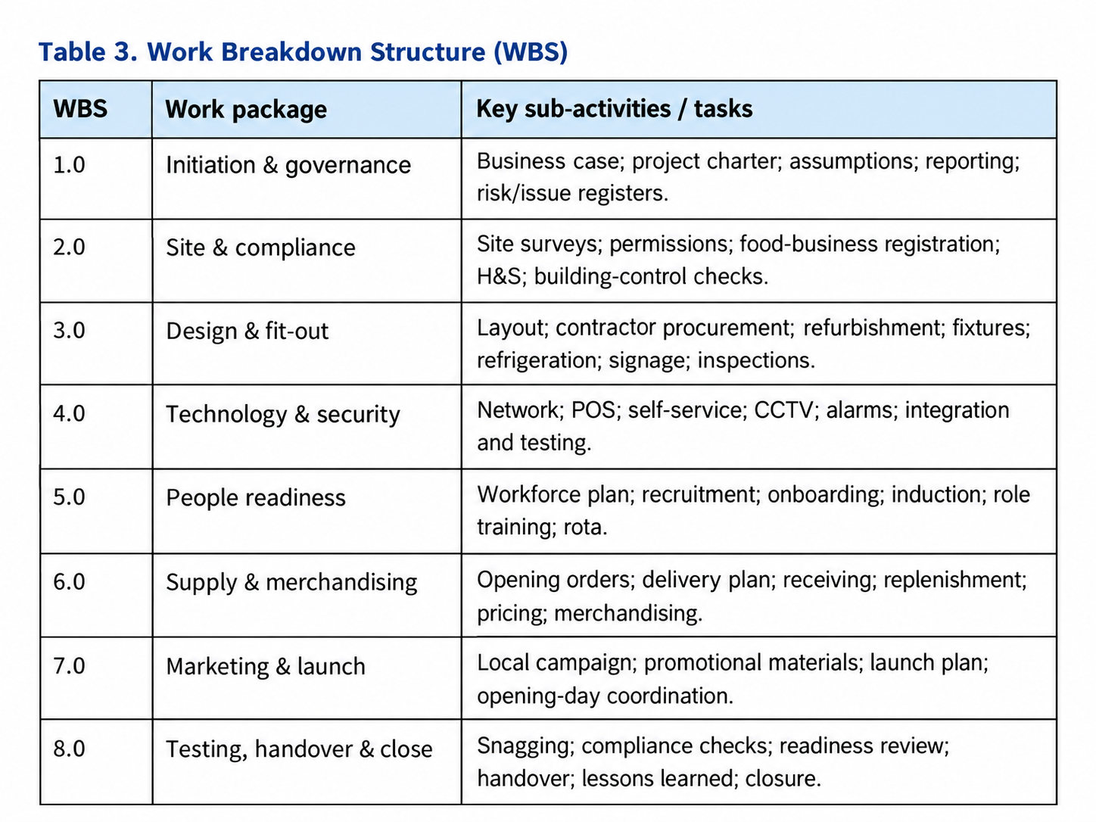

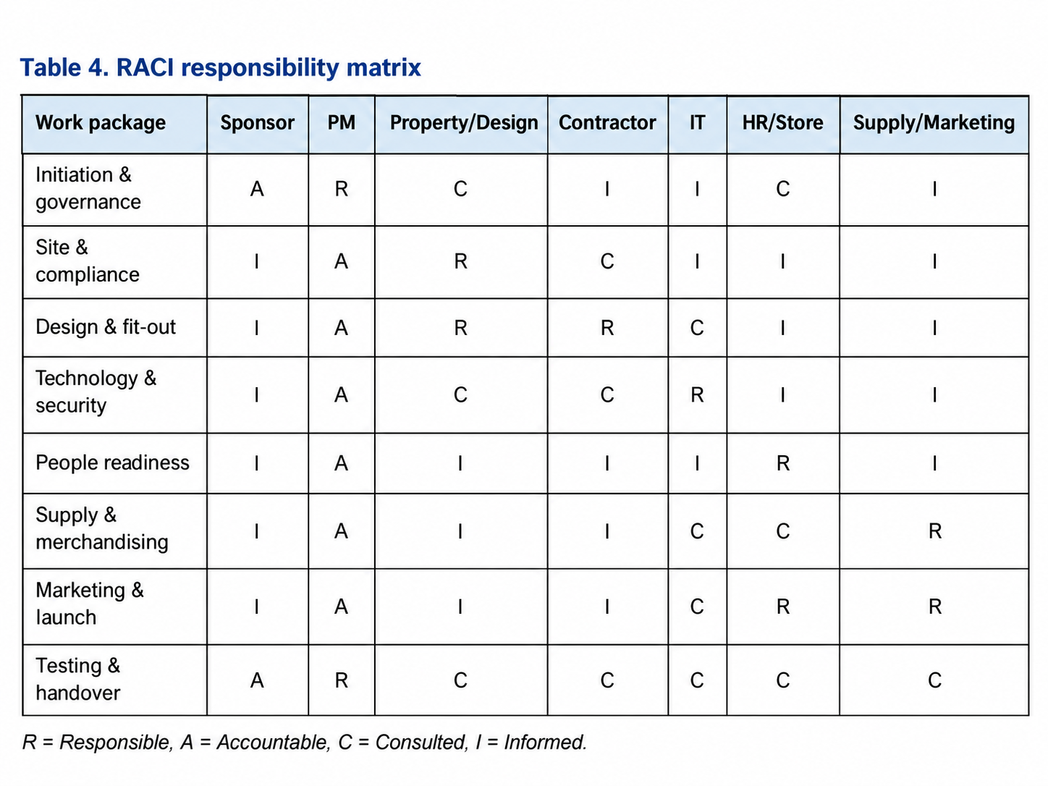

5. Project timeline and milestones
Figure 1 sets out the 32-week baseline. Feasibility and initiation take place in weeks 1–4, with design and procurement in weeks 3–8. Fit-out runs in weeks 7–18; technology installation and testing finish by week twenty-three. Recruitment, training, and stock preparation overlap later activities, followed by the readiness gate in week 31 and opening in week 32. Food-business registration is scheduled by week twenty-seven to maintain the minimum 28-day lead time. Work starting before week-4 approval is limited to reversible preparatory activity; material contractor commitments require sponsor release.
Milestones in Table 5 require objective evidence, not only elapsed time. The project will use stage gates at week 4 (business case), week 8 (design freeze), week 23 (systems acceptance) and week 31 (go-live readiness). A failed safety or transaction test prevents opening regardless of schedule pressure. This protects quality but exposes the possibility of a commercially costly delay, which must be weighed explicitly rather than concealed (PeopleCert, 2023a).
A Gantt chart illustrates timing but does not itself establish the critical path. The project manager must validate activity dependencies, float, and resource capacity, particularly for power, refrigeration, and payment integration. Where slippage occurs, resequencing independent work should be considered before overtime or acceleration, since recovery measures can raise cost, defect, and safety exposure (Larson and Gray, 2021; Kerzner, 2022).
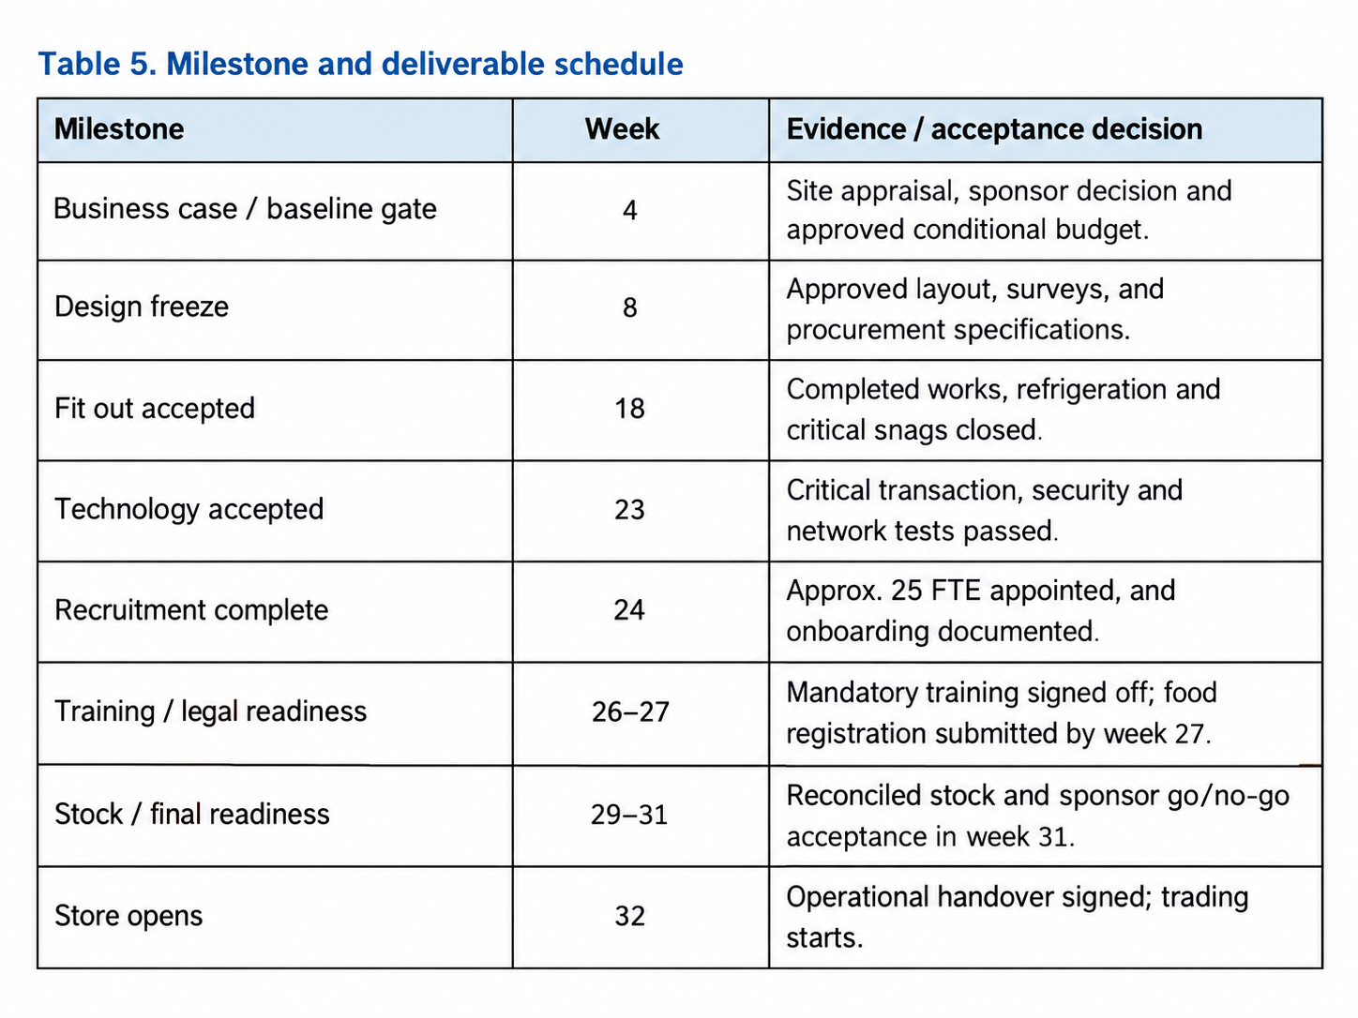

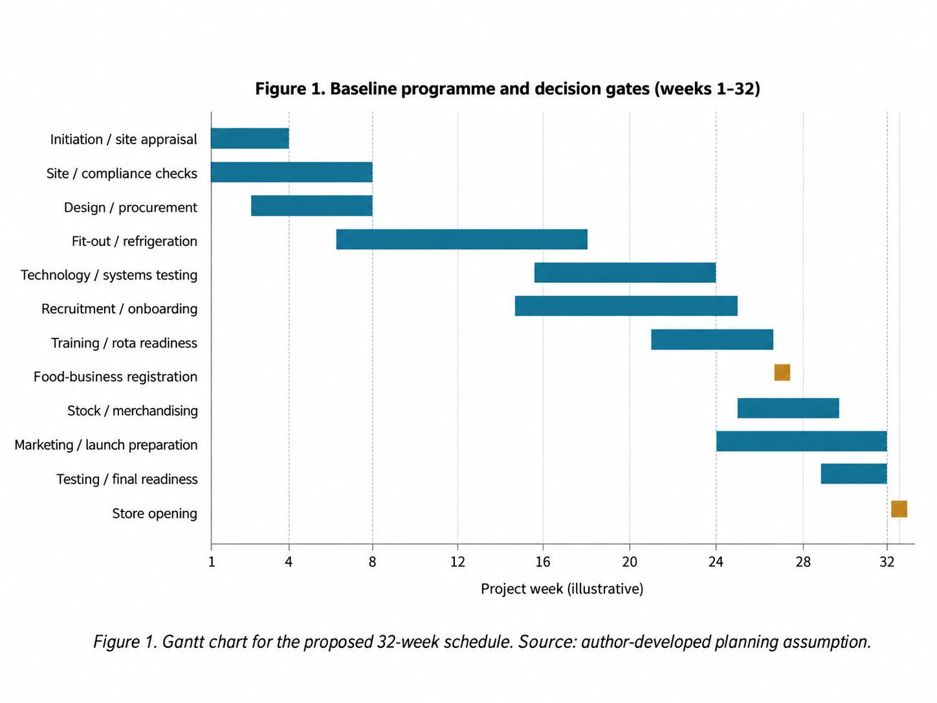

6. Stakeholder management
Stakeholder management must address influence and legitimacy, not merely broadcast progress. The power–interest assessment in Table 6 sets proportional engagement for decision-makers, delivery partners and affected communities (Freeman, 2010). The sponsor and property team need close management because they can authorise expenditure or constrain the site; residents have less formal power but can raise credible concerns about deliveries, access, and local disruption. Ratings are provisional: stakeholder influence should be reassessed after the site is identified. Communication will be evaluated through response times, unresolved concerns, and gate decisions—not simply meetings held. For instance, an earlier opening benefits the sponsor, whereas hurried fit-out may disadvantage colleagues and neighbors. The project manager must document such trade-offs and escalate stakeholder objections that threaten compliance, community acceptance or operational readiness (Freeman, 2010; Too and Weaver, 2014).
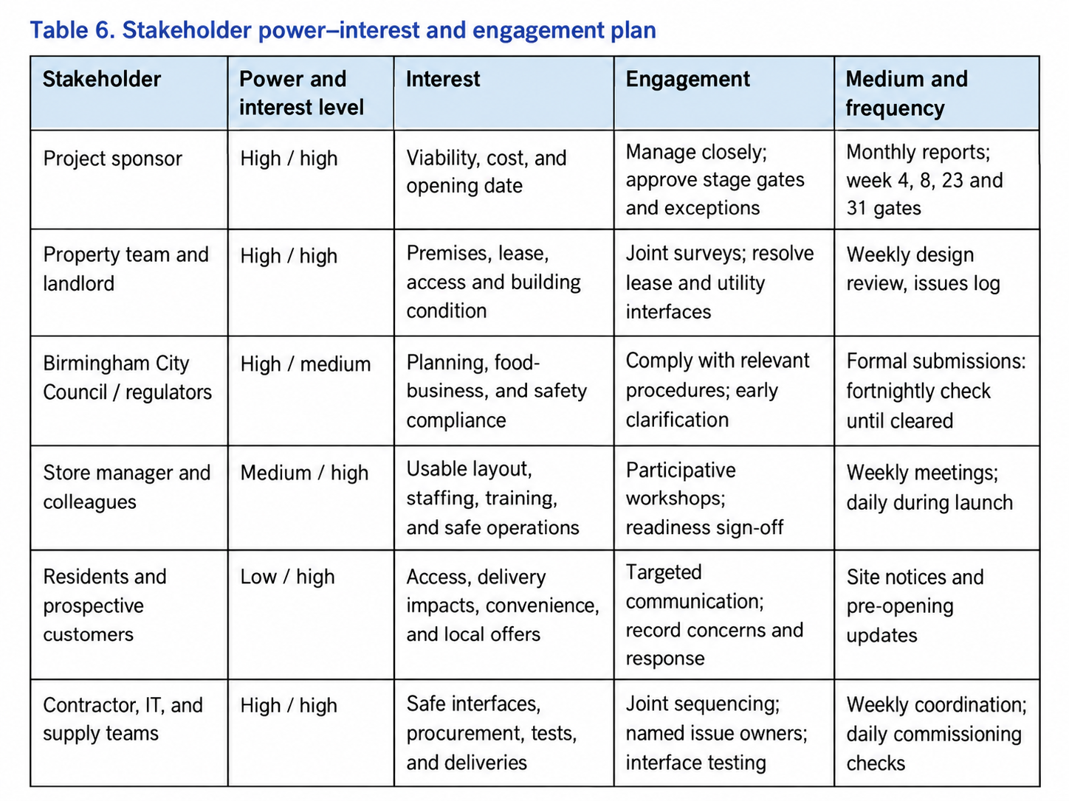

7. Resource planning
Core personnel include the sponsor, project manager, property and design leads, cost controller, contractor and trades, refrigeration specialists, IT/security technicians, HR and trainers, store manager, supply-chain personnel, and marketing support. Specialist inspection and certification tasks require appropriately qualified providers. Resourcing will be scheduled around access windows to prevent trade congestion.
Physical resources comprise fixtures, lighting, refrigeration, tills, self-service units, networking, CCTV, alarms, signage, opening stock and contractor facilities. An early utility-capacity survey is particularly important: late discovery of an electrical shortfall could affect several dependent packages simultaneously.
Figure 2 divides the illustrative £1.2 million cap into £1.06 million of planned categories and a sponsor-controlled £140,000 contingency (11.7%). It is not a Tesco cost benchmark. The cost controller will reconcile quotations, commitments and forecast completion costs, with contingency released only against documented uncertainty. Retail rent, recurring payroll and projected revenues require separate business-case analysis; they cannot be inferred from this delivery budget. Procurement should compare whole-life performance, not initial price alone, especially for refrigeration and lighting (Tesco PLC, 2026b).
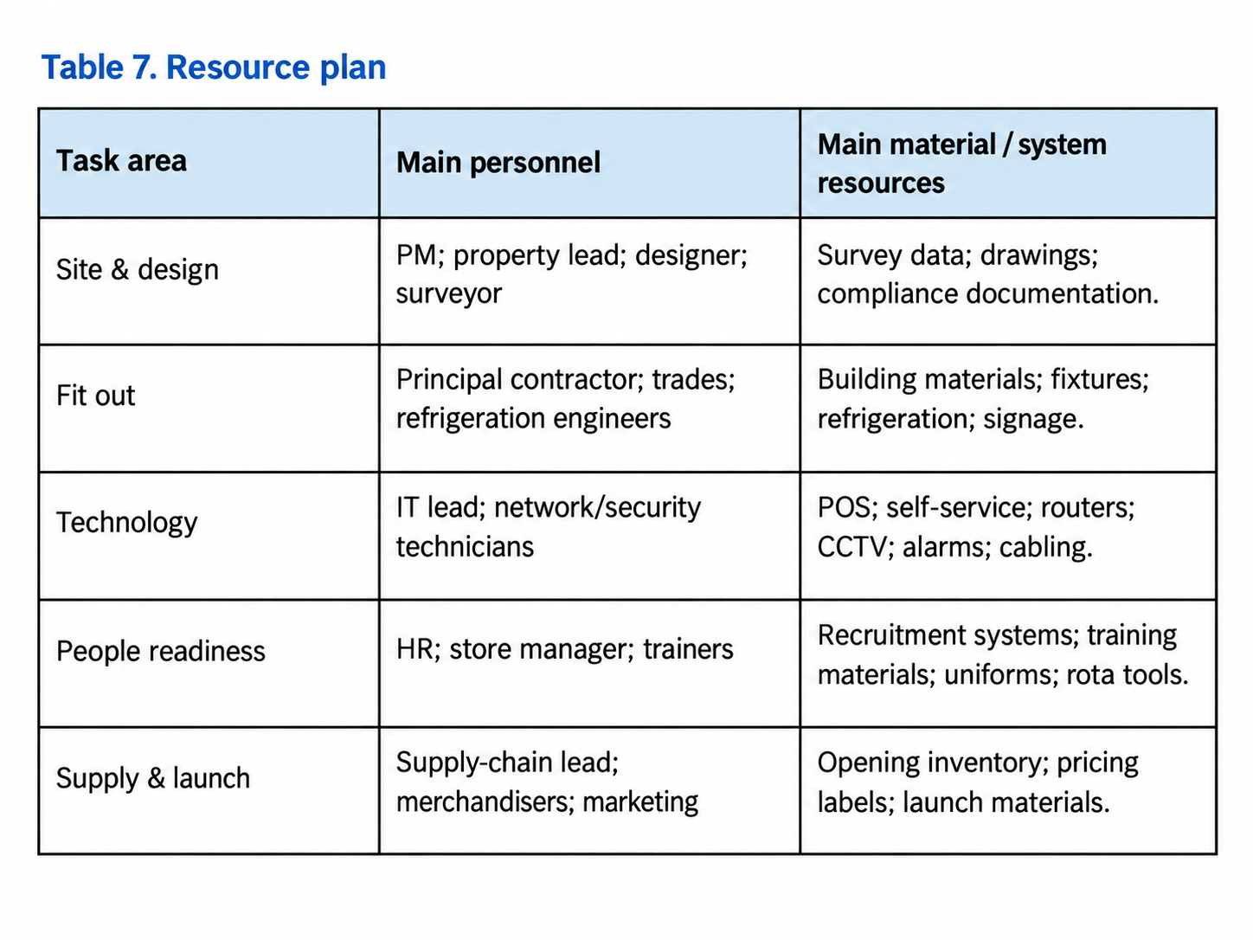
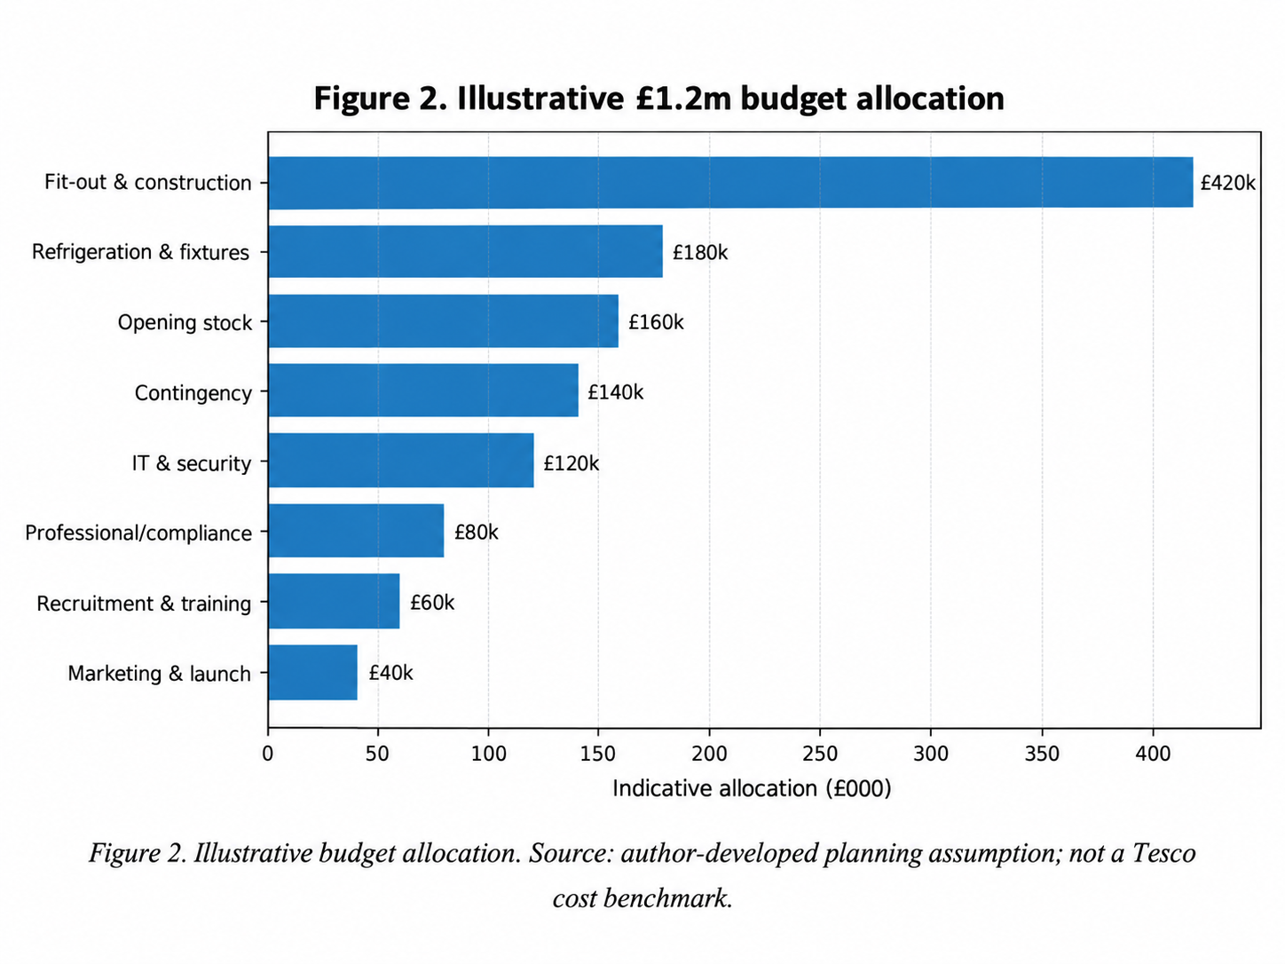

8. Project monitoring and control
Weekly control reviews will assess milestones, forecast costs, unresolved defects and risks through a red/amber/green dashboard. A forecast cost variance above 5% or a predicted critical-milestone delay of more than one week will trigger sponsor escalation; these are proposed thresholds, not Tesco policy. Unresolved statutory or life-safety failures require an immediate no-go decision. Tracking late procurement and incomplete tests alongside actual expenditure makes controls forward-looking (Too and Weaver, 2014; Maylor and Turner, 2022).
Schedule recovery will prioritise resequencing independent activities before costly acceleration. Cost reporting will distinguish expenditure, commitments and forecast completion costs. Formal quality gates require documented electrical, refrigeration, security and payment testing; critical defects must be closed before handover (Kerzner, 2022; APM, 2025).
The risk register (Table 8) assigns owners and ordinal probability–impact scores for weekly review. These ratings prioritise responses but do not quantify financial exposure (ISO, 2018; PMI, 2007). Premises defects and IT integration failures need early attention because they can delay multiple dependent work packages (Flyvbjerg and Budzier, 2011).
Risks are uncertain events; issues are problems already requiring action. Issue owners will record resolution dates and escalation routes. Material changes to scope, time or cost require a documented impact assessment and sponsor approval when delegated tolerances are exceeded. Approved changes must update the schedule, budget and risk register, without automatically treating every issue as a baseline change (PeopleCert, 2023b; PMI, 2008).
At handover, the project manager will reconcile costs, transfer remaining actions and capture lessons. Store management will own a four-week review of sales, service, availability and waste against agreed benefits, distinguishing delivery success from operating performance (Atkinson, 1999).
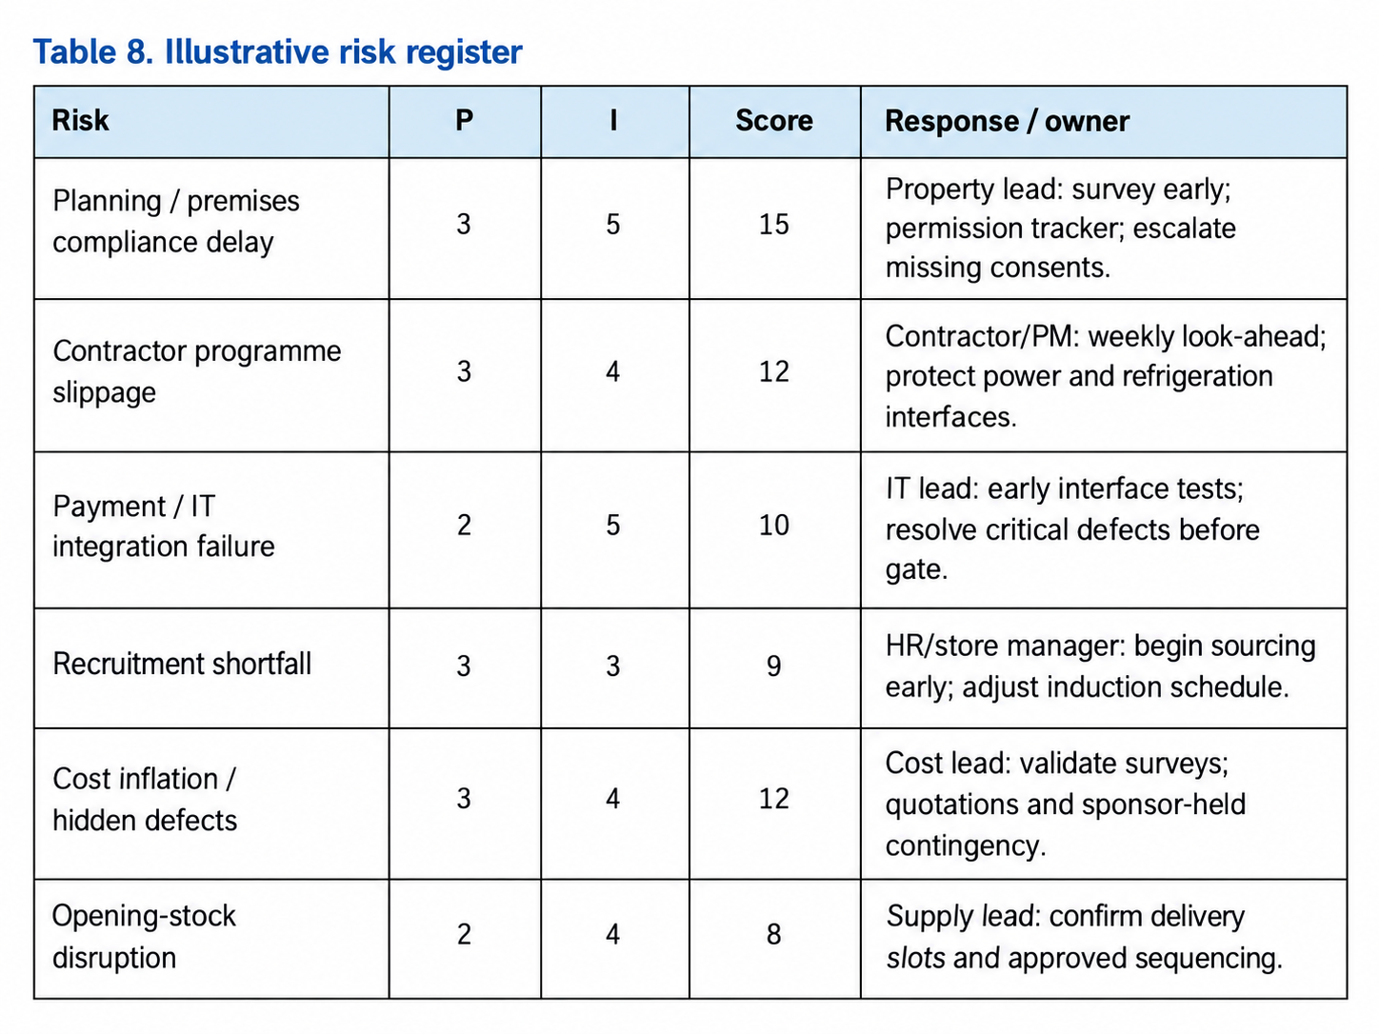
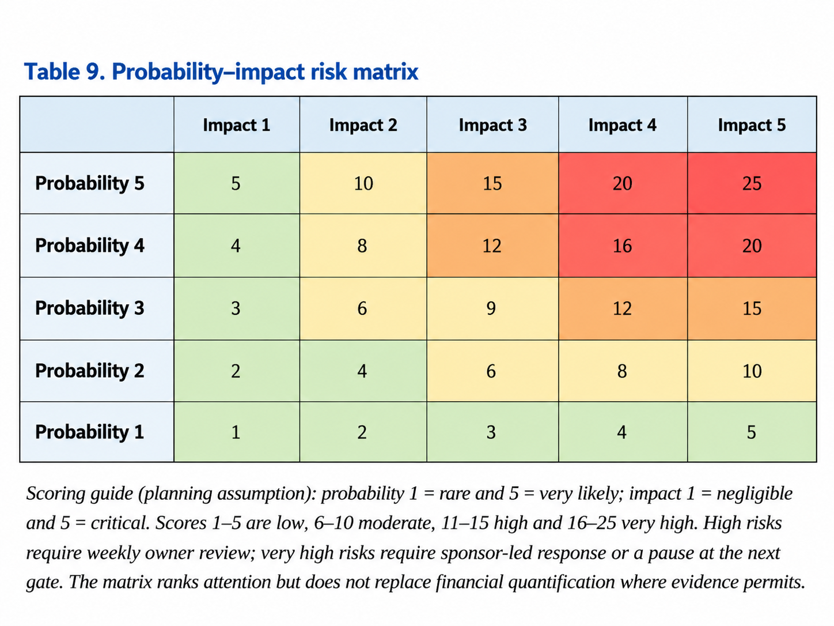

9. Conclusion
Tesco’s ongoing convenience-store expansion supports the strategic rationale for proposing a Birmingham Express, but it does not prove that an unspecified location would be commercially viable. The 32-week timescale and £1.2 million budget should therefore remain conditional planning assumptions. Before authorising substantial expenditure, Tesco should verify local demand, premises suitability, regulatory requirements, and financial returns under both expected and adverse scenarios.
The project plan offers a structured basis for delivery through the WBS, RACI matrix, Gantt baseline, stakeholder engagement and stage-gate controls. These tools clarify responsibilities and facilitate monitoring, yet their effectiveness depends on the accuracy of initial assumptions and coordination between workstreams. Premises defects, approval delays and technology failures could disrupt dependent activities. Accelerating construction to recover time might increase costs or undermine quality, meaning management should prioritise safety, compliance, and operational readiness over an inflexible opening date.
Overall, the project should proceed only if the initial feasibility assessment confirms an acceptable investment case and manageable risks. Its success should be measured not solely by completing the store in week 32, but also passing operational acceptance tests and reviewing benefits after four weeks of trading. This balances the traditional time, cost, and quality criteria with evidence of sustainable business value (Atkinson, 1999; APM, 2025).

Reference list
Association for Project Management (APM) (2025) APM Body of Knowledge. 8th edn. Princes Risborough: Association for Project Management.
Atkinson, R. (1999) ‘Project management: cost, time and quality, two best guesses and a phenomenon, its time to accept other success criteria’, International Journal of Project Management, 17(6), pp. 337–342. doi:10.1016/S0263-7863(98)00069-6.
Biesenthal, C. and Wilden, R. (2014) ‘multi-level project governance: trends and opportunities’, International Journal of Project Management, 32(8), pp. 1291–1308. doi: 10.1016/j.ijproman.2014.06.005.
Birmingham City Council (2026) New Local Plan for Birmingham. Available at: https://www.birmingham.gov.uk/BirminghamPlan (Accessed: 26 September 2026).
Flyvbjerg, B. and Budzier, A. (2011) ‘Why your IT project may be riskier than you think’, Harvard Business Review, 89(9), pp. 23-25.
Food Standards Agency (2026) Food business registration. GOV.UK. Available at: https://www.gov.uk/guidance/food-business-registration (Accessed: 26 September 2026).
Freeman, R.E. (2010) Strategic Management: A Stakeholder Approach. Cambridge: Cambridge University Press.
International Organization for Standardization (ISO) (2018) ISO 31000:2018 Risk management — Guidelines. Geneva: ISO.
International Organization for Standardization (ISO) (2020) ISO 21502:2020 Project, programme and portfolio management – Guidance on project management. Geneva: ISO.
Joslin, R. and Müller, R. (2015) ‘Relationships between a project management methodology and project success in different project governance contexts’, International Journal of Project Management, 33(6), pp. 1377–1392. doi:10.1016/j.ijproman.2015.03.005.
Kerzner, H. (2022) Project Management: A Systems Approach to Planning, Scheduling, and Controlling. 13th edn. Hoboken, NJ: Wiley.
Larson, E.W. and Gray, C.F. (2021) Project Management: The Managerial Process. 8th edn. New York: McGraw-Hill Education.
Maylor, H. and Turner, N. (2022) Project Management. 5th edn. Harlow: Pearson.
Office for National Statistics (ONS) (2026) Retail sales, Great Britain: August 2026. Available at: https://www.ons.gov.uk/businessindustryandtrade/retailindustry/bulletins/retailsales/august2026 (Accessed: 28 September 2026).
PeopleCert (2023a) PRINCE2 7 – A Process of Evolution. Available at: https://www.peoplecert.org/news-and-announcements/2023/PRINCE2%207%20-%20A%20Process%20of%20Evolution (Accessed: 28 September 2026).
PeopleCert (2023b) PRINCE2 7 Issues: Not every issue equals a change. Available at: https://www.peoplecert.org/news-and-announcements/2023/prince2-7-issues (Accessed: 28 September 2026).
Project Management Institute (PMI) (1994) ‘The WBS’, PM Network, 8(12), pp. 40-46.
Project Management Institute (PMI) (2007) Risk analysis and management. Available at: https://www.pmi.org/learning/library/risk-analysis-project-management-7070 (Accessed: 29 September 2026).
Project Management Institute (PMI) (2008) Applying work breakdown structure to project lifecycle. Available at: https://www.pmi.org/learning/library/applying-work-breakdown-structure-project-lifecycle-6979 (Accessed: 29 September 2026).
Project Management Institute (PMI) (2021) A Guide to the Project Management Body of Knowledge (PMBOK Guide) and The Standard for Project Management. 7th edn. Newtown Square, PA: PMI.
Shenhar, A.J., Dvir, D., Levy, O. and Maltz, A.C. (2001) ‘Project success: a multidimensional strategic concept’, Long Range Planning, 34(6), pp. 699–725. doi:10.1016/S0024-6301(01)00097-8.
Tesco PLC (2026a) Preliminary Results 2025/26. Available at: https://www.tescoplc.com/preliminary-results-202526 (Accessed: 30 September 2026).
Tesco PLC (2026b) Sustainability Report 2026. Available at: https://www.tescoplc.com/sustainability-report-2026 (Accessed: 02 October 2026).
Tesco PLC (2026c) Annual Report and Financial Statements 2026. Available at: https://www.tescoplc.com/investors/reports-results-and-presentations/annual-report-2026 (Accessed: 04 October 2026).
Tesco PLC (2026d) Planet. Available at: https://www.tescoplc.com/sustainability/planet/ (Accessed: 04 October 2026).
Too, E.G. and Weaver, P. (2014) ‘The management of project management: a conceptual framework for project governance’, International Journal of Project Management, 32(8), pp. 1382–1394.Available at: https://www.sciencedirect.com/science/article/pii/S026378631300094X / (Accessed: 04 October 2026).
Turner, J.R. and Müller, R. (2003) ‘On the nature of the project as a temporary organization’, International Journal of Project Management, 21(1), pp. 1–8. doi:10.1016/S0263-7863(02)00020-0.
Turner, J.R. (2014) Handbook of Project-Based Management. 4th edn. New York: McGraw-Hill Education.

