HOW I CAN USE THE DIKW AND CRAAP FRAMEWORKS TO CONFIRM OR REFUTE MY COLLECTED
ACADEMIC GRIT TEST RESULT (PRIMARY DATA) COMPARED TO THE UWTSD GRIT RESULT
(SECONDARY DATA) BASED ON THE WORK OF ANGELA DUCKWORTH TED TALK LECTURE

Module name: Digital Skills and Research Methods ( BMSW4003)
• Lecturer name: Md Nazmul Hasan
• Student name: Alexandru Dragomir
- Student ID 2107400


Executive Summary
This assignment includes discussion on the GRIT model, UWSTD GRIT model and along with the frameworks of DIKW and the CRAAP test for analyzing them. Different segments are there in analyzing the primary and secondary data.

Table of Contents
Introduction 4
Assignment 7
Introduction 7
Duckworth and CRAAP Test 7
GRIT survey, assumptions, and Calculations 8
Explanation of the components of the DIKW model 10
Application of the DIKW model 11
Explanation of the findings 12
Conclusion 13
References 14

Introduction
There are different parameters for measuring different aspects oriented with the higher education of the UK. These parameters aid in measuring the performance of the students as well as the higher educational institutions. The Academic Grit Scores provide the chance of analyzing the performance of an individual towards the academic goal the individual is set to achieve. The measurement of this score provides with the chance of understanding the characteristics of the individual towards the academics such as their determination, their focus, and many more. According to the provided pieces of information, the Academic GRIT score has been analyzed. This analysis includes three different aspects as Mean, Median, and Mod.
Mean | 3.8321428571429
Median | 3.9
Mode | 4,3.4
Table 1: GRIT score of primary data files
(Source: Self-created)
The GRIT score in table 1 shows the three aspects of the score that are the Mean, Median, and Mod. These are the score recorded for an individual. The analysis of these scores will provide an idea about the performance of the individual in their academics.
Mean | 3.5714285714286
Median | 3
Mode | 4
Table 2: Highest levels of the primary data set
(Source: Self-created)
Table 2 shows the highest level of score attained by the average individuals attaining for the GRIT analysis. The comparison of these scores provides an idea about the performance of the first individual and if the individual would pass or not (Schmidt et al. 2017).
There is another system that prevails for ensuring that the current and future graduates are provided with an idea about the market trends that the graduates are facing after they complete their education. This system is known as the UWTSD GRIT. This is basically the feedback taken by the University of Wales from their graduates 15 months after they pass out from the University. The university communicates with the students and takes their feedback about various career aspects. These inputs of the past students are marked on the basis of the GRIT system. These scores then are used for various purposes. Firstly, these scores provide the present and future students in analyzing the condition of the students after graduation (Mutawah et al. 2018). Moreover, this survey conducted including the pass out students also comprises of national importance as the inputs from the students aid various parties such as the Makers of the Policies, the organizations oriented with charity, as well as various researchers and reporters seeking information about the market of labor available in the UK for the graduates along with current state of the higher education system of the UK.
Mean | 3.5413450292398
Median | 3.6
Mode | 3.8
Table 3: GRIT score of secondary data files
(Source: Self-created)
These scores are also comprised of the three components of GRIT such as the Mean, Median, and Mode. This is the GRIT score of a graduate who passed out from the University of Wales and the feedback has been taken after 15 months time from the passing out phase.
Mean | 3.2982456140351
Median | 3
Mode | 3
Table 4: Highest levels of the secondary data set
(Source: Self-created)
This is the highest level of the average score that is gained by the feedbacks of the students. This score provides an idea about the condition of the labor market prevailing in the UK for the graduates (McClendon et al. 2017). Moreover, the comparison of tables 3 and 4 provides an idea about the present condition of the career of the individual whose score is provided int he table number 3. It is found that the students with more GRIT scores have more success in their life. So, from the analysis of tables 3 and 4, it can be said that the individual whose score is taken, is very successful in the career as the score is higher than the average score.

Assignment

Introduction
There are different opinions oriented with the measurement of the level of determination of the individuals pursuing the goals of their academic careers. While the GRIT model which was developed by Angela Duckworth provides the idea about the persistence of a student after a setback faced by the student. This signifies the determination of the student in making improvements in academics in order to overcome the setback. On the other hand, there is also Dwek’s Growth model. According to the opinion of Dwek, the individuals think that their performance is set and they cannot perform better than their provided capabilities. So, these people don’t strive for improving their academic performances (Buskirk et al. 2019).

Duckworth and CRAAP Test
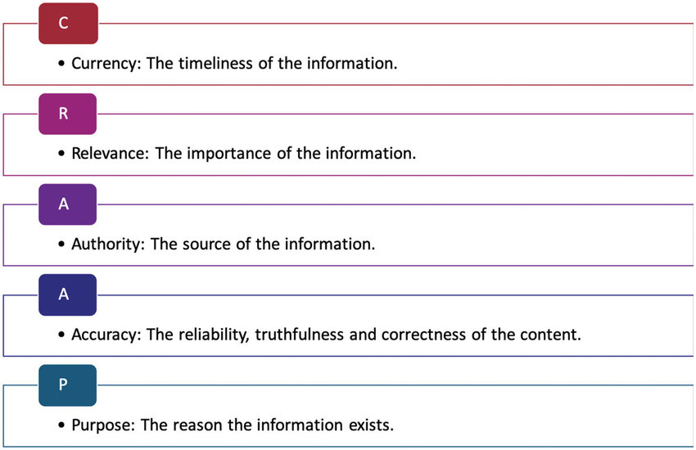
Figure 1: CRAAP test components
(Source: Researchgate.net, 2021)
The GRIT method by Duckworth is analyzed using the CRAAP test.
Currency
The model of GRIT was explained by Angela Duckworth in the year 2013. So, it can be said that the model is currently due to its origin in the recent past.
Relevance
The model is very much relevant to the measurement of the determination of the individuals in their academics. The GRIT scores provide the idea about the performance of the individuals in their academics and show their perseverance towards achieving their goals (Sigmundsson et al. 2020).
Accuracy
This model is very much accurate as it accurately measures the effort made by an individual towards the goals the individual wants to achieve in their academics.
Authority
The author of the model is Angela Duckworth, who is oriented with teaching and the University of Pennsylvania.
Purpose
The purpose of the formation of the GRIT model is to perform an analysis on the academics of the individuals of higher education in the UK and understand the efforts being made by them towards improving their academic scores (Sigmundsson et al. 2020).
So, it can be said that the “Duckworth Passes CRAAP Test”.

GRIT survey, assumptions, and Calculations
GRIT survey model
The GRIT survey model includes the GRIT scale. There are 10 questions designed by Angela Duckworth in order to analyze the determination and performance of the students. The score is given according to the chosen answers by the individuals. The scores are set by the developer according to the different questions. Analyzing the score of the questions the performance and determination of the individuals are measured. This model provides the information of setting goals and according to the goals the efforts made by the individuals are measured (Park et al. 2018).
DIKW model

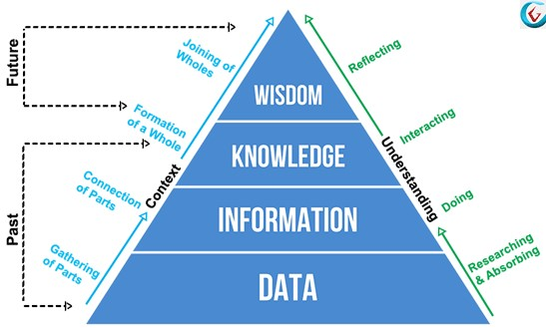
Figure 2: DIKW Framework
(Source: Certguidance.com, 2021).
Explanation
This is an important model of managing knowledge within an organization. The data at the time of its collection is collected in the form of jumbled-up data. The DIKW model provides the way in which the gathered data can be made useful by turning them into pieces of information, knowledge, as well as wisdom. The components of this model are Data, Information, Knowledge, and Wisdom.
There are two perspectives of viewing the DIKW model. These are the Contextual concept and Understanding Perspective.
Contextual Concept
According to this concept of the DIKW model and the data is transformed in the manner of moving through the phases of
- Gathering the parts of the data (DATA)
- Making a connection between the raw data (INFORMATION)
- From the raw data the meaningful matters are developed (KNOWLEDGE)
Then those meaningful mattes are joined together in order to form the contents with meaning (WISDOM) (Hein et al. 2019).
Understanding Perspective
Another perspective existing of viewing the DIKW pyramid is that a process starts with the following steps
- Performing Research and absorbing the data
- Doing things
- Interacting with others
- Reflecting the results.
Moreover, this DIKW pyramid can also be described using the parameter of time. Such as the components of Data, information, as well as knowledge is considered to be the past. On the other hand, wisdom is considered to be the future (Zisman and Ganzach, 2021).

Explanation of the components of the DIKW model
DATA
The base of the DIKW pyramid is the Data as the data is collected at the first stage of any process in order to gather insights about something. The data collected initially consists of large amount of data that are not formatted and consists of many not so useful data along with them. These data are collected from various sources while looking for some core information about something. These data are required to be processed in order to make use of them and avoid facing hurdles to find meaningful pieces of information.
INFORMATION
These are the core data that are the result of processing and filtering the gathered data. The not so useful data are removed and only the components of data that are related are kept. This provides the chance of utilizing concise pieces of information that are relevant (Barriopedro et al. 2018). These pieces of information consist of meaning as these are related to the purpose of gathering the data. These pieces of information are further processed to get to the phase of knowledge.
KNOWLEDGE
This component comprises the compilation of the related pieces of information with each other. After processing the pieces of information further all the pieces of information that are related is put together in order to form meaning out of them and align them under a single stream. These provide useful information about the objective of the process. The knowledge provides answers to all the questions that are asked and the knowledge is applied to perform a process.
WISDOM
This is the final part of the model, and this stage is reached by analyzing the knowledge in order to get to the final results. These are the most useful insights about the process which enables the user is running the process efficiently (Pretorius et al. 2019).

Application of the DIKW model
On the GRIT data (Primary data)
Data
Data is the GRIT score collected about the academic performance of the students studying in the higher education sector in the UK. This includes the data of all the students and different types of data are included altogether.
Information
These are the purified data that are gained by processing the gathered data by the GRIT model. The data after processing data are separated according to various specifications such as different streams, and other characteristics. These are the raw information about the academic performance of the students (Yusof et al. 2018).
Knowledge
These are the collection of the related pieces of information gathered from processing the information in the previous part. These provide insights into the determination and performance of the individuals.
Wisdom
This is the final insight about the determination of all the students and the capabilities of the higher education system of the UK.
On the UWTSD GRIT (Secondary Data)
The data collected from the UWSTD GRIT analysis can be processed in the same manner as the GRIT scores explained in the previous part. By processing these data collected from the survey possess the wisdom of getting insights into the job market for the graduates in the market of UK can be understood. This will provide the new and future students with the idea about the employment opportunities prevailing in the UK after their graduation.

Explanation of the findings
The findings of the assignment provide an idea about the frameworks of DIKW and CRAAP in analyzing the GRIT as well as the UWSTD GRIT scores. The above discussion states the appropriateness of the two following frameworks in analyzing the scores of these two types (Duan et al. 2018).

Conclusion
This assignment includes a discussion on the concepts of GRIT, UWSTD GRIT, DIKW MODEL, & CRAAP MODEL. Moreover, thorough the detailed discussion of the frameworks of analysis the appropriateness of the models in analyzing the scores is also explained. Through the implementation of these tools, the determination, perseverance, and performance of the individuals oriented with the higher education can be performed efficiently. Moreover, the UWSTD GRIT also provides insights into the job availability for the graduates in the UK after the completion of their Graduation. This assignment will help various students in analyzing their GRIT scores as well as getting information about their future endeavors after the completion of their graduation in the UK.

References
Journals
Al-Mutawah, M.A. and Fateel, M.J., 2018. Students' Achievement in Math and Science: How Grit and Attitudes Influence?. International Education Studies, 11(2), pp.97-105.
Barriopedro, M.I., Quintana, I. and Ruiz, L.M., 2018. La perseverancia y pasión en la consecución de objetivos: Validación española de la Escala Grit de Duckworth. RICYDE. Revista Internacional de Ciencias del Deporte, 14(54), pp.297-308.
Buskirk-Cohen, A.A. and Plants, A., 2019. Caring about Success: Students' Perceptions of Professors' Caring Matters More than Grit. International Journal of Teaching and Learning in Higher Education, 31(1), pp.108-114.
Duan, Y., Zhan, L., Zhang, X. and Zhang, Y., 2018, November. Formalizing DIKW architecture for modeling security and privacy as typed resources. In International Conference on Testbeds and Research Infrastructures (pp. 157-168). Springer, Cham.
Hein, V., Kalajas-Tilga, H., Koka, A., Raudsepp, L. and Tilga, H., 2019. How grit is related to objectively measured moderate-to-vigorous physical activity in school student. Montenegrin Journal of Sports Science and Medicine, 8(2), pp.47-53.
McClendon, C., Neugebauer, R.M. and King, A., 2017. Grit, Growth Mindset, and Deliberate Practice in Online Learning. Journal of Instructional Research, 8, pp.8-17.
Park, D., Yu, A., Baelen, R.N., Tsukayama, E. and Duckworth, A.L., 2018. Fostering grit: Perceived school goal-structure predicts growth in grit and grades. Contemporary Educational Psychology, 55, pp.120-128.
Pretorius, J.G., Mathews, M.J., Maré, P., Kleingeld, M. and Van Rensburg, J., 2019. Implementing a DIKW model on a deep mine cooling system. International Journal of Mining Science and Technology, 29(2), pp.319-326.
Schmidt, F.T., Fleckenstein, J., Retelsdorf, J., Eskreis-Winkler, L. and Möller, J., 2017. Measuring grit. European Journal of Psychological Assessment.
Sigmundsson, H., Clemente, F.M. and Loftesnes, J.M., 2020. Passion, grit and mindset in football players. New Ideas in Psychology, 59, p.100797.
Sigmundsson, H., Haga, M. and Hermundsdottir, F., 2020. Passion, grit and mindset in young adults: Exploring the relationship and gender differences. New Ideas in Psychology, 59, p.100795.
Yusof, W.S.E.Y.W., Zakaria, O. and Zainol, Z., 2018. DIKW application on knowledge based framework with situational awareness. International Journal of Academic Research in Business and Social Sciences, 8(6), pp.1110-1120.
Zisman, C. and Ganzach, Y., 2021. In a representative sample grit has a negligible effect on educational and economic success compared to intelligence. Social Psychological and Personality Science, 12(3), pp.296-303.

Website
certguidance.com, (2021). DIKW Model: Explaining the DIKW Pyramid or DIKW Hierarchy
News Available at: https://www.certguidance.com/explaining-dikw-hierarchy/#:~:text=DIKW%20Model%20is%20an%20essential,be%20organized%20within%20the%20organization.&text=DIKW%20Model%20describes%20how%20the,information%2C%20knowledge%2C%20and%20wisdom. [Accessed on 21st July,2021]

