

Information Systems Improvement

Student Name: Ioan Stefan Madaras
Student Number:2332801
Lecturer Name: Ameer Kareem
Module code: LCLM 5004
Module Name: Managing Business Information

Table of Contents
1. Introduction 3
2. Evaluation of Existing Systems 3
2.1 Analysis of the Current Information Systems in Place 3
2.2 Identification of Inefficiencies and Gaps 4
3. Recommended Solution 5
3.1 Proposal of a Suitable New Information System 5
3.2 Justification Based on Business Needs, Efficiency, Cost, and Scalability 5
3.3 How the System Will Improve Operations, Data Management, and Decision-Making 6
4. Implementation Plan 6
4.1 Steps for Implementing the New System 6
4.2 Training, Integration with Existing Infrastructure, and Potential Challenges 7
5. Conclusion 8
References 8

1. Introduction
The AKPerog Ltd. is a consumer electronics retail company that has potential growth and operates 30 brick-and-mortar stores and an online-based shopping service. In the last year, the company has had high growth in sales, and it currently seeks to grow its business. Nevertheless, even with this expansion, the company has serious operational issues as it is experiencing old and inefficient information systems. The manual inventory management system is the primary issue that frequently leads to discrepancies between the stock that is in the store and online. This results in cancelled orders, customer complaints, and lost money. Lack of a Customer Relationship Management (CRM) system is another significant problem, where the customer data is consumed by numerous disconnected systems, and it becomes hard to trace the purchase history or provide personalised service. Besides, there is slowness and inaccuracy in reporting and decision-making due to the manual preparation of sales data in spreadsheets. Another threat to the company is the absence of complete compliance with the GDPR, which threatens the safety of customer data. Lastly, the departments do not have a proper system integration, which results in errors, delays, and ineffectiveness within the business. All these problems have direct implications on customer satisfaction, the performance of the operations within the company, and its capability to compete successfully in the new retail world.

2. Evaluation of Existing Systems

2.1 Analysis of the Current Information Systems in Place
AKPerog Ltd. has a mixture of manual systems as well as individual digital systems to run this business. The manual system of tracking inventory is an important system that is applied in all the physical locations. Stock data is updated by employees with no real-time information linking to the web store. Consequently, the inventory data can be outdated and inaccurate (Wulan et al., 2024). In customer management, AKPerog Ltd. uses dishonored databases of customers. These various systems do not connect and store customer information, purchase history, and complaints. This makes it challenging to see the entire client data at a go, or to trace the long-term purchasing behaviours. The sales and performance tracking is also done using spreadsheet-based reporting in the company. The sales are manually recorded in spreadsheets by the workers using various sources of sales data. They are submitted to the management to be read and taken as a decision (Vhatkar et al., 2024). Moreover, the sales, finance, and inventory teams at the AKPerog Ltd. are not integrated with the use of separate software. These systems fail to communicate automatically, and the workers will have to transfer information manually across departments, which makes them more work-intensive, resulting in low efficiency.

2.2 Identification of Inefficiencies and Gaps
There are some significant weaknesses and loopholes in the systems currently at the AKPerog Ltd.

Figure 1: Operational Inefficiencies Overview
Manual Inventory Discrepancies: The problem with using the manual inventory system is that it will lead to discrepancies in stocks between the physical stores and the online platform (Ursic and Cater, 2025). This leads to cancellation of online orders, customer grievances, and refund expenses.
Overstocking and Understocking Issues: Another challenge facing store managers is overstocking and understocking, which results in lost sales and the use of storage space.
Lack of an Integrated CRM System: Another gap is the absence of an integrated CRM system. Since the purchasing information is distributed in a non-connected system, the business has no alternative but to identify the history of purchase, customer preferences, and implement individualised promotional activities (Tuli and Kaluvakuri, 2022). This makes customer relationships weak and makes promotional activities less successful.
Inefficient Spreadsheet-Based Reporting: Reporting by use of a spreadsheet introduces delays and mistakes in decision-making. The data is not complete, incorrect, or outdated by the time it reaches the management, since the data has to be entered manually. This will make leaders fail in analysing real-time sales trends and make them lack in forecasting and opportunities.
Security and GDPR Compliance Risks: Security and compliance lapses are also very severe. The existing systems do not have appropriate access control systems, which leaves customer information at risk of access by unauthorised personnel and cyber-attacks (Svensson and Thoss, 2021). Moreover, the company is not entirely adherent to the GDPR regulations, which may result in legal fines and reputation losses.
Lack of Departmental System Integration: Lastly, there is a lack of inter-departmental system integration that leads to data entry redundancy, communication breakdown, and delays (Tan et al., 2024). This causes a decrease in the overall productivity and the probability of expensive mistakes in business.

3. Recommended Solution

3.1 Proposal of a Suitable New Information System
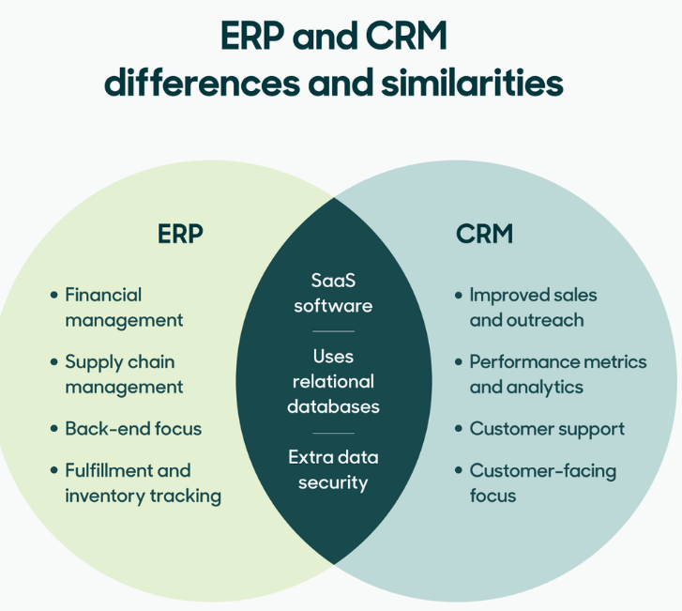
Figure 2: ERP and CRM systems
Source: (Boppana, 2023)
To solve the operational issue that AKPerog Ltd. experiences, the company should adopt a fully integrated Enterprise Resource Planning (ERP) system, along with an Integrated Customer Relationship Management (CRM) system and an inventory and reporting platform utilising cloud technologies. An appropriate solution would involve Microsoft Dynamics 365, SAP Business One, or Oracle NetSuite because these programs include all-in-one business management solutions (Svensson and Thoss, 2021). The system to be proposed will offer inventory management, sales, finance, customer data, and reporting processes into one central database. The suggested system is a cloud-based system to ensure that real-time data is accessed across all 30 physical stores and the e-commerce platform simultaneously. This will enable AKPerog Ltd. to run its operations similarly and effectively (Rohmah and Komarudin, 2023). Also, mobile connectivity will be enabled on the system to allow store management and top executives to make decisions much faster and monitor operations onsite.

3.2 Justification Based on Business Needs, Efficiency, Cost, and Scalability
The suggested system is a direct response to the core business requirements of AKPerog Ltd.
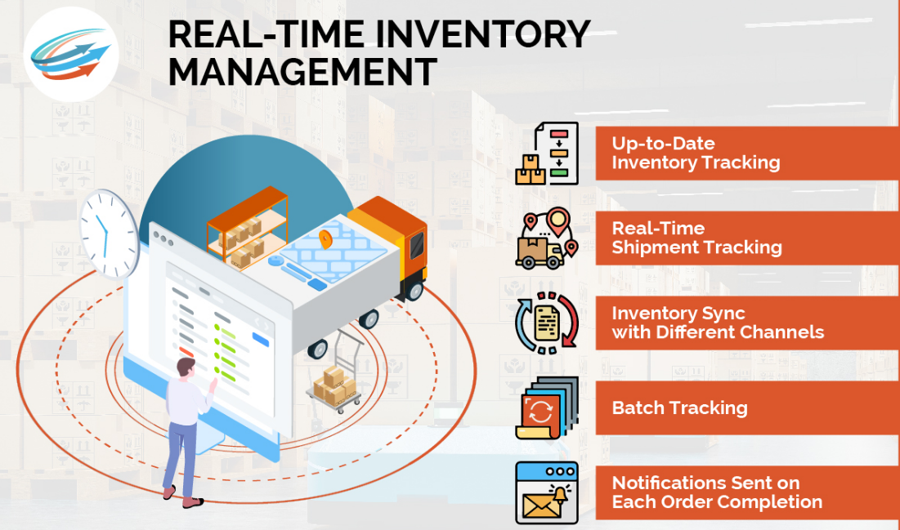
Figure 3: real-time inventory monitoring system
Source: (Pohludka and Stverkova, 2019)
Business Needs: The Company needs a real-time inventory monitoring system, proper customer information, quicker reports, and a high level of data protection to sustain its fierce growth and expansion strategies.
Operational Efficiency: When it comes to efficiency, the ERP and CRM systems will automate the numerous manual operations of updating the stock records, sales updates, and customer records. This will minimise human mistakes, conserve the time of the employees, and increase productivity (Pohludka and Stverkova, 2019). Procurement and supplier management will also be automated, and lead time will be minimized, and the replacement cycles of stocks will be enhanced.
Cost and Return on Investment (ROI): On cost and return on investment (ROI), an investor will have to pay a high initial cost of implementation, but the benefits will be huge when considered in the long run. Reduced inventory losses, fewer cancellations of orders, enhanced customer retention, and improved decision-making will enhance profitability.
Scalability and Cloud-Based Advantages: Cloud-based solutions also mean that no costly on-site servers and IT repair are required (Madamidola et al., 2024). Further, cloud pricing by subscriptions gives financial freedom, hence AKPerog Ltd. is able to spread the cost over time without investing heavily in terms of capital. The system has easy scaling capabilities regarding future growth. Improved system flexibility can easily include new users and destinations as AKPerog Ltd. opens new stores or extends its online sales.
Hence, this solution is relevant to the present operations as well as long-term growth (Kumari and Gaikwad, 2025). The ERP systems available are also modular and can add other features like advanced analytics, artificial intelligence, and supply chain optimisation as the business expands.

3.3 How the System Will Improve Operations, Data Management, and Decision-Making
New system can enhance the accuracy of inventory, and it will allow reporting real-time stock levels in both physical stores and the online platform. This will minimise refunds, not oversell, and increase order fulfilment. The integrated CRM system will enhance customer care and personalisation. The entire customer information, the purchase history, complaints, and data will be located in a single place, and the marketing team will carry out intensive promotions, and the support team will address the concerns more effectively (Boppana, 2023). Automated dashboards and real-time analytics will also make the process of reporting and making decisions faster and more precise. The management will have access to reliable data about sales trends and performance, as well as the prediction of demand (Svensson and Thoss, 2021). Encrypted role-based access, cloud storage and secure authentication can enhance the system data security and follow GDPR rules. This will ensure that customer data is not accessed unauthorised and minimise legal risks (Tuli and Kaluvakuri, 2022). Lastly, a complete departmental integration will mean eliminating the manual transfer of data. The same system will have sales, finance, and inventory teams working under the same system, which will help it to communicate, be precise, and run even faster. Such an integrated data environment will also enable strategic planning, which is based on evidence and long-term business sustainability.

4. Implementation Plan

4.1 Steps for Implementing the New System
Introduction of the suggested ERP, CRM, and cloud-based inventory at AKPerog Ltd. would be undertaken in a formatted and gradual system to minimize operational hazards.

Figure 4: ERP–CRM Implementation Process
Step 1.1: System Selection: The initial phase will be the selection of the system, and the company will consider using the appropriate vendors, which include Microsoft Dynamics 365, SAP Business One, or Oracle NetSuite (Ursic and Cater, 2025). It should be chosen according to the needs of the business, their prices, scalability, security features, and compatibility with the current e-commerce platform.
Step 1.2: Data Migration: The second phase is the data migration. All the information that is available in the manual records, spreadsheets, or disconnected customer databases should be manually cleaned, verified, and moved into the new system (Vhatkar et al., 2024). It is recommended to use data validation processes to eliminate duplication and end up with accurate information. This will ensure a proper beginning of inventory, sales, and customer information.
Step 1.3: System Integration: The third stage will be system integration. The new ERP and CRM system will need all to be connected with the online sales platform, online payment systems, and in-store point-of-sale systems. This will enable real-time exchange of the data in all 30 stores and e-commerce.
Step 1.4: Testing and Go-Live Implementation: Lastly, when the integration is done, the system will transition into testing and go-live. On a small scale, a pilot test can be performed in a few stores, and then rollout can be implemented (Wulan et al., 2024). The testing must identify any technical issues or errors in the data, which should be fixed prior to the launch of the system into the company. Once the testing is successful, the system can be launched in all the departments.

4.2 Training, Integration with Existing Infrastructure, and Potential Challenges
Successful implementation is dependent on the training of employees. The sales, inventory, finance, marketing, and customer service staff should obtain direct training through workshops and online learning solutions. Members of the organization must be assigned super users within the various departments to offer continuity (Vhatkar et al., 2024). The new system should also be well integrated with the current infrastructure, such as the e-commerce website, barcode scanners, and payment intermediaries. The cloud technology will also decrease the costs of hardware upgrades at the store level. It has various possible challenges of implementation (Tan et al., 2024). The initial high cost of ERP and CRM systems is controlled by installing payments that are paid in stages and proper budgeting. Regular communication, ensuring the benefits are explained to the employees, and training them regularly are some ways through which resistance to change by the employees can be lowered. System downtime should be minimized during transition, and it can be achieved through the system implementation in off-peak business hours and using both old and new systems at the same time in the short term. High data security protection and GDPR compliance must be followed in the implementation process. To minimize cybersecurity threats, customer information must be secured through role-based access, an encrypted cloud storage, and routine system backups (Tuli and Kaluvakuri, 2022). An implementation strategy must be well planned as it will help AKPerog Ltd. In experiencing a smooth transition to the modern information systems.

5. Conclusion
In conclusion, this report has analyzed the prevalent operational issues AKPerog Ltd. has experienced because it operates on old and ineffective information systems. The analysis of current practices showed the following significant shortcomings in the manual inventory control, lack of customer data integration, reliance on spreadsheets in reporting, insufficient GDPR integration, and the lack of interdepartmental integration. Such failures have led to wrong stocking, failure to make timely decisions, poor security of data, and poor customer satisfaction. To avoid these problems, the introduction of an integrated ERP system, a CRM platform, and cloud-based inventory and reports tools has been suggested. The solution can solve operational and strategic requirements of the organisation since it allows seeing the real-time data, automating processes, enabling enhanced security measures, and expansion subsequently. It is expected that the recommended system will lead to a better accuracy of stocks, reduced order errors and cancellations, improved customer service by better data management and customization, as well as the provision of managers with timely and reliable reports that would allow them to make sufficient decisions. Moreover, the disruption and risk will be minimized by the systematic implementation strategy that would encompass the system picking, data movement, integration, testing, personnel training, and change management.

References
Boppana, V. R. (2023). AI Integration in CRM Systems for Personalized Customer Experiences. Available at SSRN 4987149.
Kumari, A., and Gaikwad, K. K. (2025). Data carriers for real-time tracking and monitoring in smart, intelligent packaging applications: A technological review. Next Materials, 8, 100591.
Madamidola, O. A., Daramola, O. A., Akintola, K. G., and Adeboje, O. T. (2024). A Review of existing inventory management systems. International Journal of Research in Engineering and Science (IJRES), 12(9), 40-50.
Pohludka, M., and Štverková, H. (2019). The best practice of CRM implementation for small-and medium-sized enterprises. Administrative Sciences, 9(1), 22.
Rohmah, N., and Komarudin, K. (2023). Digital transformation in business operations management. American Journal of Economic and Management Business (AJEMB), 2(9), 330-336.
Svensson, A., and Thoss, A. (2021). Risk factors when implementing ERP systems in small companies. Information, 12(11), 478.
Tan, Y., Gu, L., Xu, S., and Li, M. (2024). Supply Chain Inventory Management from the Perspective of “Cloud Supply Chain”—A Data Driven Approach. Mathematics, 12(4), 573.
Tuli, F. A., and Kaluvakuri, S. (2022). Implementation of ERP systems in organizational settings: enhancing operational efficiency and productivity. Asian Business Review, 12(3), 89-96.
Uršič, D., and Čater, T. (2025). Digital innovation in management and business: A comprehensive review, multi-level framework, and future research agenda. Journal of Business Research, 197, 115475.
Vhatkar, M. S., Raut, R. D., Gokhale, R., Kumar, M., Akarte, M., and Ghoshal, S. (2024). Leveraging digital technology in retailing business: Unboxing synergy between omnichannel retail adoption and sustainable retail performance. Journal of Retailing and Consumer Services, 81, 104047.
Wulan, T. S., Novika, P. W., Nurvianti, E., and Putra, F. A. (2024). Impact of ERP System Implementation on Operational and Financial Efficiency in Manufacturing Industry. Journal of Economic Education and Entrepreneurship Studies, 5(3), 491-501.

