

MODULE CODE: ECAD5013

STUDENT NAME: Millie Brace

STUDENT NUMBER: 2304293

AI Acknowledgement

I confirm that I have not used any AI tools in the research and creation of this assignment.
I confirm that I have not presented any AI generated materials as my own work.
I confirm that I have copies of my drafts, notes, and other resources I used, which I may be asked to provide in evidence.

Targets from my previous assignment

Target | How I have addressed it in this work
Please check your use of the apostrophe in places. | Throughout
Avoid using contractions in academic work. | Throughout

Create a community profile for your PTE1 school. Using relevant literature, suggest ways in which the school could make use of its location and community to support pupil learning.

Introduction:
School A is a small community primary school within a deprived area of South Wales, with its community recognised within 10% of the most deprived in Wales (Estyn, 2024). 47.9% of children are eligible for free school meals compared to the national average of 23.7%, and 48.1% of pupils have been identified as having an additional learning need (ALN) which is over triple the national average of 13.2% (Estyn, 2024). Approximately 30% of pupils come from the local Gypsy Traveller community, and many pupils face barriers to learning involving poor housing, health issues and child protection concerns (Estyn, 2024).
The focus of this project is to engage School A’s pupils, community, and carers in supporting the social, emotional, and mental health (SEMH) of students through sport, specifically hockey. SEMH refers to a person's ability to understand and manage emotions, build positive relationships, cope with everyday challenges, and engage in learning and community life (Cornwall Council, 2024). A Censuswide survey of 1,005 UK primary and secondary school teachers in 2024 reported that 74% of teachers believe that poor mental health support for pupils is negatively impacting pupils' ability to learn (YoungMinds, n.d). Participation in sports can promote skills in pupils which support their SEMH and learning, including confidence, reduced social anxiety, communication, and self-control (Hiremath, 2019). Restoring and maintaining children’s mental health can be identified as a key priority of communities and societies, as SEMH can influence an individual's ability to earn a living, communicate, ability to contribute to their community (Banerjee et al, 2016).
Literature Review:
Children from lower-income areas are more likely to have witnessed crime and violence, potentially increasing SEMH challenges, which can be mitigated by participation in sport (Nelson, Spurr & Bally, 2022). Structured sport initiatives supervised and instructed by an adult can help socially vulnerable children develop cognitive, emotional and life skills, such as improved self-worth, goal setting, conflict resolution and empathy, (Hermens et al, 2017). The Well-being of Future Generations Act of 2015 outlines the value of a society that maximises mental and physical well-being, to encourage safe, cohesive, and well-connected communities (Future Generations Commissioner for Wales, n.d.). Though, while pupils from disadvantaged areas could be at greater risk of SEMH issues, they may be less able to participate in sport due to lack of opportunities, poorly maintained or unsafe community spaces and facilities, and limited parental support (Nelson, Spurr & Bally, 2022). Therefore, school-based clubs can be beneficial to pupils in disadvantaged areas as they may be less likely to have similar opportunities elsewhere, supporting pupils and parents in feeling more connected to their school community and utilising a secure environment with familiar staff (Early Years Resources, 2024).
According to biopsychosocial theory, a person's behaviour and emotional well-being are a product of their physical make-up, natural abilities, and contexts, such as ALN and social contexts including school and family (Carroll & Hurry, 2016). The Biopsychosocial Model of Mental Health (See Appendix 1) shows how the collective interaction of factors may positively or negatively affect a person's mental health across different elements of life (Cardoso, 2024). Therefore, from a biopsychosocial perspective, creating social and emotional provisions at schools could be extremely valuable for pupils in deprived areas possibly experiencing issues including poverty and inconsistent family support (Carroll & Hurry, 2016). Bronfrenbrenner agreed that a child’s development is a consequence of their surrounding environment and how the individual interacts with it (Bronfrenbrenner, 1979). Bronfrenbrenner argued that there are five systems revolving around the individual (See Appendix 2). The most immediate and influential being the microsystem, consisting of the child's immediate environments such as family, communities, and school (Bronfrenbrenner, 1979). The interrelated nature of these systems suggests that support or challenges faced in one area could then influence a child’s well-being or development in another system (Hayes, Toole, Halpenny, 2017). However, Bronfrenbrenner’s theory could be criticised as it fails to emphasise the influence of personality and other internal processes which can contribute to how an individual responds to their environment (Boulanger, 2016).
Participation in sports, especially in teams, can reduce social anxiety by encouraging the development of social skills, possibly preventing difficulties with social interaction from later developing into social anxiety disorder (Dimech & Seiler, 2011). Organised sport activities can allow pupils to form high-quality peer relationships, with clear rules and structured interactions which encourage learning through peer modelling, potentially increasing pupil’s self-esteem (Smith, 2003). Bandura’s Social Learning Theory agrees with this ideology, suggesting that individuals develop and learn behaviours by imitating and observing those around them, which may enhance pupil interactions (Bandura, 1977). Increased participation in team sport can have a positive relationship with children’s emotional well-being, as playing and interacting with other children can develop co-operative relationships that promote a sense of belonging (Donaldson & Ronan, 2006). Belonging can have a significantly positive impact on children’s well-being and their psychological functioning, including life satisfaction, academic achievement, and physical health (Allen & Bowles, 2012). Schools can be highly influential in creating social opportunities and networks for pupils, to increase feelings of belonging amongst peers and within the school community, so that they feel valued and supported socially and academically (Allen & Bowles, 2012).
Donaldson’s Successful Futures Report in 2015 highlighted the need for schools to promote the mental and physical well-being of children, recognising pupils’ emotional and physical requirements to promote self-reliance and independence in the learning process (Donaldson, 2015). One of the four purposes driving the Welsh curriculum identifies supporting pupils in becoming healthy and confident individuals, appropriately equipped with the mindset and skills to contribute positively to their community and wider society and lead a fulfilling life (Welsh Government, 2022). The importance of pupils’ health and well-being is further recognised as a fundamental component of the Welsh curriculum, reflected in one of the six areas of learning and experience (AOLE), focusing on developing pupils physical and SEMH so that they can navigate life’s challenges and opportunities (Welsh Government, 2020). A statement of what matters within this AOLE emphasises that physical health and well-being encourages the development of confident, informed, and positive behaviours from pupils, which show respect for themselves and others (Welsh Government, 2022).
Project Aims:
This project proposes the use of a weekly after-school mixed-gender hockey club for year 5 & 6 pupils from School A, aiming to promote positive pupil SEMH. The proposed club will be held on a Friday for one hour after school. School attendance decreases significantly on a Friday, despite school initiatives like reward assemblies. This is due to the school’s asymmetric timetable whereby pupils leave school at 12:00 instead of the usual 15:30, therefore some parents choose to not send their children to school. Operating the hockey club Fridays could increase attendance for year 5 and 6 pupils on a Friday, and potentially equate to less staffing issues, as some staff members must stay at the school to supervise the children who remain on-site after 12:00 for the KS2 after-school club.
One aim of this project is to support pupils with social skills and development. Appropriately structured sports activities, such as the proposed hockey club, can offer experiences that encourage pupils to develop psychosocial skills needed to become high-functioning and productive members of society (Kendellen & Camiré, 2019). Psychosocial skills, including emotional control, can be valuable skills learned through sports to allow individuals to succeed in other areas of life (Kendellen & Camiré, 2019). Playing hockey may support pupils with psychosocial skills including teamwork, communication, and empathy as well as the ability to recognise when they need to self-regulate by understanding how their emotions, behaviour, and reactions impact those around them (England Hockey, n.d). Sports can enhance pupils’ self-regulatory behaviours including impulse control, motivation, being able to adapt to new information and resisting distractions that are not relevant to their tasks (Howard, Vella & Cliff, 2018). These self-regulation skills can enable pupils to control their behaviours and reactions during social reactions despite contradictory urges or distractions, which can improve academic attainment and reduce frustrations associated with challenges encountered in life or learning (Howard, Vella & Cliff, 2018). The collaborative nature of the game may also promote positive pupil relationships, which can make individuals feel more valued and increase pupil well-being (Donaldson & Ronan, 2006). Bandura’s Social Learning Theory suggests that team environments, such as a hockey team, can also help expose pupils to positive behaviours, which can then be observed, imitated and understood, which may further support social development (Bandura, 1977). It is possible that this increase in social skills and the team building inspired by hockey may also increase the quality of peer relationships and friendship, which can promote well-being, by increasing pupils' ability to cope with stress, improving self-esteem, and reducing feelings of loneliness and depression (Holder & Coleman, 2015). However, the extent of the social benefits for pupils may be limited by the quality of coaching, how sessions are structured, and the sporting environment pupils are operating in, as without a safe environment with support, empathy and respect for all pupils may experience exclusion or negative peer interactions that undermine the intended outcomes (Kahn, Bailey & Jones 2019). This suggests that staff responsible for the hockey club should be appropriately trained in leading sports groups and creating inclusive environments that advocate positive behaviour, promoting social and emotional benefits for all pupils involved in the club (Kahn, Bailey & Jones 2019). However, this may impact staffing options for the club and perhaps increase the cost of its implementation as staff may require training.
Finally, another aim of the proposed hockey club is to provide pupils with a new extracurricular opportunity which they may not have access to otherwise due to boundaries linked to financial difficulties or lack of opportunity (Nelson, Spurr & Bally, 2022). The Gypsy Traveller pupils at School A may also have less access to sporting clubs due to decreased confidence in joining due to issues such as bullying or racism outside of the school community (Welsh Government, 2023). Therefore, the lack of cost and inclusive nature of the proposed hockey club may expose pupils to new opportunities and support them in recognising article 28 and 29 of their rights, which state all children have the right to equal education and opportunities to reach their full potential (UNICEF, n.d). This may also aid carers, especially in deprived areas like School A’s, as they may be able to work more hours without childcare costs, potentially reducing financial stress and making carers feel more supported by the school community (Corban, 2022). To further expose pupils to opportunities associated with hockey the club could also host a masterclass session led by a local hockey player who has represented Wales as a captain and is offering free sessions to local schools sharing her experiences and expertise. Inviting an experienced and knowledgeable guest to work with the pupils could increase pupils' awareness of pathways within sports and increase pupil motivation (Frommert, 2025).
Measuring Impact:
One method that could be used to measure the impact of the hockey club on pupils’ SEMH is pupil voice, where pupils are asked questions and invited to give their own opinions on the club's effectiveness (See Appendix 3). Estyn agrees that listening to learners can be a valuable element of good practice, ensuring that schools' approaches to supporting pupils, including extracurricular activities, are reflective and responsive to the needs of pupils (Estyn, 2020). The Curriculum for Wales strongly advocates the use of pupil voice and putting students at the centre of decision marking, to shape learning experiences in recognition of varying pupil contexts and learning requirements (Welsh Government, 2020). Actively involving pupils in assessment and reflections on learning can build positive relationships between educators and pupils and help all pupils to progress (Welsh Government, 2024). Children can be rich in knowledge regarding their experiences and the impact they have on how they think and feel better than an adult observing (Littlefair, Jopling & Kelly, 2024). Therefore, it can be argued that pupils' perspectives can be extremely valuable in measuring the impact of interventions such as the proposed hockey club. Fielding supports this view, identifying pupils as partners of school improvement, and that pupils should have a say in educational practices used by their school to promote effectiveness (Fielding, 2024).
The impact of the hockey club could also be measured using observations and monitoring of pupil's attitudes, behaviour, and attendance. Monitoring pupil development in an area of learning in a continuous process and using informal assessments, including observations and discussions, can allow educators to identify and target areas of difficulties in pupil progression (Mathew & Poehner, 2014). For example, if a group of children were struggling to communicate as a team the member of staff could focus a session on teamwork and collaboration skills to facilitate progress. This can be identified as formative assessment, whereby the educator has gathered information regarding where pupils are in their learning which has been used to inform further teaching to support learners (Boyle & Charles, 2018). Wiliam supports the idea that assessments are crucial to good teaching and learning as, despite the planning process behind episodes of learning, educators cannot predict what pupils will understand and take away (Wiliam, 2018). Formative assessments could also be supported with the use of tracking systems, to identify how pupils are progressing individually over the course of their participation in the hockey club. School A has an existing system whereby they colour code pupil progress with a specific skill with red indicating a pupil is struggling, amber to show the skill is developing but requires more practise and green meaning the pupil is displaying the skill confidently and independently (See Appendix 4). This can give a clear visual insight into pupil progress and make it easier to identify common areas of development that need to be addressed. Estyn's examples of good practice highlight refined tracking systems that track pupil progression as an extremely valuable tool in developing educators understanding of where pupils are in their learning, encouraging reflective teaching and planning to effectively support pupils (Estyn, 2024). However, a limitation of recording observations in this manner is it may consume a lot of time, particularly as the club is for two year groups, which may be challenging for staff alongside their existing school responsibilities.
Evaluation:
To evaluate the strengths and weaknesses associated with the proposed hockey club I conducted a SWOT (Strengths, Weaknesses, Opportunities and Threats) analysis (See Appendix 4), a strategic planning and analysis tool used to identify internal and external factors to measure potential impact (Keban, Arifin & Wahyono, 2019). Firstly, an internal strength of the proposed hockey club is that the school already has the appropriate infrastructure and equipment to host a hockey club on-site, which may reduce the implementation costs. This could be particularly valuable considering the current education climate in Wales, where many schools are in a state of crisis regarding funding, limiting school’s abilities to support pupils in reaching their full potential (NAHT Cymru, 2024). However, reduced school budgets may also create internal challenges including staff availability and training issues. School budget constraints are impacting staffing, resources, and the school’s ability to provide extra-curricular activities, possibly limiting opportunities for pupils from disadvantaged families who already experience accessibility issues regarding extra-curricular activities (Latham, 2025). Therefore, internal issues including staff availability and training may be difficult. A solution to internal funding issues could be charity assistance. For example, the National Lottery funds many community projects which support people in reaching their full potential and those communities facing deprivation because of the cost-of-living crisis (The National Lottery Community Fund, n.d.).
One potential external weakness could be socioeconomic deprivation and poverty within the school community, which may impact parents and carers' ability to afford appropriate clothing for their children who wish to participate. Improper clothing can also impact pupil’s self-esteem and relationships, which may lead to pupils being socially excluded and bullied (Arshad, Wrigley & Pratt, 2020). Perhaps, to mitigate this issue School A could support pupils and families by providing appropriate clothing and footwear to those who cannot afford it. A school in Dundee has adopted a similar approach to family financial difficulties, by allowing pupils to have donated gym shoes, which means that all pupils can take part in PE sessions despite socioeconomic difficulties (CPAG, n.d). Additionally, another school in Scotland uses a monthly parent-led pop-up shop where parents and carers can donate or take clothing for their children, promoting strong school and home relationships, by making families feel supported without any embarrassment or stigma (CPAG, n.d). Consequentially, this could lead to external opportunities such as increased financial support for parents financially by eliminating clothing costs associated and travel time or cost associated with extra-curricular sports clubs (Corban, 2022).
Conclusion:
To conclude, the proposed hockey club at School A offers a valuable opportunity to address the SEMH needs of pupils in a deprived community, but also support parents and carers, fostering a nurturing community environment for all. Through participating, pupils may be able to develop key skills such as self-regulation, teamwork, and communication, which could promote both social and academic success (Kendellen & Camiré, 2019). The proposal recognises the socioeconomic deprivation and challenges faced by School A’s community and aims to provide an inclusive, accessible extracurricular opportunity that supports positive SEMH, which may otherwise be unavailable to some pupils (Nelson, Spurr & Bally, 2022). Schools can have a significant impact in increasing positive development opportunities, including sports clubs, for children in deprived areas as they may be unable to access similar opportunities elsewhere, encouraging pupils and parents to feel more connected and supported by their school community (Early Years Resources, 2024). This project has also highlighted the value of inclusive, school-based interventions in creating positive learning environments and school communities so that pupils and parents feel supported. In my future practice, I will prioritise pupil well-being and community engagement, to ensure that all learners, regardless of background, have equal opportunities to thrive socially, emotionally, and academically.

References:
Allen, K.A. and Bowles, T. (2012) ‘Belonging as a guiding principle in the education of adolescents’, Australian Journal of Educational & Developmental Psychology, 12, pp. 108–119. Available at: https://files.eric.ed.gov/fulltext/EJ1002251.pdf (Accessed: 29 April 2025).
Arshad, R., Wrigley, T. and Pratt, L. (eds.) (2020) Social justice re-examined: dilemmas and solutions for the classroom teacher. Updated and expanded edition. London: Trentham Books, an imprint of UCL Institute of Education Press.
Bandura, A. (1977) Social learning theory. Englewood Cliffs, NJ: Prentice-Hall.
Banerjee, R., McLaughlin, C., Cotney, J., Roberts, L. and Peereboom, C. (2016). Promoting emotional health, well-being and resilience in primary schools. University of Sussex: Public Policy Institute for Wales. Available at: https://wcpp.org.uk/wp-content/uploads/2018/04/PPIW-Report-Promoting-Emotional-Health-Well-being-and-Resilience-in-Primary-Schools-Final.pdf (Accessed 14 Apr. 2025).
Boulanger, D., 2016. Ecosystem from discursive perspective: critique of Bronfenbrenner’s approach. Psychology & Society, 11(1), pp.212-230.
Boyle, B. and Charles, M. (2013) Formative assessment for teaching and learning. London: SAGE Publications Ltd. Available at: ProQuest Ebook Central (Accessed: 1 May 2025).
Cardoso, J. (2024) The Biopsychosocial Perspective to Mental Health and Illness. SWHELPER, 29 September. Available at: https://swhelper.org/2013/07/16/the-biopsychosocial-perspective-to-mental-health-and-illness/ (Accessed: 29 April 2025).
Carroll, C. and Hurry, J. (2018) ‘Supporting pupils in school with social, emotional and mental health needs: a scoping review of the literature’, Emotional and Behavioural Difficulties, 23(3), pp. 310–325. doi: 10.1080/13632752.2018.1452590.
Child Poverty Action Group (CPAG) (n.d.) Parent-led uniform stall. Available at: https://cpag.org.uk/what-we-do/project-work/cost-school-day/resources/ideas-bank/uniform/parent-uniform-stall (Accessed: 1 May 2025).
Child Poverty Action Group (CPAG) (n.d.) Providing new uniform and clothing. Available at: https://cpag.org.uk/what-we-do/project-work/cost-school-day/resources/ideas-bank/uniform/providing-new-uniform-clothing (Accessed: 1 May 2025).
Corban, L. (2022). The case for before- and after-school clubs. Child Poverty Action Group, 19 July. Available at: https://cpag.org.uk/news/case-and-after-school-clubs [Accessed 1 May 2025].
Dimech, A.S. and Seiler, R. (2011) ‘Extra-curricular sport participation: A potential buffer against social anxiety symptoms in primary school children’, Psychology of Sport and Exercise, 12(4), pp. 347–354. Available at: https://www.sciencedirect.com/science/article/pii/S1469029211000331 (Accessed: 29 April 2025).
Donaldson, G. (2015) Successful futures: Independent review of curriculum and assessment arrangements in Wales.Cardiff: Welsh Government. Available at: https://www.gov.wales/sites/default/files/publications/2018-03/successful-futures.pdf (Accessed: 28 April 2025).
Donaldson, S. and Ronan, K., 2006. The effects of sports participation on young adolescents' emotional well-being. Available at: https://hdl.handle.net/10018/42656 [Accessed 29 April 2025].
Early Years Resources (2024) What are the benefits of afterschool club? Available at: https://www.earlyyearsresources.co.uk/blog/what-are-the-benefits-of-afterschool-club/ (Accessed: 28 April 2025).
England Hockey, n.d. Teamship Skills. Available at: https://www.englandhockey.co.uk/play/talent-system/the-complete-player-qualities/teamship-skills [Accessed 30 April 2025].
Estyn. (2020). Giving pupils a voice benefits attitudes to learning and helps school improvement. [Online] 9 March. Available at: https://estyn.gov.wales/improvement-resources/giving-pupils-a-voice-benefits-attitudes-to-learning-and-helps-school-improvement [Accessed 1 May 2025].
Estyn, 2024. A report on School A. Available at: [Link removed to maintain school anonymity] (Accessed 14 Apr. 2025).
Estyn (2024) The progress of learners as a result of robust assessment strategies and monitoring of pupils’ achievements and next steps in learning. Effective Practice. Available at: https://estyn.gov.wales/improvement-resources/the-progress-of-learners-as-a-result-of-robust-assessment-strategies-and-monitoring-of-pupils-achievements-and-next-steps-in-learning/ (Accessed: 1 May 2025).
Fielding, M. (2004). Transformative approaches to student voice: theoretical underpinnings, recalcitrant realities. British Educational Research Journal, 30(2), pp. 295–311. doi: 10.1080/0141192042000195236. [Accessed 1 May 2025].
Frommert, C. (2025). Community partnerships: Inviting guest speakers into your classroom. Edutopia, 9 January. Available at: https://www.edutopia.org/article/guest-speakers-classroom/ [Accessed 1 May 2025].
Future Generations Commissioner for Wales (n.d.) Well-being of Future Generations Act 2015. Available at: https://futuregenerations.wales/discover/about-future-generations-commissioner/future-generations-act-2015/(Accessed: 28 April 2025).
Hayes, N., Halpenny, A.M. and O’Toole, L. (2017) Introducing Bronfenbrenner : a guide for practitioners and students in early years education. London ; Routledge. Available at: https://doi.org/10.4324/9781315646206. (Accessed: 29 April 2025).
Hermens, N., Super, S., Verkooijen, K.T. and Koelen, M.A., (2017) 'A systematic review of life skill development through sports programs serving socially vulnerable youth', Research Quarterly for Exercise and Sport, 88(4), pp. 408–424. Available at: https://doi.org/10.1080/02701367.2017.1355527 (Accessed: 25 April 2025).
Hiremath, C. (2019) Impact of sports on mental health. International Journal of Physiology, Nutrition and Physical Education, Special Issue 1, pp. 14–18. Available at: https://d1wqtxts1xzle7.cloudfront.net/76287749/SP-4-1-4-781-libre.pdf?1639499022=&response-content-disposition=inline%3B+filename%3DImpact_of_sports_on_mental_health.pdf&Expires=1745582124&Signature=gJ1SO6wHg8dQONGXkgTIveFWadkYVnxzlYpePaF3ctPoMxOr8L~9gtLXxBD2HLv~o0N9EouqbxezfMWmfEkThtrRkLxJzMgPf2svk7kItDK5a0s0AaiPxiCiG4LQQ3o1JDwXGXEa6JoX3J54yBaiUktpgaBpbXAZIv8vFO38da528ZsH8LdmnAxEqhdVQ3WpR9dyaaVaq7bVdcwkGeOTJYghbuPezktYUdkUpXs5n2WUmdnz~5ns2FN3tA2yp5xMcysxiqK0LOuSslcqxp4J1B2~MHmrA-rbRqgw3FyqhCmdVUpba7RQR~r9ALIubIHEyqUKHBZ7JxOzoBshfBTVBw__&Key-Pair-Id=APKAJLOHF5GGSLRBV4ZA (Accessed: 25 April 2025).
Holder, M.D. and Coleman, B., 2015. Children’s friendships and positive well-being. In: M. Demir, ed. 2015. Friendship and Happiness: Across the Life-Span and Cultures. Dordrecht: Springer. pp.81–97. Available at: https://www.researchgate.net/publication/283672244_Children's_Friendships_and_Positive_Well-Being [Accessed: 30 April 2025].
Howard, S.J., Vella, S.A. and Cliff, D.P. (2018) ‘Children’s sports participation and self-regulation: Bi-directional longitudinal associations’, Early Childhood Research Quarterly, 42, pp. 140–147. Available at: https://www.sciencedirect.com/science/article/pii/S0885200617302466 (Accessed: 29 April 2025).
Kahn, J., Bailey, R., & Jones, S. (2019). Coaching social and emotional skills in youth sports. Washington, DC: The Aspen Institute. Available at: https://files.eric.ed.gov/fulltext/ED603548.pdf [Accessed 30 Apr. 2025].
Keban, Y.B., Arifin, S. and Wahyono, R. (2019) ‘SWOT Analysis and Its Implementation Strategies in Educational Management’, Journal of Education and Practice, 10(12). Available at: https://d1wqtxts1xzle7.cloudfront.net/77061206/LJ201907031562119357858-libre.pdf?1640179710=&response-content-disposition=inline%3B+filename%3DSWOT_Analysis_and_Its_Implementation_Str.pdf&Expires=1746374281&Signature=NziQB53ARXNxEU3ygAcHUJSxg4gmTrkziCBggSaa2tlYDhnzbxowjBceSoP-EhIlll4zNzWg2KHClj3s3P-c-vYR7bLaJMi~I4nTWV0S-4XdDpbv4olj-648wp4tR27-7kQInO-XpRHDXF72089Vhfecmetq1Y1BMXXyMjN7gx0Z5MxShtOJgQj9tBgWiMpQ0vi899pUQWjWhdZgMr0p5mn4hxzaChJgGY9TkhMyuCqGsR~ZEy51fsmcpl0~8-~FVYGaiI-Lt96A0MaaPJQLL6nv-U~aSty7x-4oq9wn9q5IKrMmyfB2FxpEz2dleNgWQZ99Fs8LnH~RHogER98Vhw__&Key-Pair-Id=APKAJLOHF5GGSLRBV4ZA (Accessed: 1 May 2025).
Kendellen, K. and Camiré, M., 2019. Applying in life the skills learned in sport: A grounded theory. Psychology of Sport and Exercise, 40, pp. 23-32. Available at: https://www.sciencedirect.com/science/article/pii/S1469029218302176[Accessed: 30 April 2025].
Latham, K. (2025) Cuts to staffing, equipment and tutoring budgets will hit lower income students the hardest. The Sutton Trust. Available at: https://www.suttontrust.com/news-opinion/all-news-opinion/cuts-to-staffing-equipment-and-tutoring-budgets-will-hit-lower-income-students-the-hardest/ (Accessed: 4 May 2025).
Littlefair, D., Jopling, M. and Kelly, N. (2024) ‘Pupil voice in physical education and the desire for (in)visibility’, Sport, Education and Society, pp. 1–14. doi: 10.1080/13573322.2024.2349946. [Accessed 1 May 2025].
Mathew, R. and Poehner, M. (2014) ‘Monitoring progress in the classroom’, in Kunnan, A.J. (ed.) The Companion to Language Assessment. California: John Wiley & Sons, Inc. Available at: https://www.researchgate.net/profile/Rama-Mathew2/publication/316148356_Monitoring_Progress_in_the_Classroom/links/5b43454e0f7e9bb59b181d68/Monitoring-Progress-in-the-Classroom.pdf [Accessed 1 May 2025].
NAHT Cymru (2024) Falling short: The deepening school funding crisis in Wales. September 2024. NAHT Cymru. Available at: https://www.naht.org.uk/Portals/0/PDF's/Wales/NAHT%20Wales%20funding%20report_single-page-view.pdf?ver=2024-09-20-082120-060 (Accessed: 4 May 2025).
Nelson, H.J., Spurr, S. and Bally, J.M.G., (2022) 'The benefits and barriers of sport for children from low-income settings: An integrative literature review', SAGE Open, 12(1). Available at: https://doi.org/10.1177/21582440221087272(Accessed: 25 April 2025).
Self Love Rainbow (2021) The Biopsychosocial Model for Mental Health. Available at: https://www.selfloverainbow.com/the-biopsychosocial-model-for-mental-health/ (Accessed: 29 April 2025).
Simply Psychology (2025) Bronfenbrenner’s Ecological Systems Theory [image]. Available at: https://www.simplypsychology.org/bronfenbrenner.html (Accessed: 29 April 2025).
Smith, A.L. (2003) ‘Peer relationships in physical activity contexts: A road less traveled in youth sport and exercise psychology research’, Psychology of Sport and Exercise, 4(1), pp. 25–39. Available at: https://www.sciencedirect.com/science/article/pii/S1469029202000158 (Accessed: 29 April 2025).​
The National Lottery Community Fund (n.d.) National Lottery Awards for All Wales. Available at: https://www.tnlcommunityfund.org.uk/funding/programmes/national-lottery-awards-for-all-wales (Accessed: 4 May 2025).
UNICEF. (n.d.). Right to education: Introducing Articles 28 and 29. Available at: https://www.unicef.org.uk/rights-respecting-schools/the-rrsa/the-right-to-education/ [Accessed 1 May 2025].
Welsh Government. (2020). Curriculum for Wales guidance. Available at: https://hwb.gov.wales/api/storage/18d0d2f1-0563-4945-a889-d1548ae24c4e/curriculum-for-wales-guidance.pdf?preview=true [Accessed 1 May 2025].
Welsh Government (2020) Health and Well-being. Available at: https://hwb.gov.wales/curriculum-for-wales/health-and-well-being/ (Accessed: 28 April 2025).

Welsh Government (2022) Developing a vision for curriculum design: Curriculum design and the four purposes. Available at: https://hwb.gov.wales/curriculum-for-wales/designing-your-curriculum/developing-a-vision-for-curriculum-design/#curriculum-design-and-the-four-purposes (Accessed: 28 April 2025).
Welsh Government (2022) Health and Well-being: Statements of what matters. Available at: https://hwb.gov.wales/curriculum-for-wales/health-and-well-being/statements-of-what-matters/ (Accessed: 28 April 2025).
Welsh Government. (2023). Celebrate and participate: Education guidance to support Gypsy, Roma and Traveller children and young people – Young person’s version. Available at: https://www.gov.wales/sites/default/files/publications/2023-12/celebrate-and-participate-education-guidance-to-support-gypsy-roma-and-traveller-learners-young-persons-version.pdf [Accessed 1 May 2025].
Welsh Government. (2024). Supporting learner progression: Assessment guidance. Available at: https://hwb.gov.wales/curriculum-for-wales/assessment-arrangements/supporting-learner-progression-assessment-guidance/#introduction [Accessed 1 May 2025].
Wiliam, D. (2018) Embedded formative assessment. Second edition. Bloomington, Indiana: Solution Tree Press.
YoungMinds. (n.d.) Nearly three quarters of teachers believe poor mental health support is having a negative impact on learning. YoungMinds. Available at: https://www.youngminds.org.uk/about-us/media-centre/press-releases/nearly-three-quarters-of-teachers-believe-poor-mental-health-support-is-having-a-negative-impact-on-learning/[Accessed 25 Apr. 2025].

Appendix:
Appendix 1: The Biopsychosocial Model for Mental Health:
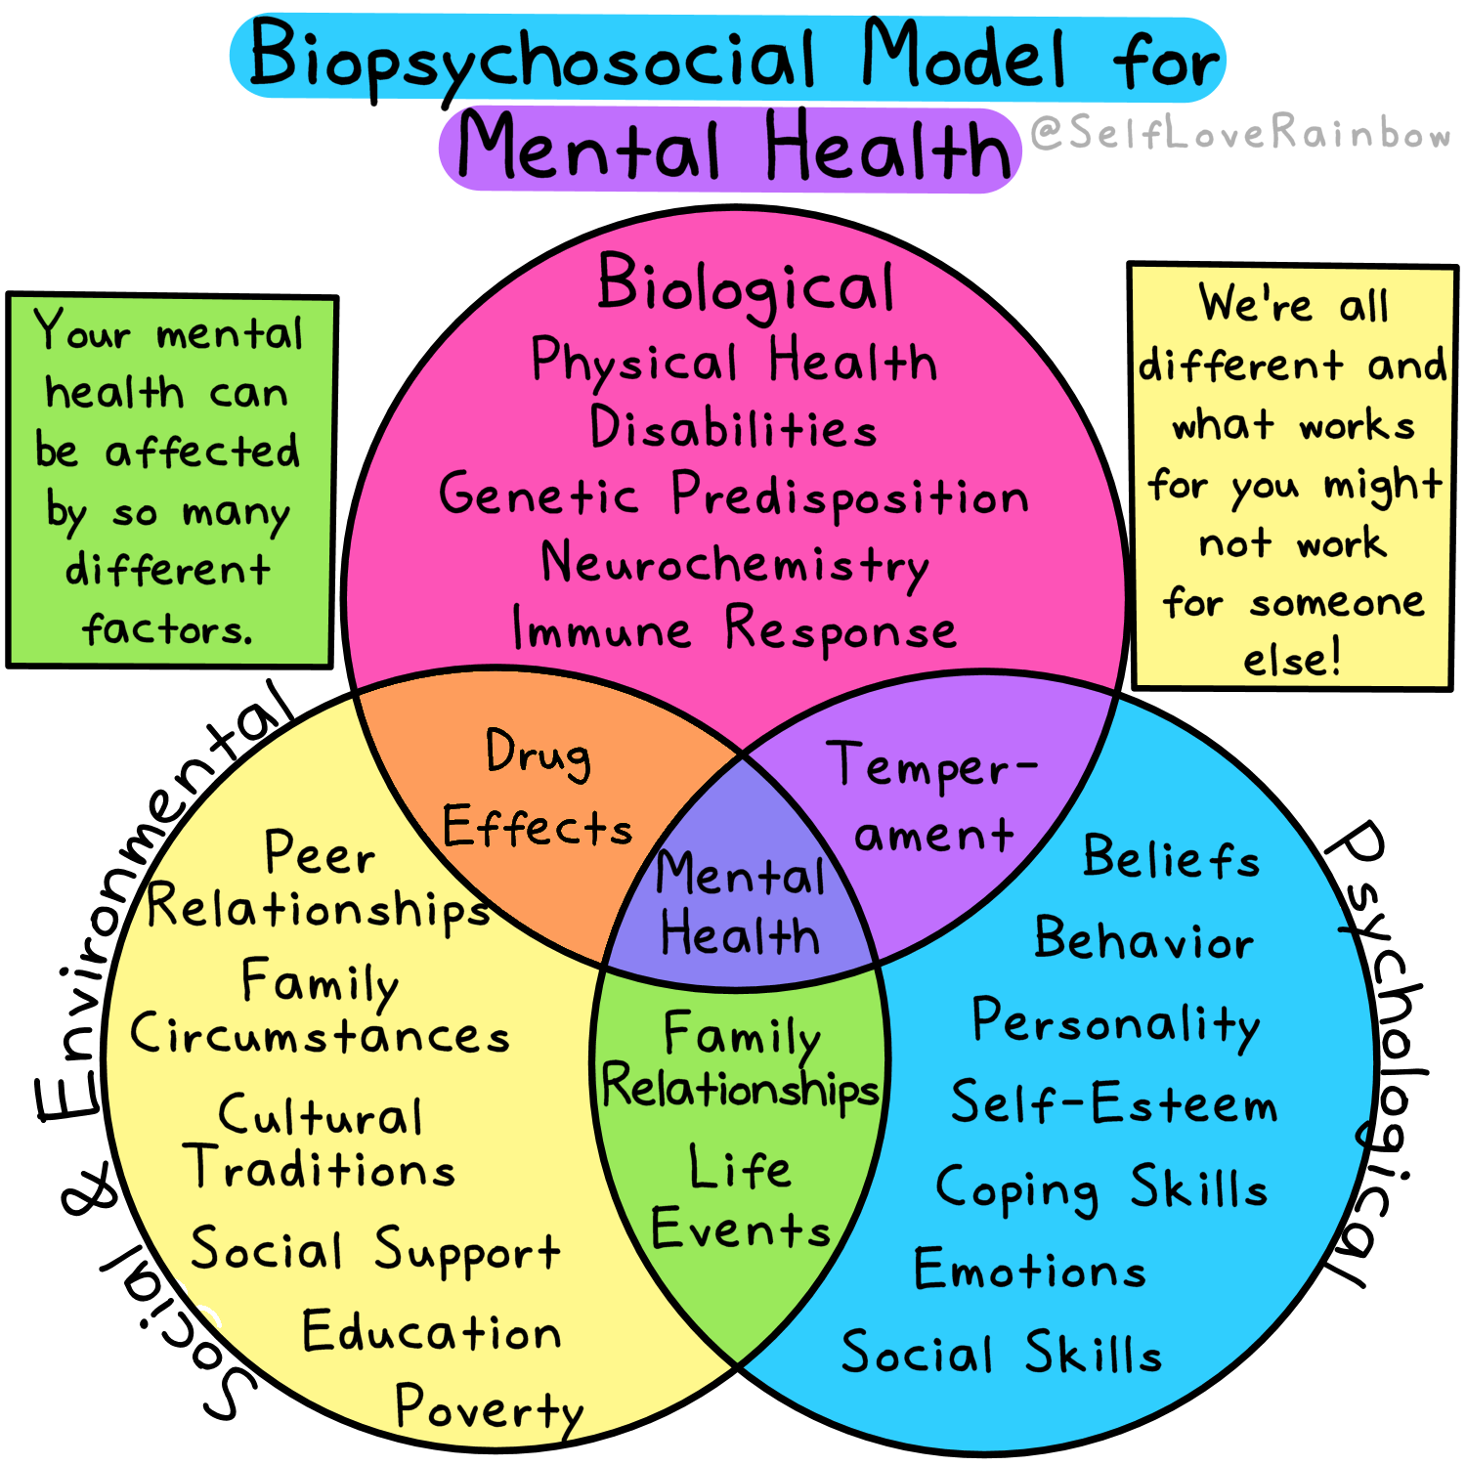
Source: Self Love Rainbow (2021) The Biopsychosocial Model for Mental Health]. Available at: https://www.selfloverainbow.com/the-biopsychosocial-model-for-mental-health/ (Accessed: 29 April 2025).

Appendix 2: Bronfrenbrenner’s Ecological Theory Model:
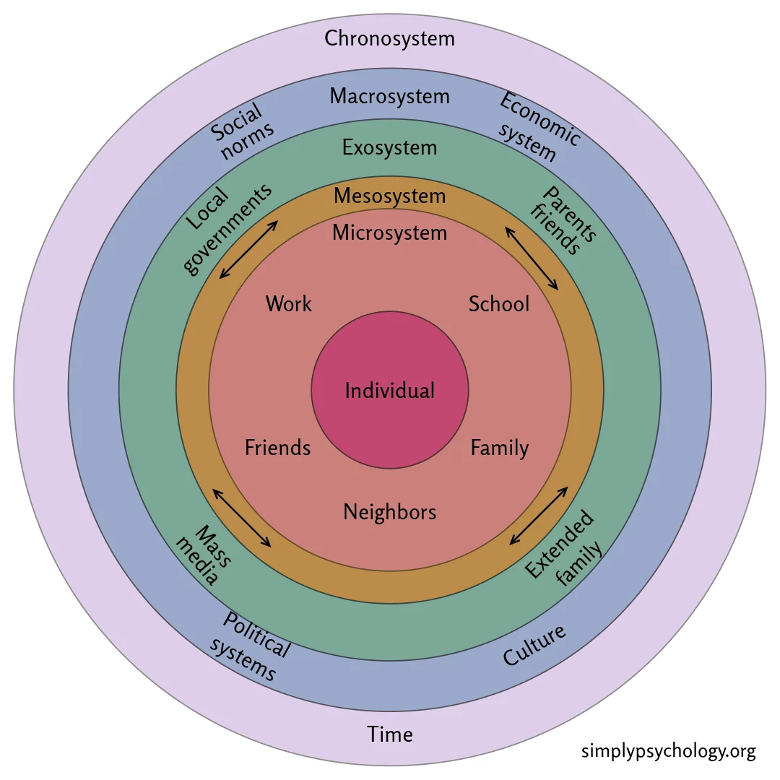
Source: Simply Psychology (2025) Bronfenbrenner’s Ecological Systems Theory. Available at: https://www.simplypsychology.org/bronfenbrenner.html (Accessed: 29 April 2025).

Appendix 3: Possible pupil voice questions to measure the impact of the hockey club on pupils:
- Do you enjoy coming to the hockey club, and why?
- Has the hockey club helped you feel more confident or proud of yourself?
- Have you made new friends or worked better with others since joining the club?
- Do you feel included and supported during hockey sessions?
- Do you find it easier to stay calm or manage your feelings during hockey?
- Has being part of the club made you feel more excited about coming to school on Fridays?
- What would you change or add to make the hockey club even better?

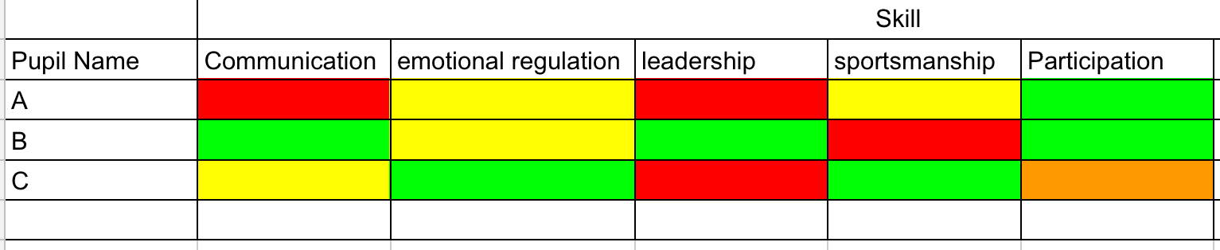
Appendix 4: Possible pupil skill tracking system example:

Appendix 5: SWOT analysis of the proposed hockey club.

 | Helpful | Harmful
INTERNAL  (Within the school) | Strengths  A member of staff has connections to a local hockey club.  Pupil engagement – While I was on placement, I created a hockey club for all year 6 pupils which most attended, and there was much pupil interest across KS2.  The school has an “aspire to inspire” program where they get local professional sports people to give talks and masterclasses, which have inspired some pupils to become semi-professional athletes.  The school already has all the appropriate equipment and multiple areas where pupils could play hockey safely. | Weaknesses  Staffing – if too many other pupils in after-school club on a Friday there may not be staff to spare for the club to maintain ratios.  Attendance – Attendance is typically low on a Friday.  Cost of implementation – staff training
EXTERNAL  (Outside of School) | Opportunities  Developing the relationship between school and community.  Increasing pupil awareness of opportunities within the community.  Supporting parents  Transport / accessibility | Threats:  Socioeconomic difficulties – affording sports clothes  Lack of parental support

