Programme: BA (Hons) Leadership and Management Skills for the Workplace
Module: Leading and Implementing Change (LIC)
Module code: LCLM6003 Contribution to Overall Module
Assignment Title: A Strategic Change Plan
Student Name: Musa Touray
Student ID:2011091
Date:11/07/2026

Executive summary
According to this study, Aston Martin's strategic challenges are the industry which is increasing digital support, the competitive automotive industry and so on. It analyses the external pressures like electrification, sustainability regulations and technological disruption. This study also evaluates internal responses, including the digital transformation, AI adoption and operational restructuring. It also assesses change management approaches through Lewin's and Kotter's models. This also highlights the role of leadership and organisational culture in enabling or resisting change. Finally, a strategic change plan is proposed focusing on AI-driven smart manufacturing.
Table of Contents
Introduction 1
Analysis of the internal and external environment 2
Recent organisational history 2
External Environment Analysis 3
Industry competition 5
Internal analysis 6
Evaluation of Strategic Change Management 7
Strategic Change by Aston Martin 7
Strategic Change Issues and Challenges 7
Evaluation Using Lewin's Three-Step Model 8
Evaluation Using Kotter's Eight-Step Model 8
Leadership and Organisational Culture 10
Evaluation of How the Change Was Managed 10
Leadership's Role in Managing the Change 10
Impact of Organisational Culture on the Change Programme 11
Proposed strategic change management plan 11
SMART objectives 11
Change Management Plan 12
Communication plan 12
Financial Plan 13
Evaluation Plan 13
Conclusion 14
References 15

Introduction
Aston Martin Lagonda Global Holdings PLC is a British Luxury automobile manufacturer which had founded in 1913. The founders of Aston Martin are Lionel Martin and Robert Bamford. This automotive company has developed a strong reputation for producing high-performance sports cars, some grand tourers, and luxury vehicles (Aston Martin, 2024). This platform has presented advanced engineering, craftsmanship and exclusivity. With some years of its foundation, it became one of the most iconic automotive brands in the world. This is also closely associated with British luxury and innovation. This company started to produce luxury sports cars like the Vantage, DB12, DBX luxury SUV and so on. There are also limited-edition hypercars offered by Aston Martin. Aston Martin also provides bespoke vehicle customisation services with the support of the Q by Aston Martin division (Aston Martin, 2024). This automotive company operates within the luxury automotive market. There are lots of premium-level competitors like Ferrari, Lamborghini, Bentley and so on. Besides the higher level of brand image, there are some pressures in the competitive environment. Besides this, the external and internal business environment have a higher impact on this business. The customers' perceptions are changing rapidly, so the existing changes and use of digitalisation sometimes do not get enough attention. In the present time, automation is very popular among users, and the lack of such aspects is also a part of the lack for this brand. At present, around 2800 employees work for Aston Martin, and they have expanded into 50 countries, including the UK. Despite this, the external and internal environment-based impacts bring challenges for Aston Martin.

Figure 1: Aston Martin.
Source: (Aston Martin, 2024).
Including all such understandings, this study will analyse the recent history of the organisation and explain the changes in the internal and external environment-based impacts. This study will also evaluate the management of change and leadership in Aston Martin. Finally, a suitable change management plan will be included for the organisation.

Analysis of the internal and external environment

Recent organisational history
Aston Martin has been facing some changes through digital disruption and technological innovation based on sustainability requirements. Besides all these, over the past few years, customer expectations have also changed rapidly, which has also had some impacts on the business processes of Aston Martin (Bathla, Awasthi and Ahuja, 2022). Such developments have had a tremendous influence on the company to transform its traditional luxury automobile business model. This contains the main influences for adopting higher digital technology-driven strategies.
Digital transformation journey: One of the most pressing developments that Aston Martin has faced is their digital transformation, in which the company has invested in digital technologies to improve manufacturing efficiency. This process allows them to transform customer engagement along with the product development process. Such implications of digital engineering tools enabled their operational performance to qualify (Chuks and Chuks, 2022). Some tools which takes part in the digital transformations are data analytics, cloud computing, smart manufacturing technologies and so on. Such implementation allowed the company to confirm the quality associated with the brand. Digitalisation has also been able to improve customer interactions through online sales platforms, personalised digital services, and so on.
Transition in EV: EV-based automotive production is also part of the major change as part of Aston Martin's transition (Albert, Rubio and Valero, 2021). The growing demand and concern for EVs, along with government regulation and changing customer preferences, have influenced Aston Martin to manufacture EVs Though this supports the reduction of carbon emission but, the cost-effective transformation was not easy for Aston Martin. By investing in battery technology, Aston Martin has been able to plan to introduce the EV mobility solution.
Artificial Intelligence: Most of the uses of AI and automation in technology influence Aston Martin to change their operations. AI technologies are increasingly used in predictive maintenance, quality control and production planning. This allows them to focus on relationship management and market forecasting compared to the past-based operational practices. AI-based analytics help Aston Martin to manage their strategic decision-making faster compared to the past manual process.
COVID-19 pandemic: Aston Martin has been highly affected by the impact of the COVID-19 Pandemic. This had shaken their historical balance, as this was part of the temporary factory closures. This had reduced customers' spending on cars, and the supply chain process was also negatively affected (Yu, Khan and Umar, 2021). Sales and operational processes were stopped for Aston Martin. So, in the post-pandemic situation, Aston Martin took a recovery strategy based on cost management during the period. The digital sales channels were launched by Aston Martin for new luxury vehicle models. These models allow them to invest in technologies and push the company to higher innovation.

External Environment Analysis
Through the PESTEL analysis, the external environment analysis for Aston Martin can be conducted. With PESTEL analysis, each part of the external environment factors can be evaluated to identify the level of opportunities and threats for Aston Martin.
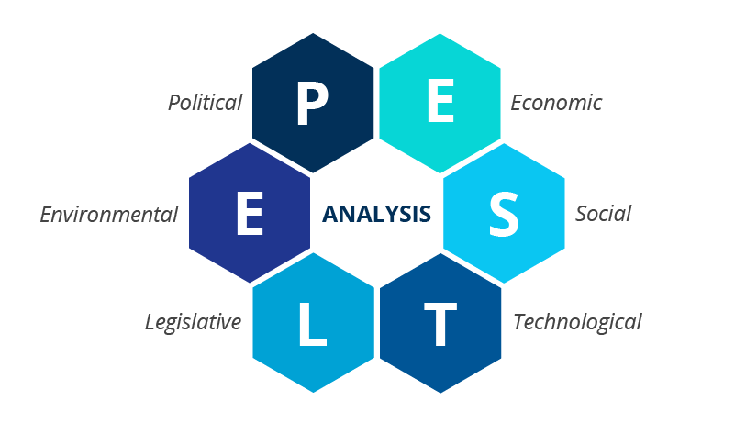
Figure 2: PESTEL analysis.
Source: (Bathla, Awasthi and Ahuja, 2022).
Political: In the UK or the international context, the political development continues to offer higher opportunities for Aston Martin. After Brexit the customers procedures and regulatory complexities had increased the customer procedures and regulatory complexities. This had also increased the cross-border trade costs by creating operational challenges. In this case, the UK-based automotive manufacturers faced higher threats (Fahim and Gelsefid, 2022). On the other hand, the UK government's support for advanced manufacturing and electric vehicle development is a part of opportunity for Aston Martin. The main opportunity is that the government provides support, as well as needed investment sources, for this innovation. Various government initiatives in the UK also promote EV adoption, which, for awareness, is good for the demand for EVs in the UK market.
Economical: Economic conditions high influence on the luxury automobile industry. There is a higher inflation rate, and the interest rate is also increasing. So, as part of economic uncertainty, this can reduce customer purchasing power. Ultimately, this process negatively affects vehicle demand (Bathla, Awasthi and Ahuja, 2022). On the other hand, the increasing cost of raw materials like lithium, aluminium and semiconductors has increased the production cost for Aston Martin and other automotive manufacturers in the UK. All these are part of threats. Besides this, the growing global wealth of high-net-worth individuals creates higher opportunities for the luxury vehicle manufacturing process. Her ethe economic recovery in emerging markets can also expand the customer base for Aston Martin. So overall, this is an opportunity.
Social: Social trends contain the power to reshape customer expectations, mainly in the automotive industry. This allows for increasing awareness of environmental sustainability, which also influences customers to seek cleaner transportation solutions. Not only this, but it also creates higher opportunities for Aston Martin for its electrification strategy (Ndzabukelwako et al., 2024). Younger customers are providing value for sustainability, technological innovation, and using it as a traditional luxury sports car. This part is a very good opportunity for Aston Martin. Here, the traditional luxury sports car contains influence on the change into electric vehicles. This part can create challenges for balancing innovation with brand heritage.
Technological: The technological part includes AI, automation, and Industry 4.0-based technologies, which are all part of opportunities for the automotive sector, like Aston Martin. Among all these, it also includes digital twins and advanced analytics, which are expected to develop operational efficiency and product quality for a better customer experience (Yu, Khan and Umar, 2021). Here, connected vehicle technologies enable real-time monitoring and predictive maintenance. Besides this, automation in manufacturing can reduce costs and improve productivity. All those are part of the opportunities for Aston Martin. Rapid technological change in the UK market is one of the challenges for the automotive industry. This requires continuous investment from Aston Martin for proper research and development.
Legal: The automotive industry operates within a highly regulated legal environment. In the UK, there are strict emission regulations across Europe and North America. These are required for manufacturers for reducing vehicles emissions and increase investments in electric vehicles. Data protection regulations such as GDPR also affect the management of customer information with connected vehicles and digital performance (Lukin, Krajnovic and Bosna, 2022). For this reason, the evolving of regal requirement creates additional operational costs, which is a part of the opportunities for Aston Martin.
Environmental: Environmental sustainability is a great priority for automotive manufacturers. Government and investors expect that organisations have to contribute to carbon reduction targets and net zero emissions. Such expectations create higher opportunities for Aston Martin to develop their reputation (Fan and Iqbal, 2022). Aligned to the sustainability manufacturing, these are higher opportunities for them. On the other hand, the chances of failing in the environmental expectations can lead to higher chances of damaging the brand reputation. So, the regulatory penalties are a part of the threat for Aston Martin here.

Industry competition
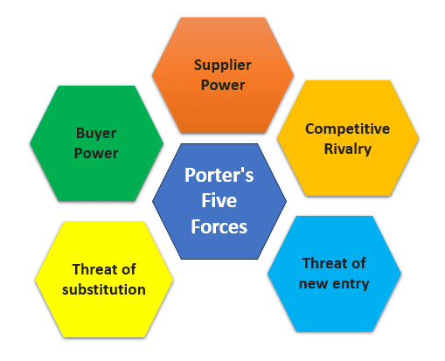
Figure 3: Porter's Five Forces.
Source: (Pangarkar and Prabhudesai, 2024).
Competitive rivalry (High): Competitive rivalry within the luxury automotive industry is extremely intense. Aston Martin competes with established premium manufacturers like Farari, Porsche, Lamborghini, Bentley and so on. They also have competitors like Tesla, which is an EV-focused manufacturer (Beier, Kiefer and Knopf, 2020). All such brands continuously invest in AI, digital technologies and innovation. So these competitive rivalry-based threats are high for Aston Martin.
Threat of substitutes (moderate): The threat of substitutes is moderate for Aston Martin. Customers in the UK market are increasingly considering luxury EVs, but also premium mobility services. Here, sustainable transportation is highly required instead of luxury cars (Albert, Rubio and Valero, 2021). Though there are fewer substitutes for EVs and advanced luxury cars provided by Aston Martin, changing environmental preferences can increase substitution risks.
Bargaining power of supplier (High): Brands like Aston Martin are highly dependent on specialised components like semiconductors, battery technology and luxury materials. In this reasoning, the suppliers' bargaining power is high. Global supply chain disruptions have increased, which influences suppliers and increases their procurement costs (Fan and Iqbal, 2022). So the limited availability of raw materials has made their power higher.
Bargaining power of buyer (Buyer): Aston Martin provides niche luxury market-based products, which makes the buyer need their products. On the other hand, as those luxury cars are competed by others for a competitive advantage, the level of buyer power is lower in terms of threats.
Threat of new entrants (Low): To start a business like Aston Martin, it requires substantial capital and strong brand loyalty (Ndzabukelwako et al., 2024). This is not normal, nor can it be achieved easily. So this indicates a lower level of threat for the new entrants for Aston Martin.

Internal analysis
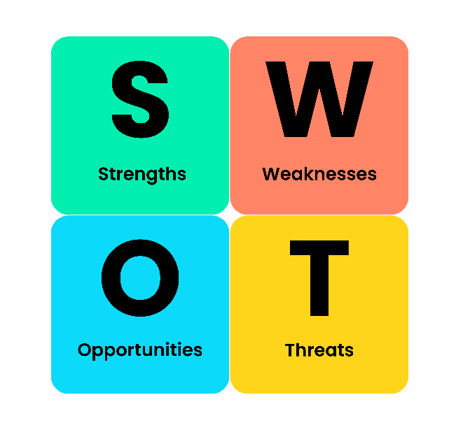
Figure 4: SWOT analysis.
Source: (Fahim and Gelsefid, 2022).
Strengths | Weakness
Aston Martin is a globally recognised luxury brand with a strong reputation.  This company also maintain significant research and development capabilities (Yu, Khan and Umar, 2021).  Aston Martin supports innovation in electrification, AI integration and advanced engineering for sustainable vehicle technologies. | Aston Martin faces higher production and operational costs for their low volume luxury manufacturing model.  Some legacy systems and traditional production processes can limit flexibility for Aston Martin (Bhatia and Jakhar, 2021).  Financial constraints may also restrict large-scale investment compared to larger automotive competitors.
Opportunities | Threats
Rapid growth in the electric market can be an opportunity for Aston Martin in expanding their innovation process.  AI integration can improve operational efficiency and predictive maintenance (Chan, Wang and Ybarra, 2018).  Digitalisation initiatives can also improve customer engagement and support new revenue. | Aston Martin faces higher competition from Tesla due to their higher investment in EV technologies (Albert, Rubio and Valero, 2021).  The Chinese EV manufacturing market is rapidly growing, which can also be a threat.  Economic uncertainty and changing regulations can be a threat to investing in technology and innovation.

Evaluation of Strategic Change Management

Strategic Change by Aston Martin
Aston Martin has been operating with excellent success over the years, but in recent years, due to environmental and other external factors, the company has had to initiate major changes within the organisation. One of those is a significant transition towards electrification or EVs, along with a comprehensive digital transformation of the supply chain and production planning (Aston Martin, 2024). This was vital to address strict government regulatory changes, meet rapidly changing customer expectations and the trend of environmental sustainability. Thus, allowing the company to operate without legal complications while staying competitive in the already saturated market.

Strategic Change Issues and Challenges
The strategic changes initiated by the company were extremely necessary, but the organisation also faced several issues or challenges during their implementation.
Internal issues: The internal issues or challenges faced by the company included incompatibility and financial constraints. The company was established in the early 90s, so till very recently, they used a legacy system of production and processing, which had limited capabilities of digital integration (Hasan and Karim, 2024). It reduced the overall flexibility of the company towards adapting to digitalisation of the supply chain, electrification and AI integration. The issue of financial constraint also created a challenge by restricting the large-scale investment required for implementing such changes.
External issues: A major external issue for Aston Martin was to keep up with the rapidly changing market and competitors. Certain brands, such as Tesla, and others had already established a large customer base and market share, which made the transition more challenging (Jeong, Kim and Jo, 2024). Furthermore, the rising cost of raw materials and supply chain disruptions were a major challenge for the company to tackle during the implementation of the changes.

Evaluation Using Lewin's Three-Step Model
Change management at Aston Martin is evaluated below using Lewin’s Change Management Model.
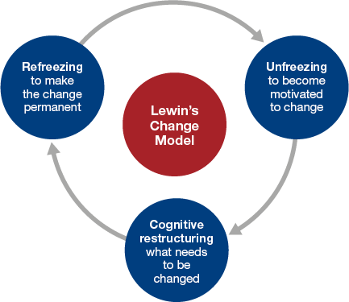
Figure 5: Lewin's Three-Step Model.
Source: (Fan and Iqbal, 2022).
Unfreeze: In the initial phase, Aston Martin ensured recognition of change requirements due to the changing customer preferences, digital disruption, and increasingly strict regulatory requirements (Harrison et al., 2021). They took the necessary measures to communicate those needs to the employees through open and transparent communication.
Change: In the next phase, the company accumulated required resources and invested in AI integration, digitalisation of the supply chain and transition to EV (Aston Martin, 2024). In order to do so, the company also took the initiative of reskilling the workforce, leading to smoother adaptation.
Refreeze: After some time, the company embedded those practices by ensuring their use on a regular basis. This also led to the development of new operational standards with the inclusion of the required changes without further issues.
Use of this change management model allowed the company to accurately evaluate the external shocks of unpredictable situations with the help of the unfreeze stage (Lewin, 1951). Yet, the rigid nature of the refreezing stage undermines the need for continuous technical evolution.

Evaluation Using Kotter's Eight-Step Model
Future evaluation of the changes is done below using the Eight-Step Model of Kotter.
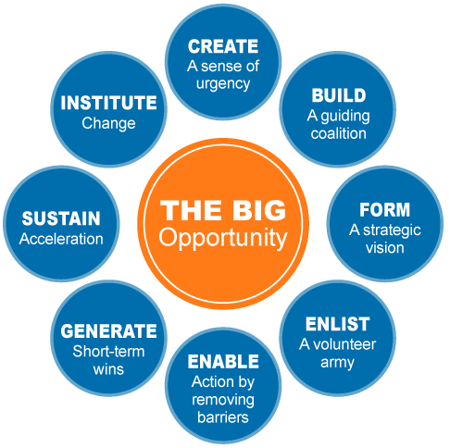
Figure 6: Kotter's Eight-Step Model.
Source: (Bhatia and Jakhar, 2021).
Creating urgency: Aston Martin was facing a decline in their profitability and market share due to the influence of factors such as digital disruption, regulatory changes and digitalisation. This created a sense of urgency to implement required changes.
Building a guiding coalition: The situation pushed the organisation to assemble a cross-functional team of experts to evaluate the situation and suggest the required changes to be made for the sustainability of the organisation (Nadler, 2024).
Developing vision: Based on the evaluation and findings, the organisation developed the new vision of digitalisation through electrification, supply chain development and AI integration.
Communicating change: The company was able to successfully communicate the necessity of change to the employees. This resulted in their cooperation and contribution to implementing the required changes.
Empowering employees: Empowerment of employees is vital to initiate such major changes, but the company was unable to effectively do so due to certain employees resisting the change (Harrison et al., 2021). This resulted in disruption, delay in implementation, and operational instability.
Creating short-term wins: Aston Martin was able to achieve short-term wins such as R&D of competitive EVs, AI integration, and so on.
Sustaining momentum: They were able to sustain the phase for a prolonged period of time, which made change implementation efficient and less resource-intensive.
Institutionalising change: Through the establishment of new policies, a tailored work environment and operational standards, the changes were instituted within the organisation for future continuity (Jeong, Kim and Jo, 2024).

Leadership and Organisational Culture

Evaluation of How the Change Was Managed
The leaders at Aston Martin played a vital role in the effective management and implementation of the required change. They were involved from change planning to resistance management to monitoring and control. In the initial phase of change planning, mange stated with identifying the need for change early under the influence of digital disruption, regulatory requirement changes and sustainability needs (Pasla et al., 2022). This influenced them to create a vision where the company addresses those changes and achieves a competitive edge in the market. In order to do so, the leader influenced employees to be a part of the change by making them aware of their necessities and reskilling them to establish the changes effectively. Transparency through communication played a vital role in ensuring that employees understood the urgency of the change. However, the leaders failed to effectively manage resistance from employees (Hasan and Karim, 2024). It was expected that making such a change of such high calibre would affect the norms of employees, creating uncertainty and fear. This affected the overall implementation and effectiveness of the change implementation programme. Yet, the leaders were able to use real-time monitoring systems and tactics in order to accurately monitor change, implement, and identify issues to address them immediately.

Leadership's Role in Managing the Change
Change management is considered one of the most difficult feats to achieve by an organisation, as the centre of it lies with the leader (Bagga, Gera and Haque, 2022). That is why using the right leadership approach is vital to the success of change management. In the case of Aston Martin, the leaders used the transformational leadership approach, where the leaders inspire, encourage, and motivate employees to work towards a shared goal (Aston Martin, 2024). The use of this leadership approach allowed effective development of engagement for change, conveying clear communication to the employees, leading to effective awareness development and many more. Thus, the use of the selected leadership approach improved the effectiveness of change management at the organisation, which resulted in the overall management programme being a success.

Impact of Organisational Culture on the Change Programme
Another core factor that can have a major influence over a company and its overall change management programme is organisational culture. The term refers to the combination of values, beliefs and behaviour of employees in a workplace (Wijethilake, Upadhaya and Lama, 2021). Aston Martin uses a hierarchical culture where the core values are control, consistency, and chain of command, allowing smoother operation (Aston Martin, 2024). The impact of the culture is discussed below using Schein's Model.
Artefacts: The company shifted its use of traditional or legacy systems to advanced digital AI systems in operation, manufacturing EVs and digitalisation of the supply chain, which fostered innovation in the organisation.
Espoused Values: The company continuously evolved their strategic target towards digitalisation, AI integration and sustainability requirements. Meaning, it developed different policies, regulations and practices within the organisation that addressed all of those means (Hasan and Karim, 2024).
Basic Underlying Assumptions: The core values of the company have also been changed towards a more digitalised and regulated culture, which made the change management easier to implement and solidify (Bagga, Gera and Haque, 2022).
Overall, the culture allowed for fostering digital transformation, supported innovation and resilience, which indicates the positive influence of the organisational culture on the overall change management programme.

Proposed strategic change management plan
The proposed change at Aston Martin is the automated manufacturing and predictive analytics programme with AI support. In the luxury automotive industry, to gain a competitive advantage AI supported Smart manufacturing and predictive analytics programme can gain the best competitive advantage (Fahim and Gelsefid, 2022). This proposed change aims to integrate artificial intelligence, automation, predictive analytics and Industry 4.0 technologies in the manufacturing and supply chain operations.

SMART objectives
- To reduce production defects by 20% through AI-based quality monitoring within 12 months.
- To improve supply chain visibility by 30% using predictive analytics within 18 months.
- To reduce operational cost by 15% through automation and process optimisation within 24 months.

Change Management Plan
With the application of Kotter’s eight-step model, the change management guide will be able to implement it.
According to the create urgency stage, it indicates that management highlights rising EV competition and digital disruption. Aligned with these inefficiencies in traditional manufacturing is also the part of it. Building a guiding coalition is mandatory. Based on this, a cross-functional leadership team is formed, including senior managers and IT specialists (Ndzabukelwako et al., 2024). Another part is forming, where strategic vision and initiation have to be formed. Here, a clear vision will be developed, like AI-enabled smart manufacturing for sustainable luxury mobility. For the vision, communication is mandatory. The vision will be communicated through internal meetings, workshops and digital platforms. Employees should be empowered to take action. Her employees will be trained for AI tools, automation systems and digital manufacturing to reduce resistance and capability gaps. Short-term wins-based task generation is also mandatory. For this step, pilot projects in production, like delivery, will be improved, assuring quality, efficiency and defect reduction (Lukin, Krajnovic and Bosna, 2022). Gains consolidation and change production are important, which, for the success of pilots, will be marked for operations for continuous improvements of AI and automation. Finally, the change should be anchored in organisational culture aligned with the AI-driven process.

Communication plan
Stakeholder | Method | Frequency
Employees | Workshop and training | Monthly
Mangers | Progress meeting | Weekly
Investors | Performance report | Quarterly
Suppliers | Briefings | Monthly
Customers | Sustainability updates | Quarterly

For the communication plan, the stakeholders will be employees, managers, investors, suppliers and customers. Their method will be different, where employees will commit to the plan through workshops and training monthly (Chan, Wang and Ybarra, 2018). Managers will use the progress meeting method each week. Investors will communicate in a performance report quarterly in a month. Suppliers will provide briefings each month; finally, customers will provide sustainability updates quarterly.

Financial Plan
Investment area | Cost in £
AI and automation systems | 200000
Training for employees | 50000
Consultants | 30000
Digital infrastructure | 70000
Total | 350000
Here for the change with AI and automation system total estimated cost is around 350000 GBP. For AI and automation systems, around 200000 GBP will be needed, which will ensure high efficiency. Around 50000 GBP will be needed for training employees, and this will ensure a skilled workforce. 30000 GBP will ensure the consultant charge for having the route of implementation. Finally, the digital infrastructure can be developed with 70000 GBP, which will improve the analytics process (Markulik, Solc and Blasko, 2024).

Evaluation Plan
Balanced scorecard evaluation framework can be used for indicating the KPIS. This will also ensure holistic evaluation of performance.
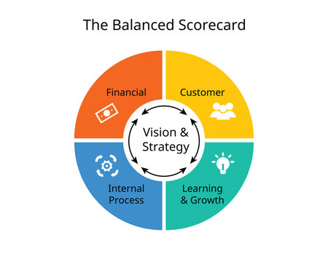
Figure 7: Balanced Scorecard.
Source: (Munten et al., 2021).
Financial perspective: According to this dimension, the financial impacts of the change programme will be included. As part of key measures, the cost reduction percentage and return on investment from the AI technology will be included (Pangarkar and Prabhudesai, 2024). Another KPI in this dimension can be revenue growth amount through improved production efficiency.
Customer perspective: This perspective focuses on customer satisfaction, brand perception and product quality. This will ensure vehicle reliability improvement in Aston Martin. So the customer trust and luxury brand position will be able to develop (Munten et al., 2021).
Internal business process perspective: This will evaluate operational improvements like product efficiency, defect reduction and automation-based performance (Gonzalez, Guzman and Guijarro, 2022). AI and predictive analytics are expected to improve decision-making and operational speed.
Learning and growth perspective: This measures the organisation's capabilities development and the employees' digital skills (Lukin, Krajnovic and Bosna, 2022). It ensures that employees are equipped for sustainable and long-term digital transformation.

Conclusion
Aston Martin operates in a highly volatile automotive environment which was shaped by digital disruption, AI and automation. This report shows that due to the influences of digitalisation and some challenges like the skills gap and high cost, some change management proposals were made for Aston Martin. Effective change management was indicated in this report, aligned with transformational leadership and flexible organisational culture. The proposed AI-driven smart manufacturing strategy provides a structured pathway for improving efficiency and innovation.

References
Albert, C.L., Rubio, F. and Valero, F. (2021). Impact of Digital Transformation on the Automotive Industry. Technological Forecasting and Social Change, 162(120343), p.120343.
Aston Martin (2024). About Us. [online] Astonmartin.com. Available at: https://www.astonmartin.com/en/corporate/about-us.
Bagga, S.K., Gera, S. and Haque, S.N. (2022). The Mediating Role of Organisational Culture: Transformational Leadership and Change Management in Virtual Teams. Asia Pacific Management Review, 28(2), pp.120–131.
Bathla, D., Awasthi, S. and Ahuja, R. (2022). PESTEL Analysis of the Automotive Industry. [online] Applying Metalytics to Measure Customer Experience in the Metaverse. Available at: https://www.igi-global.com/chapter/pestel-analysis-of-the-automotive-industry/309311 [Accessed 17 Jun. 2026].
Beier, G., Kiefer, J. and Knopf, J. (2020). Potentials of big data for corporate environmental management: A case study from the German automotive industry. Journal of Industrial Ecology, [online] 1(1). Available at: https://onlinelibrary.wiley.com/doi/full/10.1111/jiec.13062 [Accessed 17 Jun. 2026].
Bhatia, M.S. and Jakhar, S.K. (2021). The effect of environmental regulations, top management commitment, and organisational learning on green product innovation: Evidence from the automobile industry. Business Strategy and the Environment, 30(8).
Chan, T., Wang, I.M. and Ybarra, O. (2018). Leading and managing the workplace: The role of executive functions. Academy of Management Perspectives, 35(1).
Chuks, N.O. and Chuks, O.U. (2022). The Role Of Leadership In Workplace Diversity Management. Вестник Томского государственного университета. Экономика, [online] (57), pp.192–201. Available at: https://cyberleninka.ru/article/n/the-role-of-leadership-in-workplace-diversity-management [Accessed 17 Jun. 2026].
Fahim, S.R. and Gelsefid, F. (2022). The Impact of Internal and External Driving Forces and Strategic Decisions on Supply Chain Risk Management (Case Study: Automotive Industry). Journal of Applied Research on Industrial Engineering. [online] Available at: https://www.journal-aprie.com/article_161601.html [Accessed 17 Jun. 2026].
Fan, W. and Iqbal, M. (2022). Economic, Social, and Environmental Determinants of Automotive Industry Competitiveness. Journal of Energy and Environmental Policy Options, [online] 5(4), pp.36–43. Available at: https://resdojournals.com/index.php/JEEPO/article/view/296 [Accessed 17 Jun. 2026].
González, R.M., Guzmán, G. and Guijarro, A. (2022). The effect of green strategies and eco‐innovation on Mexican automotive industry sustainable and financial performance: Sustainable supply chains as a mediating variable. Corporate Social Responsibility and Environmental Management, 29(4).
Harrison, R., Fischer, S., Walpola, R.L., Chauhan, A. and Babalola, T. (2021). Where Do Models for Change management, improvement, and Implementation meet? A Systematic Review of the Applications of Change Management Models. Journal of Leadership, 13(2), pp.85–108.
Hasan, F. and Karim, S. (2024). Role of Digitalisation and Digital Capabilities to Implement Second-Life Business Models for Electric Vehicle Batteries. DIVA.
Jeong, J.H., Kim, C. and Jo, H.J. (2024). Three Major Challenges in the Shift to Electric vehicles: Industrial organization, Industrial policy, and a Just Transition. Sociology Compass, 18(5).
Lewin, K. (1951). Field Theory in Social Science: Selected Theoretical Papers. American Sociological Review, 16(3).
Lukin, E., Krajnovic, A. and Bosna, J. (2022). Sustainability Strategies and Achieving SDGs: a Comparative Analysis of Leading Companies in the Automotive Industry. Sustainability, 14(7), p.4000.
Markulik, Š., Solc, M. and Blasko, P. (2024). Use of Risk Management to Support Business Sustainability in the Automotive Industry. Sustainability, 16(10), pp.4308–4308.
Munten, P., Vanhamme, J., Maon, F., Swaen, V. and Lindgreen, A. (2021). Addressing tensions in coopetition for sustainable innovation: Insights from the automotive industry. Journal of Business Research, 136, pp.10–20.
Nadler, D.A. (2024). The Effective Management of Organisational Change. Revitalising Manufacturing, 1(2), pp.185–200.
Ndzabukelwako, Z., Mereko, O., Sambo, T. and Thango, B. (2024). The Impact of Porter’s Five Forces Model on SMEs Performance: A Systematic Review. The Impact of Porter’s Five Forces Model on SMEs Performance: A Systematic Review. [online] Available at: https://papers.ssrn.com/sol3/papers.cfm?abstract_id=4999059 [Accessed 17 Jun. 2026].
Pangarkar, N. and Prabhudesai, R. (2024). Using Porter’s Five Forces Analysis to Drive Strategy. Global Business and Organisational Excellence, 43(5), pp.1–11.
Pasla, B.N., Ayu, M.S., Fathiyah, F., Bailah, B., Rasid, F. and Ubaidillah, U. (2022). Leadership Style types: the Importance of Organisational Culture and Change Management. Journal Prajaiswara, 3(2), pp.105–115.
Wijethilake, C., Upadhaya, B. and Lama, T. (2021). The Role of Organisational Culture in Organisational Change Towards Sustainability: Evidence from the Garment Manufacturing Industry. Production Planning & Control, 34(3), pp.1–20.
Yu, Z., Khan, S.A.R. and Umar, M. (2021). Circular economy practices and Industry 4.0 technologies: A strategic move of the automobile industry. Business Strategy and the Environment, [online] 31(3). Available at: https://onlinelibrary.wiley.com/doi/abs/10.1002/bse.2918 [Accessed 17 Jun. 2026].

