Effective Teamwork for a Team Success


Student name: Evdokiya Stefanova
Student number: 2018698
Module name: Effective Team working and communication
(BMSW 4002)
Tutor name: Muhammad Islam

Contents
Introduction: 3
What is a team? 3
How to create an effective team: 4
Conditions to be met 4
Effective teamwork 5
What is teamwork and why do we need it? 5
Types of roles needed for the development of effective team 5
Roles: 5
How Next Plc. Can develop an effective team? 7
What is the Tuckman model? 7
Stages of Tuckman’s model: 8
Forming: 8
Storming: 8
Norming: 8
Performing: 9
Adjourning: 9
Impact of effective teamwork at Next Plc. and barriers to face 10
Outcomes 10
Challenges and barriers to effective team working: 10
Poor communication 10
Poor leadership: 11
Lack of commitment: 11
Loses in productivity 11
Group size: 11
Dominating team members: 11
Conclusion 12
References 13

Introduction:

In this report I will discuss teamwork and why is it significant, the boundaries to foster a successful group, Tuckman's group development model as well as how Next Plc. can utilize it to cultivate compelling collaboration, the jobs inside a group where I will exhibit Belbin's group roles model, and the effect this would all have in a business organization setting.

What is a team?
Team is the term used to describe a group of individuals collaborating to achieve a goal that they are mutually committed, according to Salas and Cannon-Bowers (2001) ‘A team can be defined as two or more individuals who interdependently and adaptively interact to achieve objectives.’, but a group is not necessarily a team.
A gathering can have individuals with varied interests and attitude, as well as thought processes. Individuals who are not reasonable with each other can never shape a team, they should share interests, viewpoints, targets, mindset, understanding and likings. Belbin (2010) states that ‘the essence of a team is a set of players who have a reciprocal part to play’

How to create an effective team:

To create a good team, there are few fundamental elements that need to be taken into consideration. Good leadership is a key to a team success, a leader that is openly communicating and sharing a vision with the rest is vital to set specific goals, a clear purpose, and action plans to achieve those.
The ability of a leader and an organisation to empower creativity to every member plays an important part enhancing the team performance.
Creating an informal and relaxed climate helps the team enjoy getting together and therefore interact easily and build solid relationships. Collaborating with each other and adopting strategies that involve every member is very important, as it helps setting team objectives, letting individual goals aside and taking a clear collective decision.

Conditions to be met

There are few identifiable conditions that contribute to creating a good team, notably collaboration and communication are the key to success.
Setting roles and responsibilities for every member helps to have clear structure and aligned purpose, this is why specific goals are essential as everyone understands what must be done.
Making decisions with open dialog and collectively offering ideas and solutions is important for the team development and commitment.
Team support and trust helps co-workers feel free to share and improve their ideas with others. Accepting members differences and diverse backgrounds it is a must, as it gives different points of view. Griffith (2015) said “Diversity membership within a team can be a tremendous asset”, but the group must figure out how to appreciate each other differences, before they can tackle the force of their knowledge. Concentrating on the positive attributes of each member can only have a constructive impact.

Effective teamwork

What is teamwork and why do we need it?

Teamwork is the key method for a successful business. Andrew Carnegie said, " Teamwork is the ability to work together toward a common vision”. It is the fuel that allows common people to obtain uncommon results " Ventura and Templin (2005).
As the world is constantly evolving, companies should also gradually change to adapt their current reality, collaboration and mutual respect for others are essentials in any organisation. This is because cooperation is a key and good attitude is what enables individuals to function admirably in a team and be prepared to succeed or fail together.

Types of roles needed for the development of effective team
Roles are an essential part in any organization, they help businesses operate in a simple and understandable way, as members within know their obligations.
During Belbin studies he began to recognize separate sorts of conduct, all of which was put together into a bunch of different responsibilities or ''group roles''. Belbin (2010) proceeds to say that ‘Team Role theory and data have a special part to play in self- management, in the management of others, and in the resolution of conflict.’
Therefore, we will use this theory to help Next plc develop as an effective team and create structure to the group.
His work uncovered nine model jobs inside groups, all of which have basic parts to play in powerful cooperation over an extended time. It is critical to understand these roles, and to do this accurately one would have to recognize what sort of employee they're managing.

Roles:
Those nine roles and what is expected of each one is:
- Plant: Creative, imaginative, and original. Someone that solves difficult problems.
- Resource investigator: Enthusiastic, communicative, and outgoing. Explores opportunities and shares them with the rest of the team.
- Co-ordinator: Mature and confident individual that encourages others. Their role is to delegate job to the rest of the team and make sure everything is evolving on the right direction
- Team worker: Works well with others, understanding, perceptive and diplomatic. Listens well and avoids friction
- Monitor Evaluator: Weights and balances all options without emotion. They make impartial judgements on the team’s behalf.
- Specialist: Dedicated and educated in specific areas or topics. Provides knowledge and skills that others do not poses.
- Shaper: Competitive, enjoys working under pressure. Someone who is motivated to overcome difficulties.
- Implementer: Planning strategies efficiently. Turns ideas into practical action
- Complete finisher: Meticulous individual who polishes mistakes at the end of a project and ensures that work is done to a high standard and points out omissions.

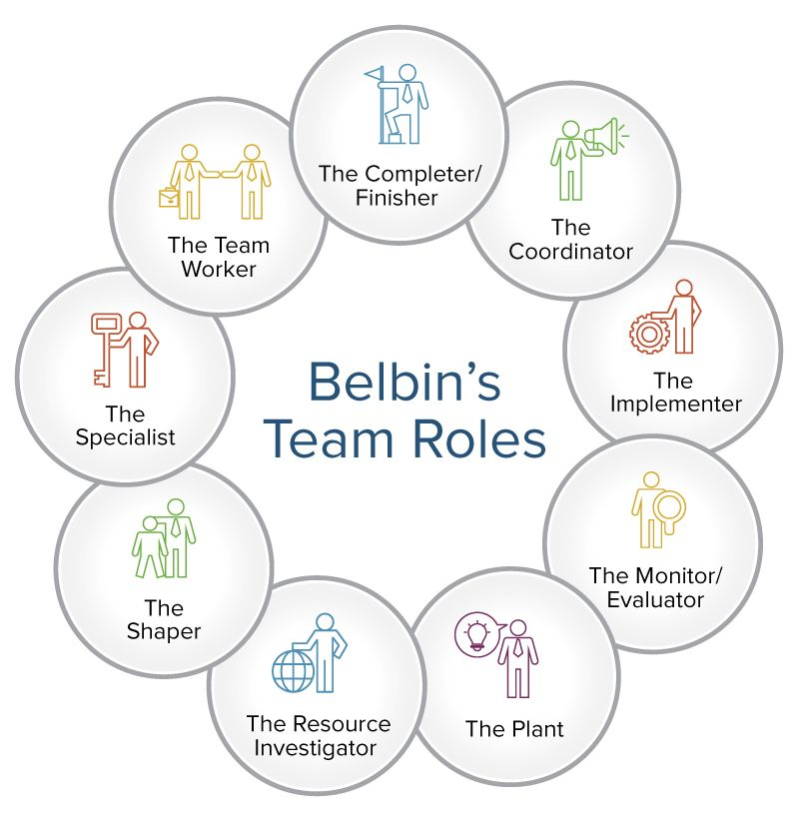

How can Next Plc. develop an effective team?

In comparison to other traditional models of team development Gersick (1988) concentrated his study about the initiation and completion of a special task with short lifespan, where members and non-members were involved.
Individuals had collective responsibilities, but not essentially working together side by side, they had external managers and provided their product for outsiders to be evaluated.
According to him the ‘team developed though the sudden information, maintenance, and revision of framework for performance’, therefore his method will not be applied to this case.
Since we clearly understand what a team consists of, we are going to examine how to appropriately develop staff members at Next Plc. using Tuckman’s theoretical model, as the team is experiencing conflict and needs help improving communication.

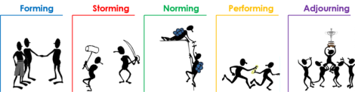

What is the Tuckman model?

In 1965, Bruce Tuckman, an enlightening expert and his associates created one of the most powerful methods for the development of a team.
Considering his view of perception in various settings and on composing study, he thought of a model consisting in four phases called: forming, storming, norming and performing, that individuals in a group need to go through to develop. Following a review to these studies a fifth stage called “Adjourning “was added by Tuckman and Jensen (1977) to address group development.
As all stages are individually focused, uncovering issues concerning the different stages and why things are happening some way or another, could drastically impact the group connection and proficiency.
Having an approach to perceiving and understanding the starting points for change in the team’s behaviour can help them extend its value.

Stages of Tuckman’s model:

Forming:
The group is formed, and everyone is on their best behaviour, clear goals and purpose are covered, and team members set personal goals to see how they will affect the big picture.
During this phase, team members also get to know each other and socialise.
The staff at Next Plc. might hold a meeting and discuss their roles and expectations.

Storming:
Storming is an important stage. A while back Adair (1987) said ‘Brainstorming is a means of generating ideas from a group of people in short time’ where members brainstorm ideas and projects.
A procedure is established for tracking the progress and success of team members, and trust is built and fostered so that everyone feels comfortable contributing ideas.
There can be group conflict due to lack of unity, as members see themselves as individuals and not as part of a team.
Those issues should be dealt with in a responsible and reasonable way, the Next Plc. staff members could set up an inbox for suggestions to be considered and reviewed in the next team meeting. Responsibilities for each role also need to be clearly defined to avoid clashing.

Norming:
Close relationships develop and there is a strong sense of identity, structure solidifies and the team has assimilated a common set of expectations.
There is a consensus about who the leaders are, what each member role is and what needs to be done next. A sense of unity has also developed within the team.
Over time, the team at Next Plc. would gain a better understanding of each other and reach this stage.

Performing:
Fully functional structure and the team is performing, there is a mutual commitment to achieving the established goals. A clear structure is pursued, and any emerging conflict are solved reasonably, as bonds between team members have already been formed.
A clear order and leadership should be established, so that staff member know to who they can turn to in case they need it, they should be able to look out for each other and have an awareness of the general corporate strategy.

Adjourning:
Is the moment to praise the group achievement and where members are assigned to other project or teams, as the work has been completed.
Team conducts assessments should take place to discuss what could they have done better and set a plan to delegate roles and recognition.
To increase motivation and keep encouraging employees towards success Next Plc. could organise a dinner party or some other bonding activities, like paint bowling to help them feel appreciated and acknowledge their hard work with monetary bonuses.

Impact of effective teamwork at Next Plc. and barriers to face

Outcomes

Teamwork increases the productivity levels of the retail business as individual knowledge and performance is limited compared to with a group of varied skill sets.
Combining different solutions, ability, and talent into one big productive unit, allows goals to be achieved faster and produces better solutions to problems, it also allows to flourish new ideas.
Teamwork helps form strong relationships and motivates the workforce, creating healthy environment between members it is beneficial, as people spend more time with their work colleagues than they do with friends or family.
Flexibility has a good impact in the team since working and communicating together enables different perspectives to be considered, and allows the business to respond faster to changes. Companies that foster a collaborative environment are the ones to succeed in the business world.

Challenges and barriers to effective team working:

Griffith (2015), began to say that ‘a team has a tremendous potential to achieve tasks beyond the reach of any single individual’,
However, sometimes there are obstructions that will emerge and bring on some issues, the most widely recognized ones are:
Poor communication: Poor communication often occurs when there is a discrepancy between what is said and what is heard.
In other words, the person being communicated to misunderstands what has been said to them, understanding is no longer mutual.
A lack of knowing can lead to negativity, hence misunderstanding and miscommunicating are common problems that leads to interpersonal conflicts. Thompson (2018) began to explain that in communication ‘it is not only about what is said, but also a matter of how and when it is said and the body language that is used.’
Poor leadership: Leaders are the ones who need to balance team members. They must have outstanding communication skills, manage their emotional responses, and consider the needs of others. Poor leadership lowers job satisfaction, commitment and increases stress levels on employees.
Lack of commitment: It is often seen in organizations that few members of a team do most of the work.
As a result, this can be frustrating for the employees that get the workload and can create resentfulness, negativity and make the team less successful and productive.
Loses in productivity: Poor structure and lack of planning and organizing leads to time wasting trying to schedule meetings, and takes longer time to conclude decisions and accomplish its objectives.
Conflicts regarding task assignment, operating procedures or goals slows down the process, to avoid this a clear structure and defined roles and responsibilities can be used to avoid loses in productivity.
Group size: Work-group size is a crucial factor in increasing or decreasing both group development and efficiency.
Group size can influence the capacity to work successfully, coordination and timetable also become more difficult to manage which can lead to taking more time to finish a task. According to the studies of Wheelan (2019), ‘a small group of people are significantly more productive and more developmentally advanced’ compared to large number of groups.
Dominating team members: On some occasions an individual or humble number of team members can come to govern the rest of the group.
This could be a result of prevailing characters, more significant limits, or differences in status among people. When individuals either don't feel focused on or acknowledge their observations are not needed, they could diminish their willingness and inclusion.

Conclusion

Teamwork is essential to any organization; every employee is subject to his colleagues to cooperate and contribute proficiently.
They need to take the assistance of their partners to productively achieve the tasks, as results emerge to be far superior when individuals work in a group as opposed to exclusively since each member can contribute in their most ideal manner.
There are issues to keep an eye out for, as individuals are very different, and clashes may occur.
Conflicts should be managed with responsibility, obligations ought to be split evenly and the board should ensure that everybody has their viewpoint heard, according to the job role they hold.
In retail, teamwork gives outstanding results reducing the risk of neglecting store operations, recruiting inconsistency and improves employees and customers satisfaction.

References

Adair, J.E. (1987) Effective teambuilding: how to make a winning team. Pan, London. Available at: https://librarysearch.uwtsd.ac.uk/permalink/44WHELF_UWTSD/1pbrh66/alma99100350860302421 Accessed on: 23rd June 2022
Belbin, M.R. (2010). ‘Team roles at Work’. Oxford: Routledge. Available at:
https://search-ebscohost-com.ezproxy.uwtsd.ac.uk/login.aspx?direct=true&db=nlebk&AN=459724&site=ehost-live Accessed on: 14th June 2022
Belbin, R.M. (2010) Team roles at work. Second edition. Amsterdam: Butterworth-Heinemann. Available at: https://librarysearch.uwtsd.ac.uk/permalink/44WHELF_UWTSD/11c0l68/alma99100436302202421 Accessed on: 22nd June 2022
Gersick, C.J.G. (1988) ‘Time and Transition in Work Teams: Toward a New Model of Group Development’, Academy of Management journal, 31(1), pp. 9–41. doi:10.2307/256496.2022
Griffith, B.A. (2015) Working in teams: moving from high potential to high performance. SAGE, Los Angeles, [California] Available at: https://librarysearch.uwtsd.ac.uk/permalink/44WHELF_UWTSD/1pbrh66/alma99100298359502421 Accessed on: 20th June 2022
Salas, E., and Cannon-Bowers, J. A. (2001). ‘THE SCIENCE OF TRAINING: A Decade’. Annu. Rev. Psychol, 52, 471-99. Available at: The Science of Training: A Decade of Progress | Annual Review of Psychology (annualreviews.org) Accessed on: 27th June 2022
Thompson, N. (2018) Effective communication [electronic resource]: a guide for the people professions. Third edition. Palgrave, London. Available at: https://librarysearch.uwtsd.ac.uk/permalink/44WHELF_UWTSD/11c0l68/alma99100278958202421 Accessed on: 22nd June 2022
Wheelan, S. A. (2009). ‘Group Size, Group Development, and Group Productivity.’ Small Group Research, 40(2), 247–262. https://doi.org/10.1177/1046496408328703
Åkerlund, M., Jacobsson, C., & Tilin, F. (2021). ‘The Legacy of Susan Wheelan’. Small Group Research, 52(1), 103–109. https://doi.org/10.1177/1046496420956713

