Date 16/07/2026
- Name: Leonardo Iwasaki
- Student ID: 2531571
- Module: ACCA4023
- Lecturer: Anum Paracha
CertHE Computing Skills for Workplace
Introduction to Web and Database Concepts

Table of Contents
Contents
Table of Contents 1
Introduction 2
Scenario Analysis 2
Entity Relationship Diagram (ERD) 4
Conceptual 5
Logical 7
Physical 9
Data Structure Design 10
Entities, attributes and datatype 10
Relationships and constraints 14
Normalization (Up to 3NF) 14
First Normal Form (1NF) 15
Second Normal Form (2NF) 18
Third Normal Form (3NF) 21
Sample Data 21
Queries 24
Forms and Reports 26
Forms 26
Reports 28
Validation and Testing 29
Reflection 30
Conclusion 30
References 31

Introduction
The proposal of this assignment is to build a database to storage information for car parking applications. For this task we have received some requests about what the customer needs and we will create tables, attributes and relationships for applications. We are going to create all documentation for this database, such as diagrams, descriptions, print screens and specifications of fields.
The DBMS is going to be MS Access as the amount of data and performance are not considered in this report.

Scenario Analysis

Nowadays, the client manages vehicles on multi plus sites manually and has all information about vehicle entries, parking slots, customer details, and payments. We are going to digitalize this control to the database could storage and an application can access easily.
Some requests will be implemented to enforce the control of the car park. A process through a centralized database system that accurately records and monitors vehicle movements, slot availability, and payment transactions in real-time.
The database will control the parking slots, customers, vehicles, bookings, and payments.
We will use MS Access as Database Manager and create template reports to the manager to control the car parking.
To exemplify the analyses to accomplish this task the following list of information will be created as resources to queries, forms and reports.

CUSTOMERS
Name
Contact Number
Post code
address
city
genre
VEHICLES
Plate
Colour
Model
Description
BOOKINGS
Status Active / Finished
Date
Start time
End time
Pre value
Final Value
Slot reserve
SITES
Name
Address
Manager
Contact
SLOTS
Identification
Status used/not used
Reserve Book
PAYMENTS
Payment Type
Date
Time Start
Time End
Payment final value

Relationships between entities

- CUSTOMERS own many VEHICLES registered
- CUSTOMER VEHICLE can make a single BOOKINGS
- Each SITES have its own SLOTS
- CUSTOMER VEHICLES make PAYMENTS to financial control
- Every SLOTS are reserved in PAYMENTS when a vehicle start its session

Entity Relationship Diagram (ERD)
An entity relationship diagram (ERD) is a visual representation of how items relate between each other in database architecture. ERDs use data modeling to represent a flowchart that conveys the relationship types between different entities within a system. [1]
It uses a defined set of symbols, including rectangles, ovals and diamonds, and links them with connecting lines
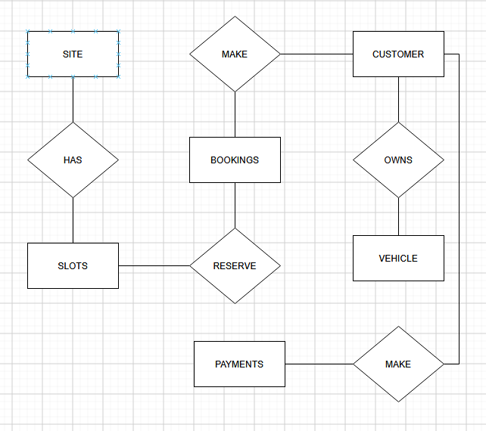
There are 3 main models of diagrams – Conceptual, Logical and Physical - which we will demonstrate and explain in this chapter.

Conceptual

A Conceptual diagram is a high-level diagram to help to understand the necessities in an overview perspective between the analysts and business. It contains how the data set relates to each other.
For the car park the necessity of controlling park slots defines the relation between the entities, their actions and data flow.

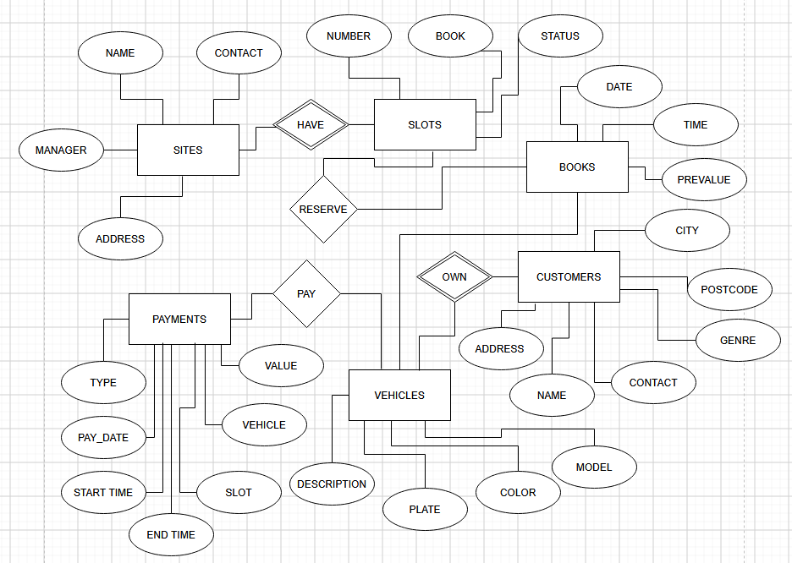
Over view

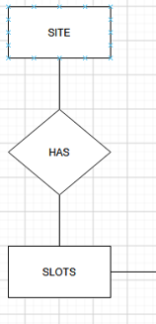 | Every site address has its own park slots.
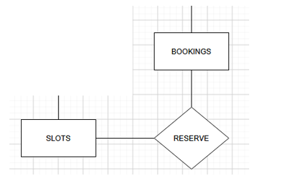 | Booking a date and time reserve Slot and guarantee a place when a customer arrives.
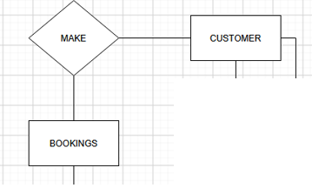 | Customer can book in advanced a date and time slot.
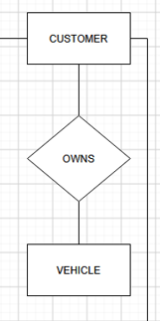 | Customers must have registered their vehicles to have access to the park.
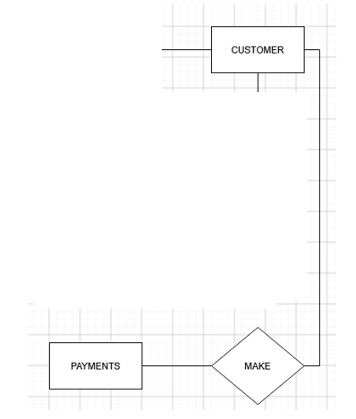 | Customers make payments when they check out the park station.

Logical

A logical diagram expands the details and visualizes attributes and relationships between data points.
In this faze we can identify the attributes and names for what is going to be storage. As its relational actions between the attributes.

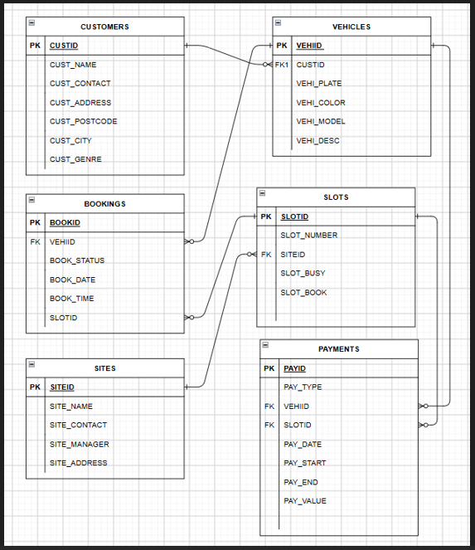

Physical

The physical diagram is a most complete description of attributes and relationships. Its show a real translation of logical diagram into real tables, columns, types, relations, and indexes. [2]

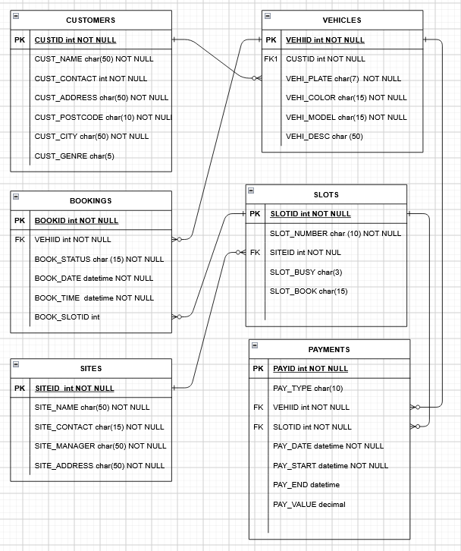

Data Structure Design

The data structure design is essential part in understand and transform the ERD into the database itself creating all tables and its attributes and relationships.

Entities, attributes and datatype

Tables created to storage all information for the car parking system.
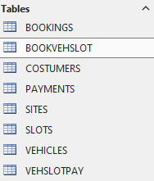
Entities, attributes, datatype and description
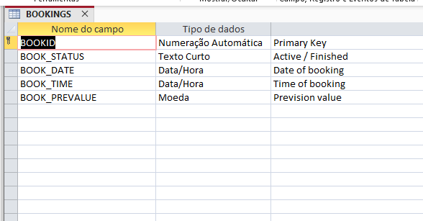
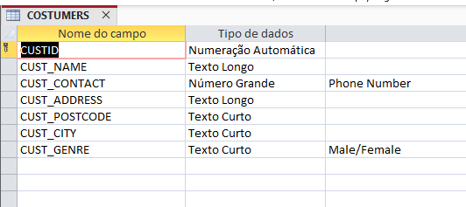
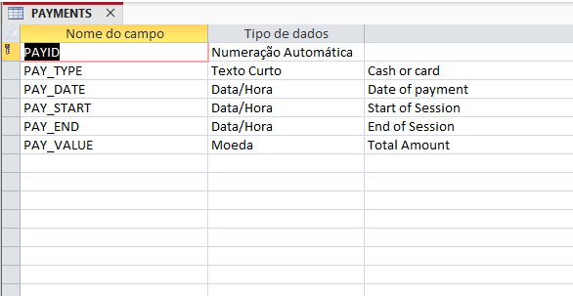
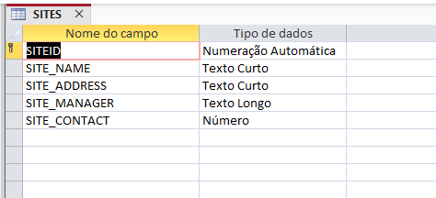
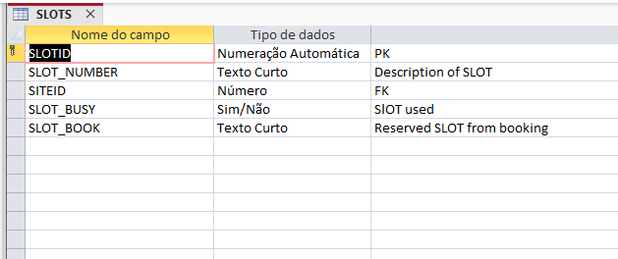
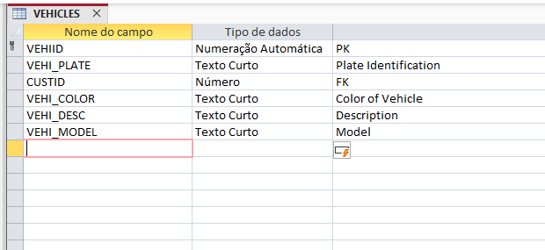

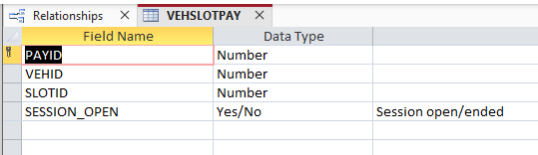
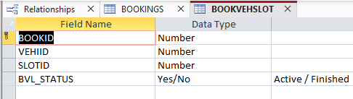

Relationships and constraints
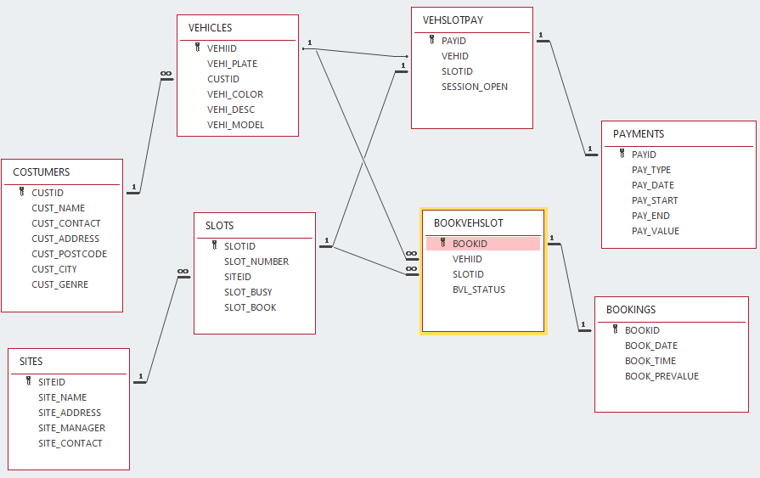
The relationship and constraints are displayed in this diagram where it’s possible to see the connections between the entities and its database relationship types.
As explained, it’s possible to analyse the relation between:
- CUSTOMERS and VEHICES, with a relation of ONE customer can have MANY vehicles.
- SITES and SLOTS, with a relation of ONE site have MANY slots.
- VEHSLOTPAY, VEHICLES, PAYMENTS and SLOTS, with a relation of ONE payment can be paid by ONE vehicle for ONE slot.
- BOOKVEHISLOT, BOOKINGS, VEHICLE and SLOTS, with a relation of ONE vehicle can make MANY bookings and ONE slot can be book in MANY slots.

Normalization (Up to 3NF)
An important process of database design is the Normalization. It organizes data into specifics tables improving integrity, help to avoid anomalies, reduces redundancy and improve performance. [3]

First Normal Form (1NF)

Most Basic form of normalization, ensures a cells/columns contain single values and requires a database table schema to include a primary key.
Before 1NF:

CUSTOMERS
NAME | ADDRESS | VEHICLE | PLATE
John M | White road | Golf, Honda, XPTO | HG87789, HL98JHG, PO78JHG

There are multiples values on `VEHICLE´ and `PLATE´. To guarantee an unique value a new table will be create and the relationship between will allow a customer to own multiples Vehicles.

After 1NF:

CUSTOMERS
CUSTOMERID | NAME | ADDRESS
1 | Jonh M | White road

VEHICLES
VEHICLEID | CUSTOMERID | VEHICLEMODEL | VEHICLEPLATE
1 | 1 | Golf | HG87789
2 | 1 | Honda | HL98JHG
3 | 1 | XPTO | PO78JHG

Before 1NF:

SITES
NAME | ADDRESS | SLOTNUMBER | SLOTBUSY
Green valley | Brown road | GAA1,GAH2,GHP0, | YES,YES,NO
Jubilee | Black house | BAA1,BAH2,BKK1 | NO.NO,NO

There are multiples values on `SLOTNUMBER´ and `SLOTBUSY´. To guarantee an unique value a new table will be create and the relationship between will allow a Site to have multiples SLOTS with availability status.

After 1NF:

SITES
SITEID | NAME | ADDRESS
1 | Green valley | Brown road
2 | Jubilee | Black house

SLOTS
SLOTID | SITEID | SLOTNUMBER | SLOTBUSY
1 | 1 | GAA1 | YES
2 | 1 | GAH2 | YES
3 | 1 | GHP0 | NO
4 | 2 | BAA1 | NO
5 | 2 | BAH2 | NO
6 | 2 | BKK1 | NO

Second Normal Form (2NF)

After applying for the 1NF, the 2NF goes a step further with an additional rule: eliminate partial dependencies. A partial dependency occurs when a non-primary attribute (a column that is not part of any candidate key) depends only on part of a composite key instead of the entire key. The 2NF rule ensures that all non-prime attributes depend on the entire primary key, not just a part of it. Leaving partial dependencies in a table means that redundant data can infiltrate the database. [4]

Before 2NF:

PAYMENTS
PAYID | VEHIID | SLOTID | TYPE | VALUE | DATE
1 | 1 | 2 | CARD | 32.00 | 17/02/2026
2 | 2 | 4 | CARD | 10.00 | 02/03/2026
3 | 5 | 5 | CASH | 50.00 | 15/05/2026

In this table the information TYPE, VALUE and DATE are only related to table PAYMENTS, and not to combination of keys PAYID, VEHIID and SLOTID. So, another table will be created to divide and organize the database.

After 2NF:

VEHSLOTID
PAYID | VEHIID | SLOTID
1 | 1 | 2
2 | 2 | 4
3 | 5 | 5

PAYMENTS
PAYID | TYPE | DATE | VALUE
1 | CARD | 17/02/2026 | 32.00
2 | CARD | 02/03/2026 | 10.00
3 | CASH | 15/05/2026 | 50.00

Before 2NF:

BOOKINGS
BOOKID | VEHIID | SLOTID | STATUS | DATE | TIME
1 | 1 | 2 | Finished | 17/02/2026 | 13:00
2 | 2 | 4 | Finished | 02/03/2026 | 13:15
3 | 5 | 5 | Active | 15/05/2026 | 09:00

In this table the information STATUS, DATE and TIME are only related to table BOOKINGS and not the combination of keys BOOKID, VEHIID and SLOTID. So, another table will be created to divide and organize the database;

After 2NF:

BOOKVEHSLOT
BOOKID | VEHIID | SLOTID
1 | 1 | 2
2 | 2 | 4
3 | 5 | 5

BOOKINGS
BOOKID | STATUS | DATE | TIME
1 | Finished | 17/02/2026 | 13:00
2 | Finished | 02/03/2026 | 13:15
3 | Active | 15/05/2026 | 09:00

Third Normal Form (3NF)

After applying for the 1NF and 2NF, the 3NF goes further, removing transitive dependencies, a situation in which non-key attributes depend indirectly on the primary key. 3NF ensures that each keyless column in a table is directly linked to the primary key and nothing else.
In this scenario, we can see all entities are already well defined with its attributes ensuring that all attributes are in the table linked to its primary key.

Sample Data

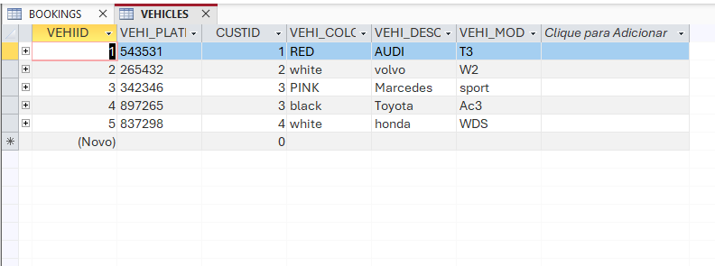
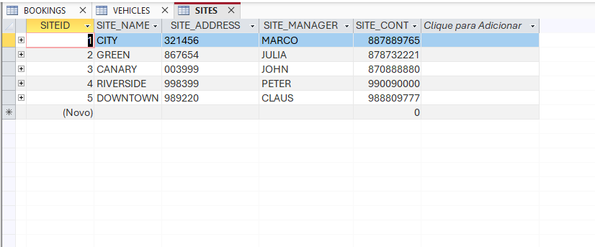
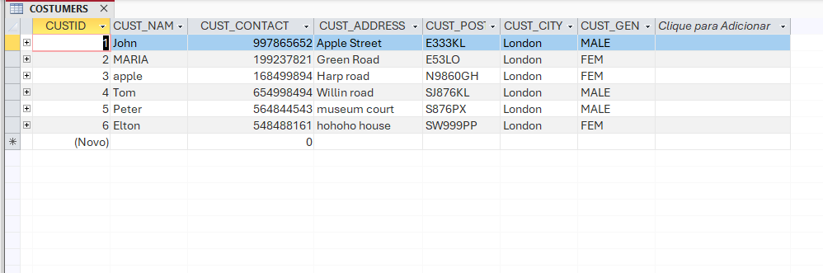
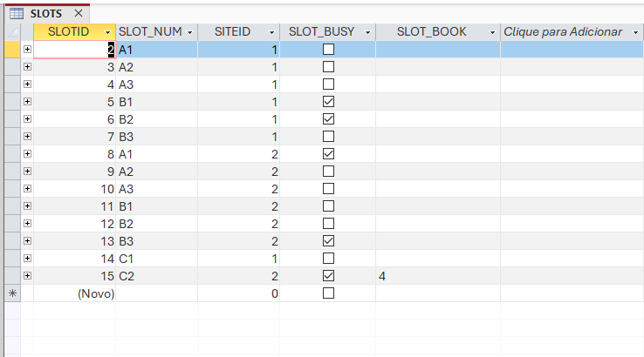
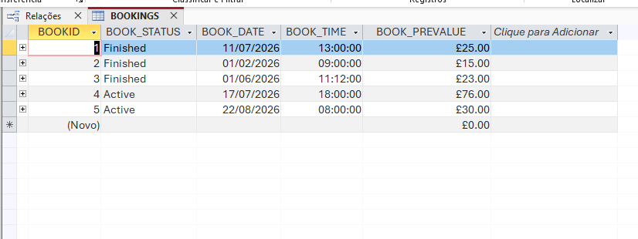
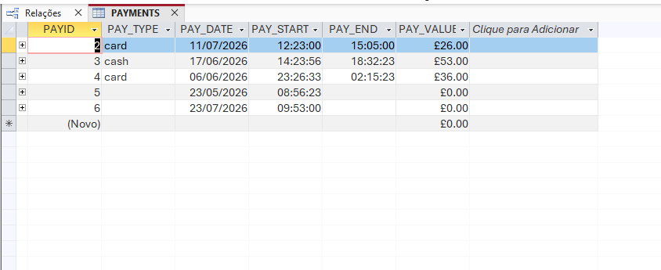

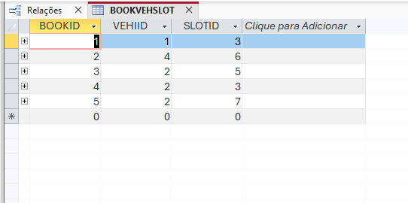
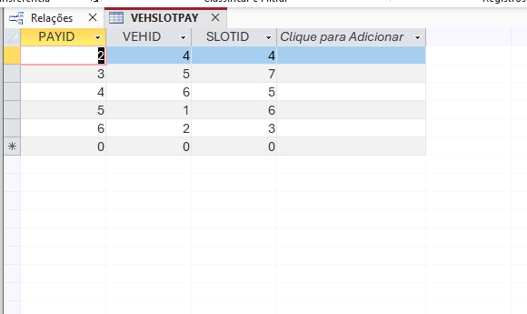

Queries
Customes PostCode
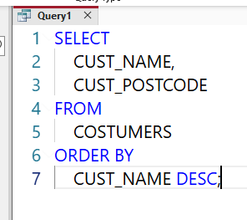 | 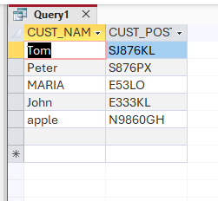
Query that results in a record set that contains the POSTCODE from all CUSTOMERS order by Z-A sort.

FREE Slots
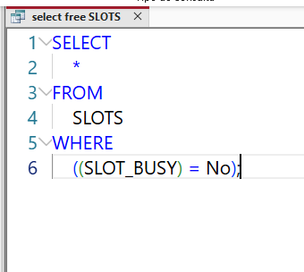 | 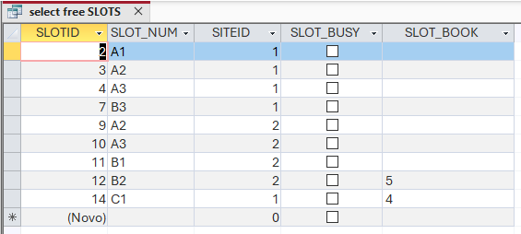
Query that results in a record set that contains all information about SLOTS that the flag BUSY is set to `No`, which means these are FREE slots.

FREE Slots
Query that results in a record set that contains all information about SLOTS that the flag BUSY is set to `No`, which means these are FREE slots.

Open session - Not ended payments
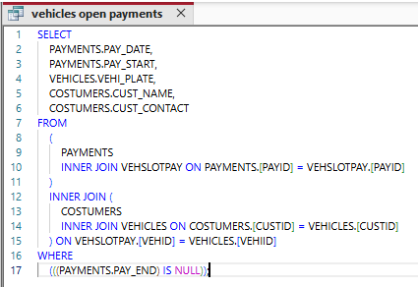 | 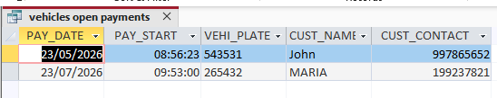
Query that results in a record set that contains information about Customer names, vehicle plates and contact numbers from PAYMENTS that are not finished, which means these sessions are currently open in the car parking.

Forms and Reports

Forms

Form with information from customers with vehicles

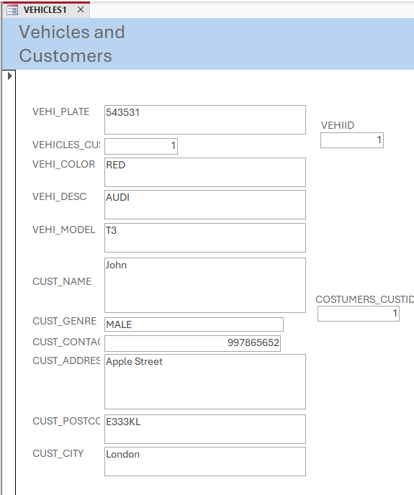

Form with information from customers

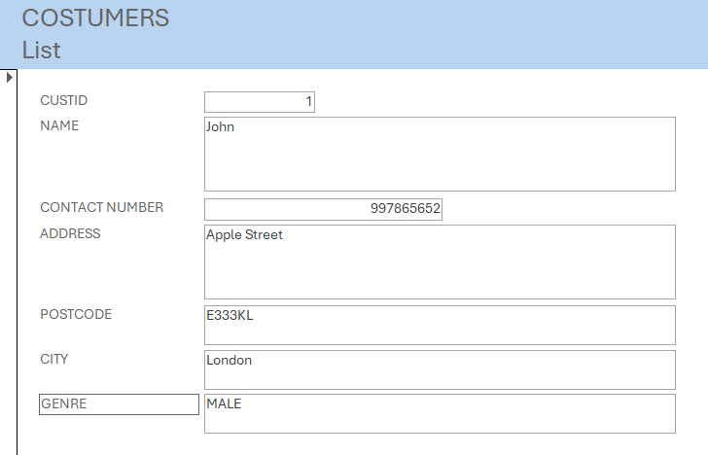

Form with information from customers

Form with information from slots based on site

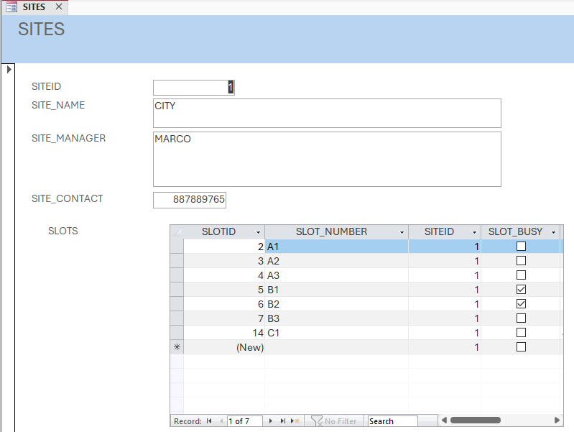

Reports

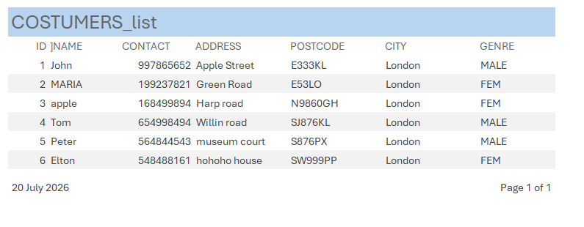 | Report to list all  Customers General information
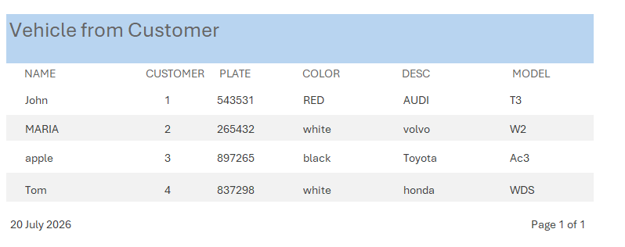 | Report to List the vehicle related to customer
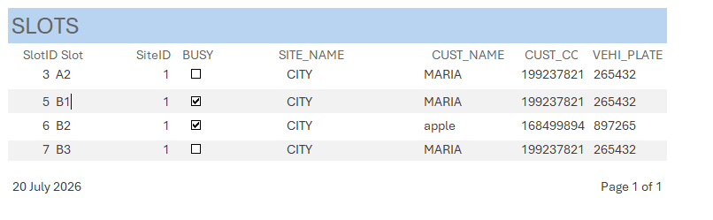 | Report to list the slots and its last update status with customer and vehicle informations

Validation and Testing
Database testing is the practice of validating database schemas, tables, procedures, triggers, and data integrity to ensure that backend data operations support application functionality correctly. It goes beyond verifying that data exists to confirm that data is accurate, consistent, complete, and properly structured. [5]
Validate currency, dates and times to don’t allow other formats and text.
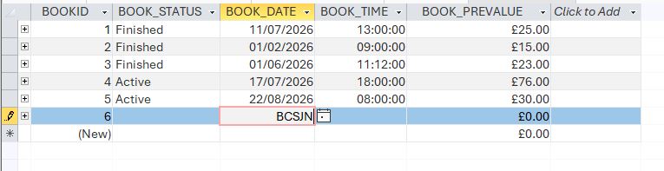
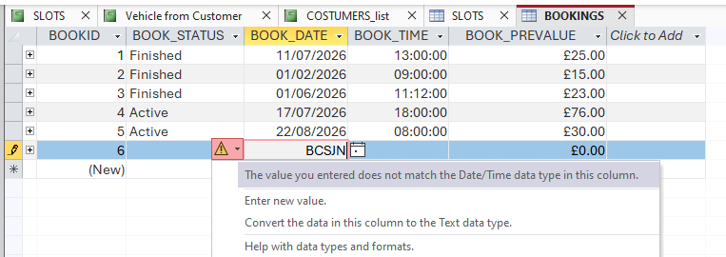

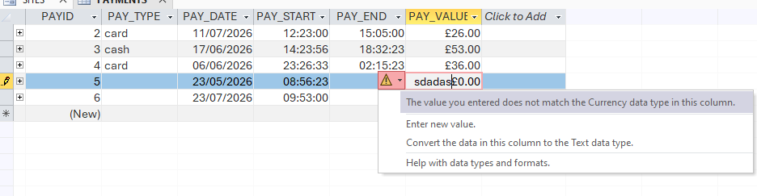

Reflection
The main challenge found in this report was to try to understand the structure to be created as we didn’t have much information about the business user’s needs and transform into diagrams. Normalization, which is an important process to database, was very helpful to correct some mistakes and improve the quality of data store.
Use of MS Access is very intuitive as, graphically, is user friendly. Is easy to create and manage all components of database, mainly in relationship management.

Conclusion
In this assessment, a car parking database system was created to store the necessity of a business. Using MS Access as DBMS we development a system with Entities, Attributes and Relationship based on ERD (Entity Relationship Diagrams). Scalability and performance are not in scope of analysis of this assessment.
As request by requirements analysis standard queries, report and form were created to view and manage data for the user.
The database system was filled with sample information to help the user to understand each field and its function.
The necessity to digitalize a business once managing manually helps to avoid user’s mistakes as all information is centralized, secured, logged and fast access by manager. The information is more trustful, and the owner of business can control all sites online in real-time.

References

[1] | C. S. Ivan Belcic, “https://www.ibm.com/,” 17 07 2026. [Online]. Available: https://www.ibm.com/think/topics/entity-relationship-diagram.
[2] | A. Athuraliya, “https://creately.com/,” 23 01 2026. [Online]. Available: https://creately.com/guides/types-of-erd/. [Accessed 18 07 2026].
[3] | A. Gomstyn, “https://www.ibm.com/br-pt/think/topics/database-normalization,” IBM, 18 07 2026. [Online]. Available: https://www.ibm.com/br-pt/think/topics/database-normalization.
[4] | E. F. Codd, “https://www.datacamp.com/,” 20 07 2026. [Online]. Available: https://www.datacamp.com//tutorial/second-normal-form.
[5] | A. Pandey, “https://www.virtuosoqa.com/,” 10 10 2025. [Online]. Available: https://www.virtuosoqa.com/testing-guides/database-testing. [Accessed 2026 07 20].

