Within this assignment, I intend to critically evaluate Assessment for Learning (AfL) strategies through analysing key documentation and exploring the implementation of AfL within a primary school setting. The strengths of Assessment for Learning will be explored throughout this assignment along with limitations. Prior to Donaldson’s (2015) review of the curriculum, the government acknowledged that “there is a need to create greater coherence between evaluation and assessment arrangements for pupils.” (Welsh Government, 2014. p. 9). This indicates that Assessment for Learning strategies and the way in which they have been enforced within schools has not been as successful as initially intended.
For this assignment three lessons have been devised in order to demonstrate personal awareness of different Assessment for Learning strategies and how they will be used in order to progress a child’s learning. The class I have created these learning experiences for consists of twenty-eight pupils in Year two, meaning they are of the ages six and seven. The class is mixed ability and contains three pupils who have been identified as having Additional Learning Needs (ALN). These needs include that of Dyslexia, Downs Syndrome and having a visual impairment with only partial sight available. Within the class there have also been six pupils identified as being More Able and Talented (MAT), meaning they exceed expectations in specific areas for their age. Welsh Government (2008) recognise MAT pupils as individuals who “require opportunities for enrichment and extension that go beyond those provided for the general cohort of pupils.” There are no pupils who are entitled to Free School Meals (FSM) within the class. The needs of all pupils have been considered when planning and devising learning episodes.
Within the overall scheme of work, the theme of ‘Environments of the World’ will take place over a half term and throughout the half term, the pupils will discover and where possible, be exposed to, different environments of the world through the Areas of Learning and Experience (AoLE). Teaching and learning taking a thematic approach allows fluidity between Areas of Learning and Experience. It has been put forward that in order for thematic teaching to be effective, the units have to be “broad enough to provide authentic experiences in more than one content area.” (Barton and Smith, 2000, p.54) The three learning episodes that have been planned for this assignment will be based on the environment of a rainforest. The pupils will not have had any previous taught knowledge of ‘The Rainforest’ as an environment. As a stimulus, the book ‘Rainforest Explorers’ written by Marnie Willow will be used to engage the pupils further with the theme. Having a story as a catalyst for the learning episodes will not only stimulate curiosity within the pupils but will allow objectives to be identified in an uncommon way and enable lines of enquiry to be established (Fletcher-Wood, 2017).
The Areas of Learning and Experience I have chosen to focus on consist of Humanities, Science and Technology and Languages, Literacy and Communication (LLC). Within the Humanities AoLE there is a specific focus on Geography where the pupils will be creating their own maps, mirroring the reading and following of a map within the story. The Science and Technology Area of Learning and Experience will be paired with Art from the Expressive Arts AoLE. Cross-curricular learning reflects the environment in which we live, Barnes (2011) states that “our experience of the world is cross-curricular” and therefore providing pupils with a one-dimensional view of that would be unrealistic. The pupils will be creating their interpretation of the layers that form a rainforest using differing mediums. The final AoLE chosen is Languages, Literacy and Communication. The pupils will embody a rainforest explorer and write a diary entry to recount what they have experienced whilst in the rainforest.

Black and Wiliam (1998) coined the term ‘assessment’ as a means to identify activities undertaken by both teacher and pupils alike in order to gain information that will enable the modification of teaching and learning activities. They argue that “such assessment becomes formative when the evidence is actually used to adapt the teaching to meet students’ needs.” Recognised also by Grigg (2015, p396) Formative learning, more commonly recognised as Assessment for Learning, should “serve the purpose of improving as well as proving learning.” The term ‘assessment’ has come under scrutiny through the years as it holds strong connotations with tests and examinations. Grigg, R. (2015) suggests that “Too readily the term ‘assessment’ is associated with marking and grading pupils’ work and success in tests or examinations” and claims “Assessment has a wider remit than just measuring learning.”
Assessment inevitably allows a teacher to understand and determine the quality of pupils’ learning. Once the teacher has this knowledge, using Assessment for Learning strategies, they can plan and adhere future learning experiences in order to enhance pupils’ learning further and encourage them to make connections with past learning experiences, current knowledge, their skills and their understanding of a particular topic. Interrelating what and how the pupils learn provides a “rich source of data” that will enable the teacher to develop targets for the pupils and encourages evaluation of teaching methods applied (Headington, 2003). It is of high importance that pupils be trained in how to interpret feedback, how to connect their feedback with the work they have produced and how to make improvements. “Any formative assessment that is not self-assessment involves communication” (Sadler, 1998). This implies that the communication between teacher and learner needs to be well established in order to create meaningful feedback. Consequently, if that dialogue between teacher and learner or even learner and learner is not credible, the child’s initial understanding of what needs to be improved will be hindered.
The NACCCE report in 1999 noted that formative assessment is of “relatively minor importance in school procedures and argued for a more privileged place for formative assessment.” (Barnes, 2015 p.217) An argument put forward by Constructivists suggests that an assessment system “intended to improve the quality of learning should not treat students as imperfect pupils, but as people who are actively trying to make sense of what they are taught” (James, 1998). Assessment for Learning may always be an ever evolving topic, research such as Clarke’s (2001) (in Barnes, 2015, p.217) eighteen-month project into formative assessment brought about the introduction of now everyday terms such as ‘learning intentions’, ‘success criteria’ and ‘pupil self-evaluation’. The conclusion of this project harvested many benefits for both pupils and teachers. The staff found that their pupils enjoyed having knowledge of the learning intentions and success criteria and seventy-five per cent of teachers who participated stated that their pupils had a better knowledge of the tasks they had to carry out. Fifty per cent of teachers noted that all pupils, no matter their ability, could access self-evaluation questions. James (1998) believes student self and peer-assessment should not be regarded as an optional extra but should be an essential part of any assessment that aspires to have a positive impact on learning.”
One of the immediate dangers with AfL is that “teachers become cosmetic in its application” They may regularly share learning objectives at the start of the lesson but fail to break them down so that pupils understand the ideas. “Pupils need to understand the goals of their learning so that they can judge whether they have achieved them” (Grigg, 2015). Previously, the assessment of how pupils learn have been left solely at the discretion of individual teachers and the ethos within a school (Headington, 2003). Within the new curriculum for Wales, becoming statutory in 2022, Assessment for Learning adopts an indispensable role. Donaldson (2015) proposed the embedment of AfL within the twelve pedagogical principles in the upcoming curriculum. Wiliam (in Donaldson, 2015, p.68) suggested that effective AfL can “double the rate of learning.”
Discussed in more detail further into the assignment, the AfL strategies chosen to be interwoven into lessons planned include that of self and peer assessment, questioning and teacher feedback. Self-assessment encourages pupils to enhance their understanding of the learning objectives and success criteria by making judgements about their work against criteria given. By doing this, pupils are encouraged to take responsibility for their work and deepen their knowledge of what is expected of them (University of Reading, No date). It has been argued that peer and self-assessment come hand in hand, it would be unlikely for a pupil to provide successful feedback to a peer without a solid understanding of the strengths and weaknesses within their own work prior. A weakness identified within peer assessment is the possibility of friendship bias, meaning that if a child is asked to assess their friend’s work, it opens up the possibility of the child ignoring the success criteria and providing their peer with positive not constructive feedback (University of Exeter, 2019).
Questioning techniques within a classroom may be seen as effective if used correctly; it is only natural to ask questions. Research implies that “teachers ask over four hundred questions a day”, (The National Society for Education in Art and Design, No Date) these questions may vary from asking the pupils to recall facts related to work ‘What is the capital of France?’, personal questions ‘How are you feeling today?’, or more general questions such as ‘Have you washed your hands?’. Black and Wiliam (1998) argue that if the “question/answer dialogue becomes a ritual, then thoughtful involvement suffers.” Questions can be used by teachers to engage students and encourage an active approach to learning. However, it has been found that many teachers fail to plan and conduct classroom dialogue in such a way that is beneficial to students’ learning. Research has found that once a teacher has asked a question, they fail to wait an appropriate amount of time, many teachers “wait less than one second” before asking further questions or in fact answering questions themselves (Black et al 2004, p.2).
Hattie and Timperly (in Hattie and Clarke, 2019) defined feedback as “relating to actions or information provided by an agent that provides information regarding one’s performance or understanding.” Feedback may come orally or written and aims to inform a child of their successes and what could be improved upon. Klunger and DeNisi (1996) found that feedback can be at its optimal effectiveness when outcomes are specific and challenging enough for pupils but when the complexity of the task is low. The effectiveness of feedback may also be questioned due to factors such as how the receiver of the feedback interprets it. If feedback is unclear, then a child may respond negatively to this and deem themselves a failure. How and whether the feedback is acted upon also coincides with a child’s perception of their ability (Hattie and Clarke, 2019).

The following section of the assignment will explore in detail the three Areas of Learning and Experience I have chosen to focus on. Linked with Assessment for Learning strategies, the ways in which the pupils could progress will be explored along with rationales for my decisions.
The first Area of Learning and Experience chosen was Humanities, more specifically the element of Geography (see appendix 1). This AoLE was chosen as it specifically supports one of the four core purposes of the draft curriculum, allowing pupils to become “ethical informed citizens of Wales and the world” (Welsh Government, 2019). The learning episode itself will take place over an hour and will begin with the reading of two pages of ‘Rainforest Explorers’ written by Marnie Willow. The choice for this book was made due to the fact that it not only ties in with the holistic theme of ‘Environments in our World’ but through allowing the pupils to fully engage with the book, it encourages different Areas of Learning and Experience to be explored. By modelling the reading of the book to the students, it strengthens their ability to listen to a text being read aloud and through teacher demonstration, allows pupils to see a purpose to reading and learning to read. Modelled reading also allows teachers to demonstrate good reading behaviour and can build a background from which pupils can adopt when reading independently (State Government of Victoria, 2019). The choice to only read the first two pages of the book in this lesson was made as I felt disclosing the whole story to the pupils initially would spoil the upcoming lessons.
The lesson focus will be to create maps of their local area and be introduced to using a compass. By completing this activity, it not only improves the pupils’ use and creation of maps but links back to the core purpose mentioned previously. Through allowing the pupils to create maps of their local area, it enhances their knowledge of the local area whilst understanding that maps are used for navigation, as the story suggests. The skills being developed within this lesson include that of listening, as they will have to listen and engage with the story and receive feedback, communication, as the pupils will be expected to ask questions to solidify their knowledge and communicate with each other orally when giving feedback to their peers and finally the development of the skills it requires to create and follow a map. In order to complete this map, the pupils previously undertook a walk around their local community to gain first-hand visual experience of where they live in order to make their map factually accurate. Linking to the ‘What Matters’ statements within the draft curriculum, the pupils will further personal knowledge of the world by understanding that “our natural world is diverse and dynamic, influenced by physical processes and human actions” (Welsh Government, 2019). Progression Step Two within the draft curriculum implies that pupils should have the knowledge to be able to “describe the distinct physical features of places, environments and landscapes in Wales and the wider world” (Welsh Government, 2019). Whilst recognising the differing abilities with the class, some pupils may be able to achieve aspects of Progression Step Three, being able to “describe and locate places, environments and landscapes, including distinctive features and landforms, using map skills where appropriate” (Welsh Government, 2019).
The pupils will be grouped based on ability, as mentioned within the introduction of this assignment, there are pupils within the class who identify as having Additional Learning Needs and will therefore be supported by the teaching assistant. These pupils will additionally be supported by their peers in the class who identify as More Able and Talented. The decision was made to pair these pupils together as the More Able and Talented pupils may have a clearer understanding of what is expected of them by acknowledging the learning objectives and success criteria, they will then be able to pass on this knowledge, in a suitable format to their peers.
The Assessment for Learning strategy imposed for this learning episode is that of peer and self-assessment. Partnering up the pupils as described above will encourage constant peer assessment throughout the lesson where they will deliver instant oral feedback whilst the activity is being completed. The aim of this is that the pupils identified as MAT will encourage the ALN pupils through positive but constructive feedback. A limitation of this could be that due to peer bias, the pupils may not feel confident in offering constructive feedback to a peer that appears less able than themselves. However, to combat this, the support of the teaching assistant will be crucial in ensuring feedback is fair. During the plenary, the pupils will partake in a ‘walking gallery’ whereby they will walk around the classroom and observe their peers’ work, offering them comments about the strengths and constructive feedback about what could be improved in alignment with the learning objectives and success criteria.

The second Area of Learning and Experiences chosen was Expressive Arts, more specifically the element of Art and Science and Technology (see appendix 2). These AoLEs were chosen not only being they link with Donaldson’s (2015) four core purposes of the imminent curriculum, being that pupils should become “ambitious, capable pupils, ready to learn throughout their lives, but it also encourages creativity and within the Foundation Phase, this is crucial (Welsh Government, 2019). Creativity through the Expressive Arts allows pupils to gain a deeper understanding and appreciation for Wales and the world in which we live. Expressive Arts encourages pupils to develop physical, social and emotional skills that may otherwise be overlooked in different AoLEs. Within the Science and Technology AoLE, the pupils will be exposed to the different habitats of the animals within the rainforest through the medium of books and the internet. This links with the core purpose of pupils being able to “enterprising, creative contributors, ready to play a full part in life and work” (Welsh Government, 2019).
The focus of the learning experience will be creating two dimensional representations of the layers within a rainforest and will take place over the course of a whole afternoon. Following the reading of the whole book ‘Rainforest Explorers’, time will be allocated for questions around what the pupils have just been read. This will allow a deeper understanding to develop. In small groups of around five, the pupils will cooperatively recreate one layer each of the rainforest using any materials available to them. Allowing the pupils to take responsibility of the materials ensures that they are able to make decisions decisively and as a group and also encourages them to explore materials they may not commonly associate with the objects they re trying to recreate. The skills the pupils should develop within this learning experience are ones not only relating to listening and oracy, through communication with the peers in their group, but fine motor skills are being enhanced through the use of scissors and materials. Through working in groups, the pupils are able to experience working together and overcoming any obstacles that may be in their way. Bertrand (No Date) suggests that the benefits of group work outweigh the disadvantages, implying that group work encourages pupils to work with peers they may not necessarily usually associate with and it teaches pupils to become leaders and to be led by someone who is not their teacher.
The pupils will once again be grouped based on ability however, for this learning experience will not be paired and will remain within their ability groups. The teaching assistant will work with the lower ability group but will play the part of an observer and will encourage the pupils to work within their group with little help from an adult. The reason for doing so links with the chosen Assessment for Learning strategy of Questioning. Allowing the pupils to express themselves freely within their assigned ability group opens up a dialogue between teacher and pupil, and pupil and pupil that will enable the teacher to gain insight on the pupils’ progress. Through asking both open and closed questions relating to the learning objective, the ability to gain knowledge of whether or not the pupils understand what is being asked of them and what they have to achieve to fulfil the success criteria. Allowing the pupils sufficient time to answer the given question is crucial to interpret what skills and knowledge is being developed.
Linking this learning episode to the draft curriculum, one of the Science and Technology ‘What Matters’ statements sets forth that pupils understand that “the world around us is full of living things that depend on each other for survival.” The Progression Step Two under this statement notes that pupils “explore how different habitats provide resources for living things to survive” (Welsh Government, 2019). Within the Expressive Arts AoLE, the ‘What Matters’ statement that best links with this learning episode states that “creative work combines knowledge and skills using the senses, inspiration and imagination.” Working on Progression Step Two, pupils should “select and use a range of create techniques, materials and resources, tools and technologies to achieve different outcomes” (Welsh Government, 2019).

The final Area of Learning and Experience explored for this assignment was that of Languages, Literacy and Communication (see appendix 3). The rationale behind choosing this AoLE was that it seemed appropriate to use the completion of the story ‘Rainforest Explorers’ to allow the pupils to explore their thoughts and feelings through writing. This AoLE marries closely with the core purpose of being “ambitious, capable pupils, ready to learn throughout their lives” (Welsh Government, 2019). The learning episode will take place over the period of a morning, allowing sufficient time for an in-depth discussion and writing time.
The main focus of this learning episode will be to produce a reflective piece of writing in a dairy format. The pupils will be asked to embody a character within the book and draw upon their thoughts and feelings using the senses to reflect upon in their writing. Through completing this, the pupils are building on previous knowledge of what they have learnt combining that with their imagination of what a rainforest will smell, look, feel, sound and taste like. The pupils will be grouped based on their ability however will be working independently for this task as it is a personal reflection. The intentions of each ability will be differentiated through the amount written. The lowest ability group will be expected to produce a minimum of six sentences, one for each sense and then their overall feeling towards the rainforest. Members of the lowest ability group will have sentence structures provided as a visual aid if needed. The child with the visual impairment will have a copy of the story with enlarged font and will work closely with the teaching assistant. As the ability increases, the amount written, and the detail provided will develop accordingly.
The Assessment for Learning strategy proposed for this learning episode is that of Written Teacher Feedback. The justification for this is that throughout the learning episodes, the pupils have encountered many instances of oral assessment and feedback, however, have had limited experience of written feedback. It will encourage the pupils to engage and understand feedback in a written format, allowing them to understand what they have done well and what they can improve upon. Written feedback can encourage independence as it will be the responsibility of the pupils to enhance their work or ask for clarification when needed. This learning episode links with the ‘What Matters’ statement “Literature fires imagination and inspires creativity.” Within Progression Step Two, one achievement outcome states that “I can use my imagination to respond to literature and create my own” (Welsh Government, 2019). The skills being developed from this learning episode could be that of creative writing, having the ability to work independently and responding to feedback correctly. The pupils will gain a deeper understanding of their feelings when completing their diary entries.
In conclusion, it is clear that the Assessment for Learning strategies chosen for the learning episodes hold both strengths and weaknesses. Overall, I believe that each AfL technique will progress a child’s learning and their ability to assess and improve their work. Peer and self-assessment allow pupils to think about their work and re-evaluate their perceptions of the learning objectives and success criteria from a personal point of view and from constructive feedback from their peers. Questioning techniques encourage pupils not only to recall factual information about what they know or have learned but also to think deeper and expand on their answers by introducing their opinion to what they have learned. Teacher feedback encourages pupils to gain an insight as to whether or not they have fully understood what is expected of them when carrying out work and encourages the pupils to independently rectify misconceptions. Despite teacher feedback most commonly being in a written format, pupils develop their communication skills though asking questions and opening up dialogue between teacher and pupil on a more personal level regarding their work. It also allows a child’s confidence to grow as teacher feedback can be personalised and can allow a child to receive comments that could usually go unsaid verbally. As well as the benefits to Assessment for Learning, there are some potential drawbacks including the time and training it would take for all staff members to feel confident using various techniques within their classroom. Possible requirements of additional professional training come at an expense to the schools: this budget may not be readily available to all staff (Cambridge Assessment, No Date).

Reference List:
Barnes, J. (2011) Cross-Curricular Learning 3-14. 2nd Ed. London: Sage.
Barnes, J. (2011, p. 217) Cross-Curricular Learning 3-14. 2nd Ed. London: Sage.
Barton, K. and Smith, L. (2000) ‘Themes or Motifs? Aiming for Coherence through Interdisciplinary Outlines’, The Reading Teacher, 54(1), pp. 54-63.
Black, P. et al (2004) Working inside the Black box: Assessment for Learning in the Classroom. London: King’s College London.
Black, P. and Wiliam, D. (1998) Inside the Black Box: Raising Standards through Classroom Assessment. London: King’s College London.
Bertrand, J. (No Date) Working in pairs and groups. Available at: https://www.teachingenglish.org.uk/article/working-pairs-groups (Accessed: 25th October 2019)
Cambridge Assessment (No date) Getting started with Assessment for Learning. Available at: https://cambridge-community.org.uk/professional-development/gswafl/index.html (Accessed: 28th October 2019)
Donaldson, G. (2015) Successful Futures. Available at: https://dera.ioe.ac.uk/22165/2/150225-successful-futures-en_Redacted.pdf (Accessed: 22nd October 2019)
Donaldson, G. (2015, p. 68) Successful Futures. Available at: https://dera.ioe.ac.uk/22165/2/150225-successful-futures-en_Redacted.pdf (Accessed: 22nd October 2019)
Fletcher-Wood, H. (2017) Starting a lesson with Initial Stimulus Material. Available at: https://improvingteaching.co.uk/2017/01/15/starting-a-lesson-with-initial-stimulus-material/ (Accessed: 22nd October 2019)
Grigg, R. (2015) Becoming an Outstanding Primary School Teacher. 2nd Ed. London: Routledge.
Hattie, J. and Clarke, S. (2019) Visible Learning. 1st Ed. London: Routledge.
Headington, R. (2003) Monitoring, Assessment, Recording, Reporting and Accountability. 2nd Ed. London: David Fulton Publishers.
James. M (1998) Using assessment for school improvement. 1st Ed. Oxford: Heinemann Educational Publishers.
Klunger, A.N. and DeNisi, A. (1996) ‘The effects of feedback interventions on performance: A historical review, a meta-analysis and a preliminary feedback intervention theory’, Psychological Bulletin, 119(2), p.254.
National Society for Education in Art and Design (No Date) Effective Questioning and Classroom Talk. Available at: http://www.nsead.org/downloads/Effective_Questioning&Talk.pdf (Accessed: 25th October 2019)
Sadler, D. R. (1998) Formative Assessment: Revisiting the territory. Available at: https://www.tandfonline.com/doi/pdf/10.1080/0969595980050104 (Accessed: 23rd October 2019)
State Government of Victoria. (2019) Education and Training: Modelled Reading. Available at: https://www.education.vic.gov.au/school/teachers/teachingresources/discipline/english/literacy/readingviewing/Pages/teachingpracmodelled.aspx (Accessed: 25th October 2019)
University of Exeter. (2019) Peer and self-assessment in student work: principles and criteria. Available at: http://as.exeter.ac.uk/academic-policy-standards/tqa-manual/lts/peerselfassessment/ (Accessed: 25th October 2019)
University of Reading. (No Date) Engage in Assessment: Peer and Self-Assessment. Available at: https://www.reading.ac.uk/engageinassessment/peer-and-self-assessment/eia-peer-and-self-assessment-main.aspx (Accessed: 25th October 2019)
Welsh Government (2019) Draft Curriculum for Wales: 2022. Available at: https://hwb.gov.wales/draft-curriculum-for-wales-2022/ (Accessed: 25th October 2019)
Welsh Government (2019) Draft Curriculum for Wales 2022: Expressive Arts. Available at: https://hwb.gov.wales/draft-curriculum-for-wales-2022/expressive-arts/ (Accessed 25th October 2019)
Welsh Government (2019) Draft Curriculum for Wales 2022: Humanities. Available at: https://hwb.gov.wales/draft-curriculum-for-wales-2022/humanities/ (Accessed: 25th October 2019)
Welsh Government (2019) Draft Curriculum for Wales 2022: Languages, Literacy and Communication. Available at: https://hwb.gov.wales/draft-curriculum-for-wales-2022/languages-literacy-and-communication/ (Accessed: 25th October 2019)
Welsh Government (2019) Draft Curriculum for Wales 2022: Science and Technology. Available at: https://hwb.gov.wales/draft-curriculum-for-wales-2022/science-and-technology/ (Accessed: 25th October 2019)
Welsh Government (2008) Meeting the Challenge: Quality Standards in Education for More Able and Talented Pupils. Available at: https://gov.wales/sites/default/files/publications/2018-11/meeting-the-challenge-quality-standards-in-education-for-more-able-and-talented-pupils_0.pdf (Accessed: 21st October 2019)

Appendices:
Appendix 1
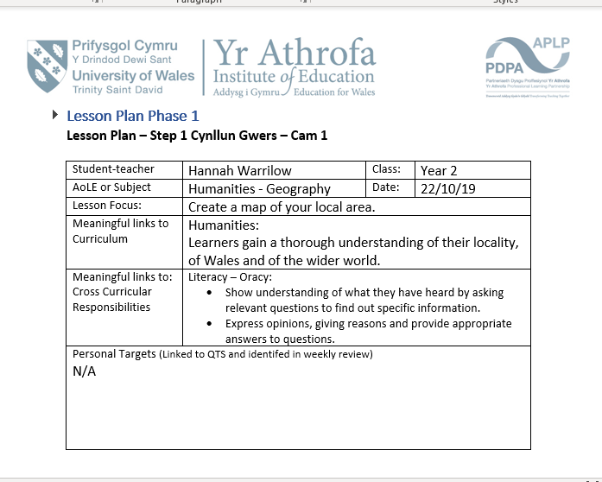
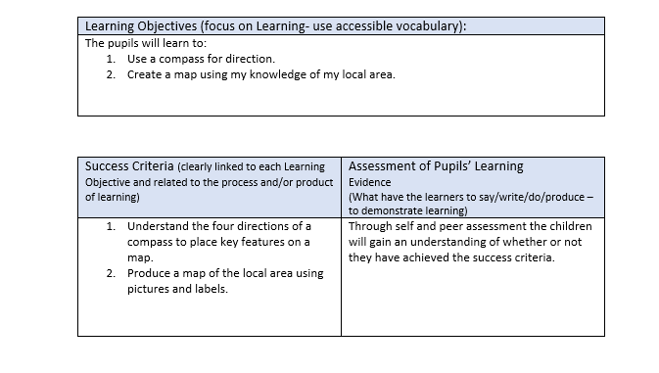

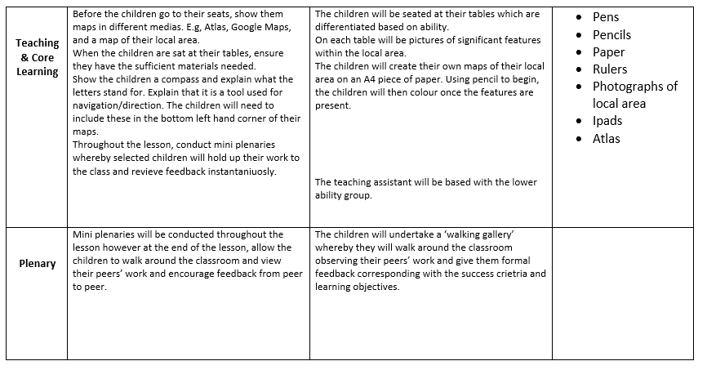
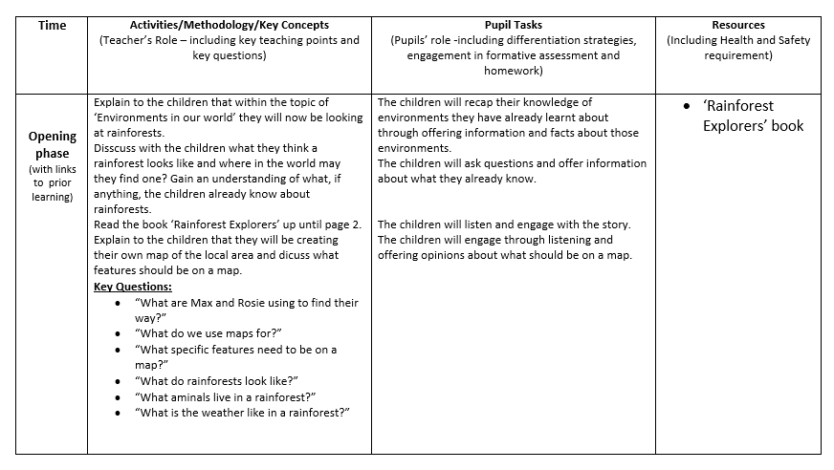

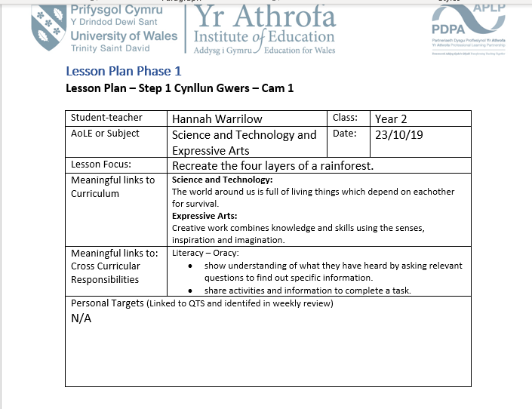
Appendix 2


