Evan Elias Proposal

BA Illustration (Hons) – Research in Practice ADAD5004
Proposal for Independent Project
Word Count – 2326
Lecturer – Delyth Lloyd-Evans

Proposed Question: What is the place of mysticism in contemporary illustration?

Context
The three key words I will be examining in this proposal are: medieval, mysticism, editorial. These words will propel my exploration into the application of mystic thought and imagery to contemporary illustration. I will dissect the intention, application, and impact of symbolic and compositional medieval artworks, and analyse the place of these elements through a modern lens. Work from prominent contemporary artists such as Robert Rurans and Lou Benesch will accompany the historical and theoretical research to reach informed conclusions.
Mysticism
Mysticism as a theological basis is subject to its cultural and historical setting (de Certeau, M and Brammer, M,1992, p.11). The analysis of mysticism in art must adhere to an underlying contextual knowledge to understand the implications of the creator. When conducting a semiotic analysis of art featuring mystic ideas/imagery, creating a layered perception is essential to form an understanding between a genuine outpour of spirituality and a contemporary application intended for aesthetic purposes. Intrinsic to this proposal is an investigation into the link between art and mysticism, and to understand how they work in conjunction with each other.

In order to establish a grounding for a following analysis, it is essential to consider the everchanging definition of mysticism. Wendell Marshall Thomas, Jr. writes “Mysticism today claims to give us union with the supreme reality; to foster social creativity; and to lie at the heart of religion” (1924, p.60) and as a generalised statement, this definition covers a lot of ground. He argues that as mysticism is placed under various contexts, it is more efficient to start broadly and to then modify the definition to be more suited to the circumstance. This presentation of mysticism can be integrated into the analysis of art, regardless of its time period, due to its flexibility regarding cultural and historical factors. Under his analysis of mysticism, he defines it as a personal relationship with religion, whether through feeling or practice.

Bernard McGinn argues “the mystical element of religion ought, by definition, to defy pictorial representation”, which is indicative of the fleeting, incorporeal state of spiritual experience (McGinn, 2003, p.131). The mystical as portrayed in art “emerges as a fascinating attempt to see the unseeable”, which is perhaps demonstrative of its longevity and fundamental basis in many primitive religions (Carus, P., 1908, p.88). This implies that art can exist in pursuit of spiritual knowledge, thus bringing forth the idea that this art is being created under speculative pretences. This could indicate that speculation is a key element of defining mysticism.

The relationship between art and experience can help to define mysticism. William Thompson writes “I would suggest that mystical experience and contemplation occupies a certain primacy. It leads and theology follows.” (Thompson, W.M., 1991, p. 113) The unprompted spontaneity of “mystical experience” exists as an origin for the filtered theological theory that is applied to religious/spiritual art. It is implicit to apply this idea to prevent intellectualising mystic art that was formed from pure spiritual experience. Since this understanding is grounded in the spiritual encounter itself, the analysis of mystic imagery may be better suited to a suspension in belief. William Phillip Downes writes:
The mystic believes it is possible to pass beyond the sphere of logical thought, that is, he believes that it is possible not only to infer that God is, but that it is possible to feel, to touch, to actually become one with God.
(1920, p.621)
This representation of mystics may imply an inherent communicative nature that can be seen in mystic art. Downes continues “knowledge of God must be, then, according to the mystic, personal, direct, intuitive.” (1920, p.623) This further demonstrates the unique perspective of mystic analyst, as art of this nature is an outpouring of not just the self, but the self-initiated contact with higher power. The relationship between religious cultural context and personal spiritual experience may be reliant upon the informing of one another. Contrary to that idea, Theodore Runyon argues “the spiritual senses have no knowledge or acquaintance with God and spiritual reality,” which again correlates the spiritual experience with an intellectual naivety/purity free from outside influence such as a religious text (1992, p.189). As a result, the definition of mysticism could incorporate the argument that “the spiritual senses” are innate.

Looking at art adjacent to spirituality instigates a wider discussion about how religion interacts with illustration. Richard Shusterman argues “art is simply another mode or expression of religion.” (2008, p.2) This idea contrasts McGinn’s theory of art’s inability to represent true spiritual experience. If this were to coincide with the defining perspectives on mysticism that have been explored, it would mean both religion and art are both results of an internal output, rather than a formulated collection of symbols.
Medieval
Having established some thought on how mysticism can interact with art, conducting a semiotic analysis of art from the middle ages will better indicate how this theory applies to real-world examples.

It is first important to establish that the medieval period is “not a specific and visitable destination” and so any conclusions produced by semiotic analysis cannot be reflective of “wider cultural aspects of the life and art of the period.” (Sekules, 2001, p.1). Discussion regarding mysticism during this time must be mindful of the lack of exterior theological knowledge available.

Art created during the medieval period “served as markers with resonances within the social practices of medieval society” (Alexander J., 1993, p.1), and from this the inference can be made that any representation of mysticism had grounding in the majority religious practice attributed to time and location. The “triumph of faith over experience” (Sekules, 2001, p.7) was comprehensive of the certainty in religion to answer all questions. This is further emphasised by Sekules “at the heart of the medieval Church many things were shrouded in mystery.” (2001, p.99) Spirituality was culturally enigmatic, which presumably kept personal encounters with higher power especially mystifying. This contrasts the idea that medieval artwork that portrays experience with the divine is able to be dissected into historical and cultural signifiers (de Saussure, 1959, p.65). The place of mysticism in the Middle Ages exists only within the experience of the individual.

John Berger writes “every painted image of something is also about the absence of the real thing,” (1998, p.11) and this idea applies to mysticism in art. It is implicit to consider the motivation behind painting images that are based on religious writings and spoken word, and to consider how this relates to the absence of the subject matter in reality. Berger’s idea that “the child looks and recognizes before it can speak” functions under the analysis of medieval art, as even the concept of the mystic is partially aesthetic.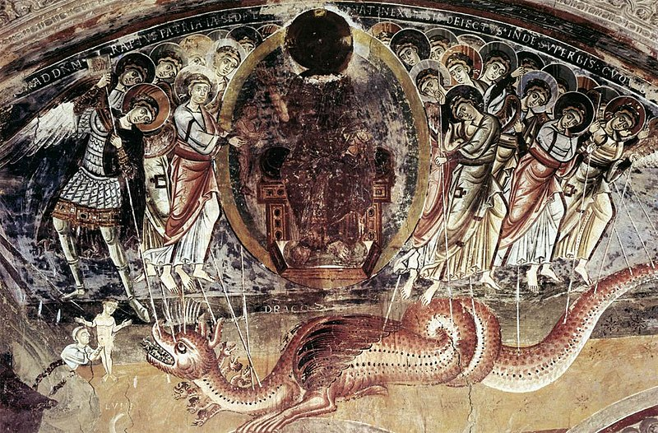
Fig 1, Untitled, Anon, 1100
Figure 1 exemplifies the narrative storytelling that is key to medieval art. The work features St. Michael surrounded by angels, fighting a seven-headed dragon. St. Michael, who “epitomized the heavenly war against Satan” (Sekules, 2001, p.162), is dressed in armour, verifying him as a warrior. Painted tributes to St. Michael were often found on the altars at “the west ends of churches”, because the battle against the dragon was representative of the “fight against all evil”. While this painting is not representative of the interpersonal experience with the Divine that is defining of mystical experience, it stands as a representation of one of the highly-regarded religious figures of the medieval Christian church. Here mysticism is used as an educational tool to represent a narrative.

The medieval art world consisted of a few different styles defined by era, some closer to illustration than others. The Romanesque empire, which was influenced by the Byzantine empire (Petzold A., 1995, p.12) is visually individual and “characterised by a greater naturalism and a more powerful sense of the dramatic” (p.11).
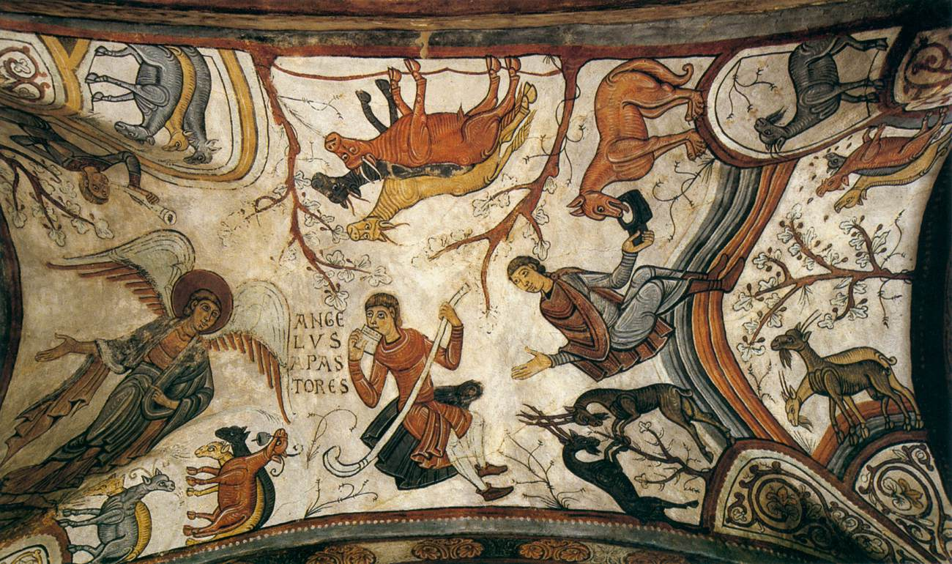
Fig 2, The Annunciation to the Shepherds, Anon, 1180
Figure 2 is demonstrative of the more illustrative side of medieval art. This is indicated by the limited colour palette, stylistic elements, playful composition, and inaccurate proportions. The Annunciation to the Shepherds uses composition to further enhance the mystic narrative. Fernande Saint-Martin writes “it is also a symbolic place where another human being organizes a representation of his own experience of reality, of his own perspectives and points of view.” (1987, p.115) This demonstrates that, in relation to the perspective of this illustration, the composition seems surreal due to the individual grounding of reality. This is an example of mysticism in medieval art existing in contrast to societal pre-conceived notions.

Editorial
Editorial in relation to the practice of illustration is defined by the Association of Illustrators as any illustration “produced for newspapers, magazines, and websites to add a visual dimension to a piece of writing.” (The AOI, n.d.) Under this definition, all illustrated work would have to be created in response to an already existing piece of writing. The inclusion of websites in this definition indicates the contemporary nature of this part of the illustration industry. Investigating the place of mysticism in this context will allow for a drastic contrast, thus indicating the potential for change over time.
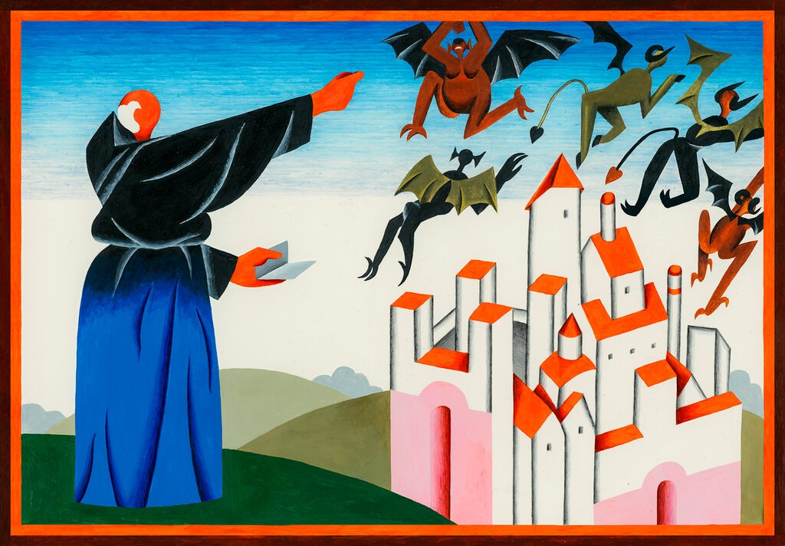
Fig 3, Thrillers, Robert Rurans, 2020
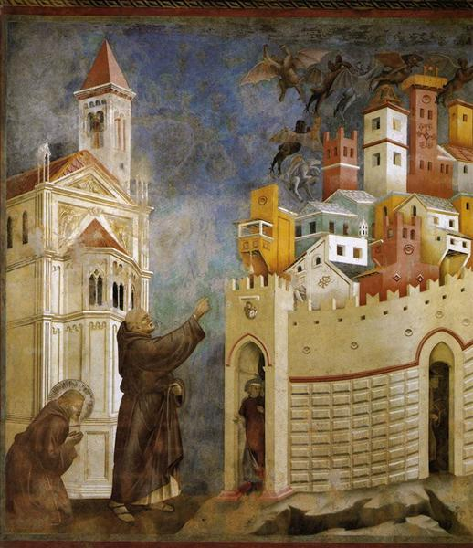
Fig 4, The Exorcism of the Demons at Arezzo, Giotto, 1299
Figure 3 is an editorial illustration created for the New York Times Book Review, and makes direct reference to The Exorcism of the Demons at Arezzo (fig. 4) by Giotto. The two artworks contain a few key parallel signifiers (de Sassure, F., 1959. p.65): composition, the man in figure 3 bears resemblance to St Francis in figure 4 as he is dressed in a similar robe, the position of the buildings, and the demons that are being exorcised. These contextual implications of the medieval image change in a modern setting. Rurans’ early modernist inspired art style (Rurans, 2019) indicates to the reader that he is referencing the past through the aforementioned signifiers, but is not trying to replicate the visual style. Therefore the use of mysticism between the two images is varied – purely because of contextual factors.

The stylistic elements of the work differ to that of Giotto, and may allude to style being the core difference between the two periods. Molly Bang writes “objects placed in the top half often feel more “spiritual””.(2001, p.39) However, the variation of the demons in figure 3 and figure 4 is due to their presentation, not placement. Bang continues “we feel more scared looking at pointed shapes; we feel more secure or comforted looking at rounded shapes or curves.” (2001, p.50) The application of this effect can be seen in figure 3, as the figure presumed to be St. Frances is illustrated to be rounded while the demons he casts away are angular and pointed. This is an example of art style influencing the way in which mysticism is used in art. Mysticism acts differently under varying stylisation, as seen in figure 3 and 4. In figure 3, by using shape and composition the characteristics of the demons and St Frances are translated without context. This analysis exists in contrast to figure 4, in which realism is utilised in order to best portray events. The levels of artistic liberty fluctuated due to the intention behind the creation of imagery. Contemporary editorial illustration sits with the intention to best represent the writing it is accompanying, while medieval illustration is bound by its intention for “physical structure or religious celebrations.” (Mann, 1992, p.1)

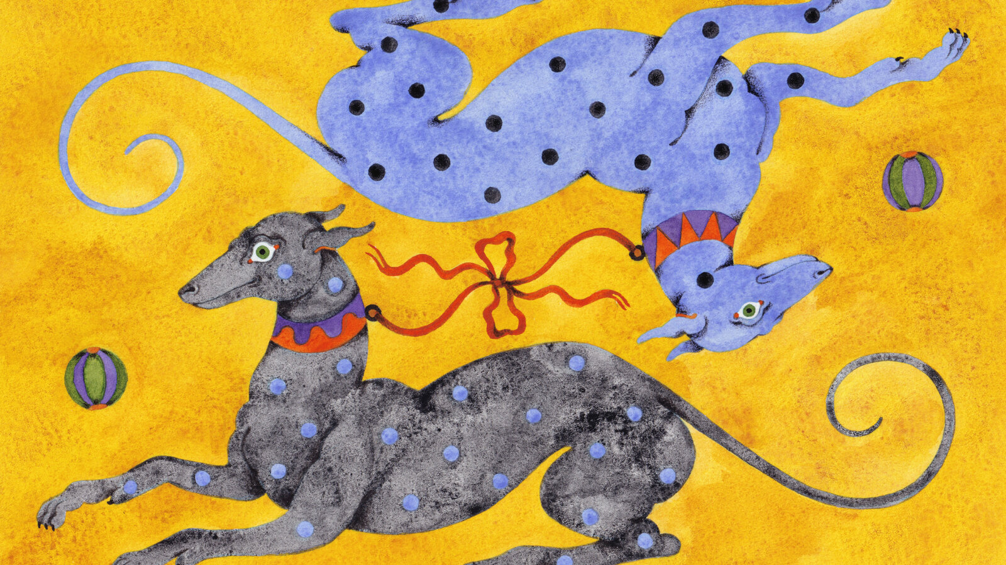
Figure 5, It’s a Dog’s Life, if You Want It, Lou Benesch, 2022
Lou Benesch is a contemporary illustrator who often explores mystical themes and plays with composition, which draws similarity to that of medieval artists. Figure 5 is a painting by Benesch, for a New York Times article about dog sitting during the 2020 Covid-19 pandemic. While the painting itself is surreal, it is not directly about mysticism. However, as Lou Benesch explores themes of spirituality and connection with a higher power, it is beneficial to see how her work can interact with a modern space. In a 2020 interview with Wertn, Benesch writes “I try as much as possible to paint a reflection of the images that come to me, almost as visions.” (2020, Wertn) This is demonstrative of the individual spiritual experience that can be funnelled into artistic practice. In the same interview, she says she has always found inspiration in the beasts “that were made in the middle ages”, and that she wants to replicate the “naïve quality you can find in medieval illustrations.” She goes on to reference Hieronymous Bosch as an inspiration. All of this again infers that medieval mysticism can act as an influence on contemporary editorial illustrators.

Overall, mysticism within contemporary editorial illustration is often tied to medieval illustrative practice, whether that can be found through direct reference, technique, or mythological influence. The connection between the two appears to be visual, as the intention behind the work shifts as the motivation of the artist changes. The influence of medieval mysticism is present among modern editorial illustrators, and is used often as a visual reference point more-so than attempting to evoke the same religious symbolism.

Conclusion
My eventual illustrative practice for this project will be a set of editorial illustrations for pre-existing news articles. I will employ themes and imagery of the mystical/spiritual to inform my personal understanding of the place of mysticism in contemporary illustration. In the footsteps of the contemporary illustrators in this proposal who create mystically thematic work, it will be essential to consider varied reference points to pay homage to pioneering mystics in the arts while also utilizing a modern perspective. I find interest in this area because of the technological advances that add a unique pressure to modern life, and how this is combatted with various forms of spirituality. This corresponds with the theory that mysticism in art is an “attempt to see the unseeable” (McGinn, 2003, p.131), and putting this into practice in a current industry. To help tie in mysticism to the illustrations, the articles selected will link to modern spiritual practice. Some topics explored in the potential articles are wellness culture, spiritual superiority, tarot resurgence, and clairvoyance.
List of Figures
Figure 1: Anon (1100) Untitled (oil) Sekules, V. (2001). Medieval art. Oxford: Oxford University Press.
Figure 2: Anon (1180) The Annunciation to the Shepherds (oil) Available at: https://www.wga.hu/html_m/zgothic/mural/12c2/02catala.html
Figure 3: Rurans, R. (2020) Thrillers (acrylic on paper) Available at: https://www.nytimes.com/interactive/2020/11/25/books/gifts-for-book-lovers.html
Figure 4: Giotto (1299) The Exorcism of the Demons at Arezzo (oil) Sekules, V. (2001). Medieval art. Oxford: Oxford University Press.
Figure 5: Benesch, L. (2022) It’s a Dog’s Life, if You Want It (Gouache and watercolour) Available at: https://www.nytimes.com/2022/03/26/style/dog-sitting.html

Bibliography
Alexander, J. J. G. (1993). Iconography and Ideology: Uncovering Social Meanings In Western Medieval Christian Art. Studies in Iconography, 15, pp. 1–44. http://www.jstor.org/stable/23923571

Berger, J. (1992). Keeping a rendezvous. New York: Vintage International.

Berger, J. (1972). Ways of seeing. Edmonton, Alta.: The Schools.
‌
Carus, P. (1908). MYSTICISM. The Monist, 18(1), pp. 75–110. http://www.jstor.org/stable/27900087

de Certeau, M., & Brammer, M. (1992). Mysticism. Diacritics, 22(2), pp. 11–25. https://doi.org/10.2307/465276

de Saussure, F. (1959). Course in General Linguistics. New York: McGraw-Hill.

Downes, W. P. (1920). Mysticism. The Biblical World, 54(6), pp. 619–624. http://www.jstor.org/stable/3136208

New York Times, The Best Books to Give This Year. (2020). New York Times. [online] 26 Nov. Available at: https://www.nytimes.com/interactive/2020/11/25/books/gifts-for-book-lovers.html [Accessed 29th March 2023].

Mann, J. W. (1992). Medieval Art. Bulletin (St. Louis Art Museum), 20(3), pp. 1–68. http://www.jstor.org/stable/40716305

McGinn, Bernard. “On Mysticism & Art.” Daedalus, vol. 132, no. 2, 2003, pp. 131–34. JSTOR, http://www.jstor.org/stable/20027848. Accessed 15 Apr. 2023.

Runyon, T. (1992). The Role of Experience in Religion. International Journal for Philosophy of Religion, 31(2/3), pp. 187–194. http://www.jstor.org/stable/40019201

Sekules, V. (2001). Medieval art. Oxford: Oxford University Press.

Shusterman, R. (2008). Art and Religion. Journal of Aesthetic Education, 42(3), pp. 1–18. http://www.jstor.org/stable/25160287

The AOI. (n.d.). The AOI - Editorial Illustration Basics. [online] Available at: https://theaoi.com/resources/professional-practice/editorial-illustration-basics/
[Accessed: 21st March 2023]

Thompson, W.M. (1991). Christology and Spirituality. Herder & Herder.

Thomas, W. M. (1924). The Truth of Mysticism. The Journal of Religion, 4(1), pp. 60–70. http://www.jstor.org/stable/1195638

