Mechanical and Manufacturing BEng
Designing a Tanker Propeller
Assignment 1
Morgan Phillips (2012414)

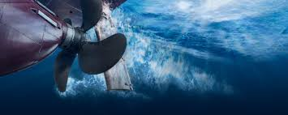

Table of Contents
Introduction 2
Reynolds Number 2
Boundary Flow 4
Propeller History and Performance 5
Modelling Techniques 7
Prototyping 8
Bibliography 10

Introduction
Design and optimization of a propeller is a fundamental task to the designer of a ship as this is due to the fact that the behaviour of a ship is significantly influenced by the dynamic performance of the propulsion system. A ship goes through various operational speeds; acceleration, deceleration, crash stop, and heavy turning are just some examples of transitory situations that a propulsion system has to sustain without reducing ship safety and reliability (GARD, 2013). The major part of this propulsion system is the propeller as this can affect the efficiency of the ship, installing a large propeller can help increase that efficiency but is limited by the draught of the vessel so optimization of the propeller design is needed (Sinha, 2021).

Reynolds Number
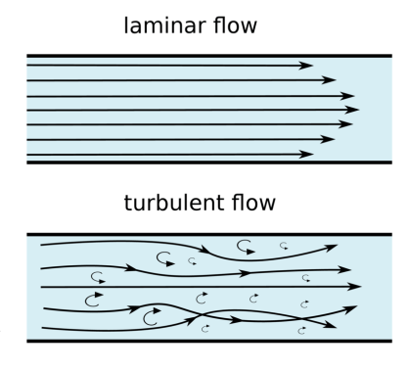
The Reynolds number is a commonly used non-dimensional parameter in fluid mechanics, which describes the ratio of inertial forces to viscous forces. In the context of propellers, the Reynolds number is defined using the kinematic viscosity of sea water, the freestream velocity of the water, and the blade length of the propeller. (Letcher, 2017)
This dimensionless parameter can be used to predict fluid behaviour, predicting if a flow condition will be laminar or turbulent. It can be interpreted that when the viscous forces are dominant compared to the inertia forces the flow will be laminar, and when the inertia forces are more dominant the flow is turbulent.
To calculate the Reynolds number of the fluid flowing around the propeller we need to first make a few assumptions about the environment the propeller is in. We are going to assume that the oil tanker is located in the British sea during the summer months and the temperature of the water is around 17°. With these assumptions we can now tell that the density of the water is going to be roughly 1026 Kg/m³ and the dynamic viscosity of the water is 0.00117 Ns/M² (Box, 2005).
We need make an assumption about what speed the tanker is travelling, so we are going to assume that the tanker is cruising at a steady velocity of 20 Knots (Rodrigue, 2020). We can make the assumptions that the pitch of the blades are 20m and the slip of the propeller is 10%.
From these assumptions we can calculate the RPM of the propeller by using the Speed of advancement formula:

$$Speed of Advancement= \frac{Pitch ×RPM ×60}{6080} ×(1-Slip)$$

This can be rearranged for RPM:
$$RPM= \frac{SOA ×6080 }{P ×60 ×(1-Slip)}$$

$$RPM= \frac{20 ×6080}{20 × 60 ×(1-10\%) }$$
$$RPM=113$$
This RPM can be substituted into the Reynolds number equations as velocity:
The length of the chord is give from the CAD as 3035mm, need to make one final assumptions that the shaft radius which the blade is attached to is 500mm, taking the diameter of full propeller to 7.07m.
$$Re= \frac{ρ υ L}{μ}$$

$$Re= \frac{1026×113×7.07}{0.00117}$$
$$Re=700582615.4$$
$$Re=7×{10}^{8}$$
From this calculation we can assume that the propeller will experience a high amount of turbulent flow around it due to the large Reynolds number which has been calculated.

Boundary Flow
On the leading edge of a propeller (A–B), a short laminar separation bubble is present this is due to a strong adverse pressure gradient, after this short laminar bubble there is a boundary-layer which is turbulent over the rest of the chord. The region (C–D) shows a laminar flow region with transition to turbulent flow downstream. The chord wise position of the transition region depends on the Reynolds number, but is generally located at some distance from the leading-edge. At the lower radii (D–E), a laminar separation region can be found due to the very low sectional Reynolds number in combination with thicker root sections.
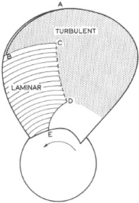

The propeller is designed like this as the turbulent flow of the water going to create the thrust which is needed to help propeller the boat through the water. Detailed studies of hydrodynamic behaviour of propellers in different water conditions have shown that the delivered thrust and thus the resultant efficiency is inversely proportional to the size/diameter of the boss. (Ghosh, 2020)
The action of turning a propeller creates a force, by moving the flow of water downward and behind the blades creating a temporary hole. This hole fills with water, creating a low pressure system that lifts and pulls the blade forward. The momentum created by the low pressure is what moves the boat forward. To create these temporary holes be formed the blades are designed in such a way that they are twisted and angled which forces the water to continuously flow behind the propeller to create the low pressure system.

Propeller History and Performance
There is an increasing demand for ship propellers to meet virtually impossible requirements, this has put a huge amount of pressure on propeller designers. Propellers now must designed in a way which they will offer higher efficiency with lower vibrations, less noise and lighter mass compared to previous propellers. As we advance as humans we are always making technological breakthroughs which allow us to design or manufacture previous products in a new process which drastically increases the efficiency of that product. The same applies for propellers, over the lifespan of the propeller it has been manufactured in several different ways, our advancement in materials has helped to reduce the weight and increase the performance of the propeller considerably. 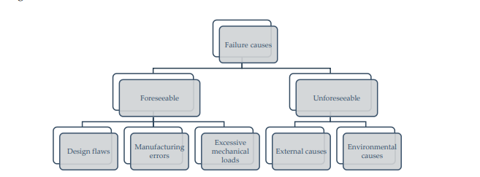
“Structural failure is a result of fracture or damage that is initiated when the material is stressed above its strength limit. In particular, structural integrity of marine structures depends, along with the material strength and loading conditions, on material (usually steel) quality, proper manufacturing (usually welding), severity of service conditions (sea, salt, winds, etc.), design quality as well as various human elements that have effects during use of the structure.” (Vizentin, 2020)
The current material being used on marine propellers is aluminium alloys and stainless steels (Anish, 2020) while these have great corrosion resistant properties which is suitable to the environment they’ll be exposed to, they still have flaws which need addressing. Even though these types of material are considered to have high tensile strength they still are quiet vulnerable to the forces they are exposed to.
There is numerous cases found where the propellers and shafts break from fatigue failure which all stems from chemical compositions of the materials being incorrect (Sitthipong, 2017). An investigation was undertaken to find out the reason for a failure of the propeller shaft on the Starboard, which is a commercial ferry in New Zealand (Commission, 2013). In this investigation “Various experts concluded that the fracture that occurred on the Aratere’s starboard propeller shaft was a fatigue fracture” (Vizentin, 2020)
This accident occurred after a new propeller was fitted during the extension project for this vessel, As the steel propeller had a rigid profile and very little deflection in the materials it meant that new propeller was putting a huge amount of uniaxial bending force on the shaft. If the propeller was manufactured from another material which had some deflection in it, this would relieve some of the forces exerted on the propulsion system.
There has been numerous investigations into whether changing traditional materials such as steel and aluminium to new lighter materials like carbon fibre reinforced plastic (CFRP) will be more beneficial for the propulsion systems. Ashok Kumar (Kumar, 2018) conducted research and physical experiments into CFRP properties to compare them to materials which we know are conventionally used on propellers.
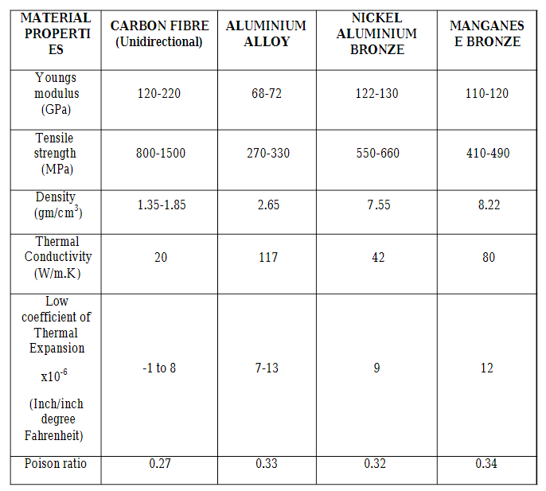

The table above shows that carbon fibres properties are significantly better that all the other conventional materials so why isn’t it being used? Even though all the signs of this investigation show that CFRP is the better material the investigation hasn’t looked into some of the limitations. The investigation doesn’t even look in to the cost implication of CFRP, Clifford Lester (Lester, 2021) report reviews the benefits and reasons why the cost of the material is so high. In conclusion he stated “Carbon fibre composite parts offer clear benefits over steel, aluminium, wood, and performance plastics due to the high specific strength and modulus. Nevertheless, they remain expensive due to the high costs of raw materials and labour required.” Cost implication is the main reason a lot of manufactures haven’t applied CFRP to the designs of their propellers.
Carbon fibres are also conductive with electric current and have a high electric potential, so when a CFRP is moulded with a metal part there is a great risk of galvanic corrosion (Yari, 2021). This corrosion would reduce the life of the propeller shaft considerably as it would lead to fatigue cracks appearing a lot earlier than expected.

Modelling Techniques
The main modelling technique which is used to simulate fluid flow is Computational Fluid Dynamics (CFD), this is a software which attempts to simulate the interaction of liquids and gases where the surfaces are defined by the boundary conditions (Anon., 2020). These boundary conditions can be defined around a computer aided model which are then in turn used to calculate and predict the fluid flow. Its strength is its high-fidelity predictive software combined with powerful graphics which allow the operator to get a full visualisation of any multi-dimensional problem which could occur on the design.
This predictive software is only a powerful tool when used correctly, there are so many inputs and parameters which need to be set correctly for this software to give accurate results. A good knowledge and experience is required to fully understand the software. This limits the amount of people who can actually use the tool which increases the value of the service provided when out sourcing this work.
Having data feedback from the CFD can be considered critical to some companies as the development of new designs is dependent on the experience of experts, scaling up from laboratory to full scale models is a very time consuming and difficult process to do, all this work could be wasted trying to achieve the same results which can be calculated using the CFD simulation (Andersson, 2011).
It would be more beneficial for the company to pay the upfront cost to get this analysis before the prototyping stage, but you can’t just base the final design off just one set of CFD results. How does the company know that the analysis carried out is correct?
“A CFD simulation contains both errors and uncertainties. An error is defined as a recognisable deficiency that is not due to a lack of knowledge, whereas an uncertainty is a potential deficiency that is due to a lack of knowledge.” (Andersson, 2011)
So for a business to base their design of just one CFD results could lead to unforeseen issues as there is no repeatability in these results and uncertainties could have arisen during the simulation. This is why often companies will send the same models to multiple CFD companies and compare the feedback. Again this is a big cost implication on the business but if they are able to streamline their products and maximise the efficiency before manufacturing, these costs can be offset by value being gained back through cost effectiveness of the product and improved risk management strategies.
One of the main tools which can used on CFD for marine propellers is simulating the cavitation of a given fluid. Cavitation is very difficult to detect as the damaged caused to the component is gradual and shows no obvious signs until it reaches a crucial threshold. (Anon., 2019). Predicting cavitation and investigating alternative designs to reduce it is essential during the design process. Even small adjustments to the propeller geometry could significantly improve vessel performance.

Prototyping
Following on from the CFD analysis of the model propeller the next stage would be to prototype the design and carry out experiments to verify this numerical analysis. If the data from the experiment and CFD are synonymous then we would have more confidence in the design of the propeller.
The performance and deformation of the propeller need to be analysed so the best way to analyse these would be to conduct a scaled model of the propellers. To measure the working performance of a propeller we would need to measure the thrust force, one way in which we could do this would be too attach a small DC motor to a pendulum rod which would drive the propeller. The other end of the rod would be restricted from rotation by a force sensor, this will be positioned to just touch the end of the rod then the propeller is off that this would be the ‘zero’ point. The amount of thrust can then be determined through a calculations using the reading data of the force sensor.
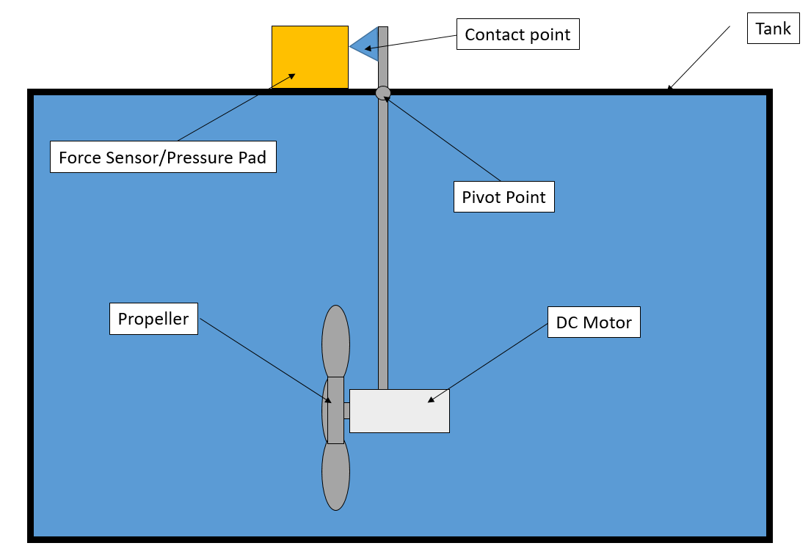
This method could create some uncertainties in the results which would differ to the CFD conducted, there would be serious vibrations from the propeller which would transmit through the rod and could cause Yaw in the propeller position. The ‘zeroing’ of the sensor would be responsible of the operator, which could lead to human error in the set up.
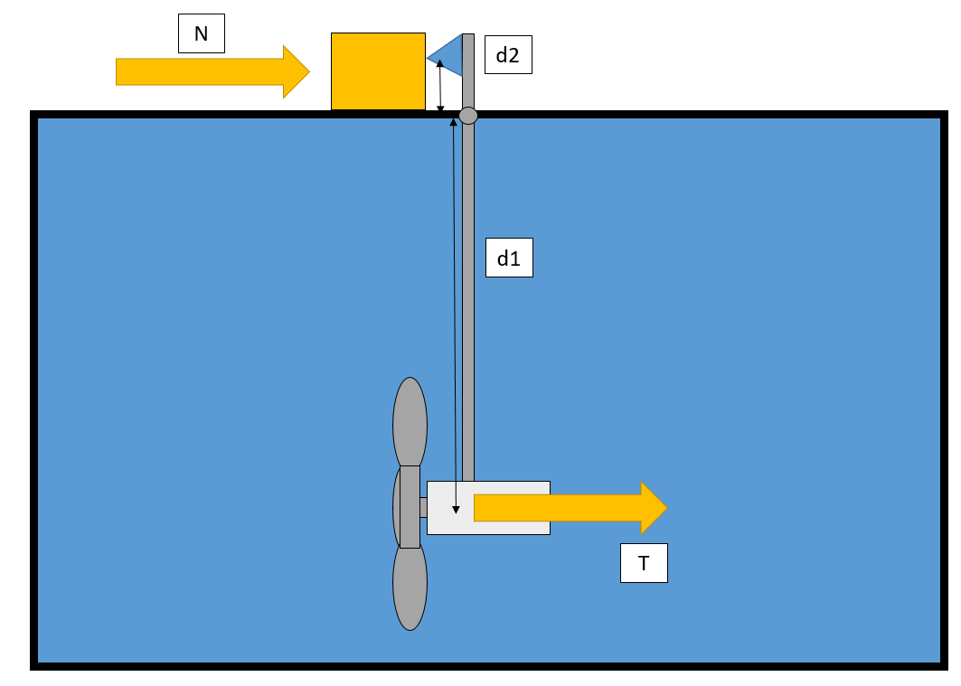

$$T= \frac{N×d2}{d1}$$
To some extent the vibration given off from the motor gives an element of real life testing once the propeller is finally operating it will in turn experience some vibration from the propulsion system and sea conditions, CFD analysis do not take into consideration some of the real life factors.
Scale modelling also comes with its own setbacks, an investigation into scale modelling compared to full scale was conducted in 2006 by Jan A. Szantyr which led to the findings that the rate of change of the cavitation number with blade position angle is much higher in full scale compared to model scale (Szantyr, 2006). This could lead to designs having the incorrect angular extent on the propellers due to having different results from the model scaling.

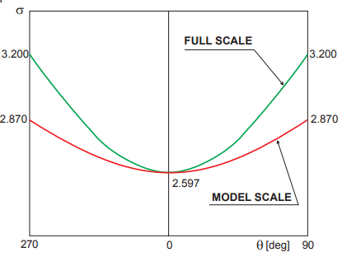
It won’t just be the cavitation number which would be affected during scaling, Reynolds number will also be affect due the change in boundary layer. According to (Braun., 1965) pressure fluctuations inside the boundary layer on a blade section profile may reach quite high amplitudes, comparable with the mean value of pressure in the vicinity of the leading edge.
Due to the difference between model and full scale Reynolds numbers this region of transition is located differently on the model scale blade section profile and in corresponding full scale situation in full scale this region is located close to the leading edge.

Bibliography

Andersson, B., 2011. Computational Fluid Dynamics. 1st ed. s.l.:Cambridge University Press.
Anish, 2020. Propellers, Types of Propellers and Construction of Propellers. [Online]
Available at: https://www.marineinsight.com/naval-architecture/propeller-types-of-propellers-and-construction-of-propellers/#:~:text=The%20materials%20used%20for%20making,materials%20and%20have%20higher%20strength.
[Accessed 28 May 2022].
Anon., 2006 . Boundary Conditions , Southamptom : Ansys.
Anon., 2019. 13 Key Applications of CFD Simulatino and Modeling. [Online]
Available at: https://blog.spatial.com/cfd-modeling-applications
[Accessed 30 May 2022].
Anon., 2020. What is CFD?. [Online]
Available at: https://www.femto.eu/stories/what-is-cfd/#:~:text=possibilities%20of%20CFD.-,What%20is%20CFD%3F,solid%20or%20fluid%2Dgas%20interaction.
[Accessed 27 05 2022].
Box, E. T., 2005. Properties of Sea Water. [Online]
Available at: https://www.engineeringtoolbox.com/sea-water-properties-d_840.html
[Accessed 24 05 2022].
Braun., V. G., 1965. Grenzschicht Theorie, s.l.: s.n.
Commission, T. A. I., 2013. Fracture of STARBOARD Propeller Shaft Resulting in Loss of Starboard Propeller Cook Strait. [Online]
Available at: https://www.iims.org.uk/wp-content/uploads/2016/12/TAIC-Investigation-report-on-loss-of-propeller.pdf
[Accessed 28 5 2022].
GARD, 2013. Marine propulsion systems. [Online]
Available at: https://www.gard.no/web/updates/content/20735244/marine-propulsion-systems#:~:text=The%20propulsion%20system%20on%20a,through%20a%20sophisticated%20control%20system.
Ghosh, S., 2020. Understanding Design Of Ship Propeller. [Online]
Available at: https://www.marineinsight.com/naval-architecture/design-of-ship-propeller/
[Accessed 1st June 2022].
Kumar, A., 2018. Design and Analysis of a Carbon Composite Propeller for Podded Propulsion. 1st ed. India: Department of Ocean Engineering.
Lester, C., 2021. Composite Materials: Advantages and Cost Factors , s.l.: s.n.
Letcher, T. M., 2017. Wind Energy Engineering. 1st ed. s.l.:Academic Press.
Rodrigue, J.-P., 2020. The Geography of Transport Systems. 5th ed. New York: Routledge.
Sinha, T., 2021. 10 Factors Considered For Efficient Ship Propeller Design. [Online]
Available at: https://www.marineinsight.com/naval-architecture/10-factors-considered-efficient-ship-propeller-design
Sitthipong, S., 2017. Failure analysis of metal alloy propeller shafts. In: Materials Today Proceedings. s.l.:Science Direct, pp. 6491-6944.
Szantyr, J. A., 2006. Scale effects in cavitation experiments , s.l.: Polish Maritime Research.
Vizentin, G., 2020. Marine Propulsion System Failures—A Review. Marine Science and Engineering, 8(9), p. 662.
Yari, M., 2021. Galvanic Corrosion of Metals Connected to Carbon Fiber Reinforced Polymers. [Online]
Available at: https://www.corrosionpedia.com/galvanic-corrosion-of-metals-connected-to-carbon-fiber-reinforced-polymers/2/1556
[Accessed 29 May 2022].

