

Skills for the Workplace
Module Assignment Submission

Student Name: | Vanya Petrova
Student Number: | 1817743
Module No: | BMSW4003_LON
Module Title: | Digital skills and research methods
Lecturer: | Amitave Banik

Statement of Confirmation of Authenticity
I declare that this work is mine own and have never been posted in other courses or modules.

Table of Contents
Introduction 3
Information and data collection 3
qualitative and quantitative methods 3
Research Project explanation 4
Analysis of the data with proper tools as well as technique 7
Conclusion 11
References: 11
Appendix 1 12

Introduction
A research will be conducted in this part of the report to evaluate the project's feasibility on ‘Analyzing the impact of Visual Learning Environment (VLE) - Moodle on student learning experience’. This part will cover the methodology of the research, data collection methods and questions will also be answered.
In education technology, a virtual learning environment (VLE) is a web-based platform for the online aspects of study courses, typically within educational institutions. Within a course framework, they provide tools, events and experiences and provide for the various assessment phases. Typically, VLEs also report on participation; and have some degree of collaboration with other institutions. VLEs will play an important role as authoring and designing environments for teachers and instructors who edit them (Wikipedia).
Information and data collection
Before starting the main research project, I just want to explain why we need to collect information, how we collect data and what methods of research I know.
The effectiveness of businesses relies to a large extent on clear access to large volumes of knowledge and the probability of using it and understanding it. Information is used of all levels of company and in all context. Managers using the information collected to plan their activities; to record purchases, sales and other documents; for measuring and decision-making process.
From the lectures I learnt that must source of data primary and secondary.
- Primary source – we are getting information by directly asking people. Primary sources are not just documents and written records. There are many kinds of primary sources, including: first-person accounts, documents, physical artefacts scientific data that has been collected but not interpreted (LO2 Methods of collecting data). Primary data collection methods from interview, face to face, written questionaries’ etc.
- Secondary source – the data have been collected from somebody else, for different reason. Example for that are government reports, division to open library, educational institutions.
Methods of research Qualitative and Quantitative
- Qualitative analysis is described as a method for market research based on data collection through verbal and open communication. Qualitative analysis methods are structured to expose a target audience's attitudes and interpretation of a topic. Different types of qualitative research methods are commonly utilised, including a profound interview, focus groups, ethnographic research, content analysis, case studies research. Qualitative research methods allow that more dialogue and explanation easier to understand. Qualitative data collection enables non-numeric data collection which lets one understand how choices are made which provides us a comprehensive perspective. The data collected should be systematic, complex and insightful and findings should be closely evaluated to accomplish this.
- QR is a systematic empirical study of observable phenomena by means of experimental, analytical or technological methods in natural and social sciences, sometime in other disciplines. The goal of quantitative research is the creation and application of phenomena-related mathematical models, hypotheses, and assumptions. The measuring method is important for quantitative research as it forms the essential link between empirical observation and the statistical interpretation of quantitative ties. Quantitative work has been commonly used in psychology, economics, demography, history, education, public health, health & human growth, gender studies, and politics (Wikipedia)
Research Project explanation
Moodle is perhaps one of the most well-known LMS solutions on the market, allowing educators to establish effective methods for delivering the material for eLearning. Nonetheless, for the first-time educators and students to use, Moodle can often be difficult.

Research report background: I am a student at the London campus of Saint David University and will now research the virtual learning system's effectiveness. We know that online study today is the most innovative and convenient and trustworthy way to work, as you can learn online whenever you want.
However, my main reason in my study is Moodle, which is the tool we used to scan the resources in our classes, the library. In this chapter we also access assignments, read comments. It's all Moodle that we need. But is this works correctly and successful as a classroom analysis? will be the main goal for a project.
- Overview of the research: A research to evaluate the feasibility of the project will be conducted. This study will be carried out to a small extent, and report on the impact of Virtual Learning Environment (VLE) – Moodle on students’ learning experience in the University of Wales Trinity Saint David London Campus will be analyzed.
- Research aims and objectives. This small research will be made to see how technology benefits the study of student and is that an effective way.
- Research methodology: It is a plan and procedure consisting of steps that form the basis for the entire study. This requires a quantitively and qualitative approach to science. The theory about analysis is focused on the experimental technique (Ghafoor, Shah & Rashid, 2017) generated in the propositional approach. Whereas the analytic approach does not rely on the development of hypotheses for observational testing in order to identify useful research information. The idea is that analytic analysis does not establish the assumption to check effects of the experiment. In this research, the testable method is used to perform a thorough study. In my project research I will use the primary data collection, and primary research but before that lets explain the difference between two and their advantages and disadvantages.
- Primary Data Collection: Qualitative research is mainly scientific discovery. It is used to discover the motives, thoughts and intentions behind it. It provides insights into the issue or helps to develop ideas or conclusions about future quantitative research. Qualitative methods of collecting data vary with unstructured or semi-structured methods.
Some common methods include focus groups, interviews and participation / observations. Typically, the sample size is small, and respondents are chosen to meet a certain daily limit.

- Secondary Data collection: Quantitative investigation is used to quantify the problem by generating numerical or useful statistics. The software quantifies attitudes, views, conduct and other specified variables– and generalizes outcomes from a larger population of samples. The methods of data collection include various forms of surveys, including online surveys, paper surveys, smartphone and kiosk surveys, face-to-face interviews and telephone interviews and observational studies, on-line database interceptors and systematic surveys.
The quantitative and quantitative method of study will be observed in this research. This study will collect the impression of tourists coming to Plovdiv and evaluate the categorical variables from the data in a quantitative way. Another city customer will also be asked about their views. In this analysis, the quantitative and qualitative approach to research will be adopted.
- Simple size: In this small case study the population will be 25 students in University of Wells Trinity Saint David Campus London.
- Data collection: For my report I will use face to face, interview and some survey to collect data from students.
- Research questions: For my report I will use the questions which I have been written in classroom task.
- Research's validity and reliability: it is necessary to ensure both high validity and reliability of research in order to preserve the credibility of the research. The study's accuracy and validity will also be preserved in this research to determine the viability of this plan. The survey participants should concentrate on the students as the research foundation. In this report, participation of both men and women will be ensured. The participants of the survey will also be guaranteed a diversity of age. In this study, the possibility of partiality for any group is limited.

Quantitively Methods
1. What age group are you in?
1. 20 -29
2. 30- 39
3. 40-49
4. 50 and above

2. What subjects are you study?
1. Business and management
2. Finance and Accountancy
3. ART
4. IT skills
5. Higher Education in Skills for the Workplace

3. Have you ever used another VLE?
1. no | 2. not sure | 3. yes

4. How many hours do you spend in Moodle per day?
1. 1 hour
2. 2 hours

3. 5 hours
4. 10 hours

5. Are you full time or part time student?
1. part time | 2. not sure | 3. full time

6. Do you experience any technical problem while using Moodle?
1. yes | 2. not sure | 3. not

7. How often do you access Moodle or any other VLE to study for your exams per week?
1. 1time | 2. 2 times | 3. 5 times | 4. 8 times | 5. 0 times

8. For what purpose have you used VLE?
1. checking emails from university
2. reading lectures
3. assessment score
4. to see my student schedule
5. upload my assignments

9. Were you given a training session on the VLE as part of your course?
1. yes | 2. not sure | 3. no

10. Is the use of VLE or other Blackboards is effective or useful for students and staff, if no answer why?
1. Yes | 2. Not sure | 3. No

Analysis of the data with proper tools as well as technique
The analysis of the research after the collection of the data is given below according to the research questions and methods.

Secondary Data /Quantitative Research
From survey made and face to face interview I have been collecting the primary data which now will use to convert in to second data and make and analysis of the research task.
Fig.1 shows primary data collected.
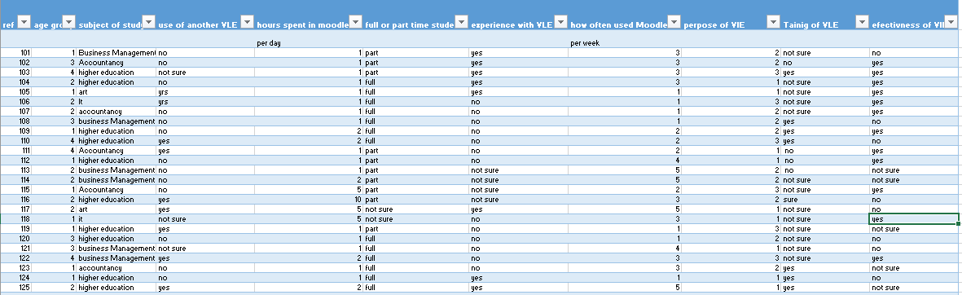

Fig. 2 show the secondary data which I transformed into number and that will help me to make an analysis of the most important questions and topic of my report.
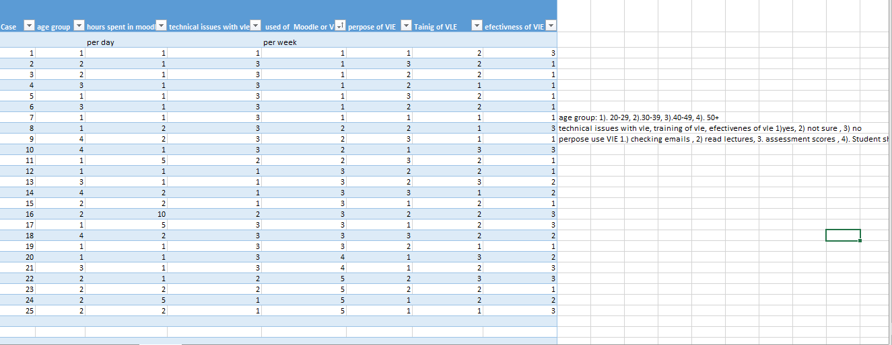
From the research I made we can see that most of student interviewed find the VLE and Moodle as effective way to study. Some of them use it only to upload their assignments but big part is interesting and from other tools Moodle offer.
Questionnaire result
q.4 how many hours do you spend in moodle.
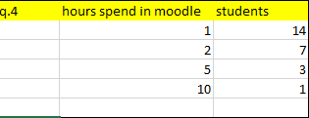
According to given respond most of students are spending 1 hour per day, to look for information in Moodle and study with VLE.
q.7 Use of VLE and Moodle per week
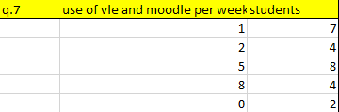
From given answers above, I can say the interested of using VLE is not so important for students as most of them using platform just one or two time per day.
q.9 training in VLE and Moodle
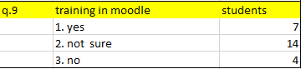
The big part of students, said they are not sure they receive a training how to use VLE, its possible they cannot remember, or have been missing it.

q.10 is the use of VLE and Moodle effective in study
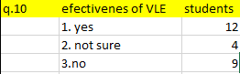

From answers above we can conclude that most of students like using VLE but is still not preferred as in option. Still preferably is the in-classroom study as students can make a question and receive answers on time and directly. We can say that VLE and Moodle are helpful tools for students, but in class is preferred still.

Conclusion
In this article, a survey focused on a questionnaire is performed to determine the use of the University of Wales Trinity Saint David London Campus Moodle-based e-learning platform. The study involved twenty-five participants. The students ' replies reveal that they have a long-term background in computer and internet technologies. In fact, the study shows that Moodle is primarily used in the sharing of training materials as a database. However, Moodle's interactive learning tools are not used. The students demonstrated a positive outlook for extending the use of digital training devices in schooling.

References:
Sigmund, W. (2016). Business Research Methods. New York: McGraw Hill Education.
Wikipedia (no date). Quantitative research. [ online]. Available from : https://en.wikipedia.org/wiki/Quantitative_research [Accessed 21/12/019]
Wikipedia, (no date). Virtual Learning Environment. [online]. Available from. https://en.wikipedia.org/wiki/Virtual_learning_environment [Accessed 19/12/2019]

Appendix 1


