This needs analysis will focus on Cardiff and on various of gaps that there are within the society. As an introduction, it is important to outline the resident population in Cardiff to gain a better image of the city and to have better understanding of some of the issues that there are in Cardiff. According to Nomisweb, (2010) the population of Cardiff is 346,090. 169.893 are males whereas 176.197 are females. Because these are census statistics from 2011, it is important to consider the fact that these figures have possibly changed throughout the eight years.

Mental health issues

2014-2015 Welsh Health Survey has shown that there are 14% of adults in Cardiff who have been diagnosed with mental health issues and have been treated. Welsh Health Survey (in the Programme Intelligence Report (2016) shows that the percentage of adults who have been treated for mental illness has increased since 2003 (See Appendix 1). Very often mental health has stigma attached to it and people tend to judge others very easily. These statistics suggests that Cardiff adult’s awareness of mental health has increased, people may feel less ashamed and confident to talk about their problems in front of other people, there are more places in Cardiff society that seek out to help people with mental health issues or there are more people in the society that influence others who are affected to seek out help that they require. Society can be much more open and work together as a group. On the other hand, we don’t know who seeks such treatment. The percentage increase can suggest that there are issues within the society e.g. with immigration, homelessness, obesity, ethnic groups or with people being ignorant which therefore increases mental issues within the society. There are various of service provision in Cardiff that supports people with mental illnesses. For example, in Cardiff there are five Community Mental Health Teams (CMHTs) who provide service provision for people aged eighteen to sixty-five who experience mental health problems (Cardiff and Vale Action for Mental Health, 2015). This organisation not only focuses on preventing mental illness but also helps with recovery and promoting health and provide range of services for people with mental illness. The services include assessment, diagnosis and treatment using variety of different therapies and techniques. Although this organisation is very successful, as mentioned there are only five CMHTs, as Cardiff is such a big city there should be more support available for people with mental illnesses.

Problems with Household

Appendix 2 refers to housing in Cardiff. Census statistics show that there are 142,557 households in Cardiff where 97.8% of households have central heating in their houses, however 2.2% do not. This means that there are 3, 141 people who do not have heating in their houses. These statistics do not show who does and who doesn’t have heating, however the fact that over 3.000 people do not have heating in their houses outline possible problems in the society. Firstly, this could suggest lack of interest and engagement from local authorities. Secondly, lack of communication between residents and e.g. landlords. Furthermore, people who own houses and do not have central heating may have financial problems and therefore are not able to invest in heating. Some of the properties that do not have central heating may be owned by the council, and this could be the reason that the standards of the houses are lower. In Cardiff, there is some help available not only for people who are struggling with housing but also for these people who are struggling financially. The ‘Speak Easy’ advice centre has started helping people in Cardiff in 1992, and continues to do so. This free and legal advice centre helps people who cannot afford to heat their home, these people with debt issues and who are in poverty by offering them professional advice, range of services, food and shelter. Each year, ‘Speak Easy’ helps over two thousand people and offer range of services to help people lift from the poverty and financial issues (The Speakeasy,n.d).

Employment.

Another issue in society in Cardiff is unemployment. Appendix 3 shows that there are 11,566 people who are unemployed. This high number of unemployed people suggest poor service provision in Cardiff. Although there are seven job centres that offer jobs to people, for some reason the number of unemployed remains high.
Although appendix 3 shows that economically inactive people include people who are retired, students, individuals who look after home and people who are long-term sick or disabled, 6,191 people are economically inactive for other reason (Nomisweb.co.uk, 2011). We can conclude that this is because of lack of support available from the local authorities, lack of services available for unemployed people to go or lack of knowledge that individuals have that would allow them to become economically active. The fact that there are 3,465 young people aged sixteen to twenty-four who are unemployed support this argument. There are different types of benefits available for unemployed people in Cardiff. Employment and Support Allowance offers financial support and personal help for people who are ill or disabled. Other benefits include; income support, benefit cap, jobseeker’s allowance and universal credit. Such support offers unemployed people help to cope with bills, if an individual has a family and loses their job suddenly, they can remain calm and know that there is support available. Job centre’s offers professional advice and thousands of jobs for people with different qualifications. However, on the other hand benefits can cause people to stay out of work for longer period, especially among young people which may be why the number of unemployed young people is high. Furthermore, as Cardiff is a big mixed city, there should be more job centres available with staff who can speak other languages. There is not enough support and encouragement available for people whose English is additional language. Providing financial benefits is successful for short period of time, rather than giving money to individuals they should be encouraged differently to seek work.

Loneliness

Throughout many years, the issue of loneliness has been a major topic of research. The graph (see appendix 4) shows that in Cardiff there are more people who are aged fifty or more than there are young people aged up to twenty. Studies on loneliness which have been carried by various of researches throughout the world have shown that loneliness has a major Impact health and wellbeing of older people. In Cardiff, there are over hundred care-homes with high-qualified staff which look after elderly people. Looking at the websites some of the care homes are specified in looking after elderly with e.g. Alzheimer’s or Dementia. National Assembly for Wales (2017, p.5.) report on loneliness has claimed that there are 458,000 people in Wales that either ‘always’ or ‘often’ feel lonely. However, National Assembly for Wales argues that this figure may not be precise. Because of the demanding and fast going society in Wales- including Cardiff many older people feel embarrassed or ashamed to talk about their feelings and therefore this figure may be significantly higher. Again, this points out an important issue of ignorance, lack of confidence and isolation that occurs in society in Cardiff. Furthermore, even though the number of care homes is very high, elderly people who are living in these care homes are lonely and face many barriers in their day-to-day life. Because Cardiff is a big mixed society, everyday situations in e.g. cafes, shops, pharmacies show how elderly people are misunderstood and ignored and as a result feel lonely.

People living on the streets

According to Mosalski, (2017) there are forty individuals who sleep on streets in Cardiff every day. Since July to September the number of people living on the streets has increased by eighteen percent. Personal experience has shown that many people have a negative attitude and are very ignorant towards homeless people who are on streets and ask for spare change. The issue in today is that people in our society very often judge others too soon and think that there is always a way out of being homeless, without taking into consideration other’s feelings and thinking why people may be homeless. Although there are different charities that offer help, the number of homeless people in Cardiff remains high.

Lack of language schools

Another issue in society is lack of language schools that are available in Cardiff. According to Wightwick (2017), Cardiff needs ten new Welsh medium schools to meet targets set out by the government for Welsh speakers. The idea of having new language schools in Cardiff is great and although in theory works, in practice there is a big issue with regards of planning the Welsh medium education. Cardiff council has been accused by Welsh language campaign of having ‘poor record for planning the growth’ in medium education.

Health gap between rich and the poor

Health gap between rich and the poor is one of the biggest issues in society. According to Savage and Lee, (2017) children who come from poor families are more likely to suffer from diabetes or asthma and end up in hospital than these children who come from richer families. Deprivation has very negative impact on young people’s health also. Poorest teenagers are almost seventy percent more likely to end up in Accident and Emergency department. People are also more likely to suffer from obesity and smoking issues in areas of higher deprivation. In Walsh deprived areas, there are 28.4% of children who are overweight. Dr Atherton sees an issue in the society as he claims that there is not enough emphasis on physical activity, diet and general health in Welsh schools (Smith, 2016).

Appendix 1

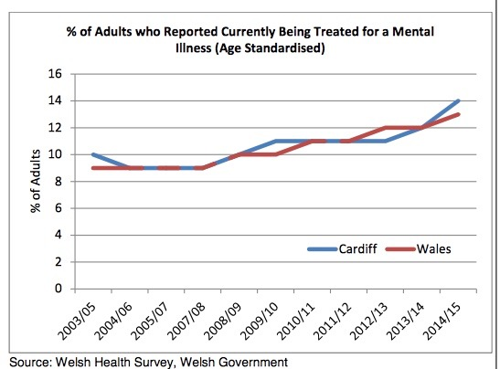

Cardiff.gov.uk., (2016)

Appendix 2

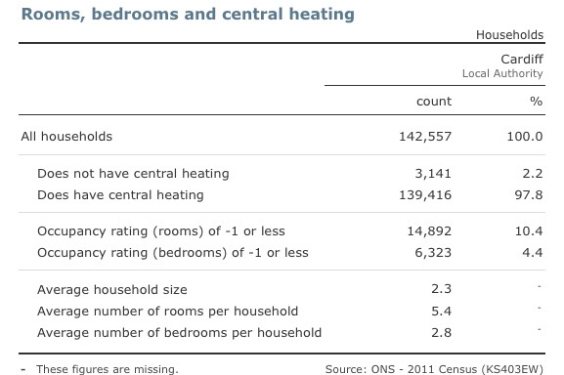

Nomisweb.co.uk, (2011).

Appendix 3
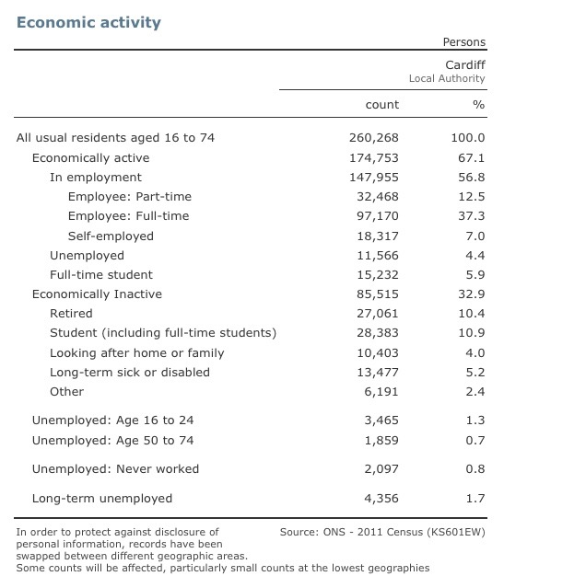

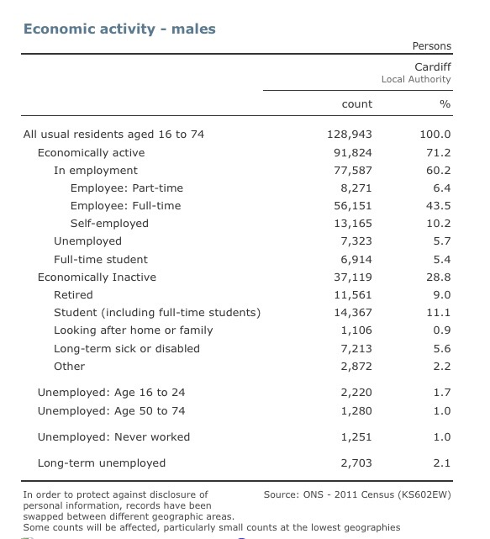

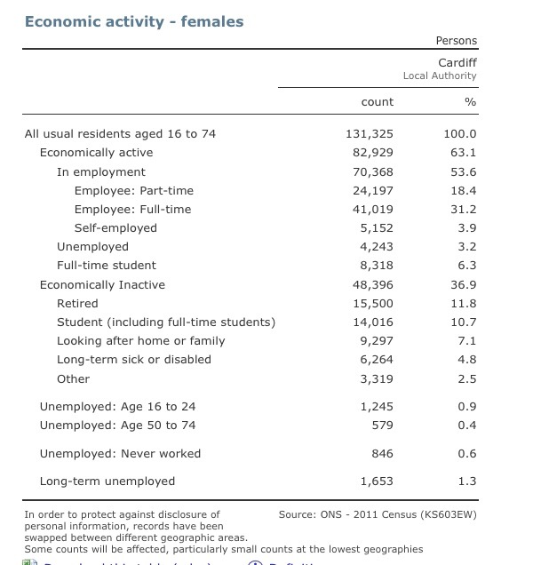

Nomisweb.co.uk, (2011)

Appendix 4

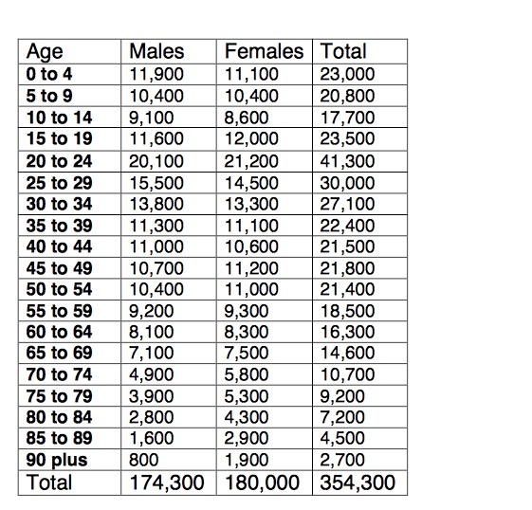

City of Cardiff Council- Aging well in Wales Report 2014

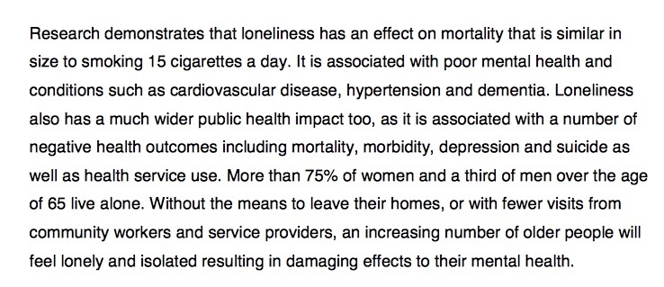

Statement taken out of the City of Cardiff Council- Aging well in Wales Report 2014

References

Assembly.Wales. (2017). Inquiry into loneliness and isolation. [online] Available at: http://www.assembly.wales/laid%20documents/cr-ld11310/cr-ld11310-e.pdf [Accessed 10 Jan. 2018].

Cardiff and Vale Action for Mental Health.org.uk. (2015). Community Mental Health Teams (CMHTs) - Cardiff and The Vale Mental Health Development Project. [online] Available at: http://www.cavamh.org.uk/directories/mental-health-directory/adult-mental-health-general-services/cardiff-and-vale-university-health-board-cardiff-vale-of-glamorgan/community-mental-health-teams-cmhts [Accessed 11 Jan. 2018].

Cardiff.gov.uk. (2016). Programme Intelligence Report Emotional, Mental Health & Well Being. [online] Available at: https://www.cardiff.gov.uk/ENG/Your-Council/Have-your-say/Ask%20Cardiff%20Library/Emotional,%20Mental%20Health%20and%20Well%20Being%20Programme%20Intelligence%20Report.pdf [Accessed 10 Jan. 2018].

Cardiff.gov.uk. (2014). Ageing Well in Cardiff. [online] Available at: https://www.cardiff.gov.uk/ENG/Your-Council/Strategies-plans-and-policies/Equality-diversity-and-cohesion/Strategic-Equality-Plan-and-Policies/Documents/strategic%20equality%20plan/Ageing%20Well%20In%20Cardiff%20Local%20Delivery%20Plan.pdf [Accessed 10 Jan. 2018].

Mosalski,R. (2017). At least 40 people are sleeping on the streets of Cardiff every single night. [online] Available at: http://www.walesonline.co.uk/news/wales-news/least-40-people-sleeping-streets-13704082

Nomisweb.co.uk. (2011). Cardiff Local Authority -Local Area Report. [online] Available at: http://www.nomisweb.co.uk/reports/localarea?compare=1946157397 [Accessed 10 Jan. 2018].

Savage, M. and Lee, D. (2017). Huge health gap revealed between UK’s rich and poor. [online] the Guardian. Available at: https://www.theguardian.com/inequality/2017/dec/23/health-gap-between-uk-rich-and-poor [Accessed 11 Jan. 2018].

Smith, M. (2017). Wales is failing to tackle the health gap between the rich and poor. [online] walesonline. Available at: http://www.walesonline.co.uk/news/health/wales-failing-tackle-health-gap-12158282 [Accessed 11 Jan. 2018].

The Speakeasy. (n.d.). Sharing the Burden. [online] Available at: https://www.speakeasy.cymru/vision/ [Accessed 11 Jan. 2018].

Wightwick, A. (2017). 'Cardiff needs 10 new Welsh language schools' - campaigners. [online] walesonline. Available at: http://www.walesonline.co.uk/news/education/cardiff-needs-10-new-welsh-13712507 [Accessed 11 Jan. 2018].

