Module code: BMPF7302D
Module Title: Authenticity and the Role of the Leader
2431841
Robert Heaton

No content generated by AI tools have been presented as my own work.

I confirm that this is my original work and that I have adhered to the University’s policy on plagiarism

Word count for component one: 3374
Word count for component two: 4896

I work as a Senior Paramedic (SP) responsible for the clinical supervision of approximately 40 emergency medical service (EMS) staff that work autonomously as crews or solo responders. Responding to various urgent, emergency and life-threatening incidents, our locality covers a geographical area which includes urban, rural, coastal and mountainous terrain each bringing unique challenges to pre-hospital care.
The number of variables in day-to-day activities presents challenges in leadership that may not be evident in other areas of healthcare. It is fair to assume that a ‘one size fits all’ approach to leadership is inappropriate and an adaptable approach should be utilised.
The Welsh Ambulance service NHS Trusts ‘2019 -2022 Leadership and Development strategy’ (WAST, 2018) highlighted the need for change and an adaptable approach to leadership. It identifies four leadership styles based on the work of Professor Michael West (2019), describing the future of NHS leadership; Compassionate, Collaborative, Collective and Servant leadership. Throughout 17 years of operational experience, I have witnessed the Authoritarian approach that was commonplace and welcome the change to these alternative methodologies.
In this assignment I will critically evaluate the above-mentioned styles and will draw a conclusion on the most suitable style for the SP role. This will be a combination of academic research and personal experience.

Throughout my career I have witnessed authoritarian leadership at every level of management across different trusts and specialities. Whilst the development strategy mentioned above is a positive step, authoritarian leadership and its effects on staff are still prevalent in the modern service.
Pizzolitto, Verna and Venditti (2023) describe how authoritarian leadership involves significant levels of control over staff, demanding obedience and ensuring a hierarchical approach over subordinates that maintains distance between management and the workforce. Whilst this hierarchical approach is necessary in certain situations, for example during time critical or complex incidents, it is widely acknowledged that the persistent use of authoritarian leadership can be detrimental. Singh et al (2024) discuss this in the context of healthcare, and how the hierarchical theory is a useful method when a time critical situation needs clear instruction and rapid decision making but acknowledges that it can cause hostility.
Outside of the time critical aspects of the job, authoritarian leadership can be demoralising, creating an atmosphere and an attitude of ‘us & them’ between the workforce and the management teams. Kiazed et al (2010) discuss how this can lead to psychological distress, anxiety, depression, conflict between colleagues and family members, and low morale. The subsequent effect of this being poor performance and job deviance impacting overall productivity. Leape et al (2012, P.845) explains that within healthcare, this can be a ‘threat to patient safety because it inhibits collegiality and cooperation essential to teamwork, cuts off communication, undermines morale, and inhibits compliance with and implementation of new practice’.
Due to the perceived ‘us and them’ mindset of staff, and the expected repercussions for anything other than blind obedience Kline (2019) adds to the detrimental effects mentioned above with a lack of trust and fear of reprisal. This leads to a culture of ‘protective hesitancy’ where staff are unable to express any opinions or concerns due to the overarching fear of repercussions, leading to a lack of trust and the inability to have open conversations, impeding worthwhile change. Whilst absences due to sickness are high, Shan et al (2022) discuss the effects of ‘presenteeism’, whereby staff work when in a state of ill health, potentially to the detriment of care due to a fear of disciplinary action for sickness. This is still prevalent in the ambulance service with staff being afraid to take time off due to fear of disciplinary action. This has long term effects on staff welfare and could lead to either increased sickness rates with infectious conditions being passed around or increased absences due to injuries not healing fully prior to return, increasing the longevity of the condition and risk of re-injury.
Shonk (2025) and Fernandopulle (2021) acknowledge that the hierarchical leadership styles have fallen out of favour in place of more inclusive styles, with the latter discussing how this approach is detrimental to healthcare and hospital settings. O’Donovan et al (2021) counter this by discussing how more direct leadership style is beneficial when dealing with inexperienced members of staff, who are not yet independent in the given task. We see this regularly within the ambulance service, and as one of the primary roles of the SP is working alongside newer staff providing additional guidance whilst they learn new skills, particularly in instances where time is limited and intervention must be rapid.

Although I have witnessed authoritarian leadership during my career, the shift towards the contrasting compassionate leadership is now increasing.
WAST (2018) show compassionate leadership as the primary style that it promotes for its 2019-2022 strategy. West (2019) discusses compassionate leadership being the foundation on which collective, collaborative and inclusive styles are based. Without compassion, the other styles cannot be achieved. West & Bailey (2022, pp1) describe compassionate leadership as a ‘focus on relationships through careful listening, understanding, empathising with and supporting other people, enabling those we lead to feel valued, respected and cared for, so they can reach their potential and do their best work’, which is a stark contrast to the authoritarian style discussed above and the traditional methodology of the service.
In 2021, West states how compassion is fundamental to providing psychological safety, health and wellbeing to NHS staff. If we then cross reference this with the long-established ‘Hierarchy of motivational needs’ (Maslow, 1943) we can see how compassionate leadership helps attain the ‘safety’ stage of the pyramid. Hayre-Kwan et al (2021) discuss the importance of meeting these basic needs, specifically throughout the COVID-19 pandemic, and the effect on nursing staff and subsequent effect on patient care.
During the pandemic, I worked on the Hazardous Area Response Team (HART), where we were among the first specialist team to have any interaction with the outbreak. I saw how failures to provide these basic requirements had a direct impact on patient care with confusion around PPE leading to mobilisation delays, and how the lack of care and sympathy shown toward staff by managers led to distrust. An example would be how all PPE provided was several years out of date, yet no alternative was provided. When questioned, management did little to quash any concerns, stating that ‘I’m sure its fine’ despite them not being on the front line dealing with the disease. This unease was further exacerbated when colleagues were becoming seriously unwell or dying. As the pandemic progressed, and more information became available, there was a shift away from the high consequence infectious disease (HCID) status of COVID, and PPE levels were downgraded. Due to the earlier lack of compassion, openness and honesty, this downgrade was met with severe doubt.
Even before the pandemic, it was highlighted by Edwards, Till & McKimm (2018), De Zulueta (2016) and Papadopoulos et al (2021) of the importance of moving from ‘rules, regulations and hierarchies’ to instead focus on compassionate leadership to improve patient care and develop services. West (2021b) adds to this by discussing how the core concepts of promoting belonging, inclusion, trust, honesty and support leads to a much more engaged workforce. This more motivated workforce, resulted in a better quality of care with staff more willing to go ‘above and beyond’ for patients, gaining greater job satisfaction and leading to self-actualisation, therefore attaining the higher tiers of Maslow’s theory.
We see this often in the ambulance service, noticeably with newer staff who have yet to become demoralised. These are the staff who will provide a more holistic approach, go above and beyond for patients and relatives and find satisfaction in doing so. The more demoralised staff are, the more likely they are to be focused on doing the bare minimum, often are seen making decisions based on what suits them, rather than being in the patients’ best interests.
This practice can be dangerous and lead to mistakes, poor patient care and worsening outcomes. From a staff wellbeing perspective we can see how these are ‘self-fulfilling prophecies’ the staff who are more engaged, gain more satisfaction, then continue to spiral upwards in their professional care and personal fulfilment. Those who do less, will become more dissatisfied with their jobs, complain about the workload and queuing outside hospitals and professional deskilling, whilst ultimately not doing anything to improve their own work conditions despite having the power to do so. This breeds poor motivation and low morale, higher staff turnover and burn out.
Ramachandran et al (2023) have reviewed many articles regarding compassionate leadership, with most of the findings all reporting positive responses to this approach such as staff feeling more appreciated, valued and engaged with a noticeable boost in performance. They have also highlighted the common criticisms of the studies reviewed such as the time taken to achieve tasks. Due to reliance on others and allowing independence, the lack of control by the traditional management styles and the ‘softer’ approach to management may be seen to slow progress with less pressure on staff to complete work to strict deadlines. Another criticism acknowledged by multiple sources reviewed in depth by Ramachandran et al (2023) is the amount of training that this leadership style will take, particularly when changing the mindset of the traditional authoritarian leaders. This includes training in coaching, mentoring, emotional resilience, empathy, and self-compassion, all of which would come with additional financial implications and ‘downtime’ for training courses.

As leadership becomes more compassionate, it also shifts focus to utilising different areas of speciality and expertise, dividing the authority and responsibilities between more of the workforce as opposed to the authoritarian leader retaining full power and control. As such, collaborative leadership builds on the compassionate approach, acknowledging that to provide optimum care, a multi-disciplinary approach is required.

Healthcare has changed over recent years, with aging populations, increasing numbers of comorbidities, poor diets and lifestyles, and changes to funding and services available leading to a requirement of a more coordinated approach to patient care. Walsh and De Sarandy (2023) discuss this across the NHS, highlighting the need for collaborative working across areas such as emergency care, primary care, social care, community-based care and in hospital multi-disciplinary teams such as physiotherapist, occupational therapist, pharmacists and dietitians. Within WAST specifically, the strategic workforce plan for 2024-2030 (WAST, 2024), puts a key focus on working with other primary care providers in the community and the development of strategies to implement cross organisational working.
O’Donnell et al (2025) discuss the importance of this interprofessional collaboration and the coordination of services in community-based care in relation to the implementation of the World Health Organisations 'Integrated Care for Older People’ (ICOPE) approach. WHO (2024) describes in detail the importance of this collaborative approach and coordinated care to optimise intrinsic capacity and functional ability in the aging population. The collaborative approach to managing this demographic of patients directly affects the ambulance service. We are often the first call when there is an issue or clinical need, therefore it is imperative that we work closely with others to direct these patients to the right point of care. If we can integrate effectively, the lower acuity and urgent care calls can be more appropriately dealt with by falls teams, district nurses, GPs, and 111 clinicians rather than emergency ambulances, therefore allowing us to be able to provide the emergency care to those who need it.
The rise in an aging population also comes with an increase in chronic conditions and it is expected that within the next few years 75% of adults will be living with 2 or more long term illnesses (WAST, 2024), which will obviously put additional strain on the ambulance service. McGraw et al (2025) discusses how the current healthcare services are overwhelmed by the management of chronic conditions, exponentially exacerbated by COVID 19, and as such highlights the importance of collaborative working to overcome the shortfalls. McLaney et al (2022) have investigated the benefits of collaborative working within hospital settings and report improvement in patient outcomes. They have created a framework for developing these relationships, covering the importance of certain elements such as communication, role clarification, interprofessional values and ethics and shared decision making. This is applicable to all healthcare workers, however, it’s something that has been practiced in the ambulance service for years utilising the Joint Decision Model (JDM) and Joint Emergency Service Interoperability Principles (JESIP, 2024). These principles, aimed at major incident management, have the same key concepts of interoperability working that are seen regardless of the situation.

In a similar methodology to collaborative leadership, collective leadership has a multi-disciplinary approach but instead of in between different agencies, it focuses on the specialities and different roles within the service itself. West et al (2014) highlight the importance of collective leadership within healthcare to boost patient care. This is achieved by using the workforce, and utilising each team members particular skill set or area of expertise, as well as promoting an open culture and sharing the organisational responsibility.
Within the ambulance service, the profession has developed significantly from the traditional view of taking patients to hospital, to a more skilled and experienced workforce delivering advanced care at the primary point of contact. As such, the development of these specialist teams has allowed for the growth of the paramedic profession to encompass areas such as Advanced practice, critical care, palliative care, and falls response. Couple this with the multi-faceted organisation that also includes aspects of emergency, routine and voluntary teams, we can easily see just how much different experience is available to push the service forward.
West et al (2014) suggests that with collective leadership and the shared understanding of roles and responsibilities it promotes, a culture where staff are more likely to intervene in areas that previously might have been seen as a ‘not my problem’ situation and help to overcome difficulties by ‘stepping up’ to achieve the organisational goals.
Collective leadership is featured heavily in WASTs 2019-2022 leadership management strategy and is echoed in the longer term organisational goals to 2030, evidencing how the methodology has been seen as beneficial and deemed to be the way forward for the service (WAST, 2024).
De Brún & McAuliffe (2022) discuss how collective leadership is particularly suited to healthcare and showed how the benefits not only improve patient care but also highlights how this shared responsibility has been evidenced to show improvements in staff satisfaction, engagement, communication, and performance.
Contrary to the above benefits, Edelmann et al (2023) states that instead of trust and cohesion, collective leadership can do the opposite, leading to internal conflicts, power struggles and the hiding of knowledge. This is a significant risk within the ambulance service and the traditional hierarchical approach as current managers could see this sharing of responsibility as a sharing of power and feel undermined. The hiding of knowledge could also be problematic, as people are often seen to do this to protect themselves from replacement or redundancy. This can have serious implications to the running of the organisation, as should that individual be unavailable, the operation would grind to a halt, leading to animosity between staff.

The final leadership philosophy mentioned in the WAST leadership and development strategy (2018) is Servant leadership. This is focussed on the leader providing for and empowering the development of others rather than self-driven power or personal goals. This altruistic methodology was based on the original article by Robert Greenleaf and explained by himself in 2008. It incorporates a more moralistic and ethical approach, involving the leader gaining fulfilment by promoting the development and growth of others, gaining trust and respect through their actions rather than the power that a position may come with. Demeke, van Engen & Markos (2024) discuss how this style of leadership is particularly suited to healthcare by the very nature of healthcare workers and their drive to provide for others.
Wong et al (2024) are more critical of this seemingly ‘perfect’ leadership style for healthcare, discussing how whilst most studies do show positive outcomes to servant leadership, most of the critiqued articles were largely opinion based or conceptual, rather than forming an evidence base, calling into question the legitimacy of the philosophy. Cottey & McKimm (2019) appears to be one such article, that whilst mentioning all the key words associated with a positive outcome and its application to healthcare such as its shared ‘core values’ with the NHS, the actual article appears more opinion than study. Similarly, the work of Trastek, Hamilton, & Niles (2013) condemns the healthcare system as broken and in need of change, offering up servant leadership as a method to bring it about, however, offers little in terms of real world evidence and is more ‘suggestive’ rather than ‘evidence based’, reaffirming the work of Wong et al (2024) mentioned above.
Prottas and Nummelin (2018) discuss Douglas McGregors’ well established theory X and theory Y philosophy and the importance of the motivation of staff. We see theory X being associated with the view that workers are unmotivated by anything other than money, that they are unfulfilled in their work and that they require a high level of ‘micro-management’ and often associated with authoritarian management styles. Theory Y staff are viewed as enthusiastic, keen, interested and take pride in their work. As such, these staff members are often better suited to the servant leadership, collaborative and more inclusive management styles. The servant leadership style plays well to these staff members, promoting independence, engagement and improving outcomes.
Within the ambulance service, I often see a distinct split between the newer, enthusiastic junior members of staff who are the typically theory Y people, and the older generation who are theory X. This is both the management and the staff.
One of the biggest issues I have witnessed is the demoralisation of staff. Due to the current authoritarian management, excess amounts of bureaucracy and challenges at senior management levels that impact effectiveness, new managers quickly become demoralised and disheartened. This leads to the disappointing shift, the theory Y staff, constantly met with hurdle after hurdle when trying to implement even small changes on a local level, gradually lose interest in something that they were originally passionate about, become demoralised and become the theory X persona that they used to hate. This becomes a ‘self-fulfilling prophecy’ as the theory Y become theory X, new staff start at theory Y and the cycle repeats.
I can see from experience a definite shift in the types of people being attracted into management positions, particularly those into the senior paramedic role. The ‘old school’ approach is becoming less common, in favour of managers more inclined to help others, support staff and offer a selfless approach with staff welfare and wellbeing featuring as a higher priority. Servant leadership and the senior paramedic role appear a perfect combination.
Conclusion
The ambulance service faces challenges that are unique in the healthcare industry. All the articles critiqued above, are from ‘in hospital’ settings. These strategies can be implemented in the wider, corporate side of an ambulance trust, however, have limited applicability in the daily operations of emergency ambulance crews. As Senior Paramedics, despite supervising many staff, we only work directly with one member of staff at a time, which changes daily, rather than oversee a set group of staff every day.
As a result, and because of the varied types of incidents we can attend, rather than have a specific leadership style, it is more important to be able to adapt and change between styles in response to the situation faced. Some incidents may require the authoritarian style depending on what is encountered and staff involved, whereas other incidents can be used to promote learning and development with less experienced staff. Therefore, whilst one specific leadership style is not appropriate to our role, taking parts from each theory and applying them in the appropriate manner will yield better results.
These critiqued leadership styles show how the ambulance service has changed in recent years. The move away from authoritarian hierarchical leadership to more inclusive and compassionate leadership can be seen as a positive step. The process of this change, however, will be a long process, as the difficulties mentioned above are seen at every level.

This element of assignment will provide a critical evaluation and reflection of my own personal leadership style and experience throughout my career so far. I have worked for two different ambulance trusts in several different roles. Starting my career in Manchester with Northwest Ambulance Service (NWAS) as an Emergency medical Technician (EMT) in 2008, qualifying as a paramedic in 2012, joining the Hazardous Area Response Team (HART) in 2016 and completing a secondment as a team leader. I moved to the Welsh Ambulance Service in 2022, working predominantly on the Cymru High Acuity Response Unit (CHARU) before moving into my current Senior Paramedic position in October 2024.
Throughout these 17 years, I have held official positions in a leadership role but also am a believer that some element of leadership is manifested in every stage of my career. My clinical confidence has meant that I can take the lead almost subconsciously when faced with different incidents and working alongside different colleagues. Through previous study and further reinforced by this module, I have realised that even with no ‘training’ in leadership previously, my character and personality have fitted into the leadership styles that I would have endeavoured to adopt.
As discussed previously, I do not believe that a ‘one size fits all’ approach to leadership is an appropriate methodology in the ambulance service due to the varied nature of the work. Instead, I believe that a true leader is one that can adapt to differing circumstances, needs, teams and workload depending on the situation. A leader should not be fixated on their ‘leadership style’ but should be able to pull elements of several styles into use as required. A leader may need to be assertive and authoritative with certain individuals or on certain incidents, and supportive and compassionate on others. Their ability to quickly assess a situation and provide the appropriate response in that moment is what will set leaders apart.
To delve deeper into my own leadership style and abilities, this reflective piece will draw upon and discuss several evaluation sources which will be analysed. These include an Insights Discovery psychometric test (The Insights Group Ltd, 2025), the Johari window assessment tool, critical reflection from incidents I have attended and feedback from my peers.

The Insights Discovery test was completed in January 2025 and involved answering scenario-based questions to create a report based upon my answers. Based on Jung’s typology (Macleod, 2019), and with similarities to the Myers-briggs Type indicator (as summarised by Simkus, 2025) the answers given result in four ‘colour dynamics’ denoting personality type. These four colour dynamics are ‘cool blue’, ‘fiery red’, ‘earth green’, and ‘sunshine yellow’ and as can be seen in diagram 1, each have key attributes associated to each colour.
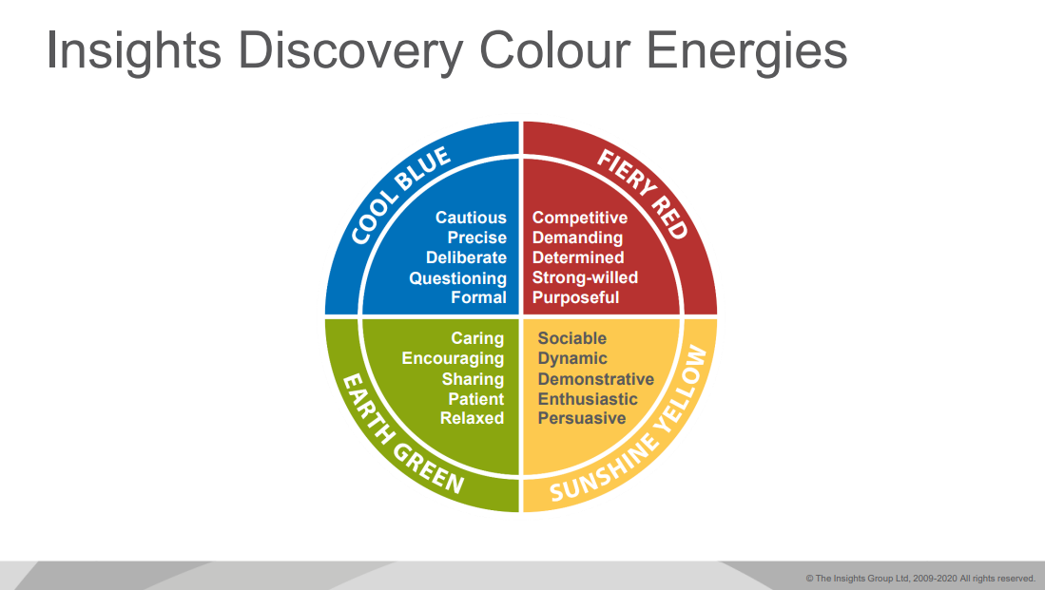
Diagram 1. (The Insights Group, 2020).
Upon completion of the assessment, I was designated a colour for both my conscious persona and a less conscious persona. I am consciously denoted as an ‘earth green’ persona, which I agree with and feel shows the attributes I value and those I seek out in a leadership role. This was closely followed by the ‘cool blue’ category, which became the predominant traits in my less conscious persona by some margin, although ‘earth green’ remained my second highest colour.
Reflecting upon these results, I feel that the summary provided in the report accurately portrays my leadership style. When compared to the leadership styles previously discussed, I can see how these factors become evident in the ‘Servant Leadership’ that I felt was my preferential method of leadership prior to completion of this tool. This reinforces my belief that your natural personality style denotes your primary leadership style and is not a learned behaviour. I am not a servant leader because I have studied how to become one, I am a servant leader because my personality built up over years is best suited to this style.
What the Insights Discovery report has shown me, is the other types of personality and how best to interact and manage them. Similarly, it has shown how the other leadership styles can best manage and influence me, and how by sharing this information with those in positions of authority can improve general performance by better understanding the other personas and what techniques to us to get the best from them. The report shows how my opposite type would be the ‘motivator’ and those within the ‘sunshine yellow’ category. I can see how this would be my opposite, and the results of my colour analysis show yellow to be significantly (around 30%) less than the others, however within my less conscious persona it is the ‘fiery red’ that scores lowest although by much closer margins. The report provides some strategies for dealing with these opposite personalities such as moving swiftly from topic to topic and to be straightforward, efficient and ‘to the point’ and to avoid aggression, undue criticism or unnecessary challenge their ideas or actions. Moving forward, I can now identify the opposite type based on their behaviours, and with the learning from this report, be able to better manage or work alongside them.
One of the key sections that I deem most useful is the ‘Possible blind Spots’ section. This section has given me the opportunity to see areas of my practice that I may have been oblivious to, and more importantly the how some of the behaviours I demonstrate may be interpreted by others. I can see how my tendency to see through one task from start to finish at a time within work can be seen as ‘stubborn or plodding’ whereas in my mind it is simply focussing on a specific task and not flitting between multiple tasks and not completing them. I understand how I can be seen as a solitary figure and sometimes distant as highlighted here, however that is due to the ‘conservation of effort’ described elsewhere within the report, only speaking when something is needed to be said. One of the most pertinent blind spots described here, is my wariness regarding decision making. Despite this being highlighted as a ‘blind spot’, this is something I am very aware of. This can be attributed to previous decisions failing which has left everlasting scars, particularly around the issue of trusting others. I trust myself, but trusting others is something I am remarkably slow to enact.
One of the criticisms in the ‘blind spots’ is also my perceived ‘suspicion of anything new and untested’ however I do not see this as a negative, rather this allows me to fully anticipate failures or problems before they become an issue and therefore have contingencies already in place in my mind. Later in my report, it states that one of my motivators is ‘reality’ rather than abstract theories. This builds into the blind spot and can be seen as cynicism or pessimism, however I feel this makes me a realist.

Created in 1955 the Johari window was created as a heuristic tool to explore an individual’s behaviours and relationships and how others perceive them (Luft & Ingham, 1955). It looks at 4 ‘quadrants’ as shown in diagram 2 below.
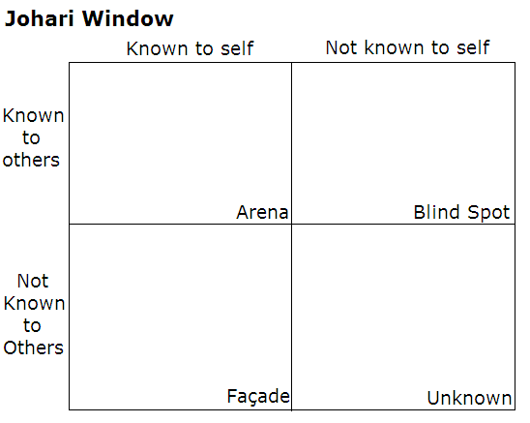
Diagram 2. Luft & Ingham, 1955.
There are numerous tools and assessments available to complete to examine your own personal Johari window, with the results denoting the size of each quadrant. Diagram 3 shows my own results plotted into a window.
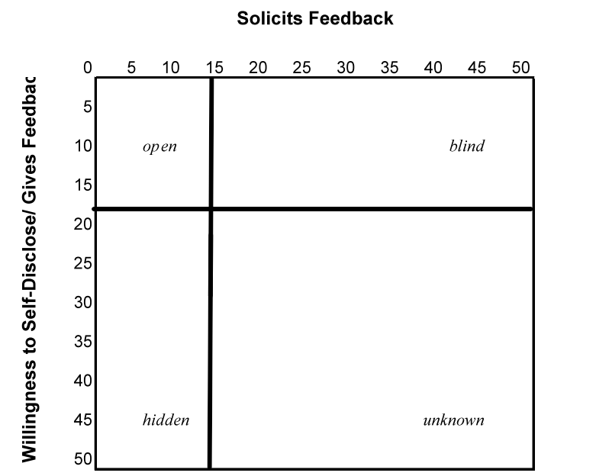
Diagram 3.
This assessment showed how my ‘open’ quadrant was particularly small, which correlates well to the Insights report stating how I am a ‘private person who keeps an emotional distance from others and a physical distance when communicating’. By seeing this window, and the context of the report, I can now see how this may be hindering my personal growth and development as a leader, and my reluctance to gain feedback or self-discovery, can be detrimental in the long term.
Diagram 4 shows how to improve the ‘open’ quadrant, therefore leading to a better personal understanding of myself. The improvements seem simple, expanding into the ‘hidden’ quadrant by being more open with others and through self-discovery such as putting myself outside of my comfort zone to gain more experience and exposure. To expand into the ‘Blind’ quadrant, I need to seek feedback from others around me, gathering their responses to see if there are any areas in which I can develop that I was unaware of previously. To do this, a form was sent out to the staff in my team asking for feedback regarding my leadership style and capability. This has then been analysed and areas for development have been identified (Appendix 1).
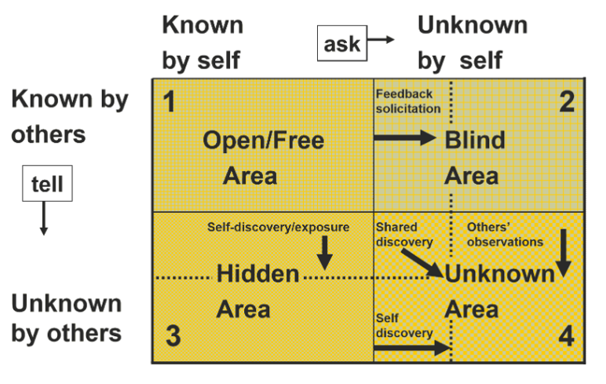
Diagram 4.

Another method for gaining feedback in the immediate aftermath of an incident is the ‘hot debrief’.
There are various debriefing tools available, such as STOP 5 (Walker, 2018), TAKE STOCK (Sugarman, 2019) which built upon the STOP 5 tool, and the SHARE debrief tool (NHS England, 2022). The SHARE tool appears to be more intended for cold debriefs although could be still used as a hot debrief tool for certain elements. The TAKE STOCK tool has been designed to build upon the STOP 5 tool by adding additional, and in my opinion unnecessary elements that would have been covered in the STOP 5 anyway just under a different section. The STOP 5 (diagram 5) tool is my preferred choice of debrief tool; its simplistic method covers all the pertinent information and can be easily remembered without the need for any additional resources or overly complicated acronyms.
This allows for support to those involved and also to give and receive constructive feedback on the incident itself and our own leadership ability. A recent example from my own practice involved a 48-year-old cardiac arrest. Following the resuscitation attempt, I ensured that a debrief was carried out, particularly with the junior volunteers as this was their first cardiac arrest attended. I took these colleagues away from the scene and used the STOP5 method to run through the incident. Following discussion around the management of the arrest itself and if there were any key learning points, I moved the focus of the debrief to ensure their welfare and offer support if required and asked for their feedback regarding my management of the job. Feedback was very positive, highlighting my calm, confident and structured approach, which in turn resulted in them feeling more comfortable and less stressed than they expected despite the nature of the call. The most junior member of the team expressed that she ‘hoped all her cardiac arrests will be run like that’ and that the experience had boosted her confidence by being able to focus without being too overwhelmed. This reassurance of my approach to scene management made me feel that just because an incident is critical, we don’t have to revert to authoritarian methods of delegation. I believe that if you must ‘shout’ orders at people, you have already lost control. This in turn makes a scene more chaotic and stressful, impacting on the care that the patient receives.

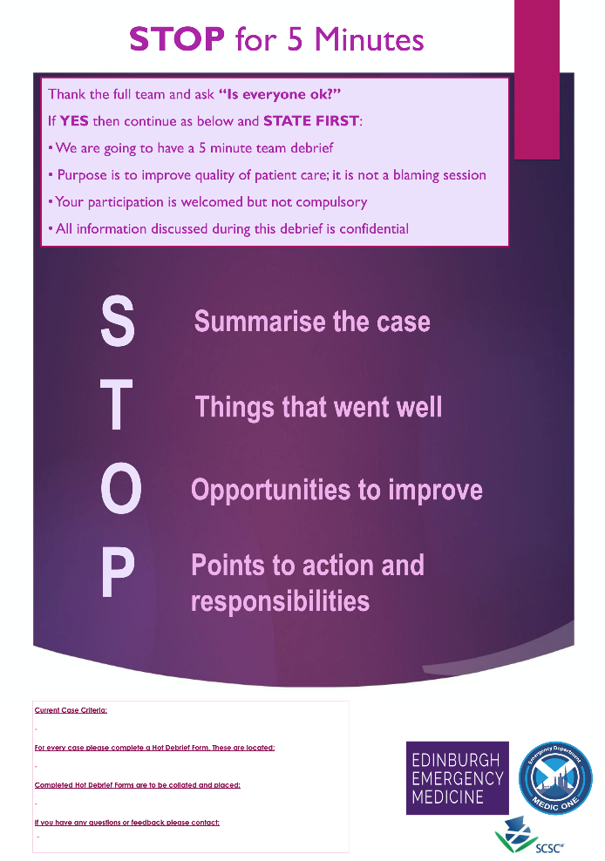
Diagram 5. Walker. (2018).

Reflective practice is common among paramedics and something we do subconsciously on most days. This allows for self-discovery, highlighting personal areas of weakness or areas that we are confident with and using this to put into practice any change into our daily interactions with staff and patients.
There are several reflective models available such as Gibbs (1988), Rolfe (2001), and Kolb (2015).
Kolb’s (2015) ‘Experiential learning cycle’ is a four-stage approach using the following four categories: Concrete Experience, Reflective observation, Abstract conceptualisation, and Active experimentation. I feel this model works well in the education setting it was designed for, however less applicable in healthcare and more suited to theoretical studies rather than ‘experimentation’ on patients. I also find the wording complex and prefer the simplistic wording in Rolfe’s 2015 model. This was built upon the original ‘What, so what, now what’ methodology first introduced by Terry Borton in 1970, with Rolfe developing it specifically for use in healthcare.
I have always struggled using Gibbs’ model, I feel this is the opposite of Rolfe and has too many categories. Due to this, I feel it impedes reflection by being too instructive and specific where reflection should be a personal journey.
Therefore, using Rolfe’s methodology, I will critically reflect on two incidents I have attended as a leader. A major incident exercise and a complex road traffic collision with multiple casualties.

Conwy Tunnel – HAZMAT exercise
What?
Following completion of my Operational commander training, I volunteered to participate as the on-scene commander in an exercise. This exercise was a multi-disciplinary exercise involving WAST, North Wales Police (NWP), North Wales Fire and Rescue Service (NWFRS) and the Highways Agency. The incident involved a road traffic collision involving multiple casualties and a vehicle containing an unknown chemical several hundred metres inside the Conwy Tunnel. As the operational commander, it was my responsibility to liaise with the other services, formulate a working strategy and implement the plan with the resources I had available.
So What?
This was my first exercise in the official capacity of an operational commander with WAST although I have previous experience of major incidents from a previous role which I could draw experience from.
We were briefed as to the details of the incident and whilst awaiting deployment I prepared for the situation by making a mental ‘to do list’ ready for the inter-agency collaboration. Upon arrival, I liaised with NWP and NWFRS on-scene commanders to create an effective strategy. This was then provided to the facilitator as a METHANE report (a structured approach to reporting a major incident standing for Major Incident declared/stand-by, Exact location, Type of incident, Hazards present, Access and Egress, number of casualties and emergency services on scene and required) and a decision made to declare a major incident ‘Stand-by’ at this time based on the number and severity of casualties. The exercise continued and it appeared that the ambulance service participation was minimal due to last minute changes to the exercise, resulting in minimal patient care and basic decontamination. This meant that for prolonged periods of the exercise, the crew and I were generally obsolete as the exercise was more to focus on the Highways agency and NWFRS/NWP involvement. This ultimately led to the incident being overly simplistic and not challenging as a commander. Further JESIP (Joint Emergency Service Interoperability Principles) meetings took place, however due to poor communication, NWP suddenly and without explanation, left the scene and did not return, leaving WAST and NWFRS to conclude the exercise. A final meeting was held back with all services at the forward command point back at the tunnel entrance and the exercise concluded.
As this was my first exercise, I approached it with slight trepidation, wanting to perform well when being scrutinised by the assessors, once the scenario began, I felt more at ease and was able to respond to the situation appropriately. Communication with the other agencies was professional and confident and I feel that I performed well as a commander.
Upon completion of the exercise, I sought feedback from the WAST facilitator who advised that my plan was sound, and my leadership and communication was structured, clear and effective, however I failed to declare a full major incident or stand down within the recommended time frame. I was disappointed with myself for this, however if this was the only negative feedback then this is something I will improve upon. The learning from this has been reinforced and moving forward would hope to not make this mistake again.
Now What?
I was disappointed how simplistic this exercise was it was as it did not test me as a commander or the crew as responders however there was still learning that took place. I have identified a need to improve my knowledge involved in procedures for major incident management and self-directed learning surrounding this subject has been included in my PDP in appendix 2.
Utilising the JESIP mobile software proved to be beneficial as it improved my ability to take notes for an incident log without the need for additional equipment, was quicker than writing by hand and did not require a solid surface. Looking back at the report created I can see that I did not complete each section fully and having them recorded would have led to a more succinct communication with control and would have been helpful with any contemporaneous notes following the incident. Moving forward I will ensure my logging and note taking is more accurately recorded.
The biggest failing of the exercise, and one that is a recurring theme throughout every incident and exercise attended is that of communication. The poor communication by the police was highlighted during the hot debrief and was fed back for review at the full debrief as this was detrimental to the response and could have endangered responders due to the lack of shared situational awareness. This highlights the very important need for effective communication both within service and multi-agency. A more detailed ‘cold debrief’ was held where this lesson was the main learning point taken away. From a personal perspective, I will endeavour to ensure my communication skills are effective, clear and that skills are maintained to minimise any difficulties in the future.

Road Traffic Collision (RTC).
What?
On Christmas Eve I was working on the CHARU fast response car out of Wrexham and was passed an incident for an RTC involving multiple casualties and one 17-year-old ‘trapped under car’. I mobilised and arrived on scene approximately 15 minutes later as the first emergency responder on scene. I was met with three casualties all around 17-18 years old, walking, but with various injuries of varying severity. The car had rolled over several times and had come to a halt on its roof which was flattened with a fourth patient appearing trapped underneath and the car had landed on her after she had been ejected. My initial thought was that this would be a fatal accident but was very surprised to find that the patient inside the car was alive and talking but obviously trapped.
I provided a brief METHANE report to control and requested further assistance including NWP, NWFRS, a Duty Operations Manager (DOM) and for 4 emergency ambulances. I then instructed the bystanders to care for the walking wounded with basic first aid until further resources arrived, then I approached the casualty in the car to try to assess her injuries. This was very difficult due to the limited space through small openings left accessible, but it appeared she had suffered a significant head injury but was still alert and talking.
As following resources arrived, I liaised with the other emergency services and the ambulance crews, designating crews to individual casualties. I handed over the control of the scene to the DOM upon his arrival and went to a ‘clinical lead’ role, overseeing the care of all four casualties with the attending crews. Following the incident, a hot debrief was carried out at the hospital, ensuring staff welfare and if any immediate issues were highlighted of which there were none.
So What?
As the first responder on scene, I took the role of operational commander, provided the initial report, instructed the bystanders how to assist in providing first aid to the walking wounded. The initial feeling was of unknowing always After this I was able to provide care to the trapped casualty, periodically stepping away to liaise with NWP and NWFRS upon their arrival to discuss an extrication plan for the casualty. I feel this was the most effective way of dealing with the patients and still being able to manage the scene in the interim period as the only clinician on scene for a prolonged time.
Due to the time that the incident occurred, I was very aware that ambulances would have been potentially delayed as all crews were either at hospital or handing over at shift change. This made it imperative that an early report requesting further assistance went in to ensure a rapid response. Two of the responding crews had been made aware of the incident and signed onto their vehicle early to assist.
Access and egress were an issue during this incident, the original plan was to egress by the same route as access, however once there were numerous resources on scene and it became difficult. The plan was changed by the DOM to egress via a clearing a path past the crashed vehicle and onwards. This resulted in confusion with the attending crews due to the plan change and the difficulties with satellite navigation, which instead of sticking to the main roads tried to send them down small country roads, or tried to get them to turn around and rejoin the closed road. This delayed the transport of casualties to the hospital but approximately 20 minutes and resulted in a more uncomfortable journey.

Now What?
As the first responder on scene, I knew that all eyes would be looking to me for help and despite the scene in front of me ensured that I appeared calm and confident to allow the members of public to feel assured that help was arriving. I feel I managed to control the scene well, quickly triaging the casualties and directing the public in how to help. Communication with control was clear and effective and led to a rapid deployment of sufficient resources. Inter-agency working was very successful and allowed for a structured and organised extrication of a casualty from a very difficult position. I feel that again, due to my calm and confident approach, I was able to direct bystanders and provide good crew resource management and minimise further stress with the casualties and bystanders.
This incident did highlight the difficulties surrounding access and egress, and how confusion can result from altered plans when handing over command. Moving forward, I will be looking to ensure egress is one of the first considerations to make, not just with ambulances arriving and leaving, but also to ensure that other responders do not block egress routes. I feel a key discussion when making joint decisions should incorporate this at the earliest opportunity and ideally have someone allocated to ensure the egress route is kept clear.

Feedback questionnaire
As the Johari Window identified a need for improved feedback, the questionnaire in appendix 1 was sent to each member of my team to ask for feedback. This covered a range of topics surrounding my leadership and behaviours and were chosen to try and give a quick overview of how others perceive me. The numbers highlighted in red are the average scores for each question.
I was very satisfied with the responses I got, and although response was limited, feel this has given me confirmation that my leadership is of a high standard. I am particularly pleased with the results for questions 5 & 8 regarding my clinical practice and the level of support offered, both elements I strive to promote.
There are areas that can be improved upon, such as the ‘encouragement of new ideas and innovation’ and ‘managing conflict’, these scored the lowest on an area specifically regarding my skills and behaviours and feel these would be the key areas to start with improving.
The lowest scoring question was in relation to balancing clinical and administrative responsibilities. I feel this result was skewed as the response that lowered the average had a written caveat that ‘I’m unable to fully answer on behalf of his administrative responsibilities as I’m not sure what those actually entail’.
The encouragement of new ideas and innovation can be difficult within our line of work, as practice is generally procedure led and evidence based, therefore the scope for trialling new methods can be laborious and time consuming, couple with significant moral and ethical issues. That said, there is always scope for developing the role, therefore I will endeavour to actively encourage participation in the research studies and working groups. I feel that my suspicion of anything new and untested that was highlighted in my Insights report, has led to a very cynical approach to ‘blue sky thinking’. An example of this would be when I attended a workshop on the future usage of drones within the ambulance service, I was very pessimistic and cynical regarding the possibilities, as I feel in the current climate that the time and expense would be much better spent elsewhere, tackling ‘now’ problems rather than ‘future’ ideas.
Regarding the management of conflict, this is something that I have had very little experience of during my career so far. From what I am learning in the role, being fair to all sides can be particularly challenging, especially with certain staff members. As I am relatively new to this management position, guidance would be sought from those more experienced and from my superiors. Further to this, and for my own development, I feel that conflict resolution training or mediation training would be beneficial for my current role and future roles.
The final section of the questionnaire allowed for staff to write some additional feedback in open text format. Generally, this feedback has been very positive, with the responses documented at the bottom of the This is the first time I have been provided any feedback on how well I am performing in this role and find these results reassuring that my methodology and characteristics are as I perceive them.
Upon reflection of the methodology used for this questionnaire, and through discussion with my senior manager during a recent appraisal, I now see that the results could have been inaccurate due to the lack of anonymity with the form. Whilst I hope that staff would be honest and open, there may have been a fear of repercussions for negative feedback. For my own development, future feedback will be anonymised to counteract this possibility.

Personal Development Plan.
This reflection has allowed the creation of a Personal Development Plan (PDP) as seen in appendix 2. There have been several areas identified which I could develop to improve my abilities as a leader and attain my current career goal of a substantiated Senior Paramedic once my two-year secondment concludes.
I have looked at 4 key areas identified during this critical reflection. The primary goal is to achieve a substantiated post prior to the completion of the secondment which is due to finish in October 2026. This is dependant on factors outside of my control such as a post becoming available or another SP moving on to a different role, however there are areas which I can improve to increase my chances of success as and when the post becomes available. As such, by completing the secondment to the best of my abilities, gaining as much experience as possible during this time and completing any additional training offered will improve the likelihood of success and by ensuring I continue to have the support of my line managers.
The following three categories are specific areas that will assist with achieving the long-term goal.
As highlighted by the insights report and the Johari window test, it was clear that my ‘openness’ to feedback was lacking. As a result of this, I was able to gain good feedback from my team through a questionnaire that was sent out. This has given some valuable insight into other areas of my practice that I would have been oblivious to and therefore moving forward with endeavour to seek out further constructive feedback from those around me. This will be 360-degree feedback ensuring I listen to the opinions of my team, other SPs and my line manager as sought during yearly appraisals or through general interactions. Further to these formal methods of feedback, I would also gain more spontaneous feedback through open discussion with colleagues on ride outs and as part of hot debriefs. By seeking this feedback and acting upon it, I would hope to see an increase in my ‘open’ quadrant of the Johari window on subsequent testing.
As highlighted through the critical reflection of the CBRN/HAZMAT exercise, I felt that my knowledge around the policies and procedures could do with development. I have signed up for further exercises to gain further experience and to test my own leadership in these situations, prior to attending I will better prepare myself by self-directed learning of the management of major incidents.
As a result of the feedback questionnaire, one area that I can improve upon is that of conflict resolution in the workplace. As this is not something I have had to do prior to this role, additional training and ‘shadowing’ has been highlighted as a need which should give me better insight and ability to deal with any conflict that arises.

Conclusion
This critical reflection has allowed me to reflect on my current practice and highlight areas in which I would like to improve. Reflection is a continual process, and whilst a PDP has been created based on the findings of this piece, the process is something that can be monitored throughout my career. The objectives will change, and priorities will shift, but the process of reflection can remain the same.
When combined with the work in the first part of this assignment and the detailed analysis of leadership styles, this critical evaluation of myself has resulted in a better understanding of the leadership role, the importance of adaptability and improved self-awareness.

References
Bailey,S., & West, M. (2022). What is compassionate leadership? Available at: What Is Compassionate Leadership? | The King's Fund (accessed 29/5/25).
Cottey, L. & McKimm, J. (2019). Putting the service back into healthcare through servant leadership. British Journal of Hospital Medicine 2019 80:4, 220-224
De Brún, A., & McAuliffe, E. (2022). When there’s collective leadership, there’s the power to make changes&#x201d;: A realist evaluation of a collective leadership intervention (Co-Lead) in healthcare teams. Journal of Leadership & Organizational Studies, 30(2), 155-172. https://doi.org/10.1177/15480518221144895
Demeke, GW., van Engen, ML. & Markos, S. (2024) Servant Leadership in the Healthcare Literature: A Systematic Review. Journal of Healthcare Leadership. 2024 Jan 3;16:1-14. doi: 10.2147/JHL.S440160.
De Zulueta, P. (2016). Developing compassionate leadership in health care: an integrative review. Journal of Healthcare Leadership, 8, pp. 1-10.
Edelmann, C. M., Boen, F., Stouten, J., Broek, G. V., & Fransen, K. (2023). The advantages and disadvantages of different implementations of shared leadership in organizations: A qualitative study. Leadership, 19(6), 467-507. https://doi.org/10.1177/17427150231200033
Edwards, L.D., Till, A. and McKimm, J. (2018). Meeting today’s healthcare leadership challenges: is compassionate, caring and inclusive leadership the answer? BMJ Leader, 2(2), pp. 64-67.
Fernandopulle, N. (2021). To what extent does hierarchical leadership affect health care outcomes? Med J Islam Repub Iran. 2021 Sep 14;35:117. doi: 10.47176/mjiri.35.117.
Gibbs, G. (1988). Learning by doing: A guide to teaching and learning methods. Further Education Unit. Oxford Polytechnic. Oxford.
Greenleaf, R.K. (2008). Greenleaf on Servant-Leadership: Who Is the Servant-Leader? The International Journal of Servant-Leadership, 4(1), pp. 29-37.
Hayre-Kwan S., Quinn B., Chu T., Orr P., & Snoke J. (2021). Nursing and Maslow's Hierarchy: A Health Care Pyramid Approach to Safety and Security During a Global Pandemic. Nurse Lead. 2021 Dec;19(6):590-595. doi: 10.1016/j.mnl.2021.08.013.
JESIP, (2024). Principles for joint working. Available at Principles for joint working - JESIP Website (accessed 16/6/25).
Kiazad, K., Lloyd, S., Restubog, D., Zagenczyk, T., Kiewitz, C. & Tang, R. (2010). In pursuit of power: The role of authoritarian leadership in the relationship between supervisors’ Machiavellianism and subordinates’ perceptions of abusive supervisory behavior, Journal of Research in Personality, Volume 44, Issue 4, P.512-519,
Kolb, D. A. (2015). Experiential learning: Experience as the source of learning and development (2nd ed.). Pearson Education
Leape, L., Shore, M., Dienstag, J., Mayer, R., Edgman-Levitan, S., Meyer, G. & Healy, G. (2012). A culture of respect, part 1 the nature and causes of disrespectful behavior by physicians. Acad Med 2012;87:845–52. Available at: Academic Medicine (accessed 21/5/25).
Luft, J., & Ingham, H. (1955). The Johari window, a graphic model of interpersonal awareness. Proceedings of the western training laboratory in group development. Los Angeles: University of California, Los Angeles.
Maslow A.H. A theory of human motivation. Psychological Review. 1943;50(4):370–396.
Macleod, S. (2019). Carl Jung’s Theory of Personality. Available at: Carl Jung's Theory of Personality (accessed 1/7/25).
McGraw M, Morin A, Tremblay Vaillancourt V, et al. (2025) Chronic Disease Patients’ Engagement in Interprofessional Telehealth Collaboration in Primary Care: A Scoping Review. Journal of Primary Care & Community Health. 2025;16. doi:10.1177/21501319251333858 (accessed 16/6/25).
McLaney E, Morassaei S, Hughes L, Davies R, Campbell M, Di Prospero L. (2022) A framework for interprofessional team collaboration in a hospital setting: Advancing team competencies and behaviours. Healthcare Management Forum. 35(2):112-117. doi:10.1177/08404704211063584 (accessed 16/6/25).
NHS England. (2022). SHARE Debrief tool. Available at: B1465-SHARE-Debrief-v1-FINAL.pdf (accessed 3/7/25).
O’Donnell, D., Davies, C., Devaney, C. et al. (2025). How can interprofessional collaboration be fostered and sustained in team-based care integration for older people in community settings? A realist evidence synthesis. Syst Rev 14, 117. Available at: How can interprofessional collaboration be fostered and sustained in team-based care integration for older people in community settings? A realist evidence synthesis | Systematic Reviews | Full Text (accessed 16/6/25).
O'Donovan, R., Rogers, L., Khurshid, Z., De Brún, A., Nicholson, E., O'Shea, M., Ward, M., & McAuliffe, E. (2021). A systematic review exploring the impact of focal leader behaviours on health care team performance. Journal of Nursing Management, 29(6), 1420–1443. https://doi.org/10.1111/jonm.13403
Papadopoulos I, Lazzarino R, Koulouglioti C, et al. (2021) The Importance of Being a Compassionate Leader: The Views of Nursing and Midwifery Managers From Around the World. Journal of Transcultural Nursing. 2021;32(6):765-777. doi:10.1177/10436596211008214
Pizzolitto, E., Verna, I. & Venditti, M. (2023). Authoritarian leadership styles and performance: a systematic literature review and research agenda. Manag Rev Q 73, 841–871. https://doi.org/10.1007/s11301-022-00263-y
Prottas, D, & Nummelin, M. (2018) Theory X/Y in the Health Care Setting: Employee Perceptions, Attitudes, and Behaviors. The Health Care Manager 37(2):p 109-117, 4/6.
Rolfe, G., Freshwater, D., Jasper, M. (2001) Critical reflection in nursing and the helping professions: a user’s guide. Basingstoke: Palgrave Macmillan
Shonk, K. (2025). Directive Leadership: When It Does—and Doesn’t—Work. Available at: Directive Leadership: When It Does—and Doesn’t—Work - PON - Program on Negotiation at Harvard Law School (Accessed: 1/5/25).
Simkus, J. (2025). Myers-Briggs Type Indicator (MBTI): 16 Personality Types . Available at: Myers-Briggs Type Indicator (MBTI): 16 Personality Types (accessed 1/7/25).
Singh, PK., Singh, S., Kumari, V,. & Tiwari, M. (2024). Navigating healthcare leadership: Theories, challenges, and practical insights for the future. J Postgrad Med. 2024 Oct 1;70(4):232-241. doi: 10.4103/jpgm.jpgm_533_24.
Sugarman, M. (2019). TAKE STOCK – Hot Debrief. Available at: TAKE STOCK - Hot Debrief - RCEMLearning (accessed 3/7/25).
Shan, G., Wang, W., Wang, S. Zhang, Y,. Guo, S. & Li, Y. (2022) Authoritarian leadership and nurse presenteeism: the role of workload and leader identification. BMC Nurs 21, 337 (2022). https://doi.org/10.1186/s12912-022-01119-2
The Insights Group. (2020). Insights Discovery An Introduction. Insights Discovery Group. Dundee.
The Insights Group Ltd, (2025). Insights Discovery Personal Profile. Insights learning and development. Dundee.
Trastek, V., Hamilton, N., & Niles,E. (2014) Leadership models in health care - a case for servant leadership. Mayo Clin Proc. 2014 Mar;89(3):374-81. doi: 10.1016/j.mayocp.2013.10.012.
Walker, C. (2018). STOP 5: STOP for 5 Minutes. Our bespoke hot debrief model. Available at: Edinburgh Emergency Medicine - “STOP 5: STOP for 5 Minutes” – Our Bespoke Hot Debrief Model (accessed 3/7/25).
Walsh, N., & De Sarandy, S. (2023). The practice of collaborative leadership across health and care services. Available at: The Practice Of Collaborative Leadership | The King's Fund. (accessed 6/6/25).
WAST, (2018). Leadership and Development: Our strategy 2019-2022. Available at: nhswales365.sharepoint.com/sites/AMB-Intranet-HR/Shared Documents/Forms/AllItems.aspx?id=%2Fsites%2FAMB-Intranet-HR%2FShared Documents%2FLeadership-Management-Our-Strategy-2019---2022%2Epdf&parent=%2Fsites%2FAMB-Intranet-HR%2FShared Documents
WAST, (2024). Our strategic workforce plan 2024-2030. Available at nhswales365.sharepoint.com/sites/AMB-Intranet-News/SiteAssets/Forms/AllItems.aspx?id=%2Fsites%2FAMB-Intranet-News%2FSiteAssets%2FSitePages%2FNews-piece%2853%29%281%29%2FWAST-Strategic-Workforce-Plan-final-Nov-2024%2Epdf&parent=%2Fsites%2FAMB-Intranet-News%2FSiteAssets%2FSitePages%2FNews-piece%2853%29%281%29 (accessed 16/6/25).
West, M. (2019). Michael West on compassionate and inclusive leadership. Available at: Michael West On Compassionate And Inclusive Leadership | The King's Fund (accessed 20/5/25).
West, M. (2021) Compassion is the key. The journal of the health visitors association. Community Practitioner, 94(1), pp. 25.
West, M. (2021b) Compassionate Leadership: sustaining wisdom, humanity and presence in health and social care. London. Swirling Leaf Press.
West, M., Eckert, R., Steward K. & Pasmore, B. (2014). Developing collective leadership for healthcare. The Kings fund. Available at Developing collective leadership for health care May 2014 (accessed 19/6/25).
WHO. (2024). Integrated care for older people (ICOPE): guidance for person-centred assessment and pathways in primary care, second edition. Geneva: World Health Organization.
Wong, LY., Sendjaya, S., Wilson, S. & Rixon, A. (2024). Evidence behind the exhortation? A rapid review of servant leadership’s influence and claims in healthcare over the last decade BMJ Leader 2024;8:88-92.

Appendix 1.
Clinical Leadership Skills Feedback Questionnaire
Instructions: Please rate the following statements based on your experience with Rob Heaton. Use the scale from 1 to 5, where 1 = Strongly Disagree and 5 = Strongly Agree.
Leadership Styles
1. demonstrates a clear vision for our team.
· 1 2 3 4 5 (4.85)
2. adapts their leadership style to meet the needs of the team.
· 1 2 3 4 5 (4.85)
3. encourages innovation and new ideas.
· 1 2 3 4 5 (4.71)
4. effectively balances clinical and administrative responsibilities.
· 1 2 3 4 5 (4.57)
Leadership Behaviours
5. leads by example in clinical practice.
· 1 2 3 4 5 (5)
6. is approachable and open to feedback.
· 1 2 3 4 5 (4.85)
7. makes decisions in a timely and effective manner.
· 1 2 3 4 5 (4.85)
8. supports professional development and growth.
· 1 2 3 4 5 (5)
Interpersonal Skills
9. communicates clearly and effectively.
· 1 2 3 4 5 (4.85)
10. shows empathy and understanding towards staff.
· 1 2 3 4 5 (4.85)
11. resolves conflicts fairly and constructively.
· 1 2 3 4 5 (4.71)
12. fosters a collaborative and inclusive work environment.
· 1 2 3 4 5 (4.85)
Overall Impact
13. leadership positively impacts team morale.
· 1 2 3 4 5 (4.71)
14. leadership enhances the quality of patient care.
· 1 2 3 4 5 (4.85)
15. leadership contributes to the overall success of the team.
· 1 2 3 4 5 (4.71)
Additional Comments:
· Please provide any additional feedback or specific examples that illustrate Rob’s leadership strengths or areas for improvement.
‘I find Rob very approachable, he is always calm, kind and considerate.’,
‘I find Rob really knowledgeable, he is always good and patient at explaining clinical procedures.’
‘At this time I could not indicate if there are any areas for improvement’.
‘Rob approaches the role with enthusiasm and brings his experience from other service roles forward into the SP role’
‘…good forward-thinking rationales and leadership for improvement and expansion for that role within the service going forward.’
‘I’ve always found Rob to be proactive, honest and supportive as a colleague and as my senior paramedic team leader. I have a lot of respect for his honesty and his work ethic’

Appendix 2.

PERSONAL DEVELOPMENT PLAN
Areas to be addressed | Activity to address this | Resources/ Support required | Completion Date | Measures of success | Review method / Review Date
Permanent SP role | Continue to work in secondment, await further job opportunities  Ensure CPD/CV is current and worked upon | PGCert  Any training offered within role  Support from HBCL and LM  Any additional relevant training/courses that become available | Oct 26 | Substantiated post | Secondment ends October 2026.  Substantiated post prior to or around this time
Improve ‘open’ quadrant in Johari window | Gain feedback from peers  Gain feedback from team  Gain feedback from line manager | Feedback forms  Open and honest discussion  Debriefs on incidents | July 26 | Larger ‘open’ quadrant  Improved self-awareness | Re-do Johari window questionnaire every 3 months to review progress
Improve knowledge of major incident procedures | Self-directed learning of policies and procedures | Major incident and casualty management plans  JESIP doctrine  MTA JOPS | October 25 | Improved confidence in operational commander role | Completion of 2 scheduled major incident exercises in Sept 25 and October 25
Conflict resolution | Mediation training  Observation of others  Self directed review of key policies | Support from LM to attend training course  Agreement to sit in on any upcoming mediation sessions  Time to review policies | July 26 | Manage conflict in the workplace, run mediation session  Be able to have confidence in advice given | Feedback from peers and Line manager upon completion of any sessions with guidance on improvement

