
School of International Hotel Management
BA (Hons) International Hotel Management

Marketing Essentials
BMIH4005
LEVEL 4
Student Name: Rebecca Flavia Macavei
Student ID: 2232071
University Name: University of Wales Trinity Saint David
Year: 2023
Table of Contents
Assessment 3
1. Introduction 3
2. Situation Analysis 3
3. Objectives 6
4. Strategy 6
5. Tactics 7
6. Action 9
7. Control 10
8. Conclusion 10
References 11
Presentation 12

Assessment

1. Introduction
The current industry analysis states opportunities for outsourcing the maintenance, room service and smart technological support for the hospitality sector. Companies like Holidays Inn, Premier Inn, Easy Hotels Plc and other contemporary companies are outsourcing their services to House Joy, SudShare, Narchie and Codementor. Premier Inn is one of the most promising hotel chains in the UK with more than 800 hotels across the country and operating with more than 35,000 people for the service of 83,000 rooms. The commercial class stay in the hotel makes it prone to frequent housekeeping and room service compliance. The marketing plan will use the SOSTAC framework for the completion of the project. Models like SWOT, STP analysis, Bowman’s strategic clock, PESTLE analysis, SMART goal setting and 4Ps of the marketing mix will be used in the marketing plan.

2. Situation Analysis
SWOT analysis
Strengths  The company has a major 17% market share in the hospitality sector in the UK (Whitbread PLC, 2022)‌. | Weaknesses  The poor global presence of the company is the primary reason for its challenging situation against hotel chains like Holiday Inn, Easy Hotel, Britannia Hotels and Hilton.
Opportunities  New BNB services are the major threat of the entire hotel industry in the UK. | Threats  New BNB services are the major threat of the entire hotel industry in the UK (Whitbread PLC, 2022)‌.

STP analysis
Around 34% of the huge monthly guests base of 5 million approximations in Premier Inn Hotel, are customers belonging from the age group of 26-34 years old. Around 65% are male and among them 23% visits with family (Bell, 2023)‌. Around 45% of the guests are from lower and middle economic class (Whitbread PLC, 2022)‌. The guests are sufficiently interested about smart digital features, housekeeping services, availability of food and transport helpdesk services. Therefore, the company needs to focus its marketing on the subscription plan for repetitive services, middle-aged and lower-middle economic class population. According to Ivanov and Webster (2019), Premier Inn also needs to optimise its operation cost and reduce prices of regular rooms for the convenience of the contemporary travel audiences.
Bowman’s strategic clock
Hybrid pricing and differentiation of services are the major take on the profitable marketing plan for Premier Inn Hotel (Bell, 2023)‌. The hotel chain needs to segment its pricing of the regular, deluxe room along with fast and slow services. This can allow the customers to get reasoning with the service and pricing compatibility.
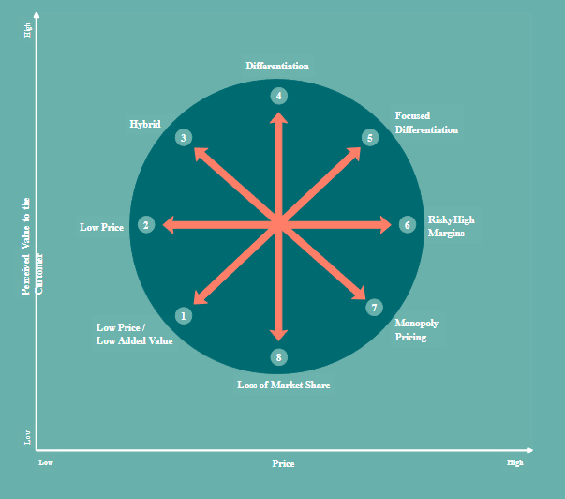
Figure 1: Bowman’s Strategy Clock
(Source: Bell, 2023)
Demonstrating awareness of Premier Inn Hotels in terms of B2B relationship, franchises and partnership
The company needs to approach SudShare and Codementor for its service outsourcing. This can allow Premier Inn to gain a significant partnership profit margin and optimised operating cost with service component resourcing (Whitbread PLC, 2022)‌. According to Baum (2019), it will also increase the B2B sales of the food and stay support services for the partner companies increasing the customer touchpoint and marketing expansion.
PESTLE analysis
PESTLE Factors | Description
Political | The food services and recruitment functions are deeply and negatively impacted by the Russia-Ukraine war, US-China trade war and Brexit law in the UK (Bell, 2023)‌.
Economic | The long ongoing inflation, trade market disruption limiting the outbound operations.
Social | The social distancing norms and expansion of adventure tourism, hitchhiking (Bell, 2023)‌.
Technological | Application of smart technologies and room service bot.
Legal | Food safety law amendments in 2021 are forcing hotels to register their food services under different business propositions (Smith and Zook, 2020)‌.
Environmental | Carbon emission control for ventilation pollution index.

3. Objectives
Objective 1: To outsource maintenance, housekeeping and room service of Premier Inn Hotel for optimised operating cost and facilitation of hybrid working in 5 months.
Objective 2: To implement smart room service bot with safety sensor, voice command and responsive contact logistics with required staff in 2 months.

4. Strategy
Product and services: According to Ivanov and Webster (2019), the service outsourcing for maintenance and room service can allow Premier Inn Hotel to understand the standardised service trend in the market.
Human resources: Recruiting and training Premier Inn employees with similar service skills can allow the hotel to adapt with the updated skill sets in the restaurant and specific hotel chains in travel destinations.
Negating challenges: Partnership contracts are required to be set with trading boundaries and service orientation policies. This can allow the hotel to sustain the personalised service protocols with the partners and companies (Jobber and Ellis-Chadwick, 2020)‌.
Customer service improvement: The customers can get a better proposition of the room service and food services. According to Stylos et al. (2021), the standardised services are less prone to personalised unacceptance from the major customer base in Premier Inn Hotel.
Challenges: The awareness of the room service outsourcing can allow the guests to lose reliability over the hospitality service of Premier Inn. This can reduce the recognition and brand value of the hotel chain (Bell, 2023)‌.
Customer retention: Arranging additional services that are unique in Premier Inn and the lagged behind technological improvisation can disrupt the interest of younger or middle-aged guests.

5. Tactics
Product (Service): Premier Inn is trying to provide responsive housekeeping, room service and fooding services with outsourcing to other companies. Codementor, SudShare and Narchie are the main choice of partnership for Premier Inn. The company has implicated a new smart room service bot and developed the programing to call room service or housekeeping in an instance of a voice command. This has a promising way of improving the service in the hotel chains (Jobber and Ellis-Chadwick, 2020)‌. The hygiene issues are controlled by the smart device sensors in the room which is detecting any potential dirt in the room and contacting room service for making an approach to the guest regarding the cleaning requests.
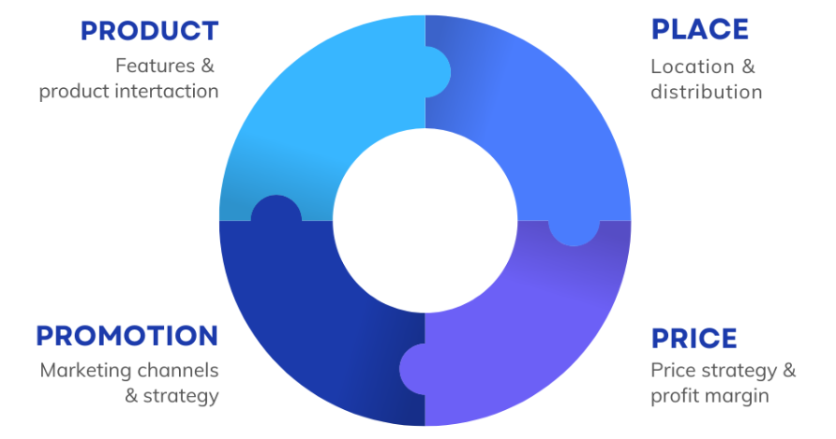
Figure 2: 4Ps of Marketing Mix
(Source: Ivanov and Webster, 2019)
Place: According to Bowie et al. (2017), Premier Inn is trying to put this service in more than 1400 locations across the UK. travel destination for adventure tourism does not comply with sufficient networking availability to apprehend with smart bot support. However, the hotel is availing this service and the outsourced service in around 98% of the urban locations and some remote locations (Bell, 2023)‌. The partnered employees are being compensated for their service orientation with the hotel’s tradition. This is further increasing the impact of the service to the customers (Jobber and Ellis-Chadwick, 2020)‌.
Price: Premier Inn Hotel is trying to reduce its pricing by implementing operating cost reductions for this smart room service support and outsourcing off maintenance. According to Ivanov and Webster (2019), the company has managed to reduce 20% pricing for regular rooms and 14% pricing cut in the Deluxe room. However, the seasonal pricing strategy is still unchecked for convenience pricing to the guests.
Promotion: Premier Inn hotel has decided to provide branded uniforms to the partners while working in the hotel. This will allow Premier Inn to keep its service marketing to the customers (Jobber and Ellis-Chadwick, 2020)‌. The food and smart bot service in the room will be promoted through online vlog marketing and social media marketing. Moreover, every VR room visit facility will also be implemented with the room service bot availability.

6. Action
Marketing channel schedule | Description | Months
Marketing channel schedule | Description | 1 | 2 | 3 | 4 | 5
Social media marketing | Post on Facebook, Instagram, Twitter along with some looks on the new services.
Teasing the service changes in official website | Some overview on the look and feel of the services with mockup and trial marketing.
Providing VR experience and room tour | In the official website and hotel booking sites.
Partnership advertising | Poster and commercial marketing.
Merged service changes tweaking in social media | Service changes with blog marketing or influencer marketing.
Teasing the smart room service bot | Product marketing
Launch event | Based on the response of the previous marketing.

7. Control
The advanced booking logistics, customer footprint, reviews, positive feedback from the customers, optimised operating costs and the partnership sustainability are the major evaluating factors for the success measurement. Premier Inn needs to at least increase 14% advanced booking between 3 months of the plan execution. The company needs to increase at least 16% customer footprint in the selected 843 urban locations. Premier Inn needs to increase at least 1.3 customer feedback points in its official online portal. Moreover, at least 8% savings in the operating cost with partnership with outsourcing maintenance service can further indicate the success of the plan.

8. Conclusion
The risk of losing the brand recognition as an excellent hospitality service provider can be most critical for Premier Inn. The partnership and smart bot implementation has optimised operation cost and facilitated hybrid working. However, it lacks the sustainable branding confirmation. Premier Inn hotel can also optimise its hotel locations by optimising the smaller chains in separate locations and expanding in remote locations with more luxury stay propositions. This can complement the current trend of adventure tourism for its existing and newly interested guests. The marketing plan has used the SOSTAC framework to convey the marketing plan with market environment analysis and plan execution strategies.

References
Baum, T., (2019). Does the hospitality industry need or deserve talent?. International Journal of Contemporary Hospitality Management.
Bell, L., (2023). The UK’s best and worst hotel chains - Which? Available at: https://www.which.co.uk/reviews/uk-hotel-chains/article/best-and-worst-uk-hotel-chains-aaVVF4u1jZpe [Accessed 2 March 2023]
Bowie,D. Buttle,F. Brookes,M &amp; Mariussen,A (2017), Hospitality Marketing. 3 rd ed, Routledge, London
Ivanov, S. and Webster, C., (2019). Robots, artificial intelligence and service automation in travel, tourism and hospitality. Emerald Group Publishing.
Jobber, D. and Ellis-Chadwick, F (2020), Principles and practice of marketing. 9th ed. London:
Smith PR &amp; Zook ZE (2020) Marketing Communications. 7 th ed, Kogan Page, London
Stylos, N., Zwiegelaar, J. and Buhalis, D., (2021). Big data empowered agility for dynamic, volatile, and time-sensitive service industries: the case of tourism sector. International Journal of Contemporary Hospitality Management.
Whitbread PLC, (2022). Our business model and strategy. Available at: https://www.whitbread.co.uk/about-us/our-business-model/ [Accessed 2 March 2023]

Presentation
Cover Page
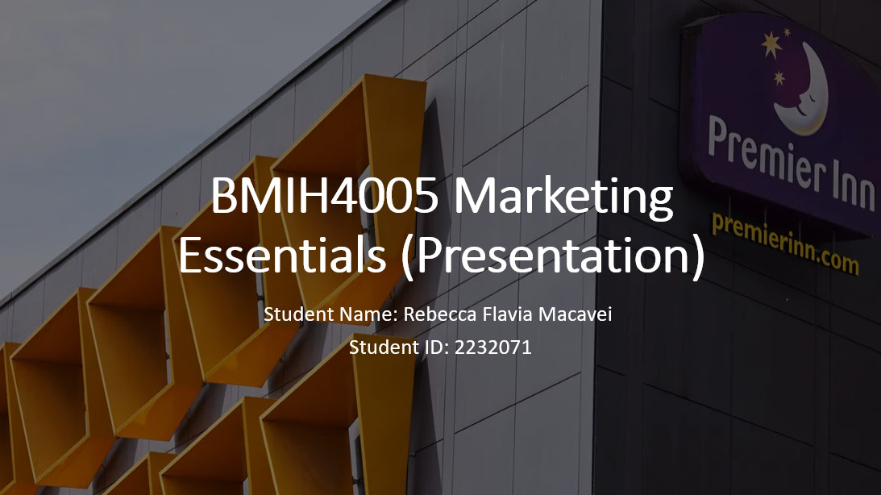
Introduction
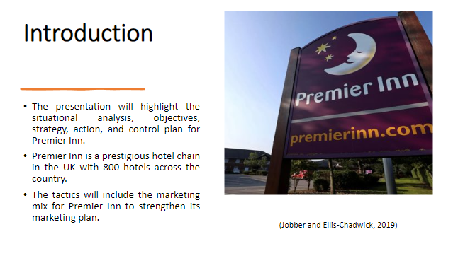
The presentation will explore knowledge about the situation analysis including 5C, SWOT analysis, customer segmentation, Perceptual positioning map, Bowman's strategy clock, and PESTLE Analysis.
Situation Analysis
5C Analysis
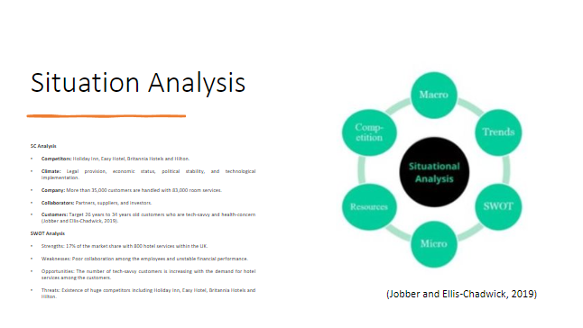
5C analysis helps Premier Inn to focus on the competitors, climate, company, collaborators, and customers. SWOT Analysis focuses on both internal and external analysis of the company.
STP Analysis
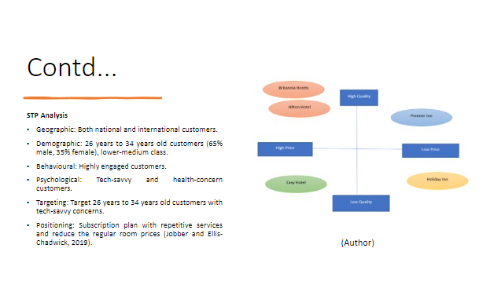
STP Analysis focuses on the comprehensive marketing plan to set the target customers and the positioning of the products in the market (Bowie et al., 2016). Perceptual mapping is important for Premier Inn to map the company's position and its competitors’ position in the perceptual map based on their price and service quality.
Bowmans’ strategy clock
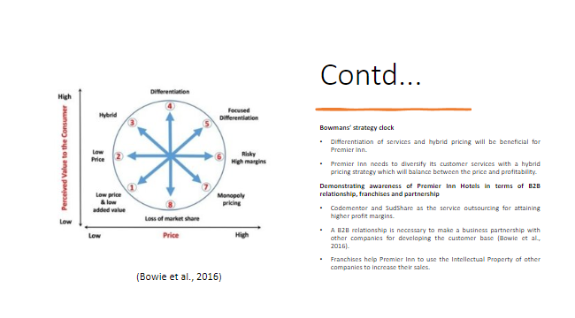
Bowmans’ strategic clock helps Premier Inn to identify the most significant strategies for the hotel to attain a higher customer base and profit margin. Service outsourcing is important to spread the services in other countries (Bowie et al., 2016). The B2B relationships and Franchises are important for Premier Inn to develop its business strengths.
PESTLE Analysis
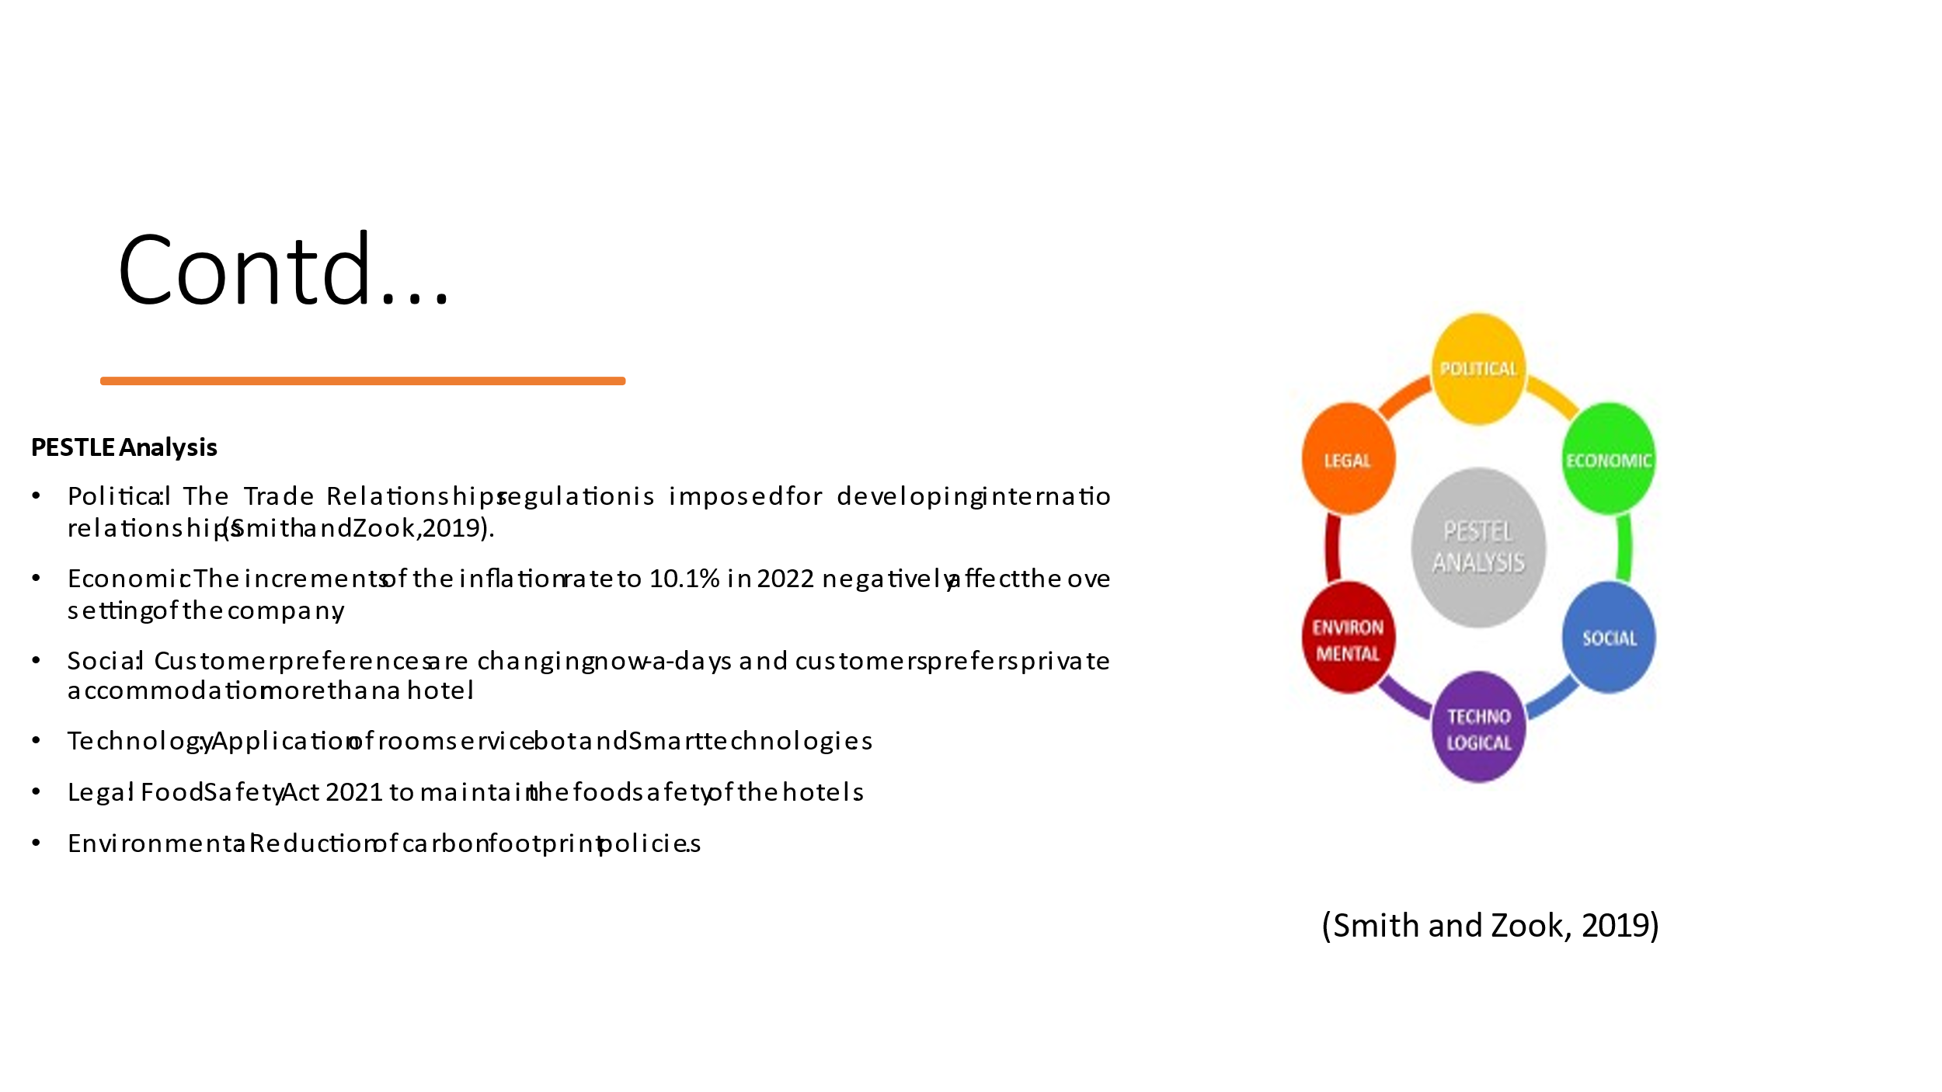
PESTLE Analysis is important to scan the macro-environment factors where Premier Inn operates.
Objectives
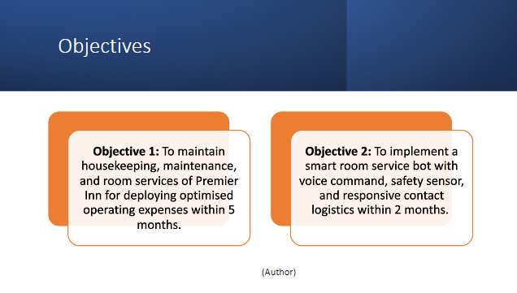
Strategy
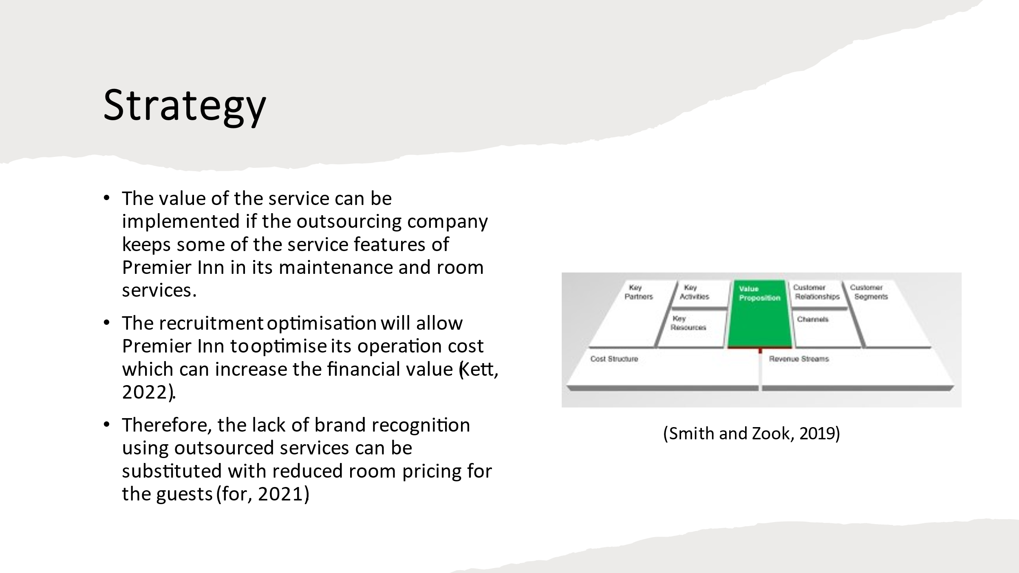
The customer service standardisation will allow Premier Inn to gather logistics on the referred service demand in the modern market. The criticality of losing some control over the safety concerns and food services can create some problems and reduce the administrative value.
Tactics
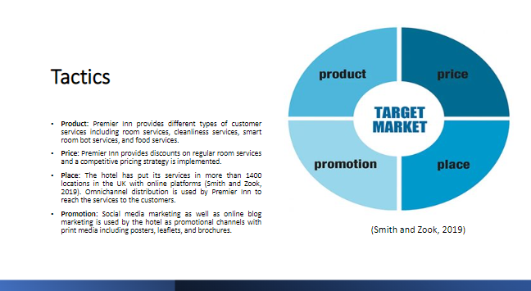
The tactics include the marketing mix of Premier Inn for supporting the comprehensive marketing plan of the hotel.
Action
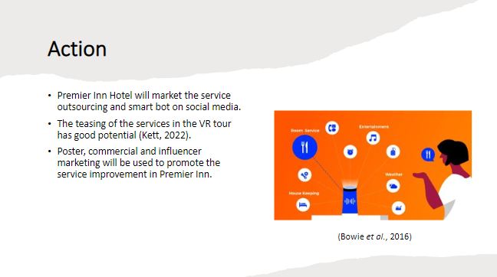
Moreover, the smart assistant improving the quality of room service can be promoted for the evaluated market launch of the mentioned services (for, 2021)‌.
Control
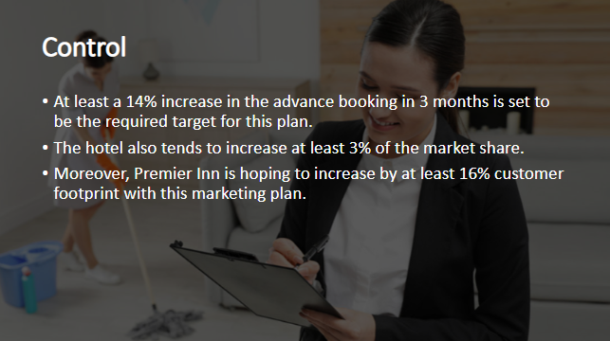
Conclusion
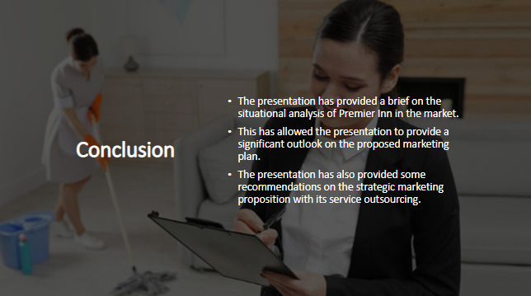
References
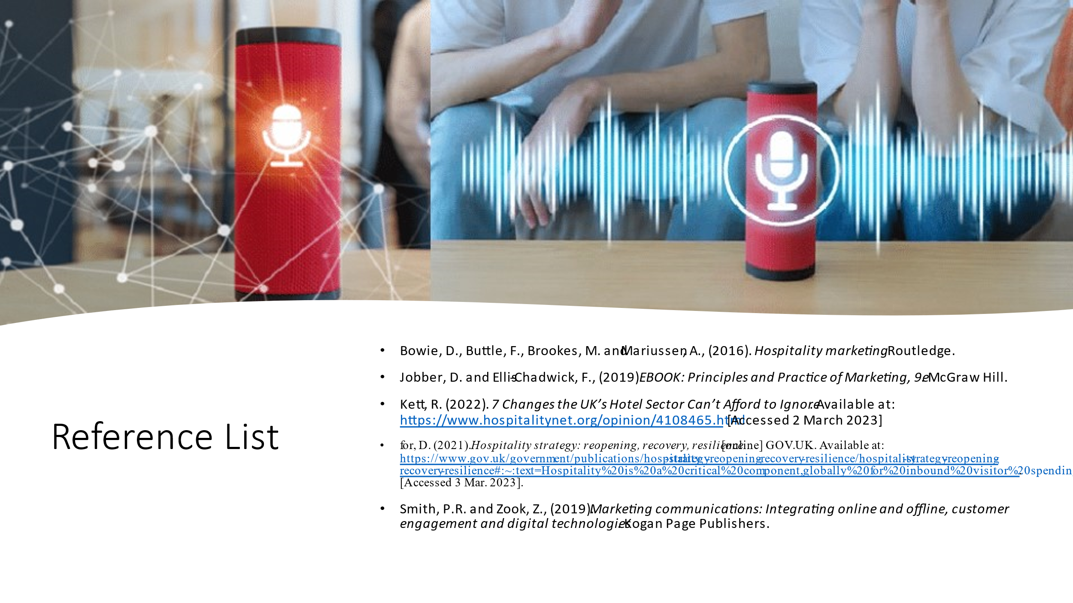
Bowie, D., Buttle, F., Brookes, M. and Mariussen, A., (2016). Hospitality marketing. Routledge.
Jobber, D. and Ellis-Chadwick, F., (2019). EBOOK: Principles and Practice of Marketing, 9e. McGraw Hill.
Kett, R. (2022). 7 Changes the UK’s Hotel Sector Can’t Afford to Ignore. Available at: https://www.hospitalitynet.org/opinion/4108465.html [Accessed 2 March 2023]
for, D. (2021). Hospitality strategy: reopening, recovery, resilience. [online] GOV.UK. Available at: https://www.gov.uk/government/publications/hospitality-strategy-reopening-recovery-resilience/hospitality-strategy-reopening-recovery-resilience#:~:text=Hospitality%20is%20a%20critical%20component,globally%20for%20inbound%20visitor%20spending. [Accessed 3 Mar. 2023]
Smith, P.R. and Zook, Z., (2019). Marketing communications: Integrating online and offline, customer engagement and digital technologies. Kogan Page Publishers.

