

Undergraduate Dissertation

Exploring the public's perception of UK policing on mobile phone use by drivers.

Police Constable Degree Apprenticeship – PCDA
Bachelor of Science Professional Police Practice (BSc)

Rhys Thomas
Student Number: 2132146

Acknowledgements
- I would like to thank all my family, friends and work colleagues in helping me complete this dissertation.

- I would like to thank my university tutor for helping me through this research project and giving me valuable feedback as always, this project would have been very difficult to complete without your support.

Declaration

This work has not previously been accepted in substance for any degree and is not being concurrently submitted in candidature for any degree.
Signed:
Date: 21/12/2024
STATEMENT 1

This dissertation is being submitted in partial fulfilment of the requirements for the degree of BA.
Signed:
Date: 21/12/2024
STATEMENT 2
This dissertation is the result of my own independent work/investigation, except where otherwise stated.

Other sources are acknowledged in the Reference Section.
Signed:
Date: 21/12/2024
STATEMENT 3

I hereby give consent for my dissertation, if accepted, to be available for photocopying and for interlibrary loan, and for the title and summary to be made available to outside organisations.
Signed:
Date: 21/12/2024
STATEMENT 4

I hereby give consent for my dissertation, if accepted, to be available on the university’s IT system to those who have consent to use the system.
Signed:
Date: 21/12/2024

Abstract
The aim of this dissertation was to investigation and examine the public’s opinion and perception of UK roads policing and its impact on mobile phone use behind the wheel. Comprehensive research has taken place regarding relevant and existing academic literature surrounding the topic of mobile phone use and police enforcement.
Comprehensive online research of statistics and legislation published by government bodies has also been completed to assist with this dissertation. To assist in understanding the publics perception regarding mobile phone and police enforcement methods a mixed method survey was completed.
The findings from the survey have been compared to relevant online media and also academic literature to draw conclusions and also highlight key themes. These themes include the demographic of drivers, the attitude towards mobile phone use and the impact of police enforcement. This dissertation highlights the key themes associated with mobile phone use and also highlights the opinion of members of the public to offer recommendations on police enforcement to better tackle the issue of mobile phone use.

Table of Contents
Chapter 1 – Introduction…………………………………………………………………………………………………………………..…5
1.1 – Research rationale…………………………………………………………………………………………………………………..….5
1.2 – Aims and objectives…………………………………………………………………………………………………………………….5

Chapter 2 – Literature Review…………………………………………………………………………………………………………..….6
2.1 - Introduction………………………………………………………………………………………………………………………………...7
2.2 - Enforcement………………………………………………………………………………………………………………………………..7
2.3 - Causes of mobile phone use………………………………………………………………………………………………………..8
2.4 - Contributors to road traffic collisions …………………………………………..……………………………………………..9

Chapter 3 – Methodology…………………………………………………………………………………………………………………….8
3.1 - Introduction……………………………..………………………………………………………………………………………………..10
3.2 - Research Strategy……………………………..……………………………………………………………………………………….10
3.3 - Data collection and analysis……………………………..………………………………………………………………………..10
3.4 - Limitations and potential problems……………………………..……………………………………………………………..10

Chapter 4 – Analysis of results……………………………………………………………………………………………………………..9
4.1 - Demographic……………………………..………………………………………………………………………………………………11
4.2 - Attitude……………………………..……………………………………………………………………………………………………….12
4.3 - Enforcement……………………………..……………………………………………………………………………………………….13

Chapter 5 – Conclusion 13
Chapter 6 – References 14
Chapter 7 – Appendix 15

Chapter 1– Introduction
This chapter of the dissertation provides context to this study and explains why it is an important area of research. It will also outline and explain the aims and objectives of the research.
The purpose of this dissertation is to explore the public perception of UK policing on mobile phone use by drivers. It will also aim to explore the public’s perception of mobile phone use whilst driving, how it is perceived by drivers, the causes of mobile phone and how enforcement has impacted the usage of mobile phones. This research projects to understand the reasoning behind mobile phone usage by drivers and if enforcement measures are enough of a deterrent. This dissertation will also offer recommendations on how police can better enforce and tackle the issue of mobile phone usage by drivers.

– Research rationale
The circumstances for this research stem from the ever-increasing number of motorists using their mobile phones, (Horsman et al., 2015). Driver distraction has been an ever-increasing issue for a number of years and has been linked as a contributing factor in road traffic collision (GOV.UK 2022). In recent years there has been a lack of government / police led campaigns surrounding mobile phone usage. The most recent campaign relating to mobile phone usage is the THINK campaign which is dated 2022, and was aimed at reducing mobile phone usage by drivers (THINK, 2022).
Campaigns surrounding mobile phone usage was heavily prevalent in the early 2000s when mobile phones were just beginning to become an everyday item for the public and became the new norm for public.
Throughout the many research and extensive academic investigations relating to mobile phone usage there is a knowledge gap relating to the public’s perception of mobile phone usage and the police enforcement surrounding it. The knowledge gap is particularly centred around how the public feel in regards to the issue of mobile phone usage and how they feel regarding Uk policing on this subject. There are underlying themes identified in academic literature and research such as the demographic of drivers which will be further explored in this research project.
This research project will be particularly valuable to roads policing departments as it provides public opinion on how they view police enforcement and strategies and how this can be changed to improve enforcement.

– Aims and objectives
The aim of this research project is to fill the academic knowledge gap relating to the public’s perception of mobile phone usage most notably in the UK and also explore the public perception of UK policing on mobile phone usage.
This research project will highlight key themes associated with mobile usage, whether or not police enforcement is effective and how this viewed by the public.
The research conducted by this project will help to fill the knowledge gap relating to drivers’ opinions in the UK.
Another aim of this project is to offer recommendations on the subject to hopefully improve police enforcement.

Chapter 2 – Literature Review
2.1 – Introduction
The purpose of this chapter is to provide an in-depth analysis of key and relevant academic sources of literature with regards to the topic of mobile phone use.
This chapter will achieve the first and second objective of the dissertation which for reference is:
To investigate and critique current available literature on causes of mobile phone use whilst driving.
To investigate and critique current available literature on police strategies to tackle mobile phone use.
2.2 – Enforcement
Since 2003, it has been illegal to use a mobile phone or hand-held device whilst in control of a motor vehicle in the UK (GOV, 2003). The Road Vehicles (Construction and Use) (Amendment) (No. 4) Regulations 2003, was created to prevent drivers and motorists from using hand held devices including mobile phones when in control of a motor vehicle (GOV, 2003). Today if motorists are found to be using a hand-held device or mobile phone by a police officer then they are issued with a £200 fine and 6 penalty points on their license (Metropolitan Police, 2024). If the offender is a new driver who has recently passed their test, then they could lose their license as a result (Metropolitan Police, 2024). There are exceptions to this legislation which include being safely parked not on a main road or making an emergency call to 999 and also the use of software which connects directly to your vehicle entertainment system (RAC, 2022).
There is a wide array of different strategies that are employed to tackle the issue of mobile phone use which include social media campaigns, dedicated police operations, dedicated patrols and schemes to target repeat offenders (NPCC, 2016). An increase in penalties and fines has been noted for its impact. In 2007 the penalties were first increased to £60 and lead to a reduction in mobile phone use and offending (Department for Transport, 2016). It has also been shown that harsher penalties encourage a change in driver behaviour (Department for Transport, 2016). However shortly after the increase in 2007 the number of offending began to rise again (GOV, 2016). This doesn’t necessarily show that the increase in penalties is ineffective but demonstrates the wide spread issue and other contributing factors such as driver complacency (Elliot and Broughton, 2005). In 2013 the penalties were increased again to a £100 fine and 3 penalty points (Department for Transport, 2016). Finally in 2017 the penalty for use of a mobile phone whilst driving was increased further to £200 fine and 6 penalty points (Sentencing Council 2022). One of the many strategies employed by police, is rather than punish motorists they can instead educate them by means of driving courses or awareness courses which offender can attend after being caught using their mobile phone. Research caried out by Savigar-Shaw et al, (2022) found that that the courses generated awareness of the police work carried out and benefitted public relations with the police but the courses struggled to compete with punitive responses such as penalty points and fines to stop re-offending.
A large portion of motorists are unaware of the penalties of using their phone as shown by RAC, (2018) survey which found that out of 2000 motorists only 36% can accurately state the correct penalties for using a mobile phone. This study also found that 31% of motorists believed the penalties were not enough to stop drivers using their phone and more “visible enforcement” was needed. 10% of people believed that awareness campaigns from the government were key to stopping re-offending. From this study it appears that many of the drivers who continue to offend often do so when they are on their own and not with others present, the reasons why are unclear but have been speculated on. One of the speculations include the drivers not wanting others to know they are doing it or alleviate boredom. A positive from this study states that 31% of motorists surveyed state they have made the decision to stop using the mobile phone whilst driving and a most positively 44% stated it was due to government campaigns surrounding road safety.
2.3 - Causes of mobile phone use
The use of mobile phones whilst driving has been linked to decreased driving performance and motorists who use their mobile phone are four times likely to be involved in road traffic collision (Briggs, et al.,2011). Mobile phone use is a key area of concern especially amongst the younger demographic, as people between the ages of 17 – 29 have been named as the highest offenders for using their mobile phone whilst driving (Department for Transport, 2022). Particularly with younger drivers there is an increased risk as noted by Choudhary and Velaga (2019), that younger drivers are more prone to underestimating risk and have an overconfidence in regards to their driving skill. A study carried out by Haque and Washington (2015), comparing braking patterns between young drivers who were distracted and those that weren’t and found that use of mobile phones did impact the driver’s behaviour and distracted drivers would reduce speed more abruptly and were more aggressive in their braking. Similarly, a study carried out by Hancock et al., (2003), demonstrated similar results regarding driver behaviour between distracted drivers and undistracted however made a key point that driver age and gender had a significant impact on reaction times. It was stated that gender had an effect on brake response times and compliance with red lights when using a mobile phone.
Research by George et al., (2018) focusing on 612 young adults aged between the ages of 17 and 24 years old found that the use of mobile phone whilst driving was a very common behaviour for this age group compared to other age groups. This research which was carried out via an online survey of young students in Australia found that the most common use of the mobile phone by drivers was to change the music and second most common was the reading of a text message. Within this research a participant stated that “music is definitely the top reason that I would be touching or fiddling with my phone while driving” and another stated “no one…our age really listens to music through the radio, they usually play it through their phones”. As previously stated, the younger demographic is more at risk of using a mobile phone, according to statistics compiled by the RAC, (2022) show that 51 % of drivers aged between 17 – 24 years illegally use their mobile phone without the use of hands-free technology, compared to the 23% of all age groups which stated they have used their phone to make calls or receive calls illegally when driving.
2.4 – Contributors to road traffic collisions
Recent statistics published for 2023 (GOV.UK 2023), show there were 133,443 reported road traffic collisions in the UK which included injuries of all types, minor, major and fatalities. Mobile phone use has been a key contributor to road traffic collisions and was reported to have been the main cause of an estimated 17 fatalities and 499 injuries in 2020 (GOV.UK 2022). In addition to the 2020 statistics, 55 fatalities with 3119 injuries were recorded but had a key contributing factor being a “distraction in the vehicle”, these recorded figures relate to all road traffic collisions where a police officer was present and completed a Stat 19 booklet (Department for Transport, 2022). A distraction in the vehicle can be contributed to a number of different factors in a vehicle not just mobile phone use and has been noted in these stats that it may be reported incorrectly as it is down to the attend officer’s judgment to what may have caused the collision (Department for Transport, 2022). A Stat 19 booklet is required to be completed by a police officer who attends a Road traffic Collison which has resulted in personal injury, the booklet is completed by a police officer either at the roadside or at a police station when reported after the incident (Department for Transport, 2018).In regards to the reporting and recording of mobile phone use in road traffic collisions by police officers, the statistics can be inaccurate or falsely recorded as shown by Ige et al., (2016) which highlights mobile phones as part of the growing problem of driver distraction. This literature review has identified knowledge gaps within academic literature, which is to be addressed in subsequent chapters.

Chapter 3 – Methodology
3.1 Introduction
This research aims to explore and understand the public perception of enforcement and policing on mobile phone use by drivers. The proposal will explore the public perception on roads policing and specifically on mobile phone use by drivers, this research aims to explore if the current approach used by roads policing is enough to prevent offences and what is the public opinion on roads policing strategies and enforcement.
This section will aim to complete one of the main objectives of my research which is to collect appropriate data to explore public opinion on roads policing and the use of various strategies. This research will also document some of the reasoning why motorists use their mobile phones whilst driving and the opinion of motorists on the issue. I have also noted there is a gap within academic research regarding the public opinion on mobile phone use specify within the United Kingdom, I aim to address this by undertaking research into this subject area.
3.2 Research Strategy
Due to the time constraints and overall scope of the research it will use a “mono method” approach. This approach can focus on either quantitative data collection or qualitive date collection (Melnikovas, 2018), but will be quantitative in nature which is much more beneficial for this research project.
Quantitative data focuses on number and measurements and is less prone to bias however has limited scope. Qualitative data focuses on opinions and concepts rather than numerical values however is prone to bias and difficult to analyse and compare, (Campbell et al., 2017).
The data will be collected via a survey which will be given to members of the public to fill in digitally and anonymously with an emphasis quantitative data collection. This has been have chosen this due to the nature of the research being centred around members of the public and their opinion on police enforcement. A greater sample size would be preferred as it is more representative of public opinion. The age range of 17 – 60 plus has been chosen as 17 is the minimum age to drive legally within the Uk and 60 is the cut of age for most drivers. Questions will be centred around central themes such as enforcement, demographic and attitudes towards phone use, to give a clear understanding of people’s opinions.
3.3 Data collection and analysis
Results gathered will be transferred into graphs and charts to establish common themes that may been produced from the research. Findings produced from my research aim to help fill in gaps in knowledge noted by the literature review. These findings will also be compared between each other for example if there is a more common theme between certain variables such as gender or demographic group.

3.4 Limitations and potential problems
When considering my research strategy, I have noted various limitations and problems that may be encountered when using a survey to collect my research. Sample size is the most concerning area, due to smaller size will produce data that may be inaccurate or unreliable and fail to produce any discernible results for me to analyse. There is also an issue with social desirability bias as people may give false information on what they feel is acceptable rather than true feelings or opinions. There is also an issue with people misinterpreting a question which may to lead to inaccurate responses in my questionnaire.

Chapter 4 – Analysis of results
For this research project I opted to use a survey that consisted of 25 questions.
The sample size for my survey was 30 – 50 participants and I have managed to gather 34 responses.
Due to the limited word count only a number of questions are being analysed in this research paper and the rest will be covered in an attached presentation. The main questions being analysed are associated with three main themes in my survey which are demographic, attitude and enforcement.
4.1 - Demographic
There was an equal number of male and female participants for this survey with there being 17 males and 17 females.
68% of participants were in the age range of 25 – 34, 21% were in the 35 – 44 age range and lastly only 12 % were in the 18 – 24 age range.
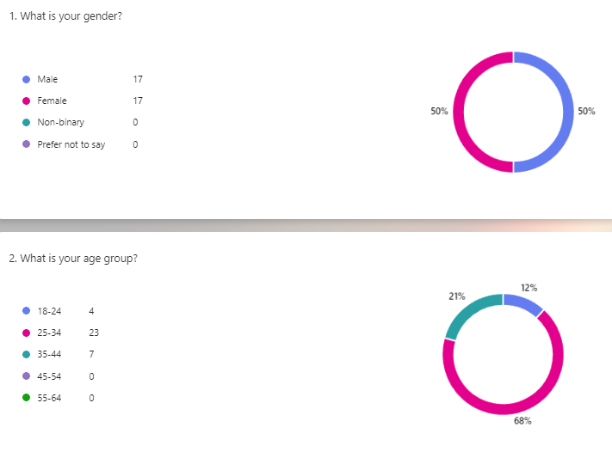

Out of these 34 participants 44 % held a UK driving license for 5- 10 years, 41% held a license for more than 10 years, 12 % held a license for 1 – 5 years and finally only 3 % never held license.
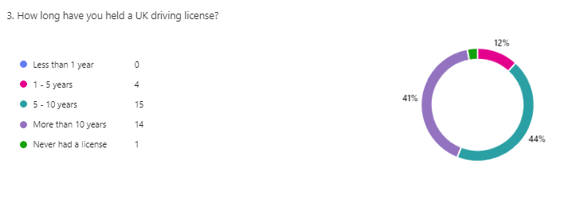
When completing the survey 50% of participants stated that male drivers were the most common and only 35% stated females were the most common. Looking at recent statistics published by the Department for Transport, this supports this claim. (GOV.UK, 2023).
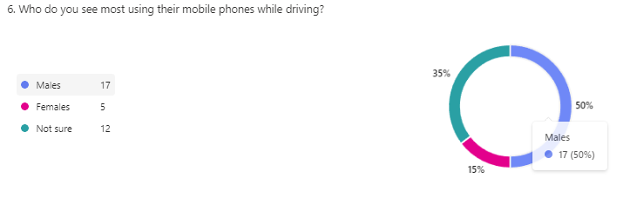
4.2 - Attitude
When asked 82% of participants stated that mobile phone use whilst driving was “high risk” compared to 18 % considering it to be “moderate risk”, 5 female participants stated it was a moderate risk level compared to only one male participant stating the same.
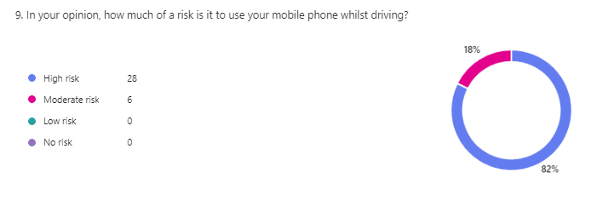
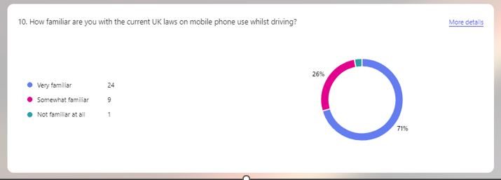
In comparison, previous studies have stated that male drivers normally associate less risk with mobile phone use behind the wheel (Sullman, et al, 2004) however my results show that female drivers associate less risk with mobile phone use and driving.
Within my survey female participants were also found to be less familiar with UK driving laws compared to male drivers.
When asked 47 % of participants stated that current penalties for mobile phone use were “sufficient enough” with 31 % stated they needed to be increased and 19 % stating they were “not strict enough”.
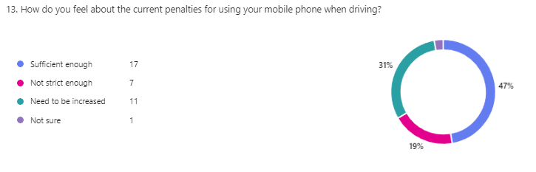4.3 - Enforcement
Participants were asked if they would be more supportive of police presence and 91% agreed with more police presence. 91 % were also supportive of camera technology on roads, previous studies conducted on public opinion into camera technology also implied that people were more supportive of this technology and also called for greater police presence on roads (Stefanidis, et al. 2023).
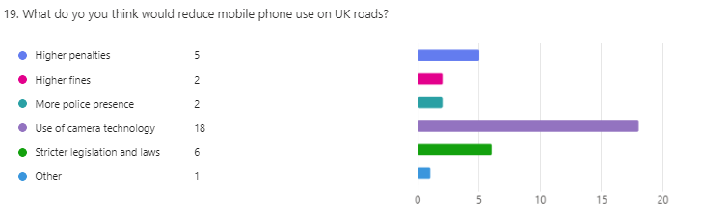
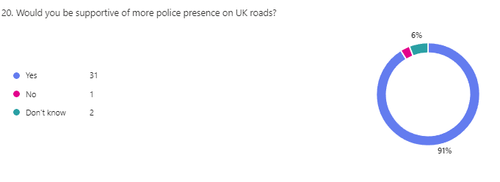
Participants were asked if police were effective and stopping motorists using their mobile phones and 50% stated police were “somewhat effective” in achieving this with the other remainder feeling they were “neither effective or ineffective” and “somewhat ineffective”.
Finally, Participants were asked what they felt could improve police enforcement and the common themes for these answers were more usage of camera systems as shown here;

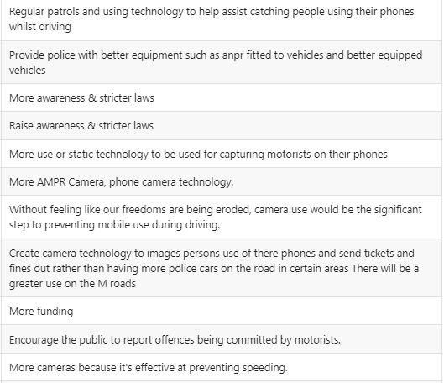

Chapter 5 – Conclusion
This final chapter has achieved the third objective of my research project which is:
Use the data collected from the research method to understand how the public perceive UK policing on mobile phone use and offer recommendations on how to improve public perception and enforcement.
The aim of this research project was to understand the public perception of UK policing on mobile phone use, I conducted research into the topic and found that the need for enforcement on mobile phone use has been increasing yearly. The penalty for using a mobile phone was first increased in 2007 however due to driver compliancy and increase in offending the penalty was further increased.
From the research I conducted I found that according to a RAC survey conducted on 2000 people, 31% thought the penalties for using your mobile phone were not strict enough and more visible enforcement was needed. It was further stated in this survey that participants have chosen to stop using their mobile phone when driving due to government led campaigns relating to road safety.
I also found that the most common offenders for using their mobile phones were between the ages of 17 – 29-year-olds. I found that younger drivers were prone to more risk and had an overconfidence when it came to their driving skill.
For this research project I opted to use a survey which was given to members of the public and consisted of 25 questions relating to mobile phone use on the roads and police enforcement. I managed to gather 34 responses; I have managed to gather an even split between male and female drivers with multiple different age ranges which has presented interesting findings. There were three main themes that arose from this survey which were the demographic of derivers, attitude of these drivers and police enforcement.
As previously stated, the demographic consisted of an even spit of male and females and the main age group of these candidates were 25 – 34. Interestingly my survey has found that more than 50% of participants stated males were the most common offenders for using their phones and only 35% stated female were the main offender, this is further supported by stats from Department for Transport, male drivers were more likely to be observed using their mobile phones whilst driving (GOV.UK, 2023). From my survey It has found that female drivers associated less risk with the use of mobile phone use which is in contrast to other studies whereby male drivers are more prone to associate less with risk with mobile phone use.
My search also showed that 91% of participants were supportive of the use of camera technology and more police presence which has also been supported by previous studies (Stefanidis, et al. 2023). Participants were also split to whether the penalties were strict enough or needed to be increased.
In conclusion my research, it has shown that members of the public are supportive of more police enforcement however are divided on whether the penalties are strict enough. It has also shown that the use of phones is seen as high risk however female drivers associated less risk with the use of phones which is contrast to other findings.
A greater sample size would have shown more clear results and has been listed as on the limitations of this research project. A more diverse demographic of participants would have also given more clear results as only one participant never had a license.

Chapter 6 – References
Briggs, G.F., Hole, G.J. and Land, M.F. (2011) ‘Emotionally involving telephone conversations lead to driver error and visual tunnelling’, Transportation research. Part F, Traffic psychology and behaviour, 14(4), pp. 313–323. Available at: https://doi.org/10.1016/j.trf.2011.02.004. [Accessed 19 July 2024].
Campbell, A., Taylor, B.J. and McGlade, A. (2017) Research design in social work : qualitative, quantitative & mixed methods. 1st edition. Los Angeles, CA: SAGE Publications, Inc. [Accessed 21 December 2024].
Choudhary, P. and Velaga, N.R. (2019) ‘Effects of phone use on driving performance: A comparative analysis of young and professional drivers’, Safety science, 111, pp. 179–187. Available at: https://doi.org/10.1016/j.ssci.2018.07.009. [Accessed 19 July 2024].
Department For Transport. (2016). A consultation on changes to the Fixed Penalty Notice and penalty points for the use of a hand-held mobile phone whilst. Available at: https://assets.publishing.service.gov.uk/media/5a7f30d440f0b6230268dfe2/hand-held-mobile-phone-drivi[Accessed 19 July 2024].
Department for Transport. (2018). STATS19 review. [Online]. Department for Transport. Available at: https://assets.publishing.service.gov.uk/media/60d05b6a8fa8f57ce63f19f7/stats19-review.pdf [Accessed 19 July 2024].
Department For Transport. (2022). Mobile phone use by drivers: Great Britain, 2021. Available at: https://www.gov.uk/government/statistics/seatbelt-and-mobile-phone-use-surveys-2021/mobile-phone-use [Accessed 19 July 2024].
Elliott M., Broughton J,. (2005) “How methods and levels of policing affect road casualty rates”, Digital report. Available at: https://trl.co.uk/uploads/trl/documents/TRL637(1).pdf. [Accessed 29 June 2024].
George, A.M. et al. (2018) ‘“I need to skip a song because it sucks”: Exploring mobile phone use while driving among young adults’, Transportation research. Part F, Traffic psychology and behaviour, 58, pp. 382–391. Available at: https://doi.org/10.1016/j.trf.2018.06.014.
GOV.UK. (2003). The Road Vehicles (Construction and Use) (Amendment) (No. 4) Regulations 2003. Available at: https://www.legislation.gov.uk/uksi/2003/2695. [Accessed 19 July 2024].
GOV.UK. (2016). Increasing Mobile Phone FPN and Penalty Points for the offence of using a Mobile Phone whilst driving. Available at: https://assets.publishing.service.gov.uk/media/5a803d04e5274a2e87db8a95/mobile-phones-driving-consul.[Accessed 19 July 2024].
GOV.UK. (2022). Mobile phone use by drivers: Great Britain, 2021. Available at: https://www.gov.uk/government/statistics/seatbelt-and-mobile-phone-use-surveys-2021/mobile-phone-use [Accessed 23 December 2024].
GOV.UK. (2023). Reported road casualties in Great Britain, provisional estimates: year ending June 2023. Available at: https://www.gov.uk/government/statistics/reported-road-casualties-in-great-britain-provisional-estim [Accessed 23 December 2024].
Hancock, P.A., Lesch, M. and Simmons, L. (2003) ‘The distraction effects of phone use during a crucial driving maneuver’, Accident analysis and prevention, 35(4), pp. 501–514. Available at: https://doi.org/10.1016/S0001-4575(02)00028-3. [Accessed 29 June 2024].
Haque, Md.M. and Washington, S. (2015) ‘The impact of mobile phone distraction on the braking behaviour of young drivers: A hazard-based duration model’, Transportation research. Part C, Emerging technologies, 50, pp. 13–27. Available at: https://doi.org/10.1016/j.trc.2014.07.011. [Accessed 29 June 2024].
Horsman, G. and Conniss, L.R. (2015) ‘Investigating evidence of mobile phone usage by drivers in road traffic accidents’, Digital investigation, 12, pp. S30–S37. Available at: https://doi.org/10.1016/j.diin.2015.01.008. [Accessed 19 July 2024].
Ige, J., Banstola, A. and Pilkington, P. (2016) ‘Mobile phone use while driving: Underestimation of a global threat’, Journal of transport & health, 3(1), pp. 4–8. Available at: https://doi.org/10.1016/j.jth.2015.11.003. [Accessed 19 July 2024].
Melnikovas, A. (2018). Towards an Explicit Research Methodology: Adapting Research Onion Model for Futures Studies. [Online]. . Available at: https://jfsdigital.org/wp-content/uploads/2019/01/03-Melnikovas-Onion-Research-Model.pdf [Accessed 21 December 2024].
Metropolitan police. (2024). Driving and using mobile devices. Metropolitan police. Available at: https://www.met.police.uk/advice/advice-and-information/rs/road-safety/driving-mobile-device-use/#:~ [Accessed 19 July 2024].
NPCC. (2016). Police forces run week-long operations against mobile phone use at the wheel. Available at: https://news.npcc.police.uk/releases/police-forces-run-week-long-operations-against-mobile-phone-use [Accessed 19 July 2024].
RAC. (2018). Fewer than four in 10 drivers aware of penalties for using a handheld phone. Available at: https://media.rac.co.uk/pressreleases/fewer-than-four-in-10-drivers-aware-of-penalties-for-using-a-h [Accessed 19 July 2024].
RAC. (2022). Mobile phone driving laws - what is and isn't illegal? Available at: https://www.rac.co.uk/drive/advice/legal/mobile-phone-laws/ [Accessed 19 July 2024].
Savigar-Shaw, L., Wells, H. and Briggs, G. (2022) ‘Taking the right course: The possibilities and challenges of offering alternatives to prosecution for drivers detected using mobile phones while driving’, Accident analysis and prevention, 173, pp. 106710–106710. Available at: https://doi.org/10.1016/j.aap.2022.106710. [Accessed 19 July 2024].
Sentencing Council. (2022). Increase in penalty points and fixed penalty for using a hand held mobile phone while driving. Available at: https://www.sentencingcouncil.org.uk/updates/magistrates-court/item/increase-in-penalty-points-and-f [Accessed 19 July 2024].
Stefanidis, K.B. et al. (2023) ‘Community narratives on Facebook regarding mobile phone use while driving and road policing technologies’, Traffic injury prevention, 24(7), pp. 592–598. Available at: https://doi.org/10.1080/15389588.2023.2224475. [Accessed 29 June 2024].
Sullman, M.J.M. and Baas, P.H. (2004) ‘Mobile phone use amongst New Zealand drivers’, Transportation research. Part F, Traffic psychology and behaviour, 7(2), pp. 95–105. Available at: https://doi.org/10.1016/j.trf.2004.03.001. [Accessed 29 June 2024].

Chapter 7 – Appendix
Copy of survey:


