L5 – Change makers: Creativity and Value Creation
(ACCA5033)
Matt Haycock -2012802
B eng Electrical & Electronic Engineering

Table of Contents

e-Portfolio…………………………………………………….... Page 3
Task 1 – Mind Map…………………………………………. Page 4
Task 2 – Image-based Video presentation………. Page 5
Task 3 – Video presentation…………………………… Page 6
Task 4 – Academic Poster…………………………………Page 7

e-Portfolio
- Link to e-portfolio homepage https://mhaycoc1.wixsite.com/mysite-1

- Screenshot of the e-portfolio homepage 

Task 1 – Mind Map
- Link to Task answer in the e-Portfolio https://mhaycoc1.wixsite.com/mysite-1/mind-map

- Screenshot of the task answer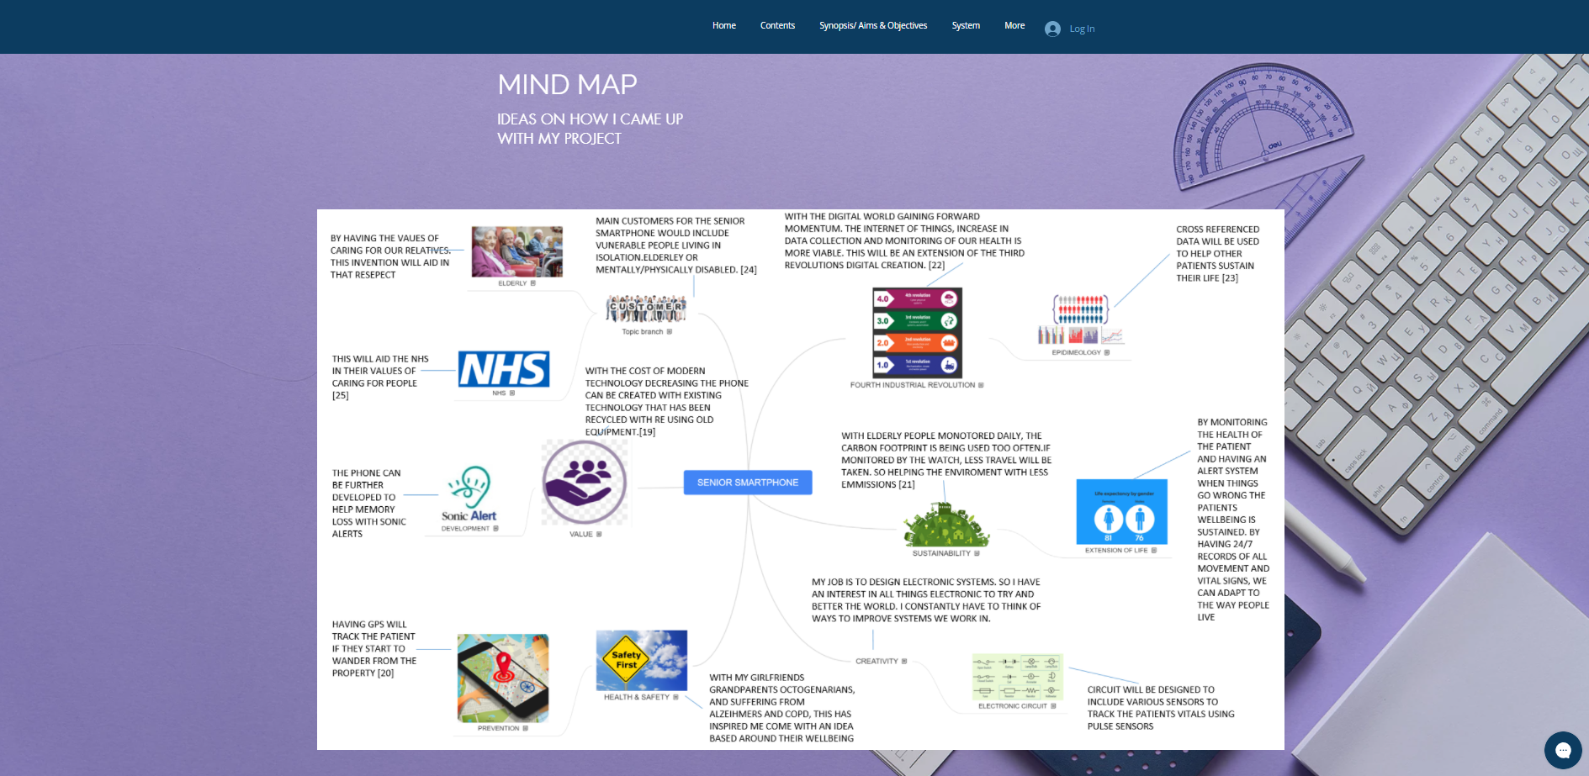

Task 2 – Image-based Video presentation
- Link to Task answer in the e-Portfolio https://mhaycoc1.wixsite.com/mysite-1/presentations

Link to the video presentation
https://youtu.be/ei3eq3lI9Xc

- Screenshot of the task answer


Task 3 – Video presentation
- Link to Task answer in the e-Portfolio https://mhaycoc1.wixsite.com/mysite-1/presentations

Link to the video presentation
https://youtu.be/7l7l9F-LjA4

- Screenshot of the task answer 

Task 4 – Academic Poster
- Link to Task answer in the e-Portfolio https://mhaycoc1.wixsite.com/mysite-1/poster

- Screenshot of the task answer 

