Postgraduate/Distance Learning
Assignment coversheet & feedback form

THIS SHEET MUST BE THE FIRST PAGE OF THE ASSIGNMENT YOU ARE SUBMITTING (DO NOT SEND AS A SEPARATE FILE)

For completion by the student:
Student Name: : Charlotte Wenner

Student University Email: : 2310536@student.uwtsd.ac.uk
Module code: HPCA7014  Module title: Sacred Geography | Student ID number:  2310536 |  |  | Educational support needs:  Yes/No
Assignment title: Essay based on a supervised research project.

Assignment due date: 6 January 2025
This assignment is for the 1st 2nd 3rd X 4th 5th 6th module of the degree
I confirm that this is my original work and that I have adhered to the University policy on plagiarism.
Signed ……………………………………………………………
Email submission: you are submitting this form via email, please tick this box □
(as a substitute for your signature) to confirm that you agree to the above declaration.
Assignment Mark
1st Marker’s Provisional mark
2nd Marker’s/Moderator’s provisional mark
External Examiner’s mark (if relevant)
Final Mark

NB. All marks are provisional until confirmed by the Final Examination Board.

For completion by Marker 1 :
Comments:

Marker’s signature: |  |  | Date:
For completion by Marker 2/Moderator:

Comments:

Marker’s Signature: |  | Date:
External Examiner’s comments (if relevant)

External Examiner’s Signature: |  | Date:
Tourist Trap or Sacred Monument:
A Phenomenological Investigation of the Pyramid of Austerlitz
Introduction
The aim of this research is to investigate whether it is possible to experience the Pyramid of Austerlitz as a sacred place. It will include the experiences at not only the Pyramid but the surrounding terrain and activities. These include a museum, a pancake restaurant, and attractions for children. There are also hiking routes in the surrounding forest. Therefore, the term ‘Pyramid’ will refer to the entire modern complex and landscape.
Most of the 30,000 tourists who visit the Pyramid each year describe a visit to the monument as a ‘fun day out for the whole family’ rather than something ‘sacred’. As such, the experience seems more like an event in the profane world of commerce and amusement than a sacred experience of something ‘wholly other’.
The Pyramid was built in 1804 at the order of French General Auguste de Marmont while stationed in the Netherlands. Yet Marmont was not the first to make use of this mountainous area. Within 15 kilometres of the Pyramid, a ‘remarkable number’ of Neolithic and Bronze Age barrows have been discovered, as well as ‘urn graves’ from the Iron Age. These mounds suggest that the area was previously considered a ritual landscape, possessing a sacred character.
The contesting approaches to the area offer different experiences, profane and sacred, of the Pyramid. This paper will draw on theories by Durkheim, Eliade, Tilley, Bender and others to investigate whether, and in what manner, the sacred can still be experienced at this place. A phenomenological approach has been used to gather and analyse autoethnographic data. These recordings, photographs, and notes describe my ‘conversations’ with the landscape during repeated visits to the Pyramid area, both as tourist and as researcher.
Literature Review
Mountain Landscape – Ritual Landscape
The Utrechtse Heuvelrug is one of the two ‘mountain’ ranges in the Netherlands, or ‘Low Lands’. The force of the meltwater from the disappearing ice-sheets at the end of the last Ice Age forced earth, sand, and rocks into hilly moraines. Standards vary, but generally an elevation is only officially a mountain when it is higher than 2,000 feet/610 metres. The tallest peak in the Utrechste Heuvelrug is 69 metres, and the Pyramid is at 52 meters. However, there is some flexibility, and the UK Ordnance Survey takes ‘local customs and traditions’ into account, for instance. Prendergast has suggested qualitative measures for the term, such as the difference in elevation with its surroundings and the difficulty of approach, and these seem appropriate for the Netherlands. Thus, the Pyramid landscape will be considered mountainous in this research.
A mountain is replete with sacred symbolism in itself. To begin with, its unique elevation in the landscape sets it apart from the surrounding area. Durkheim considered a break in homogeneity the most distinguishing characteristic separating sacred from profane. For him, this division is absolute and must be maintained. The sacred is that which is unapproachable, even forbidden, and is not immediately accessible. Mircea Eliade pointed out that a mountain is one of places where such a break is physically present. A mountain is, moreover, ‘one of the images that express the connection between heaven and earth…it is believed to be at the centre of the world…or the “navel of the earth”’. The places where the earth touches the sky can be considered ‘holy ground’ in itself because they are ‘closest to heaven.’
Such places represent a threshold to the realm of the numinous, and it is in such spots that the ‘sacred manifests itself’ through unexpected irruptions of the divine, the hierophany. At these moments, the individual transcends him- or herself, and experiences an ‘opening’, allowing communication with the gods. The immensity of the experience exerts both a strong attraction as well as Otto’s ‘feeling of terror’. Durkheim wrote that the sacred elicited ambivalent tendencies of approach and avoidance, which Eliade termed ‘kratophany’. One does not embark upon the journey lightly, making mountain locations ideal for religious ritual and monuments.
Indeed, the greatest number of barrows, tumuli, and dolmens in the Netherlands are located in the two mountain areas, suggesting intentionality. Moreover, Bourgeois has pointed out that barrows from the Bronze Age are predominantly found at the top of hills overlooking valleys, and indicate a distinct set of ritual practices. At that time, the area’s topography consisted wide plains of sandy turf and heather. Barrows were built as small mounds of earth held together by a layer of peat. New layers and mounds were often added by successive generations, resulting in concentrated groupings. By the end of the Bronze Age, the land was scattered with a ‘monotonous succession of small hills, hundreds upon thousands, in fact’. Thus, rather than referring to a barrow, it is more accurate to consider them as comprising a wider landscape.
In addition, excavations in the Netherlands indicate that barrows ‘had great social and ideological significance to prehistoric communities at large’. The barrows often had circular borders, and were within the settlement area, indicating their importance in group life. Not only were the inhumed ancestors considered guardians of individuals or the clan, they were consulted at meetings and ceremonies. They were a link to the Otherworld, and for this reason were included in important decisions. Other research has suggested that each barrow may have been located to take up a ‘specific position within the cosmological landscape.’
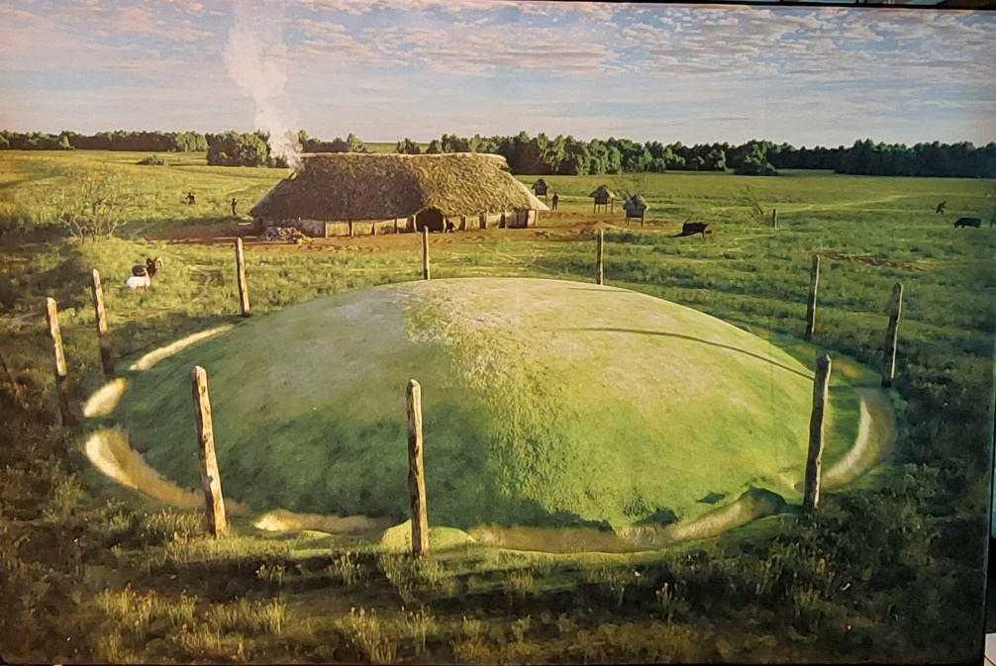
Figure 1: Charlotte Wenner, Bronze Age Solar Calendar at Tiel Museum, 2024.
Thus, the barrows, their communities, and their landscape reflect essential elements of the sacred as defined by Durkheim and Eliade. As the tribe’s ‘totem’, a barrow played a role in defining the clan’s ontology and cosmology. It was an object of veneration during group ritual, through which the individual, according to Durkheim, was able to partake of the sacred and transcend himself in an ecstatic effervescence. This provided access to the beliefs and images in the collective unconscious of the clan, allowing the individual to place the experience in its context. Ritual also prepares the individual for contact with the sacred, and helps the individual alleviate any fear surrounding contact with it.
The sacred attitude allowed ‘religious man’ to sense the extraordinary in the ordinary. By living as close as possible to the axis mundi of the barrow, nature could reveal itself ‘as a cosmic sacrality’, and his/her every act became ‘a communion with the sacred’.
A number of barrows have been identified close to the Pyramid, as near as 1.5 km away. Three have even been located next to Marmont’s former camp. David Fontijn reported that 1,492 barrows had been identified in the Netherlands, 450 of which are confined within the 50 km length of the Utrechtse Heuvelrug. While only a small percentage of them have been excavated, the type of grave goods they have revealed are consistent with the ‘uniform set’ found in graves ‘from Poland to Portugal and from Sicily to Scotland’. High or small, mountains ‘are all material metaphors for liminal spaces, guardians, gateways, and bridges from one realm to another’. They link heaven, earth, and various tribes of people throughout Europe.
Contesting Cultures – Contested Space
When new groups move into an area with sufficient economic and political power, and possess the necessary cultural capital, they appropriate the landscape and engage with it in different ways than the natives. As first the Roman Empire and then Christianity undertook the conversion of the ‘Batavian’ pagans, from sacred monuments the barrows became known as home of evil spirits, guarded by the ‘Witte Wieven’. In prehistoric times, the ‘Wieven’ were wisewomen, herbalists, and healers, but in the Middle Ages, they abducted night travellers hidden in the low-lying mist.
Whether Marmont had any knowledge of what the small mounds which surrounded his camp actually represented is uncertain (Figure 2). In any case, by that time Durkheim stated the ‘old gods had died’, and the decline of Christianity had become a fact. He suggested that a new secular religion was necessary to provide moral guidance as religions had in the past. He saw the French Revolution as a critical turning point, in which society’s new sacred ideals had appeared: ‘Fatherland, Liberty and Reason… (have been) ideas directly converted … into sacred things’. Society was able to proclaim itself God, to create other gods, and place man squarely at the centre of the universe. As Eliade put it, ‘Modern nonreligious man… regards himself solely as the subject and agent of history…Man makes himself, and he only makes himself completely in proportion as he desacralizes the world.’ Man’s purpose was no longer in sanctifying the world; the world was used by man to sanctify himself. Divested of its mystery, the former ritual landscape surrounding Marmont’s camp could be exploited in any way the general wished.
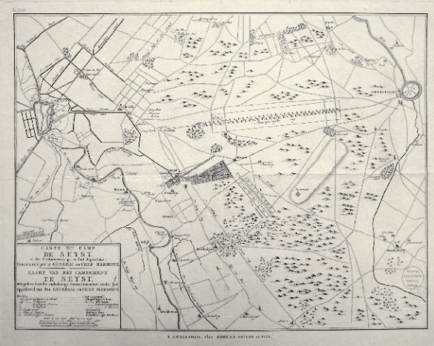
Figure 2: Mortier, Covens & Zoon, Carte Du Camp De Seyst, et des Cantonnemens qui en sont Dépendans: Commandé par le Général en Chef Marmont, 1805, Copper Engraving, 39.5 x 51, Utrecht Archive Collection
By most Dutch accounts, Marmont was an extremely ambitious, even arrogant Frenchman. He had risen quickly in ranks, and was part of the small selection of officers and soldiers to accompany Bonapart to Egypt in 1798. As a general in the Batavian Republic, Marmont was criticized for his extravagant lifestyle and great expenditures. This earned him the nickname ‘Marmont the First’ by Napoleon. When the troops had completed their training at the end of summer, Marmont decided it was time to build a monument to himself. It is generally believed that the pyramids in Giza served as inspiration, while Marmont explains his choice as follows:
I had the idea of ​​building a lasting monument that would remind future centuries of our stay on this plain, the purpose of our station, and that would perpetuate the memory of the victories with which France and its leader had already illustrated French arms… it must elevate the soul and lead it to ideas of the future and posterity… the construction of a pyramid of earth, covered with grass...
Like the prehistoric barrows, the original Pyramid was constructed of earth and peat. Each side measured 48 meters in length, and forty earthen block ‘steps’ were placed on a two-meter foundation. A 13-meter obelisk was placed at the summit, making the total height 36 meters. A right triangle of 36 meters by 48 meters results in an angle of 53°, the same as that of the Pyramid of Giza. It was, thus, a ‘sacred triangle’. The Pyramid is enclosed by a circular canal, another feature of the ancient barrows. Construction was completed in 27 days, and there were celebrations on 12 October and again on 21 October. Marmont seems to have wished to incorporate strong symbolism in his monument.
Moreover, the Pyramid’s construction reenacted a sacred ritual for ‘conquest of territory’. ‘Habitation,’ writes Eliade, ‘undergoes a process of sanctification … repeating through ritual construction the paradigmatic acts of the gods’. This process is initiated by marking the axis mundi with a tall pillar or pole. Four lines are drawn from the centre, and the resulting square is divided into four sections, a reflection of the four cosmic directions. It is quite conceivable that French soldiers followed the same steps building the Pyramid. In short, Marmont could not ‘help preserving some vestiges of religious man’, though his actions were ‘emptied of all religious meaning…modern man…still retains a large stock of camouflaged myths and degenerated rituals’.
The Pyramid may even have been intended by Marmont to serve as a ‘totem’, inspiring awe in the French empire, the size and dimensions as lofty as the Republic’s ideals. Today it remains a visual reminder of the dawn of the modern age, in which society proclaimed itself God, created other gods, and placed man squarely at the centre of the universe.
The Modern Consumption of Space
In the past two centuries, the Pyramid has crumbled, been overgrown by shrub, and repeatedly rebuilt. In 1998 the Utrechtse Nieuwsblad described the Pyramid as ‘Eternal deception that peeps, somewhat dirty, among the treetops’. Rather than a sacred site, the Pyramid seems to be considered by some as a distasteful monument to a painful period in Dutch history.
Nevertheless, local organisations have invested considerable funds and effort in maintaining it and attracting visitors. While the site itself has been thoroughly desacralized, and now offers the ‘sacralization of the profane’ for tourists. The journey to the Pyramid’s attractions, engagement in the activities, and the elevated or ecstatic feelings arising from these activities makes a visit different than everyday life. Some might even experience it as a pilgrimage, though certainly not religiously motivated. Particularly young children could experience the Pyramid as ‘sacred’, and look back as adults nostalgically. As Belk, et al. comment, ‘A secular place commonly designated as sacred is the geographic area of a person's childhood. Pilgrimages are often made to these areas on vacations, especially when accompanied by other family members.’ The majority of positive reviews on the internet are written by parents.
Yet even though visitors may momentarily experience the euphoria that transforms the ordinary to extraordinary, the feeling is usually ‘lost through habituation, forgetting, or encroachment of the profane. To prevent this loss, ongoing efforts are required to maintain sacredness’. In many cases, sacred places have been reduced to points of departure and destination, to be arrived at as quickly as possible. Thus, visitors to the Pyramid usually walk directly to the monument, climb to the top, make the descent, then get something to eat at the restaurant while the children play on the attractions outside. In fact, much, if not the most, of the time visiting is spent enjoying pancakes and rides, and these might be considered the ‘totem’ of ‘sacred consumerism’ aspect of the Pyramid landscape.

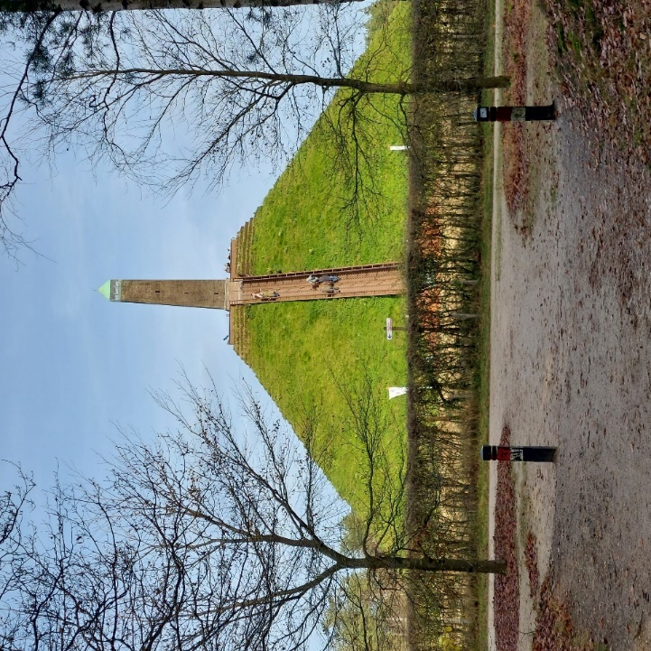
Figure 3: Charlotte Wenner, The Pyramid of Austerlitz, 24 November 2024, Woudenberg.
In short, the former ritual landscape may be tread but is not entered. The modern tourist very often just checks off an item on the bucket list and moves on to the next. The ‘systematic erosion of locality as meaningful’ can lead to ‘a deep sense of anomie… a feeling of void … that results from the deprivation of place’. Negative reviews by visitors complain that the Pyramid promises more than it actually delivers.
However, sacred places are said to possess a particular force which draws the right objects and people to them. The individual who is receptive to the place’s agency recognizes its signs, accepting that the sacred place is not chosen, but chooses to whom it reveals itself. It is from this perspective that I will investigate whether, and in what manner, the Pyramid landscape can be experienced as sacred place.

Methodological Approach
Collection of Data
The purpose of this research is to analyse my experience of the sacred at the Pyramid. Such an experience is based on a variety of individual impressions, and is of necessity subjective. A qualitative approach has been found to be particularly effective in ‘explaining people’s beliefs and behaviour’. The autoethnographic data was gathered during field work during repeated visits to the Pyramid landscape. The self-observation includes impressions, emotions, sensory experience, and intuitions. These were made as ‘live’ audio recordings in order to capture their immediacy. These were later transcribed, and written with reflections in journal entries. I also made photographs of the visits.
The study also adopts a phenomenological approach, in which I accepted the experiences as they presented themselves to me. Such an approach emphasizes the concept of ‘embodiment’, in which the body is ‘an active entity that by which, and through which, we experience the world’. As the Pyramid is a place within a prehistoric ritual landscape, I also visited some barrows in the immediate vicinity for comparison.
Two museum exhibitions provided valuable information about the lives of the ancient Pyramid landscape dwellers. I also used maps of the Netherlands, Google Earth and Google Maps to identify significant terrestrial factors, as well as Stellarium for the Pyramid’s orientation to particular celestial events.

Reflexive Considerations
Owing to the high degree of subjectivity, certain reflexive considerations need to be acknowledge in order to maintain transparency in the research design, data collection, and interpretation. It is necessary to remain aware of any potential bias throughout the entire research process.
I am a 64-year-old white woman born in the United States. I have been living and teaching English in the Netherlands for the past thirty-seven years, and awarded a Master’s of Education in 2016. I have lived 7 kilometres from the Pyramid of Austerlitz for 10 years. My religious orientation reflects a non-dual form of Buddhism. Before moving to the Netherlands, I lived at the base of three sacred mountains in Asia. The first was Emei Shan in Sichuan, People’s Republic of China (1983 – 1985), the second the hill at Swayambhunath in Kathmandu, Nepal (1985 – 1986), and the third was the hill of the Potala Palace (two weeks in 1985). My spiritual orientation and experiences at these places will colour the present research, thus I must continually assess its influence.
A trend of interpreting prehistoric cultures through perspectives of cultural romanticism, nationalism, or ‘alternative’ viewpoints has been identified. These views often appear in media about megalithic monuments and prehistoric (European) cultures. The influence of media is relevant to my interpretation of the data and experiences in this research.
Findings and Discussion
To analyse the findings, an inductive - deductive approach has provided a framework for assessing the various experiences, and codes for interpreting the data. Certain themes arose in the process which suggest three main categories for interpreting the findings:
- the experiences related to the tourist activities of the site,
- the experiences engendered exploring the ritual landscape of the Pyramid,
- and experiences in the terrain at the base of the Pyramid and within the circle.
Concepts presented earlier in the paper will guide the analysis and discussion. These include transcendence of self, effervescence or hierophany, separateness from the ordinary, the agency of place, ‘kratophany’, pilgrimage and ritual.
Experiencing the Pyramid through Tourist Activities
Previous to this research, I had visited the Pyramid several times as a tourist, and these experiences provide comparison to those of this research. The term ‘tourist activities’ refers to the ascent of the Pyramid, the rides for children, the museum with information about the Pyramid, and the pancake restaurant.
The first time I visited the Pyramid was with a friend from Zeist in 2012. I was immediately struck by how incongruous the giant ziggurat looked in the middle of the forest. As we walked up the dirt causeway, the Pyramid loomed ahead, imposing itself on the vista. The obelisk at the top presented yet another puzzling addition to the landscape, and I wondered what could have possessed a person to build such a construction that was so out of place in this landscape.
I did not, thus, experience anything that resembled a sense of the transcendence, and this was also true during my more recent visits. In my notes of 3 December I reflected that I, like the ‘regular tourists’ was ‘not at all moved by any sense of the sacred’. At worst they might ‘observe the whole ritual of climbing as a bother’, while at best it offered a nice view. In my journal entry from 24 November I also mentioned that ‘(t)hey all spoke rather loudly, commenting on the information, the exertion (of the climb), or the view. The children there were making noise and playing, which I found rather irritating. I wished everybody would just be quiet so I could enjoy the experience. Then a woman started complaining about having to pay 4 euro to climb the Pyramid. “How typically Dutch”, I thought to myself. Yet even though it is not very much money, all you do is climb a bunch of stairs and look around, which is what I think she was implying’. In short, the climb and view did not inspire elevated emotions or cause me to transcend myself. On the contrary, I felt irritated.
In earlier visits between April and October, the restaurant and the children’s attractions had teemed with visitors. The activities reinforced the hustle and bustle of modern life. Even during my visit 29 December, I was shocked that despite the cold, rainy weather, a great number of loud tourists had travelled to the place. In my field notes, I mentioned that I felt ‘Eliade’s kratophany’, more aversion than attraction to the place.
On the whole, my experience of the tourist activities at the Pyramid felt very much confined to the secular and profane. There was no sense of the extraordinary or transcendence, and I did not wish to take part in the tourist rituals.
Experiencing the Ritual Landscape of the Pyramid
My experiences in the wooded area outside of the circle surrounding the Pyramid were quite different. On the first visit 24 November, I had decided to walk wherever I seemed to be led rather than follow any set route. Almost as soon as I left the Pyramid, there was a strong feeling that I was being drawn to certain places.
‘When I descended the stairs, I decided to walk around the terrain and allow myself to just follow whatever route that I wished. As soon as I left, I felt a deep peace settle upon me. Within a very short distance, I saw a small hill, and it seemed very attractive to me, like it might be a mound. I followed my inclination and walked up to it. I went to the top, and I sat down. A deep stillness fell, time seemed to get very slow. The wind blew through the long grass, and this seemed like such an epitome of the specialness of that moment and place that I filmed the grass swaying in the wind.’
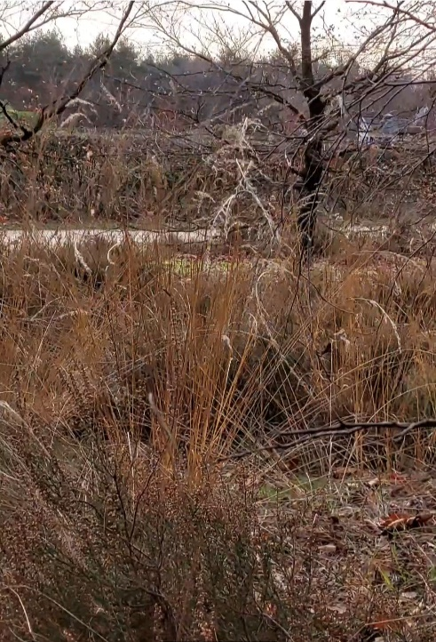
Figure 4: Charlotte Wenner, Photograph Hierophany on Mound, 24 November 2024, Pyramid of Austerlitz
After wandering for some time, I began recording myself. I felt a strong pulling sensation inside me, tugging me in specific directions, and I approached a great crossroads with a tall tree in the middle. The pull was particularly strong when I was in the forest just outside the Pyramid area. The centre somehow seemed to be there.
‘I don't want to go back on the other path that I was on (which led to away from the tree). I want to follow this feeling. (pause) I found a path. As I walk and come closer to the pyramid (pause) I feel my chest (pause) it's being touched. My heart and I know that this is somehow the navel of this area. It feels like I am being drawn to the centre of the Earth.’ Later I reflected, ‘As the trees parted, I saw I was being drawn back to the Pyramid, which truly felt like the Omphalos, something said that this the navel of that place’.
To compare my experiences at the Pyramid, I visited a few nearby barrows. As my car inched along the bumpy dirt road leading to the ‘Grafheuvel Museum’ in Amerongen, I reflected on the difficulty in approaching this place. Rather than actual barrow, however, one had been replicated, with information for tourists. Like my experience of tourist activities at the Pyramid, the barrow-museum lacked a sense of the sacred.
In contrast, two unmarked mounds 1.5 km from the Pyramid immediately transformed my sense of time and space. In my recording, I reflected that these anonymous mounds provoked the same feelings as what I experience around the Pyramid the previous week.
‘Well, I seem to have found the (pause) grave mounds in Den Trek, even though they're not on Google Maps, but I was able to locate them. And (long pause) it's funny, there's a lot of mountain bikers around here, which gives it a touristy feeling, but as soon as I moved on to this walking path… (softer) the feeling … (sigh) was the same as I had at the pyramid last week. It's a kind of reverence, a kind of stillness. Which I didn't feel an Amerongen (the ‘barrow museum’ I had visited earlier)’.
On the 15th, I travelled to two other barrow sites. To reach the first, I had to follow a small path into the woods, and there was a high mesh fence which prevented me from getting close. A sign in front of it described its discovery and the ‘enhancement’ of the barrow to be more visible for tourists. Once again, the presentation as tourist site did not inspire a sense of the sacred.
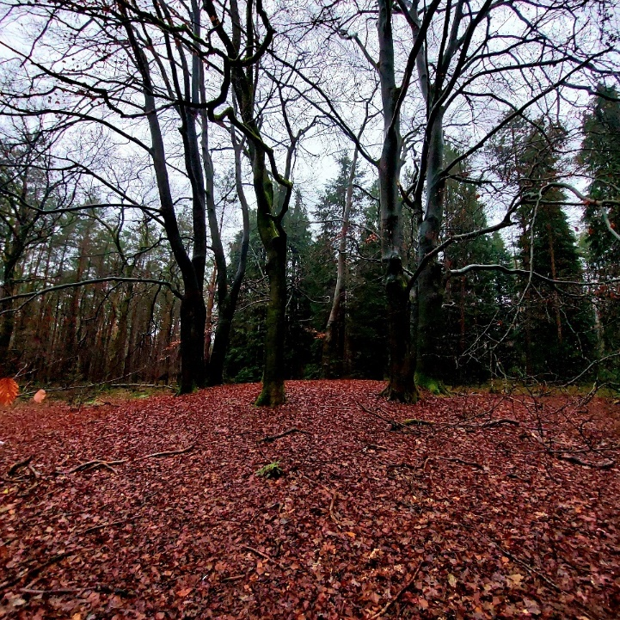
Figure 5: Charlotte Wenner, The Seven Witte Wieven on the ROB Barrow, 15 December 2024, Leersum.
In contrast, the group of barrows in Leersum were open to the public, and scattered through the woods, marked only by short posts in the ground. There was no clear-cut route, yet once again I felt that I was being led by some agency as I crisscrossed through the trees.
‘I'm able to reconnect (pause) to the sacred feeling of this ground (pause) that once existed, and which I suppose still exist. (That) religious man (pause) he was in search of’. One barrow in particular was very striking. Seven tall trees grew in a circle atop it, and I recorded, ‘It's so symbolic (pause) and they look like (pause) the Wieven, the Witte Wieven (like) in old wives tales here’.
Although not technically within the parameters of my fieldwork, there was a mysterious type of ‘synchronicity’ at work during my visits to two museums. This added to the sense that my visits in this research were linked in a meaningful way. Thus, on the 15th of December, I recorded, ‘Yeah, in a way, visiting all these different (places) is also becoming a kind of (pause) personal pilgrimage. And to what end? I don't know. Perhaps it's helping me (pause) yeah (pause) orient myself in (pause) a land where I was not born (pause) but have lived the majority of my life.
The experiences in the ritual landscape of the Pyramid thus consistently displayed several aspects of the sacred. There seemed to be a force or agency which guided me to sacred spots. The experience seemed outside of time or space, and was quite different from those of tourist attractions. There was a hierophany, the discovery of the axis mundi. Finally, the research became a kind of ritual pilgrimage with personal significance. My interaction with the Pyramid landscape was becoming a conversation.
Experiencing the Terrain at the Base and within the Enclosure of the Pyramid
The ability to perceive the extraordinary in the ordinary requires a particular attitude, and this, perhaps, is the greatest obstacle to experiencing the sacred at the Pyramid. It was a change of attitude, however, that led me to approach the monument differently on 24 November. To begin with, rather than follow the ‘tourist ritual’ of paying for the ticket, climbing the steps to the top, and gazing at the surrounding area, I choose to first walk clockwise around its square base very slowly to really ‘see’ it. Each wall had a small, mound-like appendage, and these reminded me of barrows. The grassy sides, the feel of the earth under my feet, the clumps of heather speckling the terrain all contributed expanded my sense of space.
On the 15th of December, I returned to the Pyramid visiting the mounds in Leersum. Oddly enough, I did not feel any desire to climb the monument. I just entered the enclosure and observed my experience.
Sitting here, it feels like I've ‘arrived’ (pause) and I (pause) realise that every time I've come here, it's sort of been like that. There's almost no need to climb it, although you come here to climb the pyramid and you do it. And the sight up there is really great, you know, it's nice to look all over the place. But (deep sigh) that's actually not the (the place’s) destination somehow.
As I watched the stream of tourists ascending and descending of the monument, they looked like ants on a treadmill, and I felt amused by it. ‘It's so funny to be watching people going up and down,’ I said. ‘Up and down, up and down. Thinking that, you know, maybe thousands of years ago this was (pause) a secret place (pause) and now nobody has (pause) any recollection or acknowledgement of it’. The repeated visits to the Pyramid reinforced that there is a clear-cut, ‘absolute’ difference between the experience of the ‘profane’, tourist Pyramid, and the ‘sacred’ surrounding terrain. Even after the ‘kratophany’ on the Pyramid 29 December, I was struck by the sense of the numinous as soon as I stepped off the staircase.
On Christmas morning, I awoke before dawn and decided spontaneously to be present during sunrise at the Pyramid. A heavy mist surrounded the monument, and I used Stellarium to find where the sun was rising. With a start, I realized that the sun was directly facing the eastern wall. The Pyramid might even have been built as a large solar calendar.
‘This really impresses me’, I recorded, ‘for apparently this pyramid was not constructed haphazardly, but has (pause) attention (pause) to astronomical events at the winter solstice…and maybe other Celtic holidays. This fact really deepens my appreciation of the Pyramid…Contrary to my impression (pause) at the beginning (pause) of this research, it is not so much a (pause) blasphemy (pause) but a recreation of the navel of the Earth’.
As I walked away, I suddenly heard a voice in my head say, ‘Marmont was a Freemason!’ It felt like another instance of inspiration and synchronicity.
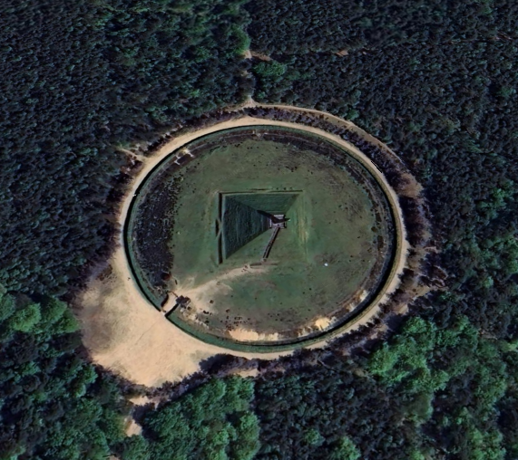
Figure 6: Charlotte Wenner, Aerial View of Pyramid Oriented True North, 25 December 2024, Google Earth.
These experiences all confirmed the absolute difference between the sacred and profane. Even sitting at the base of the Pyramid, I felt outside the world of the tourist activities in a separate space. The culmination of my engagement also led me spontaneously to perform a sacred ritual, which had perhaps been performed there in the past.
Final Thoughts
Transcribing my recorded impressions provided much more insight than I had expected. It very quickly became evident that my voice changed entirely when I spoke of the sacred. It grew soft, hesitant, and I often paused or let out a sigh. The field work became a pilgrimage, which I never expected.
The most striking sense of the sacred which I experienced in this research came through the sense of being drawn to the central area of the Pyramid, and being ‘guided’ in my journeys. The landscape seemed to transport me into a different, liminal space, in which the ordinary seemed transformed into sacred ground. It may have been this powerful power of attraction which drew Marmont to build the Pyramid at the location.
It was also surprising how absolute the difference between sacred and profane felt. Just stepping off the Pyramid onto the ground below altered my experience. The presence or absence of profane the ‘additions’ or ‘enhancements’ of tourism seemed be a decisive factor.
The idea that the Pyramid might be a solar calendar came as a complete surprise, and was a turning point in my attitude towards it. The idea that Marmont was a Freemason, however, was a bit of a shock. Although I discovered a theory circulated in the early 19th century that the Illuminati had orchestrated the French Revolution, it has long been discounted. Yet Margaret Jacobs holds that while the Freemasons did not dictate the revolution, they were involved in revolutionary groups. She also mentions that freemasonry travelled from the Netherlands to France. This subject, the possible archeoastronomy of the Pyramid, and information about the ‘barrow folk’ in the landscape are areas for further investigation.
Conclusions
This research set out to investigate the possibility of experiencing the sacred at the Pyramid of Austerlitz. Working from grounded theory, concepts from contesting perspectives were used to analyse phenomenological data. The field work indicated that the sense of the sacred is of a different quality when the Pyramid is seen as ‘totem’ for modern consumerism, as a ‘totem’ for Civil Religion, and ‘totem’ within a ritual landscape. While the experiences were all personal and highly subjective, definite themes emerged. They suggest that a sacred attitude is essential to experiencing the divine.
Modern scholars may argue that people currently sacralise the profane in order to experience inherent need for the sacred. They do so through consumerism and tourism, but any sense of the extraordinary these provide is transient. Similarly, while Civil Religion may have offered an alternative to Christianity, countries change their rulers, and national pride is being replaced with globalism. Yet the numinous realm of the Otherworld seems to still be present in the sacred landscape of the Pyramid. This suggests that the sacred resides in the natural world, despite humanity’s constructions and changing beliefs. At the same time, the recognition of the sacred requires conscious attention in order to be perceived. Through the sacralisation of the world, humanity allows itself the experience of the divine.

Bibliography
Belk, Russell W. , Melanie Wallendorf and John F. Sherry, Jr, ‘The Sacred and the Profane in Consumer Behaviour: Theodicy on the Odyssey’, Journal of Consumer Research , Jun., 1989, Vol. 16, No. 1 (Jun., 1989), pp. 1-38.
Bender, Barbara, Stonehenge: Making Space by Barbara Bender (Oxford: Berg, 1998).
Bourgeois, Quentin, Monuments on the Horizon: The Formation of the Barrow Landscape Throughout the 3rd and 2nd Millennium BC, (Leiden: Sidestone Press, 2013).
Casey, Edward S., The Fate of Place, a Philosophical History (Berkeley, CA: University of California Press, 1998).
Dagjesweg, ‘Beoordeling de Pyramide van Austerlitz’, Dagjesweg.nl < https://www.dagjeweg.nl/reviews/2670/De-Pyramide-van-Austerlitz > [ Accessed 24 December 2024].
Dempsey, Caitlyn, ‘What is a Mountain?’, Geography Realm (2020). < https://www.geographyrealm.com/mountain > [ Accessed 5 January 2020].
Desjarlais, Robert and C. Jason Throop, ‘Phenomenological Approaches in Anthropology’, Annual Review of Anthropology, 40 (2011), pp. 87-102, (p. 89). < https://www.jstor.org/stable/41287721 > [Accessed 31 December 2024].
Devereux, Paul, Secrets of Ancient and Sacred Places (London: Blandford, 1993).
Dietler, Michael, ‘"Our Ancestors the Gauls": Archaeology, Ethnic Nationalism, and the Manipulation of Celtic Identity in Modern Europe’, American Anthropologist, 96.3 (Sep., 1994), pp. 584-605.
Durkheim, Emile, The Elementary Forms of Religious Life, trans. Karen E. Fields, New York: Free Press 1995 [1st edn.., Les Formes élémentaires de la vie religieuse, Paris; F. Alcan 1912].
Eliade, Mircea, The Sacred and the Profane (New York: Harcourt Brace 1959), pp. 20-65 (‘Sacred Place and Making the World Sacred’).
Fields, Karen, ‘Translator’s Introduction’ in Emile Durkheim, The Elementary Forms of Religion, ed. by Karen Fields (New York: Free Press, 1995),
Fontijn, David, Living Near the Dead: New Research On Ancient Funerary Landscapes, (Leiden: Sidestone Press: 2010).
Fontijn, David, ‘The “Ritual” Fabric of Prehistoric Landscape Funerary Places and Deposition Sites in the Low Countries c. 5000 – 1500 cal BC’, Sozialarcheologische Perspektiven: Gesellschaftlicher Wandel 5000-1500 v. Chr. zwischen Atlantik und Kaukasus, Archaeologie in Eurasien 24, edited by S. Hansen/J. Mueller, < https://www.academia.edu/1229814/The_ritual_fabric_of_Prehistoric_Landscape_Funerary_Places_and_Deposition_Sites_in_the_Low_Countries_c_5000_1500_cal_BC > [Accessed 4 December 2024].
Gelbart, Nina R., ‘Reviewed Work(s): The Radical Enlightenment: Pantheists, Freemasons and Republicans. by Margaret C. Jacob’, Eighteenth-Century Studies, 17.2 (Winter, 1983-1984), pp. 184-189.
Gemeente Utrechtse Heuvelrug, ‘Grafheuvels of op de Utrechtse Heuvelrug (Information at the Prehistoric Barrow ‘Halm’), [photographed on 15 December 2024].
Goodrick-Clarke, Nicholas, ‘Stonehenge to the Sphinx: Esoteric Theory and Practice in Twentieth-Century Astroaraeology’, Astrologies: Plurality and Diversity in the History of Astrology, edited by Nicholas Campion and Liz Green, (Ceredigion: Sophia Centre Press, 2011), pp. 151 – 164.
Groningen, Catharina L. van, De Utrechtse heuvelrug. De Stichtse Lustwarande. Buitens in het groen, (Zeist: Waanders Uitgevers / Rijksdienst voor de Monumentenzorg, 1999). < https://www.dbnl.org/ > [ Accessed 26 December 2024].
Gunzburg, Darrelyn & Bernadette Brady (eds), Space, Place, and Religious Landscapes (London: Bloomsbury Academic Publishing, 2021).
Hennink, Monique, Inge Hutter, Ajay Baily, Qualitative Research Methods (London: Sage Publications Ltd., 2015).
Ingold, Tim. Lines: A Brief History, (London: Routledge, 2007).
Jacob, Margaret, The Radical Enlightenment: Pantheists, Freemasons and Republicans (London: George Allen and Unwin, 1981).
Jorna Kniese, ‘De Pyramide van Austerlitz: Monument aan de Franse Tijd’, Stichting Pyramide van Austerlitz.
Lane, Belden C., Landscapes of the Sacred: Geography and Narrative in American Spirituality, (Baltimore, Md; London: Johns Hopkins University Press, 2001).
Loenen, Rutger, De Pyramide van Austerlitz: Monument van de Franse Tijd, (Zeist: Uitgeverij Kerckebosch, 2008.
Marmont, Duke of Ragusa Auguste Frédéric Louis Viesse de, Memoirs of Marshal Marmont, Duke of Ragusa (2/9), (Project Gutenberg eBook #27976, February 3, 2009) < https://www.gutenberg.org/cache/epub/27976/pg27976-images.html >. [ Accessed 6 December 2024].
Magdolen, Dušan, ‘The Solar Origin of the "Sacred Triangle" in Ancient Egypt?’, Studien zur Altägyptischen Kultur, 28 (2000), pp. 207-217. < https://www.jstor.org/stable/25152823 > [27 December 2024].
Moshenska, Gabriel, ‘Alternative archaeologies’ in Key Concepts in Public Archaeology by Gabriel Moschenska, (London: UCL Press, 2017), pp. 122 – 137.
Prendergast, Frank, ‘The Archaeology of Height-Cultural Meaning in the Relativity of Irish Megalithic Tomb Settings’ in Space, Place and Religious Landscapes: Living Mountains, ed. by Darrelyn Gunzburg and Bernadette Brady (London: Bloomsbury Academic, 2021), pp. 13 – 42.
Pyramid of Austerlitz, De Pyramide. < https://www.pyramidevanausterlitz.nl/ > [ Accessed 27 December 2024].
Reginheim, Heathen History of the Achterhoek (2025). < https://web.archive.org/web/20050524111821/http://geocities.com/reginheim/dutchlegendsachterhoek.html > [ Accessed 4 January 2025].
Santiago, Jose, ‘From "Civil Religion" to Nationalism as the Religion of Modern Times: Rethinking a Complex Relationship’, Journal for the Scientific Study of Religion, 48.2 (Jun., 2009), pp. 394-401.
Schipper, Wim, Bakens op de Utrechtse heuvelrug, (Barneveld, Koninklijke Bdu Uitgevers Bv, 2012).
Sharply, Richard and Priya Sundaram, ‘Tourism: a Sacred Journey? The Case Study of Ashram Tourism, India’, International Journal of Tourism Research, Vol. 7 (2005), < https://www.proquest.com/docview/214527229?sourcetype=Scholarly%20Journals > , [Accessed 4 December 2024].
Taylor, Michael, ‘British Conservatism, the Illuminati, and the Conspiracy Theory of the French Revolution, 1797–1802’, Eighteenth-Century Studies. 47.3 (2014), pp. 293-312, (pp. 293 – 295).
Tilley, Christopher, A Phenomenology of Landscape (Oxford: Berg 1994).
Wentink, Karsten, Stereotype: The Role of Grave Sets in Corded Ware and Bell Beaker Funerary Practices, (Leiden: Sidestone Press, 2020).

* This translation, and all subsequent translations from Dutch, are by the author, unless otherwise stated. Pyramid of Austerlitz, De Pyramide. < https://www.pyramidevanausterlitz.nl/ > [ Accessed 27 December 2024].
Eliade, Mircea, The Sacred and the Profane (New York: Harcourt Brace 1959), p. 9.
Duke of Ragusa Auguste Frédéric Louis Viesse de Marmont, ‘Volume 7’ (trans. Google), Memoirs of Marshal Marmont, Duke of Ragusa (2/9). < https://www.gutenberg.org/cache/epub/27976/pg27976-images.html > [Accessed 6 December 2024].
Catharina L. van Groningen, De Utrechtse heuvelrug. De Stichtse Lustwarande. Buitens in het groen, (Zeist: Waanders Uitgevers / Rijksdienst voor de Monumentenzorg, 1999), pp. 18-19. < https://www.dbnl.org/ > [ Accessed 26 December 2024].
David Fontijn, ‘The 'ritual' fabric of Prehistoric Landscape. Funerary Places and Deposition Sites in the Low Countries c. 5000-1500 cal. BC’ in ‘Sozialarcheologische Perspektiven: Gesellschaftlicher Wandel 5000-1500 v. Chr. zwischen Atlantik und Kaukasus’, S. Hansen/J. Mueller (eds,), Archaeologie in Eurasien, 24 (2011), pp. 429 – 447, (p. 429). < https://www.academia.edu/1229814/The_ritual_fabric_of_Prehistoric_Landscape_Funerary_Places_and_Deposition_Sites_in_the_Low_Countries_c_5000_1500_cal_BC > [ Accessed 4 December 2024].
Darrelyn Gunzburg and Bernadette Brady, ‘Introduction’ in Space, Place and Religious Landscapes: Living Mountains, ed. by Darrelyn Gunzburg and Bernadette Brady (London: Bloomsbury Academic, 2021), pp. 1 – 10 (p. 1).
Caitlyn Dempsey, ‘What is a Mountain?’, Geography Realm (2020). < https://www.geographyrealm.com/mountain/ > [ Accessed 5 January 2020].
Frank Prendergast, ‘The Archaeology of Height-Cultural Meaning in the Relativity of Irish Megalithic Tomb Settings’ in Space, Place and Religious Landscapes: Living Mountains, ed. by Darrelyn Gunzburg and Bernadette Brady (London: Bloomsbury Academic, 2021), pp. 13 - 42 (p. 15).
Eliade, Sacred and Profane, p. 38 - 39.
Eliade, pp. 11-12.
Eliade, pp. 26 – 28.
Eliade, p. 9.
Russell W. Belk, Melanie Wallendorf and John F. Sherry, Jr., ‘The Sacred and the Profane in Consumer Behavior: Theodicy on the Odyssey’, Journal of Consumer Research, 16.1 (Jun., 1989), pp. 1-38, (p. 6). < https://www.jstor.org/stable/2489299 > [ Accessed 15 December 2024].
Quentin Bourgeois, Monuments on the Horizon: The Formation of the Barrow Landscape Throughout the 3rd and 2nd Millennium BC, (Leiden: Sidestone Press, 2013), p. 6.
Bourgeois, p. 5.
David Fontijn, ‘Introduction’, in Living Near the Dead ed. by David Fontijn, (Leiden: Sidestone Press, 2011) pp. 13 – 28 (p. 14).
Gemeente Utrechtse Heuvelrug, ‘Grafheuvels of op de Utrechtse Heuvelrug (Information at the Prehistoric Barrow ‘Halm’), [photographed on 15 December 2024].
Bourgeois, p. 17.
Durkheim, Elementary Forms, p. 124, 127.
Karen Fields, ‘Translator’s Introduction’ in Emile Durkheim, The Elementary Forms of Religion, ed. by Karen Fields (New York: Free Press, 1995), p. xli – xlii.
Russell W. Belk, Melanie Wallendorf and John F. Sherry, Jr., ‘The Sacred and the Profane in Consumer Behavior: (p. 7).
Eliade, Sacred and Profane, pp. 11 – 12.
Fontijn, Living Near the Dead, p. 14.
Karsten Wentink, Stereotype: The Role of Grave Sets in Corded Ware and Bell Beaker Funerary Practices, (Leiden: Sidestone Press, 2020), p. 12.
Gunzburg, Darrelyn & Bernadette Brady, ‘Introduction’, Space, Place, and Religious Landscapes: Living Mountains, Gunzburg, Darrelyn & Bernadette Brady (eds.), (London: Bloomsbury Academic Publishing, 2021), p. 2.
Barbara Bender, ‘Contested Landscapes’ in Stonehenge: Making Space by Barbara Bender (Oxford: Berg, 1998), p. 98.
Reginheim, Heathen History of the Achterhoek (2025). < https://web.archive.org/web/20050524111821/http://geocities.com/reginheim/dutchlegendsachterhoek.html > [ Accessed 4 January 2025].
Durkheim, pp. 215 – 216.
Jose Santiago, ‘From "Civil Religion" to Nationalism as the Religion of Modern Times: Rethinking a Complex Relationship’, Journal for the Scientific Study of Religion, 48.2 (Jun., 2009), pp. 394-401, (p. 395).
Eliade, p. 203.
Jorna Kniese, ‘De Pyramide van Austerlitz: Monument aan de Franse Tijd’, Stichting Pyramide van Austerlitz.
Marmont, ‘Volume 7’, Memoirs of Marshal Marmont.
Dušan Magdolen, ‘The Solar Origin of the "Sacred Triangle" in Ancient Egypt?’, Studien zur Altägyptischen Kultur, 28 (2000), pp. 207-217, (p. 207). < https://www.jstor.org/stable/25152823 > [27 December 2024].
Eliade, p. 31-32.
Eliade, p. 52.
Eliade, p. 45.
Eliade, p.204.
Jose Santiago, ‘From "Civil Religion" to Nationalism as the Religion of Modern Times, p. 395.
Rutger Loenen, De Pyramide van Austerlitz: Monument van de Franse Tijd (Zeist: Uitgeverij Kerckebosch, 2008), p. 63.
Sharply, Richard and Priya Sundaram, ‘Tourism: a Sacred Journey?, p.162.
Belk, Wallendorf, Sherry , p. 10.
Belk, Wallendorf, Sherry , p. 21.
Tim Ingold, Lines: A Brief History, (Oxon: Routledge, 2007), pp 112-112.
Belden C. Lane, Landscapes of the Sacred: Geography and Narrative in American Spirituality. Expanded ed. edn (Baltimore, Md; London: Johns Hopkins University Press, 2001), p. 19.
Tilley, Phenomenology of Landscape, p 20.
Lane, Landscapes, p. 34-35.
Dagjeweg, ‘Reviews of the Pyramid of Austerlitz’, Dagjesweg. < https://www.dagjeweg.nl/reviews/2670/De-Pyramide-van-Austerlitz > [ Accessed 3 January 2025].
Edward S. Casey, The Fate of Place, a Philosophical History (Berkeley, CA: University of California Press, 1998), p. 58.
Lane, p. 19.
Hennink, Monique, Inge Hutter, Ajay Baily, Qualitative Research Methods (London: Sage Publications Ltd., 2015), p. 10.
Hennink, Monique, Inge Hutter, Ajay Baily, Qualitative Research Methods (London: Sage Publications Ltd., 2015) pp. 194 - 195.
Robert Desjarlais and C. Jason Throop, ‘Phenomenological Approaches in Anthropology’, Annual Review of Anthropology, 40 (2011), pp. 87-102, (p. 89). < https://www.jstor.org/stable/41287721 > [Accessed 31 December 2024].
Hennink, Monique, Inge Hutter, Ajay Baily, Qualitative Research, pp. 18 – 22.
Nicholas Goodrick-Clarke, ‘Stonehenge to the Sphinx: Esoteric Theory and Practice in Twentieth-Century Astroaraeology’, Astrologies: Plurality and Diversity in the History of Astrology, edited by Nicholas Campion and Liz Green, (Ceredigion: Sophia Centre Press, 2011), pp. 151 – 164.; Michael Dietler, ‘"Our Ancestors the Gauls": Archaeology, Ethnic Nationalism, and the Manipulation of Celtic Identity in Modern Europe’, American Anthropologist, 96.3 (Sep., 1994), pp. 584-605.; Gabriel Moshenska, ‘Alternative archaeologies’ in Key Concepts in Public Archaeology by Gabriel Moschenska, (London: UCL Press, 2017), pp. 122 – 137, (p. 123).
Hennink, Monique, Inge Hutter, Ajay Baily, pp. 208 – 225.
Michael Taylor, ‘British Conservatism, the Illuminati, and the Conspiracy Theory of the French Revolution, 1797–1802’, Eighteenth-Century Studies. 47.3 (2014), pp. 293-312, (pp. 293 – 295). < https://www.jstor.org/stable/24690289 > [ Accessed 25 December 2024].
Nina R. Gelbart, ‘Reviewed Work(s): The Radical Enlightenment: Pantheists, Freemasons and Republicans. by Margaret C. Jacob’, Eighteenth-Century Studies, 17.2 (Winter, 1983-1984), pp. 184-189, (pp. 185-186).

