Engineering science tensile test report
Produced by, Iestyn Jones, student number – 2401101
Module – engineering science, ACHA4002 & ACMA4028
Submission date – Sunday 8th December

Contents
Title 1
Contents 2
Introduction 3
Procedure 4
Results 8
Analysis 13
Conclusion 15
Evaluation 18
Further work 19
References 20

introduction

During this report I will be explaining the procedure of a tensile strength test, analysing my results from a test we conducted in the lab, and evaluating any steps that could have been taken differently to avoid and eliminate errors as far as possible.

Experimental procedure
What is a tensile strength test and how is it used?
Conducting a tensile strength test is quite a simple experiment, using the ‘Tensile Tester Kie ES6’, a piece of thin material is placed into the machine, bolted down either end, and is pulled apart in different measurements, the extension is measured by a dial indicator, by increasing the axial load of the materials, the material will stretch out helping to find the materials yield strength, tensile strength and elongation, which also proves how ductile each material is.
Fitting and removing the materials
Removing a piece of material from the tensile tester after testing it is simple, firstly remove the protective guard that covers the tester, this protects the user in case of any debris that could be airborne aa the material splits in two, then, an allen key is used to remove the two bolts holding each end of the material in place.
When refitting a new piece, the load nut might need to be readjusted in order for the piece to line up with the bolt holes. It’s also vital for the safety guard to be put back in place before another test is conducted.
Setting the dial indicator
Its important to ‘zero out’ the dial indicator before the tensile test is conducted in order to get the most accurate readings possible. before calibrating the dial indicator, the load nut is to be turned until the dial indicator moves slightly.
Reading the dial indicator
Taking the dial indicator readings right away is very important since certain materials will stretch back very quickly, the PVC specimen is a perfect example since the elasticity of it is quite high.
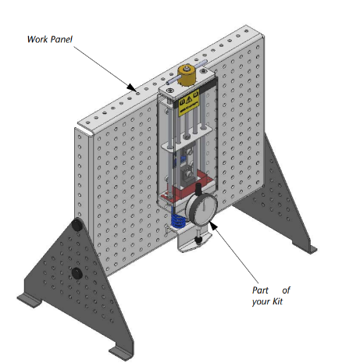
Figure 1 – work panel and tensile tester

This is how the tester for situated, it was placed upon the work panel, this is a simple design which takes a short time to build, perfect for a classroom environment where time is limited.
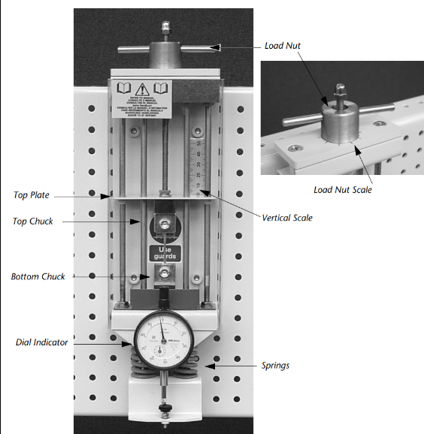
Figure 2 – close up of tensile strength tester
the tensile tester is simple to use, it holds the piece of material with two chucks, the bottom chuck is held down by two large springs as the top chuck is pulled up by the load nut. Each whole turn of the load nut is 1mm and there is a scale around the load nut showing and upward pull of 0.1mm.
the two springs which are connected with the bottom chuck is also connected with the dial indicator which measures the spring deflection. The springs obey Hooke’s law which helps calculate the force placed upon the specimen.
The vertical scale placed inside the tester helps the user remember how many turns the force control has turned, being a millimetre for each turn.
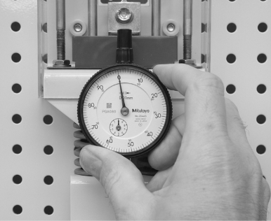
Figure 3 – dial indicator

Calibrating the dial indicator before conducting the experiment is vital for the accuracy of the results. After placing a new specimen in the tester, the force control should be turned carefully until the dial indicator just begins to move, the notch of the force should also match one of the scale points. Then turn the indicator to zero.

The four materials in question were cut into a long strip measuring 1mm x 2mm cross sectional area

Results
Below is the list of results and raw data that was collected during the experiment. The data shows the results obtained from putting the four material specimens into the tensile strength tester.
plastic
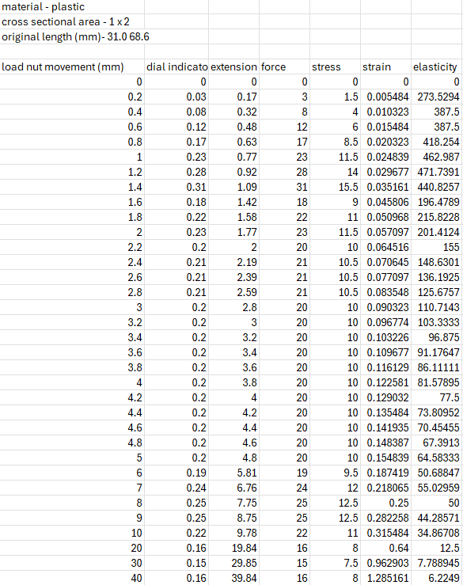
Table 1 – results from experiment for the plastic specimen
Alloy / duralumin
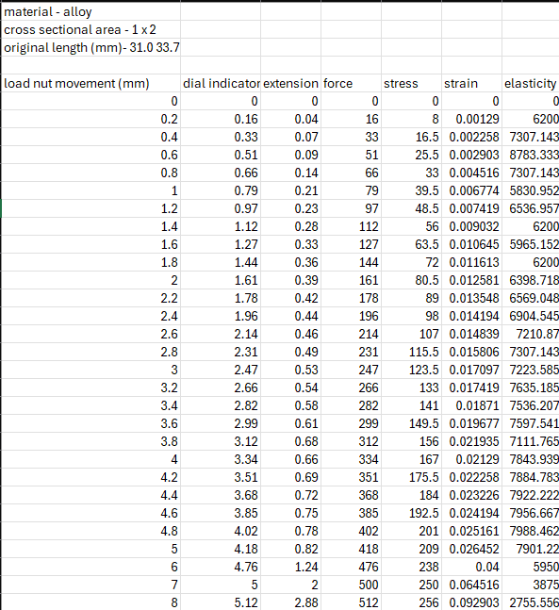
Table 2 - results from experiment for the alloy / duralumin specimen

aluminium
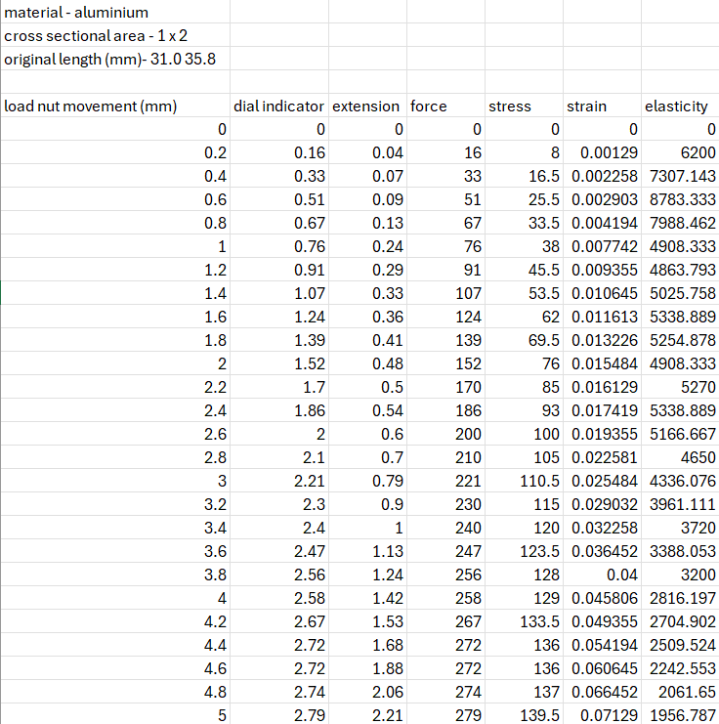
Table 3 - results from experiment for the aluminium specimen

steel
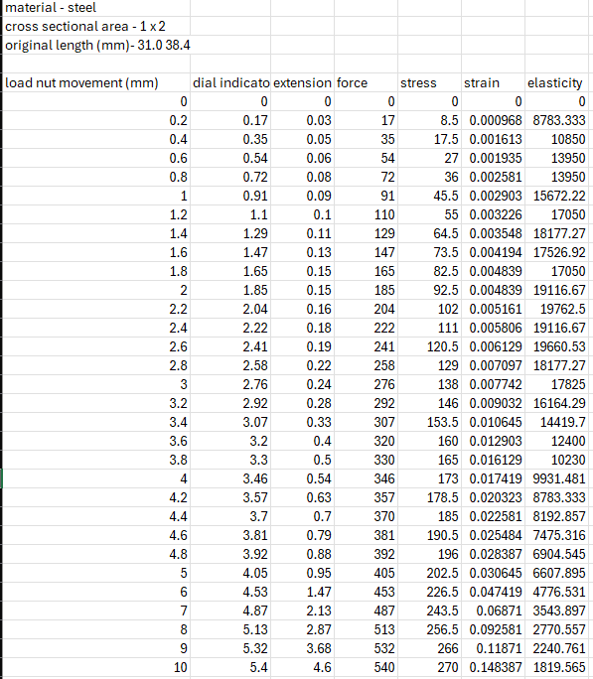
Table 4 - results from experiment for the steel specimen

Analysis
These are the graphs showing the tensile strength of each material

Stress/strain graphs
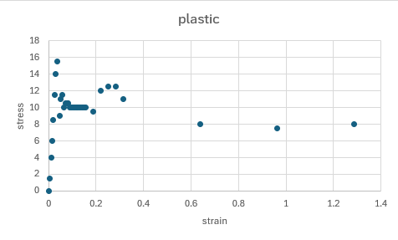
Graph 1 – stress / strain graph for plastic
This graph shows quite a wild range of results with the stress varying very often, this suggests that the raw data taken from the experiment might be incorrect. A big factor to prove this is that the ‘plastic region’ of the graph is inverted as it should either be flat or a curve upwards.
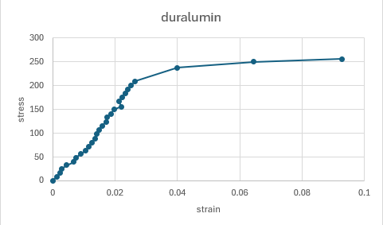
Graph 2 - stress / strain graph for duralumin
The curve shows that in the elastic region the duralumin specimen deforms linearly with the load that is applied to it. This shows that if the load is removed the specimen will return to its original shape. We also see that it has a high young modulus from the slope of the curve. We see that the yield point of the material sample is not sharp. This is the point where we see the material sample deform plastically. From this we go to the fracture point where we see the duralumin material specimen fracture. This shows duralumin has a high strength and good ductility.
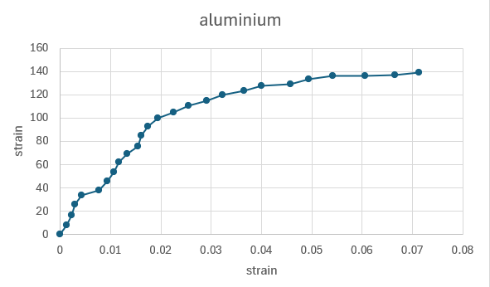
Graph 3 - stress / strain graph for aluminium
The graph indicates that aluminium deforms elastically at first which indicates that when the stress is released, the aluminium will revert to its initial shape. However, aluminium will start to flex plastically if the stress is increased above the yield point. This indicates that even once the stress is released, the metal will not revert to its initial form. The area under the stress-strain curve is equal to the toughness of the material. The graph shows that the aluminium has a relatively high toughness, meaning that aluminium can absorb a lot of energy before it fails.

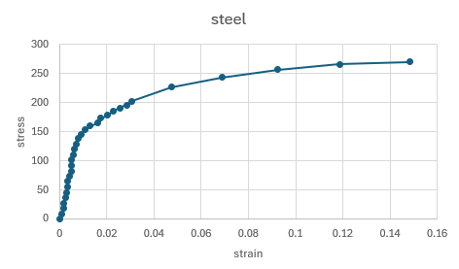
Graph 4 - stress / strain graph for steel
Since steel and other iron based materials can show a higher yield point before entering the plastic region, determined by how the material is processed, cold drawn or heat-treated. The plastic region of this graph increases quite linearly with a very high ultimate strength.

Conclusion
Plastic

during the video, a tensile strength test on a piece of PVC plastic is performed, the machine in the video is all electronically or pneumatically controlled, this is a better way of conducting this experiment since it eliminates all human error, especially since plastic is particularly ductile and the dial readings vary quickly, since its electronically controlled the machine will be more accurate and get the measurements 100% accurate. The operator also calculated the elongation from the machine by placing two dots of paint onto the specimen, it uses a video extensometer to measure the extension. The machine also provides real time graphs of the different readings.
(INSTRON, 2019)

Steel
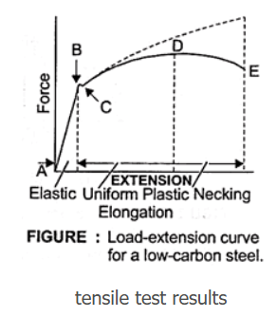
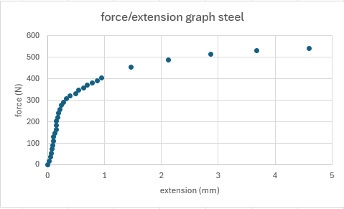
Comparing both of these force / extension graphs, we can see that the results are fairly similar although the results from our experiment do have a slight differ between ‘point B’ and ‘point C’ compared to the researched result. This was possibly a mistake in missing the ‘backlash’ as such from the dial indicator. Even of this small difference, the results are very similar which showcases that the way we conducted the experiment was correct and accurate for the equipment we were provided.

Evaluation
Eliminating errors
The best way to eliminate errors is to repeat the experiment, the bigger range of results the more accurate the analysis will become, unfortunately, we didn’t have time to repeat the experiments. During the experiment we eliminated problems by ensuring there was at least one person constantly watching the dial indicator since it moves back as the load nut pulls the specimen. This ensured that we had the most accurate reading possible.

Further work
Given unlimited time and resources, I would improve this experiment by doing multiple tests on each material, this would result in a more accurate result, I would also improve the machinery to give us more accurate results. Making the machinery more advanced, like the video above, testing the plastic, will help make these experiments more accurate and easier to conduct since it is able to measure more than one thing at a time, calculate different measurements and make real time graphs. This would help when it come to analysing different materials when we need to build anything that needs to handle a tensile force. Since temperature effects the elasticity of materials, the effect of temperature could also affect the testing so being in a temperature controlled environment would eliminate this issue.

References
https://uk.video.search.yahoo.com/search/video?fr=mcafee&p=tensile+stress+test+on+pvc+plastic&type=E211GB885G0#id=1&vid=c542176ceddb4c7d72d6bd921d86916e&action=click (INSTRON, 2019)
https://learnmech.com/tensile-test-purpose-graph-results-specimen-details/ (Sachin Thorat, no date)

