Student Number: 2405506
BA course: Illustration
Tutor: Chris Harrendence
Word count: 1386

How Anthropomorphism is used in art and why it’s important?
‘In recent decades artists have progressively expanded the boundaries of art as they have sought to engage with an increasingly pluralistic environment’. (Ramos, F.,2016,pg.5) Artists have used animal features and anthropomorphism to spread social and political comments while being able to attach more meaning and symbolism to their pieces. The use of anthropomorphism within illustration aids with the undertones while also adding a level of security from backlash for the artist. Anthropomorphism also makes it easier for an audience to receive and understand the intended message, ‘these illustrations are purposive towards attracting and disseminating certain information in a more pleasurable manner’ (Akuso and Shehu, 2022). It creates a more accessible illustration for younger audiences, heling them understand the messages presented, ‘animals can propose ways to better understand and undermine strategies of dominance, oppression and exclusion towards those who are marginalized’ (Ramos, F.,2016,pg.16).
Anthropomorphism has been used to portray different messages for decades. It was made popular in Egyptian art where they would portray sacredness by administrating animalistic body parts and traits to humans, ‘Egyptians continually attempted to integrate man and animal. Men, whose bodies are models of human perfection, retain the heads of birds and animals’ (Clark, 1977). In history anthropomorphism has been a way to show ‘radical otherness’ (Ramos, 2016) whether that be in a godly manner or whether it stems from our ‘fascination with the animal and monster ... with human and animal hybrids’ (Ramos, 2016). Humans have always had a fascination with animals and what they represent in human culture, ‘this observation has been the root on which the cultural reproduction of animals has been grafted’ (Simons, 2002). In more recent decade’s anthropomorphism has been used in a more political way, one standout artist who used anthropomorphism to make social comments was JJ Grandville. ‘Grandville visualises the embarrassment administered to men of the lower middle class from two sources: undiminished aristocrats and nouveau riche businessmen’ (Sexsmith, 1997). Grandville likes to incorporate ‘metonymy, synecdoche, puns and wordplay into his visual scenes’(Wettlaufer, 2013), this creates an interesting composition within his illustrations while also bringing a compelling play between his writings and illustrations. Grandville adds contexts into his illustrations based around class by using anthropomorphism to highlight the major differences between the class brackets while also making his own commentary on the issues. Grandville turns ‘wordplay into concrete representation’(Wettlaufer, 2013). This makes his illustrations still represent the issues and comments he wanted to make while standing alone without the text to back it up.
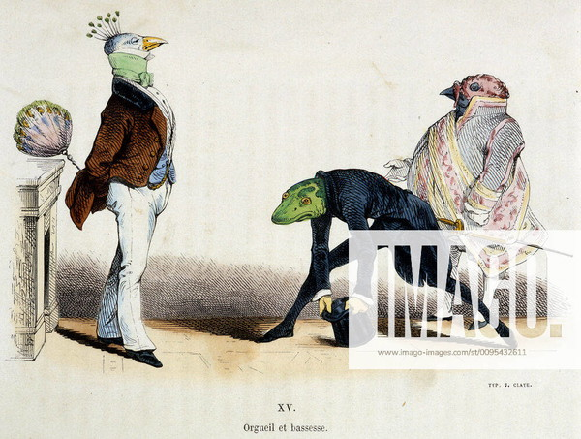
( Orgueil et bassesse, JJ Grandville 1829, lithograph)
In this illustration the reptilian man is trying to impress the bird men and climb the social ladder ‘he is attempting to acquire a fortune by opportunism at the start of a new regime’ (Sexsmith, 1997). The juxtaposition of the proud birds next to the bowing reptile solidifies the implied class difference, another way Grandville represents the class difference is through the animals. This is from the fact that birds are considered an elegant species whereas reptiles are seen as sneaky. The peacock being the main person the reptile is bowing to seems significant because ‘ these birds came to represent royalty and power’ ( Pheonix Art Museum, 2021).

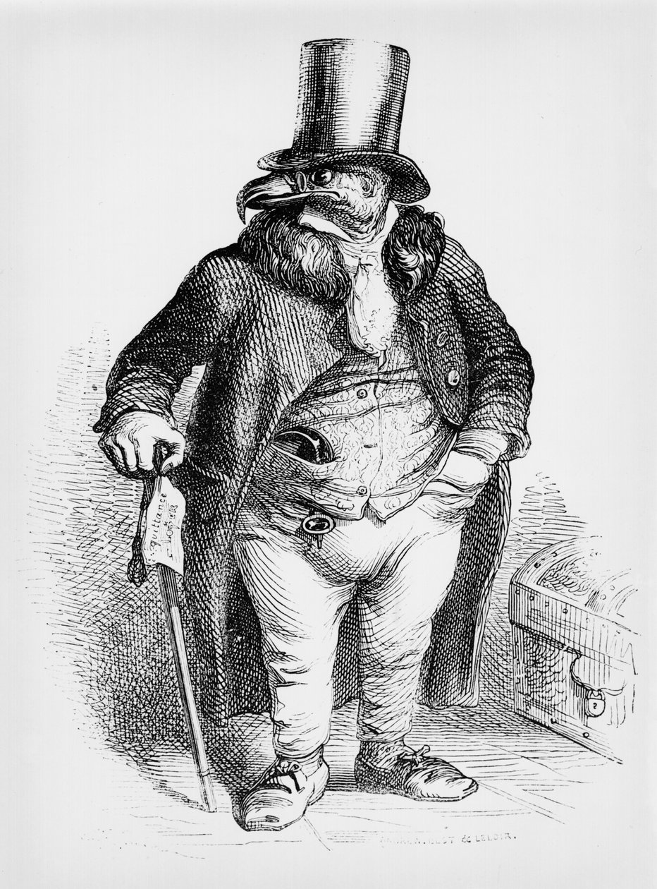
(The proprietor as Sir Vulture, JJ Grandville, 1867)
This illustration of JJ Grandville’s has a lot of context clues because of the anthropomorphism but also from the title. The bold lines from engraving create a very bold and detailed illustration and create a very proud appearing vulture man, the clothing and accessories that Grandville decided to give Sir Vulture paint him as a very wealthy man. The fact that Grandville has chosen to make the vulture a proprietor shows the viewer how he views them as people and paints them in a negative light. Vultures are ‘often associated with death, decay, doom and disaster’ (Kait Hanson, 2024). They are also associated with scavenging and the fact that they ‘primarily feed on decaying the flesh of dead animals’(Kait Hanson, 2024). Using these underlying meanings we can assume that JJ Grandville was trying to show how opportunistic proprietors were and how they would feed off the less fortunate to allow themselves to go further up the class ladder. The vulture that JJ Grandville decided to depict is obviously well off as he is on the larger side and seems well fed, this allows us to assume that Grandville is calling the proprietors greedy and shows them to take what they need and more. However vultures are also depicted as vital roles in our ecosystem ‘they provide an important ecological service by removing carcasses and harmful bacteria that would otherwise become breeding grounds for diseases’(Kait Hanson, 2024), so this illustrations could have a double meaning depending on the outlook on vultures the audience has. Vultures can also be representative of ‘devine power, and great wisdom’ (Clifford, 2020). We can assume that Grandville was not trying to call proprietors vital in our society from his previous works where he shows the imbalance and how it effects the lower classes.
Another highly effective way anthropomorphism has been used to promote and illustrate different ideas is in children’s books and media. It has been a very successful storytelling technique for children because this technique is meant ‘according to scholars, to erase degenderize, de-race and remove the notion of age in children’s text’ (Akuso and Shehu, 2022). This makes it easier for children to analyse and focus on the messages presented rather than on thee contexts that come with human characters, ‘young readers don’t see animals as ‘other’. They already believe the humans possess human characteristics’ (Wiegert, 2024). It can also allow children to create their own narratives within the illustrations from the underlying contexts from the animals without the traits being directly told to the readers, ‘proposing ways for humans to understand themselves better’ (Ramos, 2016, pg.14). A very successful example of an illustrator and author that focuses on anthropomorphism within their work for children is Beatrix Potter whose work is ‘beloved by children as well as adults’ (Pugl, 2015). Her works ‘find animals and humans living in the same society’ (Pugl, 2015). The main characteristic that sets Beatrix’s work apart from other Victorian children’s authors and illustrators is that ‘anthropomorphised animals never seem grotesque or exaggerated in anyway’ (Pugl, 2015), she also deals difficult themes including death and dangers like predators but instead softens it with humour which creates a less intense scene for children. It also helps the adults that may be reading with them to approach and discuss the issue in a more controlled less scary way. Potter also doesn’t shy away from having the characters be flawed because it ‘warns naughty children not to misbehave through anthropomorphized rabbits; their actions have consequences’ (Wiegert, 2024), this allows the children to learn about consequences in a more appealing way which makes it more likely for them to listen and learn from the anthropomorphized characters. Potter allowing her anthropomorphic characters to be flawed and make mistakes allows the readers to connect with them because they ‘experience human emotions’ (Pugl, 2015). This also allows the readers to empathise with the character’s and their journeys.
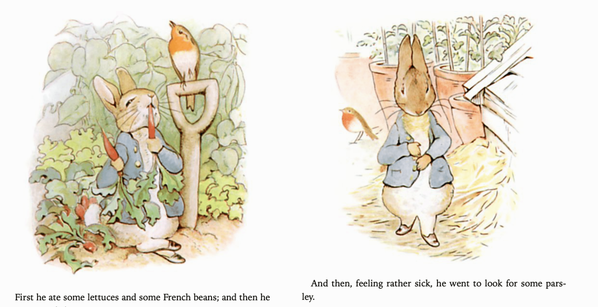
(‘The Tale of Peter Rabbit, Beatrix Potter, 1960’s)
This style is extremely appealing because of its soft lines and colours, they are really inviting to an audience because of ‘the combination of romance and fantasy with a strong sense of place captured in realistic backdrops’ (Victoria and Albert Museum, 2022). ‘Potter admired rabbits’ (Pugl, 2015), this admiration can be seen and felt within her delicate illustrations of the animals. Her ‘accurate botanical and anatomical drawings ... distinguished her tales from other children’s books’ (Pugl, 2015).
All things considered anthropomorphic art has been an influential and educational form of illustration for both children and adults alike. Anthropomorphic illustrations are ‘beneficial for leaning when tendencies of attributing human characteristic are triggered’ (Schneider et al., 2018), information is more easily comprehended when we are able to connect with it on a personal and human level. It has been an equally helpful resource for children’s authors and political illustrators as they are also able to add underlying contexts without being too on the nose. The art form of anthropomorphism is extremely versatile and particularly effective on showing different themes and issues.

Bibliography:
Akuso, E.S. and Shehu, S.F. (2022). AN ARCHETYPAL EXPLORATION INTO THE USE OF PICTORIAL AND ANTHROPOMORPHIC ILLUSTRATIONS IN SELECTED NIGERIAN CHILDRENâ€TMS TEXTS. NIGERIAN JOURNAL OF ARTS AND HUMANITIES (NJAH), [online] 2(1). Available at: https://www.nigerianjournalsonline.com/index.php/NJAH/article/view/2918.
Clark, K. (1977). Animals and men : their relationship as reflected in Western art from prehistory to the present day. William Morrow & Company, Inc.
Clifford, G.C. (2020). Vulture Symbolism & Meaning (+Totem, Spirit & Omens). [online] World Birds. Available at: https://worldbirds.com/vulture-symbolism/.
Filipa Ramos (2016). Animals. London: Whitechapel Gallery ; Cambridge (Mass.) ; London.
Kait Hanson (2024). What It Means When You See A Vulture: 4 Things You Probably Didn’t Know. [online] Southern Living. Available at: https://www.southernliving.com/meaning-of-a-vulture-8727689.
Patsiaouras, G., Fitchett, J. and Saren, M. (2014). Boris Artzybasheff and the art of anthropomorphic marketing in early American consumer culture. Journal of Marketing Management, 30(1-2), pp.117–137. doi:https://doi.org/10.1080/0267257x.2013.803141.
Phoenix Art Museum. (2021). The Symbolism of Peacocks. [online] Available at: https://phxart.org/blog/the-symbolism-of-peacocks/.
Pugl, S. (2015). ‘Anthropomorphism in Children’s Literature: Rabbits’. [online] Available at: https://phaidra.univie.ac.at/detail/o:1315331.pdf [Accessed 23 Apr. 2025].
Schneider, S., Nebel, S., Beege, M. and Rey, G.D. (2018). Anthropomorphism in decorative pictures: Benefit or harm for learning? Journal of Educational Psychology, 110(2), pp.218–232. doi:https://doi.org/10.1037/edu0000207.
Sexsmith, D.W. (1997). Going up in the world, and down: Social mobility in the caricature of J. J. Grandville, 1826-1847 - ProQuest. [online] Proquest.com. Available at: https://www.proquest.com/docview/304351099?pq-origsite=gscholar&fromopenview=true&sourcetype=Dissertations%20&%20Theses [Accessed 18 Apr. 2025].
Simons, J. (2002). The Animal as Symbol. Animal Rights and the Politics of Literacy Represention, pp.85–115. doi:https://doi.org/10.1057/9780230513549_5.
Victoria and Albert Museum. (2022). V&A · Beatrix Potter’s inspirations. [online] Available at: https://www.vam.ac.uk/articles/beatrix-potters-inspirations.
Wettlaufer, A.K. (2013). From metaphor to metamorphosis: visual/verbal wordplay and the aesthetics of modernity in Grandville’s caricature. Word & Image, 29(4), pp.456–486. doi:https://doi.org/10.1080/02666286.2013.786279.
Wiegert, L.T. (2024). Beatrix Potter’s The Tale of Peter Rabbit: Anthropomorphism in Children’s Literature | COVE. [online] Covecollective.org. Available at: https://editions.covecollective.org/content/beatrix-potter%E2%80%99s-tale-peter-rabbit-anthropomorphism-children%E2%80%99s-literature.
Orgueil et bassesse, JJ Grandville 1829, lithograph
The proprietor as Sir Vulture, carricature from ‘Vie privee et publique des Animaux’,published 1867,JJ Grandville, engraving

The Tale of Peter Rabbit, Beatrix Potter, 1960’s

