Understand the structure and function of the circulatory system

Task 1: Describe the function of the heart. (1.1)

The function of the heart is to pump blood around the body and keep the body alive. On average, the heart will beat around 100,000 times per day and five litres of blood is pump around the body through the circulatory system, a set of blood vessels in the human body. The blood provides nutrients and oxygen to all body parts to allow the organs and muscles to work efficiently.

Task 2: Using the image and space below, describe how blood moves through the four chambers of the heart and the stages of systemic and pulmonary circulation. (1.2, 1.3)
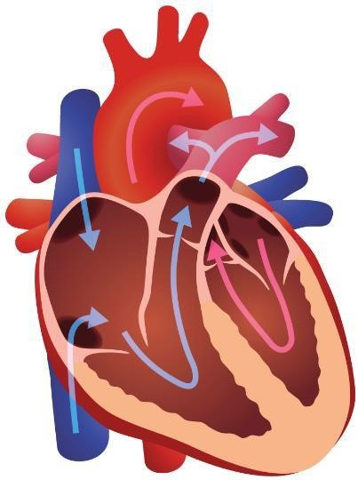
Description of blood flow:
The heart has two sections, and left side and right side with an upper chamber and lower chamber. The upper chambers consist of the left atrium and the right atrium, and the lower chamber consists of the left ventricle and the right ventricle.
De-oxygenated blood that has travelled around the body will go to the right side of the heart where the right atrium receives the low-oxygen blood and pumps it across to the right ventricle. The role of the right ventricle is to pump the low- oxygen blood to lungs to receive a fresh supply of oxygen. The role of the left side of the heart is to pump that re-oxygenated blood around the body again. The now high-oxygen blood from the lungs is transferred to left atrium and is pumped to the left ventricle where the high oxygen blood is pumped to the rest of the body.

Systemic and pulmonary circulation.
The pulmonary circulation is the flow of the blood from the right side of the heart to the lungs and then transferring back to the left side of the heart in low pressure. This is when the systemic circulation occurs, with the flow of the blood from the left side of the heart being transferred to all part of the body in high pressure.

Task 3: Describe the structure and functions of blood vessels. (1.4)

Structure | Functions
Arteries  Veins | Carries oxygenated blood, except for the pulmonary artery and carries blood away from the heart. To pump and accommodate blood, it has thick muscular and elastic walls and always carries blood at high pressure. The lumen is narrow and is the channel in the blood vessel that carries blood. Connective tissue, a type of supporting tissue provides strength.  Carries deoxygenated blood, expect for the pulmonary vein and always carries blood to the heart. Veins have thin walls. Have less connective tissue and muscular tissue than arteries. Always carries blood under low or negative pressure and has a wide lumen.

Task 4: Explain what blood pressure is and identify the different types of blood pressure classifications. (1.5, 1.6)

Blood pressure
Blood pressure is a measure of pressure that your heart uses to pump blood around the body and is produced by a contraction of the heart. It is measured in millimetres of mercury and is given as 2 figures:
Systolic pressure is the pressure when your heart pushes out blood,
Diastolic pressure is the pressure when your heart rest between beats.
A measurement of blood pressure will look like 140/90mmHg, the 140 being systolic pressure and the diastolic pressure of 90.

Blood pressure classifications
There are four types of classifications:
Normal- <120 systolic BP and <80 diastolic BP
Pre-Hypertension- 120-139 systolic BP or 80-89 diastolic BP
Stage 1 Hypertension- 140-159 Systolic BP or 90-99 Diastolic BP
Stage 2 Hypertension- >160 systolic BP or >100 Diastolic BP
These scores are for adults.

Learning outcome 2
Understand the structure and functions of the respiratory system
Task 1: Look at the image below. Using the image and spaces provided, label and describe the structure and function of the respiratory system. (2.1)

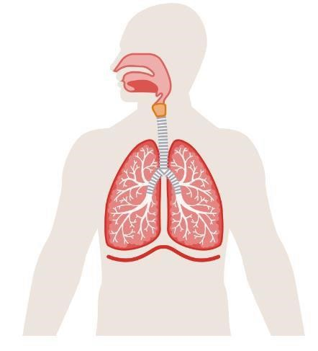
Structure from top to bottom
Pharynx
Larynx
Trachea
Bronchus
Bronchioles
Diaphragm
alveoli

Function
Pharynx- is a tube structure that connects the nasal cavity and back of mouth to the larynx and lower structures in the throat. Has two functions in air and food to pass through.
Larynx- helps conduct air through the respiratory tract by connecting the pharynx and trachea.
Trachea- role of the trachea is to bring air into the lungs and is supported by a ring of cartilage that prevents the trachea from collapsing
Bronchus- this helps the trachea to bring air into the lungs and is also supported by a ring of cartilage.
Bronchioles- a branch off the bronchi
Diaphragm- a sheet of muscle below the ribs which aids breathing.
Alveoli- small air sacks where gas exchange occurs.

Task 2: Identify the main muscles involved in breathing
The diaphragm flattens increasing the abdominal cavity, when breathing in it contracts and moves downwards allowing the size of the chest increase and decrease the air pressure inside it which allows the air to be sucked into the lungs. When breathing out, the diaphragm relaxes and allows the air to be forced out the lungs as the chest size has decreased, and the air pressure has increased.
The intercostal muscles are important as they control rib movement, when breathing in they pull the ribs downwards and inward and when breathing out pull the ribs upwards and outward to support the diaphragm.

Task 3: Describe the route of air through the respiratory system.
- Air enters the body through the nose
- Air enters the trachea
- Traches divides into two bronchi, and one enters each lung
- Each bronchus branches out into small tubes called bronchioles and air travels through
- At the end, the air enters one of the millions of alveoli, where gaseous exchange occurs.

Task 4: Describe the process of gaseous exchange. (2.4)

Diffusion is the movement of gas from a high concentration to a low concentration.
Gaseous exchange is taken place by diffusion at the alveoli in the lungs, where it is surrounded by capillaries. This allows oxygen and carbon dioxide to diffuse between the air in the alveoli and the blood in the capillaries.
Diffusion occurs as there is a high concentration of carbon dioxide in the blood and low concentration in the alveoli, which allows the carbon dioxide to travel from the blood to the alveoli through diffusion.

Learning outcome 3
Understand the structure and functions of the skeleton
Task 1: The skeleton provides vital structure to the human body. Below, describe the basic functions of the skeleton. (3.1)
Movement- allows movement individually and as whole of the body. Can also form joints that allow muscles to pull on them and produce joint movements.
Support and protection- the skeleton provides support and protects the body and organs found in the body. Examples include cranium protecting the brain and ribs protecting the heart and lungs.
Production of blood cells- bones in skeleton contain red bone marrow and this can be used to produce red and white blood cells, while also producing platelets.
Storage of minerals- bones are made of minerals and therefore are used as storage for calcium and phosphorous and can be given up if body requires the minerals for other functions.
Attachment of muscles- the skeleton does this by proving surfaces for attachment of muscles. Bones are often irregular shapes and have bony points and this allows the attachment points.

Task 2: Using the images below, identify the bones of the axial and appendicular skeleton. (3.2)
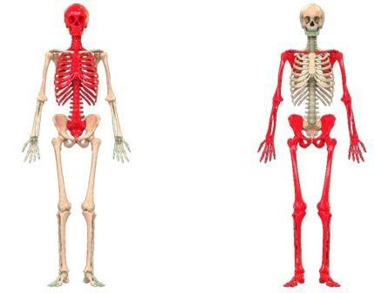
Axial bones

Skull
Hyoid bone
Chest
Sternum
Ribs
Vertebral column
Sacrum
Coccyx

Appendicular

Clavicle
Scapula
Humerus
Radius
Ulna
Carpal bones
Metacarpals
Phalanges
Hip bone
Femur
Patella
Fibula
Tibia
Metatarsals
Phalanges

Task 3: Identify the different classification of bones. (3.3)
1. Long bones
2. Short bones
3. Irregular bones
4. Flat bones
5. Sesamoid bones

Task 4: Describe the main features of a long bone. (3.4)

Long bones have length greater than breadth and found in limbs. They are important for movement. They have a tubular shaft and an epiphysis at each end covered by hyaline cartilage.

Task 5: Describe the stages of bone growth. (3.5)

Bones need a good blood supply for nutrients and oxygen to be brought in and to get rid of waste products.
Bones require nerves for information to travel to the brain when damage has been caused.
Bones will be mainly cartilage at birth. As the skeleton matures calcium and magnesium gets deposited into the bones by osteoblasts through the process of ossification. This process is completed by roughly 25 years.
Cartilage allows the bones to have resilience and calcium gives bones their strength.

Task 6: Describe the varying types of posture in terms of: (3.6)
Postural term | Description
Curves of the spine | There are 4 natural curves, cervical, Thoracic, Lumbar and Sacral. These curves allow walking easy while also maintaining an upright posture. The curves can be located centre of the head above the body.  Genetic and lifestyle factors such as work/school, sport, pregnancy, age and fashion can cause the curve of the spine to be exaggerated.
Neutral spine alignment | This is when the pelvis, rib cage and skull are aligned with each other.
Movement  potential of the spine | The potential movement in spine is flexion, extension, lateral flexion and rotation. Circumduction occurs from a combination of flexion, lateral flexion and hyperextension.
Postural deviations | 4 common deviations are  Kyphosis- causes upper back to round  Lordosis- causes lower back to arch  Flat Back- loses the natural S shape in the spine.  Forward Head- head and neck jutting forward past the neck.

Learning outcome 4
Understand joints in the skeleton
Task 1: Identify the classifications of joints. (4.1)
1. fibrous
2. cartilaginous
3. Synovial

Task 2: Describe the structure of synovial joints. (4.2)
The articular cartilage that covers the ends of the bones in synovial joints cushions the joint and reduces wear and tear and friction between the ends of the bones. Synovial joints are made by a synovial membrane.

Task 3a: Using the table below, identify the types of synovial joint and their range of motion.(4.3)
Synovial joint | Joint type | Range of motion available
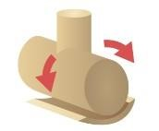 | Hinge | Allow flexion and extension in one plane.
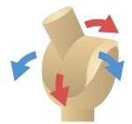 | Condyloid | Performs flexion, extension, abduction and adduction movement
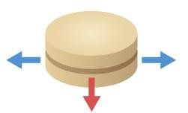 | plane | Only allows sliding movement.
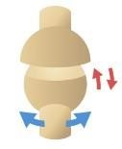 | Ball and socket | Allow all movements except gliding
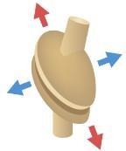 | Saddle | Permit the same movement as condyloid joints and combines to form compound joints.
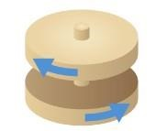 | pivot | Allows bone rotation about another bone

Task 3b: Describe joint movement potential and joint actions. (4.4, 5.6)
Joint action | Description | Joint example, eg wrist | Muscle example, eg quads
Flexion and extension | Flexion- a decrease in joint angle  Extension- a increase in joint angle | Knee | Tricep when extending elbow
Adduction and abduction | Adduction- towards the midline of the body  Abduction- away from the midline of the body | Hip and shoulder | Glute minimus
Circumduction | Where the limb moves in a circle | Shoulder | Trapezius
Supination and pronation | Supination- motion of turning the palm anteriorly  Pronation- motion of turning the palm posteriorly. | elbow | Brachioradialis in forearm.
Plantar flexion and dorsiflexion | Dorsiflexion- when ankle bends to allow toes to raise upwards  Plantar flexion- when the ankle bends to allow toes to point downwards. | Ankle | gastrocnemius
Lateral flexion and reduction | Lateral flexion- When the spine is bent to one side  Reduction- joint where the range of motion is decreased. | spine | latissimus dorsi
Horizontal flexion and extension | Horizontal flexion- When the arm is drawn across the chest while parallel to the floor  Extension- the arm is brought back out to the side from the previous position | shoulder | Pectoralis major
Elevation and depression | Elevation - movement in a superior direction  Depression- the reverse of elevation, denoting movement in a downward manner. | shoulder | trapezius

Task 4: Identify the body’s anatomical planes of movement. (4.5)
1. Sagittal
2. Coronal
3.transerve

Task 5: Define the anatomical terms of location. (4.6)
Table heading | Table heading
Distal | Further away from the area
Proximal | Closer to the area
Anterior | Is located at the front
Posterior | Is located at the back
Inferior | Lower
Superior | Higher
Deep | Something is profound or thorough
Superficial | Something that is shallow or on the surface
Medial | Towards the midline
Lateral | Away from the midline

Task 6: In the table below, describe the exercise variables and their effects on biomechanics and kinesiology. (4.7)
Exercise variable | Description | Effect on exercise
Levers | A lever is a stiff rod that pivots around a joint, usually a length of bone. | High mechanical advantage levers can move heavy loads with little effort at all.
Centre of gravity | The location of the body's centre of gravity is where its mass is concentrated. | By attempting to drag the body or a part of the body to the floor (if acting against gravity), gravity affects muscle contraction.
Momentum | When a body is in motion, its momentum is determined by multiplying its mass by its velocity. | With every repetition, its strength increases. Because the exerciser is using momentum instead of pushing the muscle to do the work, the exercise becomes faster, the muscle works less, and the joints and spine work more.
Force | Something that modifies the way an object moves | The muscles will adjust to the increasing load when a force is applied to them.

Learning outcome 3
Understand the muscular system
Task 1: Describe the characteristics and functions of the body’s 3 types of muscle. (5.1)
Muscle cell | Muscle type | Function | Characteristic
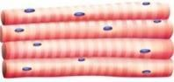 | Skeletal muscle cells | Striated muscle tissue's primary purpose is to contract and generate force | Cylindrical  Striated  Multinucleated present in skeletal muscles
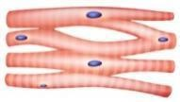 | Cardiac muscle cells | The purpose is maintaining blood circulation throughout the body and the heart's pumping action. | Single nucleus Rectangular in shape  Present in cardiac muscle such as myocardium
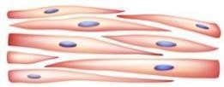 | Smooth muscles cells | utilised by a number of systems to exert pressure on organs and vessels. Sheets or strands of smooth muscle cells make up smooth muscle. | Single central nucleus  Arranged in sheets  Spindle shaped  Presented in muscular layers of vessels

Task 2: Describe the basic structure of skeletal muscle. (5.2)
Skeletal muscle is made of a series of bundles of muscles fibre and are supported by protective membranes. They connect to your bones, and this allows the body to perform a range of movement and functions. The body controls how and when they work as the muscles are voluntary.

Task 3: Using the images below, identify and locate the anterior and posterior skeletal muscles.
(5.3)
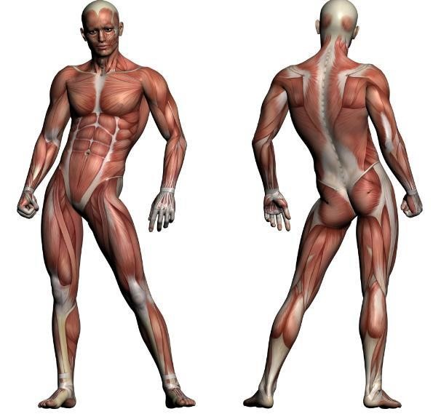
(
Muscles located within this
area under overlying
muscles)

Anterior muscles
Trapezius
Deltoid
Bicep Brachii
Pectoralis minor
Abdominals
External/internal oblique
Iliopsoas
Adductors
Quadriceps
Tibialis anterior

Posterior muscles
Trapezius
Rhomboids
Tricep brachii
Latissimus dorsi
Erector spinae
Abductors
Gluteus maximus
Hamstrings
Gastrocnemius
Soleus

Task 4: Describe the structure and function of the pelvic floor muscles. (5.4)
Function of the pelvic floor muscles is to provide stability to the core and provide resistance during coughing and lifting, allowing a proper position of the pelvic organs.

The structure is a funnel-shaped and it attaches to the walls of the lesser pelvis.

Muscle action Muscle action type and description | Muscle action Muscle action type and description
Movement  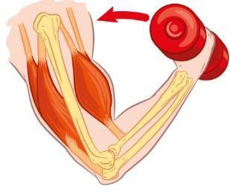 | Concentric- muscle fibres shorten
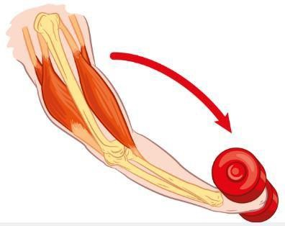  Movement | Eccentric- muscle fibre lengthens
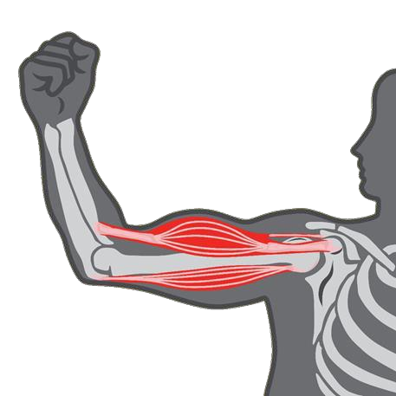  No m  ovement | Isometric- muscle contracts but doesn’t shorten

Muscle fibre | Description of characteristics
Type 1 | Slow twitch  Contraction speed- slow  Force produced- low  Small fibre size  Low fatigue
Type 2 | - Fast contraction speed  High force produced  Large fibre size  Medium fatigue
Type 2 | - Very fast contraction speed  Very high force produced  Largest fibre size  High fatigue

Learning outcome 6
Understand the life course of the musculoskeletal system and its implications for special populations’ exercise
Task 1: Describe the life course of the musculoskeletal system and its implications for exercise for the below special populations: (6.1)
Special population | Life course changes | Implications for exercise
Young people (13-18 years) | Growth hormones  Testosterone for males and oestrogen for females' changes | Decrease in balance and coordination due to growth of limbs  Osgood Schlatter's disease which causes pain in patella  Sever’s disease which causes pain in heel.
Antenatal and postnatal women | In first 3 months, blood pressure will drop, therefore might cause dizziness  Changes in posture as the baby grows  Increase stress on pelvic floor muscles | Lower impact and intensity  Lower resistance  Take care with abdominal work  Avoid developmental stretches  Avoid heavy abdominal work, especially in later.
Older adults (50+ years) | Risk of falls  Reduced bone resilience changes in posture  A decrease in muscle mass and strength  Reduced joint stability  Increased risk of fractures  Osteoporosis/osteoarthritis | Lower intensity/impact  Slower movements needed  Promote mobility and posture  Strength areas at risk of fractures such as hip and wrist.  Consider medical conditions.

Learning outcome 7
Understand energy systems and their relation to exercise
Task 1: Describe how carbohydrates, fats and proteins are used in the production of energy. (7.1)
Macronutrient | Description
Carbohydrate | provide energy for your body's functions. The body converts carbohydrates to glucose so that it can enter the bloodstream. Glucose then reacts with oxygen and allows the release of energy to the body.
Protein | Proteins are digested into amino acids and are vital in the body to allow:  Building and repairing of tissues and muscles  Providing structure to the body  Provide a healthy pH balance  Creating enzymes and hormones.
Fat | Fats are broken down into fatty acids and the functions of these are to allow:  Cell membrane health  Storing energy as fat stored serves as an energy reserve  Transport and absorption for vitamins such as K, E, D and A  Insultation and to protect the organs

Task 2: Explain the use of the 3 energy systems during aerobic and anaerobic exercise. (7.2)
Table Energy system | Explanation
ATP-PC | Role of ATP-PC is to recycles the body's meagre ATP and PC (phosphocreatine) stores to create ATP for physical activity. These high-energy phosphates that have been stored are broken down by this energy system to produce instant energy during high intensity exercise.
Aerobic | - This system generates enough energy for prolonged, low- to moderate-intensity exercise and uses oxygen to break down proteins, fats, and carbohydrates to create ATP.
Anaerobic glycolysis | This system produces a lot of power and produces energy without the need for oxygen through the breakdown of glucose. There are two pathways associated with glycolysis: anaerobic and aerobic. Energy is produced by this process for brief, intense activity bursts that don't last longer than a few minutes.

3: Identify the by-products of the 3 energy systems and describe their role in muscle fatigue. (7.3)
By-product | Role in muscle fatigue
Creatine | creatine increases your energy levels and training output; it may cause you to work out longer and harder.
Lactic acid | Muscle fatigue during exercise is caused by lactic acid buildup in muscle tissue, which lowers pH and increases acidity. Fatigue results from this further inhibition of anaerobic respiration.
Carbon dioxide and water | Carbon dioxide is a waste product and if it cannot release from your body, it can cause the body to feel tiredness causing muscle fatigue

4. Define anabolism, catabolism and excess post-exercise oxygen consumption (EPOC).

Anabolism | refers to all the chemical reaction processes that combine smaller molecules or atoms to form larger molecules.
Catabolism | Opposite to anabolism, this is the part in charge of dissolving large molecules into smaller ones
EPOC | also referred to as increased oxygen consumption after exercise, is a physiological effect that increases the number of calories burned

Learning outcome 8
Understand the nervous system and its relation to exercise
Task 1: Describe the role and functions of the nervous system. (8.1)
Role | Functions
The nervous system senses and reacts to changes both inside and outside the body. It functions as a communication network within the body. Numerous sensory receptors in the internal and external environments pick up on changes. | The primary function of the nervous system, which is made up of a network of neurons, is to create, modify, and transfer information throughout the entire body.

Task 2: Describe the principles of muscle contraction. (8.2)
There are two factors that are the foundation of the physiological theory of muscle contraction: length and tension. The definition of a muscle contraction is a change in the muscle's length during contraction. Different muscle contraction techniques result in a variety of movements. When a signal is produced by the nervous system, muscle contraction starts.

Task 3: Explain the ‘all or none law’/motor unit recruitment. (8.3)
The all or none law works within a motor unit and applies to the contraction of fibres in the unit. All the fibres in a motor unit contract when it activates and at maximum force, there is neither a strong nor a weak contraction. A stronger muscle contraction will be affected from the activation of more muscle fibres because of increased motor neuron activity.

Task 4: Identify how exercise can enhance neuromuscular connections and improve motor fitness. (8.4)
The nervous system, especially the neuromuscular junction (NMJ), benefits from exercise. While less physical activity results in degenerative changes in NMJs, exercise causes NMJs to hypertrophy and enhances recovery from peripheral nerve injuries.

Motor fitness can be improved by exercises that increase muscles strength as this will allow increase in muscular endurance which is linked to the improved blood flow to working muscles.

Learning outcome 9
Understand the structure and function of the digestive system
Task 1: Describe the function of each section of the digestive system. (9.1)
Table heading | Table heading
Mouth | First organ in digestive system, function is to cut and grind the food by the teeth and digesting the starch into sugars.
Oesophagus | Passes food and liquid from throat into the stomach.
Stomach | Digests food with a mix of enzymes produced in the stomach and digestive juices and passes to small intestine.
Small intestine | Food gets broken down, absorbed and passed onto the large intestine.
Large intestine | Long, tube pathway that travels food through the digestive system. Turns food waste into stool and passes it through to leave the body.

Task 2: Describe how fats, proteins and carbohydrates are digested and absorbed. (9.2)
Macronutrient | Enzymes used | Time scale | Location
Fat | Lipase enzymes | 3 hours | Small intestine
Protein | Protease enzymes | 3- 4 hours | Small intestine
Carbohydrate | Amylase and carbohydrase | 60 seconds | Mouth

Task 3: Describe the role of dietary fibre in the maintenance of gut function. (9.3)
Dietary fibre allows the passage of food through the intestines and removes the waste products from the body by the digestive system, while also allowing the body to absorb nutrients.

Task 4: Describe the role of the liver and pancreas in digestion.
The liver helps in digestion by producing bile, which allows the process of digestion lipids such as fats and oils.
The pancreas speeds up the digestion reaction by producing biological catalysts called digestive enzymes. This process is called chemical digestion.

Task 5: Explain the importance of maintaining fluid levels for health and exercise performance.
(9.5)
Level of performance | Explanation | Role of water
Health | Water important as it is eliminating waste from your body, controlling body temperature, and enhancing brain activity. | Creates saliva to allow digestion  Protects tissues, spinal cord and joints  Helps excrete waste.
Exercise performance | Sustaining fluid balance is essential for peak performance because even mild dehydration can affect mental and physical abilities. Maintaining hydration while exercising can help your body perform better overall, regulate temperature, and deliver nutrients. | Reduce risk of muscle cramps  Reduces exhaustion  Helps replace the water lose from sweating during exercise

