

Assignment
On

Global Business Environment. ( LCBB4005)

Coursework: Essay
Navigating International Expansion: Starbucks' Journey into India

Student Name: FARIDA AHMED
Student ID: 2123556
Lecturer: Dr Piyumika Kithulgoda Gamage

Table of Contents
- Introduction------------------------------------------------------------------------------------ 3
- Context of International Business---------------------------------------------- 3
- Business Environmental Analysis and Organizational Strategy-------- 3
- India: A Brief Overview---------------------------------------------------------------------- 3
- Cultural and Economic Context------------------------------------------------- 4
- Business Landscape-------------------------------------------------------------- 4
- Business Environment Analysis in India------------------------------------------------ 4
- PESTLE Analysis------------------------------------------------------------------- 4
- Porter's Five Forces Model------------------------------------------------------- 6
- Opportunities and Challenges------------------------------------------------------------- 7
- Corporate Governance------------------------------------------------------------ 7
- Business Strategy------------------------------------------------------------------- 8
- Cultural Sensitivity------------------------------------------------------------------ 8
- Barriers Faced by Foreign Businesses in India---------------------------------------- 9
- Legal and Regulatory Hurdles
- Market Entry Challenges
- Cultural and Social Barriers
- Strategies for Success in India------------------------------------------------------------- 9
- Recommendations for Starbucks---------------------------------------------------------- 11
- Conclusion--------------------------------------------------------------------------------------- 11
- Reference --------------------------------------------------------------------------------------- 12

1. Introduction

- Context of International Business
International business is a complex and dynamic field where companies expand their operations across borders to tap into new markets, resources, and opportunities. In an era of globalization, such endeavors are increasingly common, driven by the quest for growth, diversification, and competitiveness. Companies like Starbucks, known for their iconic coffeehouses worldwide, are no exception to this trend. To maintain their global presence and profitability, such companies often contemplate entering emerging markets, where the potential for growth is substantial.
International expansion offers various benefits, including increased revenue streams, diversification of risks, and access to new talent pools and innovations. However, it is not without challenges. Companies must navigate diverse business environments, cultural differences, regulatory landscapes, and competitive dynamics. These challenges necessitate a thorough analysis of the host country's business environment and the formulation of effective organizational strategies.

- Business Environmental Analysis and Organizational Strategy
This essay aims to provide an in-depth analysis of the business environment in a developing country, India, with a particular focus on how it might impact Starbucks' operations. The analysis will draw upon two prominent frameworks: PESTLE analysis and Porter's Five Forces Model. Furthermore, this essay will critically evaluate the opportunities and challenges presented by India's business environment, emphasizing aspects of corporate governance, business strategy, and cultural sensitivity. The discussion will also include an examination of the barriers typically faced by foreign businesses in India, followed by recommendations and strategies for Starbucks to thrive in this complex market.

2. India: A Brief Overview

India, a diverse and culturally rich nation, presents a compelling opportunity for international businesses like Starbucks (Marvin, 2021). Understanding the cultural and economic context of India is essential for making informed decisions regarding market entry and operations.

Cultural Diversity: India is a tapestry of languages, religions, traditions, and cuisines. It is a nation where diversity is celebrated, and cultural nuances are deeply ingrained. For Starbucks, recognizing and respecting this diversity is critical. For example, while coffee is popular in urban areas, chai (traditional Indian tea) holds a significant place in the hearts of many Indians. Starbucks must be culturally sensitive and offer a menu that appeals to diverse tastes, which might include not only coffee but also traditional beverages and vegetarian options (Srivastava & Thomas, 2018).
Economic Landscape: India's economy has been on a growth trajectory, driven by a large and young population, a burgeoning middle class, and a growing consumer market. However, income inequality persists, with significant disparities between urban and rural areas. Starbucks needs to tailor its pricing strategies to accommodate both budget-conscious consumers and those seeking premium experiences. Additionally, leveraging India's thriving tech industry for digital marketing and customer engagement is a strategic advantage (Bhagat, 2019).
Business Landscape: India's business landscape is characterized by its competitiveness and complexity:
Competitive Market: India's retail sector is highly competitive, with both domestic and international players vying for market share. Established domestic coffee chains, such as Café Coffee Day, and international brands like Costa Coffee, pose formidable competition to Starbucks. Starbucks must differentiate itself by offering unique value propositions, such as an exceptional café experience and ethical sourcing practices (Gupta & Arora, 2015).
Regulatory Environment: India has regulations specific to foreign direct investment (FDI) and retail that can impact Starbucks' entry and operational strategies. Starbucks must navigate these regulations, possibly through partnerships with local companies or joint ventures, to comply with FDI limits in retail (Dhawan & Landau, 2019).

Understanding this cultural and economic landscape provides Starbucks with insights into the opportunities and challenges it may encounter in India, helping the company adapt its strategies effectively.

3. Business Environment Analysis in India
External Analysis: PESTEL Model
PEST/PESTEL analysis is a simple and effective tool used to identify the key external forces that might affect an organisation. These forces can create both opportunities and threats for an organisation.
The aim of doing PEST/PESTEL is to:
- find out the current external factors affecting an organisation;
- identify the external factors that may change in the future;
- to exploit the changes (opportunities) or defend against them (threats) better than competitors would do.
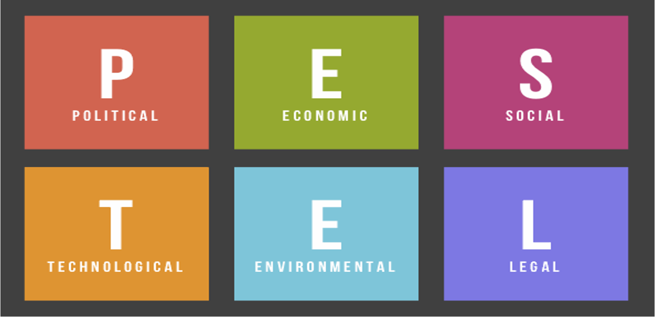

Political Factors: India's political landscape is characterized by its democratic system and federal structure. This stability is generally favourable for business. However, political changes can occur, and companies like Starbucks must closely monitor government policies, particularly those related to foreign investment, taxation, and labour laws (Panda, 2016).

Economic Factors: India's economy is growing steadily, driven by domestic consumption. For Starbucks, this represents a vast consumer market. However, income inequality is significant, and economic policies can change rapidly. Starbucks must assess the economic environment to determine pricing strategies and market positioning.

Social Factors: India's society is diverse, and cultural preferences vary widely across regions. Understanding these nuances is crucial for Starbucks, as it informs menu choices and marketing approaches. For example, Starbucks should consider offering regional flavors and vegetarian options, catering to local preferences.

Technological Factors: India's tech sector is booming, and digital adoption is on the rise. Starbucks can leverage this trend by investing in digital marketing, mobile ordering, and loyalty programs to enhance the customer experience

Legal Factors: India's legal system can be complex, with regulatory frameworks varying by sector and state. Starbucks should ensure compliance with labor laws, intellectual property rights, and food safety regulations. Legal expertise is essential to navigate these complexities.
Environmental Factors: Sustainability is gaining prominence in India. Starbucks can emphasize eco-friendly practices, such as sustainable sourcing and waste reduction, to align with India's growing environmental consciousness (Kumar & Pandey, 2018).

- Porter's Five Forces Analysis: Industry Competitiveness and Attractiveness
Porter’s Five Forces Framework helps to analyse an industry and identify its attractiveness of it in terms of five competitive forces: (i) extent of rivalry between competitors (ii) threat of entry, (iii) threat of substitutes, (iv) power of buyers and (v) power of suppliers. (UWTSD class module) | 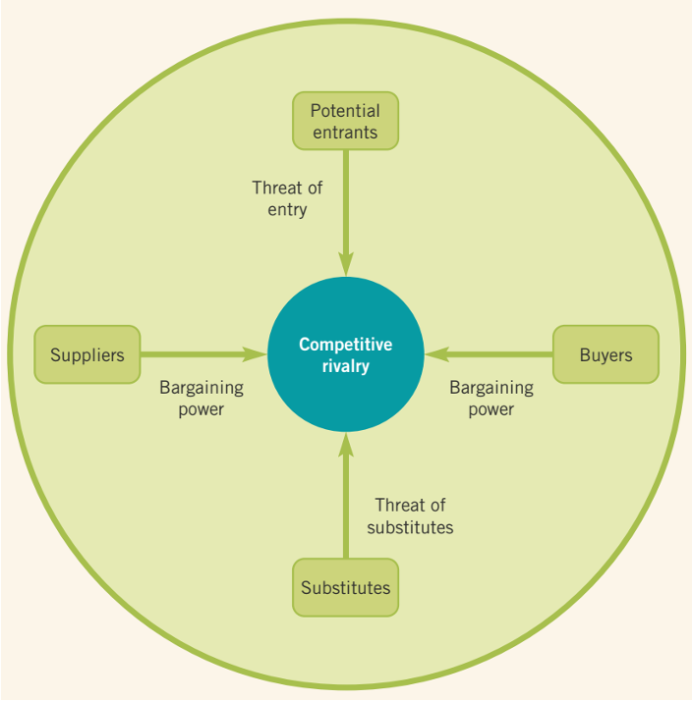

1. Threat of New Entrants: In the Indian coffee market, Starbucks faces a moderate threat of new entrants. While India has seen the emergence of several domestic coffee chains, Starbucks' global brand recognition and resources provide it with a competitive advantage. However, the barriers to entry include significant capital requirements for store establishment, competition from existing players, and adherence to complex regulatory requirements, such as foreign direct investment (FDI) limitations in the retail sector. Starbucks must continually innovate and differentiate itself to counter potential new entrants and maintain its market position.
2. Bargaining Power of Suppliers: The bargaining power of coffee bean suppliers in India can be moderate to high. India primarily relies on coffee imports, and Starbucks, like other coffee chains, needs to negotiate favorable terms with global coffee bean suppliers. Additionally, Starbucks may face pressure to source coffee beans sustainably, aligning with the increasing environmental consciousness in India. Establishing strategic partnerships with coffee suppliers and adopting sustainable sourcing practices can mitigate supplier power.
3. Bargaining Power of Buyers: Indian consumers are generally price-sensitive, which influences the bargaining power of buyers. Starbucks must carefully consider its pricing strategy to cater to both cost-conscious and premium-seeking customers. Offering a range of price points, value-added services, and loyalty programs can enhance customer loyalty and reduce buyer power.
4. Threat of Substitutes: The threat of substitutes in the Indian market is moderate. While coffee consumption is increasing, traditional Indian beverages like chai remain popular. To mitigate this threat, Starbucks can emphasize its unique coffee culture and introduce complementary products that align with Indian tastes. Additionally, the inclusion of traditional beverages and regional flavors in its menu can attract a broader customer base.
5. Competitive Rivalry: The Indian coffee market is highly competitive, marked by the presence of both domestic and international players. Starbucks faces rivalry from established domestic brands like Café Coffee Day and international chains like Costa Coffee. To excel in this environment, Starbucks must focus on product quality, innovation, and delivering a differentiated customer experience. Collaborations with local partners and strategic marketing initiatives can help it stand out in a crowded marketplace.

4. Opportunities and Challenges

Corporate Governance
Corporate governance plays a pivotal role when Starbucks considers expanding into India. It involves adhering to a system of rules and practices that ensure ethical standards, legal compliance, and stakeholder trust.
Opportunities:
Trust and Credibility: Starbucks can establish trust and credibility among Indian consumers, partners, and investors by practicing transparency in financial reporting and adhering to ethical business practices (Pandey, 2020).
Legal Compliance: Complying with India's stringent corporate governance regulations enhances Starbucks' legal standing and reputation (Mishra, 2018).
Challenges:
Navigating India's intricate regulatory landscape requires investment in legal expertise and resources to ensure compliance with local laws and regulations.
Effective corporate governance in India demands cultural sensitivity. Understanding and respecting Indian customs and business practices are essential for building strong relationships with local stakeholders (Srivastava & Thomas, 2018).

II Business Strategy
Adapting Starbucks' business strategy in India is crucial to align with the unique market characteristics.
Opportunities:
Menu Localization: Starbucks can offer a menu tailored to Indian tastes, incorporating traditional flavors and vegetarian options, catering to local preferences while maintaining the global Starbucks experience (Gupta & Arora, 2015).
Digital Marketing: India's tech-savvy population presents an opportunity for Starbucks to invest in digital marketing, mobile ordering, and loyalty programs, enhancing customer engagement and convenience (Bhagat, 2019).
Challenges:
Starbucks faces fierce competition from established domestic and international coffee chains in India. To stand out, it must continually innovate and differentiate its offerings (Dixit & Gupta, 2019).
Balancing pricing to appeal to both budget-conscious and premium-seeking consumers is challenging. Starbucks must find the right pricing strategy to cater to a diverse customer base.
III Cultural Sensitivity
Cultural sensitivity is paramount when doing business in India. Starbucks must understand and respect local customs, traditions, and values.
Opportunities:
Local Partnerships: Collaborating with local organizations and suppliers enhances cultural sensitivity and establishes a positive brand image. Sourcing products locally demonstrates a commitment to the Indian community.
Employee Training: Investing in cultural sensitivity training for employees ensures respectful interactions with customers of diverse backgrounds, building trust with local communities (Srivastava & Thomas, 2018).
Challenges:
India's incredible diversity in languages and cultures requires tailored marketing and communication strategies for different regions (Kumar & Pandey, 2018).
Being aware of and respecting religious practices and sensitivities is vital for avoiding cultural misunderstandings.
5. Barriers Faced by Foreign Businesses in India
- Regulatory Complexity: India's regulatory environment can be intricate and time-consuming to navigate. Foreign companies often encounter bureaucratic hurdles, complex tax systems, and varying state-level regulations. This complexity can lead to delays and increased operational costs.
- Cultural Diversity: India's cultural diversity is a strength, but it can also be a challenge for foreign businesses. Different regions have distinct languages, traditions, and consumer preferences. Adapting marketing strategies and products to cater to these diverse segments can be demanding.
- Infrastructure Challenges: While India is rapidly developing, infrastructure issues like inadequate transportation networks and inconsistent power supply persist in some areas. These challenges can affect supply chains and operational efficiency.
- Intense Competition: India's retail sector is fiercely competitive, with local and international players vying for market share. Foreign businesses must find ways to differentiate themselves and offer unique value propositions.
- Labor Laws: India's labor laws can be complex, and understanding and complying with them are essential. Foreign companies need to navigate these laws while also managing workforce expectations.

6. Strategies for Success in India
India, as a developing country, presents significant growth potential for Starbucks. To succeed in this dynamic market, Starbucks should consider several strategies and recommendations:

- Localization of Menu and Offerings
Strategy: Starbucks should adapt its menu to cater to local tastes and preferences. This includes offering traditional Indian beverages like masala chai and a variety of vegetarian options to resonate with Indian consumers.
Rationale: India is culturally diverse, and preferences vary widely across regions. Adapting the menu demonstrates an understanding of local tastes, making Starbucks more accessible and appealing to a broader audience (Gupta & Arora, 2015).

- Regional Expansion and Market Segmentation
Strategy: Rather than pursuing a one-size-fits-all approach, Starbucks should focus on regional expansion, recognizing that each region in India has distinct consumer behaviors and preferences. Market segmentation allows Starbucks to tailor its strategies to local markets.
Rationale: India's diversity extends beyond culture to consumer behavior and preferences. By segmenting the market and tailoring marketing campaigns, products, and store experiences to specific regions, Starbucks can achieve greater resonance.

- Digital Innovation and Mobile Ordering
Strategy: Leverage India's tech-savvy population by investing in digital innovation. Introduce mobile ordering, loyalty programs, and partnerships with popular digital payment platforms to enhance convenience and engagement.
Rationale: India's increasing smartphone penetration and the preference for digital transactions make this strategy essential. It improves customer convenience and provides valuable data for personalized marketing (Bhagat, 2019).

- Sustainability and Ethical Sourcing
Strategy: Emphasize sustainability and ethical sourcing of coffee beans. Showcase Starbucks' commitment to environmental responsibility and supporting local communities through initiatives like fair trade and responsible sourcing.
Rationale: India is increasingly conscious of environmental and ethical concerns. Aligning with these values can enhance Starbucks' reputation and attract socially conscious consumers (Kumar & Pandey, 2018).

- Regulatory Compliance and Local Partnerships
Strategy: Navigate India's complex regulatory environment by partnering with local businesses and experts. Establish robust compliance mechanisms to ensure adherence to legal requirements.
Rationale: India's regulatory landscape can be challenging for foreign companies. Local partnerships and compliance expertise mitigate risks and streamline operations.

- Continuous Innovation
Strategy: Foster a culture of innovation within the organization. Continuously introduce new products, services, and store concepts to stay ahead of competitors and meet evolving consumer preferences.
Rationale: Innovation is key in India's competitive coffee market. It keeps the brand fresh and exciting, encouraging repeat visits and customer loyalty (Dixit & Gupta, 2019).

7. Recommendations for Starbucks
Starbucks should consider a mix of company-owned stores and strategic franchising or licensing agreements with experienced local partners. This approach will allow for faster expansion while maintaining control over quality.
Developing a robust local supply chain is essential. Starbucks should source coffee beans locally and establish partnerships with dairy and plant-based milk producers to ensure product consistency and reduce costs.
Invest in continuous employee training and development programs that focus on cultural sensitivity and customer engagement. Empower local employees to take ownership of their roles and contribute to Starbucks' success in India.

8. Conclusion
In conclusion, Starbucks' potential move into India presents both vast opportunities and unique challenges. A comprehensive understanding of India's business environment, including political, economic, social, technological, legal, and environmental factors, is crucial. By carefully adapting its business strategies, addressing cultural sensitivities, and proactively addressing barriers, Starbucks can position itself for success in this dynamic and diverse market. It is imperative for Starbucks to take a long-term perspective, foster local partnerships, and embrace localization to thrive in India's rapidly evolving business landscape.

References

Bhagat, S. (2019). India’s Economic Transformation and Starbucks’ Growth Opportunities. In M. Li & J. Wilson (Eds.), International Business in a VUCA World: The Changing Role of States and Firms. Springer.

Gupta, R., & Arora, A. (2015). A Study on Retail Marketing Mix and Customer Satisfaction in Organized Retailing: A Case Study on Starbucks. Indian Journal of Marketing, 45(1), 17-30.

Srivastava, P., & Thomas, P. (2018). Consumer Cultural Identity and Consumption of Global Brands in India. Journal of International Consumer Marketing, 30(4), 240-252.

Dhawan, R., & Landau, D. (2019). Retail and FDI in India: A Comparative Perspective. In D. Landau (Ed.), Handbook of Research on Global Business Opportunities (pp. 195-220). IGI Global.

Panda, A. (2016). The Impact of Political, Economic, Socio-cultural, Technological, Legal, and Environmental Factors on Starbucks. IOSR Journal of Business and Management, 18(6), 1-6.

Marvin, H. (2021). Understanding the Business Culture of India:Global Business Culture website at - https://www.globalbusinessculture.com/cultural-awareness/understanding-the-business-culture-of-india/ (accessed on 30.08.2023)

Bhagat, S. & Ajay, P. (2019). A Review of Urban Renewal in High Density Cities: International Research Journal of Engineering and Technology, V-06, Issue – 12.

Pandey, C.M., Augustine, S., Kumar, S., Kumar, S., Nara, S., Srivastava, S. and Malhotra, B.D., 2018. Microfluidics based point‐of‐care diagnostics. Biotechnology journal, 13(1), p.1700047.

Barney, J. B. (1991). Firm Resources and Sustained Competitive Advantage. Journal of Management, 17(1), 99-120.

Grant, R. M. (2016). Contemporary Strategy Analysis: Text and Cases Edition (9th ed.). Wiley.
Porter, M. E. (1980). Competitive Strategy: Techniques for Analyzing Industries and Competitors. Free Press.

Johnson, G., Scholes, K., & Whittington, R. (2008). Exploring Corporate Strategy: Text and Cases. Financial Times Prentice Hall.

Unicef, 2015. SWOT and PESTEL. [Online] Available at: https://www.unicef.org/knowledge-exchange/files/SWOT_and_PESTEL_production.pdf [Accessed 12 08 2023].

