

School of Architecture, Built and
Natural Environments

HNC/HND/BSc Civil Engineering and
Environmental Management

Individual Research Project
Module Code : ACBA6002

The Fire Resistance of Fiber
Reinforced Concrete

By
Thomas Hinder
(1701670)

Supervised By
Juan ferriz-Papi

Abstract

Fire has become a major threat in buildings over the years. As concrete is one of the leading materials in construction their properties under fire is of seriousness and importance. Concrete is generally good when exposed to fire because of its low thermal conductivity. However an occurrence such as when the concrete starts to spall because of the rise in temperature can cause a different behaviour of the elements. The cross section area of concrete can decrease after spalling and in columns, for example, can reduce axial load resistance significantly, thereby directly exposing the reinforcement to the high temperatures. Due to its seriousness and importance of major fire incidents in buildings there is a need for experience, research, and development efforts. This research was conducted to investigate the behaviour of fiber reinforced concrete in fire. To achieve these results several mortar samples were used including three different mix designs. The first mix was the conventional mortar mix which did not contain fibers. The second mix contained glass fibers, with the third mix containing metal fibers. Each fiber mix contained a volume fraction of 1%. The specimens were exposed to temperatures of 250°C for a duration of 2 hours before undergoing flexural and compressive strength tests. A fire resistant performance and strength comparison between the conventional mortar specimens, glass fiber reinforcement, and metal fiber reinforcement was made. Despite that, results were not obtained due to restrictions imposed with Covid-19. Presented in this paper there is the experimental investigation to carry out and considerations to take, as well as a prediction of sample performance which will be compared with further research.

TABLE OF CONTENTS

ABSTRACT …………………………………………………………………...2
TABLE OF CONTENTS ……………………………………………………...3
LIST OF FIGURES ………………………………………………………….....6
LIST OF TABLES ……………………………………………………………..7

CHAPTER 1. INTRODUCTION
  - Introduction ……………………………………………………..9
  - Statement of Problem ………………………………………….10
  - Research Objectives …………………………….……………..11
  - Research Methodology ………………………………………...11
  - Dissertation Organization ……………………………………..13

CHAPTER 2. LITERATURE REVIEW
2.1 Introduction ………………………………………………….....15
2.2 Concrete ……………………………………………………….15
2.1.1 Advantages of concrete when exposed to fire ………………17
2.3 Chemical and physical response to fire ……………………….17
2.4 Spalling ………………………………………………………..19
2.4.1 Mechanisms of spalling ……………………………………..20
2.5 Measures of preventing spalling ………………………………21
2.5.1 Fibers ………………………………………………………...21
2.5.2 Thermal barriers ……………………………………………..22
2.6 Cracking ……………………………………………………….22
2.7 The effect of fire on concrete ………………………………….23
2.8 The effect of fire on fiber reinforced concrete ………………...24
2.9 The effect of fire on fiber reinforced polymers ……………….25
CHAPTER 3. EXPERIMENTAL PROGRAM
3.1 Introduction …………………………………………………....28
3.2 Materials quality tests …………………………………………28
3.2.1 Sand …………………………………………………………28
3.2.1.1 Unit weight of sand ………………………………………...28
3.2.1.2 Sieve analysis ……………………………………………...30
3.3 Cement ………………………………………………………...31
3.4 Water …………………………………………………………..32
3.5 Glass fibers ……………………………………………………32
3.6 Metal fibers ………………………………………………........34
3.7 Proportions for the mix ………………………………………..35
3.8 Samples ………………………………………………………..36
3.8.1 Sample categories …………………………………………...36
3.8.1.1 Mix 1 ……………………………………………………....36
3.8.1.2 Mix 2 …………………………………………………….....36
3.8.1.3 Mix 3 ……………………………………………………....37
3.8.1.4 Schedule …………………………………………………...37
3.9 Mixing, casting and curing ……………………………………38
3.9.1 Preparation …………………………………………………..38
3.9.1.1 Equipment used ………………………………………….../.38
3.9.2 Mixing ……………………………………………………….39
3.9.2.1 Mixing procedure ………………………………………….39
3.9.2.2 Equipment used …………………………………………....40
3.9.3 Casting……………………………………………………….40
3.9.3.1 Casting procedure………………………………………….40
3.9.3.2 Equipment used…………………………………………….41
3.9.4 Curing ………………………………………………….........42
3.9.4.1 Curing procedure ………………………………………….42
3.9.5 Heating ……………………………………………………....43
3.9.6 Flexural test ………………………………………………….43
3.9.6.1 Procedure ………………………………………………….44
3.9.7 Compression test …………………………………………….45
3.9.7.1 Procedure ………………………………………………….45

CHAPTER 4. RESULTS & DISCUSSION
4.1 Introduction ………………………………………………….....48
4.2 Glass fiber predicted results …………………………………...48
4.3 Metal fiber predicted results …………………………………..49

CHAPTER 5. CONCLUSION & RECOMMENDATION
5.1 Introduction …………………………………………………...51
5.2 Conclusions …………………………………………………...51
5.3 Recommendations …………………………………………….51

REFERENCES ………………………………………………………………52
Figures ……………………………………………………………………….56

LIST OF FIGURES

Fig 1 : Concrete column before and after being subjected to fire …………....10
Fig 2 : Surface cracking of concrete after being subjected to fire …………...16
Fig 3 : Structural failure ……………………………………………………...16
Fig 4 : Spalling impact on concrete ………………………………………….19
Fig 5 : Concretes spalling mechanism ……………………………………….20
Fig 6: Fibers providing protection…………………………………………….21
Fig 7: Thermal cracks ………………………………………………………..23
Fig 8: Sand ready to be oven dried …………………………………………..29
Fig 9: Oven dried sand …………………………………………………………30
Fig 10: 450g of Portland cement ……………………………………………..32
Fig 11: 4.5g of Glass fibers …………………………………………………..33
Fig 12: 4.5g of Metal fibers ………………………………………………….34
Fig 13: All materials weighed and labelled separately ……………………....38
Fig 14: Mechanical mortar mixer…………………………………………….39
Fig 15: Three gang moulds …………………………………………………..40
Fig 16: Vibrating table ……………………………………………………….41
Fig 17: Mortar samples after demoulding …………………………………....42
Fig 18: Curing tank …………………………………………………………..43
Fig 19: Central point loading ………………………………………………...44
Fig 20: flexural strength test …………………………………………………45
Fig 21: Failure of specimen ………………………………………………….46

LIST OF TABLES

Table 1: Portland cements mineralogical composition …………………….....18
Table.2: Usual Properties of Portland cement ………………………………..31
Table 3: Design of the mix for the samples ………………………………….35
Table 4: Mix 1 (without Fibers) ……………………………………………...36
Table 5: Mix 2 (Glass fibers) ………………………………………………...36
Table 6: Mix 3 (Fibers 2) …………………………………………………….37
Table 7: Schedule of activity ………………………………………………...37

CHAPTER ONE :

INTRODUCTION

Introduction
CH.1: Introduction
The Fire Resistance of
Fiber Reinforced Concrete

  - Introduction

The maintenance of a durable structure to resist abrasion, chemical attacks, weathering action, and other processes of degradation during its service life is just as important as the applied load on the structure. Regarding economic aspects and mechanical characteristics, concrete offers many advantages in construction, although the material can have a brittle behaviour where the seismic handicap and other applications are larger and where the essential demand for flexible behaviour is needed. Fiber reinforced concrete has recently developed a technical basis for these deficiencies to be improved. Presented in this paper will be an overview of the effect of fiber reinforced concrete under fire.

As it can cause high level of destruction to buildings in a short period of time, fire is one of the leading threats to buildings. Generally the protection to fire is used to prevent any outbreak or spread of fire within buildings.
The term that is described for delaying or reducing the fire effect is fire resistance. Many aspects to design can help to prevent or delay the out brake of a fire including fire doors, windows, building materials that are capable to withstand fire, either pre-determined for a period of time of permanently.
When exposed to fire the mass of concrete changes and will affect the concrete reinforcement members.
The concrete mechanical properties will then be reduced from the rise in temperature. Furthermore, new strains, transient, and thermal creep will be produced from these temperatures. These rise in temperatures can also then result in the surface pieces of the concrete to spall. Globally fire is a disaster in human life as it disrupts activities and leaves damage and distress for the coming times. (Fitiany & Youssef, 2009)
Due to concretes deprived thermal conductivity and its inherent non-combustibility, concrete is a fire resistance material.
There are several reasons civil engineering projects specify concrete in buildings, sometimes architectural appearance or construction speed, and sometimes cost, but one of the main reasons concrete is the major material in construction is because of its performance when subjected to fire. These factors affecting the decisions of design is overlooked in the race for the fire safety of buildings.
Concretes performance in when exposed to fire is usually good. However, concrete can suffer high amounts of distress when exposed to long term exposure to fire or abnormal high temperatures. Because the pre fire compressive strength of concrete often exceeds the design requirements, an acceptance in modest strength reduction is tolerated. But due to the large rise in temperatures of concrete this can result in the compressive strength reducing until the material has no effective structural strength. (Chen, Chang, Yao & Sheu, 2009)
CH.1: Introduction
The Fire Resistance of
Fiber Reinforced Concrete
The importance of study on RC columns are vital as they are the stability of the structure and the primary load bearing.

  - Statement of Problem
When subjected to fire concrete generally shows good behaviour, this is because of the good thermal insulation capacity from the steel bars along with concretes low thermal conductivity. However an occurrence such as when the concrete starts to spall because of the rise in temperature may cause a different behaviour of the elements. (Shihada, 2011)
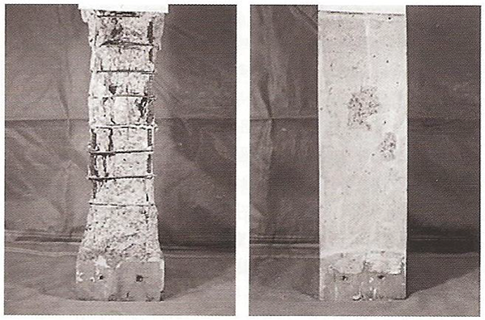
Fig 1 : Concrete column before and after being subjected to fire (So, 2016)
The cross section area of the concrete columns will start to decrease after spalling as well as the axial load resistance to decrease, thereby directly exposing the reinforcement to the high temperatures. Worldwide many studies have been performed to avoid spalling and to develop the fire resistance of concrete compositions.
CH.1: Introduction
The Fire Resistance of
Fiber Reinforced Concrete
At elevated temperatures fiber reinforcement in the concrete showed good behaviour and good controlling of the spalling effect. In this research both a metal and a glass fiber will be used in the concrete mix to compare the different effect they have when subjected to high temperatures. (Rodrigues & L.L.Correia, 2010)

  - Research Objectives
The aim of this research is to analyse the performance of fibre-reinforced concrete when subjected to fire. The objectives to complete are as follows;
- Study the effect of fire in concrete and its capacity to support high temperatures.
- Carry out concrete samples with different types of fibres and test mechanical properties under different degrees of temperature.

- Analyse the results obtained in this referred mechanical tests and compare performance of concrete with different types of fibres.
  - Research Methodology
In this experimental program a series of fire endurance tests were conducted. Examined in these tests were the effect that high temperatures have on concrete mortar samples and the effect of fibers as reinforcement. The programme consists of a series of mortar mixes each containing the same proportions of 450g of Portland cement, 1350g of sand and 247.5ml of water. The specimen sizes were be 40mm x 40mm x 160mm. A further A 1% volume fraction was used for the additional fibers. A total of eighteen specimens were made. The mixing procedure for the specimens with fiber reinforcement were according to BS EN 14889-2. After casting the specimens were then cured for twenty-four hours before they were removed from their moulds and placed in a curing tank where they were submerged in water for twenty-eight days. The procedure met the required standards BS EN 12390-2: 2019, BS EN 12350-6: 2019, BS EN 12350-7: 2019, BS EN 998-1, BS EN 998-2, and BS EN 1015-11. After twenty-eight days of curing the specimens were placed in an electrical oven where they were exposed to temperatures of 250℃ for 2hours. The specimens then underwent flexural test to determine their flexural strength to evaluate the capability of the specimens to withstand failure when bending under high temperatures. Afterwards they were tested for compression strength to determine the specimens resistance to failure under action forces of compression. These test were achieved according to the standard BS EN 1015-11:2019.
The program of tests will include the following:
CH.1: Introduction
The Fire Resistance of
Fiber Reinforced Concrete
- Define the different properties of the constitutive materials of the sample (reinforcement, fine sands and cement

- Using metal and glass fibers, examine the impact of the fibers in the concrete casting.

- Concrete mortar samples will be cast and cured before heating them in an oven for a duration of 2 hours at 250℃ before being tested for flexural and compressive strength. These tests will be based on the research gained in this research.

- These tests will study the capacity of flexural and compressive strength of the mortar samples.

- Examine the fiber reinforced mortar samples after exposure to the elevated temperatures.

- Analise test and results.

- Conclusions and recommendations based on the data results and analysis from the experimental program.

CH.1: Introduction
The Fire Resistance of
Fiber Reinforced Concrete
  - Dissertation Organization

There are six chapters to this dissertation as follows:
Chapter 1 (Introduction): In this chapter, there will be some background on the fire resistance of concrete, as well as the description of research importance, methodology, objectives, and scope.
Chapter 2 (Literature Review): In this chapter there will be a review on a number of scientific research and studies on the effect of fiber reinforced concrete when subjected to fire, and also how the fire resistance of concrete can be improved.
Chapter 3 (Experimental program): Determine the basic materials and properties of concrete, such as sand and cement. Also the preparation of the concrete samples, the process of heating, and the test result after heating.
Chapter 4 (Results & Discussion): In this chapter will include the test result that had been performed on the fiber reinforced concrete samples and the discussion of these results.
Chapter 5 (Conclusions and Recommendations): In this chapter will include the main conclusions and recommendations from the research work and also the concluding remark.
References

CHAPTER TWO :

LITERATURE REVIEW

Literature Review
CH.2: Literature Review
The Fire Resistance of
Fiber Reinforced Concrete

2.1 Introduction
In most structures and buildings fire remains one of the main safety risk. As concretes great use as a structural material is growing there is a high demand to understand the full effect that fire has on concrete. Normally concrete works well when subjected to fire. Concrete behaviour when subjected to fire is mainly dependent on its strength but also explosive spalling and the way the material property’s change. (Shihada, 2011)
Hardened concrete is homogeneous, dense and has similar durability and engineering properties as traditional concrete that has been vibrated. The strength of the concrete is affected by the rise in high temperatures by explosive spalling and so affects the structures integrity.
In recent times, there have been many researchers that have studied concretes behaviour to fire. Included in their studies were experimental assessments and analysis evaluations for concrete. The researchers include (Rodrigues & Correia, 2010), (Shihada, 2010), (Alia, Nadjai, Silcock, Tair, 2004), (Hertz & Sorensen 2005), (Komonen & Pentala, 2003), (Sideris, Manita & Chaniotakis, 2009), (Kodur, Bisby & Green, 2006), and (Chowdhurya, Bisbya, Green & Kodur, 2006).
Discussed in this chapter will be a number from previous researches that studied the effect that fire has on concrete.

  - Concrete
Concrete is a composite material. This building material is regarded as a composite material for the reason that there is a number of materials that are combined to form it. It mainly contains mineral aggregates bound together by a matrix of hydrated cement paste. In addition to calcium silicate hydrated gel and many other solid phases hydrated cement paste contains voids. Unless the matrix is artificially dried it contains a vast amount of water and is also highly porous. Primarily in the hardened cement paste these changes will begin to appear from rise in temperature. This will have an effect on concretes mechanical and physical properties. (Shihada, 2011)
The high temperatures can make the concrete to deteriorate. This deterioration can become visible in two forms:
- Global damage – failure in the elements Fig 2 (ABBOT, 2020)

- Local damage – cracks in the material Fig 3 (Hamakareem, 2020)
CH.2: Literature Review
The Fire Resistance of
Fiber Reinforced Concrete
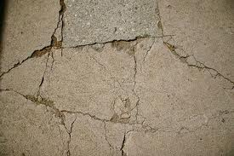

Fig 2 : Surface cracking of concrete after being subjected to fire (ABBOT, 2020)

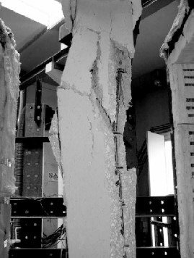

Fig 3 : Structural failure (Hamakareem, 2020)
One of the main reasons that concrete is the most used material in construction is because of its good fire resistance properties, however the structure still must be designed for the full effect of the fire. Although the strength of the concrete will decrease because of the high temperatures, the structure must still be able to withstand live and dead loads. Additionally, fires that are fully developed causes the structural components to expand and also the resulting strains and stresses are required to be resisted. (Bilow & Kamara 2008)
CH.2: Literature Review
The Fire Resistance of
Fiber Reinforced Concrete

    - Advantages of concrete when exposed to fire
According to Mamillapalli (2008), the advantages of concrete when exposed to fire include the following;
- It doesn’t burn or add to the load of the fire.
- Its fire resistance is good so it prevents the fire to spread therefore resulting in reduced environmental pollution.
- It doesn’t produce smoke or toxic gases.
- The event of a structural collapse is reduced.
- It allows a safer escape for the occupants or as an access for firefighters as it works as a good fire shield.
- It does not have an impact from the water used for tackling the fire.
- It helps businesses and residents to recover more quickly as it can be repaired after a fire.
- It is resistance to severe fire conditions which means it is good for facilities of storage where the fire load is high.

2.3 Chemical and physical response to fire
According to Shihada (2011), fires can be caused by many different problems, majority of those caused by human error but also natural means or energy sources. When a fire starts and the materials or contents begin to burn in a building, via radiation the fire will begin to spread. Conduction or convection the flames of a fire can reach temperatures of up to 1200℃.
Table (1) shows the behaviour concrete has during the heating process, the degree effect on concrete after exposure after one hour where the increase in temperature starts to deteriorate the members of the concrete. When a combination of smoke and gases from the burning materials start to arise and this is when it is harmful. (Mamillapalli, 2007-2008)
Thermo gravimetrical is used to study and analyse concretes chemical changes within a structure. The following increase in temperature has an impacts on the chemical transformations. The weight loss at around 100℃ shows evaporation of the water from the micro pores. Between the temperatures of 50℃ and 110℃ dehydration occurs from the ettringite (3CaOAl2O3 3CaSO4 31H2O). The Portland cement mineralogical composition is shown in Table (2).
CH.2: Literature Review
The Fire Resistance of
Fiber Reinforced Concrete
Further dehydration occurs at 200℃ which results in a small loss in weight of the moisture content. Until the local pore and chemically bound of water was not present there was a difference in weight loss. After temperatures of 250 - 300℃ greater weight loss is not detected. At 450 - 550℃ dehydration from the endothermic of Ca (OH)2 will appear (Ca (OH)2 → CaO + H2O. Dehydration at the temperature of 700℃ the occurrence of the calcium silicate hydrates will be found. (Shihada, 2011)
Table 1: Portland cements mineralogical composition
Name of Compound | Mineralogical composition | contribution ratio (%)
Tricalcium Silicate | C3S (3 CaO . SiO2) | 38.95
Dicalcium Silicate | C2S (2 CaO . SiO2) | 30.55
Tricalcium Aluminate | C3A (3 CaO . Al2O3) | 9.91
Tetra calcium Auminoferrite | C4AF (4 CaO . Al2O3 . Fe2O3) | 11.98

During this temperature exposure the colour could also change. The colour is likely to be a light pink at temperatures from 300℃ and 600℃. It is likely to be a light grey between temperatures from 600℃ to 900℃, and a dark beige when the temperature is 900℃ plus.
When temperature rise above 500℃ the temperature alteration become more evident. At these level of temperatures the concrete will experience huge changes and are usually considered to be irreversible. For the concrete to further decompose C-S-H gel is given. C-S-H gel is component of strength given cement paste. Concrete is prone to crumble at temperatures of 800℃. When temperatures are above 1150℃ feldspar melts along with the cement past minerals turning in to a glass phase. Concrete loses its durability and strength and structural micro changes is the result. (Shihada, 2011)
Concrete is produced from water, cement, and aggregates and is a composite material. When exposure to fire the type of aggregate and their different properties can make an important difference.

When exposed to fire concretes strength of degradation acts differently with the different aggregates. This is dependent on the aggregates mineral structure. With a temperature of 570℃ there are polymorphic changes in siliceous aggregates which results in expansion and damage.
CH.2: Literature Review
The Fire Resistance of
Fiber Reinforced Concrete
Concrete with aggregates of limestone expands at 800℃ to 900℃, turning CaCO3 to CaO. With shrinkage also contributed because of the decomposition, turning the CaCO3 into CO2 and CaO. This will result in further changes and further functional and aesthetic deterioration from the elevated temperature causing destruction.
Damage from functional impairment are very difficult as the damage will usually result in replacement other than partial repair or total repair where as aesthetic damage repairs easier. (Arioz 2007)

  - Spalling
The phenomenon of spalling is very complex. Its behavioural characteristics reaction when exposed to high temperatures is very poorly understood. Only at high temperature this process is likely to take place but can also occur at the beginning of the of a fire at temperatures of 200℃. Due to rise in temperature from the reinforcement, spalling can have a damaging effect on the structure. Fig (4).
In the event of spalling a layer of concrete might be reduced therefore exposing the reinforcement to very high temperatures. This can then lead to the strength of the reinforcement reducing and thereby deterioration in the mechanical properties of the structure. Reduction in the concretes cross section due to spalling is another major impact on structures physical strength as it is the support of the imposed load, therefore the remaining stress locations of the concrete starting to increase. (Fletcher, Welch, Torero, Carvel & Usmani, 2007)
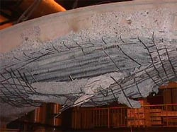
Fig 4 : Spalling impact on concrete (Promat, 2020)
2.4.1 Mechanisms of Spalling
CH.2: Literature Review
The Fire Resistance of
Fiber Reinforced Concrete
According to Khoury and Anderberg (2000), Thermal Stress or pore pressure included spalling or the two combined are the categories for concrete spalling.
There are two reasons that can make the surface of concrete spall:
- Vapour pressure internally increasing (this usually applies for normal concrete strengths).

- Compressed zones of concrete being overloaded (this usually applies for high concrete strengths).
Concretes spalling mechanism is shown in fig 5.
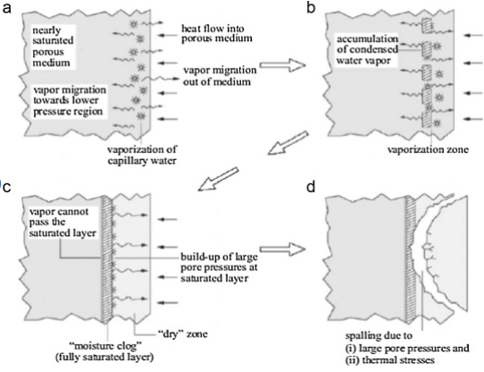
Fig 5 : Concretes spalling mechanism (Nassar, 2011)
When the temperature of concrete rises to 100℃ the free water expands and vaporises. Increased pressure of pore is the result of this. When parts of this vapour find its way to the concrete members interior, it will start to cool off and will then condense. This will result in a moisture clog because of the zones becoming increasingly wet. The maximum pressure of pore will be achieved when the vapour front reaches a critical point which will be some distance from the heated surface. A pressure reduction will be the result from further movement.
The distance of this critical point will depend on the permeability of the concrete. If the concretes maximum pressure of pore is larger than tensile strength pore pressure spalling will occur, however there has been no measurement where the pore pressure has exceeded the concrete tensile strength. This suggests that the isolation of the pore pressure does not lead to spalling.
CH.2: Literature Review
The Fire Resistance of
Fiber Reinforced Concrete
Due to concrete having a high heat and low thermal conductivity, as it is heated the concrete develops thermal gradients. Close to the surface compressive stresses are produced from the thermal gradients due to restrained tensile stresses and thermal expansion. (Khoury & Anderberg, 2000)
Increased pore pressure and thermal expansion causing tensile stresses is the most likely occurrence to cause spalling. There is still a debate on what is the key mechanism, is it the thermal stress or pore pressure. Although the debate between the two there are other mechanisms that could change. These changes could depend on moisture content, material, and section size. (Bilow & Kamara, 2008)
2.5 Measures of Preventing Spalling
When the incidence of spalling occurs there are certain principal methods that can help to reduce the phenomenon.
2.5.1 Fibers
One of these methods is that we can add fibers to the mix of the concrete. When concrete gets heated by fire at around 160℃ to 170℃ these fibers will begin to melt therefore creating a channel of escape for vapor and therefore the pore pressure being released. The influence that the rise in temperature has on compressive loads is important.
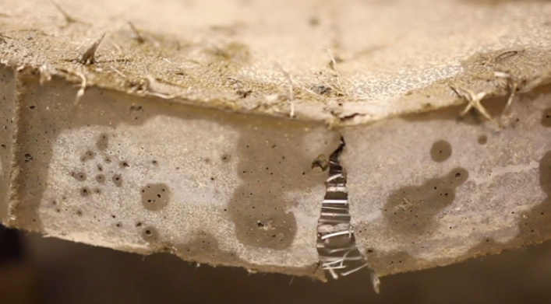
Fig 6: Fibers providing protection (Miller, 2019)
Recent test indicate that per m of unloaded concrete if 1kg of fibers are added there is a sufficient chance that spalling can be eliminated. When there is a load of 3N/mm the content of fiber will then need to be increased to 1.5kg/m and where there is a load of 6N/mm the content of fiber will need to be further increased to 3kg/m to prevent explosive spalling. It should be pointed out that although under normal conditions the segments of concrete are stressed lightly, during heating a development of compressive hoop stress will appear. This is a function from the aggregates thermal expansion. (Shihada, 2011).
CH.2: Literature Review
The Fire Resistance of
Fiber Reinforced Concrete
    - Thermal barriers
According to Shihada (2011), another measure to stop spalling is a method that is sometimes used in the construction of tunnels where the concrete surface is covered by a thermal barrier. Because of these thermal barriers over the concrete they will reduce the heating rate, this will result in the risk of loss of mechanical strength being reduced as well as explosive spalling. This method is therefore one of the most effective as adding fibers do not reduce the temperatures. However, this method consists of potential drawbacks as the insulation cost will be more than the fibers. Also, during normal services conditions manufactures experience problems with delaminating.
Other methods that can be used:
- After the concrete has completely cured, using a substance which is spray coated to slow down the heat transfer rate. The ongoing exposure from fire has been proven to be more important compared to the change in temperature.

- Providing vents in the concrete to counter the threat of spalling is a fairly new way to reduce the pressure of pore. (Khoury & Anderberg 2000).
2.6 Cracking
The process that leads to spalling is generally similar to the process that generates cracking. In addition to explosive spalling due to the dehydration and thermal expansion from heating this can also create microscopic fissures in the concrete. These fissures may then turn into gaping cracks providing a pathway for the heat to directly expose the reinforcement, this could further lead to more cracking and more thermal stress. The spread of fire from the cracks between the adjoining compartments under certain circumstances could be damaging.
Depending on the temperature of the fire, the different temperature can have an effect on the penetration depth of the crack. Near to the origin of the fire at the surface the major damage will appear, but at around 700℃ of the reinforcement causes the natural cracking of the concrete and also the discoloration. Due to the fire in the structure being extinguished, cracks where the depth extended 30 mm the cycle of the structure had attributes to a short heating and cooling. (Georgali & Tsakiridis, 2005)
Concretes stress conditions is extremely important and should be noted. Beneficial from thermal expansion from compressive loads can result in the compaction of the material and the suppression of the formation cracks. This results in the compressive strength having a smaller degradation and smaller modulus of elastic. (Khoury, 2001)
CH.2: Literature Review
The Fire Resistance of
Fiber Reinforced Concrete
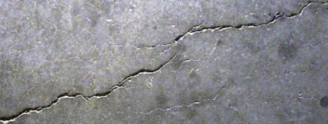
Fig 7: Thermal cracks (Mishra, 2020)
2.7 The Effect of Fire on Concrete
According to Ramachandran and Beaudoin (2001), playing a big part in the construction of building structures, concrete as a building material is arguably the most important. Concrete is virtue its versatility as it can be easily moulded into any required shapes for different forms of structures. It is also a fire resistant and durable when construction procedures and specifications are correctly executed. It is adaptable and is suitable for any standard building both single and multi-storey, also bridges and retaining walls.
Under normal environmental conditions a concrete structure can be subjected to many temperature changes. Although these structure suffer these changes, nothing compares to when there much higher temperatures such as building fires, nuclear power related, metallurgical and chemical, or bombing and arson.
The thermal properties of concrete is much more complex than other materials. It’s not because it is a composite material and they have different properties but it is because the properties of concrete depend also on porosity and moisture. When concrete is exposed to rise in temperatures its physical and mechanical properties are affected. The element could displace and distort. Due to steam pressure build up spalling could arise on the surface. Because of loss of integrity structurally, the release of gases and moisture, and dimensional changes from thermal. This is the result from free water migrating and affecting safety and plant operations.
A clear understanding of the long term effects of high temperatures on concrete as well as during thermal excursion and after thermal excursion. This is crucial for assessments and dependent design assessments. Also important are assessments performances from the concrete maturing for evaluations of safety. (Shihada, 2011)
The Fire Resistance of
Fiber Reinforced Concrete
CH.2: Literature Review

  - The Effect of Fire on Fiber Reinforced Concrete

Rodrigues and Correia (2010) presented research results on the performance of fibers as concrete reinforcement against fire. To enhance the behaviour of concrete to fire and to stop spalling. In this research included in the mix were Polypropylene fibers. When the temperature begins to rise these fibers will allow an escape route for the vapour water by creating micro- channels. Results also showed that when the concrete was exposed to fire these fibers improved the behaviour, therefore the use of these fibers can control the phenomenon of concrete spalling.
Shihada (2010) discussed the fire resistance of Polypropylene fiber reinforced concrete. To achieve these results prepared were three different mixes with a different amount of fibers in each mix. A volume of 0%, 0.5 % and 1% were used. The dimensions of the samples used were 100mm x 100mm x 100mm and were cast before being cure for a 28 day period. At different durations of 2, 4, and 6 hours they were exposed to heat of temperatures of 200℃, 400℃, and 600℃ before being tested for strength of compression. The concluded results of the experimental program showed that when exposed to fire certain amounts of fiber in the mix improves concretes resistance to fire. The mix design with 0.5% of fibers when exposed to temperatures of 600℃ for 6 hours showed that 85% of the compressive strength initially observed was still there, where as the mix design where 0% of fibers used and was exposed to the same amount of temperatures at the same duration showed only 50% of the initial strength.
Alia, Nadjai, Silcock and Tair (2004) investigated the outcomes of concrete columns under fire. In this research presented were rates of heating, levels of loading, and degree of restraint on the rise in temperature with a main focus on concrete explosive spalling. The research discussed many different performances with a comparison between normal strength and high strength concrete and their performance in fire. Illustrated also in the study were explosive spalling prevention methods with the use of fibers. The results of the study showed that without the use of polypropylene fibers there was a rise off 22% of degree of spalling compared to 1% when adding fibers to the mix.
K.Hertz, L.S.Sorensen (2005) presented research on test methods to prevent concrete spalling. Hindered stresses from thermal expansion is considered for the surface that is exposed to fire. For the compression test they have used cylinders. In alternative to full and semi full scale structures being tested with the correct load, boundary and humidity conditions the method is easy, quick, and cheap. Many samples of concrete has been used to test concrete sing this method and as a conclusion again the use of suitable fiber characteristics even when restrained by thermal expansion it still prevents the concrete to spall.
J.Komonen, V.Pentala (2003) studied the pore structure and strength when exposed to fire and the use of a polypropylene fiber cement past for reinforcement. A normal Portland cement paste was tested to different temperatures and then were compared to a paste with Polypropylene fibers. The non fiber paste was subjected to temperatures of 20, 50, 75, 100, 120, 150, 200, 300, 400, 440, 520, 600, 700, 800, and 1000℃ while the fiber paste was subjected to 20, 120, 150, 200, 300, 440, 520, and 700℃. After the heating the samples were measured through flexural and compression strength tests. At a temperature of 600℃ the capacity of compression was still 50% over the residual strength, this was the result of the temperature increase not being linear. The use of the fibers produced a decreased compressive strength, finer pore structure, and at low temperatures the strength in flexural was improved. After all the test results were gathered and compared it was clear that concrete when exposed to temperatures of 50℃ to 120℃ can just as damaging and dangerous as the exposed concrete of 400℃ and 500℃. This was produced with a paste for cement where the water to cement ratio was low.
CH.2: Literature Review
The Fire Resistance of
Fiber Reinforced Concrete
K.Sideris, P.Manita, E.Chaniotakis (2008) investigated the effect of fiber reinforced concrete after thermal damage. The production of fiber reinforced concrete is to introduce fiber into the mixtures. After casting the specimens were cured for 120 days before being subjected to temperatures of 100, 300, 500 and 700℃ maximum temperature. After the specimens have been heated in the furnace they were then strength tested from compression where up to 700℃ the reduction in residual strength were nearly linearly. This research presented a positive recommendation towards total protection against spalling when using Polypropylene fibers with a design combination method with other external materials for thermal barriers, or increasing the thickness overall of the member of concrete. The thicker member layer provided will act as a sacrificial layer which will be removed after the event of a fire for structure repair.

2.9 The Effect of Fire on Fiber Reinforced Polymers

Kodur, Bisby and Green (2006) presented research results of experiments of the fire resistance of fiber reinforced polymers. Three square concrete columns with fiber reinforced polymers results were presented. In this study there was a comparison of performance when subjected to fire between the standard concrete column and a fiber reinforced polymer column.
The obtained data from the experimental programme showed that fiber reinforced polymer concrete column as a good appropriate system of fire protection is on par with being compared to the normal concrete columns. The rating of satisfactory for fire resistance for fiber reinforced polymer concrete column was achieved by applying an acceptable measure of fire protection in to the final strengthened system of fiber reinforced polymers. Discussed also in this study were the preliminary and fire endurance criteria for recommendations for design to fire safety of strengthen fiber reinforced polymer concrete columns. To summarise the research presented the performance of the strengthen fiber reinforced polymer concrete column at high temperatures can compare or even better the normal concrete column.
Chowdhurya, Bisbya, Green and Kodur (2006) debated that safety and efficiently fiber reinforced polymers could be used in the concrete structures for strength and rehabilitation. Presented in the study were results from resent experimental studies on circular concrete columns and their performance in fire with the use of the fiber reinforced polymers. Two different columns with the two results were displayed. One test without any protection against fire and the second column with a protection from fire form the strengthened fiber reinforced polymers system applied. The main objective of these research and test were to compare and evaluate the two behaviours when subjected to fire with the best system effective for insulation.
CH.2: Literature Review
The Fire Resistance of
Fiber Reinforced Concrete
The structural and thermal behaviours of the two circular concrete columns were presented with the results showing that the fiber reinforced polymer concrete columns as sensitive to the rise in temperatures. By providing an acceptable fire protection supplement endurance fire rating attained for the strengthened fiber reinforced polymer concrete column. The debate was finalised when the results showed that the columns with strengthened fiber reinforced polymer concrete column at least lasted 90 minutes longer than the normal concrete column, uninsulated.

CHAPTER THREE :

EXPERIMENATL PROGRAM

Experimental Program
CH.3: Experimental Program
The Fire Resistance of
Fiber Reinforced Concrete

3.1 Introduction

In this experimental program a series of fire endurance tests were conducted. Examined in these tests were the effect that high temperatures have on concrete mortar samples and the effect of adding fibers in the mix. Also the concrete flexural and compressive strength will be tested after the rise in temperatures. The programme consists of 3 different types of concrete samples. The sample sizes were 40mm x 40mm x 160mm, two being mixes with different fibers and the third mix being without any fibers. The first mix contained 4.5g of glass fibers, the second mix contained 4.5g of metal fibers. All samples consisted of the same amount of Cement, sand and water and were mixed and cured in the same sequence. After full 28 days of curing the samples were tested at temperatures exposure of 250℃ at a duration of 2 hours. The samples underwent a series of test, in compression and flexural to determine their performance after being subjected to high temperatures.

3.2 Materials Quality Tests
Sand, aggregate, cement and water are the several materials to construct the composite material that is concrete. It is extremely important that the characteristics and properties of the constituent materials are known. These materials have different characteristics and properties such as unit weight, water content, size gradation and specific gravity. As they have a unique characteristics, strength and impact on concrete therefore tests on the necessary components need to be tested. As our samples are mortar samples, sand, cement and water were the materials used. These tests were conducted in the University Trinity Saint David’s Swansea.
3.2.1 Sand
3.2.1.1 Unit weight of sand
The definition of a unit weight ( γ ) is the weight of volume per unit of the material or aggregate. Bulk density is also known for this measurement. Although this term bulk density and bulk specific gravity are similar, their quantities are different. The graded aggregate is measured effectively by the unit weight. This will include the aggregates solid particles as well as the voids. The unit weight value is because of the change in the voids space amount because of the degree of compaction. (Shihada 2011)
As the sand was already distributed there was no need to do the sieve analysis test. Although the sand was ready for use I had to make sure the sand was completely dry of any moisture.
CH.3: Experimental Program
The Fire Resistance of
Fiber Reinforced Concrete
Before being oven dry saturated sand ( γ_{s} ) has a unit weight of around 20 kn/m3 and after oven drying the sand having a dry unit weight ( γ_{d} ) of around 16 kn/m3. The sand was oven dried for 24 hours.

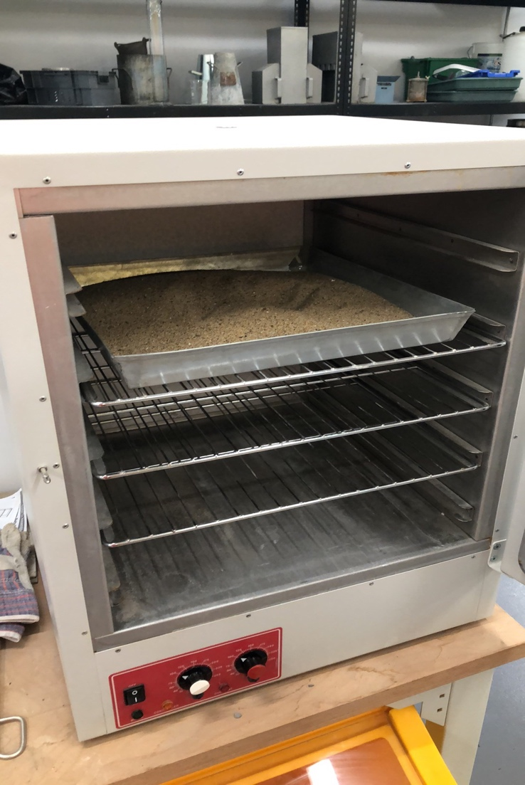

Fig 8: Sand ready to be oven dried
3.2.1.2 Sieve Analysis
CH.3: Experimental Program
The Fire Resistance of
Fiber Reinforced Concrete
The different sizes of the particles change from aggregate to aggregate, as well as different sizes for the same aggregate. This test is to determine the different aggregate sizes by mechanical sieving to distribute all the particles.
Because I used the same sand for all samples, there were not expected any variations because of the sand gradation.

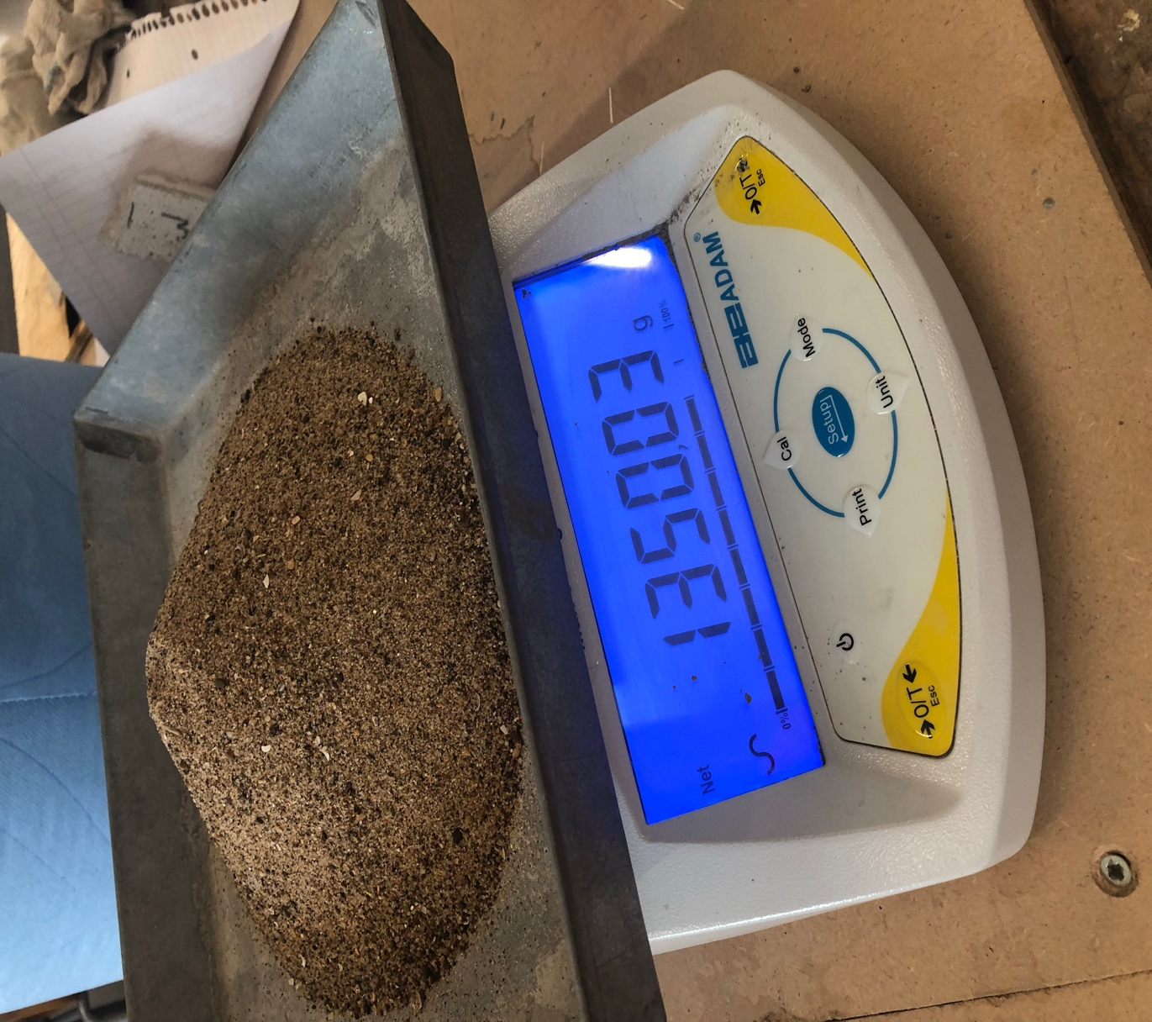
Fig 9: Oven dried sand
3.3 Cement
CH.3: Experimental Program
The Fire Resistance of
Fiber Reinforced Concrete
Portland Cement (EN 197-1 CEM I 42,5 R & EN 197-1 CEM I 42,5 N) is the cement type used for this research. The cement properties met the required standard BS 12:1996. Table 3 will summarize the cement properties.
Table.2: Usual Properties of Portland cement
No. | Description | Sample Results | Specification BS 12:1996
1- | Normal Consistency | 27 %
2- | Setting Time  1-Initial Setting (min)  2-Finial Setting (min) | 100  165 | >45  <375
3- | Compressive strength (MPa)  3-days  28-days | ----  31.5 | Min. 12 MPa  No Limit

The use of Portland cement is one of the most used in Britain. Portland cement is used for many different uses such as tiles, pipes, bricks, mortar and of course concrete. Portland cement is made by heating clay and limestone at around 1450℃ in a kiln before grinding them until they become a fine power. A small amount of gypsum is also added. The gypsum and clinker are grinded together. Clinker is the nodular material prior to being ground up. From diameter of 1mm to more than 25mm the nodules can be. (Understanding Cement 2020)

CH.3: Experimental Program
The Fire Resistance of
Fiber Reinforced Concrete
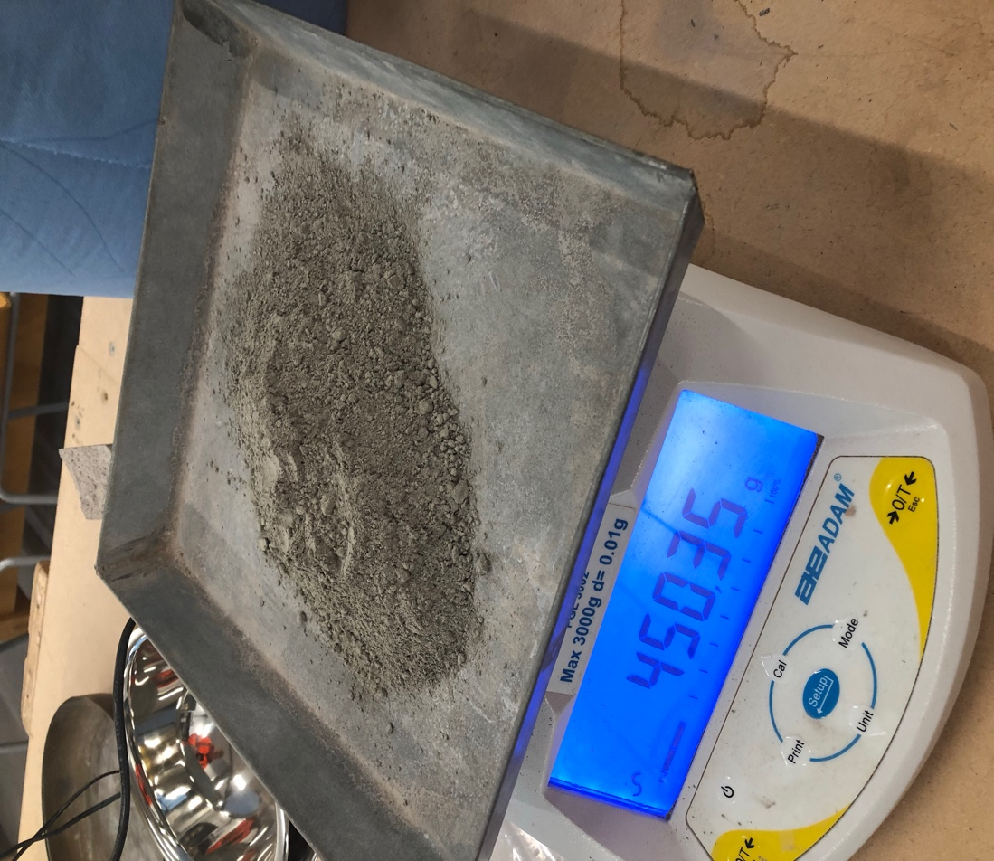

Fig 10: 450g of Portland cement

3.4 Water

For all of the concrete mixes and curing of the samples for the test, drinking water was used.

3.5 Glass Fibers

When somebody says glass fiber or fiber glass we thing of corvettes, boats, or insulation but we need to start thinking of concrete. Technically they are just spall fine glass fibers but they are really reinforced plastic glass fibers in a polymer matrix. Besides using the polymer we used sand and Portland cement.

Especially cladding panels, glass fibers for 30years have been used for many different concrete projects. Other projects such as planters, fountains, statues and ornamental domes. The benefits of glass fibers have been discovered by decorative artisans for concrete such as concrete countertops, fireplaces, decorative panels, and artificial rock work.
Glass fiber reinforcement will consist of the fibers from the glass being embedded into to the matrix. With this matrix the both chemical and physical identities will remain the same but yet with a combination of the two will create properties that the components alone could never achieve.
CH.3: Experimental Program
The Fire Resistance of
Fiber Reinforced Concrete

Fibers in a mix will be the prime members for the carrying of the loads with the matrix that surrounds them. They not only act as a transfer load between them but also act as protection against the environment.
The length of the glass fibers used were 12mm and at a volume fraction of 1% which is 4.5g for each mix. The glass fibers contain a high volume of Zirconia 17%+ which is alkali resistant.
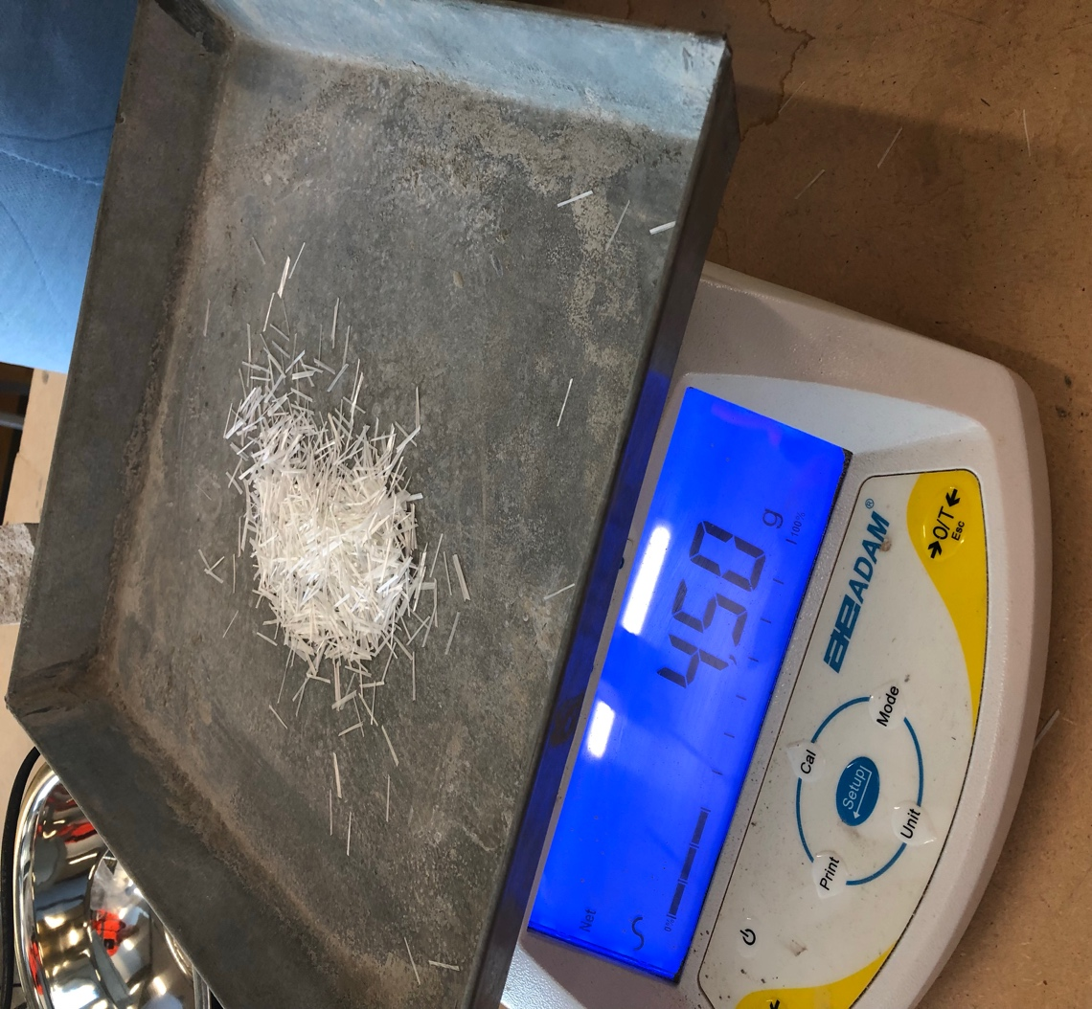
Fig 11: 4.5g of Glass fibers
Ravikumar and Thandavamoorthy (2013) investigated the strength of concrete with the addition of glass fibers when subjected to fire. In this study concrete cubes were subjected to temperatures of 300°C for a duration of 2 hours. There was a comparison made between the conventional concrete block and the concrete block that had the additional fibers in the mix. After being heated the cubes would undergo flexural and compression tests.
The glass fiber reinforced cube had an increase of strength by 35% compared to the conventional concrete cube as well as a 75% increase in flexural strength. With the retained results, the introduction of glass fibers in a concrete mix is extremely beneficial in enhancing the strength of the concrete as much as 1.78 times the conventional concrete.
CH.3: Experimental Program
The Fire Resistance of
Fiber Reinforced Concrete

3.6 Metal Fibers

Metal fibers are fibers that have been manufactured. They compose of metallic alloys, metal, metal coated plastic, plastic coated metal. They have been used ancient times mostly for clothing and textile applications for decoration of fabric.

These metal fibers can be used for reinforcement in concrete to improve flexural strength and ductility. Other mechanical properties of the fibers are that they are shock resistant, good for sound insulation, have a high failure strain and they are fire resistant.

The length of the metal fibers used were 12mm and at a volume fraction of 1% which is 4.5g for each mix.
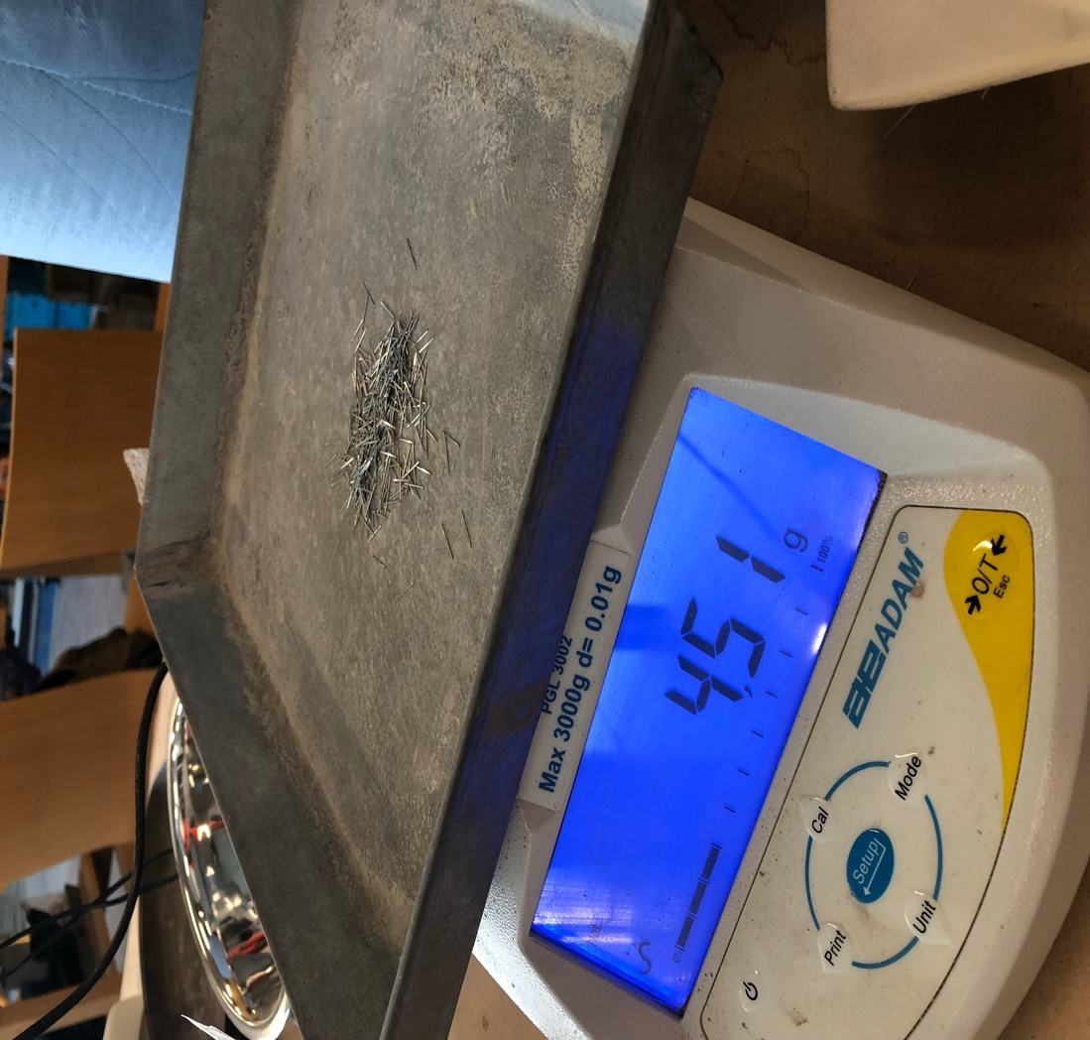

Fig 12: 4.5g of metal fibers
Nurchasanah, Alfitouri and Solikin (2016) studied the effect of fire on metal fiber reinforced concrete. A comparison was made between volume fractions of 1% and 1.5% and the conventional concrete after been exposed to temperatures of 200°C, 400°C and 600°C before undergoing strength tests. The results show that adding 1% and 1.5% to the mix is beneficial. By increasing the amount of fibers the results how an increase in compression strength. The addition of 1.5% to the concrete mic showed a better crack resistance and residual strength that the conventional concrete mix.
CH.3: Experimental Program
The Fire Resistance of
Fiber Reinforced Concrete

3.7 Proportions for the Mix
There are different materials that consist concrete which have their own individual properties. Concrete depends on these materials and their mix ration as it has an effect on the strength, durability and workability of concrete. Concrete has properties that are different to others as the formation process of concrete is a unidirectional reaction from the chemicals. Three mixes were made in this research work. A mix with Fiber 1, a mix with Fiber 2, and a mix without fibers.
All design requirements are according to BS EN 196-1:2005.
Design Requirements;
- Sand 1350g
- Cement 450g
- Water 247.5 mil
- Fibers 4.5g
Illustrated in the following table (Table 4) is the design of the mix for the samples.
Table 3: Design of the mix for the samples
 | Weight (g)
Materials | Mix 1 | Mix 2 | Mix 3
Cement | 450g | 450g | 450g
Water | 247.5ml | 247.5ml | 247.5ml
Sand | 1350g | 1350g | 1350g
Fiber 1 (glass) |  | 4.5g
Fiber 2 (metal) |  |  | 4.5g
3.8 Sample
CH.3: Experimental Program
The Fire Resistance of
Fiber Reinforced Concrete
All samples made were to the required standards of ACI 211 .1. The moulds for the samples were 40mm x 40mm x 160mm in dimensions.
A total of 18 samples were made and according the following factors the samples were distributed into categories;
- A mount of fibers used (4.5g).
- According to during of heating (2 hour ).
- According to temperature in degrees (250℃ ).
The following tables illustrate the categories of the samples;
3.8.1 Sample Categories
3.8.1.1 Mix 1
- Sand – 1350g
- Cement – 450g
- Water – 247.5ml
- No fibers
Table 4: Mix 1 (without Fibers)
Fiber | Temperature ℃ | Time (hrs) | Total samples
No fiber | 250℃ | 2 hour | 6

3.8.1.2 Mix 2
- Sand – 1350g
- Cement – 450g
- Water – 247.5ml
- Glass Fibers – 4.5g
Table 5: Mix 2 (Glass fibers)
Fiber | Temperature ℃ | Time (hrs) | Total samples
Metal | 250℃ | 2 hour | 6

3.8.1.3 Mix 3
CH.3: Experimental Program
The Fire Resistance of
Fiber Reinforced Concrete

- Sand – 1350g
- Cement – 450g
- Water – 247.5ml
- Metal Fibers – 4.5g
Table 6: Mix 3 (Fibers 2)
Fiber | Temperature ℃ | Time (hrs) | Total samples
Glass | 250℃ | 2 hour | 6

3.8.1.4 Schedule

Table 7: Schedule of activity

DATE | 25.02.20 | 26.02.20 | 27.02.20 | 28.02.20 | 24.03.20 | 25.03.20
Activity | Prepare all 18 samples and place in to plastic bags ready for mix. | Prepare mix 1 and 2. | Demould mix 1 and 2 and place in water for 28 days.  Prepare mix 3. | Demould mix 3 and place in water for 28 days. | Remove mix 1 and 2 specimens from water.  Heat mix 1 and 2 specimens at 250℃ for 2 hours.  Mix 1 and mix 2 specimens to undergo flexural and compression tests. | Remove mix 3 specimens from water.  Heat mix 3 specimens at 250℃ for 2 hours.  Mix 3 specimens to undergo flexural and compression tests.

3.9 Mixing, Casting and Curing
CH.3: Experimental Program
The Fire Resistance of
Fiber Reinforced Concrete

    - Preparation

Organisation is the key to a good experiment. After 24 hours of the sand drying in the oven I then had all the materials needed for the test. I weighed each material individually on the weighing scale and separated them all into plastic bags and labelled each bag.

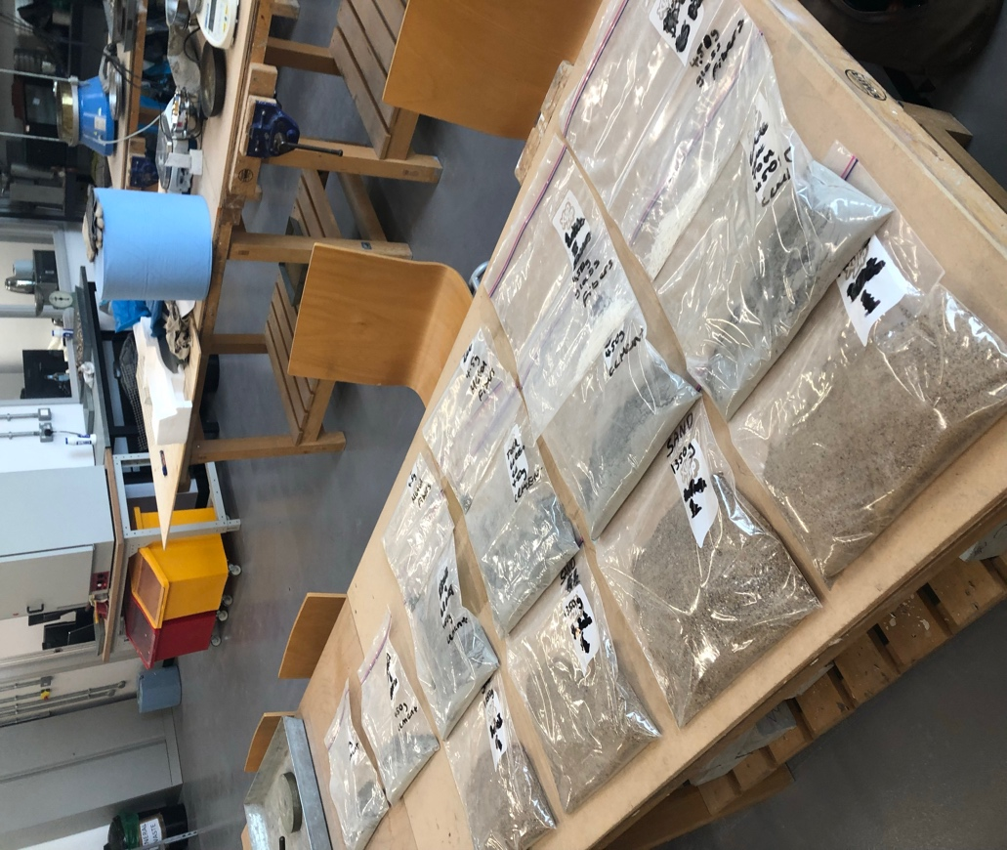

Fig 13: All materials weighed and labelled separately

      - Equipment Used

- Electrical oven
- Oven gloves
- Metal tray
- Weighing scales
- Scoop
- Grip seal polybags
3.9.2 Mixing
CH.3: Experimental Program
The Fire Resistance of
Fiber Reinforced Concrete
After all the required materials are weighed, according to the mix design previously the mixes were made. It was important that when mixing that the fine aggregates are surrounded by the fiber if any and the cement paste. The materials should equally be distributed in the mass of the concrete.
3.9.2.1 Mixing Procedure
After removing the bowl from the mortar mixer, 247.5ml of water was filled in a plastic cylinder and is poured into the bowl. For the mixes where the addition of fibers were added, the fibers were added with the water pre mixing. After placing the bowl back in its correct position and locked in place, the Mechanical mixer was turned to a low speed. As the timer started the mechanical mixer began to mix. 450g of cement was poured into the mix using a brush to make sure all the material was in the mix and none is stuck on the dispenser. When the timer hit 60 seconds, 1350g of sand is then poured. After 30 seconds of pouring the sand though the dispenser making sure it’s all in the mix. The mechanical mixer was placed on high speed for another 60 seconds. After the 60 seconds had finished the mechanical mixer was turned off.
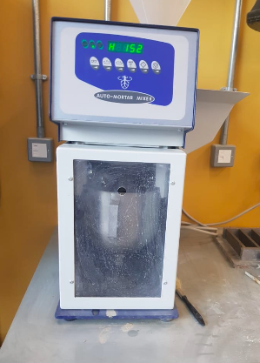
Fig 14: Mechanical mortar mixer
3.9.2.2 Equipment Used
CH.3: Experimental Program
The Fire Resistance of
Fiber Reinforced Concrete

- Mechanical mortar mixer
- Plastic cylinder
- Brush

    - Casting

3.9.3.1 Casting Procedure

Before the fresh concrete could be cast into the three gang moulds the moulds were thoroughly brushed with a water based release agent. The release agent will help to demould the samples after they have cured. If the moulds haven’t been coated they will be extremely hard to demould and could crack or brake the sample.

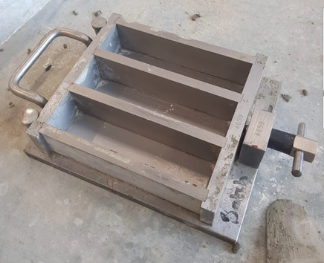

Fig 15: Three gang moulds

As the concrete was fresh and with the moulds coated, the bowl was removed from the mixer. Using a spatula the mix was then transferred to the moulds. After half filling the three gang moulds with the mix, the moulds were placed on a vibrating table. A wooden covering was placed on top of the moulds and was clamped in tight using the 2 screw either side. The vibrating table was set to 20 seconds and was turned on. After 20 seconds were up the machine
was turned off. The rest of the mix was then put into the moulds and using the spatula to compacts the edges and make the top surface flush. Ehen the moulds were full to the top they were again placed on the vibrating table for a further 20 seconds. Using the spatula again to make a smooth top finish. The casting process was repeated for each mix. The samples were then wrapped in a large bag and was left for 24 hours.
CH.3: Experimental Program
The Fire Resistance of
Fiber Reinforced Concrete

The procedure met the required standards BS EN 12390-2: 2019, BS EN 12350-6: 2019, BS EN 12350-7: 2019

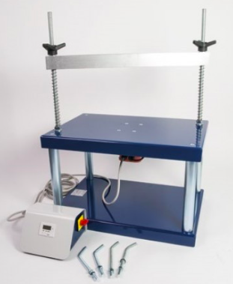

Fig 16: Vibrating table (ELE, 2020)

3.9.3.2 Equipment Used

- Mixing bowl
- Three gang moulds
- Brush
- Spatula
- Vibrating table
- Wooden coppering
3.9.4 Curing
CH.3: Experimental Program
The Fire Resistance of
Fiber Reinforced Concrete

3.9.4.1 Curing Procedure

After 24 hours after the moulds setting the specimens could be removed. As I already used the release agent it became easier. After untightening the screws of the mould, using a hammer I very carefully began to knock the moulds one by one. After all samples were demoulded they were labelled clear and correctly.

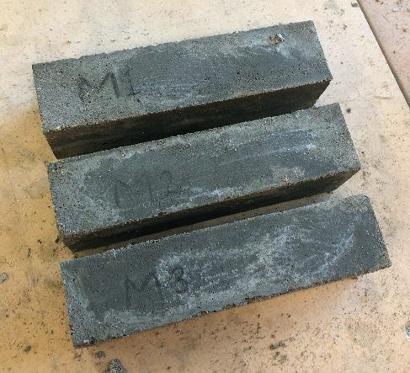

Fig 17: Mortar samples after demoulding

They were labelled as M1 to M6 for reinforced metal fiber reinforced specimens. They were labelled G1 to G6 for the glass fiber reinforcement specimens and just 1 to 6 for the samples without fibers. After all samples were cured correctly they were submerged in the water filled curing tank for a 28 day period to develop. Curing process and procedure were according to the standards BS EN 998-1, BS EN 998-2, and BS EN 1015-11.
CH.3: Experimental Program
The Fire Resistance of
Fiber Reinforced Concrete

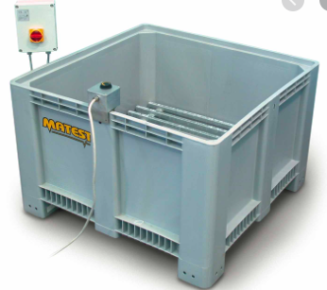

Fig 18: Curing tank (Matest, 2020)

3.9.5 Heating
After all samples have correctly completed the curing process after the 28 day period, a electrical oven was used to execute the heating process. The mortar samples would were exposed to temperatures of 250℃ for a 2 hour duration before being tested for flexural and compression strength.
3.9.6 Flexural Test
After the mortar samples were exposed to 250℃ for 2 hours they were first tested for flexural strength. Indirectly flexural strength test evaluates the mortar specimens tensile strength. It tests the capability of the specimen to withstand failure when bending. A centre point load would be used to conduct the test as show in fig 19.
This test was conducted to the British Standard: Testing Concrete: Part 118. Method for determination of flexural strength 1-3. 1983. (BS 1881 : Part 118 : 1983), and BS EN 1015-11:2019.
CH.3: Experimental Program
The Fire Resistance of
Fiber Reinforced Concrete

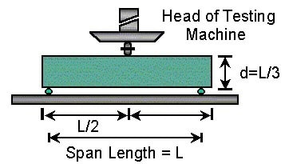
Fig 19: Central point loading (Hamakareem)

3.9.6.1 Procedure
With the central point loading testing machine there was a two roller support and the third roller will be loading roller. The loading roller was located midway above the supporting rollers. Horizontally the specimen were placed on top of the supporting rollers with the specimen surface that was hand finished facing down so the loading points were not in contact with it. This is because it ensured a good contact between the loading point and the specimen. In relation to the force applied, the loading system was centred. The applying force was brought into contact with the surface of the specimen at the point of loading. At a rate that will produce failure the load was applied. (Cemex, 2020)
The equation for calculating flexural strength (f) is:
f = 1.5 Fl bd2
Where b and d are the prism moulds internal dimensions. The 1 is the distance between one supporting roller to the other. Nearest to 0.05 N/mm2 the results were recorded with the set of results average to the nearest 0.1 N/mm2.
CH.3: Experimental Program
The Fire Resistance of
Fiber Reinforced Concrete
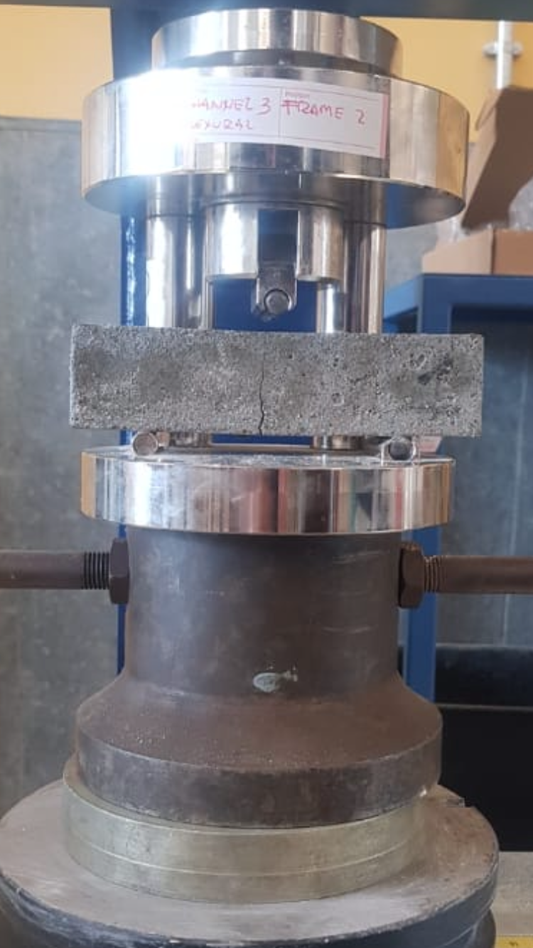
Fig 20: flexural strength test
3.9.7 Compression Test

The resistance to failure of a material under action forces of compression is the definition for compressive strength. During the service life and condition of a material, compressive strength is extremely important. The proportion or design of the mix to obtained the vital durable engineering properties needed for the engineers design.

Many materials irreversibly deform at their limit of compressive strength where as other materials fracture. The deformation amount given is considered the compressive load limit. Strength of compression is a key value for structure design. (Civildigital, 2016)
CH.3: Experimental Program
The Fire Resistance of
Fiber Reinforced Concrete

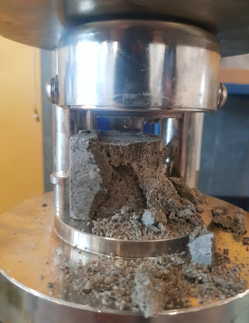
Fig 21: Failure of specimen

3.9.7 Procedure

Before the test began making sure that the loading indicator was set to zero. By using the compression jig in the testing machine the load was applied at a rate that would produce failure. The rate of loading is where there is no shock and the applied load is continuous. The appearance and type of failure is also noted.
To the nearest 0.05 N/mm2 compressive strength was recorded and the reported results for the mean was to the nearest 0.1 N/mm2.
The calculation for the compressive strength is by dividing the maximum loading with the specimens area of cross section.
Standard used for this test are BS EN 1015-11:2019 and BS EN 12390-3:2019.

CHAPTER FOUR :

RESULTS AND DISCUSSION

Results and Discussion
CH.4: Results and Discussion

The Fire Resistance of
Fiber Reinforced Concrete

4.1 Introduction
Discussed in this chapter is the test results that were performed on the mortar samples. Also, it demonstrates the impact of high temperatures on concrete. Due to restrictions imposed with Covid-19 the results could not be attained and therefore presented in this chapter are prediction results and performance which will be compared with further research.

4.2 Glass Fibers Predicted Results
The glass fiber reinforced mortar specimens with a 1% volume fraction would have provided a substantial increase in flexural strength as well as a better compressive strength after exposure to high temperatures compared to the conventional mortar specimens. Glass fibers have a low density but also have a high tensile and compressive strengths which would contributed to increase in workability of the concrete increasing the strength. After exposure to the high temperatures the glass fibers would have controlled propagation of the micro cracks much more effectively that the non-fibered reinforced specimen as well as corrosion and permeability. Although the addition of these glass fibers result in higher compressive strength, excessive amounts resulted in strength loss because workability of the concrete would reduce. It is extremely important that the correct volume fraction is added to the mix which in this case is correct.
The predicted results of this research has the similarity that was carried out by Ravikumar & Thandavamoorthy (2013). With the addition of 1% of glass fiber the flexural strength of the concrete increased 75% compared to the non-fibered reinforced mix after exposure to high temperatures. Therefore glass fiber as a reinforcement in concrete has an immense contribution in improving the flexural strength of concrete in fire. After 2 hours of exposure to temperatures of 300°C the fire tests showed that the compressive strength of the specimens reduced. The specimens without any fibers added had a compression strength decrease of 32% compared to its original strength. When a 0.5% volume fraction was added the concrete specimen had a 25% decrease compared to the original strength. Furthermore, the addition of 1% to the mix had a 10% decrease from its original strength. This research investigation showed that the addition of 1% volume fraction of glass fiber as reinforcement to concrete has much higher fire resistant characteristics to the conventional non-fibered reinforced concrete.

4.3 Metal Fibers Predicted Results
CH.4: Results and Discussion

The Fire Resistance of
Fiber Reinforced Concrete
The metal fiber reinforced mortar specimens with a volume fraction of 1% would have provided an increase in compressive strength and a larger increase in flexural strength compared to the conventional mortar specimens after being exposed to the high temperatures. Fiber reinforced concrete has a lower value of carbonation depth than non fiber reinforced concrete. The metal fiber reinforcement overall would have showed a better crack resistance and strength compared to the conventional non fibered specimen. After the exposure the high temperature the specimens would have showed an effective contribution to minimising the degradation of compressive strength. Although the fibered concrete would have suffered a quick loss of energy absorption capacity, the steel fiber reinforcement still would have showed a higher capacity loss compared to the non-fibered reinforcement specimen.
The predicted results of this research has the similarity that was carried out by Lau & Anson (2006). In this study they concluded that using metal fibers at a of volume fraction of 1% there would be no disadvantage if it is exposed to fire. In this study they concluded that metal fiber reinforcement can be beneficial to concrete to temperature exposure up to 1200°C. After the temperature exposure the fiber reinforcement showed a better crack resistance as well as overall higher residual strength than conventional concrete.

Sallal (2007) concluded results based on the comparison between metal fiber reinforced concrete and non-fibered after exposure to fire. These results showed that the compressive strength of both fiber and non-fibered reinforcement had a similar fashion in the way that their strength decreased. However, at exposed temperatures of 500°C the 1% volume fraction of fibers enhanced the compressive strength 16.5% compared to the non-fibered concrete exposed to the same elevated temperature.

CHAPTER FIVE :

CONCLUSION AND
RECOMMENDATIONS

Conclusion and Recommendations
CH.5: Conclusion and Recommendations
The Fire Resistance of
Fiber Reinforced Concrete

5.1 Introduction
The following conclusion could be drawn out based on the limited experimental work that could be achieved in this research. Also, this chapter also presents recommendations that could be taken into consideration

5.2 Conclusions

The compressive strength of both fiber and non-fibered reinforcement had a similar fashion in the way that their strength decreased after being exposed the high temperatures. However, the 1% addition volume fraction of both fibers enhances the strength and ductility of concrete beyond the ability of non-fibered reinforced concrete. Both fibers as reinforcement has a significant effect in enhancing the cracking and post-cracking characteristics of flexural toughness due to the fibers bridging the micro-cracks. Although 1% volume fraction addition of both fibers result in higher compressive and flexural strength, higher contents or lower conetents of fibers concrete loses strength due to the workability of the concrete reducing resulting in higher volume of voids and deterioration. Overall fiber reinforced concrete showed better crack resistance and strength than the non-fibered reinforced concrete.

5.3 Recommendations
There is a variety of different fibers being introduced into construction and the fiber industry is developing. With the research gained it is recommended to use fibers as a reinforcement in concrete as it heavily contributes to its strength capacity under high temperatures. All new fiber types in construction should be thoroughly investigated. The use of hybrid fibers could be a promising area of research. Hybrid fibers can be achieved by mixing different fiber materials such as both steel and glass into the concrete mix to enhance to characteristics of hardened and fresh concrete. Another hybrid mix could include fibers where their shape and size are different.
Due to its seriousness and importance in the protection of lives and properties, further research and investigation is required of “The Fire Resistance of Fiber Reinforced Concrete”. To encourage researches in the field of study, all universities should provide testing laboratories with strength testing equipment as well as electrical furnaces for the ability to test on large scales.

References

S.El.Fitiany, M.A.Youssef. (July 2009). Assessing the flexural and axial behaviour of reinforced concrete members at elevated temperatures using sectional analysis. Retrieved from:https://www.researchgate.net/publication/245054174_Assessing_the_flexural_and_axial_behaviour_of_reinforced_concrete_members_at_elevated_temperatures_using_sectional_analysis

Y.H.Chen, Y.F.Chang, G.C.Yao, M.S.Sheu. (1 July 2009). Experimental research on post-fire behaviour of reinforced concrete columns. Retrieved from: https://researchoutput.ncku.edu.tw/en/publications/experimental-research-on-post-fire-behaviour-of-reinforced-concre

D.N.Bilow, M.E.Kamara. (2008). Fire and concrete structures. Retrieved from: https://www.cement.org/docs/default-source/th-buildings-structures-pdfs/fire-concrete-struc-sei-08.pdf

R.S.Mamillapalli. (2007-2009). Impact of fire on steel reinforcement of R.C.C columns. Retrieved from: https://pdfs.semanticscholar.org/8e12/fe5019355b2d17c40ebc834d7eca997807b6.pdf?_ga=2.224270427.1358097578.1587475331-878526170.1587475331

P.S.Shihada. (2011). Improved fire resistance of reinforced concrete columns. Retrieved from: https://iugspace.iugaza.edu.ps/bitstream/handle/20.500.12358/19182/file_1.pdf?sequence=1&isAllowed=y

O.Arioz. (26 Mar 2007). Effects of elevated temperatures on properties of concrete. Retrieved from: https://www.academia.edu/36307813/Effects_of_elevated_temperatures_on_properties_of_concrete

I.A.Fletcher, S.Welch, J.L.Torero, R.O.Carvel, A.Usmani. (2007). Behaviour of concrete structures in fire. Retrieved from: https://iugspace.iugaza.edu.ps/bitstream/handle/20.500.12358/19182/file_1.pdf?sequence=1&isAllowed=y

G.A.Khoury, Y.Anderberg. (June 2000). Concrete spalling review. Retrieved from: https://www.cob.nl/wp-content/uploads/2018/01/JHO-099.V.04.D.pdf

G.A.Khoury. (7 June 2001). Effect of fire on concrete and concrete structures. Retrieved from: https://onlinelibrary.wiley.com/doi/abs/10.1002/pse.51

B.Georgali, P.E.Tsakiridis. (2005). Microstructure of fire-damaged concrete. Retrieved from: https://paratechglobal.com/wp-content/uploads/2020/01/Microstructure-of-fire-damaged-concrete..pdf

Ramachandran, J.J.Beaudoin. (2001). Handbook of analytical techniques in concrete science and technology principles, techniques and applications. Retrieved from: https://epdf.pub/handbook-of-analytical-techniques-in-concrete-science-and-technology-principles-.html

Polynar Corporation. (2017). Polypropylene fiber reinforced concrete. Retrieved from: http://polynar.com/en/portfolio-item/polypropylene-fiber-reinforced-concrete-2/

N.Iswarya. (Nov 2017). Experimental study on polypropylene reinforced concrete pavement. Retrieved from: https://www.researchgate.net/publication/321097201_Experimental_Study_on_polypropylene_reinforced_concrete_pavement

S.Mindes. (2019). Resistance of concrete to destructive agencies. Retrieved from: https://www.sciencedirect.com/topics/engineering/hydrated-cement-paste

V.Ryan. (2010). Composite materials-concrete. Retrieved from: http://www.technologystudent.com/joints/concret1.html

(28 Jan 2017). Concrete spalling: causes, effects and repairs. Retrieved from: https://cp-tech.co.uk/concrete-spalling-causes-effects-and-repair/

The Concrete Countertop Institute. (2020). Glass fibers-an essential component of GFRC concrete countertops. Retrieved from: https://concretecountertopinstitute.com/free-training/glass-fibers-an-essential-component-of-gfrc-concrete-countertops/

S.Shihada. (5 Sep 2010). Effect of polypropylene fibers on concrete fire resistance.
Retrieved from: https://www.researchgate.net/publication/254221335_Effect_of_polypropylene_fibers_on_concrete_fire_resistance

P.J.Rodrigues, L.L.Correia. (20 Oct 2009). Behaviour of fiber reinforced concrete columns in fire. Retrieved from:
https://www.sciencedirect.com/science/article/pii/S0263822309004528

F.Alia, A.Nadjai, G.Silcock, A.Abu-Tair. (Sep 2004). Outcomes of major research on fire resistance of concrete columns. Retrieved from: https://www.researchgate.net/publication/245054358_Outcomes_of_a_major_research_on_fire_resistance_of_concrete_columns

K.Hertz, L.S.Sorensen. (July 2005). Test methods for spalling of fire exposed concrete. Retrieved from : https://www.researchgate.net/publication/222280597_Test_method_for_spalling_of_fire_exposed_concrete/references

J.Komonen, V.Pentala. (Jan 2003). Effects of high temperature on the pore structure and strength of plain and polypropylene fiber reinforced cement pastes. Retrieved from: https://link.springer.com/article/10.1023/A:1021723126005

K.Sideris, P.Manita, E.Chaniotakis. (Mar 2009). Performance of thermally damaged fiber reinforced concretes. Retrieved from: https://www.researchgate.net/publication/248541737_Performance_of_thermally_damaged_fibre_reinforced_concretes

V.K.R.Kodur, L.A.Bisby, M.F.Green. (2006). Experimental evaluation of the fire behaviour of insulated fiber-reinforced-polymer-strengthened reinforced concrete columns. Retrieved from: https://www.safetylit.org/citations/index.php?fuseaction=citations.viewdetails&citationIds[]=citjournalarticle_61514_27

E.U.Chowdhurya, L.A.Bisbya, M.F.Green, V.K.R.Kodur. (2006). Investigation of insulated FRP wrapped reinforced concrete columns in fire. Retrieved from: https://www.sciencedirect.com/science/article/abs/pii/S0379711207000483

I.Hamakareem. (anon). Flexural test on concrete, its significance, procedures and applications. Retrieved from: https://theconstructor.org/concrete/flexural-test-concrete-procedure-applications/18576/

(anon). Compressive strength of concrete-cube test, procedure, results. Retrieved from: https://theconstructor.org/concrete/compressive-strength-concrete-cube-test/1561/

Understanding Cement. (2020). Some basic definitions used in cement and concrete. Retrieved from: https://www.understanding-cement.com/basic.html

Cemex. (2020). Educational guide to mortar testing. Retrieved from: https://www.cemex.co.uk/documents/45807659/45840198/mortar mortartesting.pdf/26881c8a-7775-3bdc-6321-16fcac4dc3d1

Civildigital. (2016-07-07). Compressive strength. Retrieved from: http://www.civildigital.com/compressive-strength-concrete-concrete-cubes/

C.S.Ravikumar, T.S.Thandavamoorthy. (Oct 2013). Glass fiber concrete: Investigation on strength and fire resistant properties. Retrieved from: https://www.iosrjournals.org/iosr-jmce/papers/vol9-issue3/D0932125.pdf?id=7625

Y.Nurchasanah, M.Alfitouri, M.Solikin. (July 2016). Steel fiber reinforced concrete to improve the characteristics of fire-resistance concrete. Retrieved from: https://www.researchgate.net/publication/305644005_Steel_Fiber_Reinforced_Concrete_to_Improve_the_Characteristics_of_Fire-Resistant_Concrete

A.Lau, M.Anson. (2006). Effect of high temperatures on high performance steel fibre reinforced concrete. Retrieved from: https://www.researchgate.net/publication/223904785_Effect_of_high_temperatures_on_high_performance_steel_fibre_reinforced_concrete

R.A.Sallal. (Sep 2007). Strength and elasticity of steel fiber reinforced concrete at high temperatures. Retrieved from: https://www.researchgate.net/publication/268212634_Strength_and_Elasticity_of_Steel_Fiber_Reinforced_Concrete_at_High_Temperatures

Figures

- Fig 1: Concrete column before and after being subjected to fire
H.S.So. (5 Oct 2016). Spalling prevention of high performance concrete at high temperatures. Retrieved from: https://www.intechopen.com/books/high-performance-concrete-technology-and-applications/spalling-prevention-of-high-performance-concrete-at-high-temperatures

- Fig 2: Surface cracking of concrete after being subjected to fire
ABBOT. (2020). Concrete spalling and delamination. Retrieved from : https://www.abbotbuilding.com/concrete-spalling-and-delamination/

- Fig 3: Structural Failure
M.I.Hamakareem. (2020). Explosive spalling of concrete structural elements during fire. Retrieved from: https://theconstructor.org/concrete/explosive-spalling-concrete-fire/16430/

- Fig 4: Spalling impact on concrete
Promat. (2020). The effect of fire-concrete spalling. Retrieved from: https://www.promat-tunnel.com/en/advices/fire-protection/the-effect-of-fire-test-page

- Fig 5: Concretes spalling mechanism
K.M.Nassar. (2011). Improving fire resistance of reinforced concrete columns. Retrieved from:
https://iugspace.iugaza.edu.ps/bitstream/handle/20.500.12358/19182/file_1.pdf?sequence=1&isAllowed=y

- Fig 6: Fibers providing protection
Don Miller. (20 Mar 2019). Fiber reinforced concrete-ASTM test methods. Retrieved from: https://www.allthingsfibers.com/2019/03/fiber-reinforced-concrete-astm-test-methods/

- Fig 7: Thermal cracks
G.Mishra. (2020). Thermal cracking of concrete and prevention. Retrieved from: https://theconstructor.org/concrete/thermal-cracking-of-concrete-and-prevention/8170/

- Fig 16: Vibrating table
ELE (2020). Vibrating table 600 x 400mm table top. Retrieved from: https://www.ele.com/Product/vibrating-table-600-x-400mm-table-top-220-240v-50hz-1ph-supplied-with-clamping-assm-/77

- Fig 18: Curing tank
Matest. (2020). Curing tanks, heavy plastic. Retrieved from: https://www.matest.com/en/product/c302-kit-curing-tanks-heavy-plastic

- Fig 19: Central point loading
I.Hamakareem. (anon). Flexural test on concrete, its significance, procedures and applications. Retrieved from: https://theconstructor.org/concrete/flexural-test-concrete-procedure-applications/18576/

