Module Code: BMMB7026
Module Title: Managing Marketing Change

Student Name: Md Eftanoor
Stduent ID: 2509788

KFC Marketing Strategy Report: Digital Transformation and Strategic Shortcomings

Date of Submission: 7th January 2026

Executive Summary
Kentucky Fried Chicken is in the marketing environment, becoming more complex by the day, and this owes its existence to digital disruption. This report examines KFC's existing marketing strategy, highlights key areas of implementation failure, and provides a timeline of strategic recommendations for the next 18 months. The assessment reveals that despite the significant investment KFC has made in its online foundation, reaching up to $10 billion in digital revenue (Ya, Ye and B, 2023), the organisation still has a lot of organisational baggage that prevents marketing performance from being as effective as it can be. It produces five fundamental weaknesses in my opinion, including uneven franchise strength, annual employee turnover of 150,000 employees (Li, Sun and Wang, 2023), disjointed customer information systems, lack of ethical AI, and deteriorating unit economics of franchising because of commissions to delivery platforms. On the contrary, organisational change capability, talent retention and lucid ethical governance are the actual competitive differentiators. My suggestions are centered around people-first development programmes, unified data infrastructure, and a 18 months roadmap to re-organise franchise economics.

Table of Contents
Executive Summary 2
1.0 Organisational and Strategic Context 4
1.1 KFC Overview and Industry Position 4
1.2 The Role of Marketing in KFC's Business Model 4
1.3 Digital Transformation as the Key Driver of Change 4
2.0 External Marketing Environment 6
2.1 PESTEL Analysis of the QSR Sector 6
2.2 Porter's Five Forces Analysis 7
3.0 Internal Marketing Capabilities and Strategic Position 9
3.1 SWOT Analysis 9
3.2 Digital Investment Scale and Marketing Department Contribution 10
4.0 Growth and Market Strategy Evaluation 11
4.1 Ansoff Matrix Application 11
4.2 Segmentation, Targeting and Positioning Strategy 11
5.0 Evaluation of the Marketing Mix and Programme Execution 12
6.0 Overall Judgement of KFC's Marketing Effectiveness 17
7.0 Core Strategic and Operational Shortcomings 17
8.0 Strategic Direction and Planning Framework (SOSTAC) 18
8.1 Situation: Consolidated Diagnosis 18
8.2 Strategic Objectives 18
8.3 Tactical Programmes and Implementation Plan 19
8.4 Actions, Feasibility and Control 20
References 22

TASK 1: CRITICAL EVALUATION OF KFC’S MARKETING ACTIVITIES

1.0 Organisational and Strategic Context

1.1 KFC Overview and Industry Position
Kentucky Fried Chicken has remained the second-largest chain of chicken stores in the world, operating about 27000 units in 150 countries (Husna et al., 2020). It is franchise-based in most of the activities it conducts, the majority of stores are franchise owned, 95+. Such a model of ownership develops inherent conflicts between the desires of the corporate marketing department and the real capabilities of individual franchises. KFC's parent company, Yum! Brands, has prioritised digital transformation as one of its strategic pillars since 2019. The QSR industry is being put under pressure by various forces: digital ordering already takes 75% of the transactions (Abell, Biswas and Christian Arroyo Mera, 2024), which requires rethinking the operations and marketing. Large players, such as McDonald's, have already reached $20 billion in annual online sales, making this a very challenging target to achieve (Bujalance-Lopez et al., 2025). It is further shaken up with the emergence of new digital-native players, delivery-only services and ghost kitchens.

1.2 The Role of Marketing in KFC's Business Model
QSR marketing is more than the traditional advertisements. It is concerning the orchestration of customer data, developing the omnichannel experiences, running the loyalty programmes, and determining the brand across various digital touchpoints (Valino et al., 2023). In the case of KFC, all the marketing actions are precursors to franchising, the cost of acquiring and retaining customers to the loyalty programme, which subsequently influences profitability. KFC is investing a lot into its mobile application, accumulating 380 million digital members all over the world (Guan, 2023). However, the amount of investment varies significantly among regional franchises, which, in turn, introduces the gaps that damage the brand consistency.

1.3 Digital Transformation as the Key Driver of Change
.The primary outside factor that is changing the marketing landscape of KFC is the digital transformation. The canvas framework informs us about the need to consider technology integration, process redesign, value creation and cultural change (Elia et al., 2024). The four pillars interrelate to provide opportunities and challenges. They are arranged in the way depicted in Figure 1 in the daily reality of KFC.
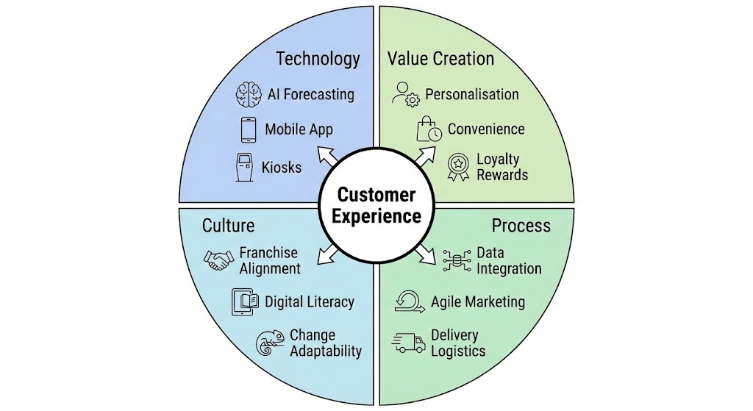
Figure 1 Digital Transformation Canvas for KFC
The company has been successful in investing in technology. AI predictive systems are already reaching 95% demand-prediction accuracy (Li, 2025), and mobile ordering is already generating 45% of the overall revenue. The implementation of franchise is again patchy however with lack of franchise in rural or low volume locations that cannot sustain the capital lift up.

2.0 External Marketing Environment

2.1 PESTEL Analysis of the QSR Sector
Table 1 presents critical environmental factors influencing KFC's marketing strategy and operational flexibility.
Table 1: PESTEL Analysis Factors Impacting KFC Marketing Environment (self-made)
Factor | Current Status | Strategic Implication
Political | Franchise regulation tightening; minimum wage increases across markets (Danley, 2023) | Rising labour costs reduce marketing budget flexibility; franchise protection requirements add compliance costs
Economic | QSR market valued at $971 billion growing to $1,930 billion at 9.01% CAGR through 2032 (Fortune Business Insights, 2025) | Growth opportunities offset by margin pressure from wage inflation and delivery commission costs
Social | 65% Gen Z and Millennials demand personalisation; 54% consumers prioritise plant-based options | Segmentation strategy requires refinement; product innovation becomes marketing necessity
Technological | Artificial intelligence, mobile-first ordering, ghost kitchens, advanced data analytics expanding rapidly | Technology adoption essential for competitiveness; legacy system constraints increasingly problematic
Environmental | Climate change awareness rising; 46% GHG reduction commitments expected by consumers (Maslansky Partners, 2024) | Sustainability communication opportunities; operational constraints from environmental targets
Legal | GDPR, CCPA, EU AI Act creating data privacy obligations (Clark, 2024) | Consent management requirements constrain targeting precision; transparency obligations increase compliance costs
Following the pandemic, the trend of contactless and delivery is changing radically among consumers (Jiang et al., 2023). Sustainability is also becoming increasingly important nowadays as younger customers are particularly sensitive to environmental promises. This compels KFC to re-evaluate its marketing mix and repackage its resource allocation strategies

2.2 Porter's Five Forces Analysis
The QSR industry has a high level of rivalry due to the low switching costs and a large number of substitutes (Banerjee, Sen and Zahay, 2023). Figure 2 indicates that the strength of forces and rivalry and buyer power are in fact hard-pressed
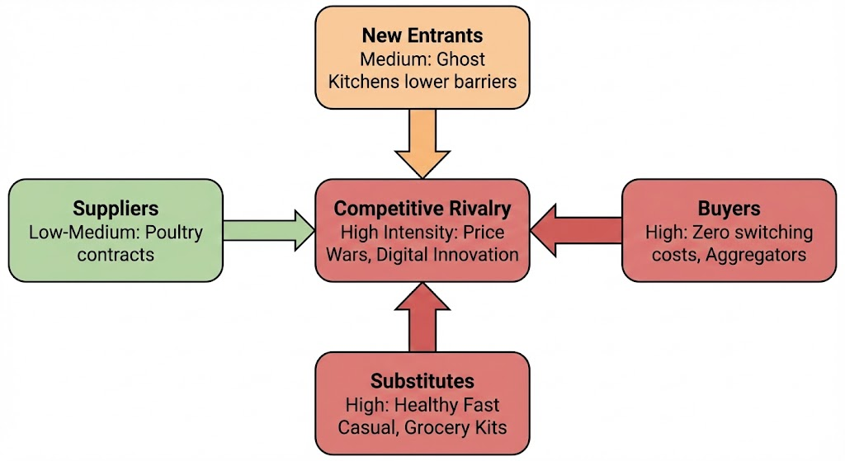
Figure 2 Porter's Five Forces Intensity Diagram
Table 2 evaluates each competitive force affecting KFC's strategic positioning in detail.
Table 2: Porter's Five Forces Framework Analysis for KFC (self-made)
Force | Intensity | Evidence | Marketing Impact
Competitive Rivalry | High | McDonald's (98% awareness, 58% preference); Starbucks (97% awareness, 72% innovation perception); Ghost kitchens disrupting traditional models | Requires aggressive loyalty programmes; innovation communication critical; brand differentiation increasingly difficult (Semeraro, 2025)
Buyer Bargaining Power | High | Zero switching costs; 75% customers use multiple QSR brands; easy digital comparison shopping (WifiTalents Team, 2025) | Customer acquisition costs rising; loyalty programme ROI declining; personalisation essential for retention
Supplier Power | Low-Medium | Multiple poultry suppliers available; bulk purchasing leverage; proprietary spice blend creates dependency | Limited strategic impact on marketing; ingredient costs affect menu pricing flexibility
Threat of New Entrants | Medium | High capital requirements for traditional outlets; brand recognition barriers; however, ghost kitchens reduce entry costs substantially | Digital-native competitors bypass franchise infrastructure advantages; continuous innovation investment required
Threat of Substitutes | High | Catering market value £250 billion; home meal delivery services growing 12.8% annually; health-conscious meal alternatives expanding (Research and Markets, 2025) | Product diversification essential; health-focused menu communication; delivery-only formats are increasingly necessary
The model assists in identifying profit levers although it has evident gaps. It is incapable of the ecosystem-grounded competition that is evolving via delivery aggregators or the rapid innovations of ghost kitchens. It also does not consider the impact of delivery platforms on consumer choice through algorithmic ranking rather than conventional competition (Chen et al., 2020).

3.0 Internal Marketing Capabilities and Strategic Position

3.1 SWOT Analysis
Table 3 presents the detailed strategic position through internal-external factor mapping.
Table 3: KFC SWOT Analysis in Digital Transformation Context (self-made)
Strengths | Weaknesses
- 98% brand awareness globally; iconic brand equity  - $10B digital revenue; 100M+ active application users (Fortune Business Insights, 2025)  - 95% demand forecast accuracy from artificial intelligence implementation  - Global scale providing network effects and bargaining power | - Franchise digital readiness inconsistency across 27,000 outlets  - Legacy point-of-sale system fragmentation preventing unified data integration  - 150% annual workforce turnover eroding training investments and capability  - Data privacy governance gaps creating regulatory exposure
Opportunities | Threats
- Artificial intelligence hyper-personalisation potential for customer lifetime value increase  - Emerging market digital infrastructure expansion in Asia and Africa  - Employee upskilling return on investment through improved retention  - Sustainability communication advantages to younger demographic segments | - Digital-native competitors (DoorDash Kitchens, Uber Eats virtual restaurants) operating at lower cost  - Rapid technology obsolescence requiring continuous capital investment  - Franchise profitability crisis from delivery aggregator commissions (25-30%) causing margin erosion (Lin, 2023)  - Consumer health consciousness shifting away from fried food category fundamentally
The SWOT model comes in handy to identify internal and external forces, yet it is not without its issues: it does not assist our prioritisation and does not reflect the dynamic development of the capability (Namugenyi, Nimmagadda and Reiners, 2019). It is also subjective to the fact that two dimensional analysts may classify the same factor differently.

3.2 Digital Investment Scale and Marketing Department Contribution
The excessive capital investment by the marketing department on digital infrastructure indicates that the marketing department is very much out of touch with strategic intent and operational reality. There are four structural inefficiencies identified by a critical audit that is currently counteracting the return on investment.
- There is an existent critical promise-delivery gap that involves the digital front that marketing has created that exceeds the manual ability of the franchise network. Corporate investment is oriented to visible digital assets, but the physical service infrastructure is still mostly analogue. As a result, marketing creates consumer need to smooth digital experience which the overworked operational backbone is not in a position to deliver, which is proactively turning digital interaction into brand dissatisfaction over brand loyalty (Nguyen et al., 2018).
- The digital transformation has already turned into a digital tax to the franchise partners. The marketing department has the top-line revenue as a priority in the cases of third-party aggregators without dampening the commission structures that eat away unit margins (Tamilmani, 2025). This decoupling creates structural resistance in that, the stakeholders see marketing initiatives as a margin-dilutive burden and not as a source of value creation.
- There is a state of data-richness and a lack of insight in the department. Although investment metrics place a lot of importance on the volume of acquisition, the lack of a single data architecture ensures that customer insights are stuck in silos. The existence of this huge data store in its operational form is insufficient to achieve the synthesisation of cross-channel interaction, which renders the conversion of generic segmentation into the hyper-personalised engagement to attain competitive advantage.
- There is a serious imbalance between the sophistication of the tools and the stability of the workforce. Marketing investments are based on the assumption of an experienced, retained workforce, regardless of the staff turnover in the sector (Welsh, Lanchimba and Bausch, 2024). Through inflicting sophisticated digital equipment to a temporary workforce, the organisation squanders capital efficiency; the equipment is theoretically very strong but practically useless in the hands of untrained employees, cancelling any effectiveness it is supposed to give.

4.0 Growth and Market Strategy Evaluation

4.1 Ansoff Matrix Application
Figure 3 below illustrates KFC's strategic growth options through the Ansoff framework.
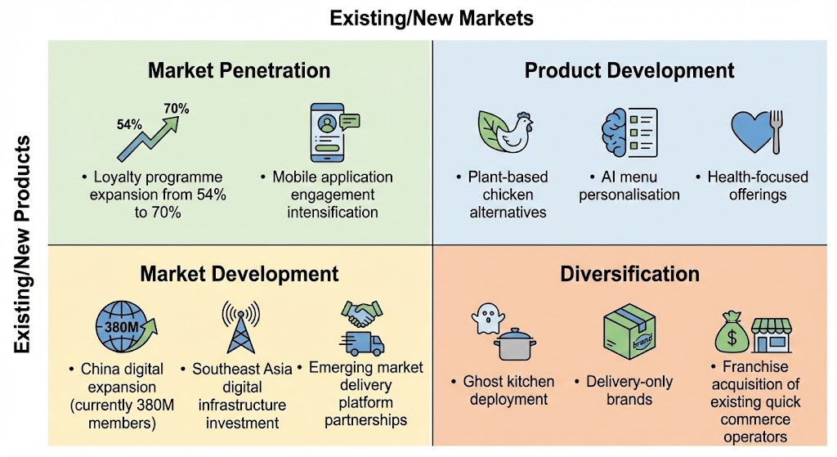
Figure 3 Ansoff Growth Matrix for KFC Strategic Positioning
Market penetration strategies focus on increasing the loyalty programme by a market. Current participation is at 54% of customers and organisational targets are to be at 70% within 18 months (Lin and Bowman, 2022). Product development includes plant-based protein offers and artificial intelligence-based menu personalisation responding to segments of the population with health consciousness. Market development focuses on emerging economy digital infrastructure investment, especially with Asian territories, where cell phone penetration shows a continuous and rapid growth (Wang, Chen and Kuang, 2025).
Diversification via ghost kitchens is the most risky yet high yielding strategy. Consumer research suggests moderate behavioural intention for ghost kitchen acceptance depending significantly upon perceived benefit-risk ratios which you may infer barrel loads of consumer education requirements before widespread adoption (Cai, Leung and Chi, 2022).

4.2 Segmentation, Targeting and Positioning Strategy
KFC's segmentation targets three priority customer groups: Gen Z/Millennials customers with personalisation and sustainability demands; emerging consumers and convenience seeking buyers, with off-premise ordering preferences; mobile-first users who have seamless digital experiences as a priority (Nguyen et al., 2018).
Positioning strategy effectiveness directly affects brand performance as research shows a good explanatory power for the positioning-performance relationship (Iyer et al., 2019).
Market orientation mediates the effectiveness of positioning (organisation culture alignment) which demonstrates strong mediating effect (Rua and Santos, 2022). This finding suggests that internal ability development is part of the precondition to positioning strategy success.

5.0 Evaluation of the Marketing Mix and Programme Execution
KFC Extended Marketing Mix (7Ps) evaluation shows a clear strategic move towards digital integration, but the execution is still uneven across different elements. Figure 4 shows the inter-relationship of these elements in the digital ecosystem.
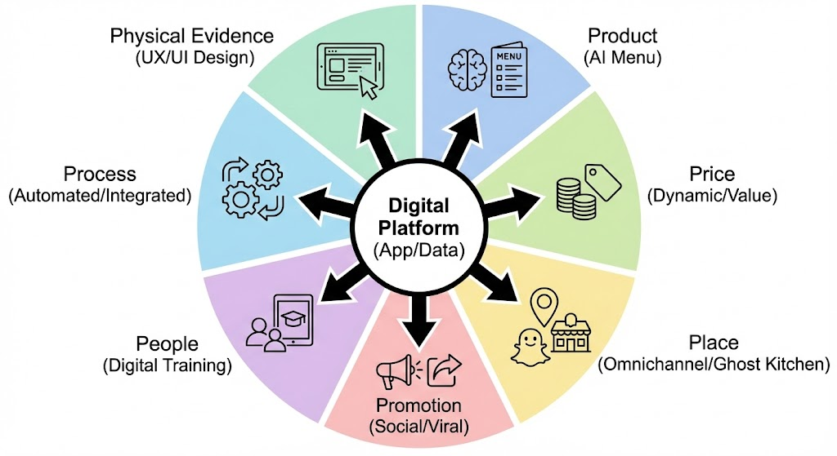
Figure 4 The 7Ps Marketing Mix Digital Integration Wheel

Table 4 provides a comprehensive critical analysis of these elements.
Table 4: Critical Evaluation of KFC’s Extended Marketing Mix (7Ps) and Digital Integration (self-made)
Marketing Mix Element | Current Strategy & Digital Integration | Critical Evaluation & Operational Issues | Strategic Gap & Impact
Product | - Core fried chicken portfolio augmented by AI-driven menu recommendations.  - Launch of plant-based options ("Beyond Fried Chicken").  - Digital-exclusive "secret menu" items. | - Innovation cycle remains slower than digital-native competitors.  - Personalisation is currently limited to basic reordering rather than predictive suggestion.  - Plant-based items suffer from inconsistent availability. | Relevance Gap: Menu innovation lags behind changing health trends, risking Gen Z attrition.  Impact: Reduced basket size potential compared to competitors with advanced AI.
Price | - App-exclusive offers and "discount framing" strategies.  - Dynamic pricing testing on third-party aggregators.  - Value bundles targeting inflation-hit consumers. | - Dynamic pricing creates transparency issues and fairness concerns among consumers (Hou, Wu and Huang, 2024)  - Aggregator commissions (up to 30%) force price inflation on delivery channels. | Trust Gap: Opaque pricing algorithms risk alienating loyalty members.  Impact: Brand trust erosion and potential regulatory scrutiny on algorithmic pricing.
Place | - Omnichannel presence: App, Kiosk, Delivery, Drive-Thru.  - Ghost Kitchen expansion in high-density urban zones.  - "Click & Collect" integration to reduce wait times. | - "Ghost kitchen" models lack physical branding, relying entirely on digital visibility.  - In-store experience often degraded by delivery driver congestion.  - Rural franchises lack capital for modern kiosk/digital upgrades. | Consistency Gap: The digital promise of speed clashes with physical store bottlenecks.  Impact: Channel conflict between dine-in customers and delivery operations.
Promotion | - Shift to short-form video (TikTok/Reels) and influencer partnerships.  - Gamified loyalty campaigns within the app.  - Data-driven targeted ads on social platforms. | - Content creation capability varies by region, leading to fragmented brand voice.  - Reliance on third-party platforms creates dependency on external algorithms (Chan et al., 2023) | Engagement Gap: Viral campaigns often fail to convert to long-term loyalty without better CRM integration.  Impact: High engagement metrics but unclear conversion to Customer Lifetime Value (CLV).
People | - Digital training modules for staff.  - Shift to "service ambassador" roles as kiosks handle ordering.  - Recruitment focused on digital literacy. | - Critical Weakness: 150% annual turnover destroys training ROI (Shriedeh, 2019).  - Staff overwhelmed by managing multiple order streams (tablet hell).  - Low wages constrain recruitment of tech-savvy staff. | Capability Gap: Frontline staff cannot effectively use the expensive digital tools provided.  Impact: Operational failure during peak digital order times, damaging customer experience.
Process | - Automated ordering flows via App/Kiosk.  - AI demand forecasting (MacromatiX) to reduce waste.  - Contactless handover protocols post-pandemic. | - Data silos prevent a "single customer view" across channels (Darvidou, 2024)  - Legacy POS systems struggle to integrate with modern delivery APIs.  - Error rates in complex digital orders remain high. | Integration Gap: Fragmented data prevents true hyper-personalisation.  Impact: Inefficiency and inability to track the full customer journey.
Physical Evidence | - "Future Store" designs with digital menu boards.  - App UX/UI design as the primary digital shopfront.  - Sustainable packaging initiatives. | - Significant disparity between slick App UI and tired physical store interiors in franchise locations.  - Inconsistent packaging quality for delivery orders. | Perception Gap: Cognitive dissonance between the modern digital brand and the physical reality.  Impact: Dilution of brand equity and premium positioning.

TASK 2: CONCLUSIONS ON KFC'S MARKETING STRATEGY SHORTCOMINGS

6.0 Overall Judgement of KFC's Marketing Effectiveness
KFC has met technology infrastructure parity with the market leaders. Why is KFC implementing its digital transformation process? It has invested in improving its outcomes in different times; its outcomes are systematic. The organisation shows competency in the areas of artificial intelligence forecasting, mobile application functionality, and customer data analytics aspects. The platform capabilities are now equal to or better than competitor standards for technical specifications. However, consumer perception metrics do show positioning failures strategically even if operational capability is there. Innovation Perception of 38% vs. Starbucks at 72% is indicative of communication ineffectiveness (Shams, Brown and Alpert, 2020). Brand preference ratings range at 42% against McDonalds 58%, which seems to indicate digital investments have not created meaningful competitive differentiation. The brand equity-satisfaction-loyalty chain shows signs of disruption, which may mean that positive digital experiences do not lead to preference.

7.0 Core Strategic and Operational Shortcomings
The major strategic weakness is the growing "strategy-execution gap" between corporate aspiration and franchise reality. While Yum! Brands develop complex digital strategies, and the "two-speed" structural operation makes a critical fracture; capital-heavy corporate outlets implement innovations that the rural or lower-volume franchises simply cannot afford. This misalignment is worsened by a serious human capital issue, as an annual workforce turnover rate of 150% makes investment in digital tools rather futile (Shi et al., 2025). Frontline staff, being transient and often ill-trained, cannot get to grips with the multifaceted digital workflows that are required to deliver the brand's promise of speed and personalisation. As a result, the marketing department's high tech initiatives fail at the "last mile" resulting in a disjointed customer experience in which the digital interface promises efficiencies that the physical store is incapable of operationalising. Furthermore, the organisation is hamstrung by the deep-seated structural and governance voids. Data fragmentation remains a constant challenge to be truly competitive; the siloed nature of legacy systems and third-party delivery platforms means that a unified customer view cannot be built, essentially blinding the marketing analytics function from cross-channel behaviours (Kitchens et al., 2018). This is further compounded by an ethical governance hollow that exists in terms of usage of AI, where a lack of transparent policies in terms of targeting algorithms to specific consumers runs the risk of alienating an achievable consumption base due to a lack of privacy (KUMAR, 2025). This is further compounded by the moral emptiness of governance regarding the use of AI, where the lack of transparent policies for algorithmic targeting of specific consumers runs the risk of alienating a potentially achievable consumer base due to a lack of privacy. Finally, the worsening economics for franchisees, who absorb 30% aggregator commissions, is the source of structural resistance to further digital investment. Without realigning financial incentives and effectively unifying data architectures, KFC's marketing strategy exists on paper but is paralysed when it comes to implementation.
TASK 3: RECOMMENDATIONS FOR IMPROVING KFC'S MARKETING STRATEGY

8.0 Strategic Direction and Planning Framework (SOSTAC)

8.1 Situation: Consolidated Diagnosis
The current situation assessment develops findings from the evaluation. KFC has a sufficient technology base and worldwide brand equity. However, organisational change capability is still poor for the execution of transformation. Franchise networks have high diversity of capabilities that require multiple levels of intervention. The main constraint is not necessarily the formulation of technology or strategy; it is the discipline of implementation.

8.2 Strategic Objectives
Strategic objectives establish measurable targets across four dimensions.
Table 5: 18-Month Strategic Objectives (SMART Targets) (self-made)
Strategic Dimension | Target Description | Success Metric (KPI)
Digital Infrastructure | Achieve unified customer profiles for personalisation by integrating platforms across the network. | 90% customer data platform integration; 75% of campaigns using unified profiles.
Workforce Development | Build frontline digital capability and tool proficiency, reducing annual turnover rates. | 80% staff certification rate; 70% tool utilisation; turnover reduced to 110%.
Franchise Readiness | Elevate franchise digital capabilities to Tier 1 standards to drive digital revenue contribution. | 25% of locations at Tier 1 standard; 48% revenue contribution from digital channels.
Governance | Eliminate regulatory exposure through audit certification and customer consent management. | 100% AI system audit certification; 85% customer consent rate for data usage.

8.3 Tactical Programmes and Implementation Plan
Table 6: Four-Programme Implementation Roadmap (18-month horizon) (self-made)
Programme | Objective | Timeline | Key Actions | Success Metrics
1. Digital Readiness Certification | Build frontline capability | Months 1-6 | Mandatory training curriculum; online certification platform; regional cohort rollout | 80% staff certification; 70% tool adoption rate
2. Customer Data Platform Integration | Unified customer view | Months 3-12 | API standardisation; franchise database migration; legacy system retirement plan | 90% integration; 75% campaign personalisation
3. Franchise Economic Restructuring | Improve unit economics | Months 6-18 | Tiered commission models; performance-based incentives, and technology investment subsidies | Commission reduction from 25-30% to 18-20%; franchise profitability increase
4. Ethical AI Governance Framework | Regulatory compliance | Months 2-9 | AI ethics policy publication; algorithmic audit system; consent management platform | 100% audit certification; 85% consent rates
Implementation requires a lot of change management discipline. Franchise resistance will arise because of capital requirements and operational disruption. Corporate communication strategy should focus on mutual benefit, and financial support mechanism for technology investments (Lok et al., 2025).

8.4 Actions, Feasibility and Control
A phased implementation roadmap is used to sequence initiatives to deal with resource constraints and franchise disruption. Figure 5 describes the phased approach for ensuring sustainable adoption.
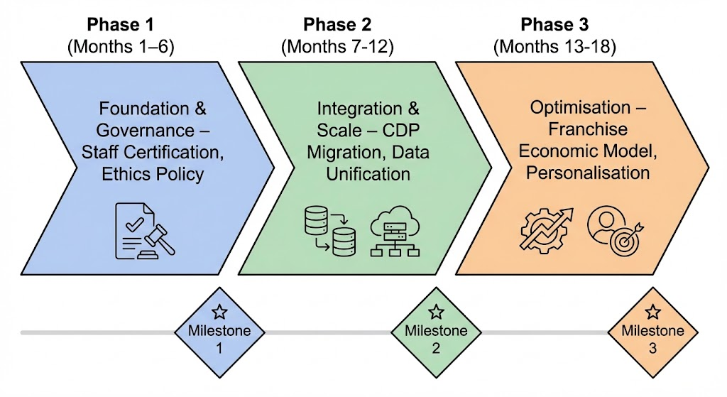
Figure 5 Phased Implementation Roadmap
Budget feasibility assessment shows that Programme 1 (Workforce development) costs about PS8-12 million for platform and training costs covering 27,000 outlets. Programmes 2-4 require additional capital. These investments are approximately 2-3% of annual digital revenue, which represents a reasonable investment intensity in strategic transformation initiatives.
Franchise capability constraints are the key issue of feasibility. Smaller franchisees lack the capital capacity to make technology investments due to the absence of a corporate subsidy.
There needs to be financial support mechanisms such as those that feature technology grants, interest-free financing, and performance-based royalty reductions for early adopters. Risk of delayed adoption by lower revenue franchisees requires contingency planning, including possible corporate outlet acquisitions in strategic markets where franchise capacity constraints have proved insurmountable.
Control mechanisms are utilised which include KPI dashboards monthly and involve tracking across four strategic dimensions:
- Digital adoption rates and percentage of platform integration,
- Workforce certification progress and tool utilisation frequency,
- Revenue mix change towards digital channels and the profitability of delivery,
- AI governance compliance and customer consent rates.
Quarterly franchise council reviews allow for course correction as well as the resolution of emerging issues. Monthly meetings of corporate marketing teams check the personalisation of campaign effectiveness and identify integration bottlenecks that need immediate remedies. Expected results of up to 15-20% customer lifetime value improvement through improved personalisation and retention. Brand perception improvements to focus groups (55-60% innovation perception within 18 months due to effective communication of the results of the transformation). Operational efficiency gains of 8-12% are created by lower promotional costs resulting from improvements in the effectiveness of loyalty programmes, and by lower costs of acquiring customers due to greater precision in targeting.

References
- Abell, A., Biswas, D. and Christian Arroyo Mera (2024). Food and technology: Using digital devices for restaurant orders leads to indulgent outcomes. Journal of the Academy of Marketing Science, 52. doi:https://doi.org/10.1007/s11747-024-01029-6.
- Banerjee, S., Sen, A. and Zahay, D. (2023). The effect of in-store electronic word of mouth on local competitor spillovers in the quick service restaurant industry. Electronic Commerce Research. doi:https://doi.org/10.1007/s10660-023-09742-0.
- Bujalance-López, L., González-Serrano, L., Lechuga, P. and Talon-Ballestero, P. (2025). Restaurant revenue management: a systematic literature review and future challenges. British Food Journal. doi:https://doi.org/10.1108/bfj-08-2024-0816.
- Cai, R., Leung, X.Y. and Chi, C.G.-Q. (2022). Ghost kitchens on the rise: Effects of knowledge and perceived benefit-risk on customers’ behavioural intentions. International Journal of Hospitality Management, [online] 101(103110), p.103110. doi:https://doi.org/10.1016/j.ijhm.2021.103110.
- Chan, H.-L., Cheung, T.-T., Choi, T.-M. and Sheu, J.-B. (2023). Sustainable successes in third-party food delivery operations in the digital platform era. Annals of Operations Research, [online] pp.1–37. doi:https://doi.org/10.1007/s10479-023-05266-w.
- Chen, H.-S., Liang, C.-H., Liao, S.-Y. and Kuo, H.-Y. (2020). Consumer Attitudes and Purchase Intentions toward Food Delivery Platform Services. Sustainability, [online] 12(23), p.10177. doi:https://doi.org/10.3390/su122310177.
- Clark, J. (2024). Europe: The EU AI Act’s relationship with data protection law: key takeaways. [online] Privacy Matters. Available at: https://privacymatters.dlapiper.com/2024/04/europe-the-eu-ai-acts-relationship-with-data-protection-law-key-takeaways/?utm_source=copilot.com [Accessed 5 Jan. 2026].
- Danley, S. (2023). Fast-Food Chains, Officials Reach Deal in California Wage Battle. [online] QSR Magazine. Available at: https://www.qsrmagazine.com/operations/fast-food/fast-food-chains-officials-reach-deal-in-california-wage-battle/?utm_source=copilot.com [Accessed 5 Jan. 2026].
- Darvidou, K. (2024). Omnichannel Marketing in the Digital Age: Creating Consistent, Personalised and Connected Customer Experiences. Technium Business and Management, [online] 10, pp.34–54. doi:https://doi.org/10.47577/business.v10i.11903.
- Elia, G., Solazzo, G., Lerro, A., Pigni, F. and Tucci, C.L. (2024). The digital transformation canvas: A conceptual framework for leading the digital transformation process. Business horizons, 67(4), pp.381–398. doi:https://doi.org/10.1016/j.bushor.2024.03.007.
- Fortune Business Insights (2025). Quick Service Restaurants Market Size, Share, Analysis, 2032. [online] Fortunebusinessinsights.com. Available at: https://www.fortunebusinessinsights.com/quick-service-restaurants-market-103236?utm_source=copilot.com [Accessed 5 Jan. 2026].
- Guan, Z. (2023). Studies on KFC’s Online Promotion in China. BCP Business & Management, 42, pp.233–238. doi:https://doi.org/10.54691/bcpbm.v42i.4587.
- Hou, H., Wu, F. and Huang, X. (2024). Dynamic pricing strategy for content products considering consumer fairness concerns and strategic behavior. Industrial management + data systems/Industrial management & data systems. doi:https://doi.org/10.1108/imds-09-2023-0669.
- Husna, N., Kee, D.M.H., Amirah, N.W., Syazreeza, R., Fatihah, N.A., Pandey, S., Agnihotri, S. and Pandey, R. (2020). How Organizational Management Affect Employees’ Motivation and Service Quality: A Study of Kentucky Fried Chicken (KFC). International Journal of Applied Business and International Management, 5(2), pp.73–81. doi:https://doi.org/10.32535/ijabim.v5i2.860.
- Iyer, P., Davari, A., Zolfagharian, M. and Paswan, A. (2019). Market orientation, positioning strategy and brand performance. Industrial Marketing Management, [online] 81(1), pp.16–29. doi:https://doi.org/10.1016/j.indmarman.2018.11.004.
- Jiang, Y., Lai, P.-L., Yang, C.-C. and Wang, X. (2023). Exploring the factors that drive consumers to use contactless delivery services in the context of the continued COVID-19 pandemic. Journal of Retailing and Consumer Services, 72, p.103276. doi:https://doi.org/10.1016/j.jretconser.2023.103276.
- Kitchens, B., Dobolyi, D., Li, J. and Abbasi, A. (2018). Advanced Customer Analytics: Strategic Value Through Integration of Relationship-Oriented Big Data. Journal of Management Information Systems, 35(2), pp.540–574.
- KUMAR, A. (2025). Ethical Concern in Marketing: Addressing the Gap in Ethical Ai - Driven Consumer Targeting. INTERNATIONAL JOURNAL OF SCIENTIFIC RESEARCH IN ENGINEERING AND MANAGEMENT, 09(05), pp.1–9. doi:https://doi.org/10.55041/ijsrem48757.
- Li, B. (2025). Ai-driven Marketing Transformation in the Supply Chain of Intelligent Manufacturing: Research Report on Transparent Traceability and Building Consumer Trust. Proceedings of the 2025 International Conference on Artificial Intelligence and Smart Manufacturing, pp.627–632. doi:https://doi.org/10.1145/3756423.3756526.
- Li, R., Sun, Y. and Wang, B. (2023). Financial Analysis and Investment of The Food Industry. BCP business & management, 37, pp.235–239. doi:https://doi.org/10.54691/bcpbm.v37i.3570.
- Lin, C. and Bowman, D. (2022). The impact of introducing a customer loyalty program on category sales and profitability. Journal of Retailing and Consumer Services, [online] 64(102769), p.102769. doi:https://doi.org/10.1016/j.jretconser.2021.102769.
- Lin, S. (2023). Market Analysis and Competitive Strategy Research of Duopoly Market Take McDonalds and KFC as Examples. Advances in Economics Management and Political Sciences, 58(1), pp.140–146. doi:https://doi.org/10.54254/2754-1169/58/20230881.
- Lok, K.S., Khaw, K.W., Chew, X. and Ng, W.C. (2025). Decade-Long Analysis of Sustainable Development Goals Compliance and Financial Performance Tiers in All Banking Companies Listed on Bursa Malaysia. International Journal of Management Finance and Accounting, 6(1), pp.32–86. doi:https://doi.org/10.33093/ijomfa.2025.6.1.2.
- Maslansky Partners (2024). What Do Consumers Expect from Companies on Climate Action in 2025? - maslansky+partners. [online] maslansky+partners. Available at: https://maslansky.com/2024/11/01/what-do-consumers-expect-from-companies-on-climate-action-in-2025/?utm_source=copilot.com [Accessed 5 Jan. 2026].
- Namugenyi, C., Nimmagadda, S.L. and Reiners, T. (2019). Design of a SWOT Analysis Model and Its Evaluation in Diverse Digital Business Ecosystem Contexts. Procedia Computer Science, 159(159), pp.1145–1154.
- Nguyen, Q., Nisar, T.M., Knox, D. and Prabhakar, G.P. (2018). Understanding customer satisfaction in the UK quick-service restaurant industry. British Food Journal, 120(6), pp.1207–1222.
- Research and Markets (2025). Fast Food & Quick Service Restaurants Business Report 2025: Global Market to Reach $384 Billion by 2030 - Emerging Markets Fuels Industry Growth Through New Franchises and Regional Specialties. [online] GlobeNewswire News Room. Available at: https://www.globenewswire.com/news-release/2025/02/28/3034816/0/en/Fast-Food-Quick-Service-Restaurants-Business-Report-2025-Global-Market-to-Reach-384-Billion-by-2030-Emerging-Markets-Fuels-Industry-Growth-Through-New-Franchises-and-Regional-Speci.html [Accessed 5 Jan. 2026].
- Rua, O.L. and Santos, C. (2022). Linking brand and competitive advantage: The mediating effect of positioning and market orientation. European Research on Management and Business Economics, [online] 28(2), p.100194. Available at: https://www.sciencedirect.com/science/article/pii/S244488342100053X.
- Semeraro, E. (2025). Data: McDonald’s Multi-Generational Appeal and More QSR Insights. [online] THE MEASURE. Available at: https://www.themeasure.net/data-mcdonalds-multi-generational-appeal-and-more-qsr-insights/?utm_source=copilot.com [Accessed 5 Jan. 2026].
- Shams, R., Brown, M. and Alpert, F. (2020). A model and empirical test of evolving consumer perceived brand innovativeness and its two-way relationship with consumer perceived product innovativeness. Australasian Marketing Journal (AMJ). doi:https://doi.org/10.1016/j.ausmj.2020.04.006.
- Shi, S., Liu, Z., Xue, Y. and Zhang, X. (2025). Impact of Employee Turnover at Different Skill Levels on Corporate Sustainability and Digital Transformation. International Theory and Practice in Humanities and Social Sciences, 2(4), pp.233–252. doi:https://doi.org/10.70693/itphss.v2i4.338.
- Shriedeh, F.B. (2019). Employee Turnover in the Fast Food Restaurants: Investigating the Role of Human Resource Management Practices. International Journal of Human Resource Studies, 9(4), p.205. doi:https://doi.org/10.5296/ijhrs.v9i4.15559.
- Tamilmani, S. (2025). Brand Loyalty in the Digital Age: The Role of Personalization and AI in Consumer Engagement. Journal of Information Systems Engineering and Management, [online] 10(32s), pp.716–721. doi:https://doi.org/10.52783/jisem.v10i32s.5404.
- Valiño, P.C., Rodríguez, P.G., Barriopedro, E.N. and Henche, B.G. (2023). Strategic orientation towards digitization to improve supermarket loyalty in an omnichannel context. Journal of Business Research, [online] 156, p.113475. doi:https://doi.org/10.1016/j.jbusres.2022.113475.
- Wang, W., Chen, Z. and Kuang, J. (2025). Artificial Intelligence-Driven Recommendations and Functional Food Purchases: Understanding Consumer Decision-Making. Foods, [online] 14(6), p.976. doi:https://doi.org/10.3390/foods14060976.
- Welsh, D.H.B., Lanchimba, C. and Bausch, M. (2024). Retail franchise ecosystem dynamics: Insights from countries of varied development levels. Journal of Retailing and Consumer Services, [online] 82, p.104096. doi:https://doi.org/10.1016/j.jretconser.2024.104096.
- WifiTalents Team (2025). Customer Experience In The Qsr Industry Statistics: Reports 2025. [online] WifiTalents. Available at: https://wifitalents.com/customer-experience-in-the-qsr-industry-statistics/?utm_source=copilot.com [Accessed 5 Jan. 2026].
- Ya, K.S., Ye, Z.K. and B, B.V. (2023). Analysis of KFC company marketing activities: aspects of sustainable development. Ekonomìčnij vìsnik Dnìprovsʹkoï polìtehnìki (Print), 84, pp.113–121. doi:https://doi.org/10.33271/ebdut/84.113.

