Programme Certificate of Higher Education Skills for the workplace
Module Academic and Employability Skills
Module Code BMSW4001_BIRM
Lecturer Rebecca Stewart
Title “What is the most effective way to motivate staff?”
Student name & ID Romeo Hanley 1914399

What is the most effective way to motivate staff?

Contents
1 Introduction

2 Motivation

2.1 Staff impact

3 Pay

4 Alternatives Modell of Motivation

4.1 Methods of payment

4.2 Records of awards
4.3 Additional awards
4.4 Good working conditions

5 Management issues

6 What recognition motivate staffs best

7 Conclusions

8 References

1 Introduction
My report will try to outline people’s motivational needs and wants: But in brief, and in general show a background using Maslow’s Hierarchy of needs (1965). Bloom’s Taxonomy and Angela Duckworth’s Grit theory, (2013). I shall discuss four key points, Pay, Recognition awards, additional holidays, and good working conditions. I shall use motivation models and other Authors to try and define the meaning of motivation.
2 Motivation
The most fundamental part of starting this new assignment is identifying exactly what is motivation and what is it purpose. Whether you already have an idea in mind, or you are still nailing down a focus, it is important to consider a few things when you are identifying a problem of not being motivated or being motivated.
There are innumerable problems in our workplace that you could devote hours toward solving, how do you choose who motivate and what. Because different people are motivated in different way, for example for love, for money, recognition, responsibility or even advancement. My understanding is that motivation needs an atmosphere and the right condition for a team to be motivated.
2.1 Staff impact
Chris Pearce (2007) states that there are ten steps to staff motivation. His definition is “Motivation is what makes people act or behave in a specific way, or in order to achieve a specific goal.” The impacts of staff involvement in making decisions, matching the right people to their skills, are just two of the steps. The other eight steps are in a simple grid below, including explanation
The steps | The brief explanations
Know your team | Remember different people are motivated in different ways
Work to clearly defined Goal | Make goals specific, measurable, achievable, realistic and timed
Review Progress Regularly | What staff do good or worst
Managing Failure effectively | Failure an opportunity to do better
Consider Basic Rewards | Low pay and bad working environment can be demotivating
Consider High level reward | Give staff high praise
Reduce Demotivation | Staff survey can be used to identify Demotivation
Refine Your Management Skills | Management needs to reflect and improve their skill if needed

Kosia Kmietowicz article in the BMJ newsletter says that companies like John Lewis can teach others about motivating staff, quoting “adopting principles from employee-owned organisations,” Jenifer Dixon director of the Nuffield trust states that the NHS and the Government are developing social enterprise companies could acts as a staff motivator. Staff involvement is always important. It would be interested to see how staff involved monetary transaction. It seems common sense that if staff is part of the problem in the workplace. Then they should be part of the solution

3 Pay
As the owner of any establishment, a worker or workforce is employed for the labour which the company provides. This in return, is exchanged for payment of services. This is a brief definition of what is given for our labour. In Event Management, Vol.24 pp. 735-752. The authors Filimonau and Corradini (2020) titled “Zero hours contracts (ZHC’s) and their perceived impact on job motivation of event catering staff” sums up the state of modern pay structure in the catering competitive industry. “The major positives are job flexibility and no mutual obligation” I question for who the company or the employee. The “negatives job insecurity and instable income” automated or robot staff. The Research also found that people have adjusted to this and well understand the implication. ZHC’s is a very good motivator. Managers and companies “Self-determination theory suggests that a ‘financial incentive’ can be a motivator, however, this can also be seen as a form of control to manage the workforce without actually ‘cracking the whip’” (Ryan & Desi 2000; Frey & Jengen 2001). Now, company and staff define the number zero as number. Let me explain! Perception is relying on a new managerial ability of fair treatment, interpersonal skills, low pay and a “Hand to mouth” staff impact. However, the nature of the job reformed, factors of financial reward, highbred working condition is a motivator in the catering industry.
4 Alternatives Modell of Motivation
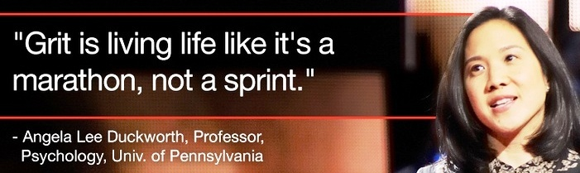
Angela Duckworth (2013) says that peoples motivating hope and belief to create a future reality for themselves and the people around them. From my understanding of her research (Duckworth et al 2007) “GRIT” and the Power of passion and perseverance motivate the ones to stick at their academic study, despite any obstacles, keeping courage and determination, the Cambridge definition of Grit. Duckworth define it as hard work and enthusiasm.

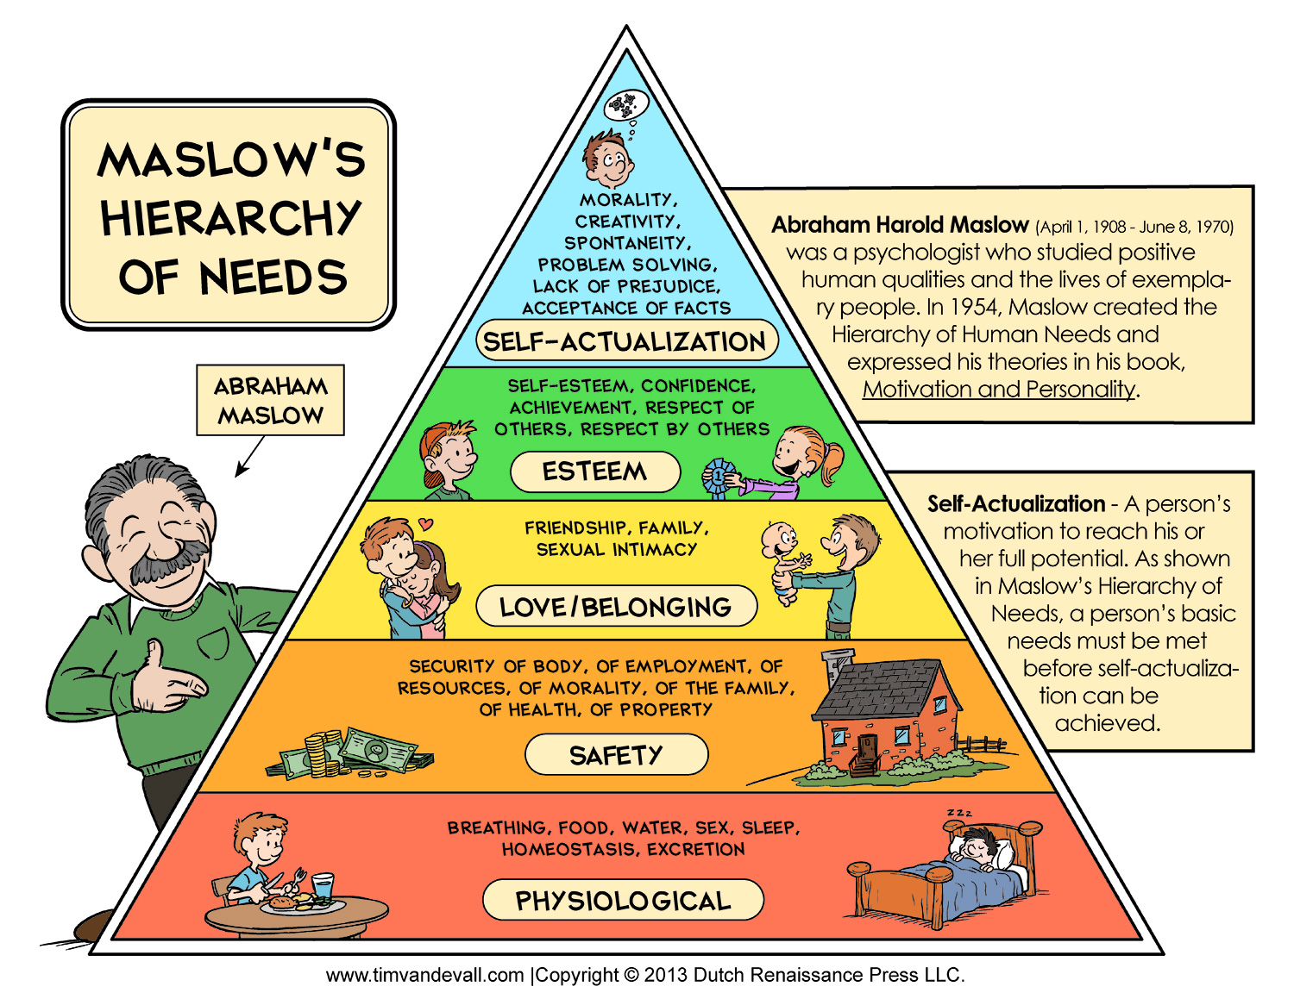
Maslow’s pyramid (Above) demonstrates the hierarchical levels in which payment incentives can be used. For example, if we view the pyramid from the base, we see that he shows us that from a psychological point of view, we need to eat and drink to sustain life and we also need to sleep. This is part of our well-being, as without this, work of any kind would be virtually impossible.
But Maslow’s second level of his pyramid also indicates that one needs a sense of safety; this entails security of the body, health, resources of morality and family. In fact, he states that each level is needed, if one wishes to succeed to achieve the next stage.
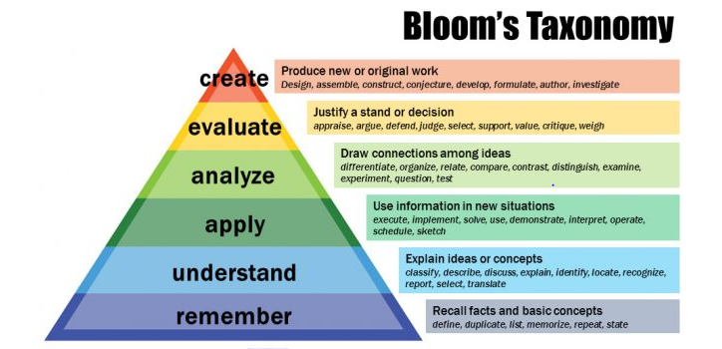
However, Bloom’s taxonomy (Above) uses this type of pyramid, but this is based on producing knowledge. This ‘theory would not be conducive to certain types of employment i.e., a factory setting where the same repetitive actions are required or working the till in a shop. Bloom’s taxonomy is based on a more academia aspect. To operate a till would not really require one to recall basic facts and basic concepts where one would have to ‘understand, apply, analyse, evaluate and create’, although remembering how to operate the various functions of a till is necessary.

4.1 Methods of payment.
There are several different ways in which a worker can be paid and “financial incentives have become a core Component of most conservation programmes because they are highly effective in motivating stewardship behaviour” remarks echoed by (Denissen and Martin (2013) Regardless of where you are, and how you are employed, you can be paid: -
- Timed or hourly rate-
- Flat rate -fix amount per week or monthly
- Overtime -worked outside the time agreed
- Piece-work rates
- On a commission basic
- Fees – for professional services
- Bonuses
- Profit sharing or Performance related pay (PRP)
- Hybrid- Post COVID 19-working at home

4.2 Recognition awards
Pearce (2007) high level rewards says that “staff praise staff achievements, giving staff appropriate additional responsibility, and providing staff with opportunity for advancement help to motivate another Author Michael Armstrong with Duncan Brown Sixth edition handbook of reward Management practice (page 16) states that “rewards are defined as the recognition of the contribution or achievement of individuals or groups by a financial payment or by some form of non-financial recognition. Reward management “deals with the strategies, policies, and practices require to ensure that the value of people and the contribution they make to achieving
Pay management three key drivers Models show how a company assess the value of their employee. Organisational, departmental and team goals is recognised and rewarded (P21)
Many organisations offer other incentive to their workers. The are called perks of the job or fringe benefits. And they can be far more valuable than obtaining an increase in pay.
- Discount on the firm goods and services, pension -scheme
- Sport facilities, life insurance, medical facilities,
- living accommodation, help with house purchase
- Supply transport to and from work, Canteen with low priced meals
- Company car, luncheon vouchers
Furthermore, Non-financial reward (p30) in the company environment is critical for growth. Motivation achievement to use of training and develop skills in one career. Awards given for achievement for example an Oscar for outstanding film. Or the Luther Halsey Gulick award
4.3 Additional holiday
Holidays with Pay Act 1938, Chapter 70 is “An Act to enable wage regulating authorities to make provision for holidays and holiday remuneration for workers whose wages they regulate, and to enable the Minister of Labour to assist voluntary schemes for securing holidays with pay for workers in any industry.” [29/07/1938)
This act became law and gave rise for workers to have a well-earned rest. We also now have certain days for bank holiday, this is when the bank is closed, and no counter transaction was done. In modern technology we now have machines that we can still have access to income. Companies do offer employees holiday breaks apart from the statuary one covered by the law. There is seven days in the week, and it was a custom that we generally work Monday to Friday and weekends are over time. Over the time we have now accepted that weekends are a normal working day. The government have made the employment law more flexible.

4.4 Good working conditions
We have now a wide range of different private and public organisation. These provide services and goods with many types, all having a varied working condition. Working condition in the United Kingdom is determine or controlled by legislation, company laws, the unions, and the employers’ policies. COVID 19 pandemic gave rise for the Government to declare it was ok to work from home. A new home working condition. This was an important step for many because traveling to their workplace would involve time, cost, inconvenience, and the fear of passing or catching the virus.
To a large extent the condition in which employees work is determined by certain legal requirements. The health and safety at Work Act 1974 (HSWA1974) essentially outlines standards and guidelines for employers and employees. So, there can be a safe and healthy environment. Not adhering to the Act one can be fined or even be sent to prison.
The potential Impacts of a good or bad working condition on the workers and the organisations are hugely important. The health of a care worker may be affected, for example lack personal protection equipment. Could cause sickness from infections during COVID 19. The company productivity can be affected and could slowdown or even stop because no absenteeism. There is a large difference in physical working condition, from offices, catering facilities, interior and exterior are just a few. Many other factors like location, environment, perks of the job can all add up to Working condition be a benefit or a curse.
5 Management issues
The Article “Eight ways bad managers Kill Conversation and motivation” written by Kevin Murray (2021) research evidence shows that management must communicate accurately to staff and managers. Communicating with empathy, persuasiveness, provide clarity, getting the team to innovate, sharing success and failures, promoting cooperation. The Problem for this according to a CMI research say “four out of five managers in the UK are accidental manager…promoted to their role without adequate training” The eight bad behaviours are …..
- Secretive and not informative, deliberately withhold information.
- Lack of giving feed back
- Will not give praise or feedback
- Manager is the only voice to be heard
- Manager who sees themselves as not part of the team, office based only
- The manager lacks presentation skills,
- Treating everyone the same, believe that all the team is motivated the same way
- Managers can be “Ambiguous, indirect or even lie,” careless who understand them or not.

6 What recognition motivate staffs best
Many organisations offer other incentive to their workers. They are called perks of the job or fringe benefits. And they can be far more valuable than obtaining an increase in pay.
- Discount on the firm goods and services, pension -scheme
- Sport facilities, life insurance, medical facilities,
- living accommodation, help with house purchase
- Supply transport to and from work, Canteen with low priced meals
- Company car, luncheon vouchers
Furthermore, Non-financial reward (p30) in the company environment is critical for growth. Motivation achievement to use of training and develop skills in one career. Awards given for achievement for example an Oscar for outstanding film. Or the Luther Halsey Gulick award. The need for individuals to be noticed by others.
7 Conclusions
In my conclusion my research has shown that in the workplace leaders need to be trained. Because the clues of motivation of motivating is available .

8 References
Armstrong and Brown (2019) Reward management overview. Pdf
Angela Duckworth (2013)
Bmj 2009.339.b2703 Bmj Publishing group (Kmietowicz Zosia)
Filimonau Viachaslau and Corradini Sara 2020 Event Management Vol,24pp735-752 Pdf
Kevin Murrey CMI (2021) https://www.managers.org.uk/Knowledge-and-insights/article/eight-ways-bad-managers-kill-conversation-and-motivation, Pdf
Cohen (2006) compliment staff.pdf
Denissen and Martin (2013)
Oxford Dictionary of English University press third edition
Pearce Chris (2007) Ten steps to staff motivation. Pdf
Phillips et al (2017) New approaches to staff Pdf.
Morgan and Peter (2017) the business student guide to study and employability. London: SAGE.
Ryan & Desi 2000; Frey & Jengen 2001 Self-determination theory
https://www.legislation.gov.uk/ukpga/Geo6/1-2/70/enacted
https://www.hse.gov.uk/legislation/hswa.htm

