BMSW4012: Professional Career Development

Part 2: Job Interview practical task
Student name: Tudorel Nusca
Lecturer’s name: Muhammad Cassamo

Table of Contents
Job description 3
Cover letter 5
CV 6
Reference list 11
Appendices 12
Appendix 1: CV 12

Job description
Human Resource Manager
vServices
London W1T

Full description
Company needs
vServices is recruiting a very professional and experienced HR manager who can manage employee wellbeing through policies and procedures, in that case, the candidate must understand the business and organisational objectives clearly. He or she must align policies to develop and retain potential staff to meet the organisational objectives.

Education
This position is open to all graduates; however, the candidates with several knowledge will be prioritised. Such as skills of Business Management, Human Resource Management, and Psychology Social Administration.

Experience
Minimum 1 year of experience

Key responsibilities
- To promote equality, diversity, and inclusion within the organisational value and structure
- To increase employee awareness regarding health and safety policies and laws.
- To understand employees skills and gaps to set training initiatives for them.
- To plan for both short and long-term HR management needs.
- To understand the policy development issues such as performance management and disciplinary procedures
- To lead and manage the recruiting campaigns to support the organisational needs. The candidate will be involved in designing job specifications, advertisements, screening and interviewing, and short-listing candidates for final selections.

Competencies
- Business and organisational awareness
- Management skills
- Willingness and positive mind-set to challenge existing organisational culture and make necessary changes
- The skills to understand, assess, explain, and utilise the employment laws within organisational policies
- Strong IT and technological skills for data-based HR management
- Potentials to tackle leadership roles.

Cover letter
To,
The HR manager,
vServices
85 Tottenham Court Road, London W1T

[Sub: Application for HR manager position]
Respected Sir / Ma’am,
I am excited to find your post on the needs of a HR manager in your organisation on Indeed. I am confident that I will be able to valuably contribute my skills and experiences for managing the needs and tasks in your organisation.
As mentioned in my resume, I have 2 years of experience in this field; I worked in NU Creative. NU Creative created attractive content for digital marketing, which focused on developing expert collaboration to build a brighter future (NU Creative, 2024). There, I developed organisational and employee engagement policies based with the understanding of both UK employee acts and organisational goals. My fair policies promoted diversity, equality and inclusion, leading to efficient collaboration and cooperation among the experts. Here, I developed my understanding of employee needs and skill gaps; based on that, I could develop training initiatives. For this reason, I think that my experience in the role of a HR manager in NU Creative developed potential in me to serve vServices potentially. vServices’s focus and specialisation on mobile apps and digital marketing needs active engagement employees for its innovation practices (‌VServices, 2025). Similarity in the organisational aims, will fetch my valuable contributions to the success of your company.
I have attached my resume for your review; I look forward to consulting with you about your required position in your company. I hope to hear from you and contribute vServices to its success.
Sincerely,

CV
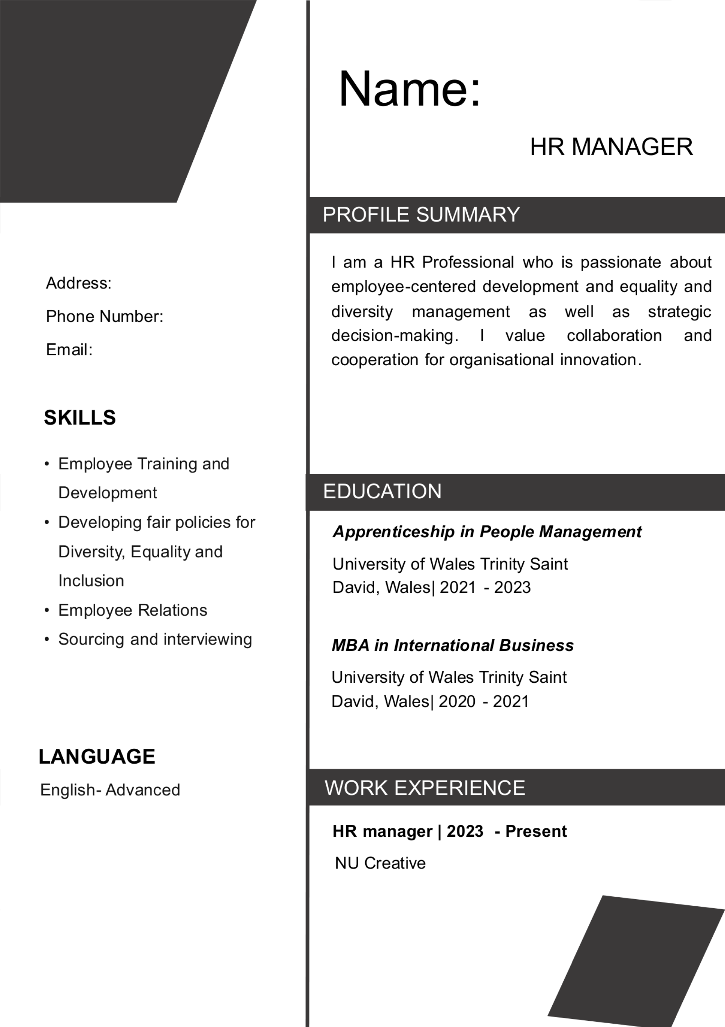

Name
HR MANAGER
Address:
Phone Number:
Email:

Profile summary
I am a HR Professional who is passionate about employee-centered development and equality and diversity management as well as strategic decision-making. I value collaboration and cooperation for organisational innovation.

Education
Apprenticeship in People Management
University of Wales Trinity Saint David, Wales| 2021 - 2023
MBA in International Business
University of Wales Trinity Saint David, Wales| 2020 - 2021

Work experiences
HR manager | 2023 - Present
NU Creative

Skills
- Employee Training and Development
- Developing fair policies for Diversity, Equality and Inclusion
- Employee Relations
- Sourcing and interviewing

Language
English - Advanced
[mentioned in Appendix 1]

Reference list
Bristol-Alagbariya, B., Ayanponle, O.L. and Ogedengbe, D.E., (2024) Leadership development and talent management in constrained resource settings: A strategic HR perspective. Comprehensive Research and Reviews Journal, 2(2), pp.13-22. https://crrjournals.com/crrj/sites/default/files/CRRJ-2024-0031.pdf
Cottrell, S. (2019) The Study Skills Handbook . Fifth edition. London :, Macmillan International Higher Education/Red Globe Press an imprint of Springer Nature Limited.
NU Creative. (2024) Strategic Brand & Design Agency London. [online] Available at: https://www.nucreative.co.uk/about-us [Accessed 13 Jun. 2025].
‌Robertson, P.J., Hooley, T., & McCash P. (eds.) (2020) The Oxford handbook of career development / [electronic resource]. New York :, Oxford University Press.
‌Smale, B. (2015) How to succeed at university : an essential guide to academic skills, personal development and employability . Second edition. London :, SAGE.
‌VServices (2025) Top Digital Marketing Agency, Web Services | vServices.com. [online] Available at: https://www.vservices.com/ [Accessed 13 Jun. 2025].
VServices-about (2025) About Us | vServices.com. [online] Available at: https://www.vservices.com/about [Accessed 13 Jun. 2025].

Appendices

Appendix 1: CV

