

Introducing the Modern Workplace

Name: Emil Milev
ID:2010835

Table of Contents
Introduction 3
Analysis of the relationship between structure, culture, people and organisational performance 3
Identification of essential nature of managerial work 4
Communicating the role of leadership 6
Explanation of the variables determining effective management and leadership 6
Factors that affect differences in individual behaviours within an organisation 8
Evaluate the behavioural approach to management concerning the above factors 10
Conclusion 11
References 13

Introduction
Organisational behaviour is important in the improvement of a manager's ability of building teams and managing conflicts. In this assessment, Sainsbury, one of the largest supermarket in the UK, is taken as an example in this assignment to convey the importance of organisational culture, structure, leadership, managerial work and more. Shaping of organisational culture is effectively done by focusing on the company employees’ engagement and business outcomes. In this report, an analysis of the relationship between organisational structure, culture and performance will be done. Also, this report includes the effects of various factors on individual behaviour in an organisation. The essential nature of managerial work will be identified as well as the role of leadership will be communicated in this report along with the determination of effective leadership and management in business operations.

Analysis of the relationship between structure, culture, people and organisational performance
Organisational structure and culture are interrelated positively that helps the decision-makers in strategically continuing with the business processes. As suggested by Mansouri et al. (2018), the organisational structure is a framework that effectively allows organisational culture to be implemented in business practices. Sainsbury’s has the management of non-executive directors, commercial director, development director, chief executive and the Chairman, which implies that Sainsbury’s has a hierarchical organisational structure. On contrary to this, organisational culture dictates the structural development of a company. Planned development of the organisational culture and structure affects and improves the employee performance of a business positively. Sainsbury’s trains, develop employees, thereby increasing productivity so that the customer's experience can be managed properly. Trieu (2017) stated that a good organisational structure reflects on business productivity. It helps in the accomplishment of individual business practices in the company with the aid of strategic decision-making processes. Hence, it is proven that there is a positive relationship between organisational culture and organisational performance.
Positive and strong organisational culture is effective in improving individual employee performance in the business environment as it provides positive motivation to the employees influencing them to improve their productivity. This is crucial for improving organisational performance as well. On contrary, weak organisational culture is a serious demotivating factor for employees affecting them in performing detrimentally. According to Ramdhani et al. (2017), organisational culture and structure often help the employees to work according to the set objectives by the organisational management, which enables an organisation such as Sainsbury’s to improve its performance in the highly competitive retail market of the UK.
In the view of Groysberg et al. (2018), a functional organisational structure and culture are effective in evaluating and identifying the political and technological factors affecting organisational practices. Increased motivating factors and collaboration among organisational people are positive and strategic influencers of improved business performance. The organisation performance and organisational culture is a strategic way of management of Human resources. In Sainsbury’s, collaborative teamwork along with zero conflicts among employees is effectively influencing to positive customer experience and increased organisational productivity. As suggested by Ogbeibu et al. (2018), the development of organisational culture is an effective way of developing employee behaviour and communication among the employees. In Sainsbury’s, the organisational structure of this retailing company is hierarchical.
The managers and employees are given responsibilities according to their capabilities and strengths. The company is the most trusted by the employees as well as the customers as the company harnesses talent, creativity and diversity of employees as part of their strategized organisational culture. The customers receive great products and company services every time they shop from Sainsbury’s due to the effective organisational structure, culture and employee engagement. The combination of all the above reflects the effective and improved organisational performance of Sainsbury’s (Sainsbury's, 2021).

Identification of essential nature of managerial work
As per Marshev and Otaboev (2019), clarification of company objectives to the workforces is identified as the most essential part of managerial work. This includes the set up of oriented goals, dynamic functions and activities by employees following the management preferences. The systematic and rational ways of decision-making are effective and future-oriented. The company objectives, culture and value of Sainsbury’s are rewarding and complementary to the employees. Planning of business activities includes the determination of action courses that are required for the completion of the organisational goals and objectives (Marshev and Otaboev, 2019). Incorporation of both external and internal factors of the company in the planning process is required. The managers in Sainsbury’s give time and consideration for planning every operation they are planning. Formulation of short-term plans, development of budgets, determining usage of resources and complying with the operational policies and procedures are necessary tasks for organisational managers of Sainsbury’s (Tawse et al. 2019). Organising the business practices by coordination of activities and resources is an important step of essential managerial work. Sainsbury’s has clarified company objectives, planned and formulated organisation according to the functions and processes of Sainsbury’s.
The determination of the company activities and delegation of them with excellent staffing is vital to managerial work. Directing and leading of business culture refers to leadership, motivation and communication, which the managers working for Sainsbury’s follow when conducting their job roles. Hoffman and Tadelis (2021) stated that managing and motivating people by reward systems are helpful in the improvement of employee performance. The activities are completed most efficiently for reaching the desired goals. Controlling of organisational activities establishes standard performances of the company employees and corrective action plan are taken accordingly. Monitoring and evaluating the activities of the employees by the management ensures that organisational productivity is accomplished. In Sainsbury’s, the HRM functions include managerial and operational functions. The managerial function of Sainsbury’s includes planning, organising, directing and controlling that influence the organisational productivity with strategic business functions and customer service through the organisational employees (Sainsbury's, 2021).
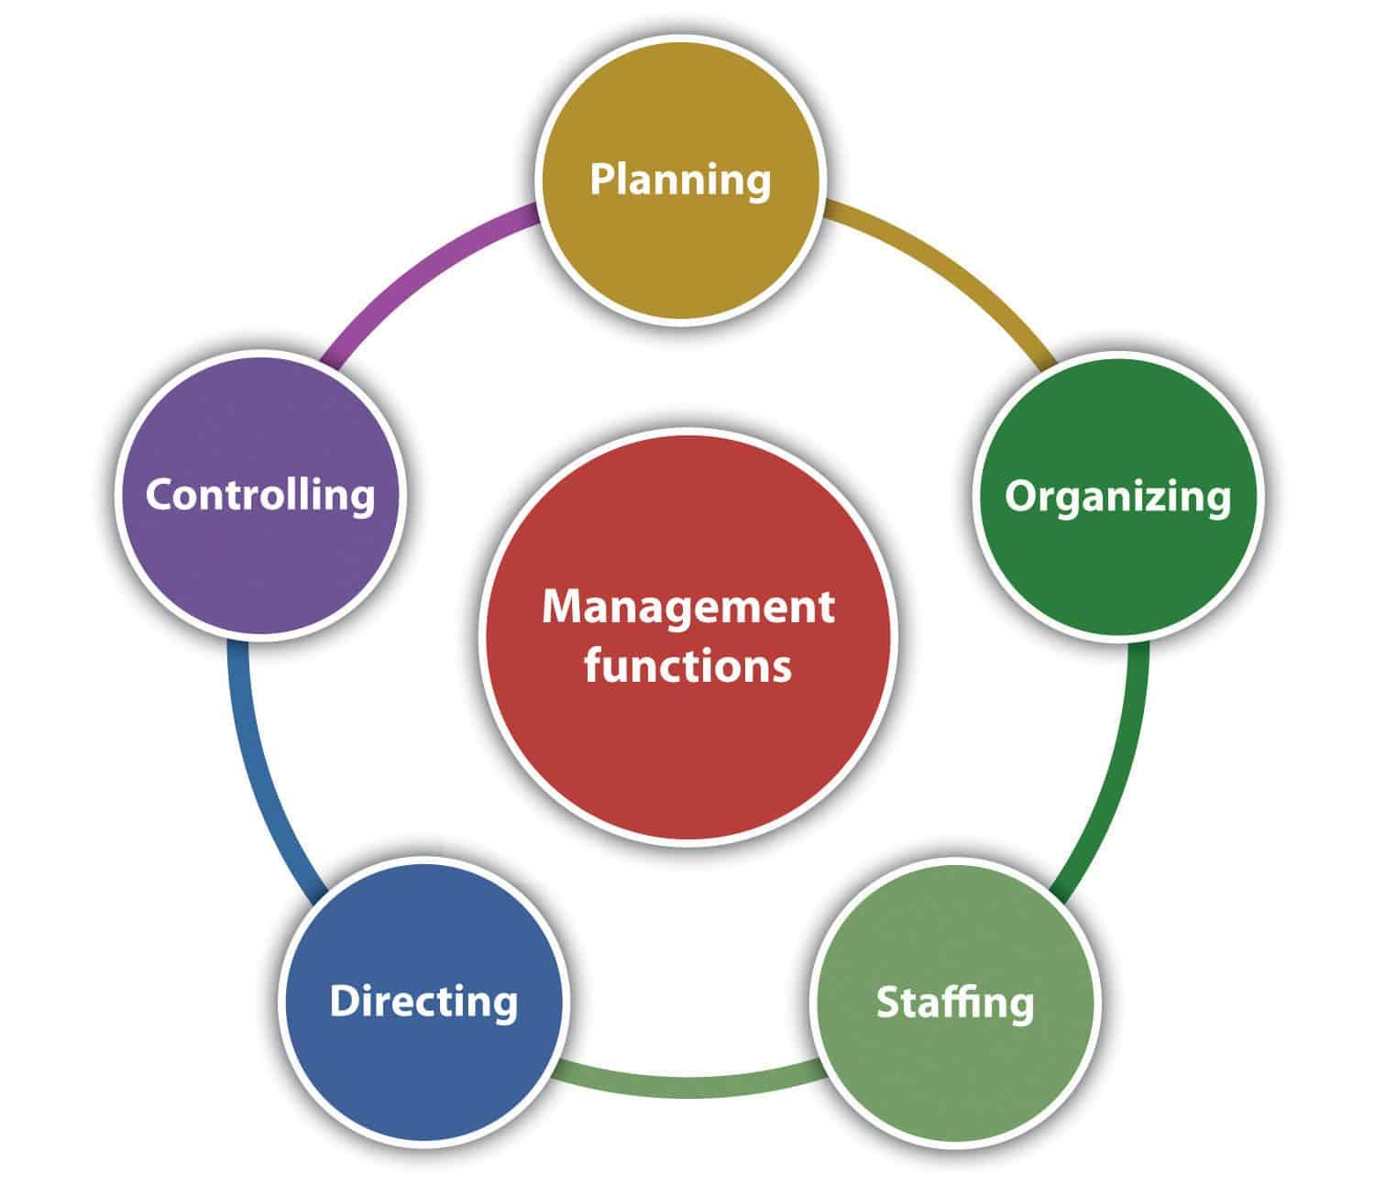

Figure 1: Nature of managerial work
(Source: Kukreja, 2021)

Communicating the role of leadership
The leadership roles in an organisation include understanding and interpreting the internal and external environment in which the firm is operating. As stated by Irnawati and Prasetyo (2020), the factors that are affecting the enterprise are evaluated by the leaders and are interpreted by the employees for better accomplishment of organisational goals. The employees are being motivated by positive motivation in the form of rewards and incentives by the leaders by applying the hygiene factors. In this case, the motivational approach designed by Herzberg is considered by the leaders. The leaders of Sainsbury’s are looking after the health and safety of the employees while rewarding them with monetary and other benefits for improving their workplace motivation even further (Alshmemri et al., 2017). The leaders of Sainsbury’s arrange meetings with their colleagues and have discussions regarding organisational decisions regularly. Oc (2018) suggested that the leader must be effective in the development of winning strategies. The execution of the winning strategies brilliantly is the most important role of leaders.
The leader must measure the effect of the applied strategies systematically. As opined by Chou and Ramser (2019), the application of Situational leadership theory has also been considered by the leaders working in Sainsbury’s, especially in this pandemic scenario. The leaders are adapting to the situational changes taking place on a global level and allowing the workers of Sainsbury’s to operate while maintaining social distancing. Moreover, the leaders and managers are trying to conduct overall selling of the products via websites, which is enabling employees to work from their houses as well. Moreover, the leaders of Sainsbury have influenced employee performance, engagement and productivity positively in the business practices by taking part in operations and leading the way from the front of the pack by taking up the role of a participative leader (Odoardi et al., 2019).
Sainsbury’s leaders applied strategic leadership skills for controlling the allocation of jobs according to the strengths of the employees. This increases the engagement of the employees in organisational practices. The leader demonstrates confidence and inspires the employees to perform better towards the organisational performance. Communication is the most vital in the role of leadership as the interpretation of the organisational practices and leaders can effectively do completion of them (Tampubolon and Harati, 2019). In Sainsbury’s, the leaders believe that democratic leadership is the most effective as the employee productivity increases due to efficient communication and reward system as motivation (Sainsbury’s, 2021). The use of behavioural theory is effectively done by the leaders of Sainsbury to increase the task-oriented skills of employees in the business practices.

Explanation of the variables determining effective management and leadership
From the opinions of Osborne and Hammoud (2017), effective leadership makes the leaders respected and shine in front of the employees in the company. Effective leadership and management help to increase the ability to influence others and encouraging risk-taking and become innovative. Effective leadership and management can be managed with assistance from the three variables of time, resources and money respectively. Several factors are present that help in determining the effectiveness of leadership and management for organisations like Sainsbury’s appropriately. The interpersonal skills, information-sharing abilities, ability to perform teamwork, employee motivation and problem-solving skills are variables that help to determine the effectiveness of leadership and management in Sainsbury’s respectively (Parvin, 2019).

Effective leadership
Good working environment

Increased employee motivation

Increased ability of teamwork

Increased productivity

Figure 1: Effective leadership in a workplace
According to Osborne and Hammoud (2017), the Situational leadership theory is implemented in the workplace to help the leaders in increasing their effectiveness in the organisation. Effective leadership helps in attaining organisational success depending on the outcomes from these factors on the companies like Sainsbury’s. Sainsbury’s should implement transactional leadership theory as it helps the managers in providing the employees with self-motivation. Employee motivation helps in improving employee performance and affects the productivity levels of the business. The employees learn to work in teams when under the leadership of an effective leader. Interpersonal skills are developed among the employees, which helps in determining effective management within the organisation (Anwar, 2017).
In the opinion of Cote (2017), leaders can be effective by following the behavioural leadership theory for developing proper behavioural and communication skills to earn the trust and belief of the employees in the company. Effective leadership is influenced by the motivation received by the employees based on their performance within the organisation. The problem-solving skills are earned by the employees under effective leaders to handle complicated situations and resolve conflicts. Therefore, the factors that help to determine effective leadership and management in companies like Sainsbury’s have been discussed appropriately.

Factors that affect differences in individual behaviours within an organisation
According to Jones et al. (2018), individual behaviours within a company are defined based on complicated responses of the internal and external stimuli. The way an individual reacts in different situations such as expressing emotions of love, happiness and anger are considered in the workplace while dealing with different situations. Individual behaviour is the way the employees behave in the workplace according to the situations. Different factors are present that affect the differences in individual behaviours taking place in a company. Individual behaviour is influenced by discrimination occurring in the workplace, biased behaviour of the management, cultural differences and health and security measures provided by the organisation (Cote, 2017). Hofstede’s Cultural Dimensions Theory helps in understanding the differences in the culture present in different nations. The dimensions are power distance, identity, uncertainty, gender and time, which influence the cultural diversities present in the workplace.
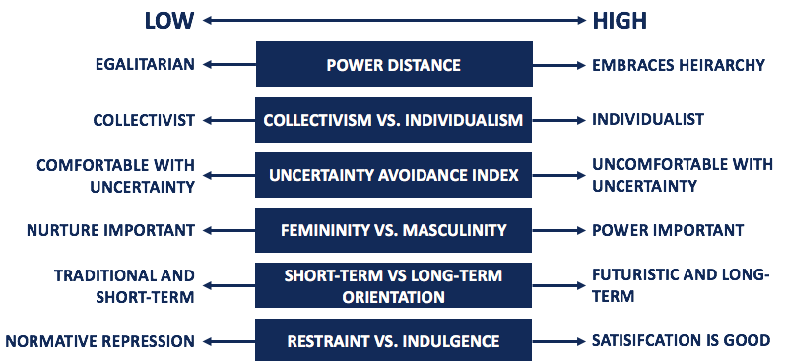
Figure 2: Hofstede's Cultural Theory
(Source: Corporate Finance Institute, 2021)
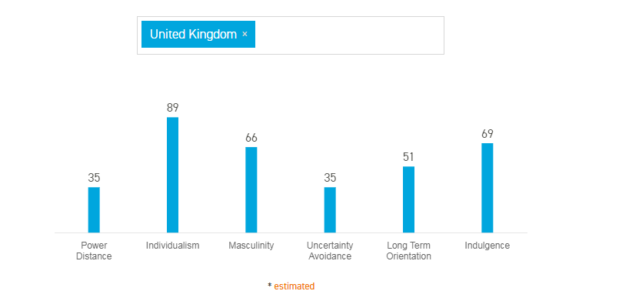
Figure 3: Hofstede’s Cultural dimension score for the UK
(Source: Hofstede Insights, 2021)
In companies like Sainsbury’s, the teams have culturally diverse employees, which increase the occurrence of conflicts in the company. The employees face discrimination in the business related to their age, sex, beliefs, cultural background and economic background as well. Age factor is an important reason for increased differences in individual behaviours because, with old age, the stamina decreases and an increase in absenteeism affect the productivity of the employees in the workplace in firms like Sainsbury’s (Bambrick-Santoyo, 2018). This suggests that there is a masculine culture in Sainsbury’s along with moderate power distance as well. It can be supported by the fact that the UK has a score of 66 when it comes to masculinity within the culture (Hofstede Insights, 2021). Herzberg’s motivation-hygiene theory and the dual-factor theory, also known as Herzberg’s Two Factor theory helps in understanding the consequences of providing good hygiene to the employees in the workplace related to employee motivation.

Poor hygiene decreases employee job satisfaction
Motivational factors help in increasing job satisfaction
Figure 4: Herzberg's Two-Factor Theory

From the views of Mark et al. (2018), favouritism and biased behaviour have been increasing factor for the differences taking place in the individual behaviours of the employees in the organisation. Some employees receive promotion based on favouritism while the deserving candidates do not receive any rewards. The performance and behaviour of the employees are influenced by the rewards and recognitions that are provided to them as compensation by the organisation. The type of leadership approach practised in the firm affects the individual behaviours in the firm as well. The behaviour of the leaders has more significance in this aspect than their qualities. The safety and health measures provided to the employees in the organisation affects the way they behave within the business (Bambrick-Santoyo, 2018). The behaviour of the employees changes with every appreciation, every discrimination and every disrespecting behaviour that they face in companies like Sainsbury’s.

Personality

Attitudes

Work Behaviour

Perception

Ability and skills

Figure 5: Individual Differences in the Workplace

Evaluate the behavioural approach to management concerning the above factors
From the views of Nawarini (2019), the behavioural approach in management helps in focusing on human relations and the well-being of the employees as well. The behavioural style manager has the responsibility of creating the conditions that help the employees in remaining motivated and satisfied. In the case of Sainsbury’s, the behavioural approach helps the leaders in combining the two kinds of behaviours for influencing the efforts required to reach the goals. The behavioural approach to management has evolved when the managers started adopting different ideas for achieving total efficiency and harmony in the workplace. The behavioural approach can be divided into two branches namely the behavioural science approach and the human relations approach. In the case of the human relations approach, the skills of the employees of Sainsbury’s are recognised and rewarded based on their performance (Mark et al., 2018). The Total Quality Management framework is used for measuring the performance of the employees in the workplace.

Focus on customers

Continuous improvement

Process-centred

Decision-making

Communication

Figure 6: Total Quality Management
From the views of Johnston (2018), behavioural approaches help in improving the use of teams for achieving organisational goals. The approaches help to train and develop the employees in companies as Sainsbury’s, to improve their skills and productivity levels within the organisation. Different innovative approaches and incentive techniques are used by the employees as contributions from the behavioural approach. The behavioural science approach helps the management in acquiring better employee performance, motivation, communication and participative management respectively. The behavioural approach to management helps to settle the tasks and demand their completion. The behavioural-style manager is responsible for creating the conditions for maintaining the satisfaction and motivation levels of the employees in the organisations like Sainsbury’s (Johnston, 2018).

Conclusion
From the above discussion, different aspects related to the relationship of organisational culture and structure with organisational performance has been concluded. The essential nature of the managerial work has been identified in the project based on projects and functions. The role of leadership has been communicated in the paper for a better understanding of the modern workplace. The variables used for determining effective management and leadership such as interpersonal skills, teamwork ability and employee motivation have been discussed. The paper has also concluded the factors that influence the differences in individual behaviours in organisations such as Sainsbury’s like organisational leadership approaches and discrimination practised among employees in the firm.

References
Alshmemri, M., Shahwan-Akl, L. and Maude, P., (2017). Herzberg’s two-factor theory. Life Science Journal, 14(5), pp.12-16.
Anwar, K., (2017). The Role of Effective Leadership in Crisis Management: Study of Private Companies in Kurdistan. Qalaai Zanist Scientific Journal, 2(4), pp.326-338.
Bambrick-Santoyo, P., (2018). Leverage leadership 2.0: A practical guide to building exceptional schools. John Wiley & Sons. http://old.wbu.edu/academics/online_programs/schedules/Syllabi/Winter17/Education/EDCI6302VC01.docx
Corporate Finance Institute, (2021). Hofstede’s Cultural Dimensions Theory - Overview and Categories . Available at: https://corporatefinanceinstitute.com/resources/knowledge/other/hofstedes-cultural-dimensions-theory/ (Accessed: 31 March 2021).
Cote, R., (2017). The vision of effective leadership. International Journal of Business Administration, 8(6), pp.1-10. https://www.academia.edu/download/57898223/Leadership_in_Aviation.pdf
Groysberg, B., Lee, J., Price, J. and Cheng, J., (2018). The leader’s guide to corporate culture. Harvard business review, 96(1), pp.44-52.
Hoffman, M. and Tadelis, S., 2021. People management skills, employee attrition, and manager rewards: An empirical analysis. Journal of Political Economy, 129(1), pp.000-000.
Hofstede Insights (2021) Country Comparison - Hofstede Insights, Hofstede Insights. Available at: https://www.hofstede-insights.com/country-comparison/the-uk/ (Accessed: 31 March 2021).
Irnawati, J.E. and Prasetyo, J.H., (2020). The Influence Over the Transformational of Leadership Style, the Organizational Culture, and Employee Empowerment towards Achievement of Organizational Strategies in one the Central Government Organization. International Journal of Innovative Science and Research Technology, 5(3), pp.917-927.
Johnston, K. (2018) Examples of Behavioral Approaches in Business Management, Yourbusiness.azcentral.com. Available at: https://yourbusiness.azcentral.com/examples-behavioral-approaches-business-management-23852.html (Accessed: 30 March 2021).
Jones, J.S., Murray, S.R. and Tapp, S.R., (2018). Generational differences in the workplace. The Journal of Business Diversity, 18(2), pp.88-97. https://search.proquest.com/openview/b824e624ee7518c25fac7867a155564a/1?pq-origsite=gscholar&cbl=1576345
Kukreja, S. (2021) Functions of Management: Planning, Organizing, Staffing, Directing & Controlling, Management Study HQ. Available at: https://www.managementstudyhq.com/functions-of-management.html (Accessed: 30 March 2021).
Mansouri, A.A.A., Singh, S.K. and Khan, M., (2018). Role of organisational culture, leadership and organisational citizenship behaviour on knowledge management. International Journal of Knowledge Management Studies, 9(2), pp.129-143.
Mark, G., Czerwinski, M. and Iqbal, S.T., (2018, April). Effects of individual differences in blocking workplace distractions. In Proceedings of the 2018 CHI Conference on Human Factors in Computing Systems (pp. 1-12). https://par.nsf.gov/servlets/purl/10164605
Marshev, V.I. and Otaboev, J.B., (2019). Reflections on the Managerial Roles: Past and Present. Management Science, 9(2), pp.94-106.
Nawarini, A.T., (2019). Behavioral approach on public sector management. Jurnal Akuntansi, Manajemen Dan Ekonomi, 21(1), pp.8-12. http://jos.unsoed.ac.id/index.php/jame/article/download/1481/1013
Oc, B., (2018). Contextual leadership: A systematic review of how contextual factors shape leadership and its outcomes. The Leadership Quarterly, 29(1), pp.218-235.
Odoardi, C., Battistelli, A., Montani, F. and Peiró, J.M., (2019). Affective commitment, participative leadership, and employee innovation: a multilevel investigation. Journal of Work and Organizational Psychology, 35(2), pp.103-113.
Ogbeibu, S., Senadjki, A. and Gaskin, J., (2018). The moderating effect of benevolence on the impact of organisational culture on employee creativity. Journal of Business Research, 90, pp.334-346.
Osborne, S. and Hammoud, M.S., (2017). Effective employee engagement in the workplace. International Journal of Applied Management and Technology, 16(1), p.4. https://scholarworks.waldenu.edu/cgi/viewcontent.cgi?article=1239&context=ijamt
Parvin, A., (2019). Leadership and management in quality assurance: insights from the context of Khulna University, Bangladesh. Higher Education, 77(4), pp.739-756.
Ramdhani, A., Ramdhani, M.A. and Ainissyifa, H., (2017). The conceptual framework of corporate culture influenced employees commitment to the organization. International business management, 11(3), pp.826-830.
Sainsbury’s (2021). Our purpose. Available at: https://about.sainsburys.co.uk/ (Accessed on 30 March 2021)
Tampubolon, M. and Harati, R., (2019). Role of organizational culture, communication and leadership style on job satisfaction. International Journal of Research in Business and Social Science (2147-4478), 8(5), pp.308-315.
Tawse, A., Patrick, V.M. and Vera, D., (2019). Crossing the chasm: Leadership nudges to help transition from strategy formulation to strategy implementation. Business Horizons, 62(2), pp.249-257.
Trieu, V.H., (2017). Getting value from Business Intelligence systems: A review and research agenda. Decision Support Systems, 93, pp.111-124.

